ZION LUTHERAN CHURCH, WOODLAND, MI
Twenty Second Sunday November 9, 2025
*If you are listening in your car, please tune your radio to FM 87.7*
(Please silence your cell phones while in the sanctuary. Thank you.)


WELCOME AND ANNOUNCEMENTS

Gathering
The Holy Spirit calls us together as the people of God.

Confession and Forgiveness
In the name of the Father,
and of the ☩ Son,
and of the Holy Spirit.
Amen.

Almighty God, to whom all hearts are open, all desires known, and from whom no secrets are hid: cleanse the thoughts of our hearts by the inspiration of your Holy Spirit, that we may perfectly love you and worthily magnify your holy name, through Jesus Christ our Lord.
Amen.

Let us confess our sin in the presence of God and of one another. Most merciful God,
we confess that we are captive to sin and cannot free ourselves. We have sinned against you in thought, word, and deed, by what we have done and by what we have left undone. We have not loved you with our whole heart; we have not loved our neighbors as ourselves. For the sake of your Son, Jesus Christ, have mercy on us. Forgive us, renew us, and lead us, so that we may delight in your will and walk in your ways, to the glory of your holy name.
Amen.

God, who is rich in mercy, loved us even when we were dead in sin, and made us alive together with Christ. By grace you have been saved. In the name of ☩ Jesus Christ, your sins are forgiven. Almighty God strengthen you with power through the Holy Spirit, that Christ may live in your hearts through faith.
Amen.
Gathering Song “On Jordan's Stormy Bank I Stand” #437

GREETING
The grace of our Lord Jesus Christ, the love of God, and the communion of the Holy Spirit be with you all.
And also with you.

Prayer of the Day
Let us pray together.
O God, our eternal redeemer, by the presence of your Spirit you renew and direct our hearts. Keep always in our mind the end of all things and the day of judgment. Inspire us for a holy life here, and bring us to the joy of the resurrection, through Jesus Christ, our Savior and Lord.
Amen.

First Reading Job 19:23-27a
A reading from Job.
²³ “O that my words were written down!
O that they were inscribed in a book!
²⁴ O that with an iron pen and with lead
they were engraved on a rock forever!
²⁵ For I know that my vindicator lives
and that in the end he will stand upon the earth;
²⁶ and after my skin has been destroyed,
then in my flesh I shall see God,
^{27a} whom I shall see on my side,
and my eyes shall behold, and not another.”

The word of the Lord
Thanks be to God.

Psalm Psalm 17:1-9

¹ Hear a just cause, O Lord; give heed | to my cry;
listen to my prayer, which does not come from | lying lips.
² Let my vindication come forth | from your presence;
let your eyes be | fixed on justice.
³ Examine my heart, visit | me by night,
melt me down; you will find no impuri- | ty in me.
⁴ I have not regarded what | others do;
at the word of your lips I have avoided the ways | of the violent.
⁵ My footsteps hold fast to your | well-worn path;
and my feet | do not slip.
⁶ I call upon you, O God, for you will | answer me;
incline your ear to me and | hear my words.
⁷ Show me your marvelous | lovingkindness,
O Savior of those who take refuge at your right hand from those who | rise against them.
⁸ Keep me as the apple | of your eye;
hide me under the shadow | of your wings,
⁹ from the wicked | who assault me,
from my deadly enemies | who surround me.

Second Reading 2 Thessalonians 2:1-5, 13-17
A reading from Romans.

¹ As to the coming of our Lord Jesus Christ and our being gathered together to him, we beg you, brothers and sisters, ² not to be quickly shaken in mind or alarmed, either by spirit or by word or by letter, as though from us, to the effect that the day of the Lord is already here. ³ Let no one deceive you in any way, for that day will not come unless the rebellion comes first and the lawless one is revealed, the one destined for destruction. ⁴ He opposes and exalts himself above every so-called god or object of worship, so that he takes his seat in the temple of God, declaring himself to be God. ⁵ Do you not remember that I told you these things when I was still with you?
¹³ But we must always give thanks to God for you, brothers and sisters beloved by the Lord, because God chose you as the first fruits for salvation through sanctification by the Spirit and through belief in the truth. ¹⁴ For this purpose he called you through our gospel, so that you may obtain the glory of our Lord Jesus Christ. ¹⁵ So then, brothers and sisters, stand firm and hold fast to the traditions that you were taught by us, either by word of mouth or by our letter.
¹⁶ Now may our Lord Jesus Christ himself and God our Father, who loved us and through grace gave us eternal comfort and good hope, ¹⁷ comfort your hearts and strengthen them in every good work and word.

The Word of the Lord
Thanks be to God.

Gospel Acclamation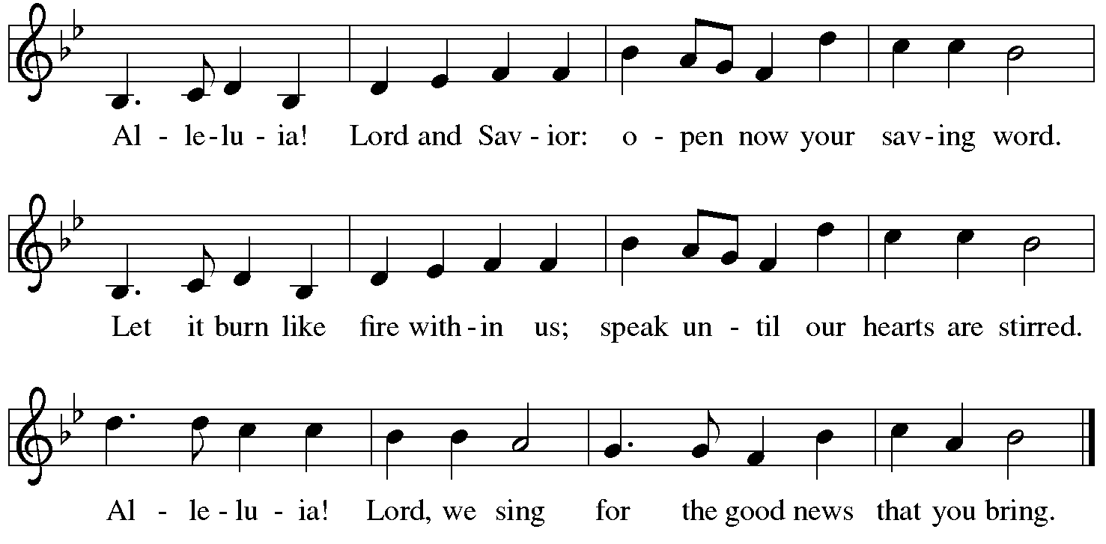
Gospel Luke 20:27-38
The holy gospel according to Luke.

²⁷ Some Sadducees, those who say there is no resurrection, came to [Jesus] ²⁸ and asked him a question: “Teacher, Moses wrote for us that if a man’s brother dies leaving a wife but no children, the man shall marry the widow and raise up children for his brother. ²⁹ Now there were seven brothers; the first married a woman and died childless; ³⁰ then the second ³¹ and the third married her, and so in the same way all seven died childless. ³² Finally the woman also died. ³³ In the resurrection, therefore, whose wife will the woman be? For the seven had married her.”
³⁴ Jesus said to them, “Those who belong to this age marry and are given in marriage, ³⁵ but those who are considered worthy of a place in that age and in the resurrection from the dead neither marry nor are given in marriage. ³⁶ Indeed, they cannot die anymore, because they are like angels and are children of God, being children of the resurrection. ³⁷ And the fact that the dead are raised Moses himself showed, in the story about the bush, where he speaks of the Lord as the God of Abraham, the God of Isaac, and the God of Jacob. ³⁸ Now he is God not of the dead but of the living, for to him all of them are alive.”

The gospel of the Lord.
Praise to you, O Christ.

CHILDREN’S MOMENT

SERMON Pastor Frank Rothfuss
hymn of the day “I Know that My Redeemer Lives!” #619 V. 1-4

cREED
I believe in God, the Father almighty,
creator of heaven and earth.
I believe in Jesus Christ, God’s only Son, our Lord,
who was conceived by the Holy Spirit,
born of the virgin Mary,
suffered under Pontius Pilate,
was crucified, died, and was buried;
he descended to the dead.*
On the third day he rose again;
he ascended into heaven,
he is seated at the right hand of the Father,
and he will come to judge the living and the dead.
I believe in the Holy Spirit,
the holy catholic church,
the communion of saints,
the forgiveness of sins,
the resurrection of the body,
and the life everlasting. Amen.

*Or, “he descended into hell,” another translation of this text in widespread use.

prayers of Intercession
Gathered with one voice, we offer our prayers for the church, the world, and all who are in need.
A brief silence.
God our Redeemer, bless your church universal and its leaders. Set all hearts on you from generation to generation in anticipation of Christ’s return. We pray especially for Redeemer Lutheran in Lansing and their pastor Rev. Janice Hite. Hear us, O God.
Your mercy is great.
God of life, we give thanks for the fruits and grains of harvest, for rivers and streams, for all that is made of rock and iron. Renew the earth’s natural resources and the lands from which they come. Hear us, O God.
Your mercy is great.
God of justice, we give thanks for the service of our veterans and pray for those needing support for wounds of any kind. Strengthen those charged with the governance and protection of vulnerable populations. Bring an end to war throughout the world. Hear us, O God.
Your mercy is great.
God who leads us to belief and truth, we give thanks that you are always and already here. Nurture and support those who are unsteady in mind, unsafe in spirit, or unwell in body. Comfort those who suffer from trauma and exposure to traumatic events.
Hear us, O God.
Your mercy is great.
God who gathers us together, we give thanks for our pastors and deacons, teachers and musicians, administrators, and building caretakers. May they find joy in leadership as we grow in faith together. Hear us, O God.
Your mercy is great.
Here other intercessions may be offered.
God of the saints, we give thanks for all who have died in faith. Uplift us as we honor their memory and await your coming in glory. Hear us, O God.
Your mercy is great.
We offer these and all our prayers to you, O God, trusting in your grace and unyielding love; through Jesus Christ, our Lord.
Amen.

PEACE
The peace of Christ be with you always.
And also with you.

OFFERING & OFFERING SONG
The joy of the Lord is my strength,
The joy of the Lord is my strength,
The joy of the Lord is my strength,
The joy of the Lord is my strength.

Offering Prayer
Let us pray.
God of all creation, all you have made is good, and your love endures forever. You bring forth bread from the earth and fruit from the vine. Nourish us with these gifts, that we might be for the world signs of your gracious presence in Jesus Christ, our Savior and Lord.
Amen.

DIALOGUE
The Lord be with you.
And also with you.
Lift up your hearts.
We lift them to the Lord.
Let us give thanks to the Lord our God.
It is right to give our thanks and praise.

PREFACE (Pastor)
It is indeed right, our duty and our joy,
that we should at all times and in all places
give thanks and praise to you, almighty and merciful God,
through our Savior Jesus Christ;
who on this day overcame death and the grave,
and by his glorious resurrection opened to us the way of everlasting life.
And so, with all the choirs of angels,
with the church on earth and the hosts of heaven,
we praise your name and join their unending hymn

holy, holy, holy
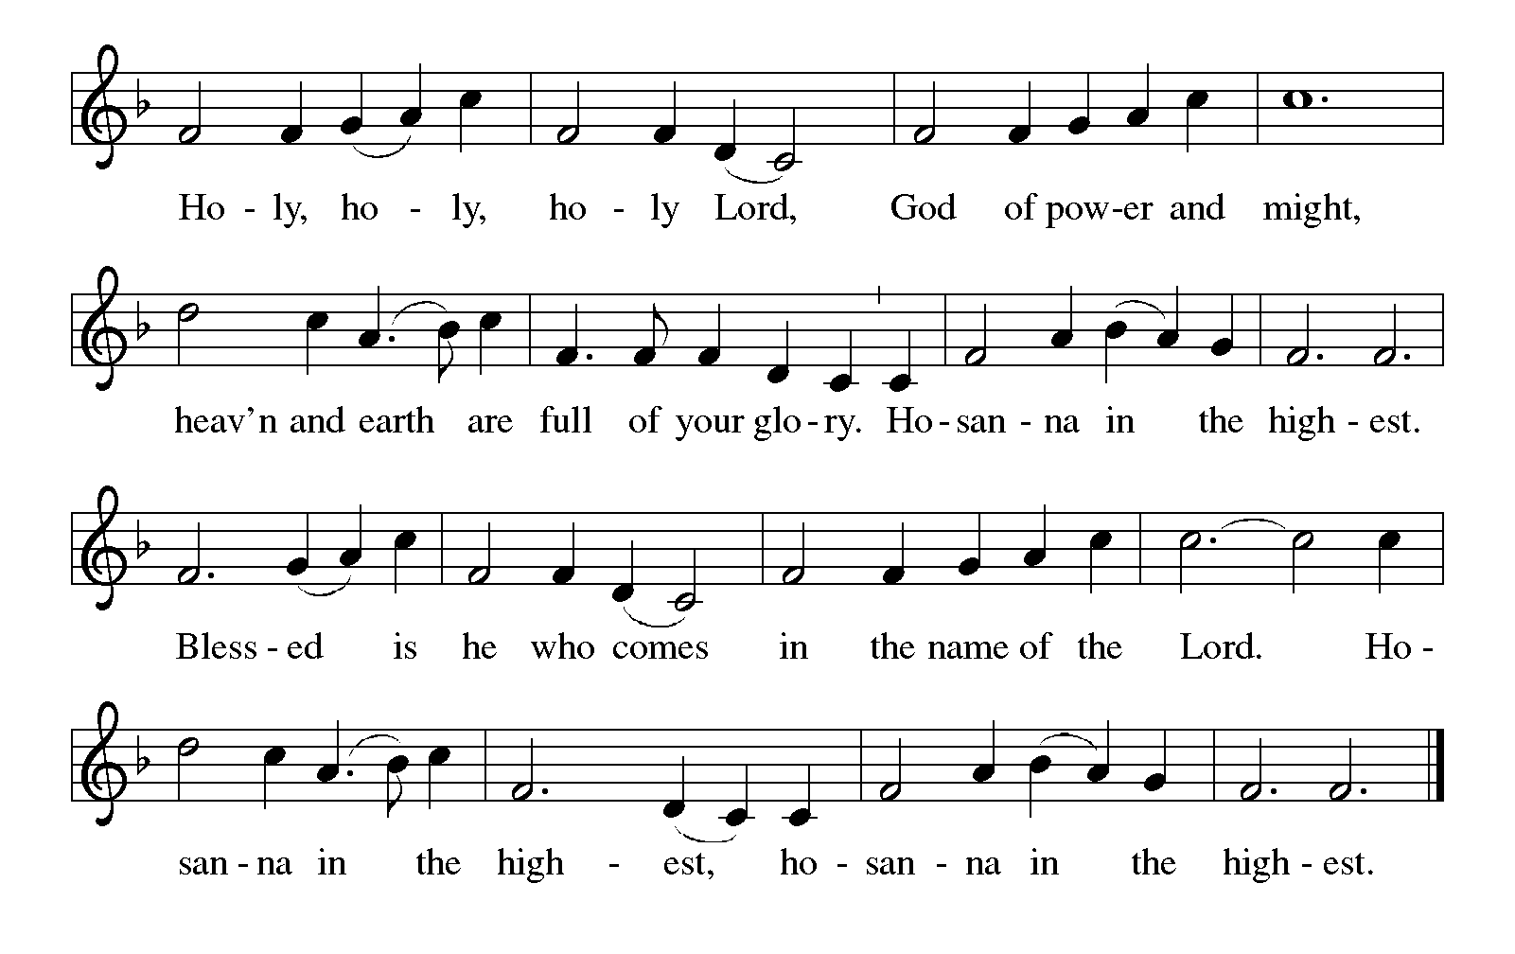

Thanksgiving at the Table
In the night in which he was betrayed,
our Lord Jesus took bread, and gave thanks;
broke it, and gave it to his disciples, saying:
Take and eat; this is my body, given for you.
Do this for the remembrance of me.

Again, after supper, he took the cup, gave thanks,
and gave it for all to drink, saying:
This cup is the new covenant in my blood,
shed for you and for all people for the forgiveness of sin.
Do this for the remembrance of me.

For as often as we eat of this bread and drink from this cup,
we proclaim the Lord’s death until he comes.

Lord’s Prayer
Gathered into one by the Holy Spirit, let us pray as Jesus taught us.
Our Father, who art in heaven,
hallowed be thy name,
thy kingdom come,
thy will be done,
on earth as it is in heaven.
Give us this day our daily bread;
and forgive us our trespasses,
as we forgive those
who trespass against us;
and lead us not into temptation,
but deliver us from evil.
For thine is the kingdom,
and the power, and the glory,
forever and ever. Amen.

INVITATION TO COMMUNION
Come to the banquet, for all is now ready.

COMMUNION *continuous
*People are welcome to kneel at the altar rail for a time of prayer after they receive their communion elements.

COMMUNION HYMNS

“Blessed Assurance” #638

“When We Are Living” #639

PRAYER AFTER COMMUNION
Let us pray.
We give you thanks, almighty God, that you have refreshed us through the healing power of this gift of life. In your mercy, strengthen us through this gift, in faith toward you and in fervent love toward one another; for the sake of Jesus Christ our Lord.
Amen.

Sending
God blesses us and sends us in mission to the world.

Blessing
The Lord bless you and keep you.
The Lord’s face shine on you with grace and mercy.
The Lord look upon you with favor and ☩ give you peace.
Amen.

Sending SonG “Soon and Very Soon” #439

Dismissal
Go in peace. Christ is with you.
Thanks be to God.
From sundaysandseasons.com. Copyright © 2017 Augsburg Fortress. All rights reserved.

Thank you to all who served in worship today!
Presiders: Pastor Frank Rothfuss Musician: Jayne Flanigan
Acolyte: Safety Person:
Elder: Naomi Wilson Trustee: Tom Krikke
Offering Counters: Paul Meade & Carlotta Willard



PRAYERS OF THE FAITHFUL

With thanks for all God’s blessings and his love for all people. Our Bishops, Julie Schneider-Thomas, Yehiel Curry, and the congregations of the North/West Lower Michigan Synod, and especially for Redeemer Lutheran in Lansing and their pastor Rev. Janice Hite.

Prayers for our friends, for all who are sick or hospitalized and for all health care workers who care for them. All those members of Zion’s family traveling; all those homebound or in frail health; all those suffering with quiet, unknown needs or worries. For those who serve on our behalf: public safety, utility workers, medical personnel, military personnel. For those who might be forgotten.

This week at Zion:

- Men’s Coffee, 8 AM, Wednesday, November 12
- Bulletin Deadline, Wednesday, November 12


ONLINE GIVING
Zion has received a QR code to facilitate online giving. If you are interested in donating online instead of bringing your donation to church, simply scan the QR code and it will direct you to the appropriate site. The code is on our website as well.

ANNOUNCEMENT
- Flowers on the Altar: The flowers on stands by the altar are placed with love in honor of what would have been Lloyd Brecheisen's 104th birthday on November 13th by his wife, Caroline Brecheisen.
- Thank You From Pastor Scheck: Thank you people of God at Zion Lutheran church. I was surprised at the Pastor Appreciation and the birthday gift. It went toward a new kitchen faucet. Thank you, Thank you, Thank you. Pastor Ken
- Thank you from Pastor Anderson: Thank you Kind Friends. Thank you for being so wonderful and loving to Vicki and I. I will continue to pray for you. Michael Anderson
- Christmas Tree Farm and Market Ministry: To date, we have 27 families and 69 children signed up to receive trees, ornaments, decor and stock stuffer bags for kids at this year's Christmas ministry. We are in need to help to bring items to the fellowship hall after worship today. We also need help to set up on Monday and Tuesday. We need helpers at the event on Friday and Saturday and we need cookies and hot chocolate. If you can help, there is a sign-up sheet in the Narthex. If you have questions, please talk with Martha, Karen, or Ruth.
- Gloria Anderson has moved into Green Acres, Independent Living in Ionia. Here is her new address and telephone number. Gloria Anderson: 2554 Commerce Lane, Apt. 109 Ionia, MI 48846. Phone #: 616.527.0474
- Special Congregational Meeting: A special congregational meeting will be held on November 16th to seek tentative approval for discussions regarding a shared ministry with Pastor Ken Scheck and Grace Lutheran Church, Hastings. Details about the shared ministry and the financial costs will be provided at the meeting. The meeting wil be immediately following worship. If you have questions, please talk with Paul Meade or a member of the church council.
- Zion Christmas Tree Farm and Market Ministry: Our free Christmas ministry will be on November 14 and 15 this year. If you can lend a hand to set up prior to the event or help with the event that would be very appreciated. There is a sign-up sheet in the Narthex along with a flyer with more details. If you have questions, please talk with Martha, Karen or Ruth. Thank you.
- Festival of Tables, November 8th, 9 am to 12 noon: The Lakewood Community Women is sponsoring a free Festival of Tables on November 8th at Clarksville Bible Church. The morning will include viewing the tables decorated in fall themes, enjoying brunch, listening to two local women, Barb Bosworth and Jessi Trierweiler, speak on harvest blessings. All women are invited to attend. The Zion Coffee Fellowship women are sponsoring a table, “Thank You for the Birds so Sweet.” There is room at the table for you! If interested there is a sign-up sheet in the narthex. If you have questions, please talk with Martha, Karen, or Ruth.
- Altar Flowers: If you are interested in putting flowers on the altar in memory of a loved one, please let Mary Makley know.
- Announcement and Newsletter Items: Please forward items for the bulletin announcements and the newsletter to the church email (Office@Zion.org). Please do not send items to people’s personal emails. Thank you.
- Door Locking Policy: Our door locking policy relies on having a volunteer(s) each Sunday to serve as the Safety Person of the Day. On Sundays where no one has volunteered, if someone arrives at church and is willing to be the Safety Person of the Day, we will follow the door locking policy. If no one steps forward to serve as the Safety Person of the Day, the doors will not be locked. Please consider volunteering for this important duty.

