ZION LUTHERAN CHURCH, WOODLAND, MI
Fourth Sunday of Advent December 21, 2025
*If you are listening in your car, please tune your radio to FM 87.7*
(Please silence your cell phones while in the sanctuary. Thank you.)


WELCOME AND ANNOUNCEMENTS

Gathering
The Holy Spirit calls us together as the people of God.

LIGHTING OF THE ADVENT WREATH: LOVE Ruth & Jimmy Hindman
Last Sunday we lit the candle of Joh, remembering the hope which comes in Christ, the candle of Peace, remembering God’s dream of a peaceful world, and the candle of Joy, remembering the Spirit within us who brings joy. Today we light the fourth candle of Advent, the candle of Love. Scripture tells us “There is no fear in love, for perfect love casts out fear.” (1 John 4:18). God created this world in love and this world will end in the love of God. God’s love pervades all aspects of this life. From birth to death, pain to delight, strangers to lovers, God’s love is there. We light this candle in Love.
On this day, we remember God is Love.

HYMN: Light One Candle to Watch for Messiah, Verse 4 HYMN #240

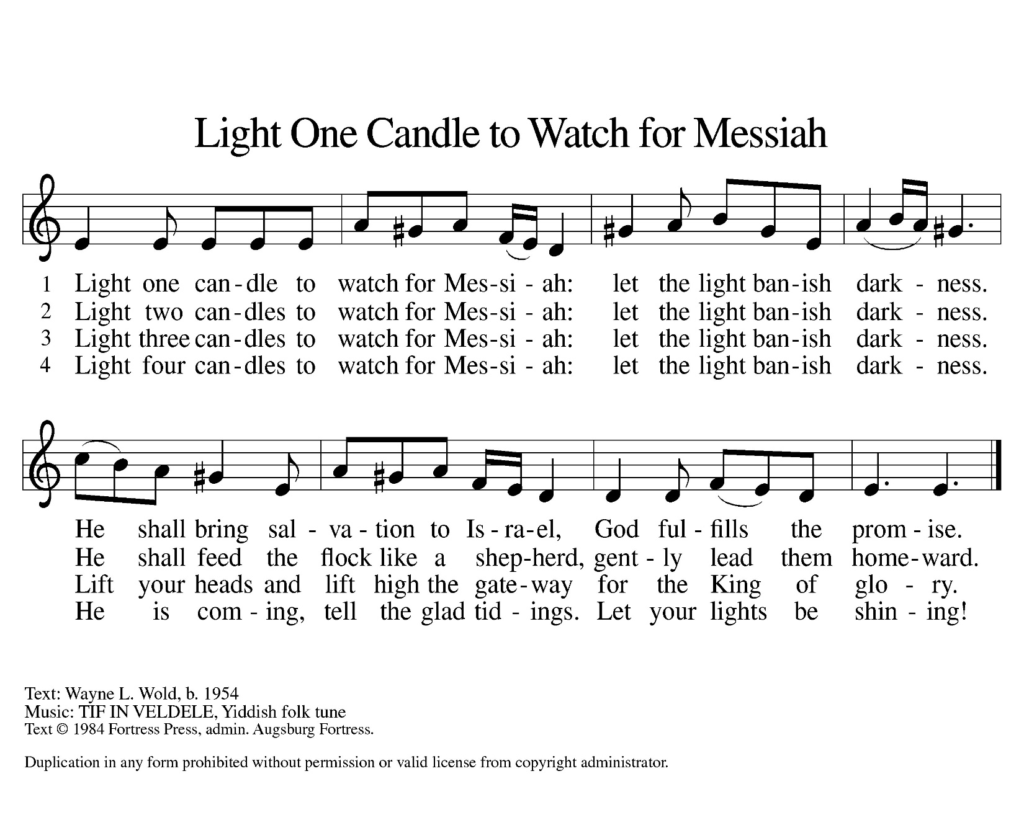

Confession and Forgiveness
In the name of the Father,
and of the ☩ Son,
and of the Holy Spirit.
Amen.

Almighty God, to whom all hearts are open, all desires known, and from whom no secrets are hid: cleanse the thoughts of our hearts by the inspiration of your Holy Spirit, that we may perfectly love you and worthily magnify your holy name, through Jesus Christ our Lord.
Amen.
Let us confess our sin in the presence of God and of one another. Most merciful God,
we confess that we are captive to sin and cannot free ourselves. We have sinned against you in thought, word, and deed, by what we have done and by what we have left undone. We have not loved you with our whole heart; we have not loved our neighbors as ourselves. For the sake of your Son, Jesus Christ, have mercy on us. Forgive us, renew us, and lead us, so that we may delight in your will and walk in your ways, to the glory of your holy name.
Amen.

God, who is rich in mercy, loved us even when we were dead in sin, and made us alive together with Christ. By grace you have been saved. In the name of ☩ Jesus Christ, your sins are forgiven. Almighty God strengthen you with power through the Holy Spirit, that Christ may live in your hearts through faith.
Amen.

Gathering Song “O Come, O Come, Emmanuel” #257

GREETING
The grace of our Lord Jesus Christ, the love of God, and the communion of the Holy Spirit be with you all.
And also with you.

Prayer of the Day
Let us pray together.
Stir up your power, Lord Christ, and come. With your abundant grace and might, free us from the sin that hinders our faith, that eagerly we may receive your promises, for you live and reign with the Father and the Holy Spirit, one God, now and forever.
Amen.

First Reading Isaiah 7:10-16
A reading from Isaiah.
¹⁰ The Lord spoke to Ahaz, saying, ¹¹ “Ask a sign of the Lord your God; let it be deep as Sheol or high as heaven.” ¹² But Ahaz said, “I will not ask, and I will not put the Lord to the test.” ¹³ Then Isaiah said, “Hear then, O house of David! Is it too little for you to weary mortals that you weary my God also? ¹⁴ Therefore the Lord himself will give you a sign. Look, the young woman is with child and shall bear a son and shall name him Immanuel. ¹⁵ He shall eat curds and honey by the time he knows how to refuse the evil and choose the good. ¹⁶ For before the child knows how to refuse the evil and choose the good, the land before whose two kings you are in dread will be deserted.”

The word of the Lord.
Thanks be to God.

Psalm Psalm 90:1-7, 17-19
¹ Hear, O Shepherd of Israel, leading Joseph | like a flock;
shine forth, you that are enthroned up- | on the cherubim.
² In the presence of Ephraim, Benjamin, | and Manasseh,
stir up your strength and | come to help us.
³ Restore | us, O God;
let your face shine upon us, and we | shall be saved.
⁴ O Lord | God of hosts,
how long will your anger fume when your | people pray?
⁵ You have fed them with the | bread of tears;
you have given them bowls of | tears to drink.
⁶ You have made us the derision | of our neighbors,
and our enemies laugh | us to scorn.
⁷ Restore us, O | God of hosts;
let your face shine upon us, and we | shall be saved.
¹⁷ Let your hand be upon the one at | your right hand,
the one you have made so strong | for yourself.
¹⁸ And so will we never turn a- | way from you;
give us life, that we may call up- | on your name.
¹⁹ Restore us, O Lord | God of hosts;
let your face shine upon us, and we | shall be saved.
Amen.

Second Reading Romans 1:1-7
A reading from Romans.
¹ Paul, a servant of Christ Jesus, called to be an apostle, set apart for the gospel of God, ² which he promised beforehand through his prophets in the holy scriptures, ³ the gospel concerning his Son, who was descended from David according to the flesh ⁴ and was declared to be Son of God with power according to the spirit of holiness by resurrection from the dead, Jesus Christ our Lord, ⁵ through whom we have received grace and apostleship to bring about the obedience of faith among all the gentiles for the sake of his name, ⁶ including you who are called to belong to Jesus Christ,
⁷ To all God’s beloved in Rome, who are called to be saints:
Grace to you and peace from God our Father and the Lord Jesus Christ.

The Word of the Lord
Thanks be to God.
Gospel Acclamation
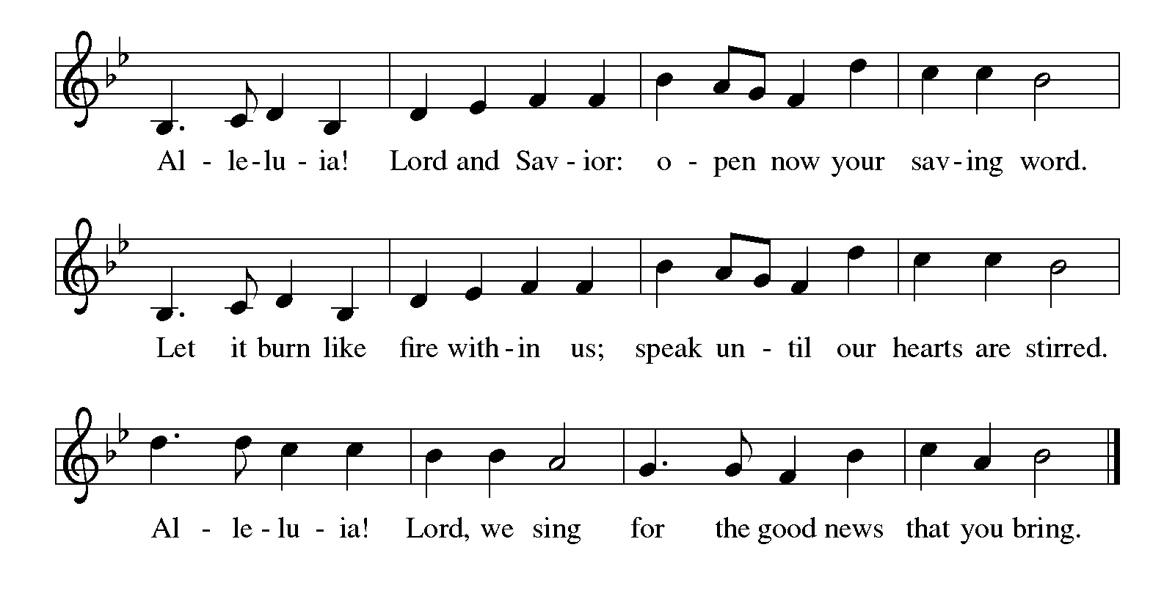

Gospel Matthew 1:19-25
The holy gospel according to Matthew.
Glory to You O Lord.
¹⁸ Now the birth of Jesus the Messiah took place in this way. When his mother Mary had been engaged to Joseph, but before they lived together, she was found to be pregnant from the Holy Spirit. ¹⁹ Her husband Joseph, being a righteous man and unwilling to expose her to public disgrace, planned to divorce her quietly. ²⁰ But just when he had resolved to do this, an angel of the Lord appeared to him in a dream and said, “Joseph, son of David, do not be afraid to take Mary as your wife, for the child conceived in her is from the Holy Spirit. ²¹ She will bear a son, and you are to name him Jesus, for he will save his people from their sins.” ²² All this took place to fulfill what had been spoken by the Lord through the prophet:
²³ “Look, the virgin shall become pregnant and give birth to a son,
and they shall name him Emmanuel,”
which means, “God is with us.” ²⁴ When Joseph awoke from sleep, he did as the angel of the Lord commanded him; he took her as his wife ²⁵ but had no marital relations with her until she had given birth to a son, and he named him Jesus.

The gospel of the Lord.
Praise to you, O Christ.

CHILDREN’S MOMENT

SERMON Pastor Ken Scheck

hymn of the day “Rejoice, Rejoice, Believers” #244

cREED
We believe in one God,
the Father, the Almighty,
maker of heaven and earth,
of all that is, seen and unseen.
We believe in one Lord, Jesus Christ,
the only Son of God,
eternally begotten of the Father,
God from God, Light from Light,
true God from true God,
begotten, not made,
of one Being with the Father;
through him all things were made.
For us and for our salvation
he came down from heaven,
was incarnate of the Holy Spirit and the virgin Mary
and became truly human.
For our sake he was crucified under Pontius Pilate;
he suffered death and was buried.
On the third day he rose again
in accordance with the scriptures;
he ascended into heaven
and is seated at the right hand of the Father.
He will come again in glory to judge the living and the dead,
and his kingdom will have no end.
We believe in the Holy Spirit, the Lord, the giver of life,
who proceeds from the Father and the Son,*
who with the Father and the Son is worshiped and glorified,
who has spoken through the prophets.
We believe in one holy catholic and apostolic church.
We acknowledge one baptism for the forgiveness of sins.
We look for the resurrection of the dead,
and the life of the world to come. Amen.

*Or, “who proceeds from the Father.” The phrase “and the Son” is a later addition to the creed.
prayers of Intercession
In our waiting and watching, we come to you in prayer, O God, trusting your promise to renew the church, the nations, and the whole creation.
A brief silence.
In the anticipation of these days, prepare our hearts for your arrival. Stir our spirits through the gifts of artists, musicians, poets, and preachers, as together we proclaim your advent among us. We pray especially for Lutheran church in Midland and their pastor Rev. Jeffrey Gramza.
God of grace,
hear our prayer.
The earth breaks forth in singing as it heralds the Messiah’s coming. Fill our hearts with wonder as we join heaven and nature in announcing this holy birth. God of grace,
hear our prayer.
You send your saving grace and peace to the nations. Lead us in work for justice and care for the common good. May we meet the Christ-child we seek in the faces of our neighbors. God of grace,
hear our prayer.
When tears of grief, exhaustion, or loneliness come, or physical or emotional hurt overwhelms us, come to our aid. Uphold all who are anxious, who know the challenges of depression, or who are ill. God of grace,
hear our prayer.
Surround expectant parents and those suffering from infant loss with communities of support. Bless young children and new parents. Guide us in ways that provide safety for all children and those who care for them. God of grace,
hear our prayer.
We give thanks for all who have treasured the gospel and lived in faithful service. Strengthen our earthly journeys until, at the last, your face shines upon us and we are held in your in love. God of grace,
hear our prayer.
Draw near to us, O God, as we commend all for whom we pray, trusting in your mercy through Jesus Christ, Emmanuel.
Amen.

PEACE
The peace of Christ be with you always.
And also with you.

OFFERING & OFFERING SONG
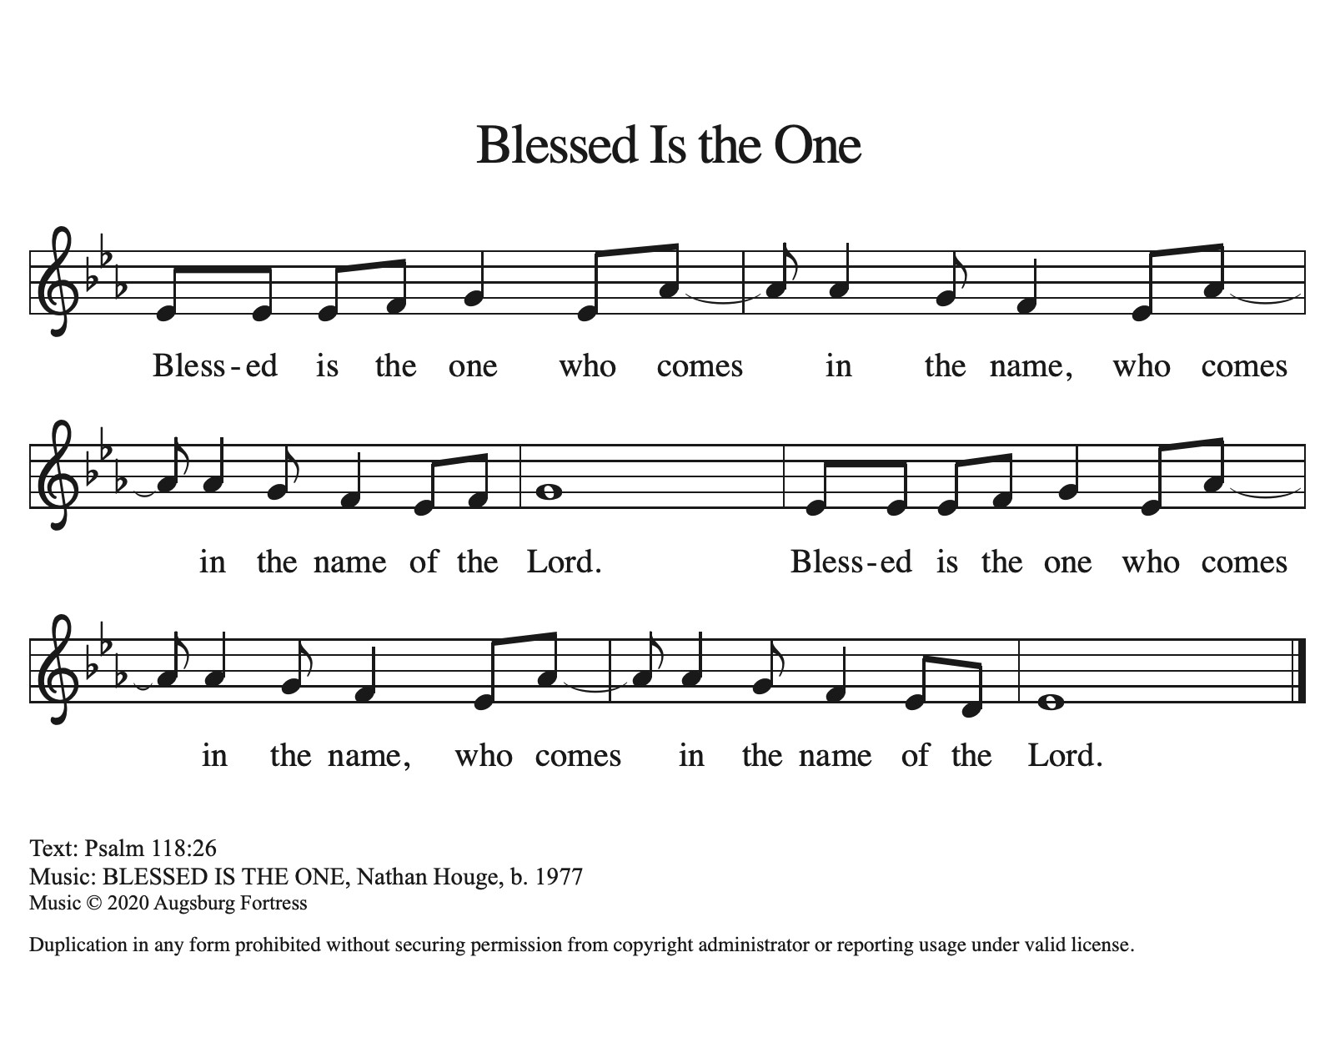

Offering Prayer
Let us pray.
God of all creation, all you have made is good, and your love endures forever. You bring forth bread from the earth and fruit from the vine. Nourish us with these gifts, that we might be for the world signs of your gracious presence in Jesus Christ, our Savior and Lord.
Amen.

DIALOGUE
The Lord be with you.
And also with you.
Lift up your hearts.
We lift them to the Lord.
Let us give thanks to the Lord our God.
It is right to give our thanks and praise.

PREFACE (Pastor)
It is indeed right, our duty and our joy,
that we should at all times and in all places
give thanks and praise to you, almighty and merciful God,
through our Savior Jesus Christ;
who on this day overcame death and the grave,
and by his glorious resurrection opened to us the way of everlasting life.
And so, with all the choirs of angels,
with the church on earth and the hosts of heaven,
we praise your name and join their unending hymn

holy, holy, holy
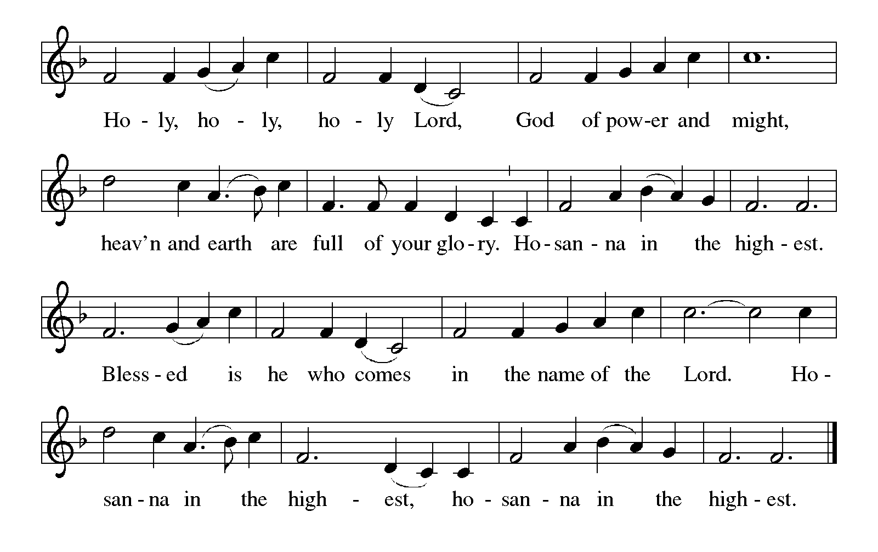

Thanksgiving at the Table
In the night in which he was betrayed,
our Lord Jesus took bread, and gave thanks;
broke it, and gave it to his disciples, saying:
Take and eat; this is my body, given for you.
Do this for the remembrance of me.

Again, after supper, he took the cup, gave thanks,
and gave it for all to drink, saying:
This cup is the new covenant in my blood,
shed for you and for all people for the forgiveness of sin.
Do this for the remembrance of me.

For as often as we eat of this bread and drink from this cup,
we proclaim the Lord’s death until he comes.

Lord’s Prayer
Gathered into one by the Holy Spirit, let us pray as Jesus taught us.
Our Father, who art in heaven,
hallowed be thy name,
thy kingdom come,
thy will be done,
on earth as it is in heaven.
Give us this day our daily bread;
and forgive us our trespasses,
as we forgive those
who trespass against us;
and lead us not into temptation,
but deliver us from evil.
For thine is the kingdom,
and the power, and the glory,
forever and ever. Amen.

INVITATION TO COMMUNION
Come to the banquet, for all is now ready.

COMMUNION *continuous
*People are welcome to kneel at the altar rail for a time of prayer after they receive their communion elements.

COMMUNION HYMNS
“My Soul Proclaims Your Greatness” #251
“He Came Down” #253
PRAYER AFTER COMMUNION
Let us pray.
We give you thanks, almighty God, that you have refreshed us through the healing power of this gift of life. In your mercy, strengthen us through this gift, in faith toward you and in fervent love toward one another; for the sake of Jesus Christ our Lord.
Amen.

Sending
God blesses us and sends us in mission to the world.

Blessing
The Lord bless you and keep you.
The Lord’s face shine on you with grace and mercy.
The Lord look upon you with favor and ☩ give you peace.
Amen.

Sending SonG “Joy to the World” #267

Dismissal
Go in peace. Christ is with you.
Thanks be to God.

From sundaysandseasons.com. Copyright © 2017 Augsburg Fortress. All rights reserved.

Thank you to all who served in worship today!
Presiders: Pastor Ken Scheck Musician: Martha Yoder
Acolyte: Safety Person:
Elder: Naomi Wilson Trustee: Tom Krikke
Offering Counters: Mary Makley & Paul Meade



PRAYERS OF THE FAITHFUL

With thanks for all God’s blessings and his love for all people. Our Bishops, Julie Schneider-Thomas, Yehiel Curry, and the congregations of the North/West Lower Michigan Synod, and especially for Lutheran church in Midland and their pastor Rev. Jeffrey Gramza.

Prayers for our friends, for all who are sick or hospitalized and for all health care workers who care for them. All those members of Zion’s family traveling; all those homebound or in frail health; all those suffering with quiet, unknown needs or worries. For those who serve on our behalf: public safety, utility workers, medical personnel, military personnel. For those who might be forgotten.

This week at Zion:
- Christmas Caroling, Tuesday, December 23, meet at the church at 1:40 pm
- Christmas Eve Service Worship 5PM, Wednesday 24
- Merry Christmas! Thursday, December 25

ONLINE GIVING
Zion has received a QR code to facilitate online giving. If you are interested in donating online instead of bringing your donation to church, simply scan the QR code and it will direct you to the appropriate site. The code is on our website as well.

ANNOUNCEMENT
- Christmas Caroling: Tuesday, December 23, meet at the church at 1:40 pm. See Martha for more information.
- Snack Potluck: On Sunday, December 28th we will have a "snack potluck" for fellowship after church. Bring a snack to share and a game to play (if you wish). Let's make this a fun fellowship opportunity.
- Retirement Open House: Arlene Forman's son, Kirk, is retiring from the Woodland DPW after 46-1/2 years. There will be an open house for Kirk at the Main Floor, 1037 4th Ave., Lake Odessa, on Sunday, December 28th from 5 - 9 pm. Everyone is invited to come and help Kirk celebrate this incredible milestone. We have been so appreciative of Kirk's help to Zion during the Woodland Homecoming and assisting in our Super Bowl food collection last year. Congratulations, Kirk. (No gifts please)
- Special Offerings: We have several special offerings this time of the year. The Thanksgiving offering goes to the Lakewood Area Ministerial Association. The Advent offering goes to Manna's Market and the Christmas offering goes to the Lakewood Community Council. Thank you for your generosity.
- Christmas Eve Service: Pastor Ken Scheck will lead our Christmas Eve Service. Our service will start at 5 pm. The earlier time makes it possible for Pastor Ken to also lead Christmas Eve Service at Grace Lutheran in Hastings at 7 pm. Mark your calendar and plan to attend this special service!
- Altar Flowers: If you are interested in putting flowers on the altar in memory of a loved one, please let Mary Makley know.
- Announcement and Newsletter Items: Please forward items for the bulletin announcements and the newsletter to the church email (Office@Zion.org). Please do not send items to people’s personal emails. Thank you.
- Door Locking Policy: Our door locking policy relies on having a volunteer(s) each Sunday to serve as the Safety Person of the Day. On Sundays where no one has volunteered, if someone arrives at church and is willing to be the Safety Person of the Day, we will follow the door locking policy. If no one steps forward to serve as the Safety Person of the Day, the doors will not be locked. Please consider volunteering for this important duty.

