ZION LUTHERAN CHURCH, WOODLAND, MI
Christmas Eve, December 24, 2025
*If you are listening in your car, please tune your radio to FM 87.7*

ANNOUNCEMENTS

LIGHTING OF THE ADVENT WREATH, Read by: The Griffin Family

To a people longing for hope and yearning for deliverance, the prophet Isaiah declared,
The people who walked in darkness have seen a great light; those who lived in a land of deep darkness on them light has shined…For a child has been born for us, a son given to us; authority rests upon his shoulders; and he is named Wonderful Counselor, Mighty God, Everlasting Father, Prince of Peace. (Isaiah 9:2, 6)
Tonight, we come seeking hope, peace, joy, and love, and we find these things in a child. God made flesh as a baby in a manger. A baby who is both the beginning and the end of our salvation, who dwells with us even now, our Emmanuel, God with us.
Congregation: We live as people in the in-between who celebrate the arrival of the Light that shines in lost and broken places as we wait for the day when we will live in the fullness of God’s kin-dom.
We light these candles as signs of our shocking hope, our just peace, our fierce joy, the love that transforms us, and Jesus Christ, our wondrous Light. May the Light burning in our hearts guide us, comfort us, protect us, and tend us in all seasons and circumstances, reminding us that day and night, in the light and in the darkness, God is with us. Our salvation has come! Amen.

Light five candles of the Advent wreath. (Verse Four)

GATHERING
The Lord is coming, always coming. When you have ears to hear and eyes to see, you will recognize him at any moment of your life. Life is Advent; life is recognizing the coming of the Lord. (Henri Nouwen)

Confession and Forgiveness
In the name of the Father, and of the ☩ Son, and of the Holy Spirit.
Amen.

Almighty God, to whom all hearts are open, all desires know, and from whom no secrets are hid; cleanse the thoughts of our hearts by inspiration of your Holy Spirit, that we may perfectly love you and worthily magnify your holy name, through Jesus Christ our Lord.
Amen

Let us confess our sin in the presence of God and of one another. Most merciful God,
we confess that we are captive to sin and cannot free ourselves. We have sinned against you in thought, word, and deed, by what we have done and by what we have left undone. We have not loved you with our whole heart; we have not loved our neighbors as ourselves. For the sake of your Son, Jesus Christ, have mercy on us. Forgive us, renew us, and lead us, so that we may delight in your will and walk in your ways, to the glory of your holy name. Amen.

God, who is rich in mercy, loved us even when we were dead in sin, and made us alive together with Christ. By grace you have been saved. In the name of ☩ Jesus Christ, your sins are forgiven. Almighty God strengthen you with power through the Holy Spirit, that Christ may live in your hearts through faith.
Amen.

Gathering Song “O Come, All Ye Faithful” ELW 283, Verses 1 and 4

GREETING
The grace of our Lord Jesus Christ, the love of God, and the communion of the Holy Spirit be with you all.
And also with you.

Prayer of the Day
Let us pray together.
Almighty God, you made this holy night shine with the brightness of the true Light. Grant that here on earth we may walk in the light of Jesus’ presence and in the last day wake to the brightness of his glory; through your Son, Jesus Christ our Lord, who lives and reigns with you and the Holy Spirit, one God, now and forever.
Amen.

First Reading Isaiah 9:2-7
A reading from Isaiah.

² The people who walked in darkness
have seen a great light;
those who lived in a land of deep darkness —
on them light has shined.
³You have multiplied the nation,
you have increased its joy;
they rejoice before you
as with joy at the harvest,
as people exult when dividing plunder.
⁴For the yoke of their burden,
and the bar across their shoulders,
the rod of their oppressor,
you have broken as on the day of Midian.
⁵For all the boots of the tramping warriors
and all the garments rolled in blood
shall be burned as fuel for the fire.
⁶For a child has been born for us,
a son given to us;
authority rests upon his shoulders;
and he is named
Wonderful Counselor, Mighty God,
Everlasting Father, Prince of Peace.
⁷His authority shall grow continually,
and there shall be endless peace
for the throne of David and his kingdom.
He will establish and uphold it
with justice and with righteousness
from this time onward and forevermore.
The zeal of the LORD of hosts will do this.

The word of the Lord.
Thanks be to God.

Second Reading Titus 2:11-14
A reading from Titus.

¹¹For the grace of God has appeared, bringing salvation to all, ¹²training us to renounce impiety and worldly passions, and in the present age to live lives that are self-controlled, upright, and godly, ¹³while we wait for the blessed hope and the manifestation of the glory of our great God and Savior, Jesus Christ. ¹⁴He it is who gave himself for us that he might redeem us from all iniquity and purify for himself a people of his own who are zealous for good deeds.

The word of the Lord.
Thanks be to God.

Gospel Acclamation
Alleluia. I am bringing you good news of great joy for
| all the people:* to you is born this day
in the city of David a Savior, who is the Messi-
| ah, the Lord. Alleluia. (Luke 2:10-11)

Gospel Luke 2:1-20
The holy gospel according to Luke.
Glory to you, O Lord.

¹In those days a decree went out from Emperor Augustus that all the world should be registered. ²This was the first registration and was taken while Quirinius was governor of Syria. ³All went to their own towns to be registered. ⁴Joseph also went from the town of Nazareth in Galilee to Judea, to the city of David called Bethlehem, because he was descended from the house and family of David. ⁵He went to be registered with Mary, to whom he was engaged and who was expecting a child. ⁶While they were there, the time came for her to deliver her child. ⁷And she gave birth to her firstborn son and wrapped him in bands of cloth, and laid him in a manger, because there was no place for them in the inn.

HYMN “Away in a Manger” ELW 277 Verse 1

⁸In that region there were shepherds living in the fields, keeping watch over their flock by night. ⁹Then an angel of the Lord stood before them, and the glory of the Lord shone around them, and they were terrified. ¹⁰But the angel said to them, "Do not be afraid; for see — I am bringing you good news of great joy for all the people: ¹¹to you is born this day in the city of David a Savior, who is the Messiah, the Lord. ¹²This will be a sign for you: you will find a child wrapped in bands of cloth and lying in a manger." ¹³And suddenly there was with the angel a multitude of the heavenly host, praising God and saying,
¹⁴"Glory to God in the highest heaven,
and on earth peace among those whom he favors!"

HYMN “Hark the Herald Angels Sing” ELW 270 Verse 1

¹⁵When the angels had left them and gone into heaven, the shepherds said to one another, "Let us go now to Bethlehem and see this thing that has taken place, which the Lord has made known to us." ¹⁶So they went with haste and found Mary and Joseph, and the child lying in the manger. ¹⁷When they saw this, they made known what had been told them about this child; ¹⁸and all who heard it were amazed at what the shepherds told them. ¹⁹But Mary treasured all these words and pondered them in her heart. ²⁰The shepherds returned, glorifying and praising God for all they had heard and seen, as it had been told them.
The gospel of the Lord.
Praise to you, O Christ.

HYMN “Go Tell it on the Mountain” ELW 290 Verse 1

SERMON Pastor Ken Scheck

Hymn of the Day “O Little Town of Bethlehem” ELW 279, Vs 1-2

cREED
I believe in God, the Father almighty,
creator of heaven and earth.
I believe in Jesus Christ, God’s only Son, our Lord,
who was conceived by the Holy Spirit,
born of the virgin Mary,
suffered under Pontius Pilate,
was crucified, died, and was buried;
he descended to the dead.*
On the third day he rose again;
he ascended into heaven,
he is seated at the right hand of the Father,
and he will come to judge the living and the dead.
I believe in the Holy Spirit,
the holy catholic church,
the communion of saints,
the forgiveness of sins,
the resurrection of the body,
and the life everlasting. Amen.

*Or, “he descended into hell,” another translation of this text in widespread use.

prayers of Intercession
Empowered by the news of Christ’s birth, let us pray boldly for the church, creation, and all who are in need.
A brief silence.
Gathering God, you bring your people from every corner of the earth together before the manger that you have made a throne. Unite the church in love as we rejoice in the news of your coming. Hear us, O God.
Your mercy is great.
Creating God, you brought forth the earth and all that is in it. Join our voices with the roaring seas, the exulting fields, and the trees of the forest singing for joy on this holy night. Hear us, O God.
Your mercy is great.
Transforming God, the world trembles amid violence and war. Empower our hands, feet, and hearts with your Spirit to shatter the rod of the oppressor and turn swords into plowshares. Hear us, O God.
Your mercy is great.
Shepherding God, you lead us to your love in the face of our neighbor. Send us into the world to find your Word made flesh in one another, especially those who are sick or struggling. We pray especially for Jerry and Carol Engle, Connie Battice, Rick Stowell, the family of Jean Chase, Carol Morton, Cliff and Karen Byington, Terry Cotter, Lee Starks, Phil Walsh, Dave Makley, Linden and Judy Fisher, Karen Knight, Evelyn Brecheisen, Ed Markwart, Gloria Anderson, Brent and Natalie Merrit and family, Wayne Hazel, Armani Morado, Larry Duda, Cindy Utterback, Alice Morrow, Jeff Engle, Arlene Forman, Chloe Makley, Erik Anderson, Cort Zylstra, and all countries involved in ongoing conflicts. Hear us, O God.
Your mercy is great.
Nurturing God, you dwell with us in humble places. Sustain housing and clothing ministries in this community, that all find shelter and warmth. We pray especially for youth seeking safety and care. Hear us, O God.
Your mercy is great.
Abiding God, you remain at the side of all the departed. Grant all who mourn hope in the resurrection and peace in Christ Jesus. Hear us, O God.
Your mercy is great.
With the joy of Christ’s birth in our hearts, we commend our prayers to you, O God, trusting in your boundless mercy and eternal love; through Jesus Christ our Savior.
Amen.

Peace
The peace of Christ be with you always.
And also with you.
Offering & Offering song
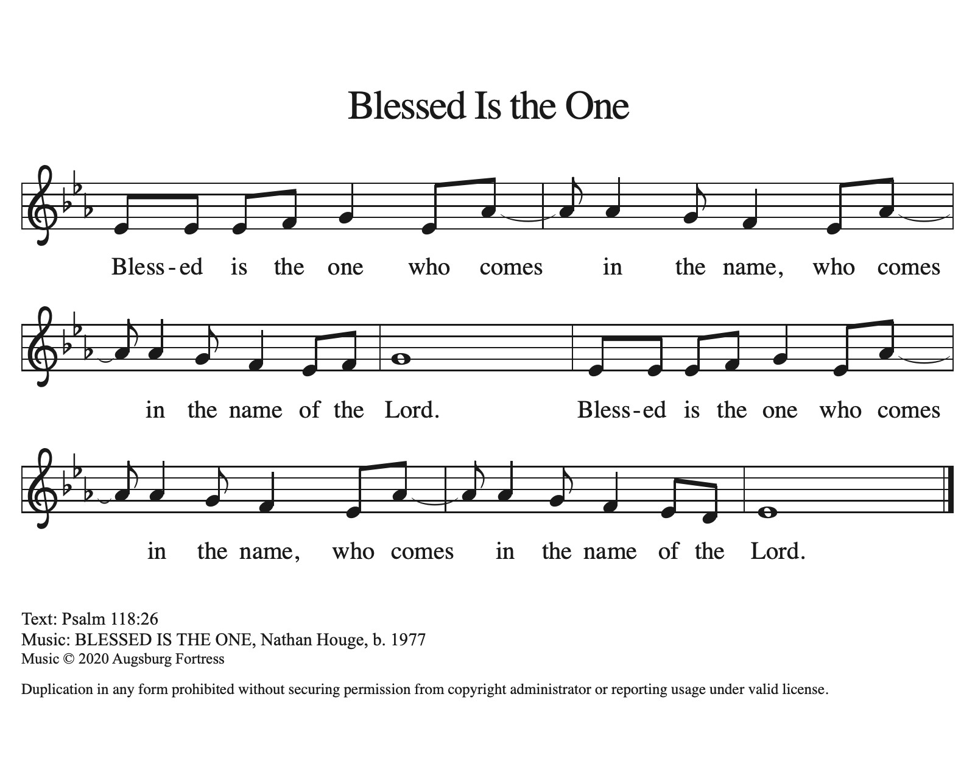
Offering Prayer
Let us pray. God of goodness and growth, all creation is yours, and your faithfulness is sure. Word and water, wine and bread: these are signs of your abundant grace. Receive the gifts we bring, and nourish us to proclaim your abiding love in our communities and in the world, through Jesus Christ, our strength and our song.
Amen.

Thanksgiving at the Table
In the night in which he was betrayed,
our Lord Jesus took bread, and gave thanks;
broke it, and gave it to his disciples, saying:
Take and eat; this is my body, given for you.
Do this for the remembrance of me.
Again, after supper, he took the cup, gave thanks,
and gave it for all to drink, saying:
This cup is the new covenant in my blood,
shed for you and for all people for the forgiveness of sin.
Do this for the remembrance of me.

Lord’s Prayer
Gathered into one by the Holy Spirit, let us pray as Jesus taught us.
Our Father, who art in heaven,
hallowed be thy name,
thy kingdom come,
thy will be done,
on earth as it is in heaven.
Give us this day our daily bread;
and forgive us our trespasses,
as we forgive those
who trespass against us;
and lead us not into temptation,
but deliver us from evil.
For thine is the kingdom,
and the power, and the glory,
forever and ever. Amen.

INVITATION TO COMMUNION
Taste and see that the Lord is good.

COMMUNION *Continuous
*People are welcome to kneel at the altar rail for a time of prayer after they receive their communion elements.

COMMUNION HYMNS
“Infant Holy, Infant Lowly” ELW 276

“What Child is This” ELW 296

“The First Noel” ELW 300

BLESSING AFTER COMMUNION
The body and blood of our Lord Jesus Christ bless you and keep you in His grace.
(Light your candles)
“Silent Night, Holy Night” ELW 281 All Verses
Sending
God blesses us and sends us in mission to the world.

Blessing
God, the Source of glory, God, the Word of life, God, the Spirit of truth
☩ bless you all, now and forever.
Amen.
Sending SonG “Joy to the World ” ELW 267 Vs 1-2

Dismissal
Go in peace. Christ is with you. Merry Christmas!
Thanks be to God.

Thank you to all who served in worship today!
Presiders: Pastor Ken Scheck Musician: Jayne Flanigan & Martha Yoder
Acolyte: Kole Hokanson Safety Person:
Elder: Paul Meade Trustee: Mike Johnson
Offering Counters: Diane Griffin and Carlotta Willard



PRAYERS OF THE FAITHFUL

With thanks for all God’s blessings and his love for all people. Our Bishops, Julie Schneider-Thomas, Yehiel Curry, and the congregations of the North/West Lower Michigan Synod.

Prayers for our friends, for all who are sick or hospitalized and for all health care workers who care for them. We pray especially for Jerry and Carol Engle, Connie Battice, Rick Stowell, the family of Jean Chase, Carol Morton, Cliff and Karen Byington, Terry Cotter, Lee Starks, Phil Walsh, Dave Makley, Linden and Judy Fisher, Karen Knight, Evelyn Brecheisen, Ed Markwart, Gloria Anderson, Brent and Natalie Merrit and family, Wayne Hazel, Armani Morado, Larry Duda, Cindy Utterback, Alice Morrow, Jeff Engle, Arlene Forman, Chloe Makley, Erik Anderson, Cort Zylstra, and all countries involved in ongoing conflicts

All those members of Zion’s family traveling; all those homebound or in frail health; all those suffering with quiet, unknown needs or worries. For those who serve on our behalf: public safety, utility workers, medical personnel, military personnel. For those who might be forgotten.

This week at Zion:
- Snack potluck Sunday, December 28th
- Bulletin Deadline, Wednesday, December 31


ONLINE GIVING
Zion has received a QR code to facilitate online giving. If you are interested in donating online instead of bringing your donation to church, simply scan the QR code and it will direct you to the appropriate site. The code is on our website as well.

ANNOUNCEMENTS

- Snack Potluck: On Sunday, December 28th we will have a "snack potluck" for fellowship after church. Bring a snack to share and a game to play (if you wish). Let's make this a fun fellowship opportunity.
- Christmas Hymn Sing: The service on December 28th will be a time to sing carols! Don’t miss this opportunity to pick your favorite hymns to sing!
- Special Offerings: We have several special offerings this time of the year. The Thanksgiving offering goes to the Lakewood Area Ministerial Association. The Advent offering goes to Manna's Market and the Christmas offering goes to the Lakewood Community Council. Thank you for your generosity.
- Announcement and Newsletter Items: Please forward items for the bulletin announcements and the newsletter to the church email (Office@Zion.org). Please do not send items to people’s personal emails. Thank you.
- Door Locking Policy: Our door locking policy relies on having a volunteer(s) each Sunday to serve as the Safety Person of the Day. On Sundays where no one has volunteered, if someone arrives at church and is willing to be the Safety Person of the Day, we will follow the door locking policy. If no one steps forward to serve as the Safety Person of the Day, the doors will not be locked. Please consider volunteering for this important duty.



In Memory
Ken, Chris and Tammy Makley by The Makley Family
Lester Forman by Arlene Forman
Charles and Shawn Heise by Joyce, Ken, and Karen Heise
Gene and Donna Beyer by Your Friends at Zion
Larry Brodbeck by Marie Brodbeck

In Honor of
Mark Willard Family by Carlotta Willard
Our Family by the Griffin Family
Our Family by Claude and Mary Smith
My Loving Family by Caroline Brecheisen

