ZION LUTHERAN CHURCH, WOODLAND, MI
Frist Sunday of Christmas December 28, 2025
*If you are listening in your car, please tune your radio to FM 87.7*
(Please silence your cell phones while in the sanctuary. Thank you.)



WELCOME AND ANNOUNCEMENTS

Gathering
The Holy Spirit calls us together as the people of God.

Confession and Forgiveness
In the name of the Father,
and of the ☩ Son,
and of the Holy Spirit.
Amen.

Almighty God, to whom all hearts are open, all desires known, and from whom no secrets are hid: cleanse the thoughts of our hearts by the inspiration of your Holy Spirit, that we may perfectly love you and worthily magnify your holy name, through Jesus Christ our Lord.
Amen.
Let us confess our sin in the presence of God and of one another. Most merciful God,
we confess that we are captive to sin and cannot free ourselves. We have sinned against you in thought, word, and deed, by what we have done and by what we have left undone. We have not loved you with our whole heart; we have not loved our neighbors as ourselves. For the sake of your Son, Jesus Christ, have mercy on us. Forgive us, renew us, and lead us, so that we may delight in your will and walk in your ways, to the glory of your holy name.
Amen.

God, who is rich in mercy, loved us even when we were dead in sin, and made us alive together with Christ. By grace you have been saved. In the name of ☩ Jesus Christ, your sins are forgiven. Almighty God strengthen you with power through the Holy Spirit, that Christ may live in your hearts through faith.
Amen.

Gathering Song Congregation Chooses

GREETING
The grace of our Lord Jesus Christ, the love of God, and the communion of the Holy Spirit be with you all.
And also with you.

Prayer of the Day
Let us pray together.
O Lord God, you know that we cannot place our trust in our own powers. As you protected the infant Jesus, so defend us and all the needy from harm and adversity, through Jesus Christ, our Savior and Lord, who lives and reigns with you and the Holy Spirit, one God, now and forever.
Amen.

Psalm Psalm 148

¹ Hallelujah! Praise the Lord | from the heavens;
praise God | in the heights.
² Praise the Lord, | all you angels;
sing praise, all you | hosts of heaven.
³ Praise the Lord, | sun and moon;
sing praise, all you | shining stars.
⁴ Praise the Lord, heav- | en of heavens,
and you waters a- | bove the heavens.
⁵ Let them praise the name | of the Lord,
who commanded, and they | were created,
⁶ who made them stand fast forev- | er and ever,
giving them a law that shall not | pass away. R
⁷ Praise the Lord | from the earth,
you sea monsters | and all deeps;
⁸ fire and hail, | snow and fog,
tempestuous wind, do- | ing God’s will;
⁹ mountains | and all hills,
fruit trees | and all cedars;
¹⁰ wild beasts | and all cattle,
creeping things and | flying birds;
¹¹ sovereigns of the earth | and all peoples,
princes and all rulers | of the world;
¹² young | men and maidens,
old and | young together. R
¹³ Let them praise the name | of the Lord,
Amen.
Gospel Acclamation
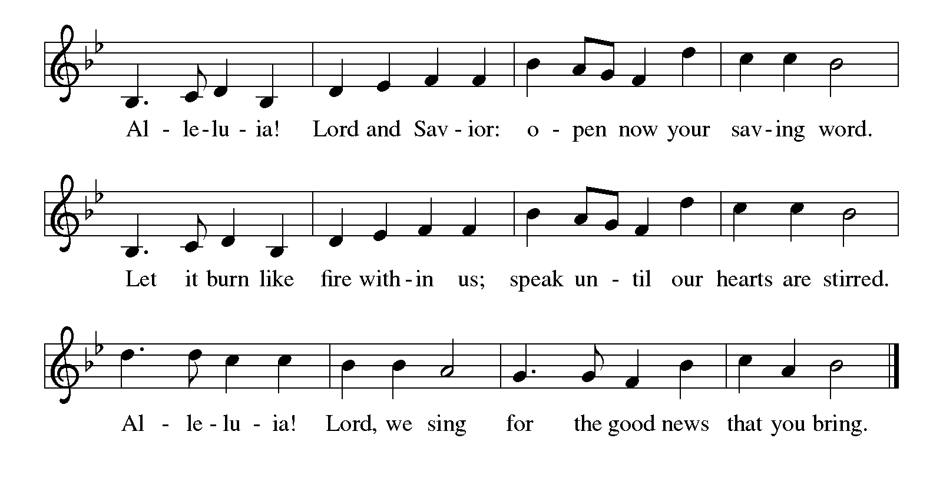

Gospel Matthew 2:13-23
The holy gospel according to Matthew.
Glory to You O Lord.
¹³ Now after [the magi] had left, an angel of the Lord appeared to Joseph in a dream and said, “Get up, take the child and his mother, and flee to Egypt, and remain there until I tell you, for Herod is about to search for the child, to destroy him.” ¹⁴ Then Joseph got up, took the child and his mother by night, and went to Egypt ¹⁵ and remained there until the death of Herod. This was to fulfill what had been spoken by the Lord through the prophet, “Out of Egypt I have called my son.”
¹⁶ When Herod saw that he had been tricked by the magi, he was infuriated, and he sent and killed all the children in and around Bethlehem who were two years old or under, according to the time that he had learned from the magi. ¹⁷ Then what had been spoken through the prophet Jeremiah was fulfilled:
¹⁸ “A voice was heard in Ramah,
wailing and loud lamentation,
Rachel weeping for her children;
she refused to be consoled, because they are no more.”
¹⁹ When Herod died, an angel of the Lord suddenly appeared in a dream to Joseph in Egypt and said, ²⁰ “Get up, take the child and his mother, and go to the land of Israel, for those who were seeking the child’s life are dead.” ²¹ Then Joseph got up, took the child and his mother, and went to the land of Israel. ²² But when he heard that Archelaus was ruling Judea in place of his father Herod, he was afraid to go there. And after being warned in a dream, he went away to the district of Galilee. ²³ There he made his home in a town called Nazareth, so that what had been spoken through the prophets might be fulfilled, “He will be called a Nazarene.”

The gospel of the Lord.
Praise to you, O Christ.

CHILDREN’S MOMENT

christmas carol hymn sing Martha Yoder

cREED
I believe in God, the Father almighty,
creator of heaven and earth.
I believe in Jesus Christ, his only Son, our Lord.
He was conceived by the power of the Holy Spirit
and born of the virgin Mary.
He suffered under Pontius Pilate,
was crucified, died, and was buried.
He descended into hell.*
On the third day he rose again.
He ascended into heaven,
and is seated at the right hand of the Father.
He will come again to judge the living and the dead.
I believe in the Holy Spirit,
the holy catholic Church,
the communion of saints,
the forgiveness of sins,
the resurrection of the body,
and the life everlasting. Amen

*Or, He descended to the dead.

prayers of Intercession
(Please Be Seated)
Empowered by the news of Christ’s birth, let us pray boldly for the church, creation, and all who are in need.
A brief silence.
God of grace, you show us mercy not according to our worthiness, but according to the abundance of your steadfast love. Grant us the courage to go into the world and do likewise. We pray especially Trinity Lutheran in Millersburg and their pastor Rev. Mary Hughes. Hear us, O God.
Your mercy is great.
God of abundance, the sun and moon praise you and the shining stars sing of your love. Where we have desecrated your creation, make us into a healing balm for what we have broken. Hear us, O God.
Your mercy is great.
God of life, you claim us as your own and care for us as Christ’s siblings. Pour out your compassion in every place your people suffer, and protect them in the palm of your hand. We pray especially for Jerry and Carol Engle, Connie Battice, Rick Stowell, the family of Jean Chase, Carol Morton, Cliff and Karen Byington, Terry Cotter, Lee Starks, Phil Walsh, Dave Makley, Linden and Judy Fisher, Karen Knight, Evelyn Brecheisen, Ed Markwart, Gloria Anderson, Brent and Natalie Merrit and family, Wayne Hazel, Armani Morado, Larry Duda, Cindy Utterback, Alice Morrow, Jeff Engle, Arlene Forman, Chloe Makley, Erik Anderson, Cort Zylstra, and all countries involved in ongoing conflicts.
Hear us, O God.
Your mercy is great.
With the joy of Christ’s birth in our hearts, we commend our prayers to you, O God, trusting in your boundless mercy and eternal love; through Jesus Christ our Savior.
Amen.

PEACE
The peace of Christ be with you always.
And also with you.

OFFERING & OFFERING SONG
The joy of the Lord is my strength,
The joy of the Lord is my strength,
The joy of the Lord is my strength,
The joy of the Lord is my strength.

Offering Prayer
Let us pray.
God of all creation, all you have made is good, and your love endures forever. You bring forth bread from the earth and fruit from the vine. Nourish us with these gifts, that we might be for the world signs of your gracious presence in Jesus Christ, our Savior and Lord.
Amen.

Lord’s Prayer
Gathered into one by the Holy Spirit, let us pray as Jesus taught us.
Our Father, who art in heaven,
hallowed be thy name,
thy kingdom come,
thy will be done,
on earth as it is in heaven.
Give us this day our daily bread;
and forgive us our trespasses,
as we forgive those
who trespass against us;
and lead us not into temptation,
but deliver us from evil.
For thine is the kingdom,
and the power, and the glory,
forever and ever. Amen.

Sending
God blesses us and sends us in mission to the world.

Blessing
The Lord bless you and keep you.
The Lord’s face shine on you with grace and mercy.
The Lord look upon you with favor and ☩ give you peace.
Amen.

Sending SonG Congregation Chooses

Dismissal
Go in peace. Christ is with you.
Thanks be to God.

From sundaysandseasons.com. Copyright © 2017 Augsburg Fortress. All rights reserved.

Thank you to all who served in worship today!
Presiders: Martha Yoder Musician: Jayne Flanigan
Acolyte: Safety Person:
Elder: Buffy Meyers Trustee: Doug MacKenzie
Offering Counters: Paul Meade & Carlotta Willard



PRAYERS OF THE FAITHFUL

With thanks for all God’s blessings and his love for all people. Our Bishops, Julie Schneider-Thomas, Yehiel Curry, and the congregations of the North/West Lower Michigan Synod, and especially Trinity Lutheran in Millersburg and their pastor Rev. Mary Hughes.

Prayers for our friends, for all who are sick or hospitalized and for all health care workers who care for them. All those members of Zion’s family traveling; all those homebound or in frail health; all those suffering with quiet, unknown needs or worries. For those who serve on our behalf: public safety, utility workers, medical personnel, military personnel. For those who might be forgotten. We pray especially for Jerry and Carol Engle, Rick Stowell, the family of Jean Chase, Cliff and Karen Byington, Terry Cotter, Lee Starks, Phil Walsh, Dave Makley, Linden and Judy Fisher, Karen Knight, Evelyn Brecheisen, Ed Markwart, Gloria Anderson, Brent and Natalie Merrit and family, Wayne Hazel, Armani Morado, Larry Duda, Cindy Utterback, Alice Morrow, Jeff Engle, Arlene Forman, Chloe Makley, Erik Anderson, Cort Zylstra, and all countries involved in ongoing conflicts.

This week at Zion:
- Bulletin Deadline, Wednesday, December 31
- Happy New Years, Thursday, January 1

ONLINE GIVING
Zion has received a QR code to facilitate online giving. If you are interested in donating online instead of bringing your donation to church, simply scan the QR code and it will direct you to the appropriate site. The code is on our website as well.

ANNOUNCEMENT

- Snack Potluck: Today Sunday, December 28th we will have a "snack potluck" for fellowship after church. Plan to stay for this time of fellowship.
- Special Offerings: We have several special offerings this time of the year. The Thanksgiving offering goes to the Lakewood Area Ministerial Association. The Advent offering goes to Manna's Market and the Christmas offering goes to the Lakewood Community Council. Thank you for your generosity.
- Announcement and Newsletter Items: Please forward items for the bulletin announcements and the newsletter to the church email (Office@Zion.org). Please do not send items to people’s personal emails. Thank you.
- Door Locking Policy: Our door locking policy relies on having a volunteer(s) each Sunday to serve as the Safety Person of the Day. On Sundays where no one has volunteered, if someone arrives at church and is willing to be the Safety Person of the Day, we will follow the door locking policy. If no one steps forward to serve as the Safety Person of the Day, the doors will not be locked. Please consider volunteering for this important duty.

