ZION LUTHERAN CHURCH, WOODLAND, MI
Second Sunday of Advent December 7, 2025
*If you are listening in your car, please tune your radio to FM 87.7*
(Please silence your cell phones while in the sanctuary. Thank you.)


WELCOME AND ANNOUNCEMENTS

Gathering
The Holy Spirit calls us together as the people of God.

LIGHTING OF THE ADVENT WREATH: HOPE Claude & Mary Smith
Today we light the first candle of Advent, the candle of Hope.
We put our hope in the one to come, the promised one who comes from God to bring good news of salvation. We hope in the one who will lead us to walk in the light of the LORD. We hope he will not let us live in dark valleys, but on the high mountain of God. We light this candle in Hope.
On this day, we remember to hopefully look for the coming of Christ.

LIGHTING OF THE ADVENT WREATH: PEACE Heises??
Last Sunday we lit the candle of Hope, remembering the hope which comes in Christ. Today we light the second candle of Advent, the candle of Peace.
God has a peaceful dream for the world, and we dream it too. We dream of peaceful world full of wolves and leopards and lions eating and sleeping and dancing with lambs, kids, and calves. We dream of a peaceful world where nations come together, where war is a memory, and we eat at one table. We light this candle in Peace.
On this day, we remember the Lord of All who brings peace surpassing all understanding.

HYMN: Light One Candle to Watch for Messiah, Verse 2 HYMN #240

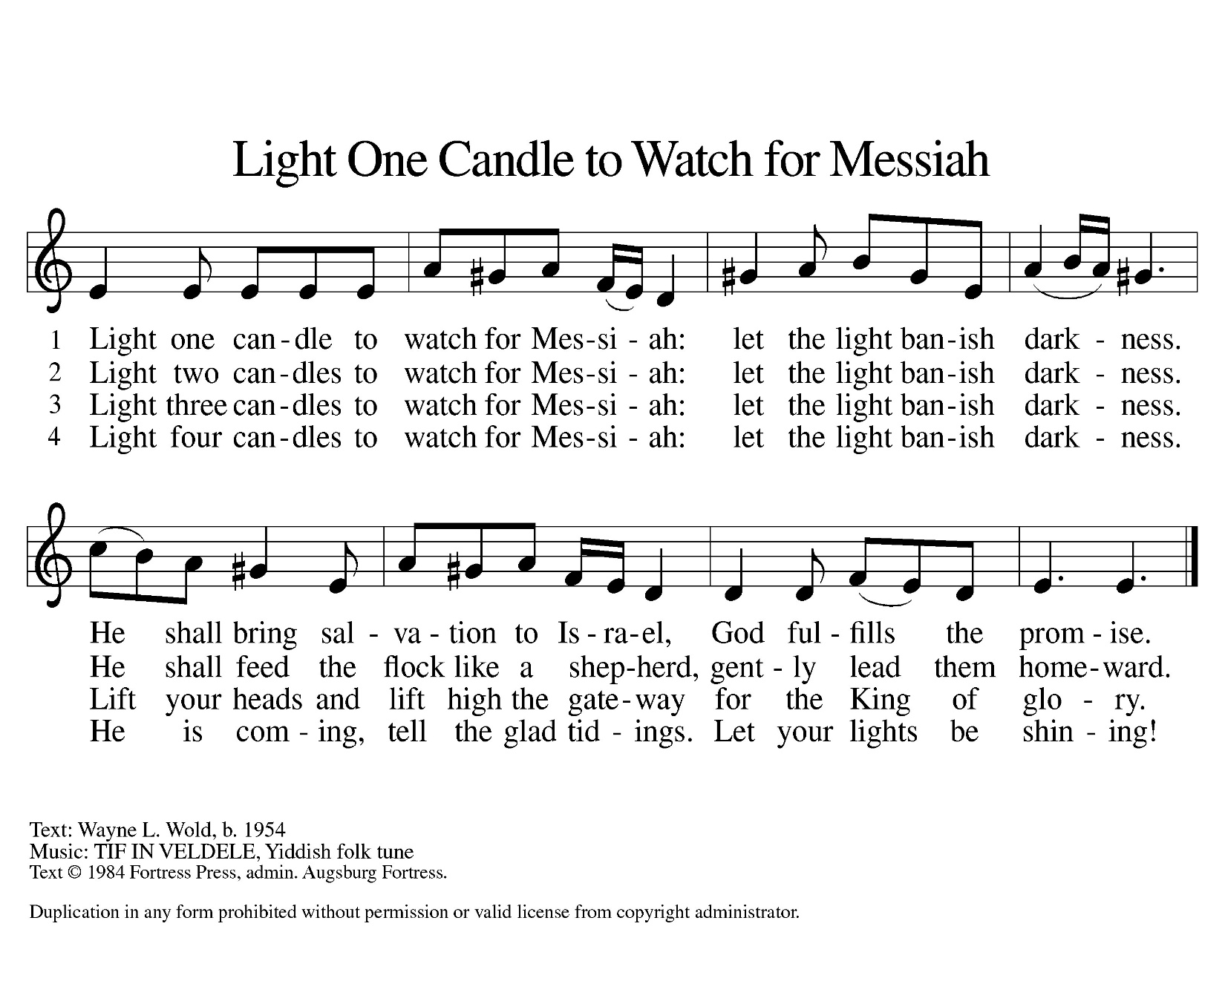

Confession and Forgiveness
In the name of the Father,
and of the ☩ Son,
and of the Holy Spirit.
Amen.

Almighty God, to whom all hearts are open, all desires known, and from whom no secrets are hid: cleanse the thoughts of our hearts by the inspiration of your Holy Spirit, that we may perfectly love you and worthily magnify your holy name, through Jesus Christ our Lord.
Amen.

Let us confess our sin in the presence of God and of one another. Most merciful God,
we confess that we are captive to sin and cannot free ourselves. We have sinned against you in thought, word, and deed, by what we have done and by what we have left undone. We have not loved you with our whole heart; we have not loved our neighbors as ourselves. For the sake of your Son, Jesus Christ, have mercy on us. Forgive us, renew us, and lead us, so that we may delight in your will and walk in your ways, to the glory of your holy name.
Amen.

God, who is rich in mercy, loved us even when we were dead in sin, and made us alive together with Christ. By grace you have been saved. In the name of ☩ Jesus Christ, your sins are forgiven. Almighty God strengthen you with power through the Holy Spirit, that Christ may live in your hearts through faith.
Amen.

Gathering Song “Hark, the Glad Sound!” #239
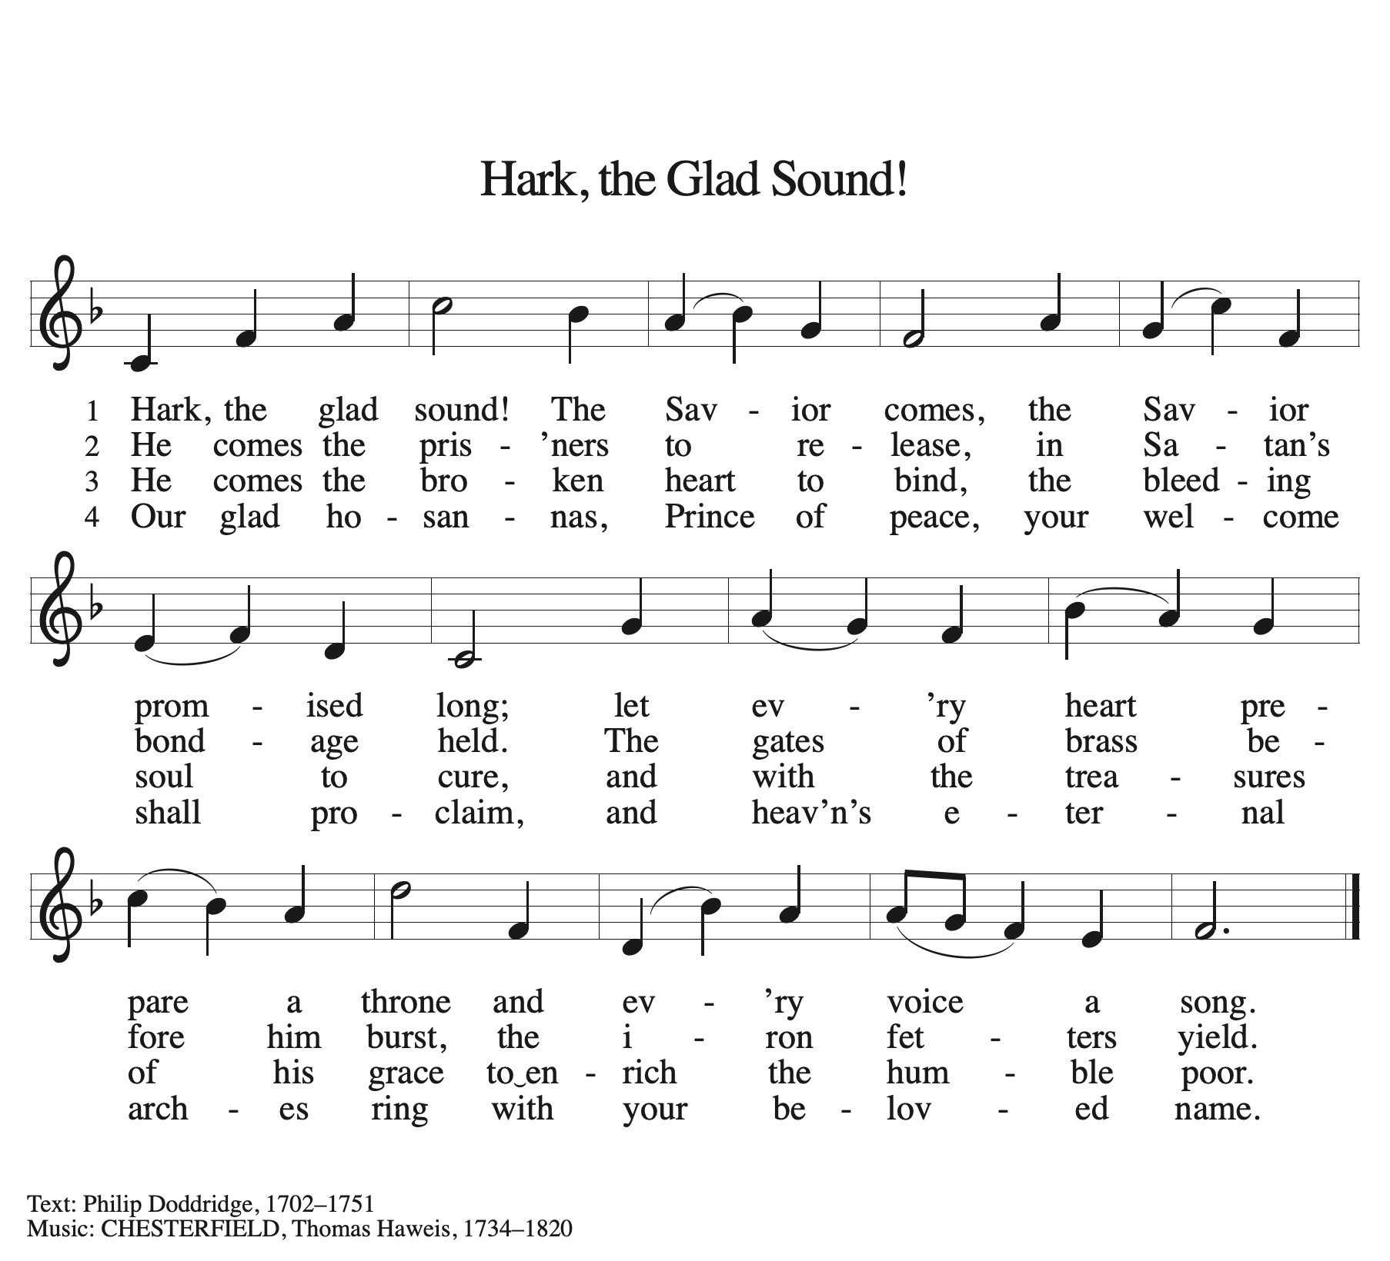

GREETING
The grace of our Lord Jesus Christ, the love of God, and the communion of the Holy Spirit be with you all.
And also with you.

Prayer of the Day
Let us pray together.
Stir up our hearts, Lord God, to prepare the way of your only Son. By his coming nurture our growth as people of repentance and peace; through Jesus Christ, our Savior and Lord, who lives and reigns with you and the Holy Spirit, one God, now and forever.
Amen.

First Reading Isaiah 11:1-10
A reading from Isaiah.

¹ A shoot shall come out from the stump of Jesse,
and a branch shall grow out of his roots.
² The spirit of the Lord shall rest on him,
the spirit of wisdom and understanding,
the spirit of counsel and might,
the spirit of knowledge and the fear of the Lord.
³ His delight shall be in the fear of the Lord.
He shall not judge by what his eyes see
or decide by what his ears hear,
⁴ but with righteousness he shall judge for the poor
and decide with equity for the oppressed of the earth;
he shall strike the earth with the rod of his mouth,
and with the breath of his lips he shall kill the wicked.
⁵ Righteousness shall be the belt around his waist
and faithfulness the belt around his loins.
⁶ The wolf shall live with the lamb;
the leopard shall lie down with the kid;
the calf and the lion will feed together,
and a little child shall lead them.
⁷ The cow and the bear shall graze;
their young shall lie down together;
and the lion shall eat straw like the ox.
⁸ The nursing child shall play over the hole of the asp,
and the weaned child shall put its hand on the adder’s den.
⁹ They will not hurt or destroy
on all my holy mountain,
for the earth will be full of the knowledge of the Lord
as the waters cover the sea.
¹⁰ On that day the root of Jesse shall stand as a signal to the peoples; the nations shall inquire of him, and his dwelling shall be glorious.
The word of the Lord.
Thanks be to God.

Psalm Psalm 72:1-7, 18-19
¹ Give the king your jus- | tice, O God,
and your righteousness to | the king’s son;
² that he may rule your | people righteously
and the | poor with justice;
³ that the mountains may bring prosperity | to the people,
and the | hills, in righteousness.
⁴ Let him defend the needy a- | mong the people,
rescue the poor, and crush | the oppressor.
⁵ May he live as long as the sun and | moon endure,
from one generation | to another.
⁶ Let him come down like rain upon | the mown field,
like showers that wa- | ter the earth.
⁷ In his time may the | righteous flourish;
and let there be an abundance of peace till the moon shall | be no more.
¹⁸ Blessed are you, Lord God, the | God of Israel;
you alone do | wondrous deeds!
¹⁹ And blessed be your glorious | name forever,
and may all the earth be filled with your glory. A- | men. Amen.

Second Reading Romans 15:4-13
A reading from Romans.
⁴ Whatever was written in former days was written for our instruction, so that by steadfastness and by the encouragement of the scriptures we might have hope. ⁵ May the God of steadfastness and encouragement grant you to live in harmony with one another, in accordance with Christ Jesus, ⁶ so that together you may with one voice glorify the God and Father of our Lord Jesus Christ.
⁷ Welcome one another, therefore, just as Christ has welcomed you, for the glory of God. ⁸ For I tell you that Christ has become a servant of the circumcised on behalf of the truth of God in order that he might confirm the promises given to the ancestors ⁹ and that the gentiles might glorify God for his mercy. As it is written,
“Therefore I will confess you among the gentiles
and sing praises to your name”;
¹⁰ and again he says,
“Rejoice, O gentiles, with his people”;
¹¹ and again,
“Praise the Lord, all you gentiles,
and let all the peoples praise him”;
¹² and again Isaiah says,
“The root of Jesse shall come,
the one who rises to rule the gentiles;
in him the gentiles shall hope.”
¹³ May the God of hope fill you with all joy and peace in believing, so that you may abound in hope by the power of the Holy Spirit.

The Word of the Lord
Thanks be to God.
Gospel Acclamation
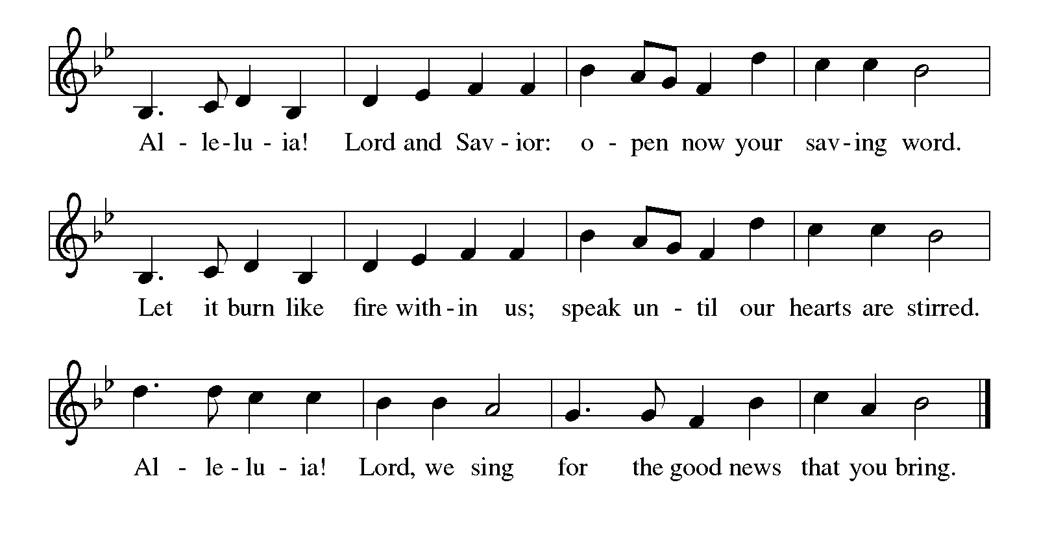

Gospel Matthew 3:1-12
The holy gospel according to Matthew.
Glory to You O Lord.
¹ In those days John the Baptist appeared in the wilderness of Judea, proclaiming, ² “Repent, for the kingdom of heaven has come near.” ³ This is the one of whom the prophet Isaiah spoke when he said,
“The voice of one crying out in the wilderness:
‘Prepare the way of the Lord;
make his paths straight.’ ”
⁴ Now John wore clothing of camel’s hair with a leather belt around his waist, and his food was locusts and wild honey. ⁵ Then Jerusalem and all Judea and all the region around the Jordan were going out to him, ⁶ and they were baptized by him in the River Jordan, confessing their sins.
⁷ But when he saw many of the Pharisees and Sadducees coming for his baptism, he said to them, “You brood of vipers! Who warned you to flee from the coming wrath? ⁸ Therefore, bear fruit worthy of repentance, ⁹ and do not presume to say to yourselves, ‘We have Abraham as our ancestor,’ for I tell you, God is able from these stones to raise up children to Abraham. ¹⁰ Even now the ax is lying at the root of the trees; therefore every tree that does not bear good fruit will be cut down and thrown into the fire.
¹¹ “I baptize you with water for repentance, but the one who is coming after me is more powerful than I, and I am not worthy to carry his sandals. He will baptize you with the Holy Spirit and fire. ¹² His winnowing fork is in his hand, and he will clear his threshing floor and will gather his wheat into the granary, but the chaff he will burn with unquenchable fire.”

The gospel of the Lord.
Praise to you, O Christ.

CHILDREN’S MOMENT

SERMON Pastor Frank Rothfus

hymn of the day “On Jordan's Bank The Baptist's Cry” #249

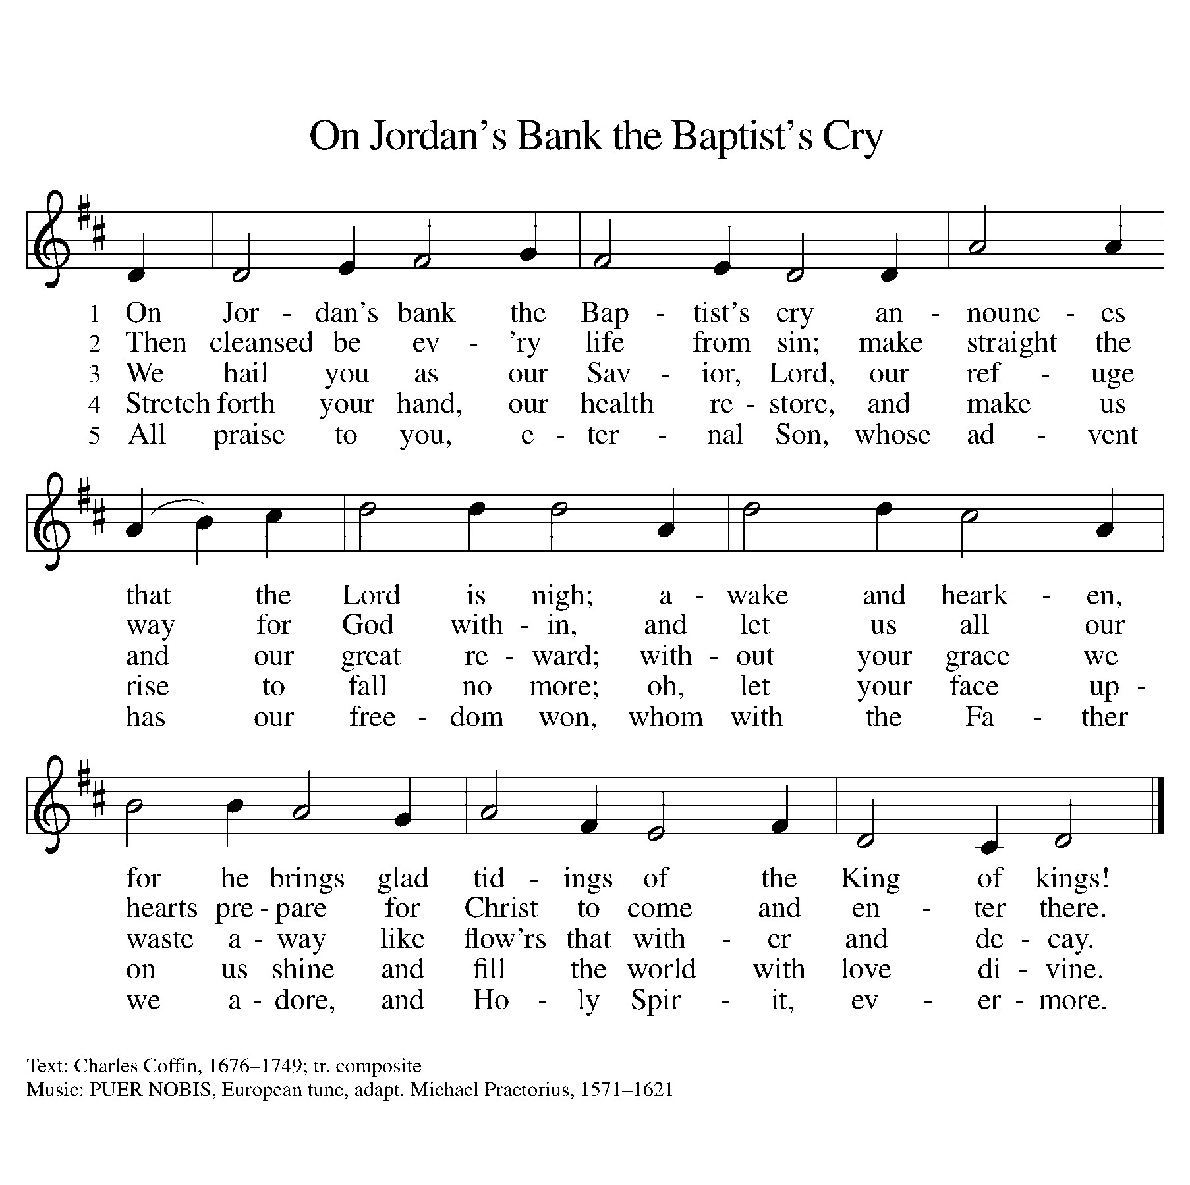

cREED
We believe in one God,
the Father, the Almighty,
maker of heaven and earth,
of all that is, seen and unseen.
We believe in one Lord, Jesus Christ,
the only Son of God,
eternally begotten of the Father,
God from God, Light from Light,
true God from true God,
begotten, not made,
of one Being with the Father;
through him all things were made.
For us and for our salvation
he came down from heaven,
was incarnate of the Holy Spirit and the virgin Mary
and became truly human.
For our sake he was crucified under Pontius Pilate;
he suffered death and was buried.
On the third day he rose again
in accordance with the scriptures;
he ascended into heaven
and is seated at the right hand of the Father.
He will come again in glory to judge the living and the dead,
and his kingdom will have no end.
We believe in the Holy Spirit, the Lord, the giver of life,
who proceeds from the Father and the Son,*
who with the Father and the Son is worshiped and glorified,
who has spoken through the prophets.
We believe in one holy catholic and apostolic church.
We acknowledge one baptism for the forgiveness of sins.
We look for the resurrection of the dead,
and the life of the world to come. Amen.

*Or, “who proceeds from the Father.” The phrase “and the Son” is a later addition to the creed.

prayers of Intercession
In our waiting and watching, we come to you in prayer, O God, trusting your promise to renew the church, the nations, and the whole creation.
A brief silence.
With wisdom and understanding, inspire the faithful around the world. Unite hearts and minds in work to address poverty, access to housing, and equity among peoples. God of grace,
hear our prayer.
With counsel and might, move us to care for creation. As we dream of the day when all creatures will flourish alongside one another, guide us in ways humanity and all creation will mutually thrive. God of grace,
hear our prayer.
With righteousness and faithfulness, encourage nations to live in harmony with one another. We pray for international student and teacher exchanges, for our partner churches, and for the shared mission of Lutheran World Relief and Lutheran Disaster Response. God of grace,
hear our prayer.
With steadfastness and encouragement, strengthen those who have lost hope in the face of grief, depression, or disease. We pray especially for Rick Stowell, Jean Chase, Cliff and Karen Byington, Terry Cotter, Lee Starks, Tristen Alderink, Phil Walsh, Matthew Wilson and family, Dave Makley, Linden and Judy Fisher, Karen Knight, Evelyn Brecheisen, Ed Markwart, Gloria Anderson, Brent and Natalie Merrit, Wayne Hazel, Armani Morado, Larry Duda, Cindy Utterback, Alice Morrow, Jeff Engle, Arlene Forman, Chloe Makley, Erik Anderson, Cort Zylstra, and all countries involved in ongoing conflicts. Renew the spirits of those recovering from surgery and medical procedures. God of grace,
hear our prayer.
With welcome and hospitality, embolden us in our shared ministry to overcome all that divides. In acts of repentance, reconciliation, and reparation, may we serve in the way of Christ. God of grace,
hear our prayer.
Here other intercessions may be offered.
With joy and peace, we remember our ancestors in the faith. Fill us with the hope of the Holy Spirit now and into the ages of ages. God of grace,
hear our prayer.
Draw near to us, O God, as we commend all for whom we pray, trusting in your mercy through Jesus Christ, Emmanuel.
Amen.

PEACE
The peace of Christ be with you always.
And also with you.

OFFERING & OFFERING SONG
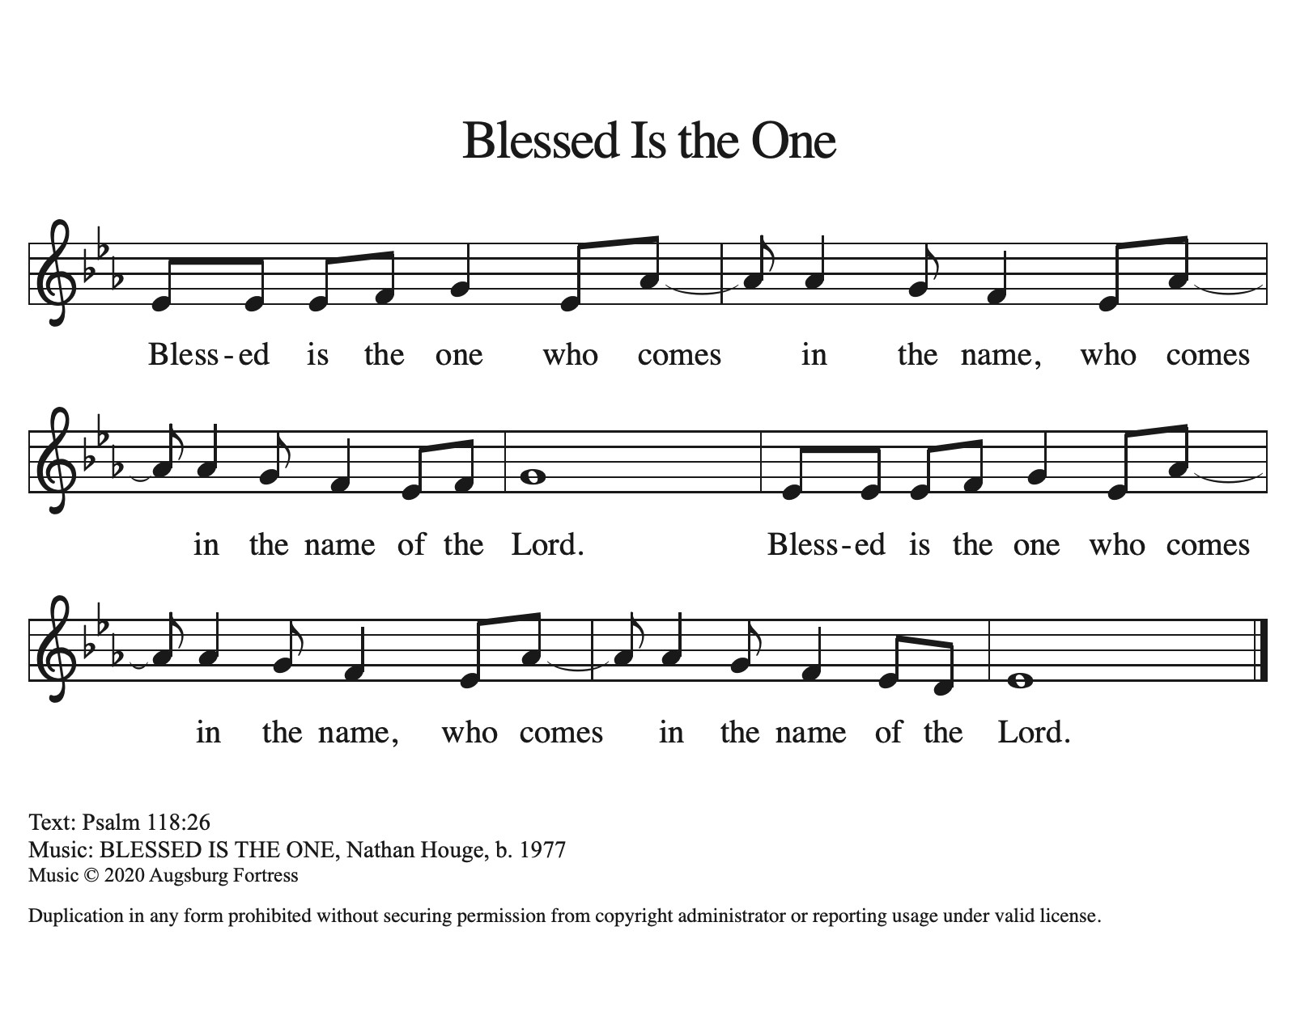

Offering Prayer
Let us pray.
God of all creation, all you have made is good, and your love endures forever. You bring forth bread from the earth and fruit from the vine. Nourish us with these gifts, that we might be for the world signs of your gracious presence in Jesus Christ, our Savior and Lord.
Amen.

DIALOGUE
The Lord be with you.
And also with you.
Lift up your hearts.
We lift them to the Lord.
Let us give thanks to the Lord our God.
It is right to give our thanks and praise.

PREFACE (Pastor)
It is indeed right, our duty and our joy,
that we should at all times and in all places
give thanks and praise to you, almighty and merciful God,
through our Savior Jesus Christ;
who on this day overcame death and the grave,
and by his glorious resurrection opened to us the way of everlasting life.
And so, with all the choirs of angels,
with the church on earth and the hosts of heaven,
we praise your name and join their unending hymn

holy, holy, holy
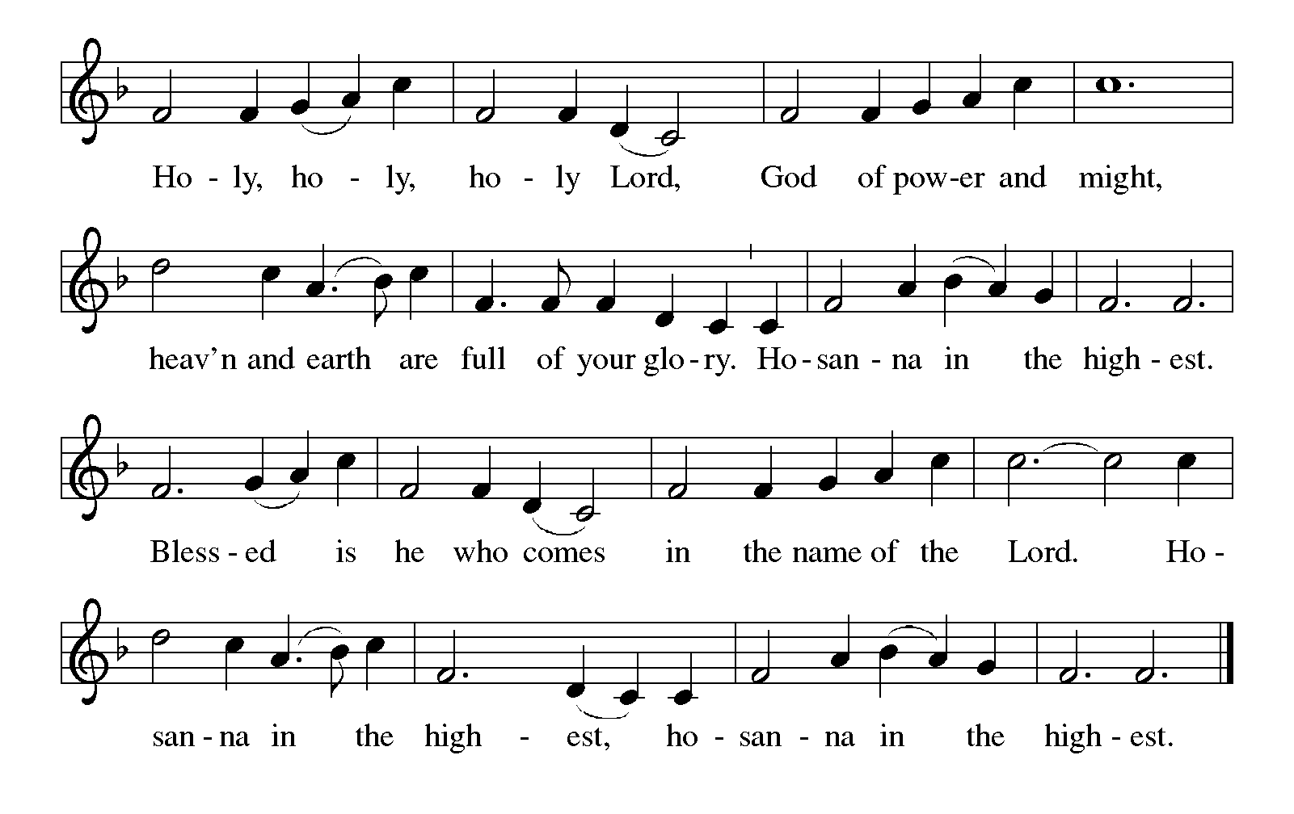

Thanksgiving at the Table
In the night in which he was betrayed,
our Lord Jesus took bread, and gave thanks;
broke it, and gave it to his disciples, saying:
Take and eat; this is my body, given for you.
Do this for the remembrance of me.

Again, after supper, he took the cup, gave thanks,
and gave it for all to drink, saying:
This cup is the new covenant in my blood,
shed for you and for all people for the forgiveness of sin.
Do this for the remembrance of me.

For as often as we eat of this bread and drink from this cup,
we proclaim the Lord’s death until he comes.

Lord’s Prayer
Gathered into one by the Holy Spirit, let us pray as Jesus taught us.
Our Father, who art in heaven,
hallowed be thy name,
thy kingdom come,
thy will be done,
on earth as it is in heaven.
Give us this day our daily bread;
and forgive us our trespasses,
as we forgive those
who trespass against us;
and lead us not into temptation,
but deliver us from evil.
For thine is the kingdom,
and the power, and the glory,
forever and ever. Amen.

INVITATION TO COMMUNION
Come to the banquet, for all is now ready.

COMMUNION *continuous
*People are welcome to kneel at the altar rail for a time of prayer after they receive their communion elements.

COMMUNION HYMNS
“All Earth Is Hopeful: Toda la tierra ” #266
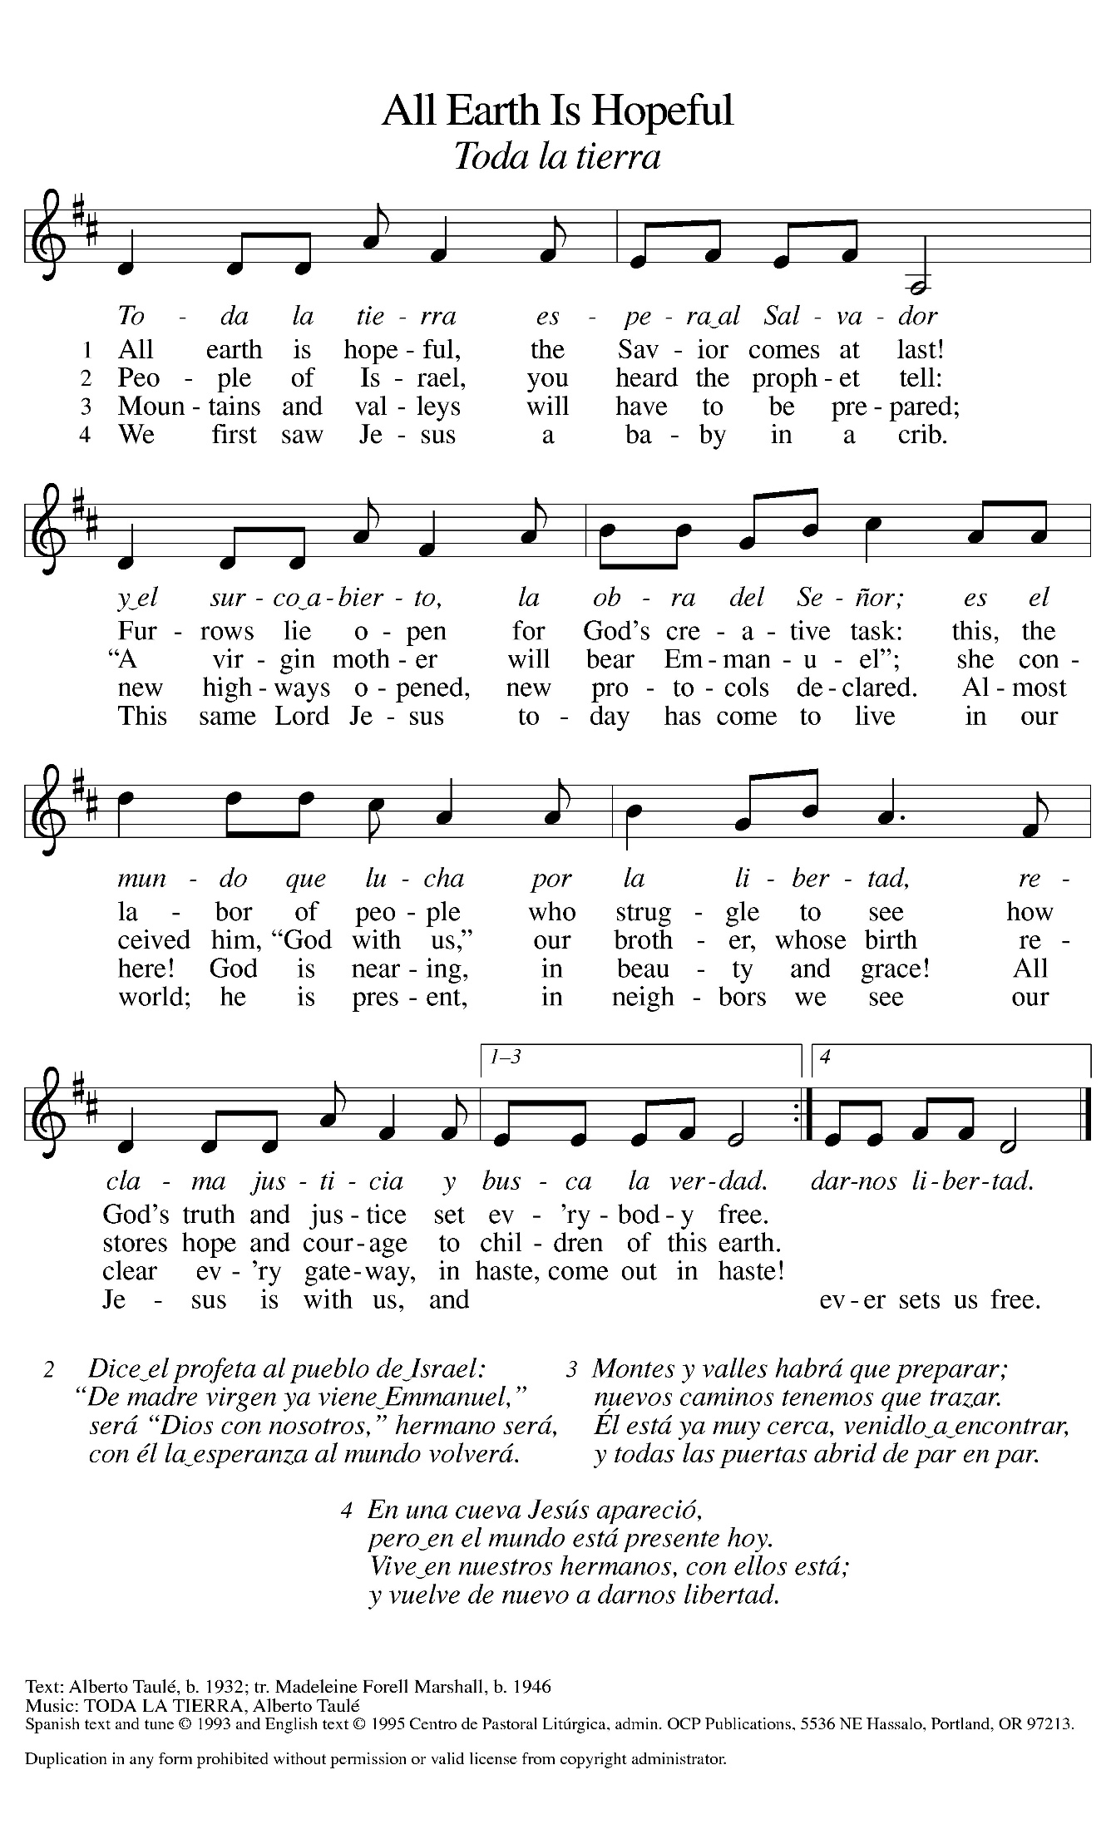

“He Came Down” #253
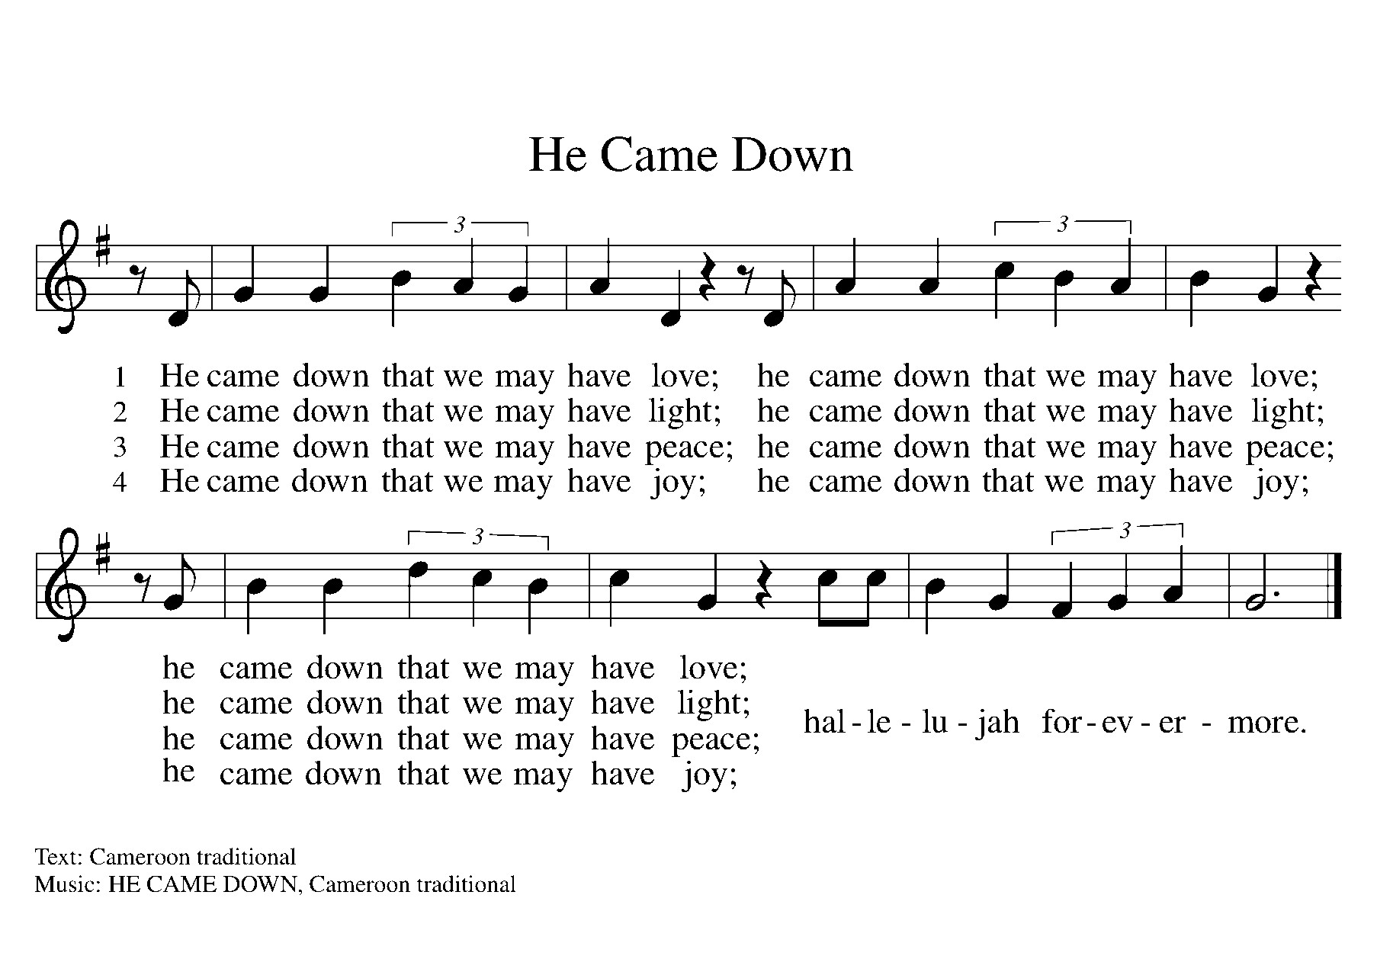

PRAYER AFTER COMMUNION
Let us pray.
We give you thanks, almighty God, that you have refreshed us through the healing power of this gift of life. In your mercy, strengthen us through this gift, in faith toward you and in fervent love toward one another; for the sake of Jesus Christ our Lord.
Amen.

Sending
God blesses us and sends us in mission to the world.

Blessing
The Lord bless you and keep you.
The Lord’s face shine on you with grace and mercy.
The Lord look upon you with favor and ☩ give you peace.
Amen.

Sending SonG “Prepare the Royal Highway” #264
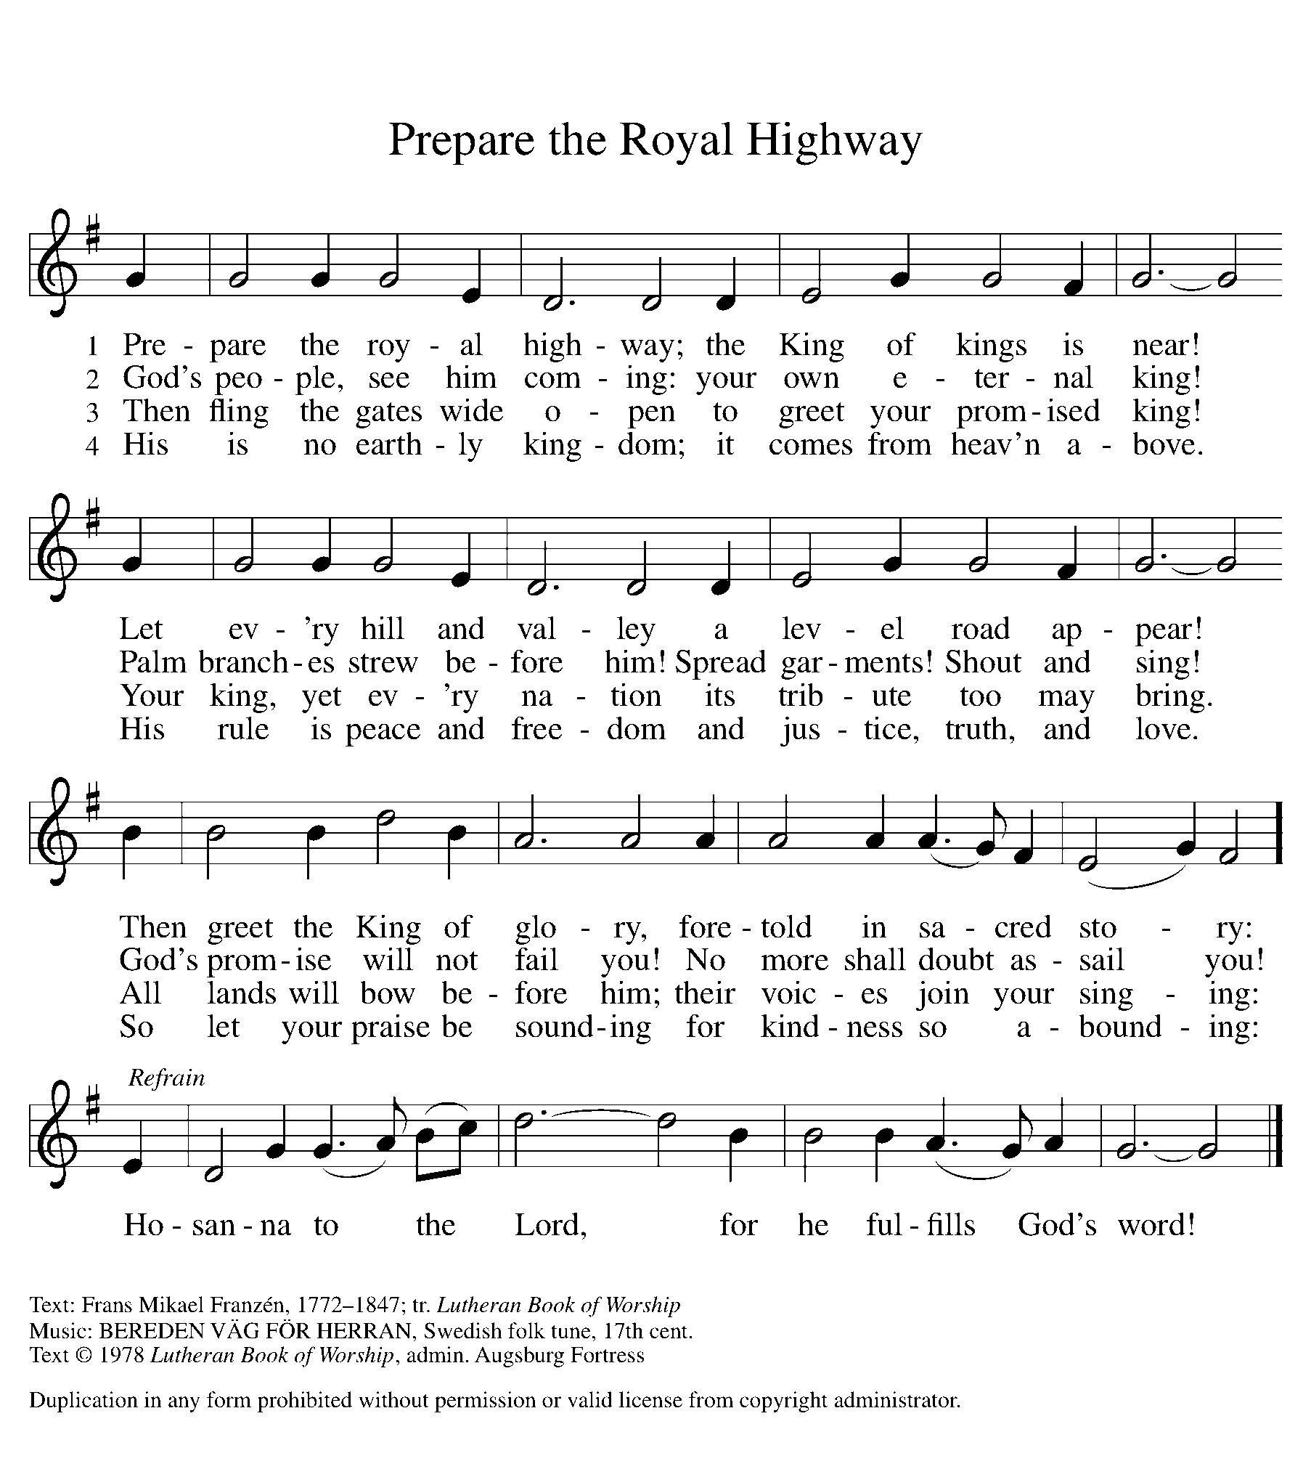

Dismissal
Go in peace. Christ is with you.
Thanks be to God.
From sundaysandseasons.com. Copyright © 2017 Augsburg Fortress. All rights reserved.

Thank you to all who served in worship today!
Presiders: Pastor Fank Rothfus Musician: Jayne Flanigan
Acolyte: Kole Hokanson Safety Person:
Elder: Dan Utterback Trustee: Mike Johnson
Offering Counters: Paul Meade & Carlotta Willard



PRAYERS OF THE FAITHFUL

With thanks for all God’s blessings and his love for all people. Our Bishops, Julie Schneider-Thomas, Yehiel Curry, and the congregations of the North/West Lower Michigan Synod, and especially for

Prayers for our friends, for all who are sick or hospitalized and for all health care workers who care for them. All those members of Zion’s family traveling; all those homebound or in frail health; all those suffering with quiet, unknown needs or worries. For those who serve on our behalf: public safety, utility workers, medical personnel, military personnel. For those who might be forgotten. We pray especially for Rick Stowell, Jean Chase, Cliff and Karen Byington, Terry Cotter, Lee Starks, Tristen Alderink, Phil Walsh, Matthew Wilson and family, Dave Makley, Linden and Judy Fisher, Karen Knight, Evelyn Brecheisen, Ed Markwart, Gloria Anderson, Brent and Natalie Merrit, Wayne Hazel, Armani Morado, Larry Duda, Cindy Utterback, Alice Morrow, Jeff Engle, Arlene Forman, Chloe Makley, Erik Anderson, Cort Zylstra, and all countries involved in ongoing conflicts.

This week at Zion:
- Council Meeting 6PM, Tuesday, December, 9
- Men’s Coffee, 8 AM, Wednesday, December 10
- Bulletin Deadline, Wednesday, December 10

ONLINE GIVING
Zion has received a QR code to facilitate online giving. If you are interested in donating online instead of bringing your donation to church, simply scan the QR code and it will direct you to the appropriate site. The code is on our website as well.

ANNOUNCEMENT
- The Zion Lutheran Church Women would like to thank you all for the generous donations for our annual Thankoffering service. We received a total of $ 535.00. These funds will be sent to the Women of the ELCA to help with their many projects. If anyone needs a tax receipt, contact Carol Engle.
- Church Decorating: We will be decorating the church today Sunday, November 30th after worship. If you can stay to help, it would be appreciated.
- Special Offerings: We have several special offerings this time of the year. The Thanksgiving offering goes to the Lakewood Area Ministerial Association. The Advent offering goes to Manna's Market and the Christmas offering goes to the Lakewood Community Council. Thank you for your generosity.
- Christmas Eve Service: Pastor Ken Scheck will lead our Christmas Eve Service. Our service will start at 5 pm. The earlier time makes it possible for Pastor Ken to also lead Christmas Eve Service at Grace Lutheran in Hastings at 7 pm. Mark your calendar and plan to attend this special service!
- Lakewood Community Council Christmas Basket Project 2025: In preparation for delivery of the Christmas baskets, we begin our drive for warm hats, gloves/mittens and socks in all sizes. Boxes are under the mailboxes in the west hall. Cash donations may be given to help with food and meat donations, so earmarked in your offering. Gifts for children have been purchased via a Thrivent Action Grant. After worship, November 30, Mary Smith is seeking help from children to wrap these gifts Apples have been purchased from Heidi’s Orchard by another Thrivent Action Grant. See Claude if you can help with the apples. Helpers are needed also for delivery on Saturday, December. See the November newsletter for more information.
- Advent Devotional Booklets: Advent devotion books are in your mailboxes for the Advent Season. We hope these special devotions make the time from the beginning to Advent to Christmas more meaningful for you.
- Altar Flowers: If you are interested in putting flowers on the altar in memory of a loved one, please let Mary Makley know.
- Announcement and Newsletter Items: Please forward items for the bulletin announcements and the newsletter to the church email (Office@Zion.org). Please do not send items to people’s personal emails. Thank you.
- Door Locking Policy: Our door locking policy relies on having a volunteer(s) each Sunday to serve as the Safety Person of the Day. On Sundays where no one has volunteered, if someone arrives at church and is willing to be the Safety Person of the Day, we will follow the door locking policy. If no one steps forward to serve as the Safety Person of the Day, the doors will not be locked. Please consider volunteering for this important duty.

