ZION LUTHERAN CHURCH, WOODLAND, MI
Third Sunday of Advent December 14, 2025
*If you are listening in your car, please tune your radio to FM 87.7*
(Please silence your cell phones while in the sanctuary. Thank you.)

Children’s Christmas Program


WELCOME AND ANNOUNCEMENTS

Gathering
The Holy Spirit calls us together as the people of God.

LIGHTING OF THE ADVENT WREATH: JOY Sunday School Teachers & Kids
Last Sunday we lit the candle of Peace, remembering the hope which comes in Christ, and we lit the candle of Peace, remembering God’s dream of a peaceful world. Today we light the third candle of Advent, the candle of Joy.
In Advent, we are in a time of waiting. Like the Israelites who wandered through the Wilderness, waiting to come into the Promised Land, we wait for the coming of the Joy of Ages. We wait for the day where we can join our voices with the angels to sing “Joy to the World, the Lord is come!” We wait for the day when everlasting joy will be on each of us. We light this candle in Joy.
On this day, we remember the Spirit who breathes joy into our lives.

HYMN: Light One Candle to Watch for Messiah, Verse 3 HYMN #240

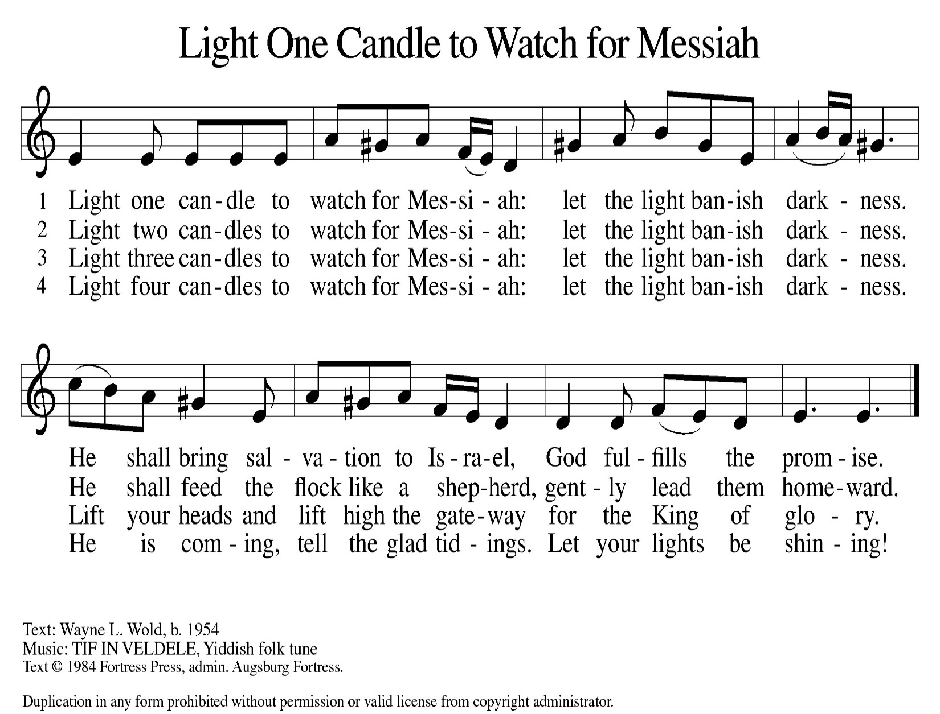

Greeting
The grace of our Lord Jesus Christ, the love of God,
and the communion of the Holy Spirit be with you all.
And also with you.

Prayer of the Day
Let us pray.
Stir up the wills of all who look to you, Lord God, and strengthen our faith in your coming, that, transformed by grace, we may walk in your way; through Jesus Christ, our Savior and Lord, who lives and reigns with you and the Holy Spirit, one God, now and forever.
Amen.

OFFERING & OFFERING SONG

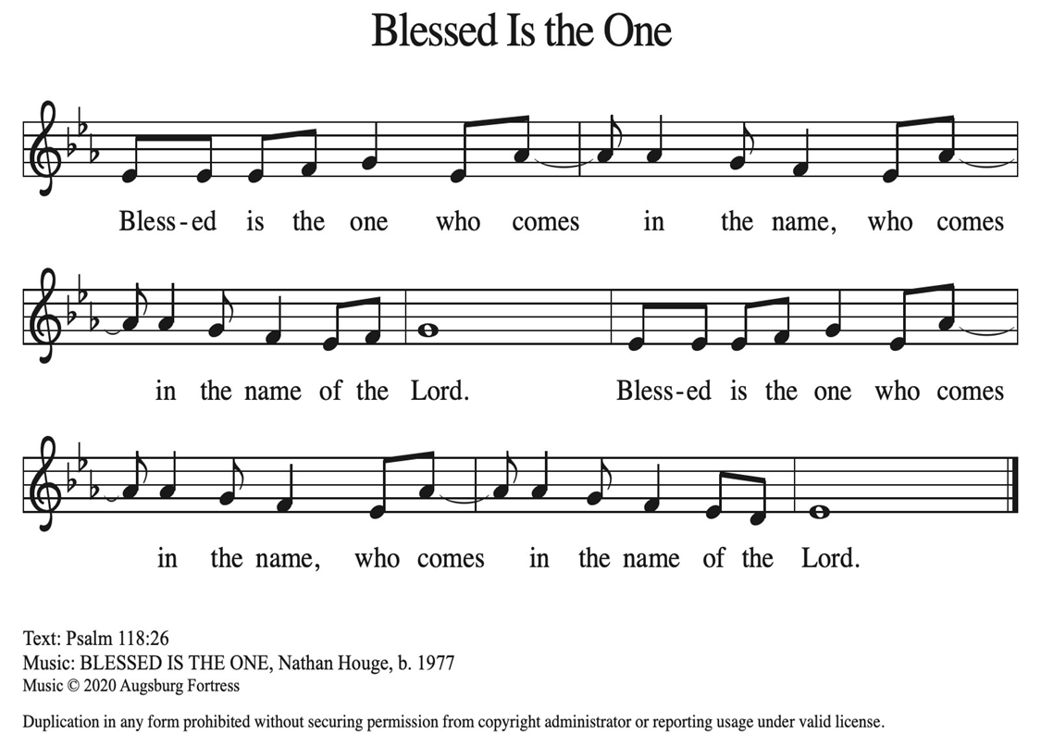

Offering Prayer
Let us pray.
God of all creation, all you have made is good, and your love endures forever. You bring forth bread from the earth and fruit from the vine. Nourish us with these gifts, that we might be for the world signs of your gracious presence in Jesus Christ, our savior and lord.
Amen.

Sunday school Christmas program
Thank you for joining us today to hear about the birth of Jesus through the eyes of our youth. We ask that you join us in the hymns throughout the program.

Children go where i send thee – Children only

silent night #281 (v.1)
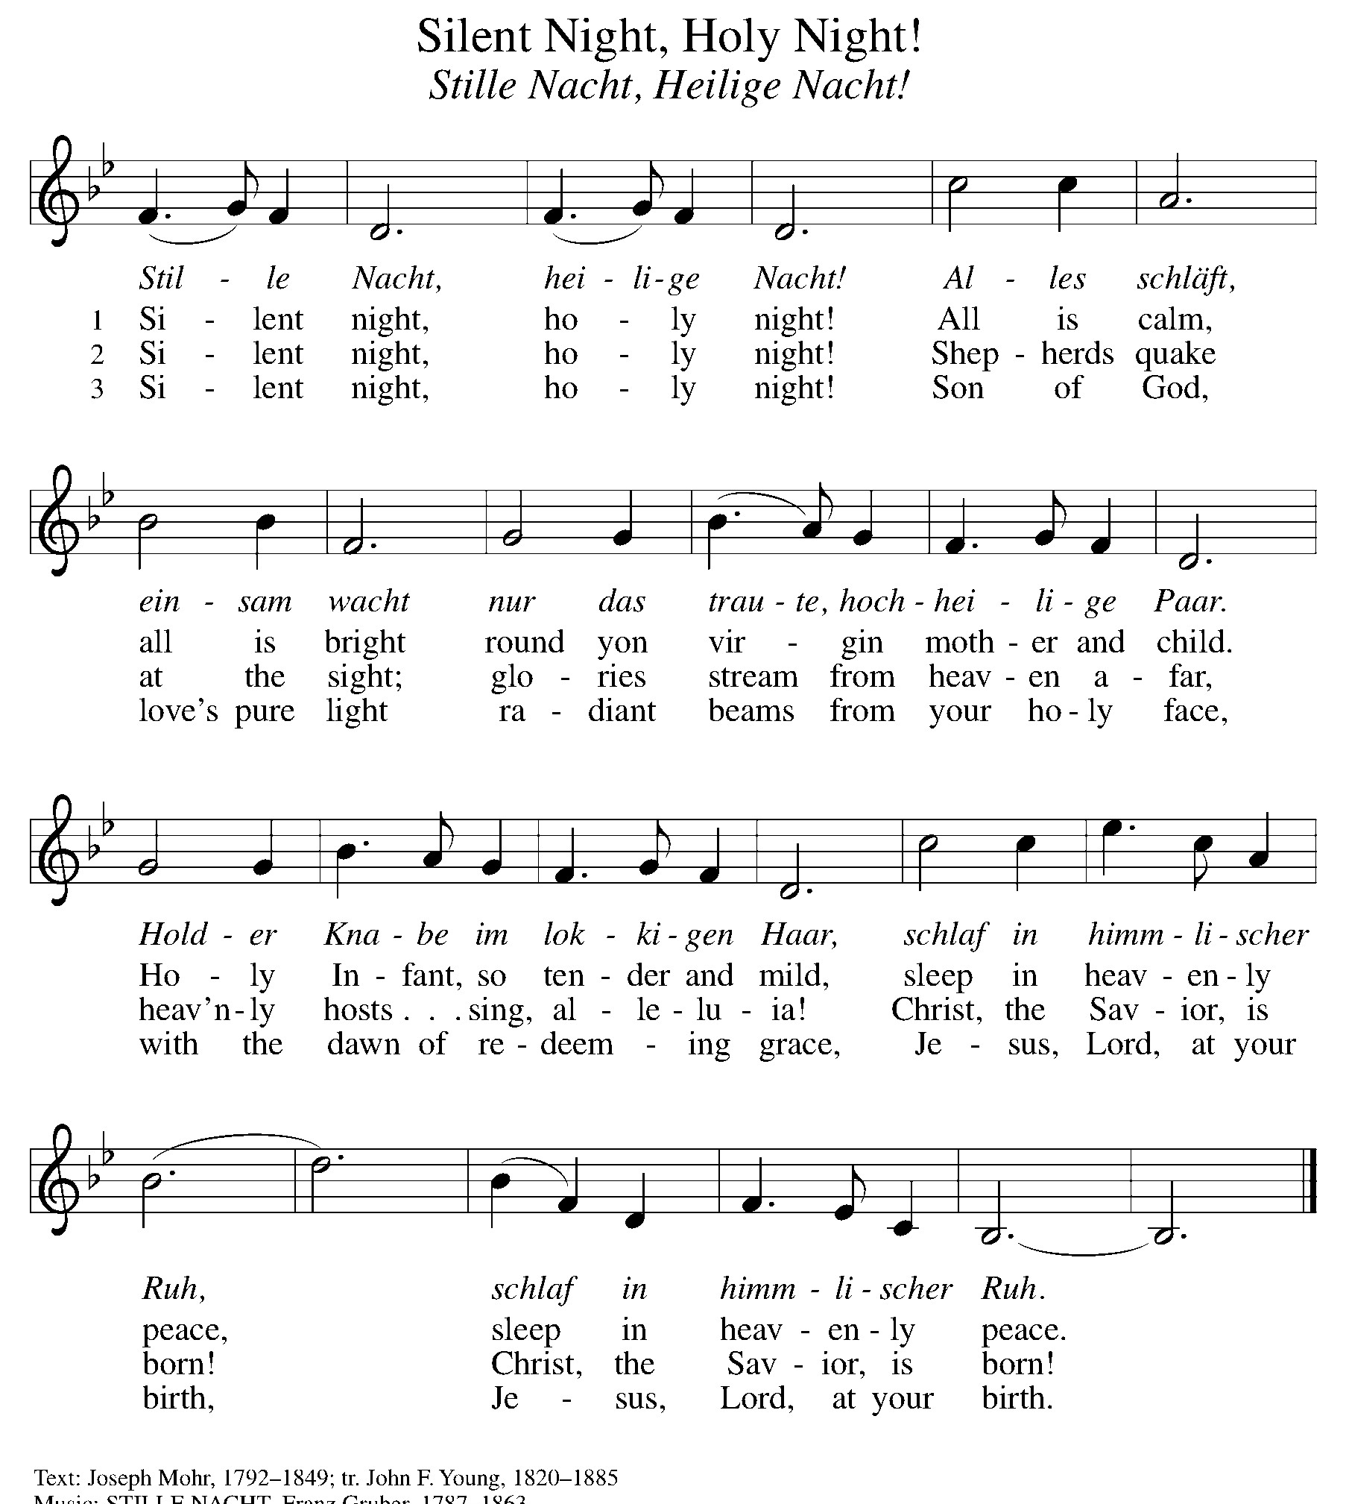

happy birthday-Children only

away in a manger #277 (V.1-3)
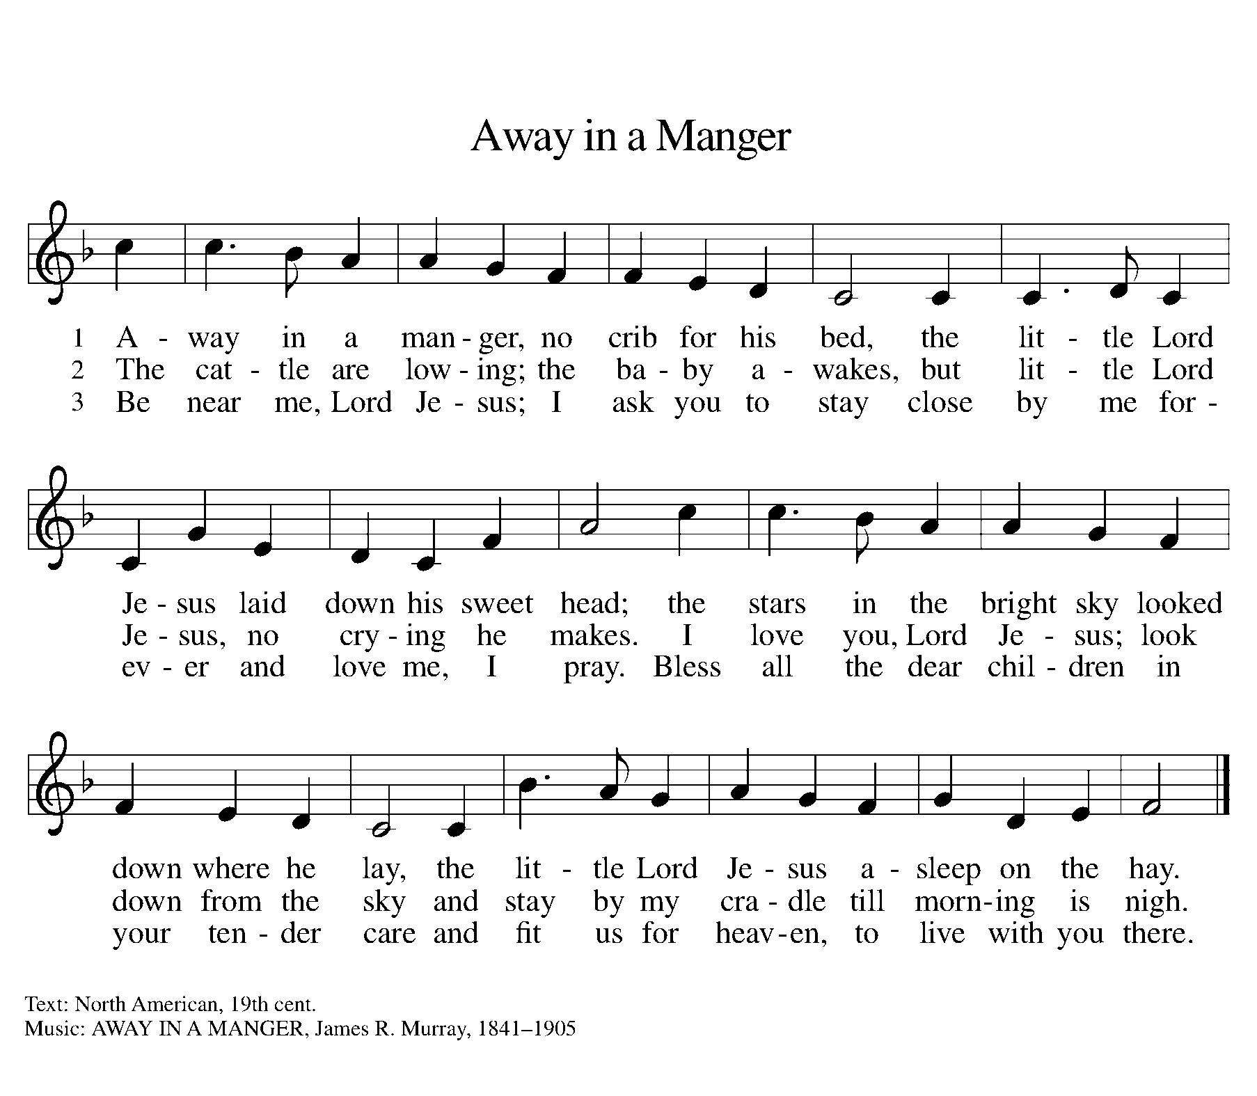

joy to the world #267 (V. 1 &4)
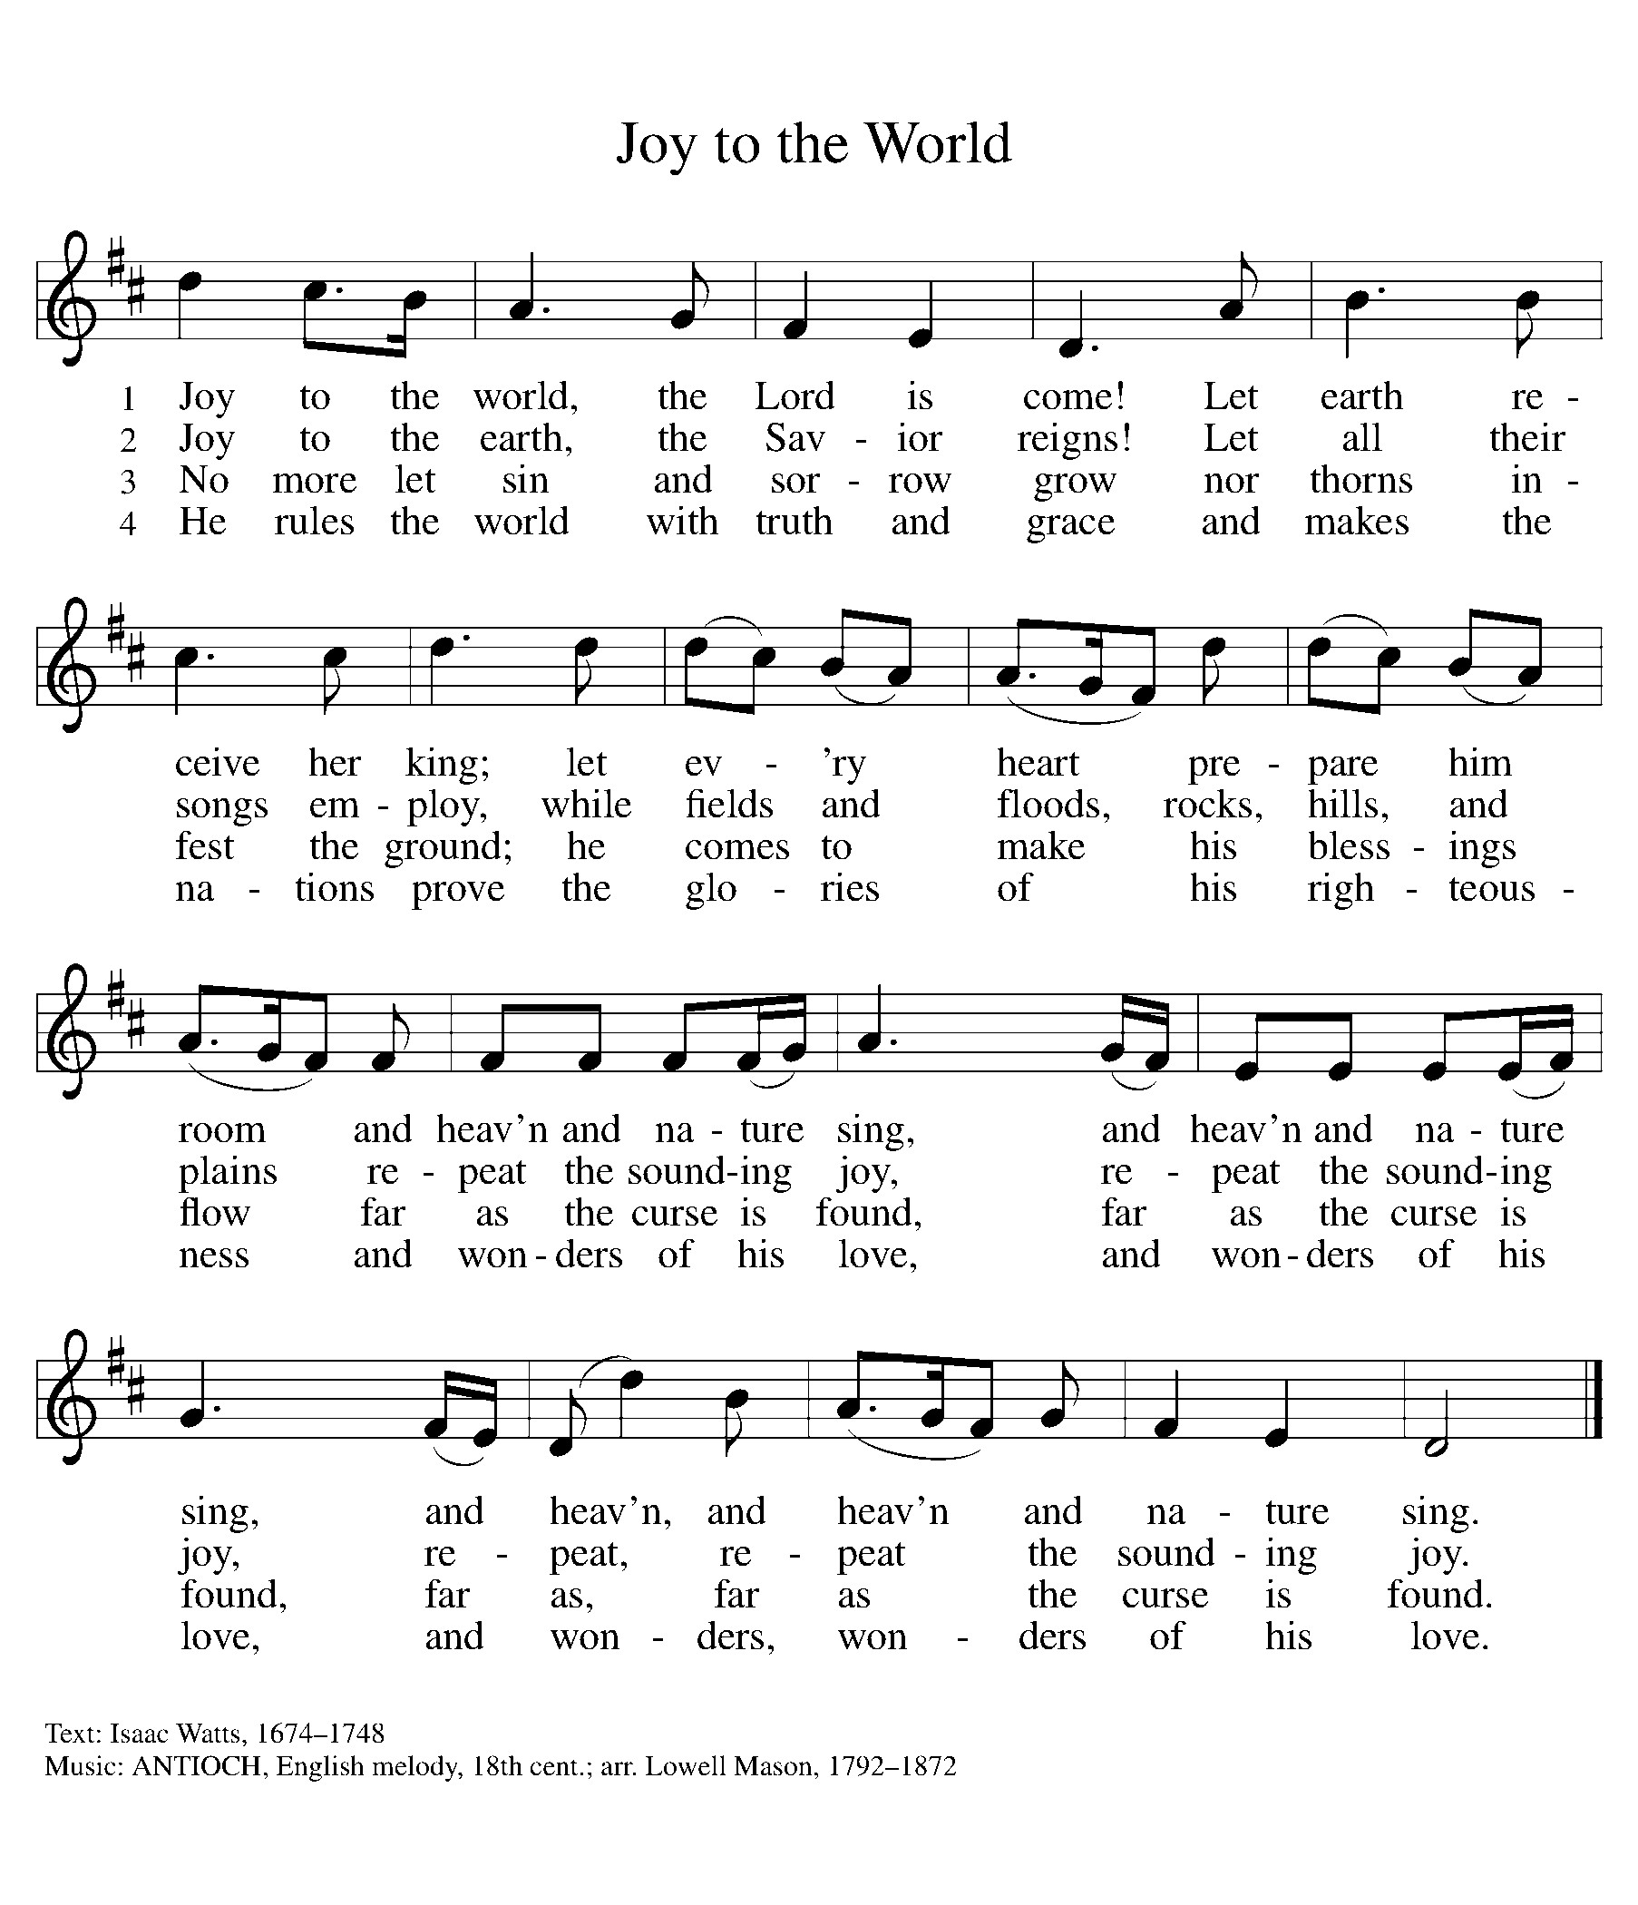

blessing
The Lord bless you and keep you.
The Lord’s face shine on you with grace and mercy.
The Lord look upon you with favor and ☩ give you peace.
Amen.

Dismissal
Go in peace. Christ is with you.
Thanks be to God.
From sundaysandseasons.com. Copyright © 2017 Augsburg Fortress. All rights reserved.

Thank you to all who served in worship today!
Presiders: Sunday School Students & Helpers
Musician: Martha Yoder
Safety Person:
Trustee: Doug MacKenzie
Offering Counters: Doug MacKenzie & Mike Johnson


PRAYERS OF THE FAITHFUL

With thanks for all God’s blessings and his love for all people. Our Bishops, Julie Schneider-Thomas, Yehiel Curry, and the congregations of the North/West Lower Michigan Synod, and especially for Christ Lutheran Church and their pastor Rev. Robert Martin.

Prayers for our friends, for all who are sick or hospitalized and for all health care workers who care for them. All those members of Zion’s family traveling; all those homebound or in frail health; all those suffering with quiet, unknown needs or worries. For those who serve on our behalf: public safety, utility workers, medical personnel, military personnel. For those who might be forgotten.

This week at Zion:
- Women’s Advent tea 5 PM, Tuesday, December 16 at Martha Yoder’s home
- Men’s Coffee, 8 AM, Wednesday, December 17
- Bulletin Deadline, Wednesday, December 17


ONLINE GIVING
Zion has received a QR code to facilitate online giving. If you are interested in donating online instead of bringing your donation to church, simply scan the QR code and it will direct you to the appropriate site. The code is on our website as well.

ANNOUNCEMENT
- Today: Thank you to our Sunday School teachers, kids, and Jolene Griffin for our Children’s Christmas Program today. It is always a special Sunday! Please stay for a potluck fellowship following worship
- Retirement Open House: Arlene Forman's son, Kirk, is retiring from the Woodland DPW after 46-1/2 years. There will be an open house for Kirk at the Main Floor, 1037 4th Ave., Lake Odessa, on Sunday, December 28th from 5 - 9 pm. Everyone is invited to come and help Kirk celebrate this incredible milestone. We have been so appreciative of Kirk's help to Zion during the Woodland Homecoming and assisting in our Super Bowl food collection last year. Congratulations, Kirk. (No gifts please)
- Special Offerings: We have several special offerings this time of the year. The Thanksgiving offering goes to the Lakewood Area Ministerial Association. The Advent offering goes to Manna's Market and the Christmas offering goes to the Lakewood Community Council. Thank you for your generosity.
- Christmas Eve Service: Pastor Ken Scheck will lead our Christmas Eve Service. Our service will start at 5 pm. The earlier time makes it possible for Pastor Ken to also lead Christmas Eve Service at Grace Lutheran in Hastings at 7 pm. Mark your calendar and plan to attend this special service!
- Altar Flowers: If you are interested in putting flowers on the altar in memory of a loved one, please let Mary Makley know.
- Announcement and Newsletter Items: Please forward items for the bulletin announcements and the newsletter to the church email (Office@Zion.org). Please do not send items to people’s personal emails. Thank you.
- Door Locking Policy: Our door locking policy relies on having a volunteer(s) each Sunday to serve as the Safety Person of the Day. On Sundays where no one has volunteered, if someone arrives at church and is willing to be the Safety Person of the Day, we will follow the door locking policy. If no one steps forward to serve as the Safety Person of the Day, the doors will not be locked. Please consider volunteering for this important duty.

