NEW PASTOR -Congregational Meeting Vote
We have the best news to share, starting in January we have a pastor to shepherd our flock. Pastor Ken Scheck will be here every Sunday (except his vacation Sundays). With a vote of 24 to 2, we will enter into a contract with Grace Lutheran Hastings for shared ministry. Only one church can call a pastor, so Grace will remain the congregation of his call. We will share Pastor Ken equally with Grace, both in time and expenses. This means we have 20 hours each week.
Thank you so much for praying for the Call Committee and Council for so many months. This is an exciting time for Zion. We hope to host an open house for Pastor Ken in the new year, so the community can share in our joy and meet our “new” pastor.
Pastor Ken has been serving us the third Sunday of each month since June, so most of you know him. Grace will have their Sunday service at 9:30am and we will have service at 11am. Pastor Ken is looking forward to serving Zion.

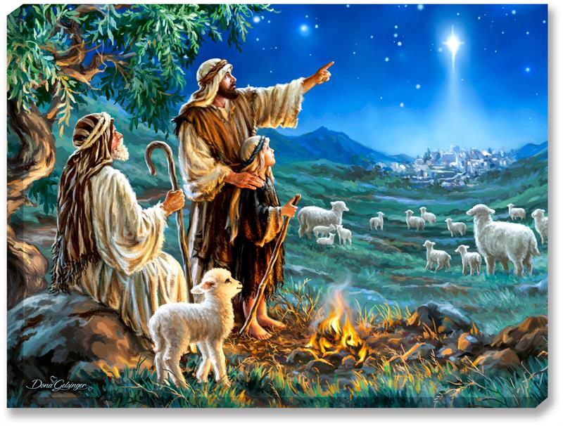

Zion Christmas Tree Farm and Market Ministry
This year our Christmas Tree ministry served 42 families by providing them with new trees, lights, and ornaments. Families could also shop from all the donated Christmas items and new stocking stuffer items. In addition, we provided bags of gifts for 82 children ranging in age from 7 months to 18 years. All the families were very grateful for all the items received. A heartfelt thank you to everyone who donated items or provided financial support, those who helped carry the donated items to the fellowship hall, those who helped set-up, worked at the ministry, helped to clean up and those who delivered our excess items to Enrich in Ionia. Because of your generosity and efforts, these families will have a happy and blessed Christmas. We were blessed with a grant of $500 from the synod to help defray the cost of the trees and lights for this ministry.

Christmas Eve Service, December 24 at 5 pm
We are excited to announce that Pastor Ken Scheck will lead Zion’s Christmas Eve Service on Wednesday, December 24th at 5 pm in the afternoon. This earlier time will allow Pastor Ken to also lead Grace Lutheran in Hastings in their service at 7 pm. We hope that you can attend this very special annual service.

Hymn Sing Service
Sunday, December 28th will be a hymn sing, so be sure to mark your calendar. Worship Planning has heard that the congregation wants to sing more Christmas carols; this will give you that opportunity. Be sure to plan on staying after service and bring a snack to share for coffee fellowship. It is sure to be a Sunday full of the sounds of the Christmas season and great fellowship.
ZLCW Thankoffering
We want to thank Jolene Griffin for giving us so much insight into her pilgrimage in the Pyrenees. Her talk on her trip was very inspirational and informative. She explained to us the mental and physical challenges and the chocolate rewards she had along the path. The children’s moment gave included our kiddos in this interesting talk.
Thank you to Roxanne Johnson, Cheyenne Wallace, Mary Smith, and Karen Heise for reading various portions of our service. A special thank you to the young ladies who brought the Thankoffering basket up.

Pray Without Ceasing
Thank you to everyone who stayed after worship service to participate in our special Pay Without Ceasing services. In all, we held 16 Pray Without Ceasing services. Matthew 18:20 tells us “For where two or three are gathered together in my name, there am I in the midst of them,” and we felt that presence and power. Unfortunately, there is no longer sufficient interest in continuing these services. Again, thank you to all who took the time to pray together.

Thank Yous
- Martha Yoder for “hunting” for supply pastors the past two and a half years!
- The family of Lloyd Brecheisen for sharing the fall mums on the altar in memory of his 104th birthday.
- The family of Phyllis Baitinger for sharing the fresh flower arrangements in memory of her 100th birthday.
- Naomi Wilson for leading the youth singing and the elementary Sunday School class.

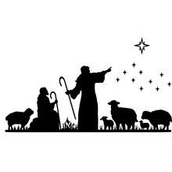

CHILDRENS’S PROGRAM
Sunday, December 14th, we will be blessed to have our Sunday School lead us in worship. There will be a potluck to follow the service. We should not take for granted that we have a Sunday School group to share the Christmas story.

ZLCW Women's Advent Tea 
The ZLCW will host an Advent Tea dinner for all women of the church on Tuesday, December 16th , 5:00 pm at Martha Yoder's , 535 6th Avenue, Lake Odessa, Michigan. Come for an evening of festive holiday fellowship sharing a meal, singing some carols and sharing our best holiday memories. We encourage everyone to come ready to share a favorite Christmas memory from participating in a church play/church service or share one of your special holiday traditions. We will be our own program! A sign-up sheet is in the narthex. We hope you can come for this special time of fellowship. If you have questions, please see Buffy or Martha.
Thankoffering Donations
The Zion Lutheran Church Women would like to thank you all for the generous donations for our annual Thankoffering service. We received a total of $ 535.00. These funds will be sent to the Women of the ELCA to help with their many projects. If anyone needs a tax receipt, contact Carol Engle.

Special Offering Designations
We have several special offering designations this time of the year. As a reminder of our special offering designations, the Thanksgiving offering was designated for the Lakewood Area Ministerial Association. The Advent offering goes to Manna’s Market, and the Christmas offering is designated for the Lakewood Community Council. Your generosity is very appreciated.
Lakewood Community Women Fall Festival of Tables
The Lakewood Community Women held their fall gathering on November 8th with a Festival of Tables with fall themes and local speakers. It was a wonderful morning filled with good music, good food, good messages, and good fellowship! The Zion Women's Coffee Fellowship group sponsored two tables. One table featured birds, white and pink pumpkins and was based on the children's poem/song, "Thank You for the World So Sweet." The second table featured traditional fall colors, pumpkin plates and centerpiece, and was based on the blessings of fall. Those attending from Zion were Caroline Brecheisen, Janine Frizzell, Diane Griffin, Rocky Johnson, Ruth Hindman and Martha Yoder.
Church Cleaning
Zion now has a paid person to clean the church on a weekly basis. At the November 11th council meeting, council supported hiring Ruth Hindman for approximately three to four hours per week to do the routine cleaning that is needed to keep our church looking good. Therefore, there will not be a monthly cleaning list for 2026 and those scheduled for the weekly rotation in December do not need to clean. There may still be "cleaning days" scheduled periodically to attend to non-routine cleaning needs. We appreciate Ruth being willing to take on this position.
New Church Sign
Sometime back the congregation approved the purchase of a new sign for outside in front of the church. This sign has been purchased and will be installed soon. The old black sign with the removable letters has been removed. It was too deteriorated to salvage or save. The remaining wooden sign will also be removed. The new sign is lighted and has the ability for us to add lettered messages.



Cleaning Schedule
Thank you Ruth for taking over the cleaning of our beautiful building! All of the people who have cleaned are overjoyed.

SERVING COFFEE FELLOWSHIP
The 28th – please bring a snack to share.

SUNDAYS IN DECEMBER

December 7 - Communion
Pastor Frank Rothfuss
Acolyte: Kole Hokanson
Elder: Dan Utterback
Trustee: Mike Johnson
Offering Counters: Paul Meade and Carlotta Willard
Musician: Jayne Flanigan

December 14- Sunday School Program
Leaders – Our Youth
Acolyte: Aliyanna Morado
Elder: Buffy Meyers
Trustee: Doug Mackenzie
Offering Counters: Doug MacKenzie and Mike Johnson
Musician: Martha Yoder

December 21- Communion 11am
Pastor Ken Scheck
Acolyte:
Elder: Naomi Wilson
Trustee: Tom Krikke
Offering Counters: Mary Makley and Martha Yoder
Musician: Martha Yoder

Decemember 24 -Communion 5pm
Pastor Ken Scheck
Acolyte: Kole Hokanson and Emil Meyers
Elder: Dan Utterback
Trustee: Mike Johnson
Offering Counters: Diane Griffin and Carlotta Willard
Musician: Jayne Flanigan and Martha Yoder

December 28 – Hymn Sing
Leader: Martha Yoder
Acolyte: Aliyanna Morado
Elder: Buffy Meyers
Trustee: Doug Mackenzie
Offering Counters: Paul Meade and Carlotta Willard
Musician: Jayne Flanigan

