ZION LUTHERAN CHURCH, WOODLAND, MI
Baptism of Our Lord, January 11, 2026
*If you are listening in your car, please tune your radio to FM 87.7*
(Please silence your cell phones while in the sanctuary. Thank you.)


WELCOME AND ANNOUNCEMENTS

Gathering
The Holy Spirit calls us together as the people of God.

Thanksgiving for Baptism (please stand)
In the name of the Father,
and of the ☩ Son,
and of the Holy Spirit.
Amen.

Joined to Christ in the waters of baptism,
we are clothed with God's mercy and forgiveness.
Let us give thanks for the gift of baptism.

We give you thanks, O God,
for in the beginning your Spirit moved over the waters
and by your Word you created the world,
calling forth life in which you took delight.

Through the waters of the flood you delivered Noah and his family.
Through the sea you led your people Israel from slavery into freedom.
At the river your Son was baptized by John and anointed with the Holy Spirit.
By water and your Word you claim us as daughters and sons,
making us heirs of your promise and servants of all.

We praise you for the gift of water that sustains life,
and above all we praise you for the gift of new life in Jesus Christ.
Shower us with your Spirit,
and renew our lives with your forgiveness, grace, and love.

To you be given honor and praise
through Jesus Christ our Lord
in the unity of the Holy Spirit, now and forever.
Amen.
Gathering Song “Brightest and Best of the Stars ” #303

GREETING
The grace of our Lord Jesus Christ, the love of God, and the communion of the Holy Spirit be with you all.
And also with you.

Prayer of the Day
Let us pray together.
O God our Father, at the baptism of Jesus you proclaimed him your beloved Son and anointed him with the Holy Spirit. Make all who are baptized into Christ faithful to their calling to be your daughters and sons, and empower us all with your Spirit, through Jesus Christ, our Savior and Lord, who lives and reigns with you and the Holy Spirit, one God, now and forever. Amen.

First Reading Isaiah 42:1-9
A reading from Isaiah.
Thus says the Lord:
¹ Here is my servant, whom I uphold,
my chosen, in whom my soul delights;
I have put my spirit upon him;
he will bring forth justice to the nations.
² He will not cry out or lift up his voice
or make it heard in the street;
³ a bruised reed he will not break,
and a dimly burning wick he will not quench;
he will faithfully bring forth justice.
⁴ He will not grow faint or be crushed
until he has established justice in the earth,
and the coastlands wait for his teaching.
⁵ Thus says God, the Lord,
who created the heavens and stretched them out,
who spread out the earth and what comes from it,
who gives breath to the people upon it
and spirit to those who walk in it:
⁶ I am the Lord; I have called you in righteousness;
I have taken you by the hand and kept you;
I have given you as a covenant to the people,
a light to the nations,
⁷ to open the eyes that are blind,
to bring out the prisoners from the dungeon,
from the prison those who sit in darkness.
⁸ I am the Lord; that is my name;
my glory I give to no other,
nor my praise to idols.
⁹ See, the former things have come to pass,
and new things I now declare;
before they spring forth,
I tell you of them.

The word of the Lord.
Thanks be to God.

Psalm Psalm 29
¹ Ascribe to the | Lord, you gods,
ascribe to the Lord glo- | ry and strength.
² Ascribe to the Lord the glory | due God’s name;
worship the Lord in the beau- | ty of holiness.
³ The voice of the Lord is upon the waters; the God of | glory thunders;
the Lord is upon the | mighty waters.
⁴ The voice of the Lord is a pow- | erful voice;
the voice of the Lord is a | voice of splendor.
⁵ The voice of the Lord breaks the | cedar trees;
the Lord breaks the ce- | dars of Lebanon;
⁶ the Lord makes Lebanon skip | like a calf,
and Mount Hermon like a | young wild ox.
⁷ The voice | of the Lord
bursts forth in | lightning flashes.
⁸ The voice of the Lord | shakes the wilderness;
the Lord shakes the wilder- | ness of Kadesh.
⁹ The voice of the Lord makes the oak trees writhe and strips the | forests bare.
And in the temple of the Lord all are | crying, “Glory!”
¹⁰ The Lord sits enthroned a- | bove the flood;
the Lord sits enthroned as king for- | evermore.
¹¹ O Lord, give strength | to your people;
give them, O Lord, the bless- | ings of peace.

Second Reading Acts 10:34-43
A reading from Acts.
³⁴ Peter began to speak to [Cornelius and his household]: “I truly understand that God shows no partiality, ³⁵ but in every people anyone who fears him and practices righteousness is acceptable to him. ³⁶ You know the message he sent to the people of Israel, preaching peace by Jesus Christ—he is Lord of all. ³⁷ That message spread throughout Judea, beginning in Galilee after the baptism that John announced: ³⁸ how God anointed Jesus of Nazareth with the Holy Spirit and with power; how he went about doing good and healing all who were oppressed by the devil, for God was with him. ³⁹ We are witnesses to all that he did both in Judea and in Jerusalem. They put him to death by hanging him on a tree, ⁴⁰ but God raised him on the third day and allowed him to appear, ⁴¹ not to all the people but to us who were chosen by God as witnesses and who ate and drank with him after he rose from the dead. ⁴² He commanded us to preach to the people and to testify that he is the one ordained by God as judge of the living and the dead. ⁴³ All the prophets testify about him that everyone who believes in him receives forgiveness of sins through his name.”

The Word of the Lord
Thanks be to God.
Gospel Acclamation

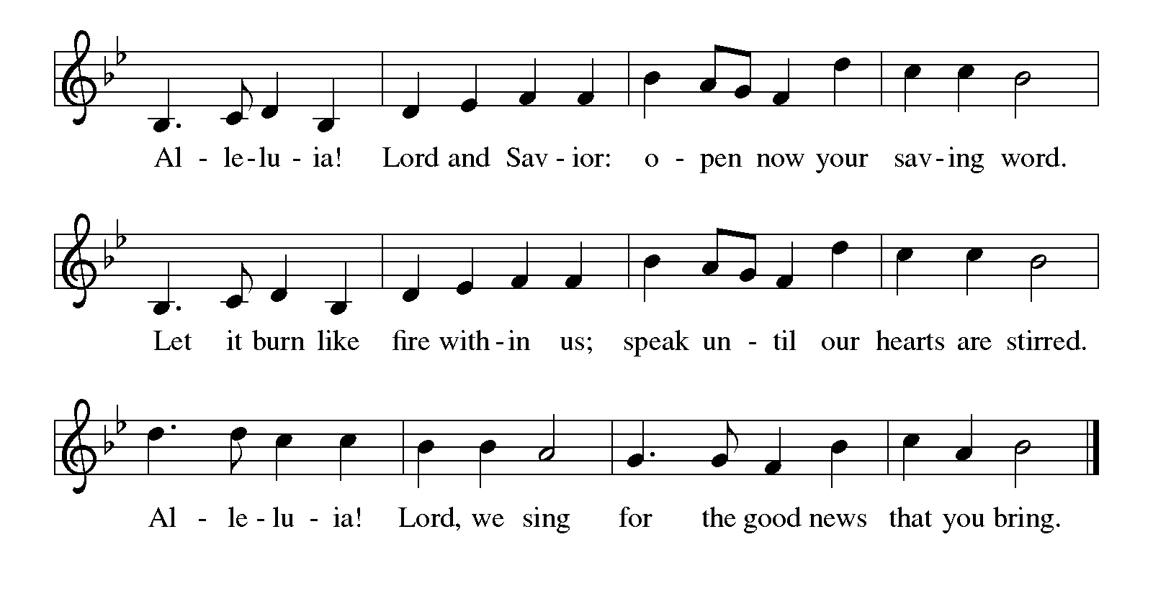

Gospel Matthew 3:13-17
The holy gospel according to Matthew .
Glory to You O Lord.
¹³ Jesus came from Galilee to John at the Jordan, to be baptized by him. ¹⁴ John would have prevented him, saying, “I need to be baptized by you, and do you come to me?” ¹⁵ But Jesus answered him, “Let it be so now, for it is proper for us in this way to fulfill all righteousness.” Then he consented. ¹⁶ And when Jesus had been baptized, just as he came up from the water, suddenly the heavens were opened to him and he saw God’s Spirit descending like a dove and alighting on him. ¹⁷ And a voice from the heavens said, “This is my Son, the Beloved, with whom I am well pleased.”

The gospel of the Lord.
Praise to you, O Christ.
CHILDREN’S MOMENT

SERMON Pastor Ken Scheck

hymn of the day “Christ, When for Us You Were Baptized” #304

Creed
We believe in one God,
the Father, the Almighty,
maker of heaven and earth,
of all that is, seen and unseen.
We believe in one Lord, Jesus Christ,
the only Son of God,
eternally begotten of the Father,
God from God, Light from Light,
true God from true God,
begotten, not made,
of one Being with the Father;
through him all things were made.
For us and for our salvation
he came down from heaven,
was incarnate of the Holy Spirit and the virgin Mary
and became truly human.
For our sake he was crucified under Pontius Pilate;
he suffered death and was buried.
On the third day he rose again
in accordance with the scriptures;
he ascended into heaven
and is seated at the right hand of the Father.
He will come again in glory to judge the living and the dead,
and his kingdom will have no end.
We believe in the Holy Spirit, the Lord, the giver of life,
who proceeds from the Father and the Son,*
who with the Father and the Son is worshiped and glorified,
who has spoken through the prophets.
We believe in one holy catholic and apostolic church.
We acknowledge one baptism for the forgiveness of sins.
We look for the resurrection of the dead,
and the life of the world to come. Amen.

*Or, “who proceeds from the Father.” The phrase “and the Son” is a later addition to the creed.

prayers of Intercession
(Please Be Seated)
As God’s beloved children united in Christ, let us pray for the church, the whole human community, and the well-being of the earth, our home.
A brief silence.
Steadfast God, give courage to your servant church. Heal our divisions and unite us in mission. Uphold our lay leaders, missionaries, pastors, and bishops, and all who proclaim hope in a broken world. We pray especially First Lutheran in Muskegon and their Pastor, Rev. Jake Ferra. Merciful God,
receive our prayer.
Restoring God, cleanse the life-giving waters of rivers, seas, and springs. Create in us an urgent desire to preserve the beauty and bounty of your good creation. Merciful God,
receive our prayer.
Righteous God, you guide the nations. Reconcile warring enemies and end cycles of violent retribution. Defend the rights of prisoners, detainees, and all who flee from persecution. Sustain international aid workers and peacemakers. Merciful God,
receive our prayer.
Compassionate God, you care for all in distress. Provide safety and support for those seeking asylum or in need of shelter. Be near to the dying, and comfort all who are grieving or ill. Merciful God,
receive our prayer.
Loving God, awaken the gifts of the Spirit in this congregation, that we may serve Christ by loving one another, our neighbors, and our enemies. We pray for travelers and those who are homebound. Merciful God,
receive our prayer.
Promising God, in baptism we die and rise with Christ. We give thanks for those who have gone before us, and we trust that we will join them in your everlasting peace. Merciful God,
receive our prayer.
Confident that the Holy Spirit receives our prayers and answers us, we commend all for whom we pray to God’s loving-kindness made known to us in Christ Jesus our Savior.
Amen.
PEACE
The peace of Christ be with you always.
And also with you.
OFFERING & OFFERING SONG
The joy of the Lord is my strength,
The joy of the Lord is my strength,
The joy of the Lord is my strength,
The joy of the Lord is my strength.

Offering Prayer
Let us pray.
Holy God, gracious and merciful, you bring forth food from the earth and nourish your whole creation. Turn our hearts toward those who hunger in any way, that all may know your care; and prepare us now to feast on the bread of life, Jesus Christ, our Savior and Lord.
Amen.

DIALOGUE
The Lord be with you.
And also with you.
Lift up your hearts.
We lift them to the Lord.
Let us give thanks to the Lord our God.
It is right to give our thanks and praise.

PREFACE (Pastor)
It is indeed right, our duty and our joy,
that we should at all times and in all places
give thanks and praise to you, almighty and merciful God,
through our Savior Jesus Christ;
who on this day overcame death and the grave,
and by his glorious resurrection opened to us the way of everlasting life.
And so, with all the choirs of angels,
with the church on earth and the hosts of heaven,
we praise your name and join their unending hymn

holy, holy, holy
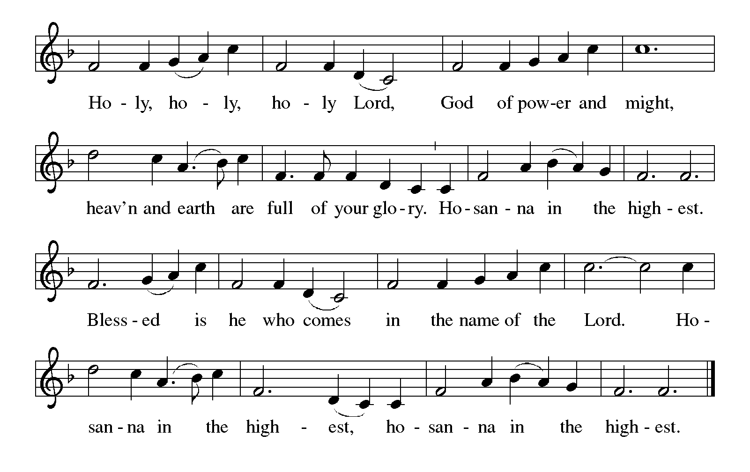

Thanksgiving at the Table
In the night in which he was betrayed,
our Lord Jesus took bread, and gave thanks;
broke it, and gave it to his disciples, saying:
Take and eat; this is my body, given for you.
Do this for the remembrance of me.

Again, after supper, he took the cup, gave thanks,
and gave it for all to drink, saying:
This cup is the new covenant in my blood,
shed for you and for all people for the forgiveness of sin.
Do this for the remembrance of me.

For as often as we eat of this bread and drink from this cup,
we proclaim the Lord’s death until he comes.

Lord’s Prayer
Gathered into one by the Holy Spirit, let us pray as Jesus taught us.
Our Father, who art in heaven,
hallowed be thy name,
thy kingdom come,
thy will be done,
on earth as it is in heaven.
Give us this day our daily bread;
and forgive us our trespasses,
as we forgive those
who trespass against us;
and lead us not into temptation,
but deliver us from evil.
For thine is the kingdom,
and the power, and the glory,
forever and ever. Amen.

INVITATION TO COMMUNION
Come to the banquet, for all is now ready.

COMMUNION *continuous
*People are welcome to kneel at the altar rail for a time of prayer after they receive their communion elements.

COMMUNION HYMNS
“Spirit of Gentleness” #396
“Here Is Bread” #483

PRAYER AFTER COMMUNION
Let us pray.
We give you thanks, almighty God, that you have refreshed us through the healing power of this gift of life. In your mercy, strengthen us through this gift, in faith toward you and in fervent love toward one another; for the sake of Jesus Christ our Lord.
Amen.

Sending
God blesses us and sends us in mission to the world.

Blessing
The Lord bless you and keep you.
The Lord’s face shine on you with grace and mercy.
The Lord look upon you with favor and ☩ give you peace.
Amen.
Sending SonG “Songs of Thankfulness and Praise” #310

Dismissal
Go in peace. Christ is with you.
Thanks be to God.
From sundaysandseasons.com. Copyright © 2017 Augsburg Fortress. All rights reserved.

Thank you to all who served in worship today!
Presiders: Pastor Ken Scheck Musician: Martha Yoder
Acolyte: Safety Person:
Elder: Dan Utterback Trustee: Mike Johnson
Offering Counters: Mary Makley & Martha Yoder



PRAYERS OF THE FAITHFUL

With thanks for all God’s blessings and his love for all people. Our Bishops, Julie Schneider-Thomas, Yehiel Curry, and the congregations of the North/West Lower Michigan Synod, and especially First Lutheran in Muskegon and their pastor Rev. Jake Ferra.

Prayers for our friends, for all who are sick or hospitalized and for all health care workers who care for them. All those members of Zion’s family traveling; all those homebound or in frail health; all those suffering with quiet, unknown needs or worries. For those who serve on our behalf: public safety, utility workers, medical personnel, military personnel. For those who might be forgotten.

This week at Zion:
- Church Council, Tuesday 13th, 6:30 pm
- Men’s Breakfast 8am, Wednesday 14th
- Bulletin Deadline, Wednesday 14th


ONLINE GIVING
Zion has received a QR code to facilitate online giving. If you are interested in donating online instead of bringing your donation to church, simply scan the QR code and it will direct you to the appropriate site. The code is on our website as well.

ANNOUNCEMENT

- How to Contact the Pastor: If there is a pastoral need, please contact Pastor Ken Scheck II at 269-370-4632 or by email at kscheckii@aol.com.
- Worship 11 AM: Starting Sunday, January 4th, worship starts at 11 am and Sunday School at 9:45 am.
- Annual Meeting and Potluck, January 18th. Please plan to attend our annual meeting. There are several important issues on the agenda including elections to the Council and Boards and discussion on the future of the parsonage. There will be a potluck lunch following the annual meeting.
- Special Offerings: We have several special offerings this time of the year. The Thanksgiving offering goes to the Lakewood Area Ministerial Association. The Advent offering goes to Manna's Market and the Christmas offering goes to the Lakewood Community Council. Thank you for your generosity.
- Announcement and Newsletter Items: Please forward items for the bulletin announcements and the newsletter to the church email (Office@Zion.org). Please do not send items to people’s personal emails. Thank you.
- Door Locking Policy: Our door locking policy relies on having a volunteer(s) each Sunday to serve as the Safety Person of the Day. On Sundays where no one has volunteered, if someone arrives at church and is willing to be the Safety Person of the Day, we will follow the door locking policy. If no one steps forward to serve as the Safety Person of the Day, the doors will not be locked. Please consider volunteering for this important duty.

