ZION LUTHERAN CHURCH, WOODLAND, MI
Third Sunday Sunday After Epiphany January 25, 2026
*If you are listening in your car, please tune your radio to FM 87.7*
(Please silence your cell phones while in the sanctuary. Thank you.)


WELCOME AND ANNOUNCEMENTS

Gathering
The Holy Spirit calls us together as the people of God.

INSTALLATION OF COUNCIL AND BOARD MEMBERS
The following people have been elected by the congregation to positions of leadership. We give thanks for their willingness to serve. In baptism we are welcomed into the body of Christ and sent to share in the mission of God; we rejoice now that these sisters and brothers will lead us in our common life and our mutual mission as a congregation.

Please come forward when you hear your name.
The offices and names of those who are to be installed are read by President Paul Meade or another representative of the congregation.

Pastor Scheck addresses those being installed.
A reading from First Corinthians: There are varieties of gifts, but the same Spirit; and there are varieties of services, but the same Lord; and there are varieties of activities, but it is the same God who activates all of them in everyone. To each is given the manifestation of the Spirit for the common good. (1 Corinthians 12:4-7)

The presiding minister continues.
You have been elected to positions of leadership and trust here at Zion Lutheran Church. You are to see that the words and deeds of this household of faith bear witness to God, who gathers us into one together with the whole church. You are to seek to involve all members of this congregation in worship, learning, witness, service, and support, so that the mission of Christ is carried out in this congregation, in the wider church, in this community, and in the entire world. You are to be faithful in your specific area of serving, that the Spirit who empowers you may be glorified. You are to be examples of faith active in love, fostering peace, harmony, and mutual understanding in this congregation.

On behalf of your sisters and brothers in Christ, I ask you: Will you accept and faithfully carry out the duties of the offices to which you have been elected? If so answer, “I will, and I ask God to help me”
Response: I will, and I ask God to help me.

The assembly stands. Those being installed face the assembly. The presiding minister addresses the assembly.
People of God, I ask you:
Will you support these, your elected leaders,
and will you share in the mutual ministry
that Christ has given to all who are baptized? If so answer, “We will, and we ask God to help us.”
We will, and we ask God to help us.
Those being installed face the presiding minister, who addresses them.
I now declare you installed as officers and council members of Zion Lutheran Church.
Almighty God bless you, and direct your days and your deeds in peace,
that you may be faithful servants of Christ.
Amen.

Gathering Song “Listen, God Is Calling” #513

GREETING
The grace of our Lord Jesus Christ, the love of God, and the communion of the Holy Spirit be with you all.
And also with you.

Praise hymn: “This Little Light of Mine”
STANZA 2
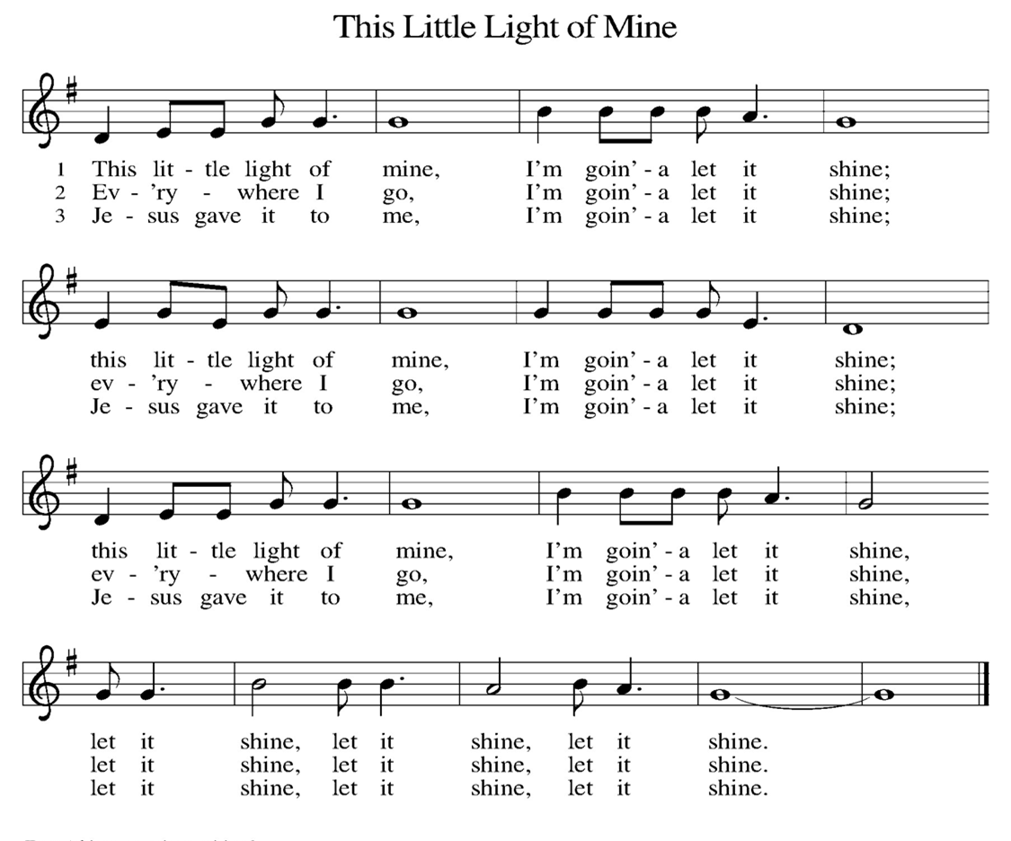

Prayer of the Day
Let us pray together.
Lord God, your lovingkindness always goes before us and follows after us. Summon us into your light, and direct our steps in the ways of goodness that come through the cross of your Son, Jesus Christ, our Savior and Lord.
Amen.

First Reading Isaiah 9:1-4
A reading from Isaiah.
Thus says the Lord:
¹ There will be no gloom for those who were in anguish. In the former time [the Lord] brought into contempt the land of Zebulun and the land of Naphtali, but in the latter time he will make glorious the way of the sea, the land beyond the Jordan, Galilee of the nations.
² The people who walked in darkness
have seen a great light;
those who lived in a land of deep darkness—
on them light has shined.
³ You have multiplied exultation;
you have increased its joy;
they rejoice before you
as with joy at the harvest,
as people exult when dividing plunder.
⁴ For the yoke of their burden
and the bar across their shoulders,
the rod of their oppressor,
you have broken as on the day of Midian.

The word of the Lord.
Thanks be to God.

Psalm Psalm 27:1,4-9

¹ The Lord is my light and my salvation; whom then | shall I fear?
The Lord is the stronghold of my life; of whom shall I | be afraid?
⁴ One thing I ask of the Lord; one | thing I seek;
that I may dwell in the house of the Lord all the days of my life; to gaze upon the beauty of the Lord and to seek God | in the temple.
⁵ For in the day of trouble God will | give me shelter,
hide me in the hidden places of the sanctuary, and raise me high up- | on a rock.
⁶ Even now my head is lifted up above my enemies | who surround me.
Therefore I will offer sacrifice in the sanctuary, sacrifices of rejoicing; I will sing and make music | to the Lord.
⁷ Hear my voice, O Lord, | when I call;
have mercy on me and | answer me.
⁸ My heart speaks your message— | “Seek my face.”
Your face, O Lord, | I will seek.
⁹ Hide not your face from me, turn not away from your ser- | vant in anger.
Cast me not away—you have been my helper; forsake me not, O God of | my salvation.

Second Reading 1 Corinthians 1:10-18
A reading from 1 Corinthians.

¹⁰ Now I appeal to you, brothers and sisters, by the name of our Lord Jesus Christ, that all of you be in agreement and that there be no divisions among you but that you be knit together in the same mind and the same purpose. ¹¹ For it has been made clear to me by Chloe’s people that there are quarrels among you, my brothers and sisters. ¹² What I mean is that each of you says, “I belong to Paul,” or “I belong to Apollos,” or “I belong to Cephas,” or “I belong to Christ.” ¹³ Has Christ been divided? Was Paul crucified for you? Or were you baptized in the name of Paul? ¹⁴ I thank God that I baptized none of you except Crispus and Gaius, ¹⁵ so that no one can say that you were baptized in my name. ¹⁶ I did baptize also the household of Stephanas; beyond that, I do not know whether I baptized anyone else. ¹⁷ For Christ did not send me to baptize but to proclaim the gospel—and not with eloquent wisdom, so that the cross of Christ might not be emptied of its power.
¹⁸ For the message about the cross is foolishness to those who are perishing, but to us who are being saved it is the power of God.

The Word of the Lord
Thanks be to God.
Gospel Acclamation

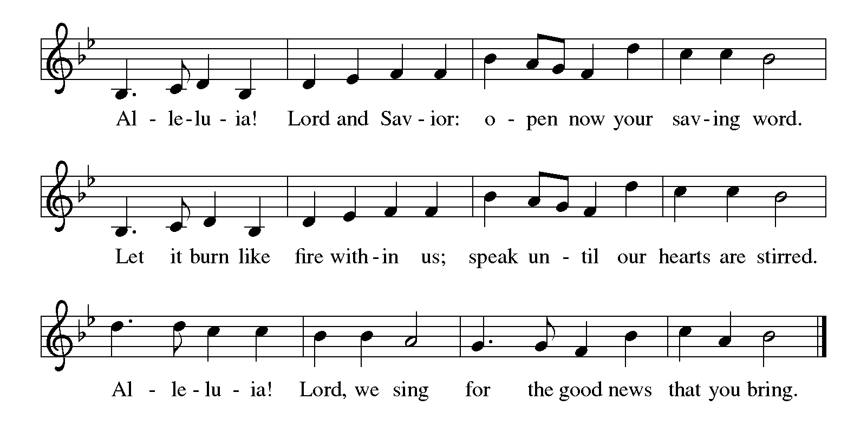

Gospel Matthew 4:12-23
The holy gospel according to Matthew.
Glory to You O Lord.
¹² Now when Jesus heard that John had been arrested, he withdrew to Galilee. ¹³ He left Nazareth and made his home in Capernaum by the sea, in the territory of Zebulun and Naphtali, ¹⁴ so that what had been spoken through the prophet Isaiah might be fulfilled:
¹⁵ “Land of Zebulun, land of Naphtali,
on the road by the sea, across the Jordan, Galilee of the gentiles—
¹⁶ the people who sat in darkness
have seen a great light,
and for those who sat in the region and shadow of death
light has dawned.”
¹⁷ From that time Jesus began to proclaim, “Repent, for the kingdom of heaven has come near.”
¹⁸ As he walked by the Sea of Galilee, he saw two brothers, Simon, who is called Peter, and Andrew his brother, casting a net into the sea—for they were fishers. ¹⁹ And he said to them, “Follow me, and I will make you fishers of people.” ²⁰ Immediately they left their nets and followed him. ²¹ As he went from there, he saw two other brothers, James son of Zebedee and his brother John, in the boat with their father Zebedee, mending their nets, and he called them. ²² Immediately they left the boat and their father and followed him.
²³ Jesus went throughout all Galilee, teaching in their synagogues and proclaiming the good news of the kingdom and curing every disease and every sickness among the people.

The gospel of the Lord.
Praise to you, O Christ.

CHILDREN’S MOMENT

SERMON Pastor Ken Scheck

hymn of the day “Will You Come and Follow Me” #798

cREED
I believe in God, the Father almighty,
creator of heaven and earth.
I believe in Jesus Christ, God’s only Son, our Lord,
who was conceived by the Holy Spirit,
born of the virgin Mary,
suffered under Pontius Pilate,
was crucified, died, and was buried;
he descended to the dead.*
On the third day he rose again;
he ascended into heaven,
he is seated at the right hand of the Father,
and he will come to judge the living and the dead.
I believe in the Holy Spirit,
the holy catholic church,
the communion of saints,
the forgiveness of sins,
the resurrection of the body,
and the life everlasting. Amen.

*Or, “he descended into hell,” another translation of this text in widespread use.

prayers of Intercession
(Please Be Seated)
As God’s beloved children united in Christ, let us pray for the church, the whole human community, and the well-being of the earth, our home.
Holy One, you entrust the message of the cross and the mission of the gospel to the church in every land. Guide the newly baptized and deepen the faith of all who follow Christ. We pray especially Trinity Lutheran in New Era, and their pastor Rev. Chrysanne Timm. Merciful God,
receive our prayer.
Holy Creator, you lavish creation with splendor, and we praise you for the gift of life. Teach us to live as wise stewards, sharing the earth’s resources with all inhabitants of this garden planet. Merciful God,
receive our prayer.
Holy Judge, your power is love, and you judge the nations by the measure of Christ. Free any who are unjustly accused or wrongly condemned. We pray for those in authority. Merciful God,
receive our prayer.
Holy Lover, you care for vulnerable young children, frail elders, and any who are sick.
Provide for their needs and relieve their suffering. Merciful God,
receive our prayer.
Holy Giver, you gather, forgive, and shape us as disciples of Christ. Nurture in us a spirit of patience and respect, that we may love one another as you love us. Merciful God,
receive our prayer.
Holy Savior, you free us from the power of death. Lead and guide us until we come at last into the communion of all your saints in light. Merciful God,
receive our prayer.
Confident that the Holy Spirit receives our prayers and answers us, we commend all for whom we pray to God’s loving-kindness made known to us in Christ Jesus our Savior.
Amen.

PEACE
The peace of Christ be with you always.
And also with you.

OFFERING & OFFERING SONG
The joy of the Lord is my strength,
The joy of the Lord is my strength,
The joy of the Lord is my strength,
The joy of the Lord is my strength.

Offering Prayer
Let us pray.
Holy God, gracious and merciful, you bring forth food from the earth and nourish your whole creation. Turn our hearts toward those who hunger in any way, that all may know your care; and prepare us now to feast on the bread of life, Jesus Christ, our Savior and Lord.
Amen.

DIALOGUE
The Lord be with you.
And also with you.
Lift up your hearts.
We lift them to the Lord.
Let us give thanks to the Lord our God.
It is right to give our thanks and praise.

PREFACE (Pastor)
It is indeed right, our duty and our joy,
that we should at all times and in all places
give thanks and praise to you, almighty and merciful God,
through our Savior Jesus Christ;
who on this day overcame death and the grave,
and by his glorious resurrection opened to us the way of everlasting life.
And so, with all the choirs of angels,
with the church on earth and the hosts of heaven,
we praise your name and join their unending hymn

holy, holy, holy
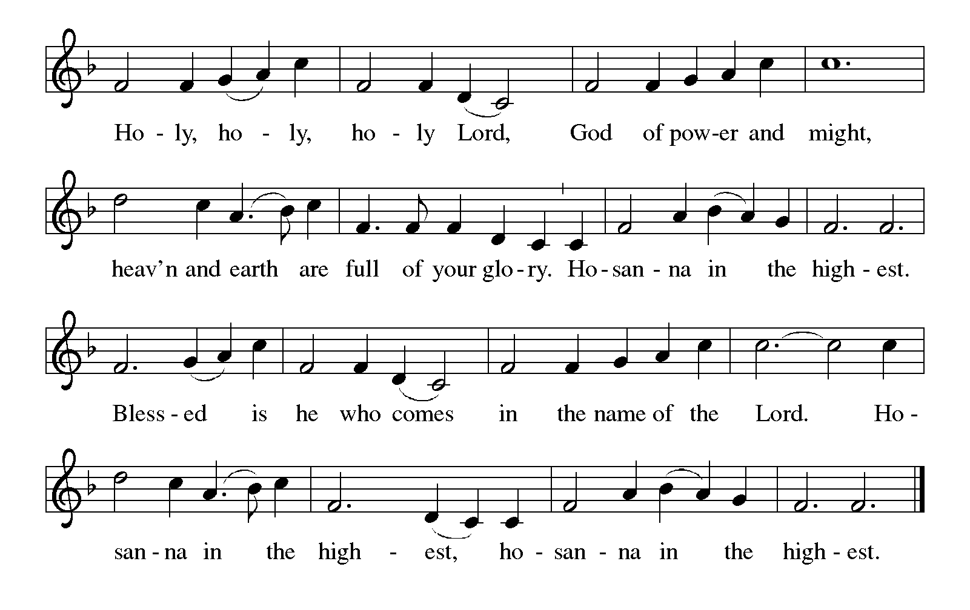

Thanksgiving at the Table
In the night in which he was betrayed,
our Lord Jesus took bread, and gave thanks;
broke it, and gave it to his disciples, saying:
Take and eat; this is my body, given for you.
Do this for the remembrance of me.

Again, after supper, he took the cup, gave thanks,
and gave it for all to drink, saying:
This cup is the new covenant in my blood,
shed for you and for all people for the forgiveness of sin.
Do this for the remembrance of me.

For as often as we eat of this bread and drink from this cup,
we proclaim the Lord’s death until he comes.

Lord’s Prayer
Gathered into one by the Holy Spirit, let us pray as Jesus taught us.
Our Father, who art in heaven,
hallowed be thy name,
thy kingdom come,
thy will be done,
on earth as it is in heaven.
Give us this day our daily bread;
and forgive us our trespasses,
as we forgive those
who trespass against us;
and lead us not into temptation,
but deliver us from evil.
For thine is the kingdom,
and the power, and the glory,
forever and ever. Amen.

INVITATION TO COMMUNION
Come to the banquet, for all is now ready.

COMMUNION *continuous
*People are welcome to kneel at the altar rail for a time of prayer after they receive their communion elements.

COMMUNION HYMNS
“I Want to Walk as a Child of the Light” #815
“Eat This Bread” #472
PRAYER AFTER COMMUNION
Let us pray.
We give you thanks, almighty God, that you have refreshed us through the healing power of this gift of life. In your mercy, strengthen us through this gift, in faith toward you and in fervent love toward one another; for the sake of Jesus Christ our Lord.
Amen.

Sending
God blesses us and sends us in mission to the world.

Blessing
The Lord bless you and keep you.
The Lord’s face shine on you with grace and mercy.
The Lord look upon you with favor and ☩ give you peace.
Amen.

Sending SonG “Let Us Talents and Tongues Employ” #674

Dismissal
Go in peace. Christ is with you.
Thanks be to God.
From sundaysandseasons.com. Copyright © 2017 Augsburg Fortress. All rights reserved.

Thank you to all who served in worship today!
Presiders: Pastor Ken Scheck Musician: Jayne Flanigan
Acolyte: Safety Person:
Elder: Naomi Wilson Trustee:
Offering Counters: Paul Meade & Carlotta Willard



PRAYERS OF THE FAITHFUL

With thanks for all God’s blessings and his love for all people. Our Bishops, Julie Schneider-Thomas, Yehiel Curry, and the congregations of the North/West Lower Michigan Synod, and especially Trinity Lutheran in New Era, and their pastor Rev. Chrysanne Timm.

Prayers for our friends, for all who are sick or hospitalized and for all health care workers who care for them. All those members of Zion’s family traveling; all those homebound or in frail health; all those suffering with quiet, unknown needs or worries. For those who serve on our behalf: public safety, utility workers, medical personnel, military personnel. For those who might be forgotten.

This week at Zion:
- Men’s Breakfast 8am, Wednesday 28th
- Bulletin Deadline, Wednesday 28th

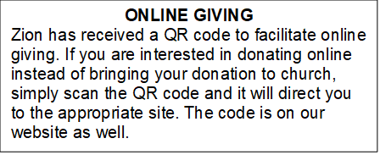

ANNOUNCEMENT

- VISITATION COMMITTEE: The church council has approved the Board of Elders plans to form a Visitation Committee. This new committee will be supporting Pastor Ken by ensuring that our shut-ins have been contacted every month by phone call, cards, and a visit. Can you help? Sign-up sheet is on the table in the narthex indicating your interest in being part of this new ministry. There will be an organizational meeting soon to develop plans of this outreach. More information can be found in the February Newsletter or speak with one of the elders: Naomi, Buffy, and Dan.
- Pastor Ken's installation: Join us for Pastor Ken's installation service on March 22. Bishop Julie Schneider-Thomas will be here for the Sunday School hour, worship and a time of fellowship. Join us for this time of celebration.
- Shut-in Bags: The shut-in bags are in the fellowship hall and are ready to have treats, cards, symbols of Valentine's Day or any other goodies that would fit into them. There are 8 bags (6 singles and 2 couples). They will be there until Sunday, February 7th, then we need volunteers to take the bags to shut-ins. Thank you for your support of this ZLCW project.
- Acolyte Interest: Any youth interested in being an acolyte, please let an Elder (Naomi, Buffy and Dan) know. We will have an opportunity for training and then you can be on the schedule.
- How to Contact the Pastor: If there is a pastoral need, please contact Pastor Ken Scheck II at 269-370-4632 or by email at kscheckii@aol.com.
- Worship 11 AM: Starting Sunday, January 4th, worship starts at 11 am and Sunday School at 9:45 am.
- Announcement and Newsletter Items: Please forward items for the bulletin announcements and the newsletter to the church email (Office@Zion.org). Please do not send items to people’s personal emails. Thank you.
- Door Locking Policy: Our door locking policy relies on having a volunteer(s) each Sunday to serve as the Safety Person of the Day. On Sundays where no one has volunteered, if someone arrives at church and is willing to be the Safety Person of the Day, we will follow the door locking policy. If no one steps forward to serve as the Safety Person of the Day, the doors will not be locked. Please consider volunteering for this important duty.

