ZION LUTHERAN CHURCH, WOODLAND, MI
Second Sunday of Christmas 4, 2026
*If you are listening in your car, please tune your radio to FM 87.7*
(Please silence your cell phones while in the sanctuary. Thank you.)


WELCOME AND ANNOUNCEMENTS

Gathering
The Holy Spirit calls us together as the people of God.

Confession and Forgiveness
In the name of the Father,
and of the ☩ Son,
and of the Holy Spirit.
Amen.

Almighty God, to whom all hearts are open, all desires known, and from whom no secrets are hid: cleanse the thoughts of our hearts by the inspiration of your Holy Spirit, that we may perfectly love you and worthily magnify your holy name, through Jesus Christ our Lord.
Amen.

Let us confess our sin in the presence of God and of one another. Most merciful God,
we confess that we are captive to sin and cannot free ourselves. We have sinned against you in thought, word, and deed, by what we have done and by what we have left undone. We have not loved you with our whole heart; we have not loved our neighbors as ourselves. For the sake of your Son, Jesus Christ, have mercy on us. Forgive us, renew us, and lead us, so that we may delight in your will and walk in your ways, to the glory of your holy name.
Amen.

God, who is rich in mercy, loved us even when we were dead in sin, and made us alive together with Christ. By grace you have been saved. In the name of ☩ Jesus Christ, your sins are forgiven. Almighty God strengthen you with power through the Holy Spirit, that Christ may live in your hearts through faith.
Amen.

Gathering Song “All My Heart Again Rejoices” #273

GREETING
The grace of our Lord Jesus Christ, the love of God, and the communion of the Holy Spirit be with you all.
And also with you.

Prayer of the Day
Let us pray together.
Almighty God, you have filled all the earth with the light of your incarnate Word. By your grace empower us to reflect your light in all that we do, through Jesus Christ, our Savior and Lord, who lives and reigns with you and the Holy Spirit, one God, now and forever.

Amen.

First Reading Jeremiah 31:7-14
A reading from Jeremiah.
Thus says the Lord:
Sing aloud with gladness for Jacob,
and raise shouts for the chief of the nations;
proclaim, give praise, and say,
“Save, O Lord, your people,
the remnant of Israel.”
⁸ See, I am going to bring them from the land of the north
and gather them from the farthest parts of the earth,
among them the blind and the lame,
those with child and those in labor together;
a great company, they shall return here.
⁹ With weeping they shall come,
and with consolations I will lead them back;
I will let them walk by brooks of water,
in a straight path where they shall not stumble,
for I have become a father to Israel,
and Ephraim is my firstborn.
¹⁰ Hear the word of the Lord, O nations,
and declare it in the coastlands far away;
say, “He who scattered Israel will gather him
and will keep him as a shepherd does a flock.”
¹¹ For the Lord has ransomed Jacob
and has redeemed him from hands too strong for him.
¹² They shall come and sing aloud on the height of Zion,
and they shall be radiant over the goodness of the Lord,
over the grain, the wine, and the oil,
and over the young of the flock and the herd;
their life shall become like a watered garden,
and they shall never languish again.
¹³ Then shall the young women rejoice in the dance,
and the young men and the old shall be merry.
I will turn their mourning into joy;
I will comfort them and give them gladness for sorrow.
¹⁴ I will give the priests their fill of fatness,
and my people shall be satisfied with my bounty,
says the Lord.

The word of the Lord.
Thanks be to God.
Psalm Psalm 147: 12-20

¹² Worship the Lord, | O Jerusalem;
praise your | God, O Zion,
¹³ who has strengthened the bars | of your gates
and has blessed your chil- | dren within you.
¹⁴ God has established peace | on your borders
and satisfies you with the | finest wheat.
¹⁵ God sends out a command | to the earth,
a word that runs | very swiftly.
¹⁶ God gives | snow like wool,
scattering | frost like ashes.
¹⁷ God scatters | hail like bread crumbs.
Who can stand a- | gainst God’s cold?
¹⁸ The Lord sends forth the | word and melts them;
the wind blows, and the | waters flow.
¹⁹ God declares the | word to Jacob,
statutes and judg- | ments to Israel.
²⁰ The Lord has not done so to any | other nation;
they do not know God’s judgments. | Hallelujah!

Second Reading Ephesians 1:3-14
A reading from Ephesians.

³ Blessed be the God and Father of our Lord Jesus Christ, who has blessed us in Christ with every spiritual blessing in the heavenly places, ⁴ just as he chose us in Christ before the foundation of the world to be holy and blameless before him in love. ⁵ He destined us for adoption as his children through Jesus Christ, according to the good pleasure of his will, ⁶ to the praise of his glorious grace that he freely bestowed on us in the Beloved. ⁷ In him we have redemption through his blood, the forgiveness of our trespasses, according to the riches of his grace ⁸ that he lavished on us. With all wisdom and insight ⁹ he has made known to us the mystery of his will, according to his good pleasure that he set forth in Christ, ¹⁰ as a plan for the fullness of time, to gather up all things in him, things in heaven and things on earth. ¹¹ In Christ we have also obtained an inheritance, having been destined according to the purpose of him who accomplishes all things according to his counsel and will, ¹² so that we, who were the first to set our hope on Christ, might live for the praise of his glory. ¹³ In him you also, when you had heard the word of truth, the gospel of your salvation, and had believed in him, were marked with the seal of the promised Holy Spirit; ¹⁴ this is the pledge of our inheritance toward redemption as God’s own people, to the praise of his glory.

The Word of the Lord
Thanks be to God.
Gospel Acclamation

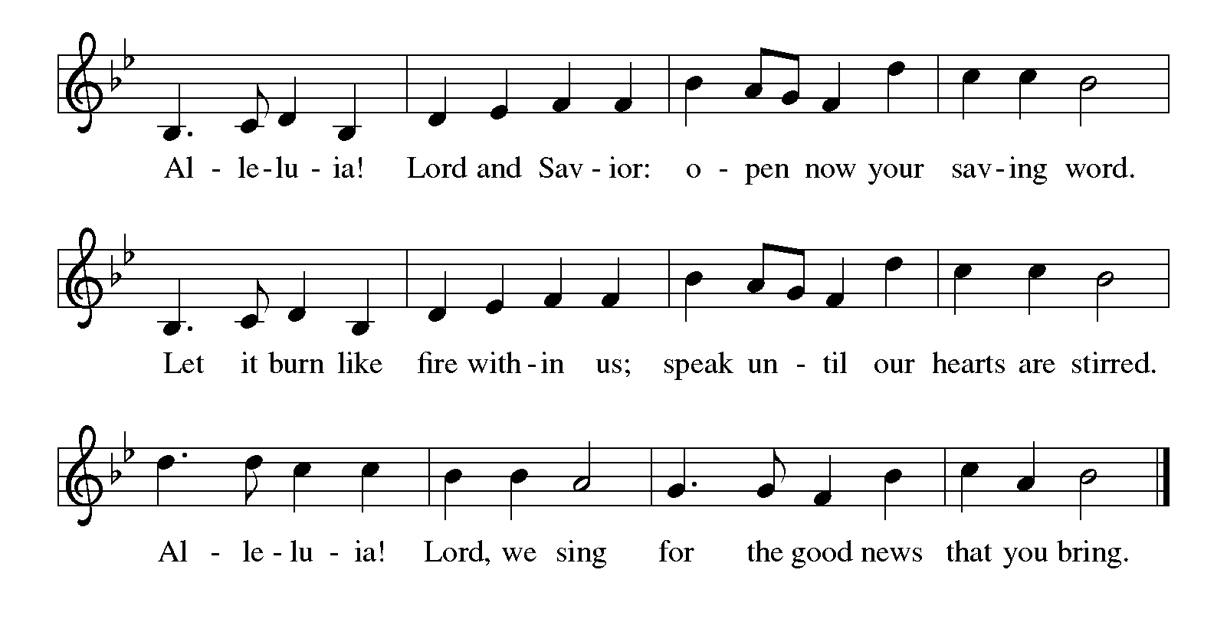

Gospel John 1:[1-9] 10-18
The holy gospel according to Luke.
Glory to You O Lord.
[¹ In the beginning was the Word, and the Word was with God, and the Word was God. ² He was in the beginning with God. ³ All things came into being through him, and without him not one thing came into being. What has come into being ⁴ in him was life, and the life was the light of all people. ⁵ The light shines in the darkness, and the darkness did not overtake it.
⁶ There was a man sent from God whose name was John. ⁷ He came as a witness to testify to the light, so that all might believe through him. ⁸ He himself was not the light, but he came to testify to the light. ⁹ The true light, which enlightens everyone, was coming into the world.]
¹⁰ He was in the world, and the world came into being through him, yet the world did not know him. ¹¹ He came to what was his own, and his own people did not accept him. ¹² But to all who received him, who believed in his name, he gave power to become children of God, ¹³ who were born, not of blood or of the will of the flesh or of the will of man, but of God.
¹⁴ And the Word became flesh and lived among us, and we have seen his glory, the glory as of a father’s only son, full of grace and truth. ¹⁵ (John testified to him and cried out, “This was he of whom I said, ‘He who comes after me ranks ahead of me because he was before me.’ ”) ¹⁶ From his fullness we have all received, grace upon grace. ¹⁷ The law indeed was given through Moses; grace and truth came through Jesus Christ. ¹⁸ No one has ever seen God. It is the only Son, himself God, who is close to the Father’s heart, who has made him known.
The gospel of the Lord.
Praise to you, O Christ.
CHILDREN’S MOMENT

SERMON Pastor Ken Scheck

hymn of the day “Of the Father's Love Begotten” #295

Creed
We believe in one God,
the Father, the Almighty,
maker of heaven and earth,
of all that is, seen and unseen.
We believe in one Lord, Jesus Christ,
the only Son of God,
eternally begotten of the Father,
God from God, Light from Light,
true God from true God,
begotten, not made,
of one Being with the Father;
through him all things were made.
For us and for our salvation
he came down from heaven,
was incarnate of the Holy Spirit and the virgin Mary
and became truly human.
For our sake he was crucified under Pontius Pilate;
he suffered death and was buried.
On the third day he rose again
in accordance with the scriptures;
he ascended into heaven
and is seated at the right hand of the Father.
He will come again in glory to judge the living and the dead,
and his kingdom will have no end.
We believe in the Holy Spirit, the Lord, the giver of life,
who proceeds from the Father and the Son,*
who with the Father and the Son is worshiped and glorified,
who has spoken through the prophets.
We believe in one holy catholic and apostolic church.
We acknowledge one baptism for the forgiveness of sins.
We look for the resurrection of the dead,
and the life of the world to come. Amen.

*Or, “who proceeds from the Father.” The phrase “and the Son” is a later addition to the creed.

prayers of Intercession
(Please Be Seated)
Empowered by the news of Christ’s birth, let us pray boldly for the church, creation, and all who are in need.
A brief silence.
O God, you reveal yourself wherever two or three are gathered in your name. Be with us now, not only in the infant Jesus and resurrected Christ, but in the beloved people of this assembly. We pray especially Immanuel Lutheran in Mt Pleasant, and their Pastor Dana Hendershot.
Hear us, O God.
Your mercy is great.
You reveal yourself in the waters of the womb; in brooks, ponds, and oceans; and in the waters of baptism. Grant us wisdom to tenderly care for the earth as a garden watered by your grace. Hear us, O God.
Your mercy is great.
You reveal yourself in blessed diversity. Help us to look for you in people near and far, in bodies of all kinds, and in kindred young and old. Let us seek you in many places, praising you in many tongues. Hear us, O God.
Your mercy is great.
You reveal yourself in new life. Support those beginning a new job, a new relationship, or a new living situation, especially those displaced because of tragedy or loss. Be with all others who need your life-giving touch this day.
Hear us, O God.
Your mercy is great.
You reveal yourself in holy communion. Sustain all who provide food and fellowship in this congregation and in the wider community. Make our tables signs of your welcoming presence among us. Hear us, O God.
Your mercy is great.
You promise to turn mourning into joy and to comfort those who weep. We remember those who have died and look to being united with them in your glory. Hear us, O God.
Your mercy is great.
With the joy of Christ’s birth in our hearts, we commend our prayers to you, O God, trusting in your boundless mercy and eternal love; through Jesus Christ our Savior.
Amen.

PEACE
The peace of Christ be with you always.
And also with you.

OFFERING & OFFERING SONG
The joy of the Lord is my strength,
The joy of the Lord is my strength,
The joy of the Lord is my strength,
The joy of the Lord is my strength.

Offering Prayer
Let us pray.
Good and loving God, we rejoice in the birth of Jesus, who came among the poor to bring the riches of your grace. As you have blessed us with your gifts, let them be blessing for others. With the trees of the field, with all earth and heaven, we shout for joy at the coming of your Son, Jesus Christ our Lord.
Amen.

DIALOGUE
The Lord be with you.
And also with you.
Lift up your hearts.
We lift them to the Lord.
Let us give thanks to the Lord our God.
It is right to give our thanks and praise.

PREFACE (Pastor)
It is indeed right, our duty and our joy,
that we should at all times and in all places
give thanks and praise to you, almighty and merciful God,
through our Savior Jesus Christ;
who on this day overcame death and the grave,
and by his glorious resurrection opened to us the way of everlasting life.
And so, with all the choirs of angels,
with the church on earth and the hosts of heaven,
we praise your name and join their unending hymn

holy, holy, holy
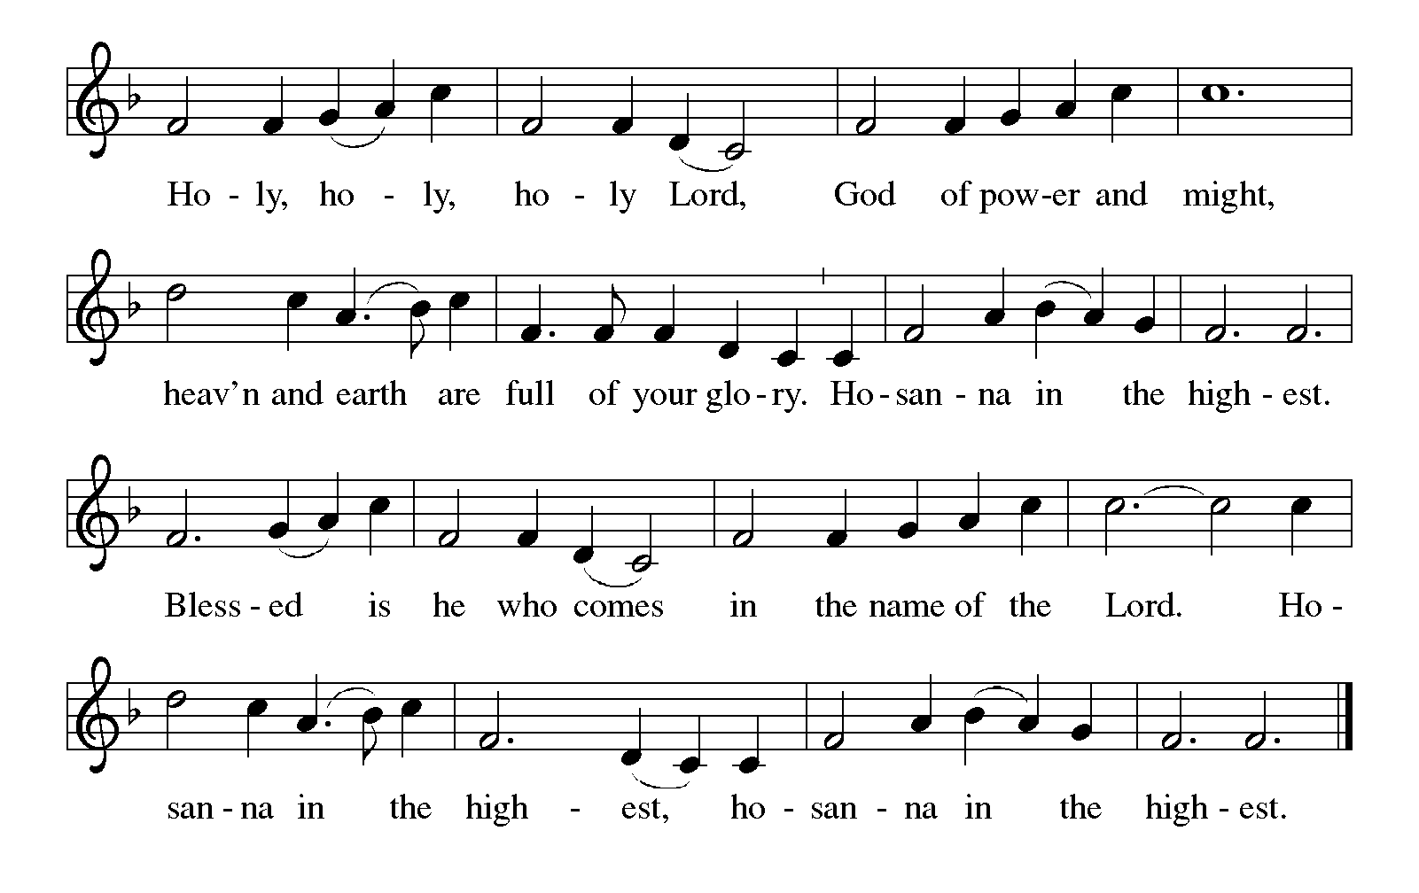

Thanksgiving at the Table
In the night in which he was betrayed,
our Lord Jesus took bread, and gave thanks;
broke it, and gave it to his disciples, saying:
Take and eat; this is my body, given for you.
Do this for the remembrance of me.

Again, after supper, he took the cup, gave thanks,
and gave it for all to drink, saying:
This cup is the new covenant in my blood,
shed for you and for all people for the forgiveness of sin.
Do this for the remembrance of me.

For as often as we eat of this bread and drink from this cup,
we proclaim the Lord’s death until he comes.

Lord’s Prayer
Gathered into one by the Holy Spirit, let us pray as Jesus taught us.
Our Father, who art in heaven,
hallowed be thy name,
thy kingdom come,
thy will be done,
on earth as it is in heaven.
Give us this day our daily bread;
and forgive us our trespasses,
as we forgive those
who trespass against us;
and lead us not into temptation,
but deliver us from evil.
For thine is the kingdom,
and the power, and the glory,
forever and ever. Amen.

INVITATION TO COMMUNION
Come to the banquet, for all is now ready.

COMMUNION *continuous
*People are welcome to kneel at the altar rail for a time of prayer after they receive their communion elements.

COMMUNION HYMNS
“Love Has Come ” #292
“That Boy-Child of Mary ” #293

PRAYER AFTER COMMUNION
Let us pray.
We give you thanks, almighty God, that you have refreshed us through the healing power of this gift of life. In your mercy, strengthen us through this gift, in faith toward you and in fervent love toward one another; for the sake of Jesus Christ our Lord.
Amen.

Sending
God blesses us and sends us in mission to the world.

Blessing
The Lord bless you and keep you.
The Lord’s face shine on you with grace and mercy.
The Lord look upon you with favor and ☩ give you peace.
Amen.

Sending SonG “Let All Together Praise Our God ” #287

Dismissal
Go in peace. Christ is with you.
Thanks be to God.
From sundaysandseasons.com. Copyright © 2017 Augsburg Fortress. All rights reserved.

Thank you to all who served in worship today!
Presiders: Pastor Ken Scheck Musician: Martha Yoder
Acolyte: Safety Person:
Elder: Naomi Wilson Trustee: Tom Krikke
Offering Counters: Doug MacKenzie & Mike Johnson



PRAYERS OF THE FAITHFUL

With thanks for all God’s blessings and his love for all people. Our Bishops, Julie Schneider-Thomas, Yehiel Curry, and the congregations of the North/West Lower Michigan Synod, and especially Immanuel Lutheran in Mt Pleasant, and their Pastor Dana Hendershot.

Prayers for our friends, for all who are sick or hospitalized and for all health care workers who care for them. All those members of Zion’s family traveling; all those homebound or in frail health; all those suffering with quiet, unknown needs or worries. For those who serve on our behalf: public safety, utility workers, medical personnel, military personnel. For those who might be forgotten.

This week at Zion:
- Men’s Breakfast 8am, Wednesday 7th
- Bulletin Deadline, Wednesday 7th


ONLINE GIVING
Zion has received a QR code to facilitate online giving. If you are interested in donating online instead of bringing your donation to church, simply scan the QR code and it will direct you to the appropriate site. The code is on our website as well.

ANNOUNCEMENT

- Worship 11 AM: Starting Sunday, January 4th, worship starts at 11 am and Sunday School at 9:45 am.
- Special Offerings: We have several special offerings this time of the year. The Thanksgiving offering goes to the Lakewood Area Ministerial Association. The Advent offering goes to Manna's Market and the Christmas offering goes to the Lakewood Community Council. Thank you for your generosity.
- Announcement and Newsletter Items: Please forward items for the bulletin announcements and the newsletter to the church email (Office@Zion.org). Please do not send items to people’s personal emails. Thank you.
- Door Locking Policy: Our door locking policy relies on having a volunteer(s) each Sunday to serve as the Safety Person of the Day. On Sundays where no one has volunteered, if someone arrives at church and is willing to be the Safety Person of the Day, we will follow the door locking policy. If no one steps forward to serve as the Safety Person of the Day, the doors will not be locked. Please consider volunteering for this important duty.

