ZION LUTHERAN CHURCH, WOODLAND, MI
Fourth Sunday After Epiphany February 1, 2026
*If you are listening in your car, please tune your radio to FM 87.7*
(Please silence your cell phones while in the sanctuary. Thank you.)


WELCOME AND ANNOUNCEMENTS

Gathering
The Holy Spirit calls us together as the people of God.

Confession and Forgiveness
In the name of the Father,
and of the ☩ Son,
and of the Holy Spirit.
Amen.

Almighty God, to whom all hearts are open, all desires known, and from whom no secrets are hid: cleanse the thoughts of our hearts by the inspiration of your Holy Spirit, that we may perfectly love you and worthily magnify your holy name, through Jesus Christ our Lord.
Amen.

Let us confess our sin in the presence of God and of one another. Most merciful God,
we confess that we are captive to sin and cannot free ourselves. We have sinned against you in thought, word, and deed, by what we have done and by what we have left undone. We have not loved you with our whole heart; we have not loved our neighbors as ourselves. For the sake of your Son, Jesus Christ, have mercy on us. Forgive us, renew us, and lead us, so that we may delight in your will and walk in your ways, to the glory of your holy name.
Amen.

God, who is rich in mercy, loved us even when we were dead in sin, and made us alive together with Christ. By grace you have been saved. In the name of ☩ Jesus Christ, your sins are forgiven. Almighty God strengthen you with power through the Holy Spirit, that Christ may live in your hearts through faith.
Amen.

Gathering Song “Rejoice, Ye Pure in Heart!” #873

GREETING
The grace of our Lord Jesus Christ, the love of God, and the communion of the Holy Spirit be with you all.
And also with you.

Praise hymn: “This Little Light of Mine”
STANZA 3
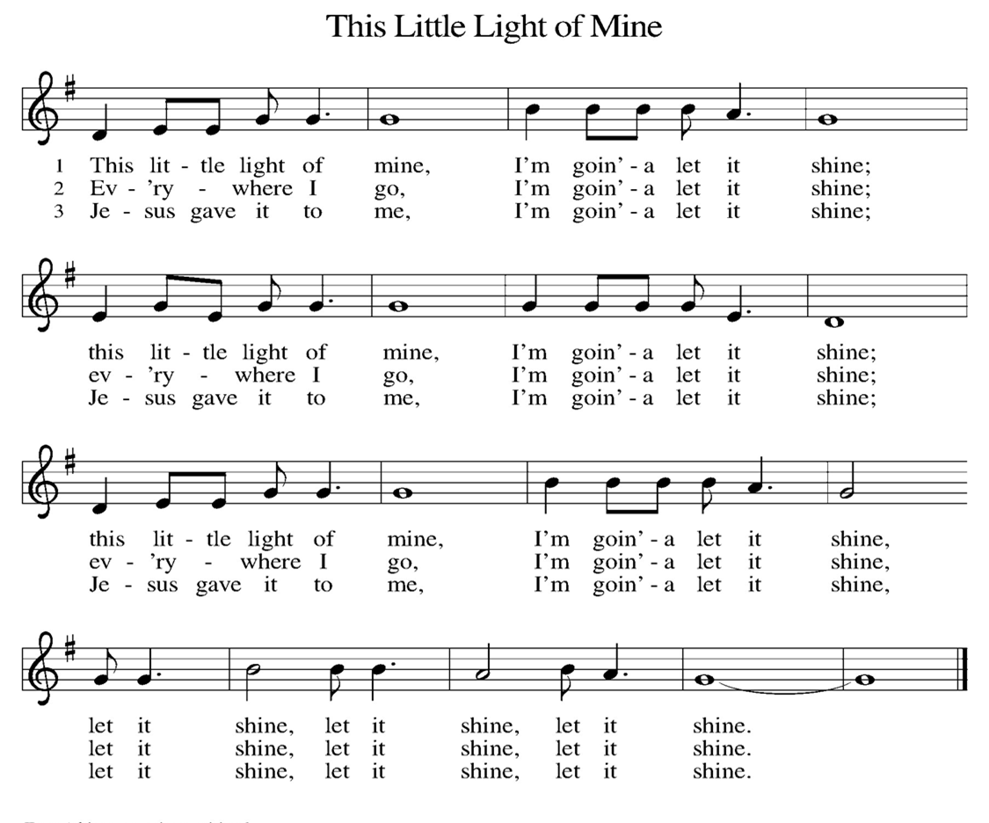
Prayer of the Day
Let us pray together.
Holy God, you confound the world’s wisdom in giving your kingdom to the lowly and the pure in heart. Give us such a hunger and thirst for justice, and perseverance in striving for peace, that in our words and deeds the world may see the life of your Son, Jesus Christ, our Savior and Lord.
Amen.

First Reading Micah 6:1-8
A reading from Micah.
Thus says the Lord:
¹ Hear what the Lord says:
Rise, plead your case before the mountains,
and let the hills hear your voice.
² Hear, you mountains, the case of the Lord,
and you enduring foundations of the earth,
for the Lord has a case against his people,
and he will contend with Israel.
³ “O my people, what have I done to you?
In what have I wearied you? Answer me!
⁴ For I brought you up from the land of Egypt
and redeemed you from the house of slavery,
and I sent before you Moses,
Aaron, and Miriam.
⁵ O my people, remember now what King Balak of Moab devised,
what Balaam son of Beor answered him,
and what happened from Shittim to Gilgal,
that you may know the saving acts of the Lord.”
⁶ “With what shall I come before the Lord
and bow myself before God on high?
Shall I come before him with burnt offerings,
with calves a year old?
⁷ Will the Lord be pleased with thousands of rams,
with ten thousands of rivers of oil?
Shall I give my firstborn for my transgression,
the fruit of my body for the sin of my soul?”
⁸ He has told you, O mortal, what is good,
and what does the Lord require of you
but to do justice and to love kindness
and to walk humbly with your God?

The word of the Lord.
Thanks be to God.

Psalm Psalm 15

¹ Lord, who may dwell in your | tabernacle?
Who may abide upon your | holy hill?
² Those who lead a blameless life and do | what is right,
who speak the truth | from their heart;
³ they do not slander with the tongue, they do no evil | to their friends;
they do not cast discredit up- | on a neighbor.
⁴ In their sight the wicked are rejected, but they honor those who | fear the Lord.
They have sworn upon their health and do not take | back their word.
⁵ They do not give their money in hope of gain, nor do they take bribes a- | gainst the innocent.
Those who do these things shall never be | overthrown.

Second Reading 1 Corinthians 1:18-31
A reading from 1 Corinthians.
¹⁸ The message about the cross is foolishness to those who are perishing, but to us who are being saved it is the power of God. ¹⁹ For it is written,
“I will destroy the wisdom of the wise,
and the discernment of the discerning I will thwart.”
²⁰ Where is the one who is wise? Where is the scholar? Where is the debater of this age? Has not God made foolish the wisdom of the world? ²¹ For since, in the wisdom of God, the world did not know God through wisdom, God decided, through the foolishness of the proclamation, to save those who believe. ²² For Jews ask for signs and Greeks desire wisdom, ²³ but we proclaim Christ crucified, a stumbling block to Jews and foolishness to gentiles, ²⁴ but to those who are the called, both Jews and Greeks, Christ the power of God and the wisdom of God. ²⁵ For God’s foolishness is wiser than human wisdom, and God’s weakness is stronger than human strength.
²⁶ Consider your own call, brothers and sisters: not many of you were wise by human standards, not many were powerful, not many were of noble birth. ²⁷ But God chose what is foolish in the world to shame the wise; God chose what is weak in the world to shame the strong; ²⁸ God chose what is low and despised in the world, things that are not, to abolish things that are, ²⁹ so that no one might boast in the presence of God. ³⁰ In contrast, God is why you are in Christ Jesus, who became for us wisdom from God, and righteousness and sanctification and redemption, ³¹ in order that, as it is written, “Let the one who boasts, boast in the Lord.”

The Word of the Lord
Thanks be to God.

Gospel Acclamation

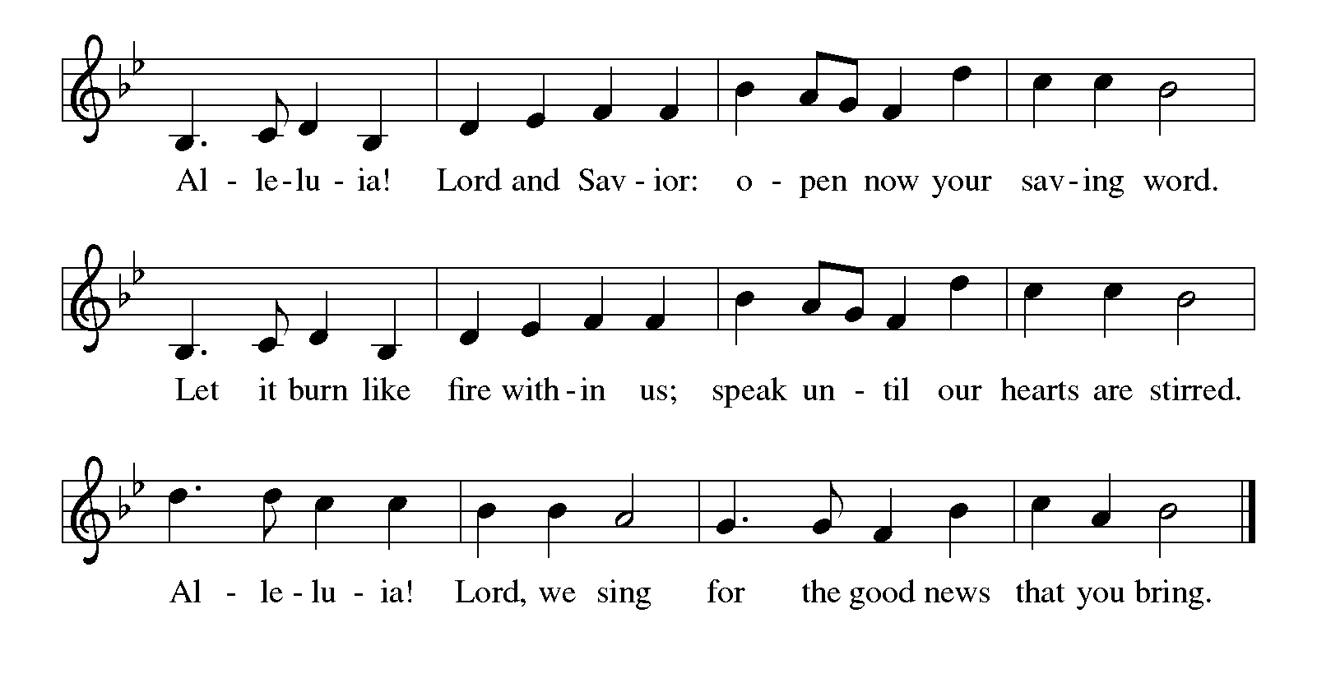

Gospel Matthew 5:1-12
The holy gospel according to Matthew.
Glory to You O Lord.
¹ When Jesus saw the crowds, he went up the mountain, and after he sat down, his disciples came to him. ² And he began to speak and taught them, saying:
³ “Blessed are the poor in spirit, for theirs is the kingdom of heaven.
⁴ “Blessed are those who mourn, for they will be comforted.
⁵ “Blessed are the meek, for they will inherit the earth.
⁶ “Blessed are those who hunger and thirst for righteousness, for they will be filled.
⁷ “Blessed are the merciful, for they will receive mercy.
⁸ “Blessed are the pure in heart, for they will see God.
⁹ “Blessed are the peacemakers, for they will be called children of God.
¹⁰ “Blessed are those who are persecuted for the sake of righteousness, for theirs is the kingdom of heaven.
¹¹ “Blessed are you when people revile you and persecute you and utter all kinds of evil against you falsely on my account. ¹² Rejoice and be glad, for your reward is great in heaven, for in the same way they persecuted the prophets who were before you.”

The gospel of the Lord.
Praise to you, O Christ.

CHILDREN’S MOMENT

SERMON Pastor Ken Scheck

hymn of the day “As We Gather at Your Table” #522

cREED
I believe in God, the Father almighty,
creator of heaven and earth.
I believe in Jesus Christ, God’s only Son, our Lord,
who was conceived by the Holy Spirit,
born of the virgin Mary,
suffered under Pontius Pilate,
was crucified, died, and was buried;
he descended to the dead.*
On the third day he rose again;
he ascended into heaven,
he is seated at the right hand of the Father,
and he will come to judge the living and the dead.
I believe in the Holy Spirit,
the holy catholic church,
the communion of saints,
the forgiveness of sins,
the resurrection of the body,
and the life everlasting. Amen.

*Or, “he descended into hell,” another translation of this text in widespread use.

prayers of Intercession
(Please Be Seated)
As God’s beloved children united in Christ, let us pray for the church, the whole human community, and the well-being of the earth, our home.
A brief silence.
God our wisdom, renew the church in the power of the Spirit, that it may do justice, love kindness, live humbly, and boldly proclaim Christ crucified. We pray for social justice and humanitarian aid ministries especially Bethany Lutheran in Northport, and their pastor Rev. Chrysanne Timm. Merciful God,
receive our prayer.
God our source, we honor you by caring wisely for your creation. We pray for the health of old growth forests, ice caps, and ocean currents. Preserve the diversity of life on earth. Merciful God,
receive our prayer.
God our righteousness, raise up visionary leaders who serve with integrity and respect human rights. Increase freedom in every nation. Protect educators, journalists, artists, and religious activists who are reviled for speaking truth. Merciful God,
receive our prayer.
God our advocate, you give hope to all who suffer because of persecution, poverty, or war. Reunite separated families and bring orphaned children to safety. Comfort any who grieve or suffer in any way.
Merciful God,
receive our prayer.
God our blessing, we pray for the children and youth of this congregation, and for parents, grandparents, mentors, teachers, and youth ministers who model love for their neighbor and care for others. Merciful God,
receive our prayer.
God our joy, we give thanks for the lives of those before us who journeyed humbly with you. Merciful God,
receive our prayer.
Confident that the Holy Spirit receives our prayers and answers us, we commend all for whom we pray to God’s loving-kindness made known to us in Christ Jesus our Savior.
Amen.

PEACE
The peace of Christ be with you always.
And also with you.

OFFERING & OFFERING SONG
The joy of the Lord is my strength,
The joy of the Lord is my strength,
The joy of the Lord is my strength,
The joy of the Lord is my strength.

Offering Prayer
Let us pray.
Holy God, gracious and merciful, you bring forth food from the earth and nourish your whole creation. Turn our hearts toward those who hunger in any way, that all may know your care; and prepare us now to feast on the bread of life, Jesus Christ, our Savior and Lord.
Amen.

DIALOGUE
The Lord be with you.
And also with you.
Lift up your hearts.
We lift them to the Lord.
Let us give thanks to the Lord our God.
It is right to give our thanks and praise.

PREFACE (Pastor)
It is indeed right, our duty and our joy,
that we should at all times and in all places
give thanks and praise to you, almighty and merciful God,
through our Savior Jesus Christ;
who on this day overcame death and the grave,
and by his glorious resurrection opened to us the way of everlasting life.
And so, with all the choirs of angels,
with the church on earth and the hosts of heaven,
we praise your name and join their unending hymn

holy, holy, holy
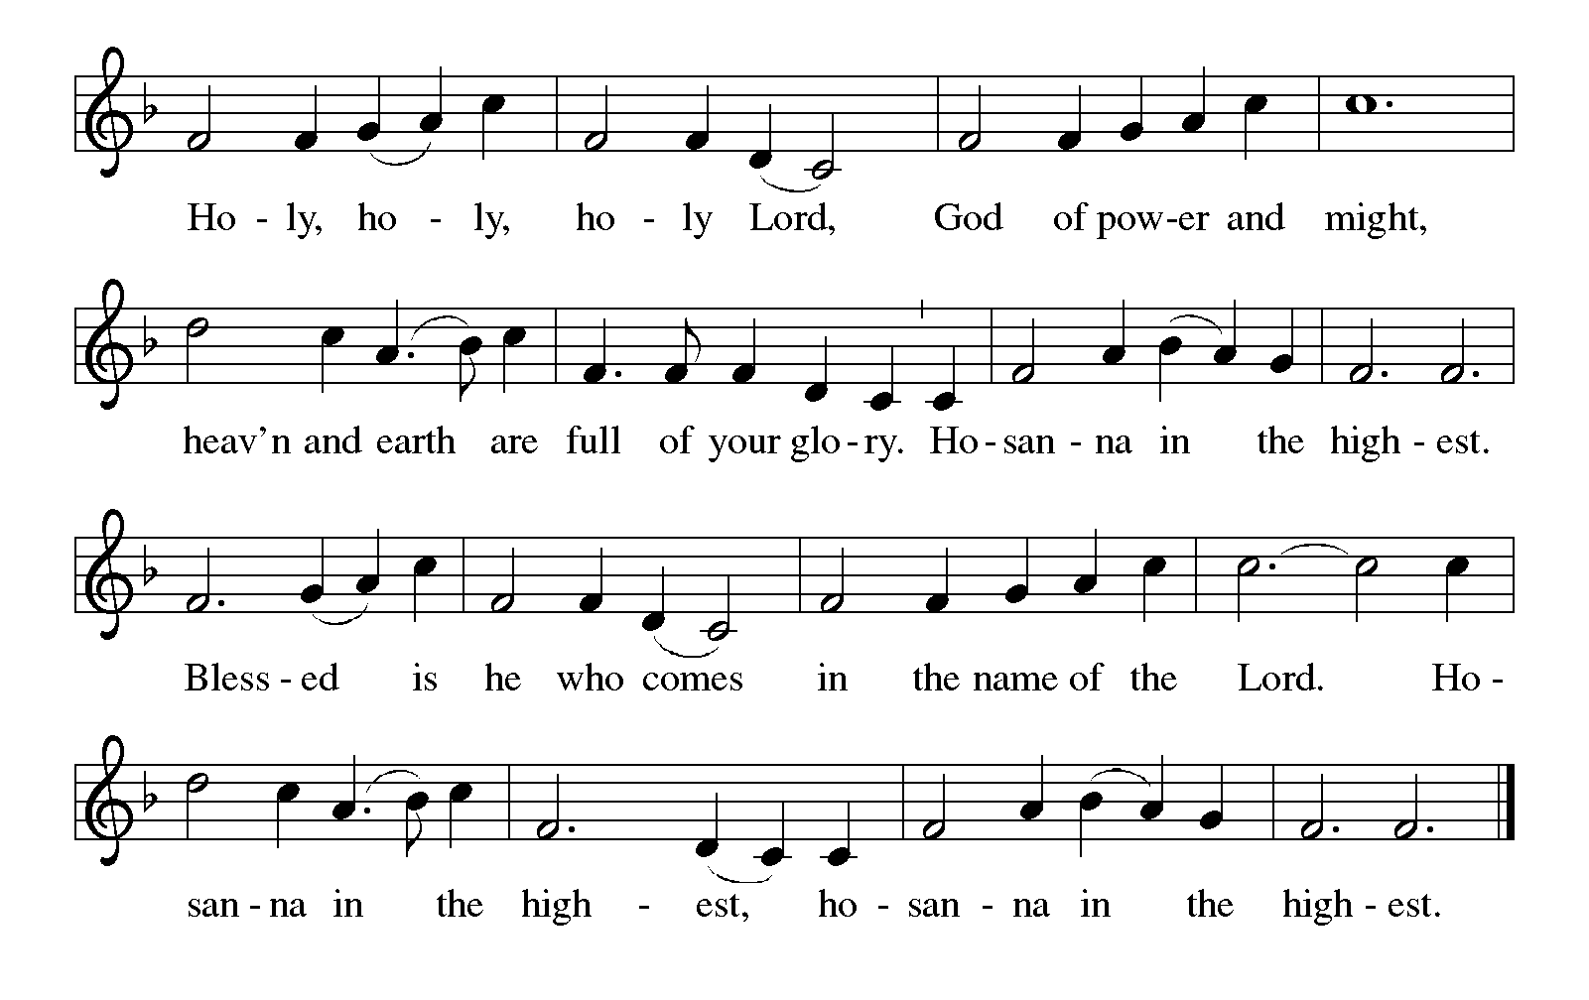

Thanksgiving at the Table
In the night in which he was betrayed,
our Lord Jesus took bread, and gave thanks;
broke it, and gave it to his disciples, saying:
Take and eat; this is my body, given for you.
Do this for the remembrance of me.

Again, after supper, he took the cup, gave thanks,
and gave it for all to drink, saying:
This cup is the new covenant in my blood,
shed for you and for all people for the forgiveness of sin.
Do this for the remembrance of me.

For as often as we eat of this bread and drink from this cup,
we proclaim the Lord’s death until he comes.

Lord’s Prayer
Gathered into one by the Holy Spirit, let us pray as Jesus taught us.
Our Father, who art in heaven,
hallowed be thy name,
thy kingdom come,
thy will be done,
on earth as it is in heaven.
Give us this day our daily bread;
and forgive us our trespasses,
as we forgive those
who trespass against us;
and lead us not into temptation,
but deliver us from evil.
For thine is the kingdom,
and the power, and the glory,
forever and ever. Amen.

INVITATION TO COMMUNION
Come to the banquet, for all is now ready.

COMMUNION *continuous
*People are welcome to kneel at the altar rail for a time of prayer after they receive their communion elements.

COMMUNION HYMNS
“O God of Mercy, God of Light” #714
“Come to the Table” #481
PRAYER AFTER COMMUNION
Let us pray.
We give you thanks, almighty God, that you have refreshed us through the healing power of this gift of life. In your mercy, strengthen us through this gift, in faith toward you and in fervent love toward one another; for the sake of Jesus Christ our Lord.
Amen.

Sending
God blesses us and sends us in mission to the world.

Blessing
The Lord bless you and keep you.
The Lord’s face shine on you with grace and mercy.
The Lord look upon you with favor and ☩ give you peace.
Amen.
Sending SonG “Rise Up, O Saints of God!” #669

Dismissal
Go in peace. Christ is with you.
Thanks be to God.
From sundaysandseasons.com. Copyright © 2017 Augsburg Fortress. All rights reserved.

Thank you to all who served in worship today!
Presiders: Pastor Ken Scheck Musician: Jayne Flanigan
Acolyte: Safety Person:
Elder: Dan Utterback Trustee: Mike Johnson
Offering Counters: Doug MacKenzie & Mike Johnson



PRAYERS OF THE FAITHFUL

With thanks for all God’s blessings and his love for all people. Our Bishops, Julie Schneider-Thomas, Yehiel Curry, and the congregations of the North/West Lower Michigan Synod, and especially Bethany Lutheran in Northport, and their pastor Rev. Chrysanne Timm.

Prayers for our friends, for all who are sick or hospitalized and for all health care workers who care for them. All those members of Zion’s family traveling; all those homebound or in frail health; all those suffering with quiet, unknown needs or worries. For those who serve on our behalf: public safety, utility workers, medical personnel, military personnel. For those who might be forgotten.

This week at Zion:
- Board of Evangelism, Tuesday 3rd at 6:30 at Martha's house
- Men’s Breakfast 8am, Wednesday 4th
- Bulletin Deadline, Wednesday 4th
- Board of Worship Planning, Thursday 5th at 4:00 pm at the Church

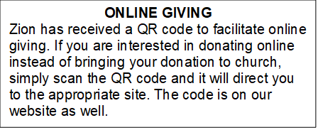

How to Contact the Pastor: If there is a pastoral need, please contact Pastor Ken Scheck II at 269-370-4632 or by email at kscheckii@aol.com.

ANNOUNCEMENT
- Pray Without Ceasing: Everyday there seems to be something new that needs our prayer! To help us have more time in prayer for people and events near and far, we are interested in restarting our special Pray Without Ceasing services. We are reaching out to learn if there is enough interest. One suggestion is to hold the services on Thursdays at 3:00 pm and also following worship on Sundays when there is no fellowship. There is a sheet on the table in the Narthex to indicate whether you are interested, if this day/time would work, or if you would suggest a different day and time. If you have questions, please see Martha.
- Seeking GOD’S Way: This Lent you are invited to journey with God. Come to our dinner and worships (7:00 pm after Ash Wednesday), as we Seek God’s Way. We will explore God’s MERCY, which is the heart of God. As we journey, we will find God’s PASSION for each of us. We will find that God’s LOVE is on the move, allowing us to realize the grace that is given to all creation. Even in hardship Christians know the gift of LIFE, as we walk with the knowledge of God’s care, allowing all of us to have JOY. Zion Dinners at 6:00 p.m. Wednesdays on February 25; March 4, 11, 18 and 25.
- Pastor’s Availability: Pastor Ken Scheck II is available by appointment to meet with you. As you know homebound visitation has begun and will continue until all homebound have been visited by Pastor Ken. Generally speaking, he is at Grace on Mondays and Wednesdays and Zion on Tuesdays and Thursdays with a day off on Friday. As you may be aware, Pastor Ken has come to the Men’s meeting and Lakewood Area Ministerial Association meetings on Wednesday here at Zion. Flexibility is the name of the game. He is more than willing to be contacted at any time by cellphone or email. Please feel free to contact him at 269-370-4632 or at kscheckii@aol.com. You are able to send a text to the cellphone, but please identify yourself at least the first time.
- Bring Your Palms: If you have palms at home from previous Palm Sunday services, please bring them to Zion. Pastor Ken will be burning them to use the ashes for the imposition of ashes at the Ash Wednesday Service on February 18th at 7:15 pm. There is a box for your palms in the Narthex.
- VISITATION COMMITTEE: The church council has approved the Board of Elders plans to form a Visitation Committee. This new committee will be supporting Pastor Ken by ensuring that our shut-ins have been contacted every month by phone call, cards, and a visit. Can you help? Sign-up sheet is on the table in the narthex indicating your interest in being part of this new ministry. There will be an organizational meeting soon to develop plans of this outreach. More information can be found in the February Newsletter or speak with one of the elders: Naomi, Buffy, and Dan.
- Pastor Ken's installation: Join us for Pastor Ken's installation service on March 22. Bishop Julie Schneider-Thomas will be here for the Sunday School hour, worship and a time of fellowship. Join us for this time of celebration.
- Shut-in Bags: The shut-in bags are in the fellowship hall and are ready to have treats, cards, symbols of Valentine's Day or any other goodies that would fit into them. There are 8 bags (6 singles and 2 couples). They will be there until Sunday, February 7th, then we need volunteers to take the bags to shut-ins. Thank you for your support of this ZLCW project.
- Acolyte Interest: Any youth interested in being an acolyte, please let an Elder (Naomi, Buffy and Dan) know. We will have an opportunity for training and then you can be on the schedule.
- Announcement and Newsletter Items: Please forward items for the bulletin announcements and the newsletter to the church email (Office@Zion.org). Please do not send items to people’s personal emails. Thank you.
- Door Locking Policy: Our door locking policy relies on having a volunteer(s) each Sunday to serve as the Safety Person of the Day. On Sundays where no one has volunteered, if someone arrives at church and is willing to be the Safety Person of the Day, we will follow the door locking policy. If no one steps forward to serve as the Safety Person of the Day, the doors will not be locked. Please consider volunteering for this important duty.

