ZION LUTHERAN CHURCH, WOODLAND, MI
Last Sunday After Epiphany February 15, 2026
*If you are listening in your car, please tune your radio to FM 87.7*
(Please silence your cell phones while in the sanctuary. Thank you.)


WELCOME AND ANNOUNCEMENTS

Gathering
The Holy Spirit calls us together as the people of God.

Confession and Forgiveness
In the name of the Father,
and of the ☩ Son,
and of the Holy Spirit.
Amen.

Almighty God, to whom all hearts are open, all desires known, and from whom no secrets are hid: cleanse the thoughts of our hearts by the inspiration of your Holy Spirit, that we may perfectly love you and worthily magnify your holy name, through Jesus Christ our Lord.
Amen.

Let us confess our sin in the presence of God and of one another. Most merciful God,
we confess that we are captive to sin and cannot free ourselves. We have sinned against you in thought, word, and deed, by what we have done and by what we have left undone. We have not loved you with our whole heart; we have not loved our neighbors as ourselves. For the sake of your Son, Jesus Christ, have mercy on us. Forgive us, renew us, and lead us, so that we may delight in your will and walk in your ways, to the glory of your holy name.
Amen.

God, who is rich in mercy, loved us even when we were dead in sin, and made us alive together with Christ. By grace you have been saved. In the name of ☩ Jesus Christ, your sins are forgiven. Almighty God strengthen you with power through the Holy Spirit, that Christ may live in your hearts through faith.
Amen.
Gathering Song “Beautiful Savior” #838

GREETING
The grace of our Lord Jesus Christ, the love of God, and the communion of the Holy Spirit be with you all.
And also with you.

Praise hymn: “This Little Light of Mine” All Stanzas
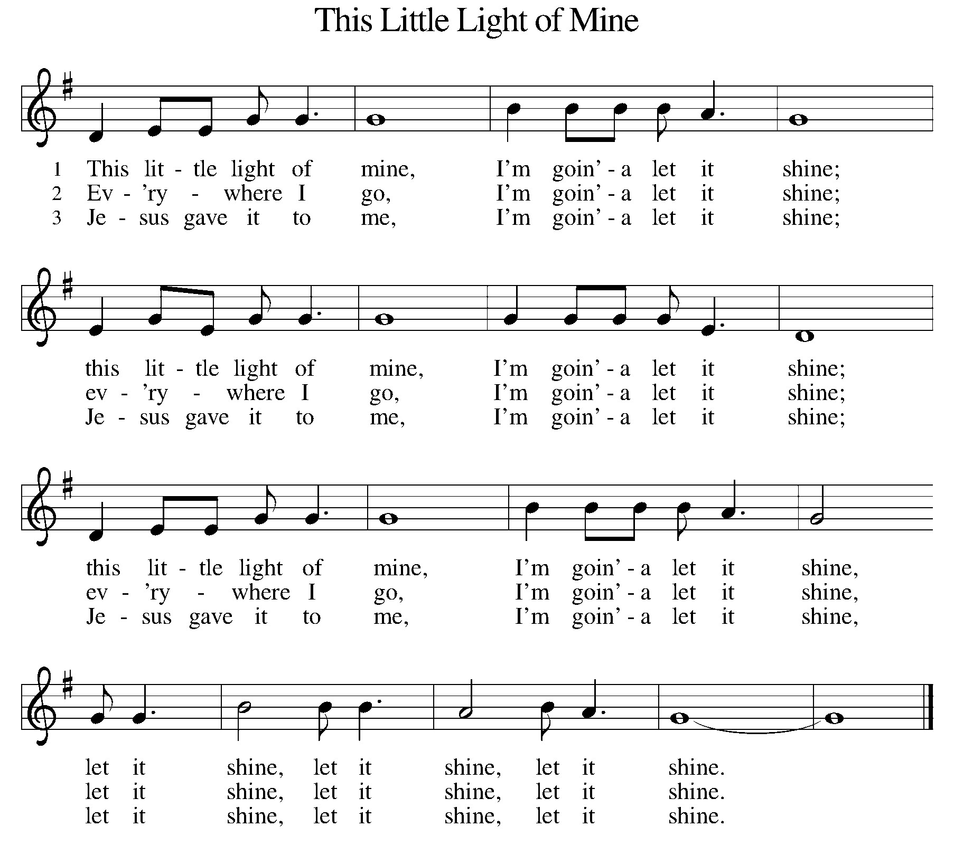

Prayer of the Day
Let us pray together.
O God, in the transfiguration of your Son you confirmed the mysteries of the faith by the witness of Moses and Elijah, and in the voice from the bright cloud declaring Jesus your beloved Son, you foreshadowed our adoption as your children. Make us heirs with Christ of your glory, and bring us to enjoy its fullness, through Jesus Christ, our Savior and Lord, who lives and reigns with you and the Holy Spirit, one God, now and forever.
Amen.

First Reading Exodus 24:12-18
A reading from Exodus.
¹² The Lord said to Moses, “Come up to me on the mountain and wait there; I will give you the tablets of stone, with the law and the commandment, which I have written for their instruction.” ¹³ So Moses set out with his assistant Joshua, and Moses went up onto the mountain of God. ¹⁴ To the elders he had said, “Wait here for us, until we come back to you. Look, Aaron and Hur are with you; whoever has a dispute may go to them.”
¹⁵ Then Moses went up on the mountain, and the cloud covered the mountain. ¹⁶ The glory of the Lord settled on Mount Sinai, and the cloud covered it for six days; on the seventh day he called to Moses out of the cloud. ¹⁷ Now the appearance of the glory of the Lord was like a devouring fire on the top of the mountain in the sight of the Israelites. ¹⁸ Moses entered the cloud and went up on the mountain. Moses was on the mountain for forty days and forty nights.
The word of the Lord.
Thanks be to God.

Psalm Psalm 99
The Lord is king; let the peoples tremble!
He sits enthroned upon the cherubim; let the earth quake!
² The Lord is great in Zion;
he is exalted over all the peoples.
³ Let them praise your great and awesome name.
Holy is he!
⁴ Mighty King, lover of justice,
you have established equity;
you have executed justice
and righteousness in Jacob.
⁵ Extol the Lord our God;
worship at his footstool.
Holy is he!
⁶ Moses and Aaron were among his priests,
Samuel also was among those who called on his name.
They cried to the Lord, and he answered them.
⁷ He spoke to them in the pillar of cloud;
they kept his decrees
and the statutes that he gave them.
⁸ O Lord our God, you answered them;
you were a forgiving God to them
but an avenger of their wrongdoings.
⁹ Extol the Lord our God,
and worship at his holy mountain,
for the Lord our God is holy.

Second Reading 2 Peter 1:16-21
A reading from 2 Peter.
¹⁶ We did not follow cleverly devised myths when we made known to you the power and coming of our Lord Jesus Christ, but we had been eyewitnesses of his majesty. ¹⁷ For he received honor and glory from God the Father when that voice was conveyed to him by the Majestic Glory, saying, “This is my Son, my Beloved, with whom I am well pleased.” ¹⁸ We ourselves heard this voice come from heaven, while we were with him on the holy mountain.
¹⁹ So we have the prophetic message more fully confirmed. You will do well to be attentive to this as to a lamp shining in a dark place, until the day dawns and the morning star rises in your hearts. ²⁰ First of all you must understand this, that no prophecy of scripture is a matter of one’s own interpretation, ²¹ because no prophecy ever came by human will, but men and women moved by the Holy Spirit spoke from God.
The Word of the Lord
Thanks be to God.

Gospel Acclamation

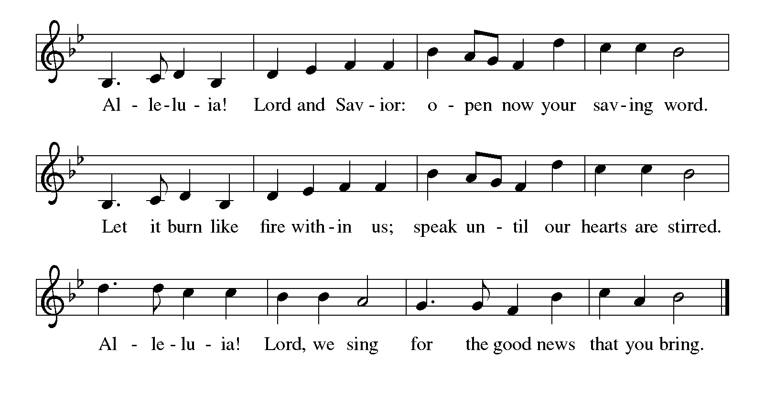

Gospel Matthew 17:1-9
The holy gospel according to Matthew.
Glory to You O Lord.

¹ Six days later, Jesus took with him Peter and James and his brother John and led them up a high mountain, by themselves. ² And he was transfigured before them, and his face shone like the sun, and his clothes became bright as light. ³ Suddenly there appeared to them Moses and Elijah, talking with him. ⁴ Then Peter said to Jesus, “Lord, it is good for us to be here; if you wish, I will set up three tents here, one for you, one for Moses, and one for Elijah.” ⁵ While he was still speaking, suddenly a bright cloud overshadowed them, and a voice from the cloud said, “This is my Son, the Beloved; with him I am well pleased; listen to him!” ⁶ When the disciples heard this, they fell to the ground and were overcome by fear. ⁷ But Jesus came and touched them, saying, “Get up and do not be afraid.” ⁸ And when they raised their eyes, they saw no one except Jesus himself alone.
⁹ As they were coming down the mountain, Jesus ordered them, “Tell no one about the vision until after the Son of Man has been raised from the dead.”

The gospel of the Lord.
Praise to you, O Christ.

CHILDREN’S MOMENT
SERMON Pastor Ken Scheck

hymn of the day “I Love To Tell The Story” #661

cREED
I believe in God, the Father almighty,
creator of heaven and earth.
I believe in Jesus Christ, God’s only Son, our Lord,
who was conceived by the Holy Spirit,
born of the virgin Mary,
suffered under Pontius Pilate,
was crucified, died, and was buried;
he descended to the dead.*
On the third day he rose again;
he ascended into heaven,
he is seated at the right hand of the Father,
and he will come to judge the living and the dead.
I believe in the Holy Spirit,
the holy catholic church,
the communion of saints,
the forgiveness of sins,
the resurrection of the body,
and the life everlasting. Amen.

*Or, “he descended into hell,” another translation of this text in widespread use.

prayers of Intercession
(Please Be Seated)
As God’s beloved children united in Christ, let us pray for the church, the whole human community, and the well-being of the earth, our home.
A brief silence.
Revealing God, your Spirit sustains the church. Strengthen the faithful with the revelation of Christ transfigured, that we may joyfully follow him in the way of the cross. We pray especially for Hope St. John’s in Oscoda, and their Supply Pastors. Merciful God,
receive our prayer.
Life-giving God, creation is full of your majesty. Nurture in us a deep respect for the interdependence of all life, and make us wise and vigilant stewards of your good earth. Merciful God,
receive our prayer.
Peacemaking God, the nations are in turmoil. We pray for an end to violent conflict.
Give wisdom to negotiators and sanctuary to refugees. Defend any who are in danger. Merciful God,
receive our prayer.
Healing God, you desire wholeness for all people. Bring healing to any who are experiencing illness, chronic pain, or mental anguish. Comfort the dying and those who grieve. Merciful God,
receive our prayer.
Holy God, in our worship we glimpse your glory, hear your voice, and receive assurance of your love. Inspire all who prepare, lead, and participate in worship to serve you with reverence and joy. Merciful God,
receive our prayer.
Transforming God, you bring life from death. We give thanks for the witness of those who have died in faith, and we praise you for the hope we have in Christ, our Morning Star. Merciful God,
receive our prayer.
Confident that the Holy Spirit receives our prayers and answers us, we commend all for whom we pray to God’s loving-kindness made known to us in Christ Jesus our Savior.
Amen.

PEACE
The peace of Christ be with you always.
And also with you.

OFFERING & OFFERING SONG
The joy of the Lord is my strength,
The joy of the Lord is my strength,
The joy of the Lord is my strength,
The joy of the Lord is my strength.

Offering Prayer
Let us pray.
Holy God, gracious and merciful, you bring forth food from the earth and nourish your whole creation. Turn our hearts toward those who hunger in any way, that all may know your care; and prepare us now to feast on the bread of life, Jesus Christ, our Savior and Lord.
Amen.

DIALOGUE
The Lord be with you.
And also with you.
Lift up your hearts.
We lift them to the Lord.
Let us give thanks to the Lord our God.
It is right to give our thanks and praise.

PREFACE (Pastor)
It is indeed right, our duty and our joy,
that we should at all times and in all places
give thanks and praise to you, almighty and merciful God,
through our Savior Jesus Christ;
who on this day overcame death and the grave,
and by his glorious resurrection opened to us the way of everlasting life.
And so, with all the choirs of angels,
with the church on earth and the hosts of heaven,
we praise your name and join their unending hymn

holy, holy, holy
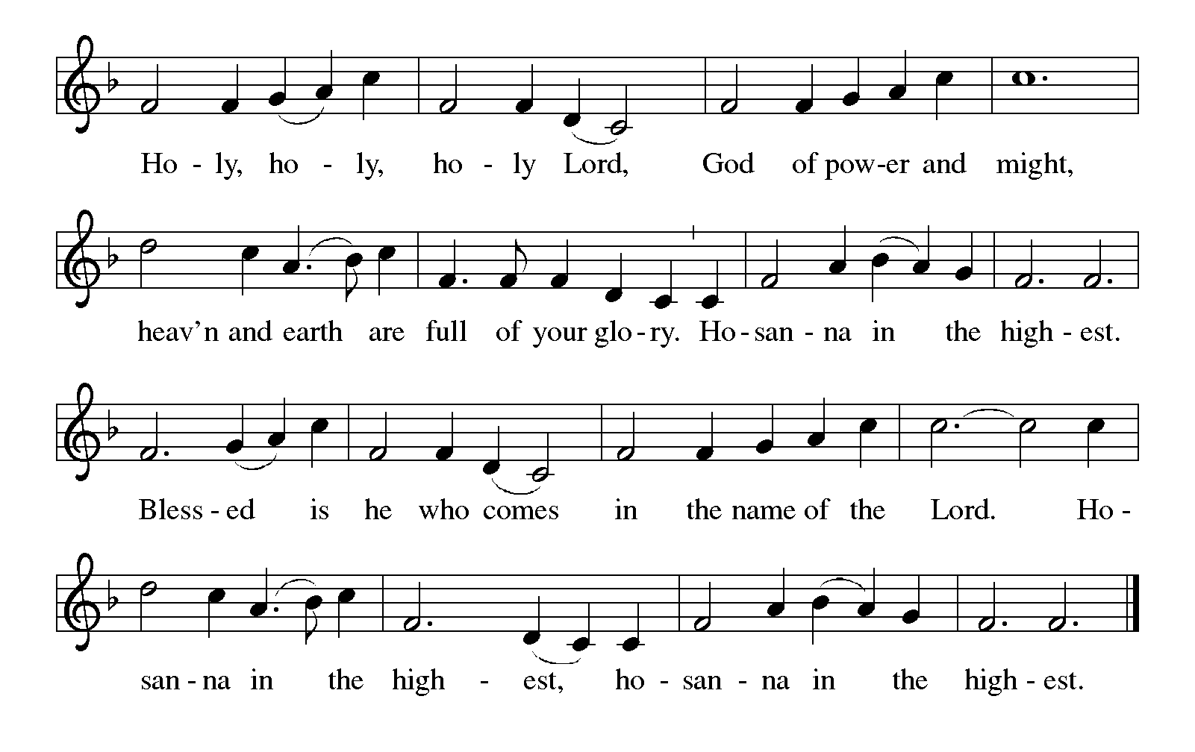

Thanksgiving at the Table
In the night in which he was betrayed,
our Lord Jesus took bread, and gave thanks;
broke it, and gave it to his disciples, saying:
Take and eat; this is my body, given for you.
Do this for the remembrance of me.

Again, after supper, he took the cup, gave thanks,
and gave it for all to drink, saying:
This cup is the new covenant in my blood,
shed for you and for all people for the forgiveness of sin.
Do this for the remembrance of me.

For as often as we eat of this bread and drink from this cup,
we proclaim the Lord’s death until he comes.

Lord’s Prayer
Gathered into one by the Holy Spirit, let us pray as Jesus taught us.
Our Father, who art in heaven,
hallowed be thy name,
thy kingdom come,
thy will be done,
on earth as it is in heaven.
Give us this day our daily bread;
and forgive us our trespasses,
as we forgive those
who trespass against us;
and lead us not into temptation,
but deliver us from evil.
For thine is the kingdom,
and the power, and the glory,
forever and ever. Amen.

INVITATION TO COMMUNION
Come to the banquet, for all is now ready.

COMMUNION *continuous
*People are welcome to kneel at the altar rail for a time of prayer after they receive their communion elements.

COMMUNION HYMNS
“Let Us Break Bread Together” #471
“Just As I Am” #592

PRAYER AFTER COMMUNION
Let us pray.
We give you thanks, almighty God, that you have refreshed us through the healing power of this gift of life. In your mercy, strengthen us through this gift, in faith toward you and in fervent love toward one another; for the sake of Jesus Christ our Lord.
Amen.

Sending
God blesses us and sends us in mission to the world.

Blessing
The Lord bless you and keep you.
The Lord’s face shine on you with grace and mercy.
The Lord look upon you with favor and ☩ give you peace.
Amen.
Sending SonG “Shine, Jesus, Shine” #671

Dismissal
Go in peace. Christ is with you.
Thanks be to God.
From sundaysandseasons.com. Copyright © 2017 Augsburg Fortress. All rights reserved.

Thank you to all who served in worship today!
Presiders: Pastor Ken Scheck Musician: Martha Yoder
Acolyte: Safety Person:
Elder: Naomi Wilson Trustee: Jimmy Hindman
Offering Counters: Diane Griffin & Carlotta Willard



PRAYERS OF THE FAITHFUL

With thanks for all God’s blessings and his love for all people. Our Bishops, Julie Schneider-Thomas, Yehiel Curry, and the congregations of the North/West Lower Michigan Synod, and especially Hope St. John’s in Oscoda, and their Supply Pastors.

Prayers for our friends, for all who are sick or hospitalized and for all health care workers who care for them. All those members of Zion’s family traveling; all those homebound or in frail health; all those suffering with quiet, unknown needs or worries. For those who serve on our behalf: public safety, utility workers, medical personnel, military personnel. For those who might be forgotten.

This week at Zion:
- Men’s Breakfast 8am, Wednesday 18th
- Bulletin Deadline, Wednesday 18th
- Newsletter Deadline, Thursday 19th

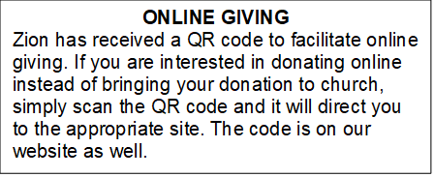

How to Contact the Pastor: If there is a pastoral need, please contact Pastor Ken Scheck II at 269-370-4632 or by email at kscheckii@aol.com.

ANNOUNCEMENT
- Notice of Special Congregational Meeting: There will be a special congregational meeting on March 1st immediately following worship. This meeting is to review and vote on a recommendation from council to have carpeting installed in the fireside lounge, the front and back entryway basement landings, and two classrooms. Please plan to attend this important meeting.If you have questions, please see one of the trustees or Paul.
- Thank you, Zion! Zion received a letter from Rachel Wind, Executive for Development, ELCA, thanking us for our gift of $750 to the ELCA Good Gifts ministry. "As a church, we are empowered to love and serve our neighbors as Christ first loved us. Your gifts to the ministries of the ELCA help people around the world feel the power and hope that flow from God's full, boundless love...Thank you for your gracious gifts. You make God's love real." Thank you to everyone who generously gave to this special ministry!
- Manna's Market Annual Meijer Simply Giving Program: Starting this week, we will be kicking off our annual collection for Manna's Market to use during the Meijer Simply Giving shopping opportunity. As you may recall, each year Meijer provides specific dates for food pantries to shop and receive a double bonus. That means a $100 donation becomes $300 in buying power. Last year Zion contributed $1,344 for $4,032 in buying power. The Board of Evangelism met this week and set a goal of $1,500 for Manna's this year. If we reach our goal, we will provide them with $4,500 in buying power! You may donate through your offering envelope or the container on the table in the Narthex. Manna's Market serves all of Barry County and the communities of Lakewood School District in Eaton and Ionia counties. They provide food, clothing, personal care, and baby pantry items. Our collection will continue through March 15th for Manna's to use on their March 21st purchasing date. Let's help fil the pantry!
- Provisions for the Homeless: Do you encounter people who look in need when we are out and about and wish that you had something to give them to help? The Board of Evangelism would like to equip Zion members to help those they encounter who look in need by gathering needed items and putting together bags that members can take to distribute. Watch for a display in the Fellowship Hall and a "shopping list" that you can use to help purchase items for the bags. If you have questions, please see any Evangelism Board member.
- Pray Without Ceasing: Everyday there seems to be something new that needs our prayer! To help us have more time in prayer for people and events near and far, we are interested in restarting our special Pray Without Ceasing services. We are reaching out to learn if there is enough interest. One suggestion is to hold the services on Thursdays at 3:00 pm and also following worship on Sundays when there is no fellowship. There is a sheet on the table in the Narthex to indicate whether you are interested, if this day/time would work, or if you would suggest a different day and time. If you have questions, please see Martha.
- Seeking GOD’S Way: This Lent you are invited to journey with God. Come to our dinner and worships (7:00 pm after Ash Wednesday), as we Seek God’s Way. We will explore God’s MERCY, which is the heart of God. As we journey, we will find God’s PASSION for each of us. We will find that God’s LOVE is on the move, allowing us to realize the grace that is given to all creation. Even in hardship Christians know the gift of LIFE, as we walk with the knowledge of God’s care, allowing all of us to have JOY. Zion Dinners at 6:00 p.m. Wednesdays on February 25; March 4, 11, 18 and 25.
- Pastor’s Availability: Pastor Ken Scheck II is available by appointment to meet with you. As you know homebound visitation has begun and will continue until all homebound have been visited by Pastor Ken. Generally speaking, he is at Grace on Mondays and Wednesdays and Zion on Tuesdays and Thursdays with a day off on Friday. As you may be aware, Pastor Ken has come to the Men’s meeting and Lakewood Area Ministerial Association meetings on Wednesday here at Zion. Flexibility is the name of the game. He is more than willing to be contacted at any time by cellphone or email. Please feel free to contact him at 269-370-4632 or at kscheckii@aol.com. You are able to send a text to the cellphone, but please identify yourself at least the first time.
- Pastor Ken's installation: Join us for Pastor Ken's installation service on March 22. Bishop Julie Schneider-Thomas will be here for the Sunday School hour, worship and a time of fellowship. Join us for this time of celebration.
- Acolyte Interest: Any youth interested in being an acolyte, please let an Elder (Naomi, Buffy and Dan) know. We will have an opportunity for training and then you can be on the schedule.
- Announcement and Newsletter Items: Please forward items for the bulletin announcements and the newsletter to the church email (Office@Zion.org). Please do not send items to people’s personal emails. Thank you.
- Door Locking Policy: Our door locking policy relies on having a volunteer(s) each Sunday to serve as the Safety Person of the Day. On Sundays where no one has volunteered, if someone arrives at church and is willing to be the Safety Person of the Day, we will follow the door locking policy. If no one steps forward to serve as the Safety Person of the Day, the doors will not be locked. Please consider volunteering for this important duty.

