ZION LUTHERAN CHURCH, WOODLAND, MI
First Sunday in Lent February 22, 2026
*If you are listening in your car, please tune your radio to FM 87.7*
(Please silence your cell phones while in the sanctuary. Thank you.)

WELCOME AND ANNOUNCEMENTS

Gathering
The Holy Spirit calls us together as the people of God.

Confession and Forgiveness
In the name of the Father,
and of the ☩ Son,
and of the Holy Spirit.
Amen.

Almighty God, to whom all hearts are open, all desires known, and from whom no secrets are hid: cleanse the thoughts of our hearts by the inspiration of your Holy Spirit, that we may perfectly love you and worthily magnify your holy name, through Jesus Christ our Lord.
Amen.

Let us confess our sin in the presence of God and of one another. Most merciful God,
we confess that we are captive to sin and cannot free ourselves. We have sinned against you in thought, word, and deed, by what we have done and by what we have left undone. We have not loved you with our whole heart; we have not loved our neighbors as ourselves. For the sake of your Son, Jesus Christ, have mercy on us. Forgive us, renew us, and lead us, so that we may delight in your will and walk in your ways, to the glory of your holy name.
Amen.

God, who is rich in mercy, loved us even when we were dead in sin, and made us alive together with Christ. By grace you have been saved. In the name of ☩ Jesus Christ, your sins are forgiven. Almighty God strengthen you with power through the Holy Spirit, that Christ may live in your hearts through faith. Amen.
Gathering Song “O Lord, throughout These Forty Days” #319

GREETING
The grace of our Lord Jesus Christ, the love of God, and the communion of the Holy Spirit be with you all.
And also with you.

Praise hymn: “Kyrie Eleison”

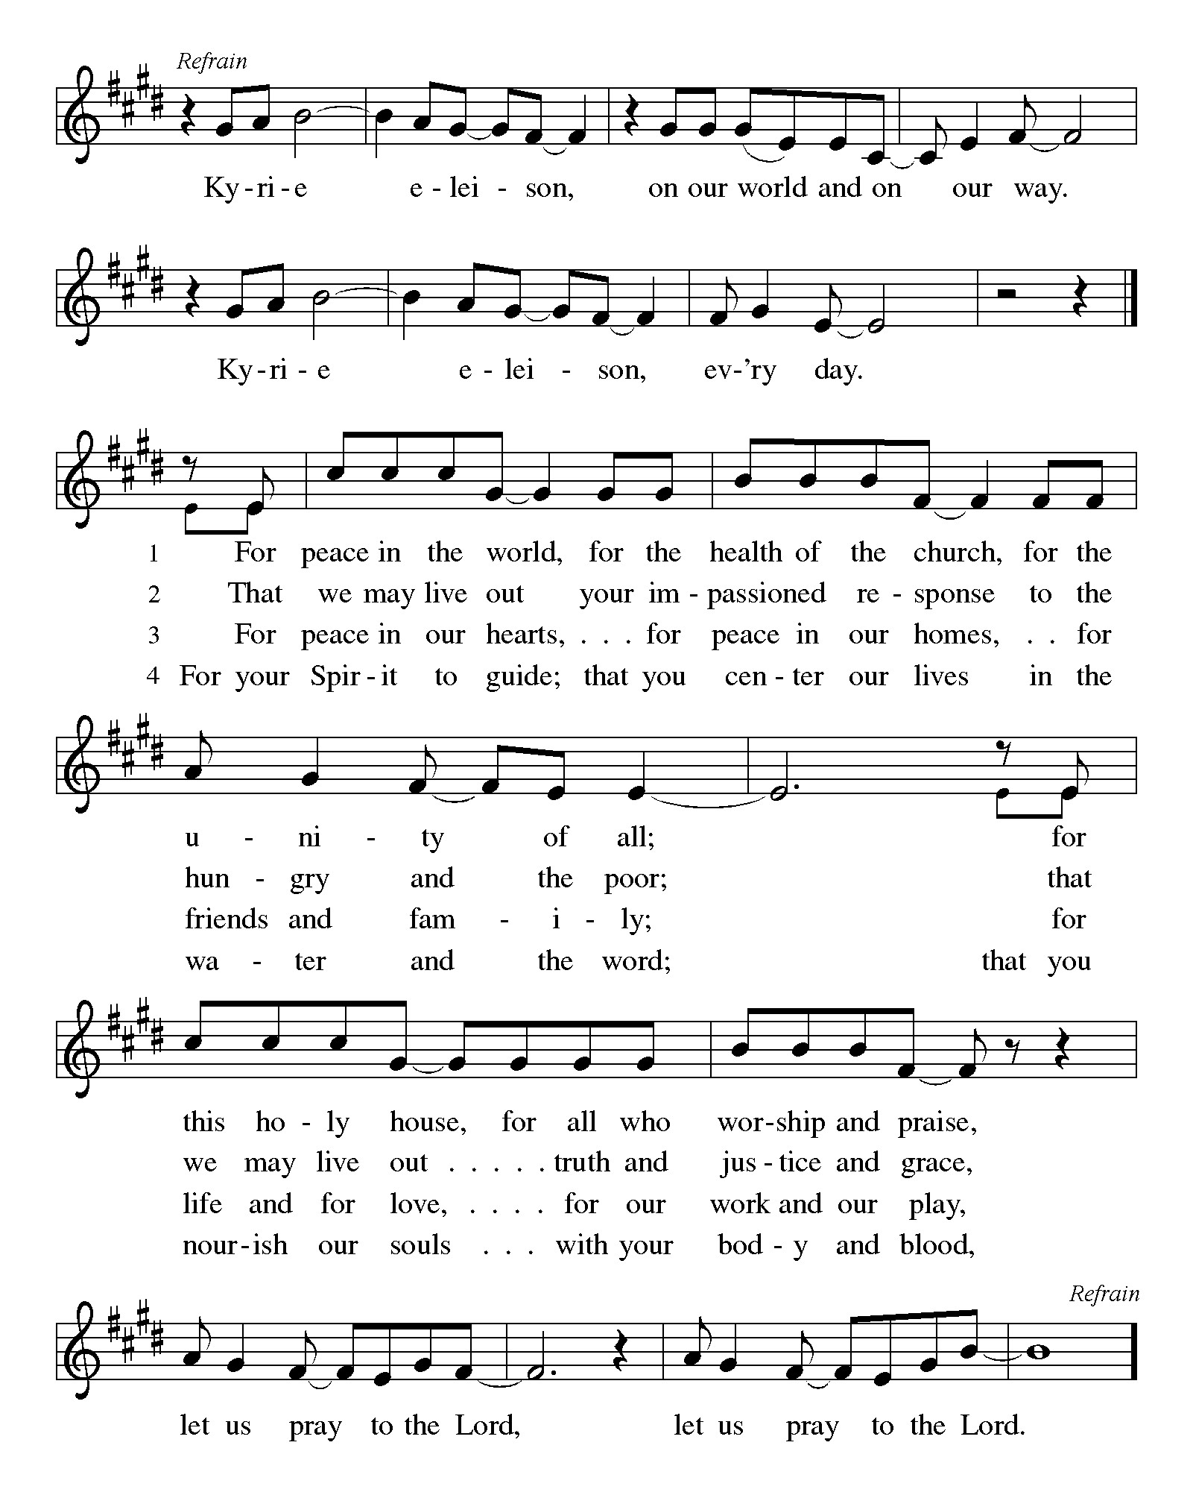

Prayer of the Day
Let us pray together.
Lord God, our strength, the struggle between good and evil rages within and around us, and the devil and all the forces that defy you tempt us with empty promises. Keep us steadfast in your word, and when we fall, raise us again and restore us through your Son, Jesus Christ, our Savior and Lord, who lives and reigns with you and the Holy Spirit, one God, now and forever. Amen.

First Reading Genesis 2:15-17; 3:1-7
A reading from Genesis.

¹⁵ The Lord God took the man and put him in the garden of Eden to till it and keep it. ¹⁶ And the Lord God commanded the man, “You may freely eat of every tree of the garden, ¹⁷ but of the tree of the knowledge of good and evil you shall not eat, for in the day that you eat of it you shall die.”
^{3:1} Now the serpent was more crafty than any other wild animal that the Lord God had made. He said to the woman, “Did God say, ‘You shall not eat from any tree in the garden’?” ² The woman said to the serpent, “We may eat of the fruit of the trees in the garden, ³ but God said, ‘You shall not eat of the fruit of the tree that is in the middle of the garden, nor shall you touch it, or you shall die.’ ” ⁴ But the serpent said to the woman, “You will not die, ⁵ for God knows that when you eat of it your eyes will be opened, and you will be like God, knowing good and evil.” ⁶ So when the woman saw that the tree was good for food and that it was a delight to the eyes and that the tree was to be desired to make one wise, she took of its fruit and ate, and she also gave some to her husband, who was with her, and he ate. ⁷ Then the eyes of both were opened, and they knew that they were naked, and they sewed fig leaves together and made loincloths for themselves.
The word of the Lord.
Thanks be to God.

Psalm Psalm 32
The Lord is king; let the peoples tremble!
¹ Happy are they whose transgressions | are forgiven,
and whose sin is | put away!
² Happy are they to whom the Lord im- | putes no guilt,
and in whose spirit there | is no guile!
³ While I held my tongue, my bones with- | ered away,
because of my groaning | all day long.
⁴ For your hand was heavy upon me | day and night;
my moisture was dried up as in the | heat of summer.
⁵ Then I acknowledged my sin to you, and did not con- | ceal my guilt.
I said, “I will confess my transgressions to the Lord.” Then you forgave me the guilt | of my sin.
⁶ Therefore all the faithful will make their prayers to you in | time of trouble;
when the great waters overflow, they | shall not reach them.
⁷ You are my hiding-place; you preserve | me from trouble;
you surround me with shouts | of deliverance.
⁸ “I will instruct you and teach you in the way that | you should go;
I will guide you | with my eye.
⁹ Do not be like horse or mule, which have no | understanding;
who must be fitted with bit and bridle, or else they will | not stay near you.”
¹⁰ Great are the tribulations | of the wicked;
but mercy embraces those who trust | in the Lord.
¹¹ Be glad, you righteous, and rejoice | in the Lord;
shout for joy, all who are | true of heart.

Second Reading Romans 5:12-19
A reading from Romans.
¹² Just as sin came into the world through one man, and death came through sin, and so death spread to all because all have sinned ¹³ for sin was indeed in the world before the law, but sin is not reckoned when there is no law. ¹⁴ Yet death reigned from Adam to Moses, even over those who did not sin in the likeness of Adam, who is a pattern of the one who was to come.
¹⁵ But the free gift is not like the trespass. For if the many died through the one man’s trespass, much more surely have the grace of God and the gift in the grace of the one man, Jesus Christ, abounded for the many. ¹⁶ And the gift is not like the effect of the one man’s sin. For the judgment following one trespass brought condemnation, but the gift following many trespasses brings justification. ¹⁷ If, because of the one man’s trespass, death reigned through that one, much more surely will those who receive the abundance of grace and the gift of righteousness reign in life through the one man, Jesus Christ.
¹⁸ Therefore just as one man’s trespass led to condemnation for all, so one man’s act of righteousness leads to justification and life for all. ¹⁹ For just as through the one man’s disobedience the many were made sinners, so through the one man’s obedience the many will be made righteous.

The Word of the Lord
Thanks be to God.

Gospel Acclamation

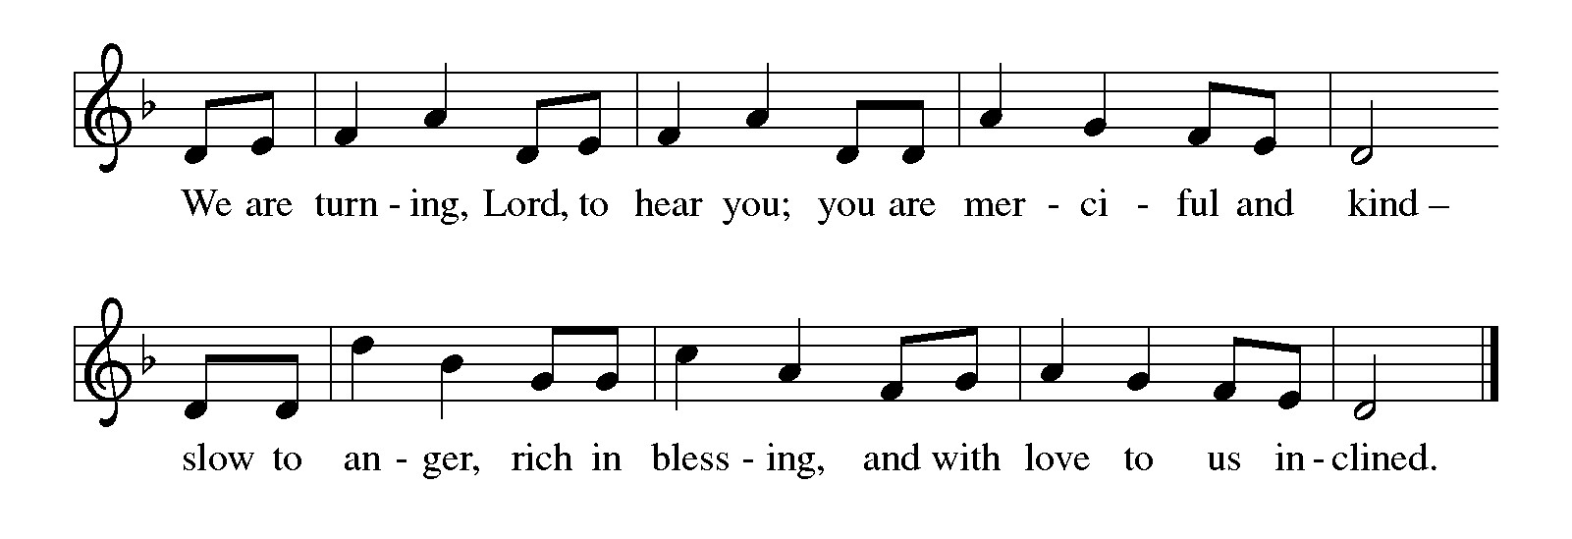

Gospel Matthew 4:1-11
The holy gospel according to Matthew.
Glory to You O Lord.
¹ Jesus was led up by the Spirit into the wilderness to be tested by the devil. ² He fasted forty days and forty nights, and afterward he was famished. ³ The tempter came and said to him, “If you are the Son of God, command these stones to become loaves of bread.” ⁴ But he answered, “It is written,
‘One does not live by bread alone,
but by every word that comes from the mouth of God.’ ”
⁵ Then the devil took him to the holy city and placed him on the pinnacle of the temple, ⁶ saying to him, “If you are the Son of God, throw yourself down, for it is written,
‘He will command his angels concerning you,’
and ‘On their hands they will bear you up,
so that you will not dash your foot against a stone.’ ”
⁷ Jesus said to him, “Again it is written, ‘Do not put the Lord your God to the test.’ ”
⁸ Again, the devil took him to a very high mountain and showed him all the kingdoms of the world and their glory, ⁹ and he said to him, “All these I will give you, if you will fall down and worship me.” ¹⁰ Then Jesus said to him, “Away with you, Satan! for it is written,
‘Worship the Lord your God,
and serve only him.’ ”
¹¹ Then the devil left him, and suddenly angels came and waited on him.

The gospel of the Lord.
Praise to you, O Christ.

CHILDREN’S MOMENT
SERMON Pastor Ken Scheck

hymn of the day “A Mighty Fortress Is Our God” #504

prayers of Intercession
(Please Be Seated)
Reconciled by God’s mercy and sustained by God’s presence, let us pray for the world and its needs.
A brief silence.
God of all grace, grant faith to your church. Give to all the baptized the will to resist temptation and to worship and serve you alone. Hear us, O God.
Your mercy is great.
God of all creation, tend this earth. When human greed and disobedience threaten this planet and the life it contains, lead us by your Spirit into ways of reverence, awe, and gentleness. Hear us, O God.
Your mercy is great.
God of all nations, preserve us from trouble. Surround all living in places of violence with your steadfast love and give resilience to all who work for peace. Grant courage to those who challenge, especially around issues of racism and systemic oppression. Hear us, O God.
Your mercy is great.
God of all healing, mend our wounds. Bring wholeness to all who are sick, give peace to all who groan in grief, and send companions to all who are lonely or isolated. We pray for all those on our prayer list and those in our heart. We pray for all countries involved in ongoing conflicts and all who are affected by natural disasters.
Hear us, O God.
Your mercy is great.
God of all people, provide for our community. For any among us who hunger for bread, bring nourishment. For any among us who hunger for truth, speak your life-giving word. Hear us, O God.
Your mercy is great.
God of all life, bring us to you. We thank you for your free and abounding grace, and for those who, by that same grace, now rest eternally in you (especially). Hear us, O God.
Your mercy is great.
Receive our prayers, O God, through Jesus Christ, our strength and salvation.
Amen.

PEACE
The peace of Christ be with you always.
And also with you.

OFFERING & OFFERING SONG
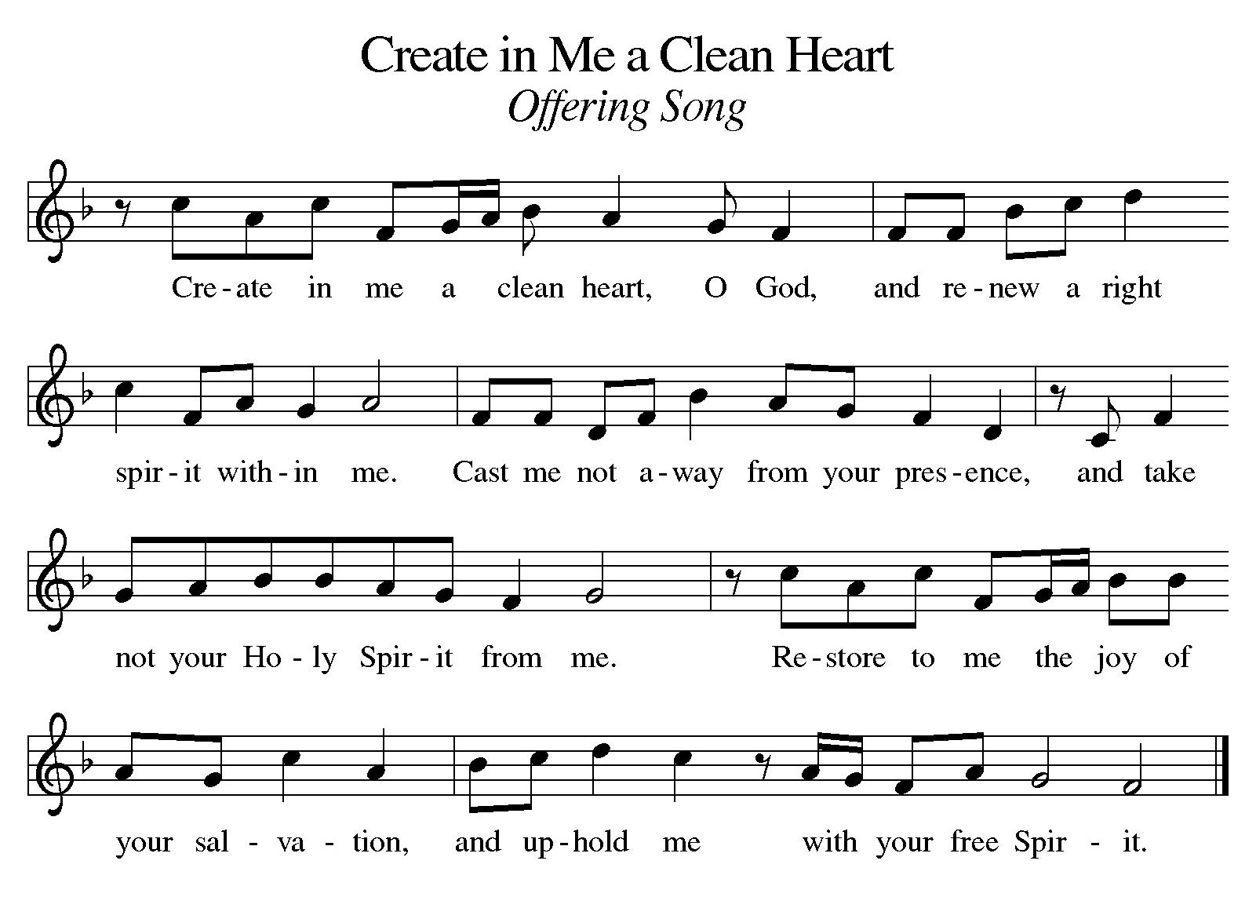

Offering Prayer
Let us pray.
Holy God, gracious and merciful, you bring forth food from the earth and nourish your whole creation. Turn our hearts toward those who hunger in any way, that all may know your care; and prepare us now to feast on the bread of life, Jesus Christ, our Savior and Lord.
Amen.

DIALOGUE
The Lord be with you.
And also with you.
Lift up your hearts.
We lift them to the Lord.
Let us give thanks to the Lord our God.
It is right to give our thanks and praise.

PREFACE (Pastor)
It is indeed right, our duty and our joy,
that we should at all times and in all places
give thanks and praise to you, almighty and merciful God,
through our Savior Jesus Christ;
who on this day overcame death and the grave,
and by his glorious resurrection opened to us the way of everlasting life.
And so, with all the choirs of angels,
with the church on earth and the hosts of heaven,
we praise your name and join their unending hymn

holy, holy, holy
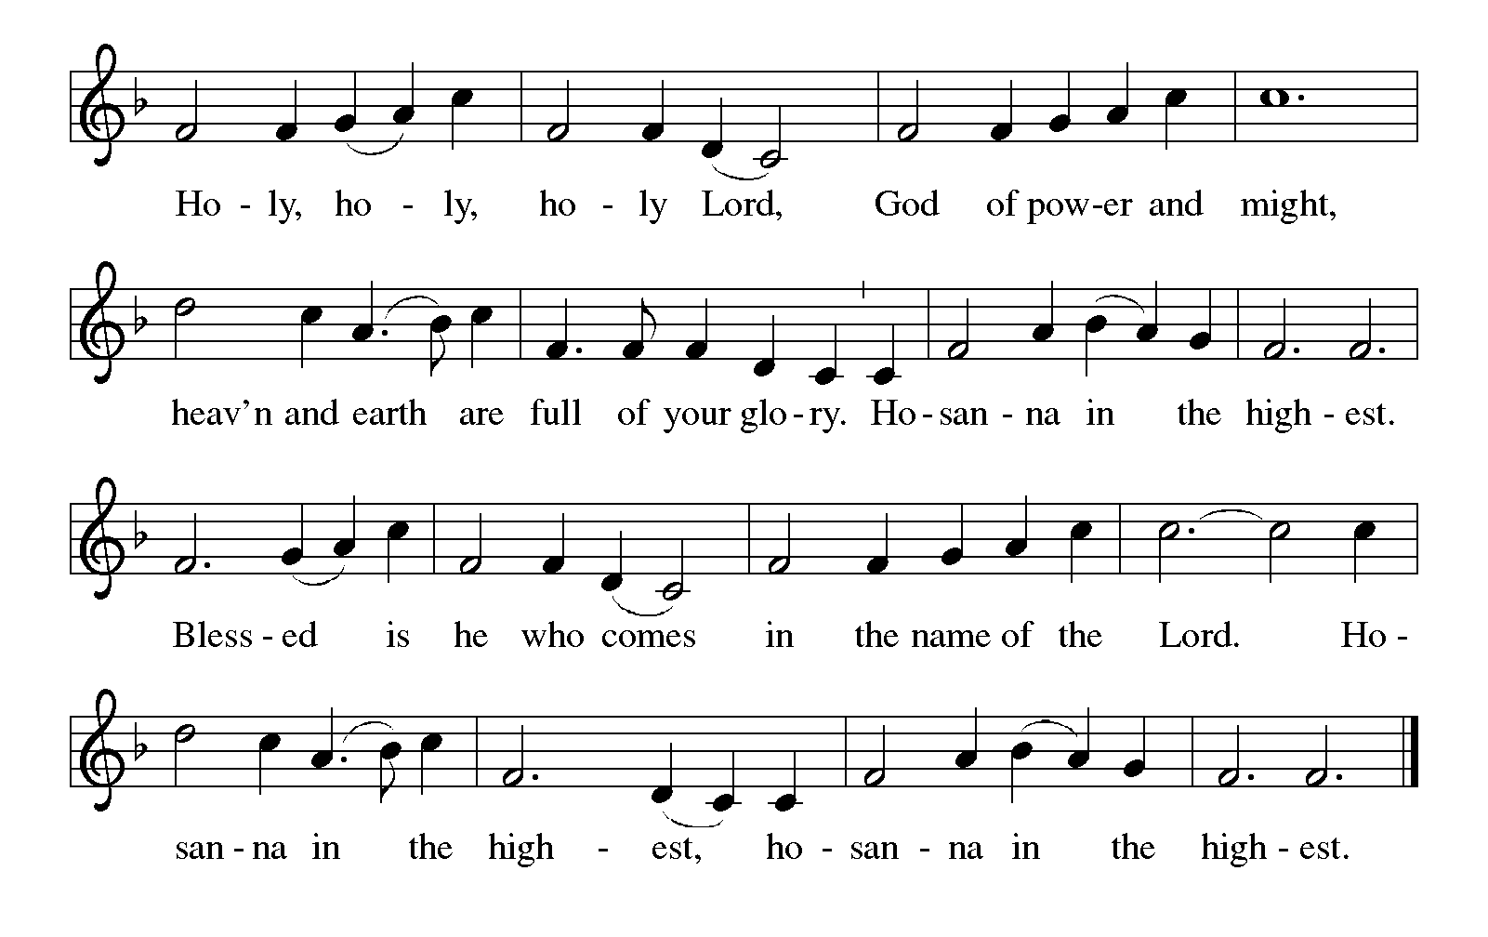

Thanksgiving at the Table
In the night in which he was betrayed,
our Lord Jesus took bread, and gave thanks;
broke it, and gave it to his disciples, saying:
Take and eat; this is my body, given for you.
Do this for the remembrance of me.

Again, after supper, he took the cup, gave thanks,
and gave it for all to drink, saying:
This cup is the new covenant in my blood,
shed for you and for all people for the forgiveness of sin.
Do this for the remembrance of me.

For as often as we eat of this bread and drink from this cup,
we proclaim the Lord’s death until he comes.

Lord’s Prayer
Gathered into one by the Holy Spirit, let us pray as Jesus taught us.
Our Father, who art in heaven,
hallowed be thy name,
thy kingdom come,
thy will be done,
on earth as it is in heaven.
Give us this day our daily bread;
and forgive us our trespasses,
as we forgive those
who trespass against us;
and lead us not into temptation,
but deliver us from evil.
For thine is the kingdom,
and the power, and the glory,
forever and ever. Amen.

INVITATION TO COMMUNION
Come to the banquet, for all is now ready.

COMMUNION *continuous
*People are welcome to kneel at the altar rail for a time of prayer after they receive their communion elements.

COMMUNION HYMNS
“I Want Jesus to Walk with Me” #325
“Lord Jesus, Think on Me” #599

PRAYER AFTER COMMUNION
Let us pray.
We give you thanks, almighty God, that you have refreshed us through the healing power of this gift of life. In your mercy, strengthen us through this gift, in faith toward you and in fervent love toward one another; for the sake of Jesus Christ our Lord.
Amen.

Sending
God blesses us and sends us in mission to the world.

Blessing
The Lord bless you and keep you.
The Lord’s face shine on you with grace and mercy.
The Lord look upon you with favor and ☩ give you peace.
Amen.

Sending SonG “Jesus, Still Lead On” #624

Dismissal
Go in peace. Christ is with you.
Thanks be to God.
From sundaysandseasons.com. Copyright © 2017 Augsburg Fortress. All rights reserved.

Thank you to all who served in worship today!
Presiders: Pastor Ken Scheck Musician: Jayne Flanigan
Acolyte: Safety Person:
Elder: Buffy Meyers Trustee: Mike Johnson
Offering Counters: Paul Meade & Carlotta Willard



PRAYERS OF THE FAITHFUL

With thanks for all God’s blessings and his love for all people. Our Bishops, Julie Schneider-Thomas, Yehiel Curry, and the congregations of the North/West Lower Michigan Synod, and especially Cross of Christ Lutheran Church, and their pastor Rev. Sherry McGuffin.

Prayers for our friends, for all who are sick or hospitalized and for all health care workers who care for them. All those members of Zion’s family traveling; all those homebound or in frail health; all those suffering with quiet, unknown needs or worries. For those who serve on our behalf: public safety, utility workers, medical personnel, military personnel. For those who might be forgotten.

This week at Zion:
- Men’s Breakfast 8am, Wednesday 25th
- Bulletin Deadline, Wednesday 25th
- Lenten Supper 6 pm, Lenten Service 7:15 pm, Wednesday 25th
- Bell Ringing & Prayer, 1 pm, Saturday 28th

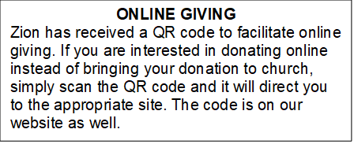

How to Contact the Pastor: If there is a pastoral need, please contact Pastor Ken Scheck II at 269-370-4632 or by email at kscheckii@aol.com.

ANNOUNCEMENTS
- Notice of Special Congregational Meeting: There will be a special congregational meeting on March 1st immediately following worship. This meeting is to review and vote on a recommendation from council to have carpeting installed in the fireside lounge, the front and back entryway basement landings, and two classrooms. Please plan to attend this important meeting.If you have questions, please see one of the trustees or Paul.
- First-Aid Supplies for Synod Mission Trip to Honduras: Our synod’s mission trip to Honduras in April supports the “Health for Life” ministry. This project promotes healthy living by educating health volunteers and by increasing access to life’s basis needs. Our synod has been asked to conduct training on basic first-aid and health. They will be training and equipping volunteers who will help those in their communities. We can help by providing first-aid supplies and donations for this ministry. There is a “shopping list” on the table in the narthex. Please consider supporting our synod team that includes Pastor Mike Anderson and Vicki.
- Pray Without Ceasing: Everyday there seems to be something new that needs our prayer! To help us have more time in prayer for people and events near and far, we are interested in restarting our special Pray Without Ceasing services. We are reaching out to learn if there is enough interest. One suggestion is to hold the services on Thursdays at 3:00 pm and also following worship on Sundays when there is no fellowship. There is a sheet on the table in the Narthex to indicate whether you are interested, if this day/time would work, or if you would suggest a different day and time. If you have questions, please see Martha.
- Seeking GOD’S Way: This Lent you are invited to journey with God. Come to our dinner and worships (7:00 pm after Ash Wednesday), as we Seek God’s Way. We will explore God’s MERCY, which is the heart of God. As we journey, we will find God’s PASSION for each of us. We will find that God’s LOVE is on the move, allowing us to realize the grace that is given to all creation. Even in hardship Christians know the gift of LIFE, as we walk with the knowledge of God’s care, allowing all of us to have JOY. Zion Dinners at 6:00 p.m. Wednesdays on February 25; March 4, 11, 18 and 25.
- Pastor’s Availability: Pastor Ken Scheck II is available by appointment to meet with you. As you know homebound visitation has begun and will continue until all homebound have been visited by Pastor Ken. Generally speaking, he is at Grace on Mondays and Wednesdays and Zion on Tuesdays and Thursdays with a day off on Friday. As you may be aware, Pastor Ken has come to the Men’s meeting and Lakewood Area Ministerial Association meetings on Wednesday here at Zion. Flexibility is the name of the game. He is more than willing to be contacted at any time by cellphone or email. Please feel free to contact him at 269-370-4632 or at kscheckii@aol.com. You are able to send a text to the cellphone, but please identify yourself at least the first time.
- Pastor Ken's installation: Join us for Pastor Ken's installation service on March 22. Bishop Julie Schneider-Thomas will be here for the Sunday School hour, worship and a time of fellowship. Join us for this time of celebration.
- Save the Date: Mark your calendar for April 19th! We will be hosting an open house for Pastor Ken and inviting the community to come, have lunch with us, and meet our Pastor. Watch for more details!
- Announcement and Newsletter Items: Please forward items for the bulletin announcements and the newsletter to the church email (Office@Zion.org). Please do not send items to people’s personal emails. Thank you.
- Door Locking Policy: Our door locking policy relies on having a volunteer(s) each Sunday to serve as the Safety Person of the Day. On Sundays where no one has volunteered, if someone arrives at church and is willing to be the Safety Person of the Day, we will follow the door locking policy. If no one steps forward to serve as the Safety Person of the Day, the doors will not be locked. Please consider volunteering for this important duty.
- Annual Easter Egg Hunt for Zion’s Kids: The Parish Board will be sponsoring an Easter Egg Hunt for our kiddos on Palm Sunday, March 29th. We are asking for donations of candy, trinkets, coins or other kid friendly items that will fit into our plastic Easter eggs. Please put donations in the box marked for these donations in the Fellowship Hall by March 22nd. We want to thank the congregation for their continued support for this event for our Sunday School kids.
- Service for Jerry Engle and Thank You: My family and I want to thank you all for the prayers, kind messages, cards, calls and gifts of food and other items since the time of Jerry's passing. These kindnesses are greatly appreciated. Jerry's celebration of life service will be at Zion on Saturday, April 11th. Visitation will begin at 10:00 with the service at 11:00. We will have time to share stories of Jerry at the lunch, prepared and served by our church family, in the Fellowship Hall immediately following the service. --- Carol Engle and family
- Join us for Lent: The theme for our first Lenten service is MERCY: The Heart of God. The Soup/Salad Supper starts at 6 pm, come when you can. The service follows at 7:15 pm. (You can come to the service only if the

