ZION LUTHERAN CHURCH, WOODLAND, MI
Fifth Sunday After Epiphany February 8, 2026
*If you are listening in your car, please tune your radio to FM 87.7*
(Please silence your cell phones while in the sanctuary. Thank you.)


WELCOME AND ANNOUNCEMENTS

Gathering
The Holy Spirit calls us together as the people of God.

Confession and Forgiveness
In the name of the Father,
and of the ☩ Son,
and of the Holy Spirit.
Amen.

Almighty God, to whom all hearts are open, all desires known, and from whom no secrets are hid: cleanse the thoughts of our hearts by the inspiration of your Holy Spirit, that we may perfectly love you and worthily magnify your holy name, through Jesus Christ our Lord.
Amen.

Let us confess our sin in the presence of God and of one another. Most merciful God,
we confess that we are captive to sin and cannot free ourselves. We have sinned against you in thought, word, and deed, by what we have done and by what we have left undone. We have not loved you with our whole heart; we have not loved our neighbors as ourselves. For the sake of your Son, Jesus Christ, have mercy on us. Forgive us, renew us, and lead us, so that we may delight in your will and walk in your ways, to the glory of your holy name.
Amen.

God, who is rich in mercy, loved us even when we were dead in sin, and made us alive together with Christ. By grace you have been saved. In the name of ☩ Jesus Christ, your sins are forgiven. Almighty God strengthen you with power through the Holy Spirit, that Christ may live in your hearts through faith.
Amen.
Gathering Song “Gather Us In” #532

GREETING
The grace of our Lord Jesus Christ, the love of God, and the communion of the Holy Spirit be with you all.
And also with you.

Praise hymn: “This Little Light of Mine” Stanzas 1 and 2

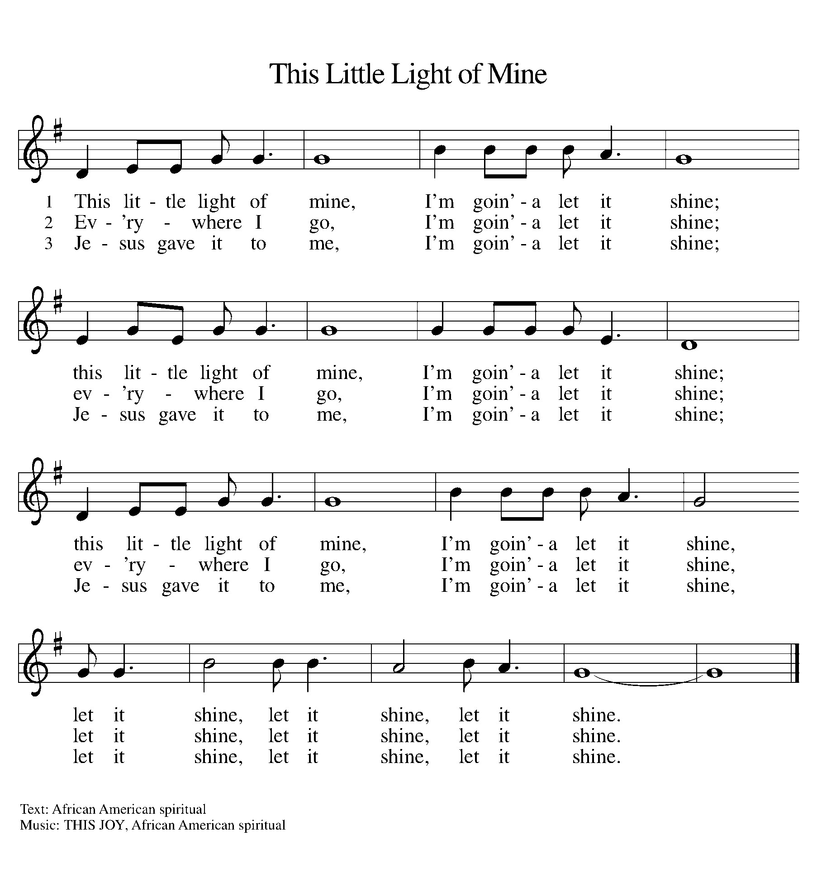

Prayer of the Day
Let us pray together.
Lord God, with endless mercy you receive the prayers of all who call upon you. By your Spirit show us the things we ought to do, and give us the grace and power to do them, through Jesus Christ, our Savior and Lord.
Amen.

First Reading Isaiah 58:1-9a
A reading from Isaiah.

¹ Shout out; do not hold back!
Lift up your voice like a trumpet!
Announce to my people their rebellion,
to the house of Jacob their sins.
² Yet day after day they seek me
and delight to know my ways,
as if they were a nation that practiced righteousness
and did not forsake the ordinance of their God;
they ask of me righteous judgments;
they want God on their side.
³ “Why do we fast, but you do not see?
Why humble ourselves, but you do not notice?”
Look, you serve your own interest on your fast day
and oppress all your workers.
⁴ You fast only to quarrel and to fight
and to strike with a wicked fist.
Such fasting as you do today
will not make your voice heard on high.
⁵ Is such the fast that I choose,
a day to humble oneself?
Is it to bow down the head like a bulrush
and to lie in sackcloth and ashes?
Will you call this a fast,
a day acceptable to the Lord?
⁶ Is not this the fast that I choose:
to loose the bonds of injustice,
to undo the straps of the yoke,
to let the oppressed go free,
and to break every yoke?
⁷ Is it not to share your bread with the hungry
and bring the homeless poor into your house;
when you see the naked, to cover them
and not to hide yourself from your own kin?
⁸ Then your light shall break forth like the dawn,
and your healing shall spring up quickly;
your vindicator shall go before you;
the glory of the Lord shall be your rear guard.
^{9a} Then you shall call, and the Lord will answer;
you shall cry for help, and he will say, “Here I am.”
The word of the Lord.
Thanks be to God.

Psalm Psalm 112:1-9
¹ Hallelujah! Happy are they who | fear the Lord
and have great delight in | God’s commandments!
² Their descendants will be mighty | in the land;
the generation of the upright | will be blessed.
³ Wealth and riches will be | in their house,
and their righteousness will | last forever.
⁴ Light shines in the darkness | for the upright;
the righteous are merciful and full | of compassion.
⁵ It is good for them to be gener- | ous in lending
and to manage their af- | fairs with justice.
⁶ For they will nev- | er be shaken;
the righteous will be kept in everlast- | ing remembrance.
⁷ They will not be afraid of any | evil rumors;
their heart is steadfast, trusting | in the Lord.
⁸ Their heart is established and | will not shrink,
until they see their desire up- | on their enemies.
⁹ They have given freely to the poor, and their righteousness stands | fast forever;
they will hold up their | head with honor.

Second Reading 1 Corinthians 2:1-12
A reading from 1 Corinthians.
¹ When I came to you, brothers and sisters, I did not come proclaiming the testimony of God to you with superior speech or wisdom. ² For I decided to know nothing among you except Jesus Christ and him crucified. ³ And I came to you in weakness and in fear and in much trembling. ⁴ My speech and my proclamation were made not with persuasive words of wisdom but with a demonstration of the Spirit and of power, ⁵ so that your faith might rest not on human wisdom but on the power of God.
⁶ Yet among the mature we do speak wisdom, though it is not a wisdom of this age or of the rulers of this age, who are being destroyed. ⁷ But we speak God’s wisdom, a hidden mystery, which God decreed before the ages for our glory ⁸ and which none of the rulers of this age understood, for if they had, they would not have crucified the Lord of glory. ⁹ But, as it is written,
“What no eye has seen, nor ear heard,
nor the human heart conceived,
what God has prepared for those who love him”—
¹⁰ God has revealed to us through the Spirit, for the Spirit searches everything, even the depths of God. ¹¹ For what human knows what is truly human except the human spirit that is within? So also no one comprehends what is truly God’s except the Spirit of God. ¹² Now we have received not the spirit of the world but the Spirit that is from God, so that we may understand the gifts bestowed on us by God.
The Word of the Lord
Thanks be to God.

Gospel Acclamation

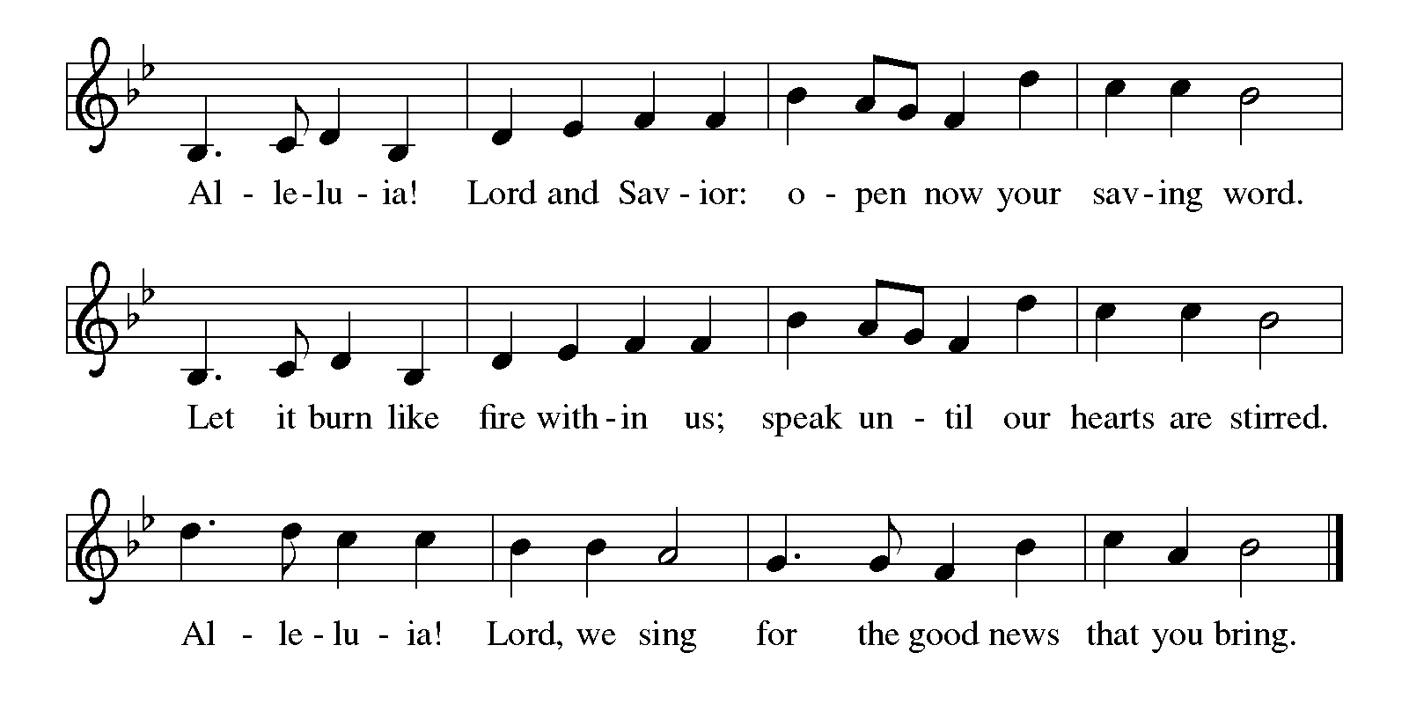

Gospel Matthew 5:13-20

The holy gospel according to Matthew.
Glory to You O Lord.
¹³ “You are the salt of the earth, but if salt has lost its taste, how can its saltiness be restored? It is no longer good for anything but is thrown out and trampled under foot.
¹⁴ “You are the light of the world. A city built on a hill cannot be hid. ¹⁵ People do not light a lamp and put it under the bushel basket; rather, they put it on the lampstand, and it gives light to all in the house. ¹⁶ In the same way, let your light shine before others, so that they may see your good works and give glory to your Father in heaven.
¹⁷ “Do not think that I have come to abolish the Law or the Prophets; I have come not to abolish but to fulfill. ¹⁸ For truly I tell you, until heaven and earth pass away, not one letter, not one stroke of a letter, will pass from the law until all is accomplished. ¹⁹ Therefore, whoever breaks one of the least of these commandments and teaches others to do the same will be called least in the kingdom of heaven, but whoever does them and teaches them will be called great in the kingdom of heaven. ²⁰ For I tell you, unless your righteousness exceeds that of the scribes and Pharisees, you will never enter the kingdom of heaven.”
The gospel of the Lord.
Praise to you, O Christ.

CHILDREN’S MOMENT

SERMON Pastor Ken Scheck

hymn of the day “Christ Be Our Light” #715

cREED
I believe in God, the Father almighty,
creator of heaven and earth.
I believe in Jesus Christ, God’s only Son, our Lord,
who was conceived by the Holy Spirit,
born of the virgin Mary,
suffered under Pontius Pilate,
was crucified, died, and was buried;
he descended to the dead.*
On the third day he rose again;
he ascended into heaven,
he is seated at the right hand of the Father,
and he will come to judge the living and the dead.
I believe in the Holy Spirit,
the holy catholic church,
the communion of saints,
the forgiveness of sins,
the resurrection of the body,
and the life everlasting. Amen.

*Or, “he descended into hell,” another translation of this text in widespread use.

prayers of Intercession
(Please Be Seated)
As God’s beloved children united in Christ, let us pray for the church, the whole human community, and the well-being of the earth, our home.
A brief silence.
Your church does ministry in many and various ways. Keep the baptized true to the mind of Christ, that our works and witness bring hope to a troubled world. We pray especially Faith Lutheran Church in Okemos and their pastor Rev. Megan Floyd.
Merciful God,
receive our prayer.
Your marvelous creation cries out to you. Restore polluted air, soil, and water sources to wholeness. Guard honeybees, elephants, great whales and songbirds from harm, and renew the face of the earth. Merciful God,
receive our prayer.
Your people in every nation suffer injustice, poverty, and the threat of violence. Guide those in authority to govern with compassion, and bring peace to war zones. We pray for our enemies. Merciful God,
receive our prayer.
Your blessings are poured out for all in need. Help and heal any who experience trauma, discrimination, disease, hunger, abuse, or persecution. Comfort those who are sick or grieving.
Merciful God,
receive our prayer.
Your wisdom guides this congregation and its ministries. Sustain our ordained leaders, staff, lay leaders, and volunteers. Form us to be salt and light for the neighbors we serve, following the example of Christ. Merciful God,
receive our prayer.
Your saints rejoice at your heavenly banquet. We give thanks for their lives of faith, trusting that we also will be embraced by your eternal love. Merciful God,
receive our prayer.
Confident that the Holy Spirit receives our prayers and answers us, we commend all for whom we pray to God’s loving-kindness made known to us in Christ Jesus our Savior.
Amen.

PEACE
The peace of Christ be with you always.
And also with you.

OFFERING & OFFERING SONG
The joy of the Lord is my strength,
The joy of the Lord is my strength,
The joy of the Lord is my strength,
The joy of the Lord is my strength.

Offering Prayer
Let us pray.
Holy God, gracious and merciful, you bring forth food from the earth and nourish your whole creation. Turn our hearts toward those who hunger in any way, that all may know your care; and prepare us now to feast on the bread of life, Jesus Christ, our Savior and Lord.
Amen.

DIALOGUE
The Lord be with you.
And also with you.
Lift up your hearts.
We lift them to the Lord.
Let us give thanks to the Lord our God.
It is right to give our thanks and praise.

PREFACE (Pastor)
It is indeed right, our duty and our joy,
that we should at all times and in all places
give thanks and praise to you, almighty and merciful God,
through our Savior Jesus Christ;
who on this day overcame death and the grave,
and by his glorious resurrection opened to us the way of everlasting life.
And so, with all the choirs of angels,
with the church on earth and the hosts of heaven,
we praise your name and join their unending hymn

holy, holy, holy
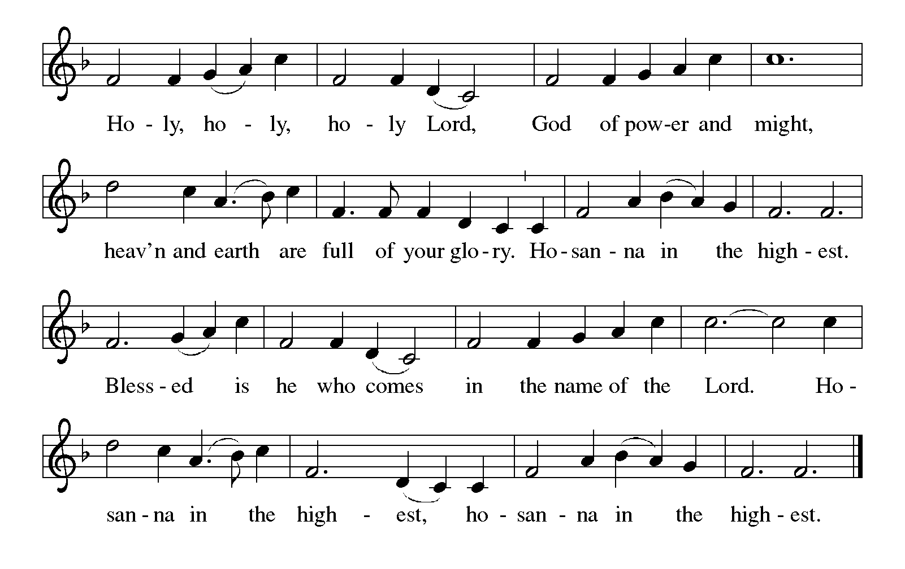

Thanksgiving at the Table
In the night in which he was betrayed,
our Lord Jesus took bread, and gave thanks;
broke it, and gave it to his disciples, saying:
Take and eat; this is my body, given for you.
Do this for the remembrance of me.

Again, after supper, he took the cup, gave thanks,
and gave it for all to drink, saying:
This cup is the new covenant in my blood,
shed for you and for all people for the forgiveness of sin.
Do this for the remembrance of me.

For as often as we eat of this bread and drink from this cup,
we proclaim the Lord’s death until he comes.

Lord’s Prayer
Gathered into one by the Holy Spirit, let us pray as Jesus taught us.
Our Father, who art in heaven,
hallowed be thy name,
thy kingdom come,
thy will be done,
on earth as it is in heaven.
Give us this day our daily bread;
and forgive us our trespasses,
as we forgive those
who trespass against us;
and lead us not into temptation,
but deliver us from evil.
For thine is the kingdom,
and the power, and the glory,
forever and ever. Amen.

INVITATION TO COMMUNION
Come to the banquet, for all is now ready.

COMMUNION *continuous
*People are welcome to kneel at the altar rail for a time of prayer after they receive their communion elements.

COMMUNION HYMNS
“Let Justice Flow like Streams” #717
“Jesus Loves Me!” #595
PRAYER AFTER COMMUNION
Let us pray.
We give you thanks, almighty God, that you have refreshed us through the healing power of this gift of life. In your mercy, strengthen us through this gift, in faith toward you and in fervent love toward one another; for the sake of Jesus Christ our Lord.
Amen.

Sending
God blesses us and sends us in mission to the world.

Blessing
The Lord bless you and keep you.
The Lord’s face shine on you with grace and mercy.
The Lord look upon you with favor and ☩ give you peace.
Amen.
Sending SonG “Make Me A Channel Of Your Peace”

Dismissal
Go in peace. Christ is with you.
Thanks be to God.
From sundaysandseasons.com. Copyright © 2017 Augsburg Fortress. All rights reserved.

Thank you to all who served in worship today!
Presiders: Pastor Ken Scheck Musician: Martha Yoder
Acolyte: Safety Person:
Elder: Dan Utterback Trustee: Doug MacKenzie
Offering Counters: Mary Makley & Martha Yoder



PRAYERS OF THE FAITHFUL

With thanks for all God’s blessings and his love for all people. Our Bishops, Julie Schneider-Thomas, Yehiel Curry, and the congregations of the North/West Lower Michigan Synod, and especially Faith Lutheran Church in Okemos and their pastor Rev. Megan Floyd.

Prayers for our friends, for all who are sick or hospitalized and for all health care workers who care for them. All those members of Zion’s family traveling; all those homebound or in frail health; all those suffering with quiet, unknown needs or worries. For those who serve on our behalf: public safety, utility workers, medical personnel, military personnel. For those who might be forgotten. We pray especially for the family of Jerry Engle, the Bursley family, Cliff and Karen Byington, Terry Cotter, Lee Starks, Phil Walsh, Dave Makley, Linden and Judy Fisher, Karen Knight, Evelyn Brecheisen, Ed Markwart, Gloria Anderson, Brent and Natalie Merrit and family, Wayne Hazel, Armani Morado, Larry Duda, Cindy Utterback, Alice Morrow, Jeff Engle, Arlene Forman, Chloe Makley, Erik Anderson, Cort Zylstra, and all countries involved in ongoing conflicts.

This week at Zion:
- Men’s Breakfast 8am, Wednesday 11th
- Bulletin Deadline, Wednesday 11th

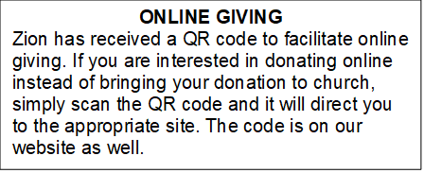

How to Contact the Pastor: If there is a pastoral need, please contact Pastor Ken Scheck II at 269-370-4632 or by email at kscheckii@aol.com.

ANNOUNCEMENT
- Thank you, Zion! Zion received a letter from Rachel Wind, Executive for Development, ELCA, thanking us for our gift of $750 to the ELCA Good Gifts ministry. "As a church, we are empowered to love and serve our neighbors as Christ first loved us. Your gifts to the ministries of the ELCA help people around the world feel the power and hope that flow from God's full, boundless love...Thank you for your gracious gifts. You make God's love real." Thank you to everyone who generously gave to this special ministry!
- Manna's Market Annual Meijer Simply Giving Program: Starting this week, we will be kicking off our annual collection for Manna's Market to use during the Meijer Simply Giving shopping opportunity. As you may recall, each year Meijer provides specific dates for food pantries to shop and receive a double bonus. That means a $100 donation becomes $300 in buying power. Last year Zion contributed $1,344 for $4,032 in buying power. The Board of Evangelism met this week and set a goal of $1,500 for Manna's this year. If we reach our goal, we will provide them with $4,500 in buying power! You may donate through your offering envelope or the container on the table in the Narthex. Manna's Market serves all of Barry County and the communities of Lakewood School District in Eaton and Ionia counties. They provide food, clothing, personal care, and baby pantry items. Our collection will continue through March 15th for Manna's to use on their March 21st purchasing date. Let's help fil the pantry!
- Provisions for the Homeless: Do you encounter people who look in need when we are out and about and wish that you had something to give them to help? The Board of Evangelism would like to equip Zion members to help those they encounter who look in need by gathering needed items and putting together bags that members can take to distribute. Watch for a display in the Fellowship Hall and a "shopping list" that you can use to help purchase items for the bags. If you have questions, please see any Evangelism Board member.
- Pray Without Ceasing: Everyday there seems to be something new that needs our prayer! To help us have more time in prayer for people and events near and far, we are interested in restarting our special Pray Without Ceasing services. We are reaching out to learn if there is enough interest. One suggestion is to hold the services on Thursdays at 3:00 pm and also following worship on Sundays when there is no fellowship. There is a sheet on the table in the Narthex to indicate whether you are interested, if this day/time would work, or if you would suggest a different day and time. If you have questions, please see Martha.
- Seeking GOD’S Way: This Lent you are invited to journey with God. Come to our dinner and worships (7:00 pm after Ash Wednesday), as we Seek God’s Way. We will explore God’s MERCY, which is the heart of God. As we journey, we will find God’s PASSION for each of us. We will find that God’s LOVE is on the move, allowing us to realize the grace that is given to all creation. Even in hardship Christians know the gift of LIFE, as we walk with the knowledge of God’s care, allowing all of us to have JOY. Zion Dinners at 6:00 p.m. Wednesdays on February 25; March 4, 11, 18 and 25.
- Pastor’s Availability: Pastor Ken Scheck II is available by appointment to meet with you. As you know homebound visitation has begun and will continue until all homebound have been visited by Pastor Ken. Generally speaking, he is at Grace on Mondays and Wednesdays and Zion on Tuesdays and Thursdays with a day off on Friday. As you may be aware, Pastor Ken has come to the Men’s meeting and Lakewood Area Ministerial Association meetings on Wednesday here at Zion. Flexibility is the name of the game. He is more than willing to be contacted at any time by cellphone or email. Please feel free to contact him at 269-370-4632 or at kscheckii@aol.com. You are able to send a text to the cellphone, but please identify yourself at least the first time.
- Bring Your Palms: If you have palms at home from previous Palm Sunday services, please bring them to Zion. Pastor Ken will be burning them to use the ashes for the imposition of ashes at the Ash Wednesday Service on February 18th at 7:15 pm. There is a box for your palms in the Narthex.
- VISITATION COMMITTEE: The church council has approved the Board of Elders plans to form a Visitation Committee. This new committee will be supporting Pastor Ken by ensuring that our shut-ins have been contacted every month by phone call, cards, and a visit. Can you help? Sign-up sheet is on the table in the narthex indicating your interest in being part of this new ministry. There will be an organizational meeting soon to develop plans of this outreach. More information can be found in the February Newsletter or speak with one of the elders: Naomi, Buffy, and Dan.
- Pastor Ken's installation: Join us for Pastor Ken's installation service on March 22. Bishop Julie Schneider-Thomas will be here for the Sunday School hour, worship and a time of fellowship. Join us for this time of celebration.
- Shut-in Bags: The shut-in bags are in the fellowship hall and are ready to have treats, cards, symbols of Valentine's Day or any other goodies that would fit into them. There are 8 bags (6 singles and 2 couples). They will be there until Sunday, February 7th, then we need volunteers to take the bags to shut-ins. Thank you for your support of this ZLCW project.
- Acolyte Interest: Any youth interested in being an acolyte, please let an Elder (Naomi, Buffy and Dan) know. We will have an opportunity for training and then you can be on the schedule.
- Announcement and Newsletter Items: Please forward items for the bulletin announcements and the newsletter to the church email (Office@Zion.org). Please do not send items to people’s personal emails. Thank you.
- Door Locking Policy: Our door locking policy relies on having a volunteer(s) each Sunday to serve as the Safety Person of the Day. On Sundays where no one has volunteered, if someone arrives at church and is willing to be the Safety Person of the Day, we will follow the door locking policy. If no one steps forward to serve as the Safety Person of the Day, the doors will not be locked. Please consider volunteering for this important duty.

