ZION LUTHERAN CHURCH, WOODLAND, MI
Second Sunday in Lent March 1, 2026
*If you are listening in your car, please tune your radio to FM 87.7*
(Please silence your cell phones while in the sanctuary. Thank you.)

WELCOME AND ANNOUNCEMENTS

Gathering
The Holy Spirit calls us together as the people of God.

Confession and Forgiveness
In the name of the Father,
and of the ☩ Son,
and of the Holy Spirit.
Amen.

Almighty God, to whom all hearts are open, all desires known, and from whom no secrets are hid: cleanse the thoughts of our hearts by the inspiration of your Holy Spirit, that we may perfectly love you and worthily magnify your holy name, through Jesus Christ our Lord.
Amen.

Let us confess our sin in the presence of God and of one another. Most merciful God,
we confess that we are captive to sin and cannot free ourselves. We have sinned against you in thought, word, and deed, by what we have done and by what we have left undone. We have not loved you with our whole heart; we have not loved our neighbors as ourselves. For the sake of your Son, Jesus Christ, have mercy on us. Forgive us, renew us, and lead us, so that we may delight in your will and walk in your ways, to the glory of your holy name.
Amen.

God, who is rich in mercy, loved us even when we were dead in sin, and made us alive together with Christ. By grace you have been saved. In the name of ☩ Jesus Christ, your sins are forgiven. Almighty God strengthen you with power through the Holy Spirit, that Christ may live in your hearts through faith. Amen.
Gathering Song “Lift High the Cross” #660

GREETING
The grace of our Lord Jesus Christ, the love of God, and the communion of the Holy Spirit be with you all.
And also with you.

Praise hymn: “Kyrie Eleison”

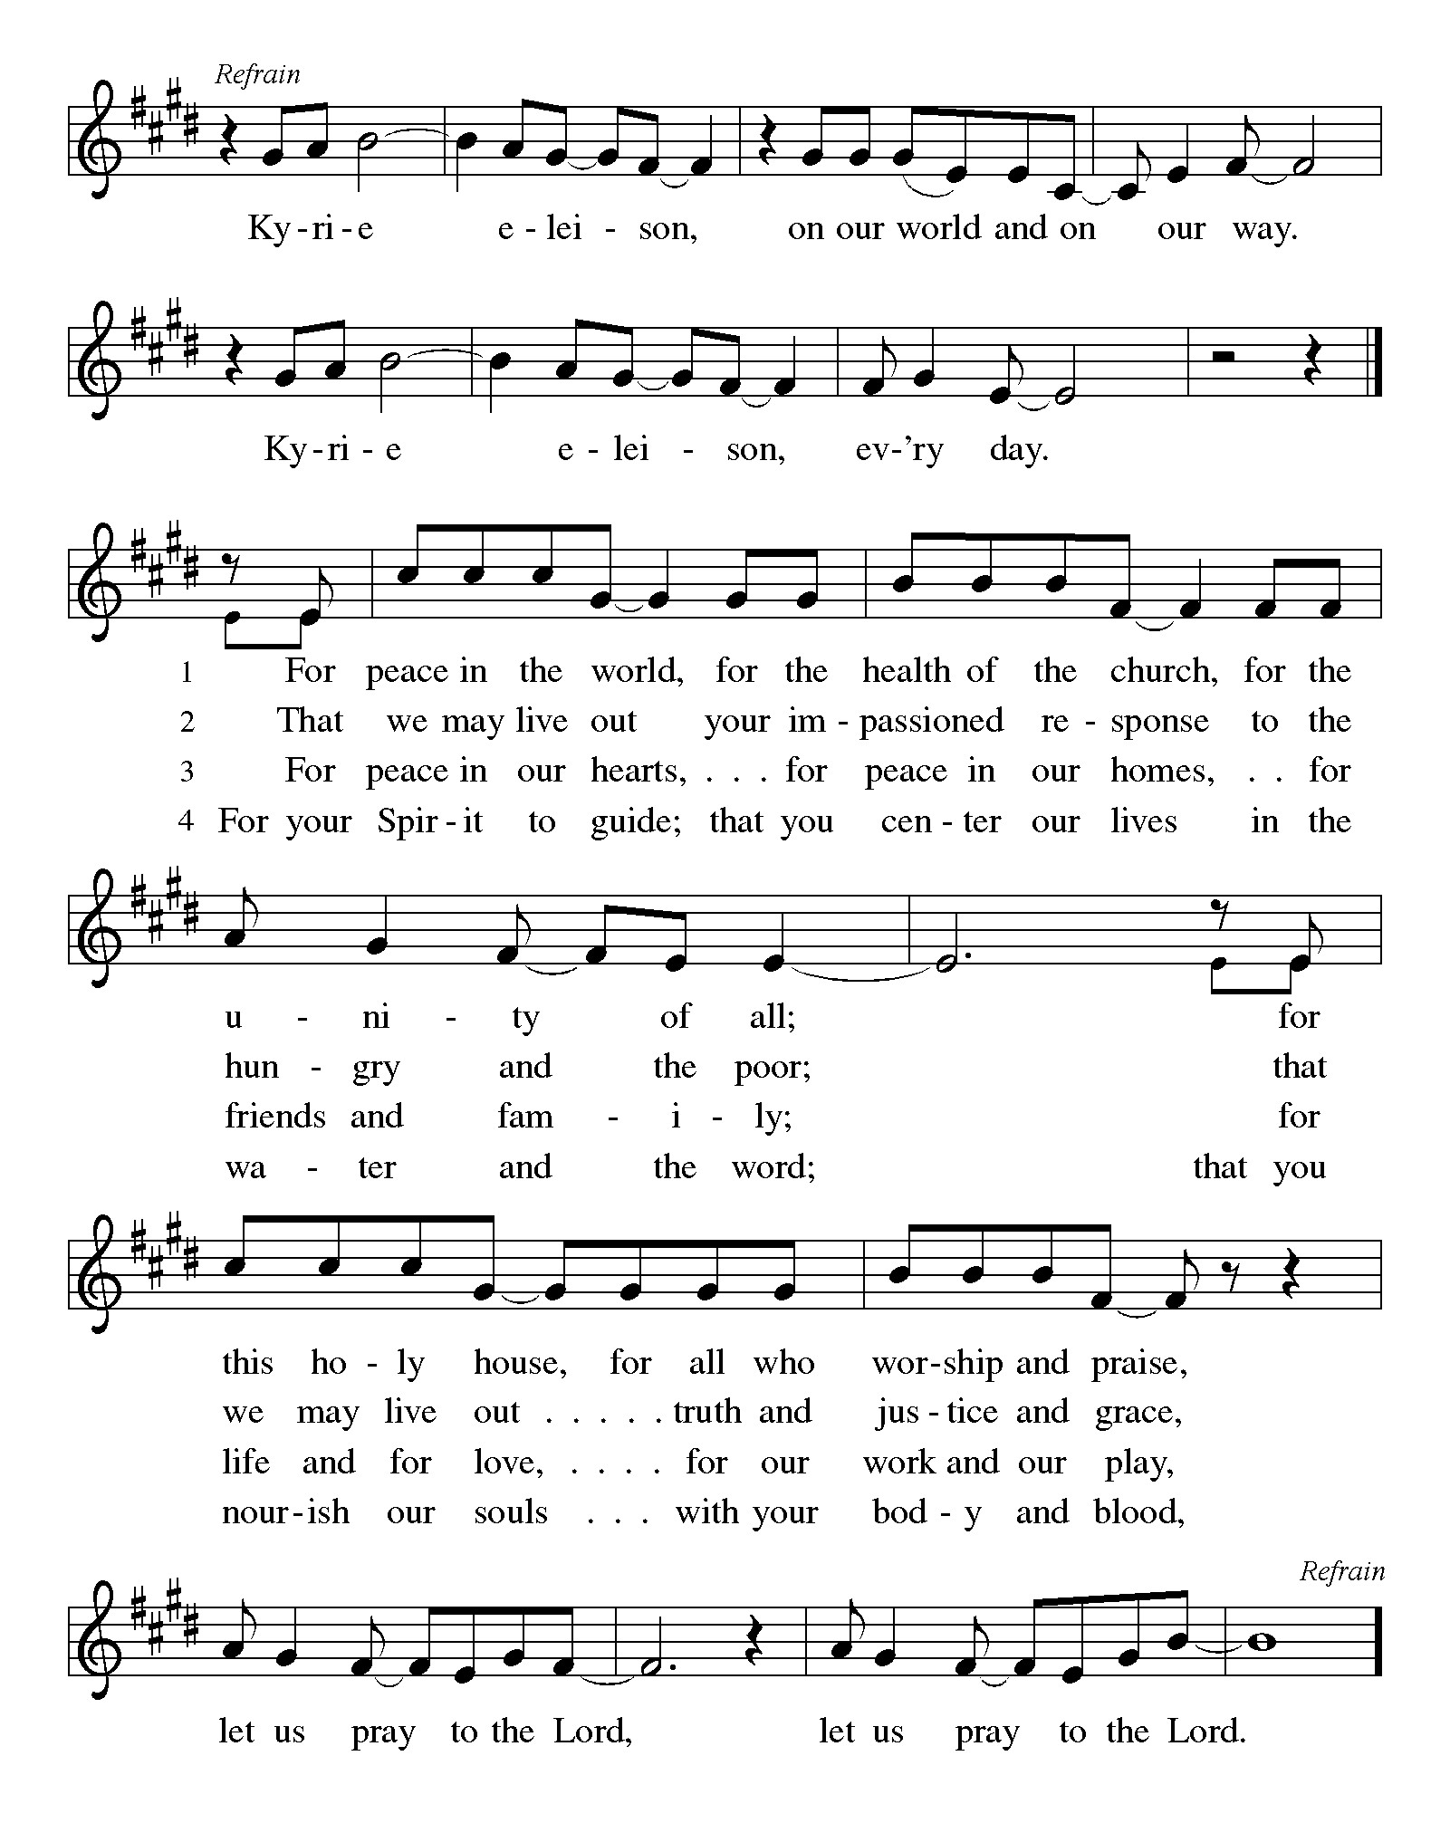
Prayer of the Day
Let us pray together.
O God, our leader and guide, in the waters of baptism you bring us to new birth to live as your children. Strengthen our faith in your promises, that by your Spirit we may lift up your life to all the world through your Son, Jesus Christ, our Savior and Lord, who lives and reigns with you and the Holy Spirit, one God, now and forever.
Amen.

First Reading Genesis 12:1-4a
A reading from Genesis.
¹ The Lord said to Abram, “Go from your country and your kindred and your father’s house to the land that I will show you. ² I will make of you a great nation, and I will bless you and make your name great, so that you will be a blessing. ³ I will bless those who bless you, and the one who curses you I will curse, and in you all the families of the earth shall be blessed.”
^{4a} So Abram went, as the Lord had told him, and Lot went with him.

The word of the Lord.
Thanks be to God.

Psalm Psalm 121
The Lord is king; let the peoples tremble!
¹ I lift up my eyes | to the hills;
from where is my | help to come?
² My help comes | from the Lord,
the maker of heav- | en and earth.
³ The Lord will not let your | foot be moved
nor will the one who watches over you | fall asleep.
⁴ Behold, the keep- | er of Israel
will neither slum- | ber nor sleep;
⁵ the Lord watches | over you;
the Lord is your shade at | your right hand;
⁶ the sun will not strike | you by day,
nor the | moon by night.
⁷ The Lord will preserve you | from all evil
and will | keep your life.
⁸ The Lord will watch over your going out and your | coming in,
from this time forth for- | evermore.

Second Reading Romans 4:1-5, 13-17
A reading from Romans.
¹ What then are we to say was gained by Abraham, our ancestor according to the flesh? ² For if Abraham was justified by works, he has something to boast about, but not before God. ³ For what does the scripture say? “Abraham believed God, and it was reckoned to him as righteousness.” ⁴ Now to one who works, wages are not reckoned as a gift but as something due. ⁵ But to one who does not work but trusts him who justifies the ungodly, such faith is reckoned as righteousness.
¹³ For the promise that he would inherit the world did not come to Abraham or to his descendants through the law but through the righteousness of faith. ¹⁴ For if it is the adherents of the law who are to be the heirs, faith is null and the promise is void. ¹⁵ For the law brings wrath, but where there is no law, neither is there transgression.
¹⁶ For this reason the promise depends on faith, in order that it may rest on grace, so that it may be guaranteed to all his descendants, not only to the adherents of the law but also to those who share the faith of Abraham (who is the father of all of us, ¹⁷ as it is written, “I have made you the father of many nations”), in the presence of the God in whom he believed, who gives life to the dead and calls into existence the things that do not exist.

The Word of the Lord
Thanks be to God.

Gospel Acclamation

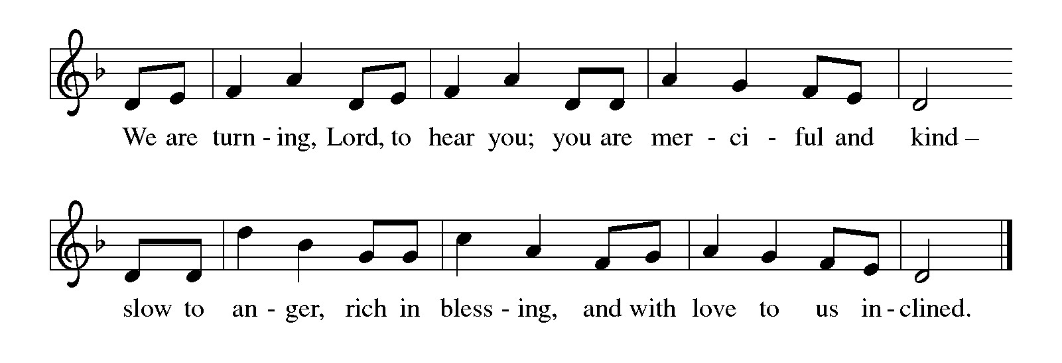

Gospel John 3:1-17
The holy gospel according to John.
Glory to You O Lord.

¹ Now there was a Pharisee named Nicodemus, a leader of the Jews. ² He came to Jesus by night and said to him, “Rabbi, we know that you are a teacher who has come from God, for no one can do these signs that you do unless God is with that person.” ³ Jesus answered him, “Very truly, I tell you, no one can see the kingdom of God without being born from above.” ⁴ Nicodemus said to him, “How can anyone be born after having grown old? Can one enter a second time into the mother’s womb and be born?” ⁵ Jesus answered, “Very truly, I tell you, no one can enter the kingdom of God without being born of water and Spirit. ⁶ What is born of the flesh is flesh, and what is born of the Spirit is spirit. ⁷ Do not be astonished that I said to you, ‘You must be born from above.’ ⁸ The wind blows where it chooses, and you hear the sound of it, but you do not know where it comes from or where it goes. So it is with everyone who is born of the Spirit.” ⁹ Nicodemus said to him, “How can these things be?” ¹⁰ Jesus answered him, “Are you the teacher of Israel, and yet you do not understand these things?
¹¹ “Very truly, I tell you, we speak of what we know and testify to what we have seen, yet you do not receive our testimony. ¹² If I have told you about earthly things and you do not believe, how can you believe if I tell you about heavenly things? ¹³ No one has ascended into heaven except the one who descended from heaven, the Son of Man. ¹⁴ And just as Moses lifted up the serpent in the wilderness, so must the Son of Man be lifted up, ¹⁵ that whoever believes in him may have eternal life.
¹⁶ “For God so loved the world that he gave his only Son, so that everyone who believes in him may not perish but may have eternal life.
¹⁷ “Indeed, God did not send the Son into the world to condemn the world but in order that the world might be saved through him.”

The gospel of the Lord.
Praise to you, O Christ.

CHILDREN’S MOMENT
SERMON Pastor Ken Scheck

hymn of the day “What Wonderous Love Is This” #666

prayers of Intercession
(Please Be Seated)
Reconciled by God’s mercy and sustained by God’s presence, let us pray for the world and its needs.
A brief silence.
Faithful One, you renew us by grace. As you have inspired faith through the work of church artists and hymnwriters throughout the ages, give your church the means to praise your beauty today. Hear us, O God.
Your mercy is great.
Living One, you delight in this world. The sun and moon, the wind and the water declare your goodness. Preserve this earth, and protect conservationists, scientists, and all who labor in service to creation. Hear us, O God.
Your mercy is great.
Ruling One, you bless us to be a blessing. Open the hearts of all leaders to seek the flourishing of every person and lend your help to all who wait for justice, deliverance, and peace. Hear us, O God.
Your mercy is great.
Compassionate One, you send your Son to save. Declare your word of acceptance to any who feel condemned and lift up any brought low by hatred and exclusion. Tend to all who are struggling with illness or loss We pray for all those on our prayer list and those in our heart. We pray for all countries involved in ongoing conflicts and all who are affected by natural disasters.
Hear us, O God.
Your mercy is great.
Guiding One, you watch over our going out and coming in. Bless newcomers and new members in this assembly and accompany those who have recently left this community to journey elsewhere. Hear us, O God.
Your mercy is great.
Eternal One, you neither slumber nor sleep. Be our keeper in life and in death. Thank you for our beloved who have died, and for your promise which saves this whole world by your love. Hear us, O God.
Your mercy is great.
Receive our prayers, O God, through Jesus Christ, our strength and salvation.
Amen.

PEACE
The peace of Christ be with you always.
And also with you.

OFFERING & OFFERING SONG
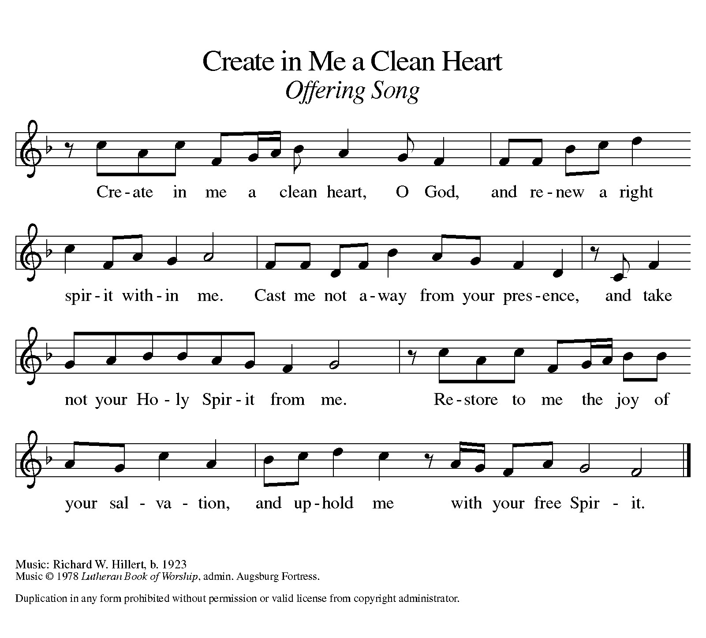

Offering Prayer
Let us pray.
Holy God, gracious and merciful, you bring forth food from the earth and nourish your whole creation. Turn our hearts toward those who hunger in any way, that all may know your care; and prepare us now to feast on the bread of life, Jesus Christ, our Savior and Lord.
Amen.

DIALOGUE
The Lord be with you.
And also with you.
Lift up your hearts.
We lift them to the Lord.
Let us give thanks to the Lord our God.
It is right to give our thanks and praise.

PREFACE (Pastor)
It is indeed right, our duty and our joy,
that we should at all times and in all places
give thanks and praise to you, almighty and merciful God,
through our Savior Jesus Christ;
who on this day overcame death and the grave,
and by his glorious resurrection opened to us the way of everlasting life.
And so, with all the choirs of angels,
with the church on earth and the hosts of heaven,
we praise your name and join their unending hymn

holy, holy, holy

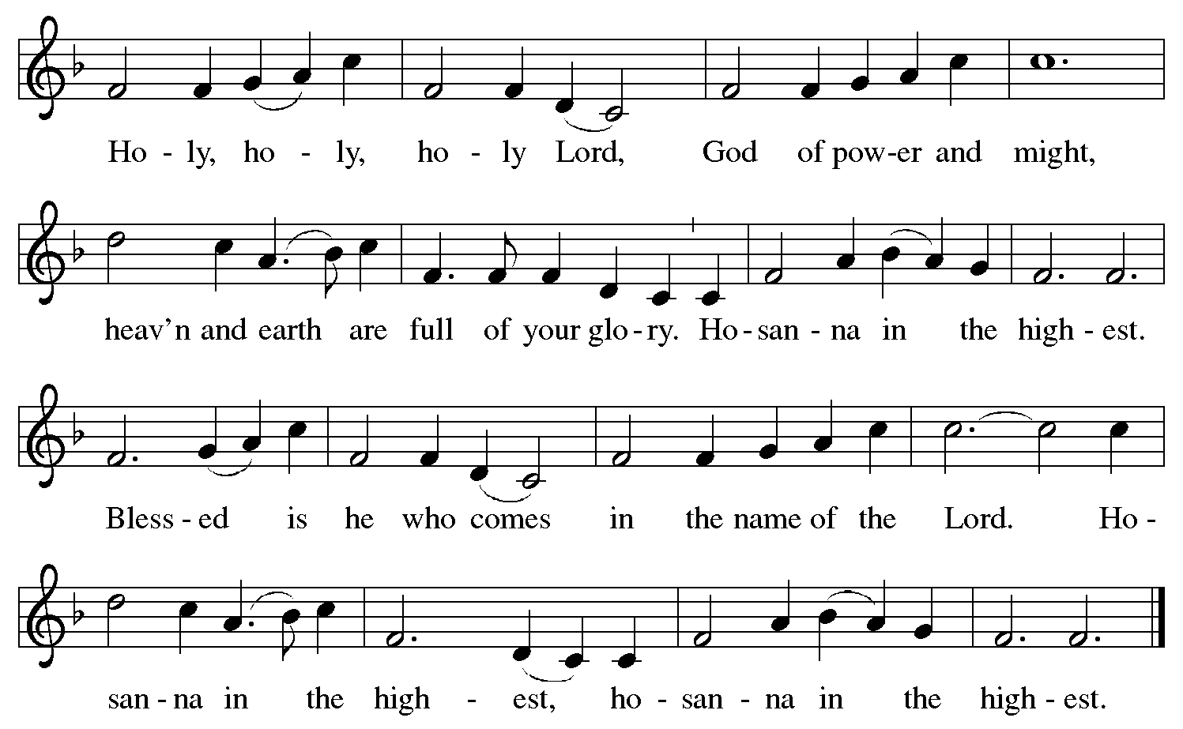

Thanksgiving at the Table
In the night in which he was betrayed,
our Lord Jesus took bread, and gave thanks;
broke it, and gave it to his disciples, saying:
Take and eat; this is my body, given for you.
Do this for the remembrance of me.

Again, after supper, he took the cup, gave thanks,
and gave it for all to drink, saying:
This cup is the new covenant in my blood,
shed for you and for all people for the forgiveness of sin.
Do this for the remembrance of me.

For as often as we eat of this bread and drink from this cup,
we proclaim the Lord’s death until he comes.

Lord’s Prayer
Gathered into one by the Holy Spirit, let us pray as Jesus taught us.
Our Father, who art in heaven,
hallowed be thy name,
thy kingdom come,
thy will be done,
on earth as it is in heaven.
Give us this day our daily bread;
and forgive us our trespasses,
as we forgive those
who trespass against us;
and lead us not into temptation,
but deliver us from evil.
For thine is the kingdom,
and the power, and the glory,
forever and ever. Amen.

INVITATION TO COMMUNION
Come to the banquet, for all is now ready.

COMMUNION *continuous
*People are welcome to kneel at the altar rail for a time of prayer after they receive their communion elements.

COMMUNION HYMNS
“I Want Jesus to Walk with Me” #325
“We Are Baptized in Christ Jesus” #451

PRAYER AFTER COMMUNION
Let us pray.
We give you thanks, almighty God, that you have refreshed us through the healing power of this gift of life. In your mercy, strengthen us through this gift, in faith toward you and in fervent love toward one another; for the sake of Jesus Christ our Lord.
Amen.

Sending
God blesses us and sends us in mission to the world.

Blessing
The Lord bless you and keep you.
The Lord’s face shine on you with grace and mercy.
The Lord look upon you with favor and ☩ give you peace.
Amen.

Sending SonG “Blessed Assurance” #638

Dismissal
Go in peace. Christ is with you.
Thanks be to God.
From sundaysandseasons.com. Copyright © 2017 Augsburg Fortress. All rights reserved.

Thank you to all who served in worship today!
Presiders: Pastor Ken Scheck Musician: Jayne Flanigan
Acolyte: Safety Person:
Elder: Buffy Meyers Trustee: Doug MacKenzie
Offering Counters: Doug MacKenzie & Mike Johnson



PRAYERS OF THE FAITHFUL

With thanks for all God’s blessings and his love for all people. Our Bishops, Julie Schneider-Thomas, Yehiel Curry, and the congregations of the North/West Lower Michigan Synod, and especially Hope Lutheran Church in Plainwell, and their pastor Rev. Nicole Smith.

Prayers for our friends, for all who are sick or hospitalized and for all health care workers who care for them. All those members of Zion’s family traveling; all those homebound or in frail health; all those suffering with quiet, unknown needs or worries. For those who serve on our behalf: public safety, utility workers, medical personnel, military personnel. For those who might be forgotten. We pray especially for all countries involved in ongoing conflicts.

This week at Zion:
- Men’s Breakfast 8am, Wednesday 4th
- Bulletin Deadline, Wednesday 4th
- Bell Ringing & Prayer, 1 pm, Saturday 7

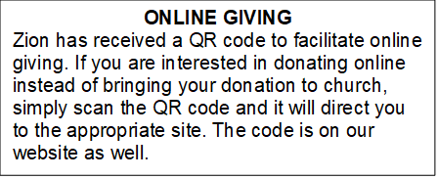

How to Contact the Pastor: If there is a pastoral need, please contact Pastor Ken Scheck II at 269-370-4632 or by email at kscheckii@aol.com.

ANNOUNCEMENTS
- Our congregation continues to grow in its mission to share Christ’s love in our community. As we look ahead to the coming months, we will be facing a shortfall in our operating budget. If you are able, we invite you to consider an additional gift to support our worship, outreach, and care ministries. Every contribution, large or small, strengthens the work we do together in Christ’s name. Thank you for your faithful generosity.
- Notice of Special Congregational Meeting: There will be a special congregational meeting on March 1st immediately following worship. This meeting is to review and vote on a recommendation from council to have carpeting installed in the fireside lounge, the front and back entryway basement landings, the nursery and two classrooms. Please plan to attend this important meeting. If you have questions, please see one of the trustees or Paul.
- First-Aid Supplies for Synod Mission Trip to Honduras: Our synod’s mission trip to Honduras in April supports the “Health for Life” ministry. This project promotes healthy living by educating health volunteers and by increasing access to life’s basis needs. Our synod has been asked to conduct training on basic first-aid and health. They will be training and equipping volunteers who will help those in their communities. We can help by providing first-aid supplies and donations for this ministry. There is a “shopping list” on the table in the narthex. Please consider supporting our synod team that includes Pastor Mike Anderson and Vicki.
- Note from the Board of Stewardship: Our congregation continues to grow in its mission to share Christ’s love in our community. As we look ahead to the coming months, we will be facing a shortfall in our operating budget. If you are able, we invite you to consider an additional gift to support our worship, outreach, and care ministries. Every contribution, large or small, strengthens the work we do together in Christ’s name. Thank you for your faithful generosity.
- Annual Easter Egg Hunt for Zion’s Kids: The Parish Board will be sponsoring an Easter Egg Hunt for our kiddos on Palm Sunday, March 29th. We are asking for donations of candy, trinkets, coins or other kid friendly items that will fit into our plastic Easter eggs. Please put donations in the box marked for these donations in the Fellowship Hall by March 22nd. We want to thank the congregation for their continued support for this event for our Sunday School kids.
- Service for Jerry Engle and Thank You: My family and I want to thank you all for the prayers, kind messages, cards, calls and gifts of food and other items since the time of Jerry's passing. These kindnesses are greatly appreciated. Jerry's celebration of life service will be at Zion on Saturday, April 11th. Visitation will begin at 10:00 with the service at 11:00. We will have time to share stories of Jerry at the lunch, prepared and served by our church family, in the Fellowship Hall immediately following the service. --- Carol Engle and family
- Join us for Lent: The theme for our second Lenten service is PASSION: God’s Will. The Soup/Salad Supper starts at 6 pm, come when you can. The service follows at 7:15 pm. (You can come to the service only if the dinner time does not work for you.) We hope to see you on Wednesday!
- Palm Sunday Path: The Palm Sunday Path is a Christian walk being planned for Palm Sunday in Lansing from Pilgrim Church to the Capitol Building at 3:00 pm. If you are interested in more information or joining in the walk, there are information sheets on the table in the Narthex.
- Pray Without Ceasing: Everyday there seems to be something new that needs our prayer! To help us have more time in prayer for people and events near and far, we are interested in restarting our special Pray Without Ceasing services. We are reaching out to learn if there is enough interest. One suggestion is to hold the services on Thursdays at 3:00 pm and also following worship on Sundays when there is no fellowship. There is a sheet on the table in the Narthex to indicate whether you are interested, if this day/time would work, or if you would suggest a different day and time. If you have questions, please see Martha.
- Seeking GOD’S Way: This Lent you are invited to journey with God. Come to our dinner and worships (7:00 pm after Ash Wednesday), as we Seek God’s Way. We will explore God’s MERCY, which is the heart of God. As we journey, we will find God’s PASSION for each of us. We will find that God’s LOVE is on the move, allowing us to realize the grace that is given to all creation. Even in hardship Christians know the gift of LIFE, as we walk with the knowledge of God’s care, allowing all of us to have JOY. Zion Dinners at 6:00 p.m. Wednesdays on February 25; March 4, 11, 18 and 25.
- Pastor’s Availability: Pastor Ken Scheck II is available by appointment to meet with you. As you know homebound visitation has begun and will continue until all homebound have been visited by Pastor Ken. Generally speaking, he is at Grace on Mondays and Wednesdays and Zion on Tuesdays and Thursdays with a day off on Friday. As you may be aware, Pastor Ken has come to the Men’s meeting and Lakewood Area Ministerial Association meetings on Wednesday here at Zion. Flexibility is the name of the game. He is more than willing to be contacted at any time by cellphone or email. Please feel free to contact him at 269-370-4632 or at kscheckii@aol.com. You are able to send a text to the cellphone, but please identify yourself at least the first time.
- Pastor Ken's installation: Join us for Pastor Ken's installation service on March 22. Bishop Julie Schneider-Thomas will be here for the Sunday School hour, worship and a time of fellowship. Join us for this time of celebration.
- Save the Date: Mark your calendar for April 19th! We will be hosting an open house for Pastor Ken and inviting the community to come, have lunch with us, and meet our Pastor. Watch for more details!
- Announcement and Newsletter Items: Please forward items for the bulletin announcements and the newsletter to the church email (Office@Zion.org). Please do not send items to people’s personal emails. Thank you.
- Door Locking Policy: Our door locking policy relies on having a volunteer(s) each Sunday to serve as the Safety Person of the Day. On Sundays where no one has volunteered, if someone arrives at church and is willing to be the Safety Person of the Day, we will follow the door locking policy. If no one steps forward to serve as the Safety Person of the Day, the doors will not be locked. Please consider volunteering for this important duty.

