ZION LUTHERAN CHURCH, WOODLAND, MI
Midweek Lent Service, February 25, 2026
*If you are listening in your car, please tune your radio to FM 87.7*



Seeking God’s Way
Mercy

OPENING DIALOGUE

Long ago God spoke to our ancestors in many and various ways, by the prophets,
but in these last days God has spoken to us by the Son.
He is the reflection of God’s glory and the exact imprint of God’s very being,
and he sustains all things by his powerful word.
Since we have confidence by the new and living way opened for us by Jesus,
let us approach with a true heart in full assurance of faith.

GATHERING SONG “Rejoice, Rejoice Believers” ELW 244

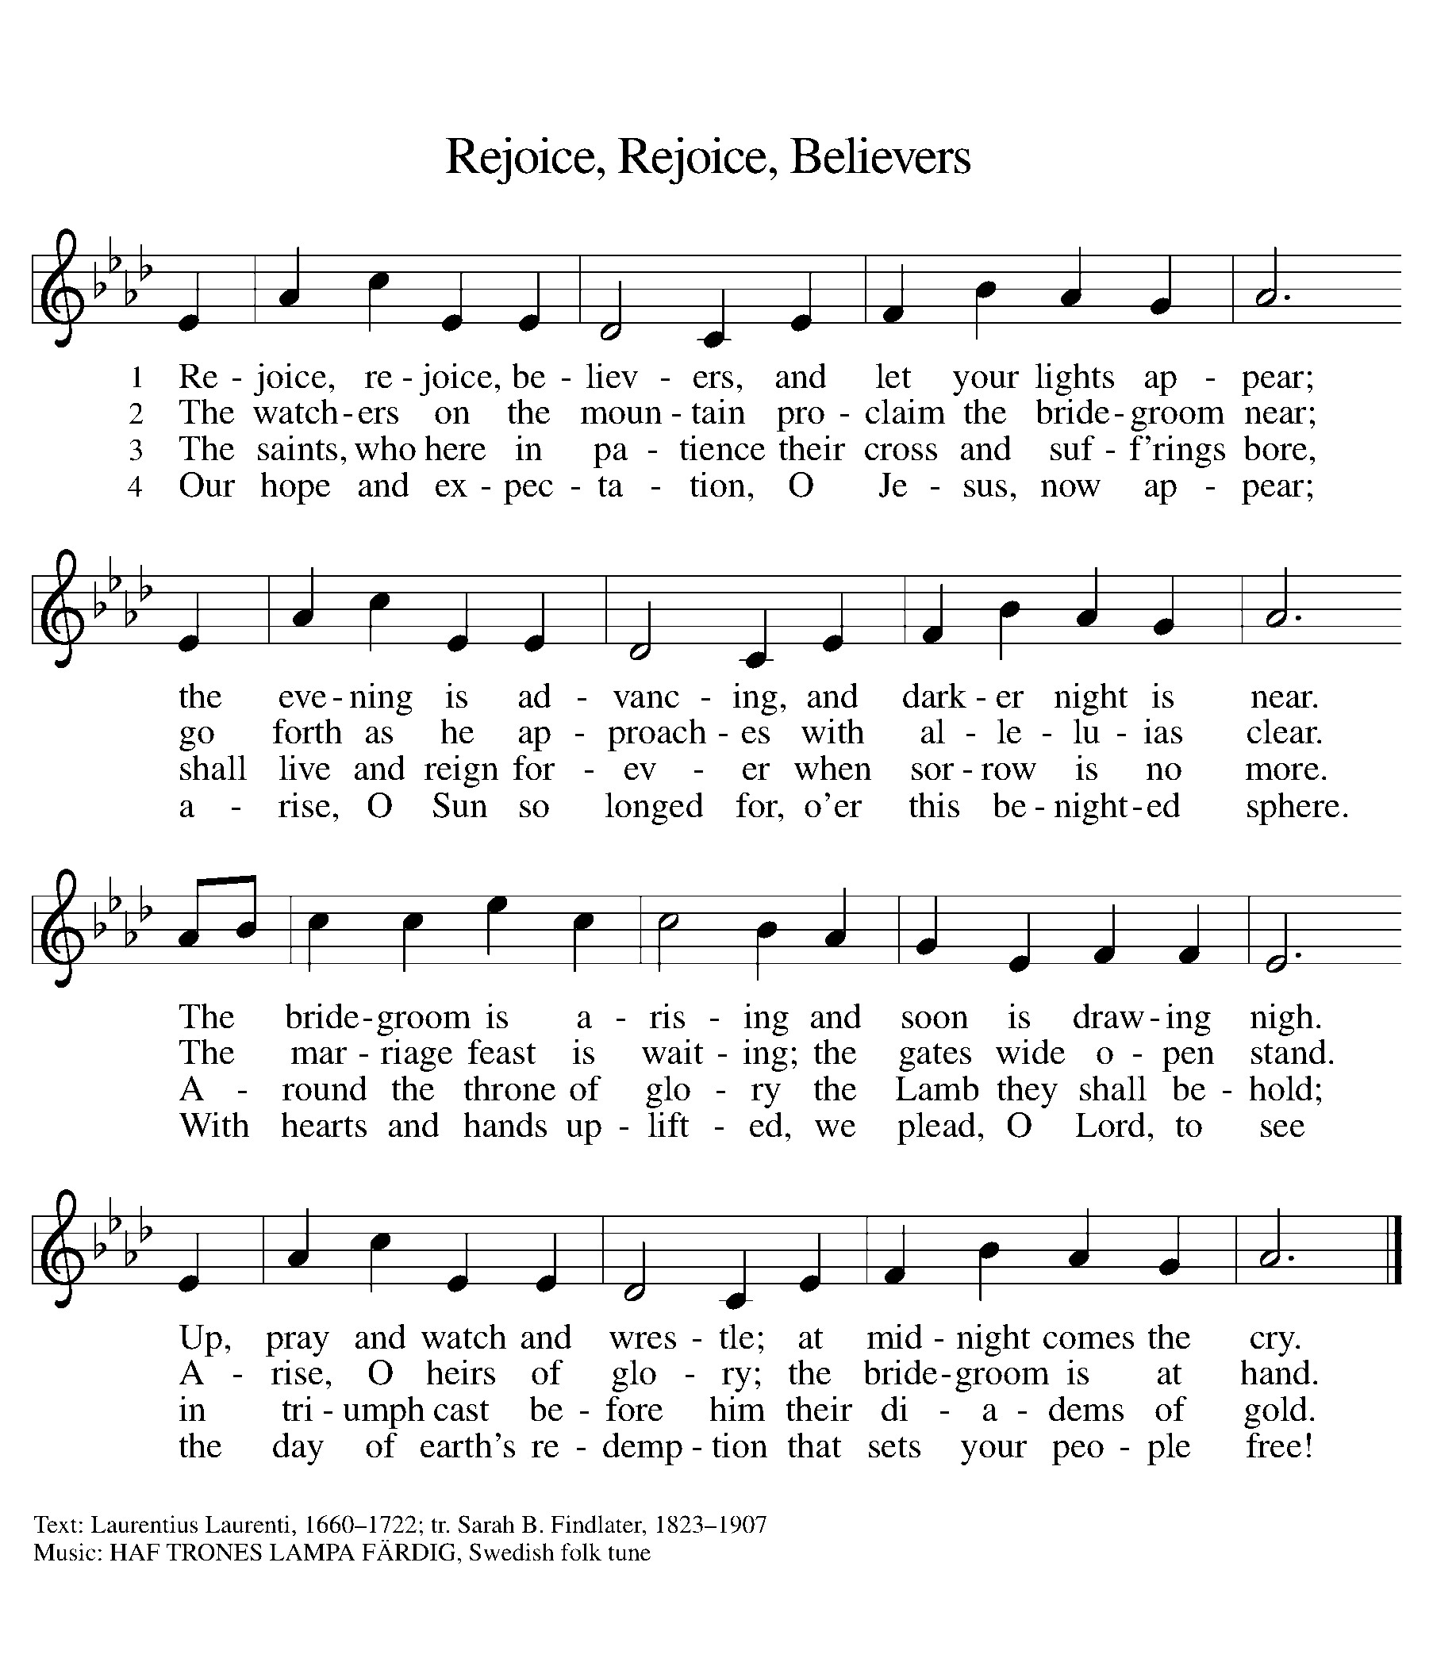

GREETING
The grace of our Lord Jesus Christ, the love of God,
and the communion of the Holy Spirit be with you all.
And also with you.

Isaiah 30:18-21
A reading from Isaiah.

¹⁸Therefore the Lord waits to be gracious to you;
therefore he will rise up to show mercy to you.
For the Lord is a God of justice;
blessed are all those who wait for him.
¹⁹ O people in Zion, inhabitants of Jerusalem, you shall weep no more. He will surely be gracious to you at the sound of your cry; when he hears it, he will answer you. ²⁰ Though the Lord may give you the bread of adversity and the water of affliction, yet your Teacher will not hide himself any longer, but your eyes shall see your Teacher. ²¹ And when you turn to the right or when you turn to the left, your ears shall hear a word behind you, saying, “This is the way; walk in it.”

The Word of the Lord.
Thanks be to God.

Psalm 51
¹Have mercy on me, O God, according to your steadfast love;
in your great compassion blot out my offenses.
²Wash me through and through from my wickedness,
and cleanse me from my sin.

³For I know my offenses,
and my sin is ever before me.
⁴Against you only have I sinned and done what is evil in your sight;
so you are justified when you speak and right in your judgment.

⁵Indeed, I was born steeped in wickedness,
a sinner from my mother’s womb.
⁶Indeed, you delight in truth deep within me,
and would have me know wisdom deep within.

⁷Remove my sins with hyssop, and I shall be clean;
wash me, and I shall be purer than snow.
⁸Let me hear joy and gladness;
that the body you have broken may rejoice.

⁹Hide your face from my sins,
and blot out all my wickedness.
¹⁰Create in me a clean heart, O God,
and renew a right spirit within me.

¹¹Cast me not away from your presence,
and take not your Holy Spirit from me.
¹²Restore to me the joy of your salvation
and sustain me with your bountiful Spirit.

READING 1 John 4:9-10
A reading from 1 John.

⁹ God’s love was revealed among us in this way: God sent his only Son into the world so that we might live through him. ¹⁰ In this is love, not that we loved God but that he loved us and sent his Son to be the atoning sacrifice for our sins.

The Word of the Lord.
Thanks be to God.

REFLECTION Pastor Ken Scheck II

The reflection will conclude with:

Now faith is the assurance of things hoped for,
the conviction of things not seen.

HYMN OF THE DAY “Softly and Tenderly Jesus Is Calling” ELW 608
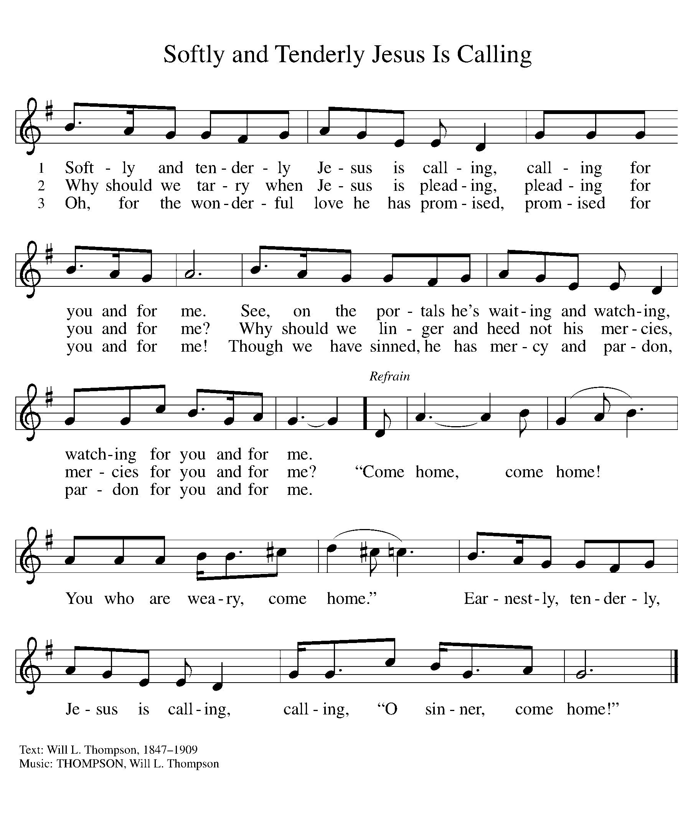

PRAYERS
Surrounded by a great cloud of witnesses, let us pray for the church, those in need, and all of God’s creation.
A brief silence.
Faithful God, shower the world with your lovingkindness,
that all may know your peace.

Open our eyes to the needs of our neighbors,
that all may know your love.

Comfort the sick and dying,
that all may know your mercy.

Guide our leaders in the way of truth,
that all may know your justice.

Focus our hearts on the way of the cross,
that all may have faith in you.

Let us pray in the words of Martin Luther:
Behold, Lord, an empty vessel that needs to be filled.
My Lord, fill it. I am weak in the faith; strengthen me.
I am cold in love; warm me and make me fervent, that
my love may go out to my neighbor. I do not have a
strong and firm faith; at times I doubt and am unable
to trust you altogether. O Lord, help me. Strengthen
my faith and trust in you. In you I have sealed the treasure
of all I have. I am poor; you are rich and came to
be merciful to the poor. I am a sinner; you are upright.
With me, there is an abundance of sin; in you is the
fullness of righteousness. Therefore I will remain with
you, of whom I can receive, but to whom I may not give.
Amen.
(Evangelical Lutheran Worship, p. 87)

LORD’S PRAYER
Finally, let us pray with the words our Savior gave us:
Our Father, who art in heaven,
hallowed be thy name,
thy kingdom come,
thy will be done,
on earth as it is in heaven.
Give us this day our daily bread;
and forgive us our trespasses,
as we forgive those
who trespass against us;
and lead us not into temptation,
but deliver us from evil.
For thine is the kingdom,
and the power, and the glory,
forever and ever. Amen.

BLESSING
The God of peace,
who brought back from the dead our Lord Jesus,
the great shepherd of the sheep,
make you complete in everything good
so that you may do God’s will,
through Jesus Christ, to whom be the glory forever and ever.
Amen.

SENDING SONG “Go Tell It On The Mountain” ELW 290

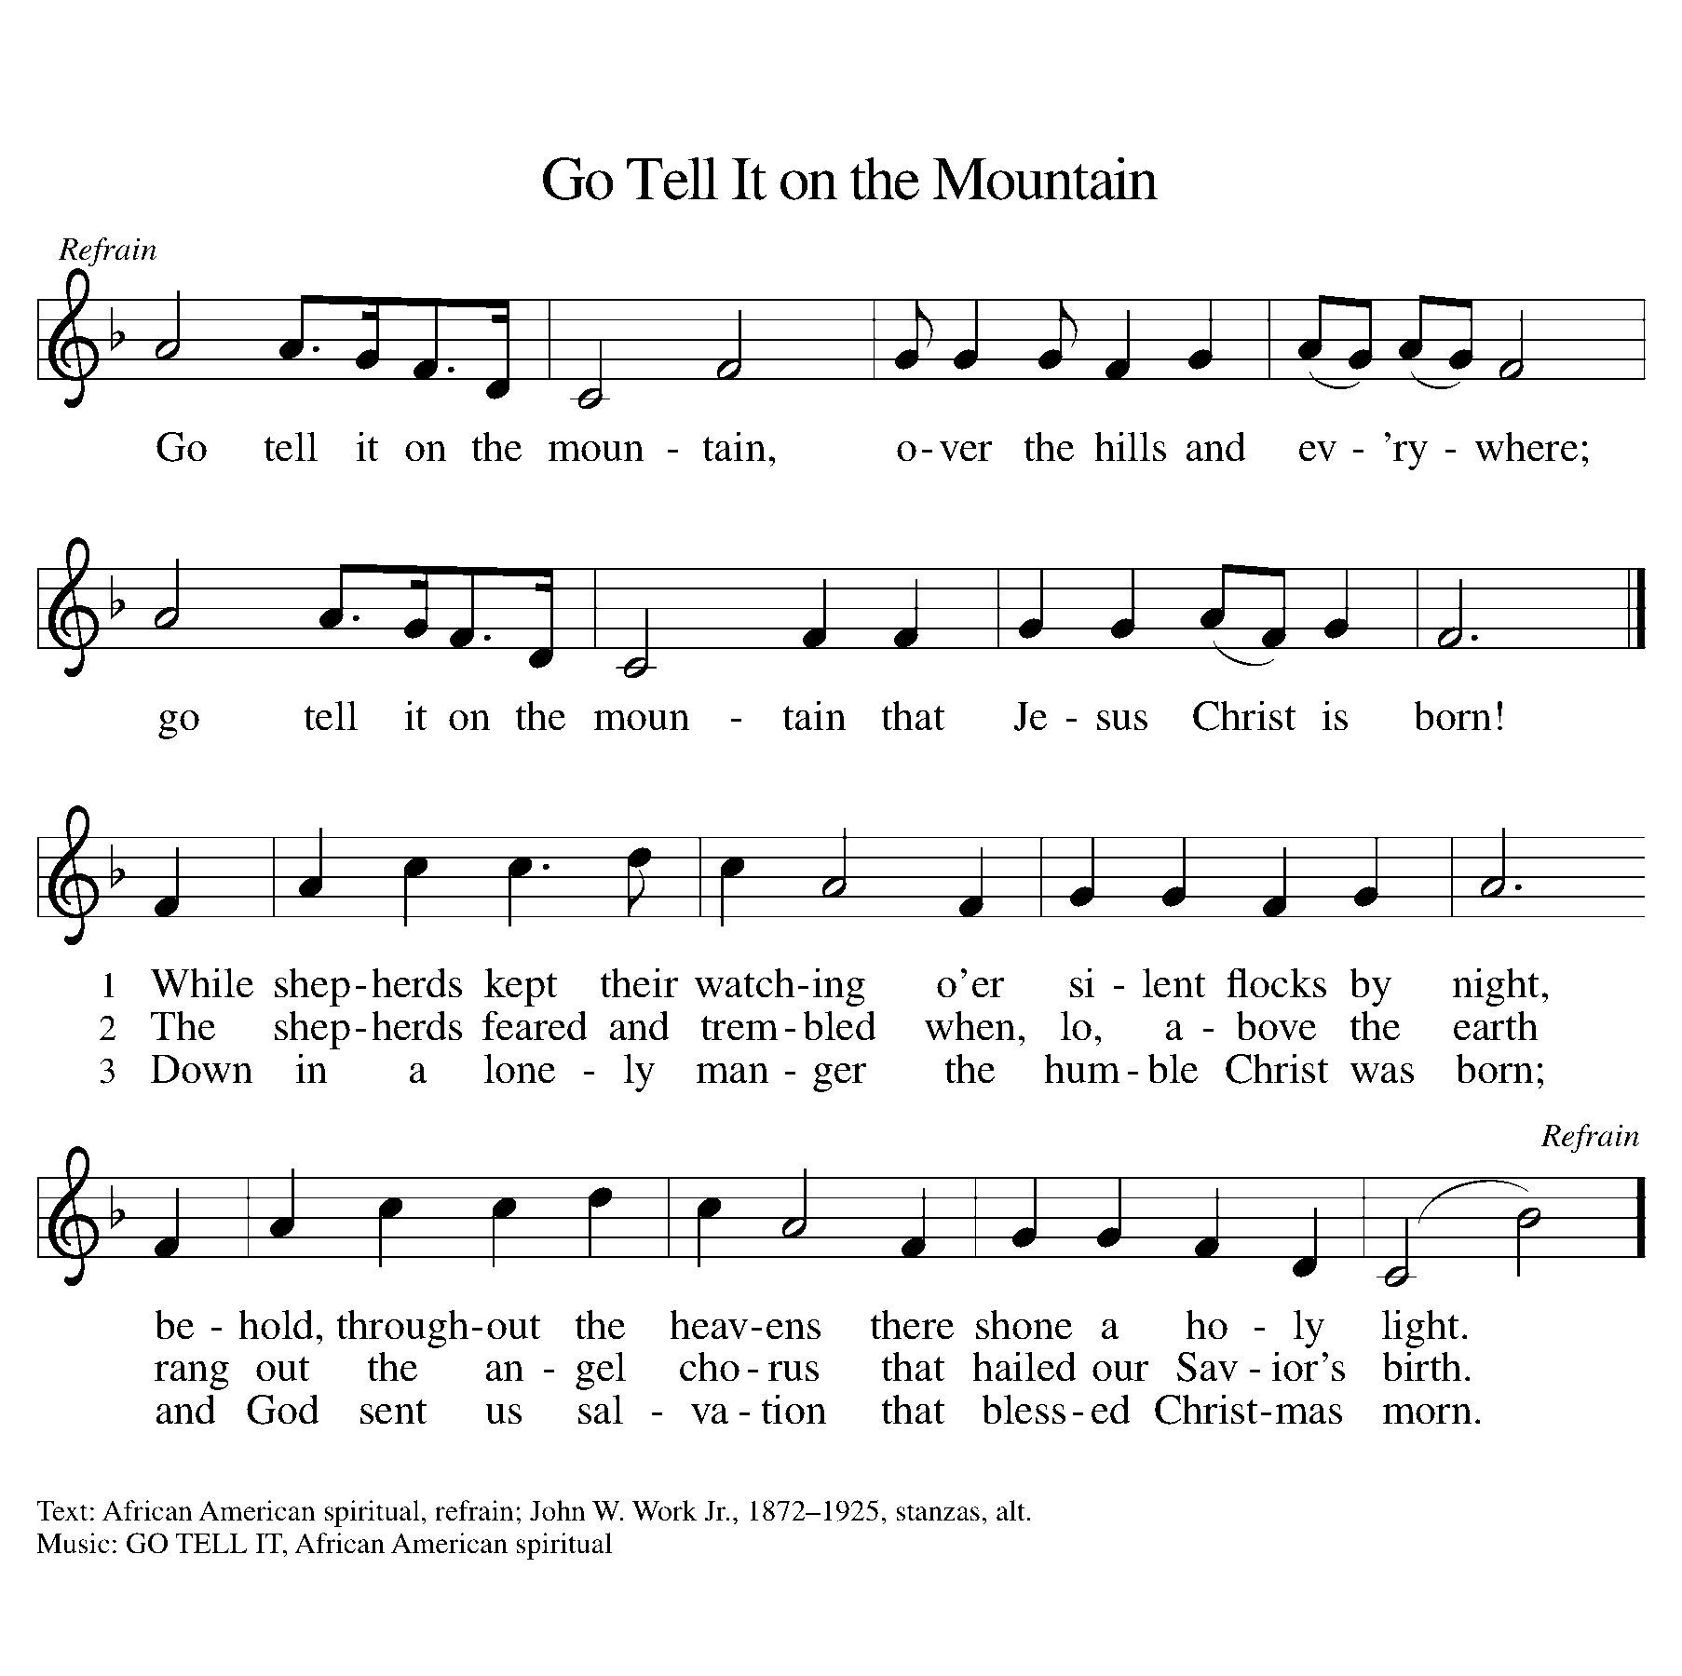

DISMISSAL
Go in peace. Christ is with you.
Thanks be to God.

Next Week: PASSION: God’s Will
(Dinner 6 pm; Service 7:15 pm)

