ZION LUTHERAN CHURCH, WOODLAND, MI
Third Sunday in Lent March 8, 2026
*If you are listening in your car, please tune your radio to FM 87.7*
(Please silence your cell phones while in the sanctuary. Thank you.)

WELCOME AND ANNOUNCEMENTS

Gathering
The Holy Spirit calls us together as the people of God.

Confession and Forgiveness
In the name of the Father,
and of the ☩ Son,
and of the Holy Spirit.
Amen.

Almighty God, to whom all hearts are open, all desires known, and from whom no secrets are hid: cleanse the thoughts of our hearts by the inspiration of your Holy Spirit, that we may perfectly love you and worthily magnify your holy name, through Jesus Christ our Lord.
Amen.

Let us confess our sin in the presence of God and of one another. Most merciful God,
we confess that we are captive to sin and cannot free ourselves. We have sinned against you in thought, word, and deed, by what we have done and by what we have left undone. We have not loved you with our whole heart; we have not loved our neighbors as ourselves. For the sake of your Son, Jesus Christ, have mercy on us. Forgive us, renew us, and lead us, so that we may delight in your will and walk in your ways, to the glory of your holy name.
Amen.

God, who is rich in mercy, loved us even when we were dead in sin, and made us alive together with Christ. By grace you have been saved. In the name of ☩ Jesus Christ, your sins are forgiven. Almighty God strengthen you with power through the Holy Spirit, that Christ may live in your hearts through faith. Amen.
Gathering Song “Open Now Thy Gates of Beauty” #533

GREETING
The grace of our Lord Jesus Christ, the love of God, and the communion of the Holy Spirit be with you all.
And also with you.

Praise hymn: “Kyrie Eleison”

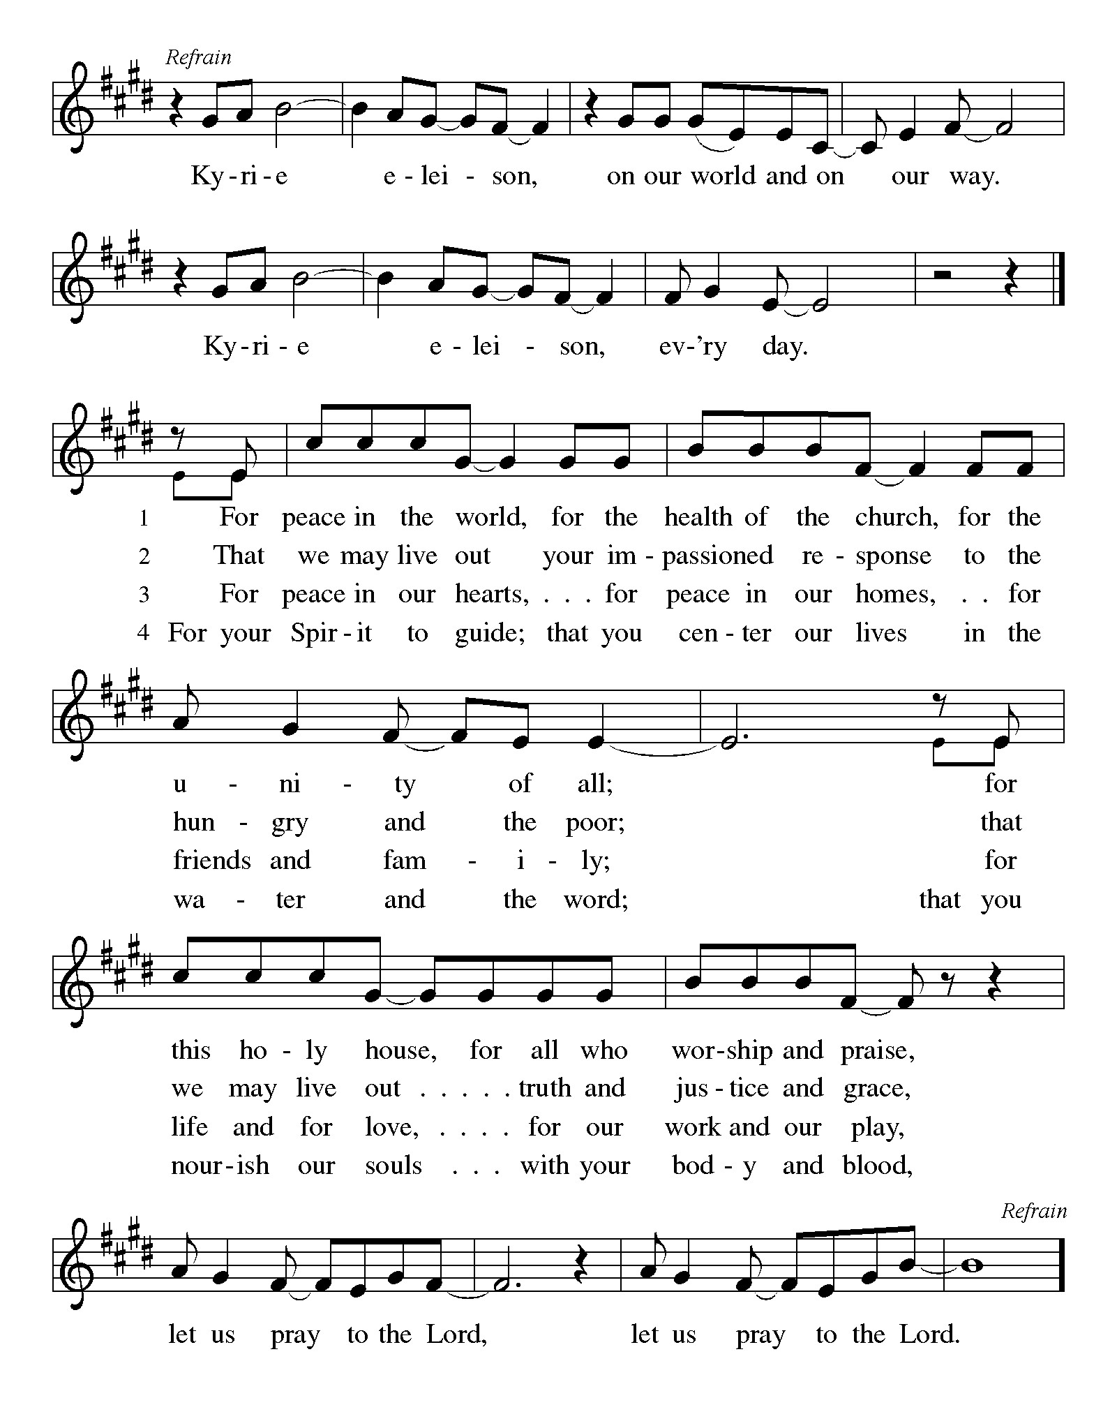
Prayer of the Day
Let us pray together.
Merciful God, the fountain of living water, you quench our thirst and wash away our sin. Give us this water always. Bring us to drink from the well that flows with the beauty of your truth through Jesus Christ, our Savior and Lord, who lives and reigns with you and the Holy Spirit, one God, now and forever.
Amen.

First Reading Exodus 17:1-7
A reading from Exodus.
¹ From the wilderness of Sin the whole congregation of the Israelites journeyed by stages, as the Lord commanded. They camped at Rephidim, but there was no water for the people to drink. ² The people quarreled with Moses and said, “Give us water to drink.” Moses said to them, “Why do you quarrel with me? Why do you test the Lord?” ³ But the people thirsted there for water, and the people complained against Moses and said, “Why did you bring us out of Egypt, to kill us and our children and livestock with thirst?” ⁴ So Moses cried out to the Lord, “What shall I do for this people? They are almost ready to stone me.” ⁵ The Lord said to Moses, “Go on ahead of the people and take some of the elders of Israel with you; take in your hand the staff with which you struck the Nile and go. ⁶ I will be standing there in front of you on the rock at Horeb. Strike the rock, and water will come out of it, so that the people may drink.” Moses did so, in the sight of the elders of Israel. ⁷ He called the place Massah and Meribah, because the Israelites quarreled and tested the Lord, saying, “Is the Lord among us or not?”

The word of the Lord.
Thanks be to God.

Psalm Psalm 95
The Lord is king; let the peoples tremble!
¹ Come, let us sing | to the Lord;
let us shout for joy to the rock of | our salvation.
² Let us come before God’s presence | with thanksgiving
and raise a loud shout to the | Lord with psalms.
³ For you, Lord, | are a great God,
and a great ruler a- | bove all gods.
⁴ In your hand are the caverns | of the earth;
the heights of the hills are | also yours.
⁵ The sea is yours, | for you made it,
and your hands have molded | the dry land.
⁶ Come, let us worship | and bow down,
let us kneel before the | Lord our maker.
⁷ For the Lord is our God, and we are the people of God’s pasture and the sheep | of God’s hand.
Oh, that today you would | hear God’s voice!
⁸ “Harden | not your hearts,
as at Meribah, as on that day at Massah | in the desert.
⁹ There your ancestors | tested me,
they put me to the test, though they had | seen my works.
¹⁰ Forty years I loathed that gener- | ation, saying,
‘The heart of this people goes astray; they do not | know my ways.’
¹¹ Indeed I swore | in my anger,
‘They shall never come | to my rest.’ ”

Second Reading Romans 5:1-11
A reading from Romans.
¹ Since we are justified by faith, we have peace with God through our Lord Jesus Christ, ² through whom we have obtained access to this grace in which we stand, and we boast in our hope of sharing the glory of God. ³ And not only that, but we also boast in our afflictions, knowing that affliction produces endurance, ⁴ and endurance produces character, and character produces hope, ⁵ and hope does not put us to shame, because God’s love has been poured into our hearts through the Holy Spirit that has been given to us.
⁶ For while we were still weak, at the right time Christ died for the ungodly. ⁷ Indeed, rarely will anyone die for a righteous person—though perhaps for a good person someone might actually dare to die. ⁸ But God proves his love for us in that while we still were sinners Christ died for us. ⁹ Much more surely, therefore, since we have now been justified by his blood, will we be saved through him from the wrath of God. ¹⁰ For if while we were enemies we were reconciled to God through the death of his Son, much more surely, having been reconciled, will we be saved by his life. ¹¹ But more than that, we even boast in God through our Lord Jesus Christ, through whom we have now received reconciliation.

The Word of the Lord
Thanks be to God.

Gospel Acclamation

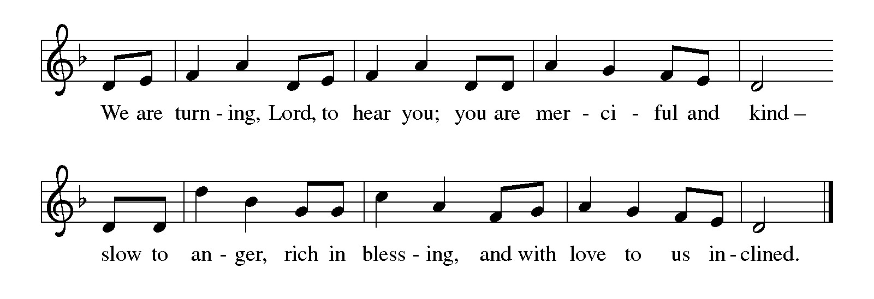

Gospel John 4:5-42
The holy gospel according to John.
Glory to You O Lord.
⁵ [Jesus] came to a Samaritan city called Sychar, near the plot of ground that Jacob had given to his son Joseph.⁶ Jacob’s well was there, and Jesus, tired out by his journey, was sitting by the well. It was about noon.
⁷ A Samaritan woman came to draw water, and Jesus said to her, “Give me a drink.” ⁸ (His disciples had gone to the city to buy food.) ⁹ The Samaritan woman said to him, “How is it that you, a Jew, ask a drink of me, a woman of Samaria?” (Jews do not share things in common with Samaritans.) ¹⁰ Jesus answered her, “If you knew the gift of God and who it is that is saying to you, ‘Give me a drink,’ you would have asked him, and he would have given you living water.” ¹¹ The woman said to him, “Sir, you have no bucket, and the well is deep. Where do you get that living water? ¹² Are you greater than our ancestor Jacob, who gave us the well and with his sons and his flocks drank from it?” ¹³ Jesus said to her, “Everyone who drinks of this water will be thirsty again, ¹⁴ but those who drink of the water that I will give them will never be thirsty. The water that I will give will become in them a spring of water gushing up to eternal life.” ¹⁵ The woman said to him, “Sir, give me this water, so that I may never be thirsty or have to keep coming here to draw water.”
¹⁶ Jesus said to her, “Go, call your husband, and come back.” ¹⁷ The woman answered him, “I have no husband.” Jesus said to her, “You are right in saying, ‘I have no husband,’ ¹⁸ for you have had five husbands, and the one you have now is not your husband. What you have said is true!” ¹⁹ The woman said to him, “Sir, I see that you are a prophet. ²⁰ Our ancestors worshiped on this mountain, but you say that the place where people must worship is in Jerusalem.” ²¹ Jesus said to her, “Woman, believe me, the hour is coming when you will worship the Father neither on this mountain nor in Jerusalem. ²² You worship what you do not know; we worship what we know, for salvation is from the Jews. ²³ But the hour is coming and is now here when the true worshipers will worship the Father in spirit and truth, for the Father seeks such as these to worship him. ²⁴ God is spirit, and those who worship him must worship in spirit and truth.” ²⁵ The woman said to him, “I know that Messiah is coming” (who is called Christ). “When he comes, he will proclaim all things to us.” ²⁶ Jesus said to her, “I am he, the one who is speaking to you.”
²⁷ Just then his disciples came. They were astonished that he was speaking with a woman, but no one said, “What do you want?” or, “Why are you speaking with her?” ²⁸ Then the woman left her water jar and went back to the city. She said to the people, ²⁹ “Come and see a man who told me everything I have ever done! He cannot be the Messiah, can he?” ³⁰ They left the city and were on their way to him.
³¹ Meanwhile the disciples were urging him, “Rabbi, eat something.” ³² But he said to them, “I have food to eat that you do not know about.” ³³ So the disciples said to one another, “Surely no one has brought him something to eat?” ³⁴ Jesus said to them, “My food is to do the will of him who sent me and to complete his work.
³⁵ Do you not say, ‘Four months more, then comes the harvest’? But I tell you, look around you, and see how the fields are ripe for harvesting. ³⁶ The reaper is already receiving wages and is gathering fruit for eternal life, so that sower and reaper may rejoice together. ³⁷ For here the saying holds true, ‘One sows and another reaps.’ ³⁸ I sent you to reap that for which you did not labor. Others have labored, and you have entered into their labor.”
³⁹ Many Samaritans from that city believed in him because of the woman’s testimony, “He told me everything I have ever done.” ⁴⁰ So when the Samaritans came to him, they asked him to stay with them, and he stayed there two days. ⁴¹ And many more believed because of his word. ⁴² They said to the woman, “It is no longer because of what you said that we believe, for we have heard for ourselves, and we know that this is truly the Savior of the world.”
The gospel of the Lord.
Praise to you, O Christ.

CHILDREN’S MOMENT
SERMON Pastor Ken Scheck

hymn of the day “Jesus, Keep Me Near The Cross” #335

prayers of Intercession
(Please Be Seated)
Reconciled by God’s mercy and sustained by God’s presence, let us pray for the world and its needs.
A brief silence.
O God, when suffering arises, preserve your church. Give to pastors, deacons, bishops, and all servants of your gospel the endurance that produces character and the hope that will never disappoint. We pray especially for Lord of Life Lutheran Church in Portage, and their pastor Rev. Martha Porter-Reid. Hear us, O God.
Your mercy is great.
When the waters run dry, sustain this earth. Send water to places languishing with drought and bring relief to places damaged by floods (especially). Hear us, O God.
Your mercy is great.
When quarrels ensue, soften our hearts. Quell hostilities between nations and peoples, and reconcile all humans across the lines of race, class, nationality, moral conviction, religion, and all else that divides or oppresses. Hear us, O God.
Your mercy is great.
When your people thirst, satisfy their needs. Send water and food to all who need nourishment. Grant welcome to all who are excluded. Show your mercy to any in need. Hear us, O God.
Your mercy is great.
When we gather to worship, send us your Spirit. Renew our hearts through the joyful noise we make and bless the work of our church musicians and musical ensembles. We pray for all those on our prayer list and those in our heart. We pray for all countries involved in ongoing conflicts and all who are affected by natural disasters.
Hear us, O God.
Your mercy is great.
O God, when death draws near, we rejoice in the promise of life with you. We remember all who have entered eternal rest, and we pray that you bring us the hope of sharing in your glory. Hear us, O God.
Your mercy is great.
Receive our prayers, O God, through Jesus Christ, our strength and salvation.
Amen.

PEACE
The peace of Christ be with you always.
And also with you.

OFFERING & OFFERING SONG
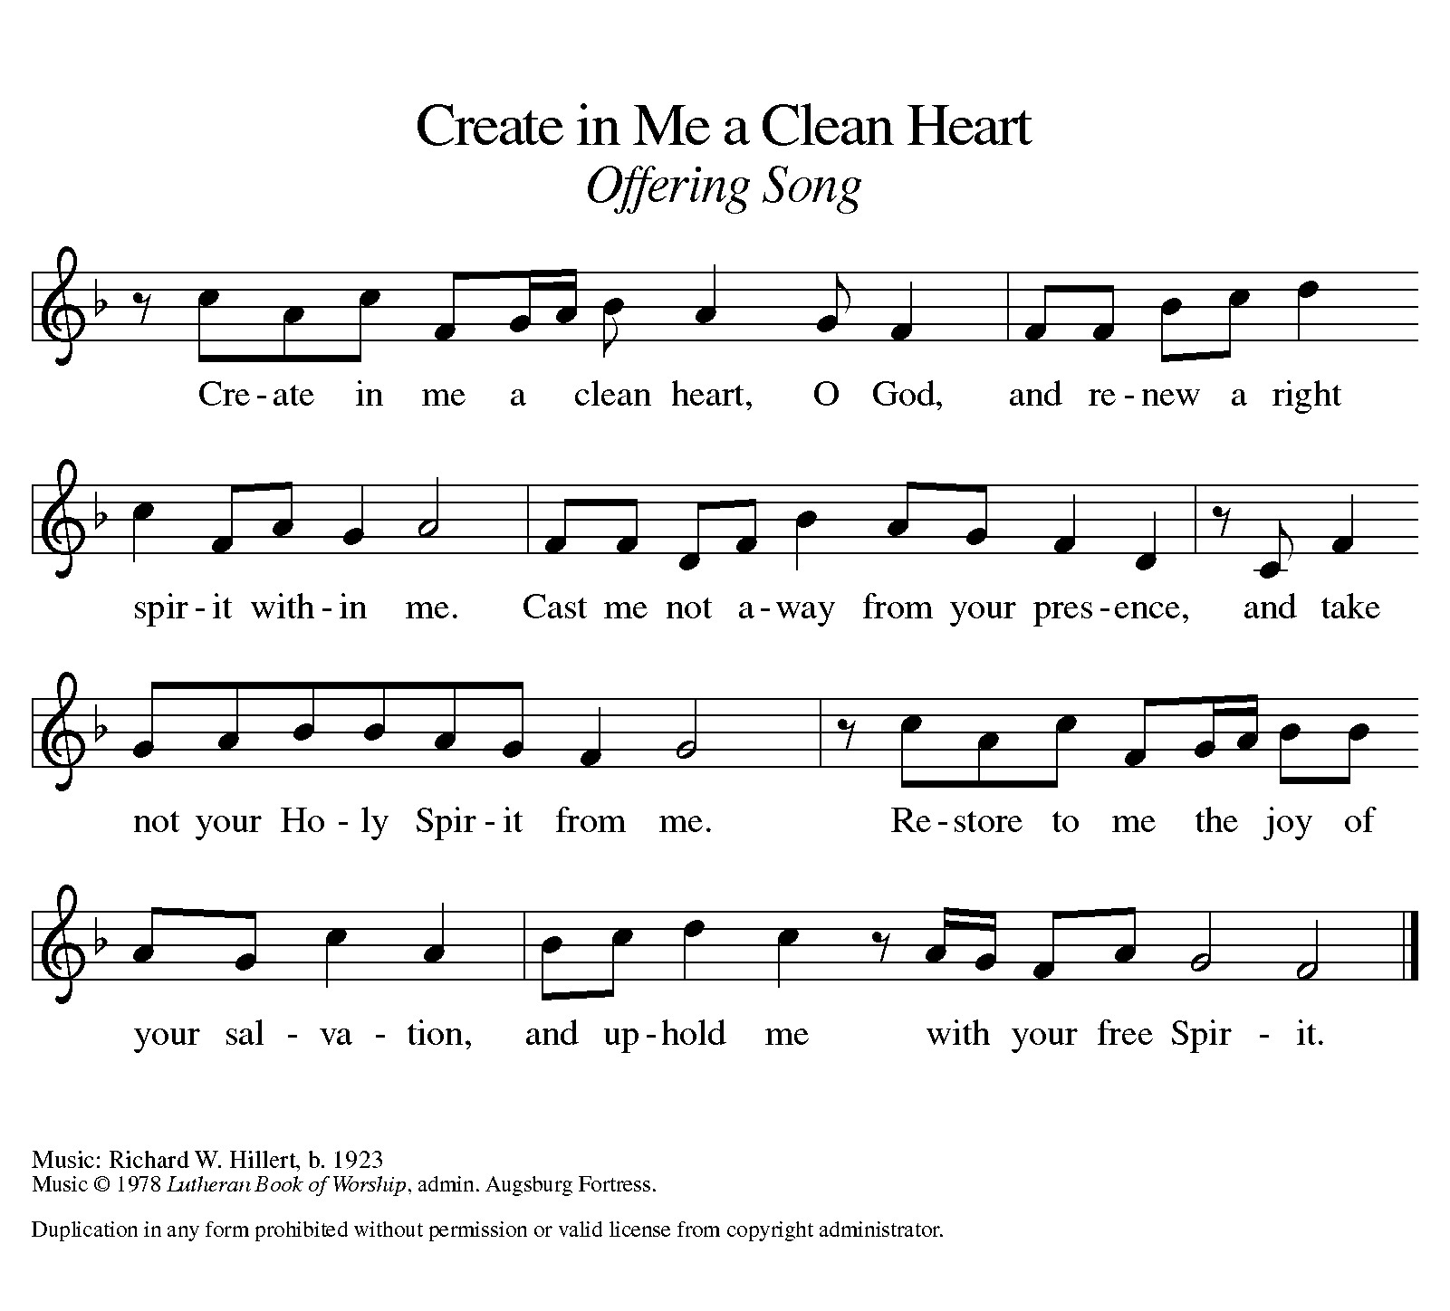
Offering Prayer
Let us pray.
Holy God, gracious and merciful, you bring forth food from the earth and nourish your whole creation. Turn our hearts toward those who hunger in any way, that all may know your care; and prepare us now to feast on the bread of life, Jesus Christ, our Savior and Lord.
Amen.

DIALOGUE
The Lord be with you.
And also with you.
Lift up your hearts.
We lift them to the Lord.
Let us give thanks to the Lord our God.
It is right to give our thanks and praise.

PREFACE (Pastor)
It is indeed right, our duty and our joy,
that we should at all times and in all places
give thanks and praise to you, almighty and merciful God,
through our Savior Jesus Christ;
who on this day overcame death and the grave,
and by his glorious resurrection opened to us the way of everlasting life.
And so, with all the choirs of angels,
with the church on earth and the hosts of heaven,
we praise your name and join their unending hymn

holy, holy, holy
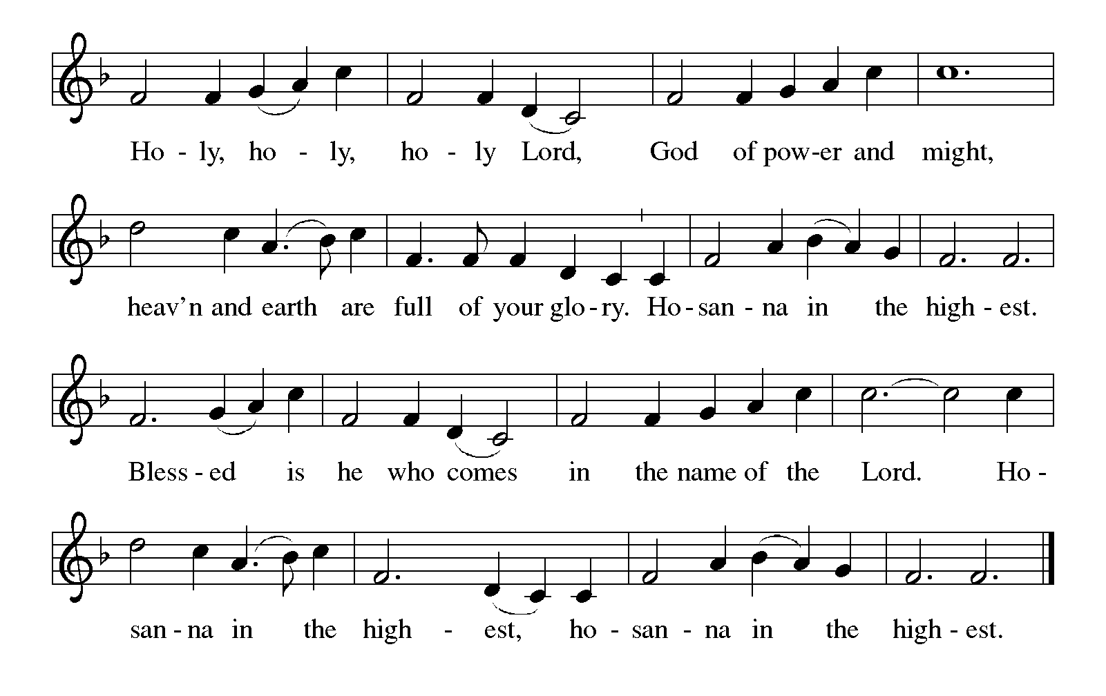
Thanksgiving at the Table
In the night in which he was betrayed,
our Lord Jesus took bread, and gave thanks;
broke it, and gave it to his disciples, saying:
Take and eat; this is my body, given for you.
Do this for the remembrance of me.

Again, after supper, he took the cup, gave thanks,
and gave it for all to drink, saying:
This cup is the new covenant in my blood,
shed for you and for all people for the forgiveness of sin.
Do this for the remembrance of me.

For as often as we eat of this bread and drink from this cup,
we proclaim the Lord’s death until he comes.

Lord’s Prayer
Gathered into one by the Holy Spirit, let us pray as Jesus taught us.
Our Father, who art in heaven,
hallowed be thy name,
thy kingdom come,
thy will be done,
on earth as it is in heaven.
Give us this day our daily bread;
and forgive us our trespasses,
as we forgive those
who trespass against us;
and lead us not into temptation,
but deliver us from evil.
For thine is the kingdom,
and the power, and the glory,
forever and ever. Amen.

INVITATION TO COMMUNION
Come to the banquet, for all is now ready.

COMMUNION *continuous
*People are welcome to kneel at the altar rail for a time of prayer after they receive their communion elements.

COMMUNION HYMNS
“I Want Jesus to Walk with Me” #325
“Bread of Life from Heaven” #474

PRAYER AFTER COMMUNION
Let us pray.
We give you thanks, almighty God, that you have refreshed us through the healing power of this gift of life. In your mercy, strengthen us through this gift, in faith toward you and in fervent love toward one another; for the sake of Jesus Christ our Lord.
Amen.

Sending
God blesses us and sends us in mission to the world.

Blessing
The Lord bless you and keep you.
The Lord’s face shine on you with grace and mercy.
The Lord look upon you with favor and ☩ give you peace.
Amen.

Sending SonG “Guide Me Ever, Great Redeemer” #618

Dismissal
Go in peace. Christ is with you.
Thanks be to God.
From sundaysandseasons.com. Copyright © 2017 Augsburg Fortress. All rights reserved.

Thank you to all who served in worship today!
Presiders: Pastor Ken Scheck Musician: Jayne Flanigan
Acolyte: Safety Person:
Elder: Naomi Wilson Trustee: Jimmy Hindman
Offering Counters: Mary Makley & Martha Yoder



PRAYERS OF THE FAITHFUL

With thanks for all God’s blessings and his love for all people. Our Bishops, Julie Schneider-Thomas, Yehiel Curry, and the congregations of the North/West Lower Michigan Synod, and especially Lord of Life Lutheran Church in Portage, and their pastor Rev. Martha Porter-Reid.

Prayers for our friends, for all who are sick or hospitalized and for all health care workers who care for them. All those members of Zion’s family traveling; all those homebound or in frail health; all those suffering with quiet, unknown needs or worries. For those who serve on our behalf: public safety, utility workers, medical personnel, military personnel. For those who might be forgotten. We pray especially all countries involved in ongoing conflicts.

This week at Zion:
- Council Metting 6:30pm, Tuesday 10
- Men’s Breakfast 8am, Wednesday 11
- Bulletin Deadline, Wednesday 11
- Women’s Coffee Fellowship, C&R, 9 am, Thursday 12
- Bell Ringing & Prayer, 1 pm, Saturday 14

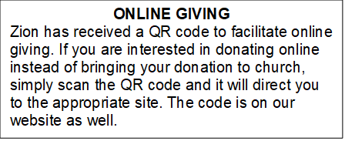

How to Contact the Pastor: If there is a pastoral need, please contact Pastor Ken Scheck II at 269-370-4632 or by email at kscheckii@aol.com.

ANNOUNCEMENTS
- First-Aid Supplies for Synod Mission Trip to Honduras: Our synod’s mission trip to Honduras in April supports the “Health for Life” ministry. This project promotes healthy living by educating health volunteers and by increasing access to life’s basis needs. Our synod has been asked to conduct training on basic first-aid and health. They will be training and equipping volunteers who will help those in their communities. We can help by providing first-aid supplies and donations for this ministry. There is a “shopping list” on the table in the narthex. Please consider supporting our synod team that includes Pastor Mike Anderson and Vicki.
- Note from the Board of Stewardship: Our congregation continues to grow in its mission to share Christ’s love in our community. As we look ahead to the coming months, we will be facing a shortfall in our operating budget. If you are able, we invite you to consider an additional gift to support our worship, outreach, and care ministries. Every contribution, large or small, strengthens the work we do together in Christ’s name. Thank you for your faithful generosity.
- Annual Easter Egg Hunt for Zion’s Kids: The Parish Board will be sponsoring an Easter Egg Hunt for our kiddos on Palm Sunday, March 29th. We are asking for donations of candy, trinkets, coins or other kid friendly items that will fit into our plastic Easter eggs. Please put donations in the box marked for these donations in the Fellowship Hall by March 22nd. We want to thank the congregation for their continued support for this event for our Sunday School kids.
- Service for Jerry Engle and Thank You: My family and I want to thank you all for the prayers, kind messages, cards, calls and gifts of food and other items since the time of Jerry's passing. These kindnesses are greatly appreciated. Jerry's celebration of life service will be at Zion on Saturday, April 11th. Visitation will begin at 10:00 with the service at 11:00. We will have time to share stories of Jerry at the lunch, prepared and served by our church family, in the Fellowship Hall immediately following the service. --- Carol Engle and family
- Join us for Lent: The theme for our second Lenten service is PASSION: God’s Will. The Soup/Salad Supper starts at 6 pm, come when you can. The service follows at 7:15 pm. (You can come to the service only if the dinner time does not work for you.) We hope to see you on Wednesday!
- Palm Sunday Path: The Palm Sunday Path is a Christian walk being planned for Palm Sunday in Lansing from Pilgrim Church to the Capitol Building at 3:00 pm. If you are interested in more information or joining in the walk, there are information sheets on the table in the Narthex.
- Pray Without Ceasing: Everyday there seems to be something new that needs our prayer! To help us have more time in prayer for people and events near and far, we are interested in restarting our special Pray Without Ceasing services. We are reaching out to learn if there is enough interest. One suggestion is to hold the services on Thursdays at 3:00 pm and also following worship on Sundays when there is no fellowship. There is a sheet on the table in the Narthex to indicate whether you are interested, if this day/time would work, or if you would suggest a different day and time. If you have questions, please see Martha.
- Seeking GOD’S Way: This Lent you are invited to journey with God. Come to our dinner and worships (7:00 pm after Ash Wednesday), as we Seek God’s Way. We will explore God’s MERCY, which is the heart of God. As we journey, we will find God’s PASSION for each of us. We will find that God’s LOVE is on the move, allowing us to realize the grace that is given to all creation. Even in hardship Christians know the gift of LIFE, as we walk with the knowledge of God’s care, allowing all of us to have JOY. Zion Dinners at 6:00 p.m. Wednesdays on February 25; March 4, 11, 18 and 25.
- Pastor’s Availability: Pastor Ken Scheck II is available by appointment to meet with you. As you know homebound visitation has begun and will continue until all homebound have been visited by Pastor Ken. Generally speaking, he is at Grace on Mondays and Wednesdays and Zion on Tuesdays and Thursdays with a day off on Friday. As you may be aware, Pastor Ken has come to the Men’s meeting and Lakewood Area Ministerial Association meetings on Wednesday here at Zion. Flexibility is the name of the game. He is more than willing to be contacted at any time by cellphone or email. Please feel free to contact him at 269-370-4632 or at kscheckii@aol.com. You are able to send a text to the cellphone, but please identify yourself at least the first time.
- Pastor Ken's installation: Join us for Pastor Ken's installation service on March 22. Bishop Julie Schneider-Thomas will be here for the Sunday School hour, worship and a time of fellowship. Join us for this time of celebration.
- Save the Date: Mark your calendar for April 19th! We will be hosting an open house for Pastor Ken and inviting the community to come, have lunch with us, and meet our Pastor. Watch for more details!
- Announcement and Newsletter Items: Please forward items for the bulletin announcements and the newsletter to the church email (Office@Zion.org). Please do not send items to people’s personal emails. Thank you.
- Door Locking Policy: Our door locking policy relies on having a volunteer(s) each Sunday to serve as the Safety Person of the Day. On Sundays where no one has volunteered, if someone arrives at church and is willing to be the Safety Person of the Day, we will follow the door locking policy. If no one steps forward to serve as the Safety Person of the Day, the doors will not be locked. Please consider volunteering for this important duty.

