ZION LUTHERAN CHURCH, WOODLAND, MI
Fourth Sunday in Lent March 15, 2026
*If you are listening in your car, please tune your radio to FM 87.7*
(Please silence your cell phones while in the sanctuary. Thank you.)

WELCOME AND ANNOUNCEMENTS

Gathering
The Holy Spirit calls us together as the people of God.

Confession and Forgiveness
In the name of the Father,
and of the ☩ Son,
and of the Holy Spirit.
Amen.

Almighty God, to whom all hearts are open, all desires known, and from whom no secrets are hid: cleanse the thoughts of our hearts by the inspiration of your Holy Spirit, that we may perfectly love you and worthily magnify your holy name, through Jesus Christ our Lord.
Amen.

Let us confess our sin in the presence of God and of one another. Most merciful God,
we confess that we are captive to sin and cannot free ourselves. We have sinned against you in thought, word, and deed, by what we have done and by what we have left undone. We have not loved you with our whole heart; we have not loved our neighbors as ourselves. For the sake of your Son, Jesus Christ, have mercy on us. Forgive us, renew us, and lead us, so that we may delight in your will and walk in your ways, to the glory of your holy name.
Amen.

God, who is rich in mercy, loved us even when we were dead in sin, and made us alive together with Christ. By grace you have been saved. In the name of ☩ Jesus Christ, your sins are forgiven. Almighty God strengthen you with power through the Holy Spirit, that Christ may live in your hearts through faith. Amen.
Gathering Song “O Christ, Your Heart, Compassionate” #722

GREETING
The grace of our Lord Jesus Christ, the love of God, and the communion of the Holy Spirit be with you all.
And also with you.
Praise hymn: “Kyrie Eleison”
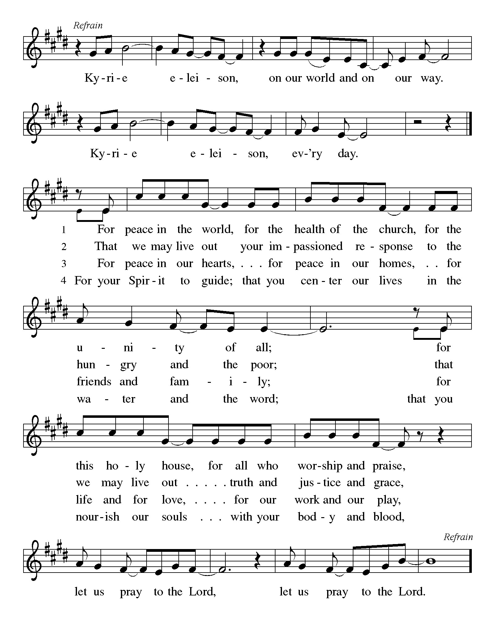

Prayer of the Day
Let us pray together.
Bend your ear to our prayers, Lord Christ, and come among us. By your gracious life and death for us, bring light into the darkness of our hearts, and anoint us with your Spirit, for you live and reign with the Father and the Holy Spirit, one God, now and forever.
Amen.

First Reading 1 Samuel 16:1-13
A reading from 1 Samuel.
¹ The Lord said to Samuel, “How long will you grieve over Saul? I have rejected him from being king over Israel. Fill your horn with oil and set out; I will send you to Jesse the Bethlehemite, for I have provided for myself a king among his sons.” ² Samuel said, “How can I go? If Saul hears of it, he will kill me.” And the Lord said, “Take a heifer with you and say, ‘I have come to sacrifice to the Lord.’ ³ Invite Jesse to the sacrifice, and I will show you what you shall do, and you shall anoint for me the one whom I name to you.” ⁴ Samuel did what the Lord commanded and came to Bethlehem. The elders of the city came to meet him trembling and said, “Do you come peaceably?” ⁵ He said, “Peaceably. I have come to sacrifice to the Lord; sanctify yourselves and come with me to the sacrifice.” And he sanctified Jesse and his sons and invited them to the sacrifice.
⁶ When they came, he looked on Eliab and thought, “Surely his anointed is now before the Lord.” ⁷ But the Lord said to Samuel, “Do not look on his appearance or on the height of his stature, because I have rejected him, for the Lord does not see as mortals see; they look on the outward appearance, but the Lord looks on the heart.” ⁸ Then Jesse called Abinadab and made him pass before Samuel. He said, “Neither has the Lord chosen this one.” ⁹ Then Jesse made Shammah pass by. And he said, “Neither has the Lord chosen this one.” ¹⁰ Jesse made seven of his sons pass before Samuel, and Samuel said to Jesse, “The Lord has not chosen any of these.” ¹¹ Samuel said to Jesse, “Are all your sons here?” And he said, “There remains yet the youngest, but he is keeping the sheep.” And Samuel said to Jesse, “Send and bring him, for we will not sit down until he comes here.” ¹² He sent and brought him in. Now he was ruddy and had beautiful eyes and was handsome. The Lord said, “Rise and anoint him, for this is the one.” ¹³ Then Samuel took the horn of oil and anointed him in the presence of his brothers, and the spirit of the Lord came mightily upon David from that day forward. Samuel then set out and went to Ramah.

The word of the Lord.
Thanks be to God.

Psalm Psalm 23
¹ The Lord | is my shepherd;
I shall not | be in want.
² The Lord makes me lie down | in green pastures
and leads me be- | side still waters.
³ You restore my | soul, O Lord,
and guide me along right pathways | for your name’s sake.
⁴ Though I walk through the valley of the shadow of death, I shall | fear no evil;
for you are with me; your rod and your staff, they | comfort me.
⁵ You prepare a table before me in the presence | of my enemies;
you anoint my head with oil, and my cup is | running over.
⁶ Surely goodness and mercy shall follow me all the days | of my life,
and I will dwell in the house of the | Lord forever.

Second Reading Ephesians 5:8-14
A reading from Ephesians.
⁸ Once you were darkness, but now in the Lord you are light. Walk as children of light, ⁹ for the fruit of the light is found in all that is good and right and true. ¹⁰ Try to find out what is pleasing to the Lord. ¹¹ Take no part in the unfruitful works of darkness; rather, expose them. ¹² For it is shameful even to mention what such people do secretly, ¹³ but everything exposed by the light becomes visible, ¹⁴ for everything that becomes visible is light. Therefore it says,
“Sleeper, awake!
Rise from the dead,
and Christ will shine on you.”

The Word of the Lord
Thanks be to God.

Gospel Acclamation

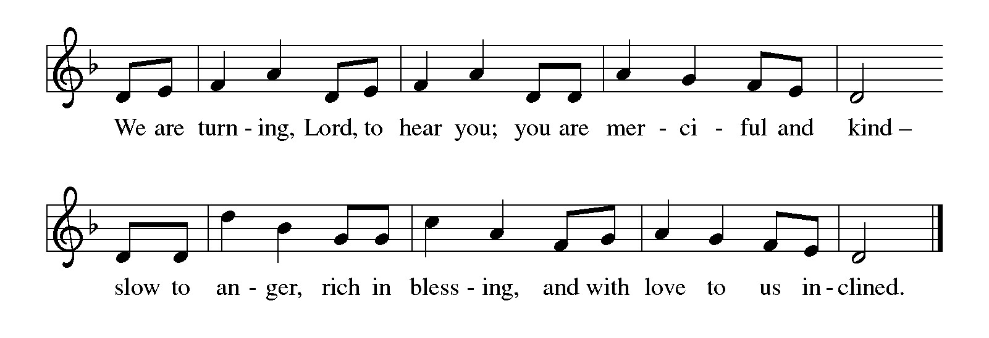

Gospel John 9:1-41
The holy gospel according to John.
Glory to You O Lord.
¹ As [Jesus] walked along, he saw a man blind from birth. ² His disciples asked him, “Rabbi, who sinned, this man or his parents, that he was born blind?” ³ Jesus answered, “Neither this man nor his parents sinned; he was born blind so that God’s works might be revealed in him. ⁴ We must work the works of him who sent me while it is day; night is coming, when no one can work. ⁵ As long as I am in the world, I am the light of the world.” ⁶ When he had said this, he spat on the ground and made mud with the saliva and spread the mud on the man’s eyes, ⁷ saying to him, “Go, wash in the pool of Siloam” (which means Sent). Then he went and washed and came back able to see. ⁸ The neighbors and those who had seen him before as a beggar began to ask, “Is this not the man who used to sit and beg?” ⁹ Some were saying, “It is he.” Others were saying, “No, but it is someone like him.” He kept saying, “I am he.” ¹⁰ But they kept asking him, “Then how were your eyes opened?” ¹¹ He answered, “The man called Jesus made mud, spread it on my eyes, and said to me, ‘Go to Siloam and wash.’ Then I went and washed and received my sight.” ¹² They said to him, “Where is he?” He said, “I do not know.”
¹³ They brought to the Pharisees the man who had formerly been blind. ¹⁴ Now it was a Sabbath day when Jesus made the mud and opened his eyes. ¹⁵ Then the Pharisees also began to ask him how he had received his sight. He said to them, “He put mud on my eyes. Then I washed, and now I see.” ¹⁶ Some of the Pharisees said, “This man is not from God, for he does not observe the Sabbath.” Others said, “How can a man who is a sinner perform such signs?” And they were divided. ¹⁷ So they said again to the blind man, “What do you say about him? It was your eyes he opened.” He said, “He is a prophet.”
¹⁸ The Jews did not believe that he had been blind and had received his sight until they called the parents of the man who had received his sight ¹⁹ and asked them, “Is this your son, who you say was born blind? How then does he now see?” ²⁰ His parents answered, “We know that this is our son and that he was born blind, ²¹ but we do not know how it is that now he sees, nor do we know who opened his eyes. Ask him; he is of age. He will speak for himself.” ²² His parents said this because they were afraid of the Jews, for the Jews had already agreed that anyone who confessed Jesus to be the Messiah would be put out of the synagogue. ²³ Therefore his parents said, “He is of age; ask him.”
²⁴ So for the second time they called the man who had been blind, and they said to him, “Give glory to God! We know that this man is a sinner.” ²⁵ He answered, “I do not know whether he is a sinner. One thing I do know, that though I was blind, now I see.” ²⁶ They said to him, “What did he do to you? How did he open your eyes?” ²⁷ He answered them, “I have told you already, and you would not listen. Why do you want to hear it again? Do you also want to become his disciples?” ²⁸ Then they reviled him, saying, “You are his disciple, but we are disciples of Moses. ²⁹ We know that God has spoken to Moses, but as for this man, we do not know where he comes from.” ³⁰ The man answered, “Here is an astonishing thing! You do not know where he comes from, yet he opened my eyes. ³¹ We know that God does not listen to sinners, but he does listen to one who worships him and obeys his will. ³² Never since the world began has it been heard that anyone opened the eyes of a person born blind. ³³ If this man were not from God, he could do nothing.” ³⁴ They answered him, “You were born entirely in sins, and are you trying to teach us?” And they drove him out.
³⁵ Jesus heard that they had driven him out, and when he found him he said, “Do you believe in the Son of Man?” ³⁶ He answered, “And who is he, sir? Tell me, so that I may believe in him.” ³⁷ Jesus said to him, “You have seen him, and the one speaking with you is he.” ³⁸ He said, “Lord, I believe.” And he worshiped him. ³⁹ Jesus said, “I came into this world for judgment, so that those who do not see may see and those who do see may become blind.” ⁴⁰ Some of the Pharisees who were with him heard this and said to him, “Surely we are not blind, are we?” ⁴¹ Jesus said to them, “If you were blind, you would not have sin. But now that you say, ‘We see,’ your sin remains.”

The gospel of the Lord.
Praise to you, O Christ.

CHILDREN’S MOMENT
SERMON Pastor Ken Scheck

hymn of the day “Amazing Grace, How Sweet the Sound” #779

prayers of Intercession
(Please Be Seated)
Reconciled by God’s mercy and sustained by God’s presence, let us pray for the world and its needs.
A brief silence.
God, our shepherd, we pray that you guide the church. Lead Christians in our community across the globe in right paths for your name’s sake. We pray especially for Prince of Peace Lutheran Church, and their pastor Rev. Rachel Laughlin.
Hear us, O God.
Your mercy is great.
God our provider, we cry out for this planet and the life it holds. Rescue endangered animals and plants, preserve threatened ecosystems, and save creatures from natural disasters. Hear us, O God.
Your mercy is great.
God our sovereign, we plead for your peace on earth. Bring an end to war and violence, and raise up leaders in governments, courts, businesses, schools, and community organizations who seek goodness and mercy. Hear us, O God.
Your mercy is great.
God our healer, we call to you in our need. Uplift all who are made to feel unimportant, and transform the hearts of all infected by bigotry and prejudice. Care for all in special need this day. Hear us, O God.
Your mercy is great.
God our friend, we praise you for the diversity of people among us. Awaken us to share and receive the gifts we each possess, and stir up a spirit of understanding, celebration, and welcome for all. Hear us, O God.
Your mercy is great.
God our home, we thank you for all who have died and completed their baptismal journeys. Grant us faith to live until we too dwell in your house forever. Hear us, O God.
Your mercy is great.
Receive our prayers, O God, through Jesus Christ, our strength and salvation.
Amen.

PEACE
The peace of Christ be with you always.
And also with you.

OFFERING & OFFERING SONG
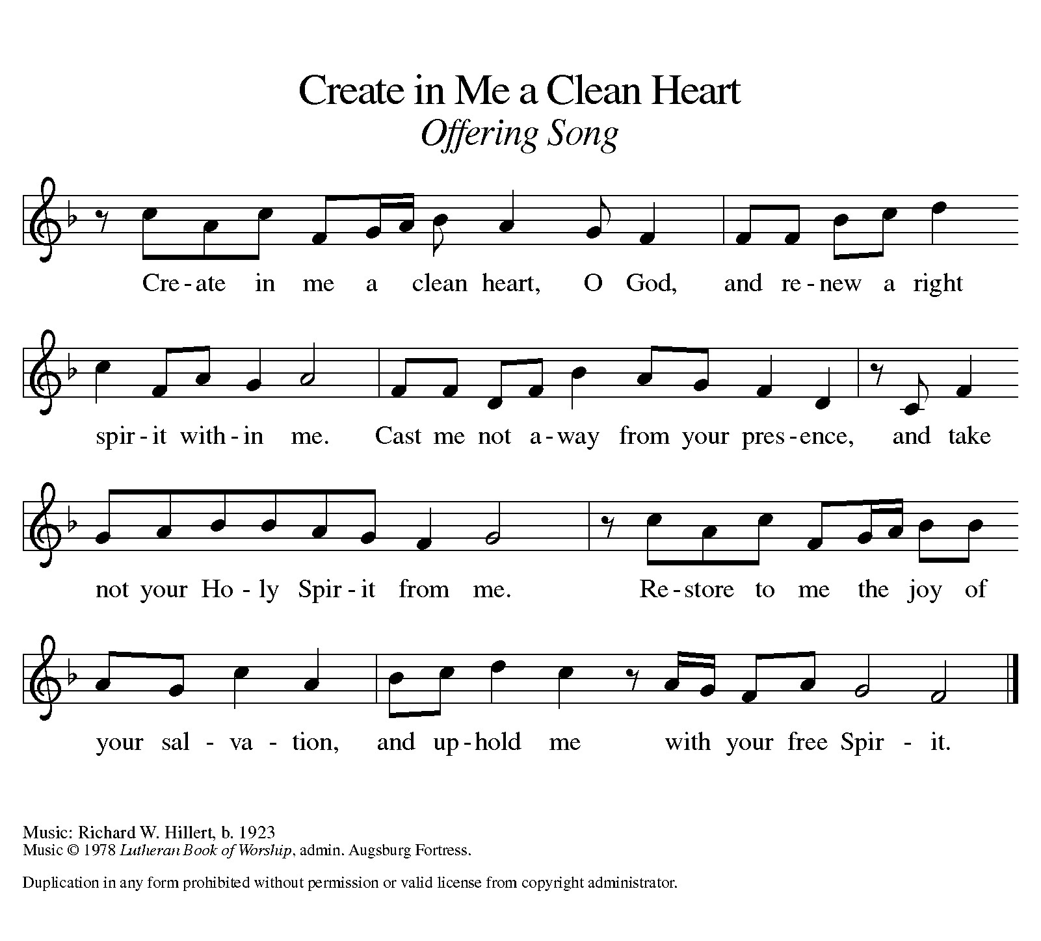

Offering Prayer
Let us pray.
Holy God, gracious and merciful, you bring forth food from the earth and nourish your whole creation. Turn our hearts toward those who hunger in any way, that all may know your care; and prepare us now to feast on the bread of life, Jesus Christ, our Savior and Lord.
Amen.

DIALOGUE
The Lord be with you.
And also with you.
Lift up your hearts.
We lift them to the Lord.
Let us give thanks to the Lord our God.
It is right to give our thanks and praise.

PREFACE (Pastor)
It is indeed right, our duty and our joy,
that we should at all times and in all places
give thanks and praise to you, almighty and merciful God,
through our Savior Jesus Christ;
who on this day overcame death and the grave,
and by his glorious resurrection opened to us the way of everlasting life.
And so, with all the choirs of angels,
with the church on earth and the hosts of heaven,
we praise your name and join their unending hymn

holy, holy, holy

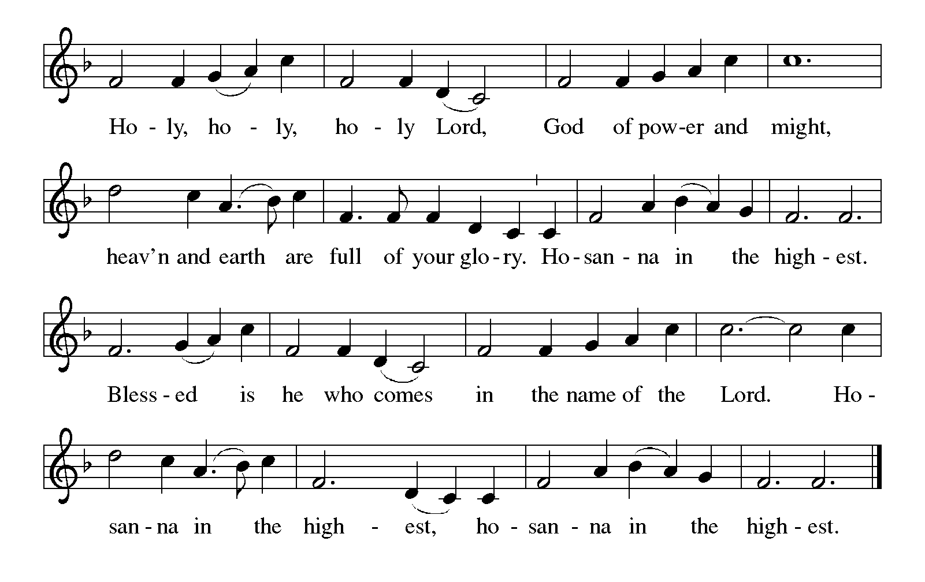

Thanksgiving at the Table
In the night in which he was betrayed,
our Lord Jesus took bread, and gave thanks;
broke it, and gave it to his disciples, saying:
Take and eat; this is my body, given for you.
Do this for the remembrance of me.

Again, after supper, he took the cup, gave thanks,
and gave it for all to drink, saying:
This cup is the new covenant in my blood,
shed for you and for all people for the forgiveness of sin.
Do this for the remembrance of me.

For as often as we eat of this bread and drink from this cup,
we proclaim the Lord’s death until he comes.

Lord’s Prayer
Gathered into one by the Holy Spirit, let us pray as Jesus taught us.
Our Father, who art in heaven,
hallowed be thy name,
thy kingdom come,
thy will be done,
on earth as it is in heaven.
Give us this day our daily bread;
and forgive us our trespasses,
as we forgive those
who trespass against us;
and lead us not into temptation,
but deliver us from evil.
For thine is the kingdom,
and the power, and the glory,
forever and ever. Amen.

INVITATION TO COMMUNION
Come to the banquet, for all is now ready.

COMMUNION *continuous
*People are welcome to kneel at the altar rail for a time of prayer after they receive their communion elements.

COMMUNION HYMNS
“I Want Jesus to Walk with Me” #325
“Be Thou My Vision” #793

PRAYER AFTER COMMUNION
Let us pray.
We give you thanks, almighty God, that you have refreshed us through the healing power of this gift of life. In your mercy, strengthen us through this gift, in faith toward you and in fervent love toward one another; for the sake of Jesus Christ our Lord.
Amen.

Sending
God blesses us and sends us in mission to the world.

Blessing
The Lord bless you and keep you.
The Lord’s face shine on you with grace and mercy.
The Lord look upon you with favor and ☩ give you peace.
Amen.
Sending SonG “In the Cross of Christ I Glory” #324

Dismissal
Go in peace. Christ is with you.
Thanks be to God.
From sundaysandseasons.com. Copyright © 2017 Augsburg Fortress. All rights reserved.

Thank you to all who served in worship today!
Presiders: Pastor Ken Scheck Musician: Martha Yoder
Acolyte: Kole Hokanson Safety Person:
Elder: Dan Utterback Trustee: Mike Johnson
Offering Counters: Diane Griffin & Carlotta Willard



PRAYERS OF THE FAITHFUL

With thanks for all God’s blessings and his love for all people. Our Bishops, Julie Schneider-Thomas, Yehiel Curry, and the congregations of the North/West Lower Michigan Synod, and especially Prince of Peace Lutheran Church, and their pastor Rev. Rachel Laughlin.

Prayers for our friends, for all who are sick or hospitalized and for all health care workers who care for them. All those members of Zion’s family traveling; all those homebound or in frail health; all those suffering with quiet, unknown needs or worries. For those who serve on our behalf: public safety, utility workers, medical personnel, military personnel. For those who might be forgotten. We pray especially for all countries involved in ongoing conflicts.

This week at Zion:
- Men’s Breakfast 8am, Wednesday 18
- Bulletin Deadline, Wednesday 18
- Lenten Service, 7pm Wednesday 18
- Bell Ringing & Prayer, 1 pm, Saturday 21

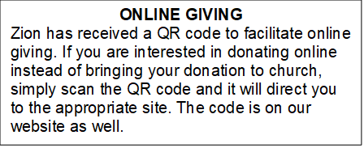

How to Contact the Pastor: If there is a pastoral need, please contact Pastor Ken Scheck II at 269-370-4632 or by email at kscheckii@aol.com.

ANNOUNCEMENTS
- First-Aid Supplies for Synod Mission Trip to Honduras: Our synod’s mission trip to Honduras in April supports the “Health for Life” ministry. This project promotes healthy living by educating health volunteers and by increasing access to life’s basis needs. Our synod has been asked to conduct training on basic first-aid and health. They will be training and equipping volunteers who will help those in their communities. We can help by providing first-aid supplies and donations for this ministry. There is a “shopping list” on the table in the narthex. Please consider supporting our synod team that includes Pastor Mike Anderson and Vicki.
- Note from the Board of Stewardship: Our congregation continues to grow in its mission to share Christ’s love in our community. As we look ahead to the coming months, we will be facing a shortfall in our operating budget. If you are able, we invite you to consider an additional gift to support our worship, outreach, and care ministries. Every contribution, large or small, strengthens the work we do together in Christ’s name. Thank you for your faithful generosity.
- Annual Easter Egg Hunt for Zion’s Kids: The Parish Board will be sponsoring an Easter Egg Hunt for our kiddos on Palm Sunday, March 29th. We are asking for donations of candy, trinkets, coins or other kid friendly items that will fit into our plastic Easter eggs. Please put donations in the box marked for these donations in the Fellowship Hall by March 22nd. We want to thank the congregation for their continued support for this event for our Sunday School kids.
- Service for Jerry Engle and Thank You: My family and I want to thank you all for the prayers, kind messages, cards, calls and gifts of food and other items since the time of Jerry's passing. These kindnesses are greatly appreciated. Jerry's celebration of life service will be at Zion on Saturday, April 11th. Visitation will begin at 10:00 with the service at 11:00. We will have time to share stories of Jerry at the lunch, prepared and served by our church family, in the Fellowship Hall immediately following the service. --- Carol Engle and family
- Join us for Lent: The theme for our second Lenten service is PASSION: God’s Will. The Soup/Salad Supper starts at 6 pm, come when you can. The service follows at 7:00 pm. (You can come to the service only if the dinner time does not work for you.) We hope to see you on Wednesday!
- Palm Sunday Path: The Palm Sunday Path is a Christian walk being planned for Palm Sunday in Lansing from Pilgrim Church to the Capitol Building at 3:00 pm. If you are interested in more information or joining in the walk, there are information sheets on the table in the Narthex.
- Pray Without Ceasing: Everyday there seems to be something new that needs our prayer! To help us have more time in prayer for people and events near and far, we are interested in restarting our special Pray Without Ceasing services. We are reaching out to learn if there is enough interest. One suggestion is to hold the services on Thursdays at 3:00 pm and also following worship on Sundays when there is no fellowship. There is a sheet on the table in the Narthex to indicate whether you are interested, if this day/time would work, or if you would suggest a different day and time. If you have questions, please see Martha.
- Seeking GOD’S Way: This Lent you are invited to journey with God. Come to our dinner and worships (7:00 pm after Ash Wednesday), as we Seek God’s Way. We will explore God’s MERCY, which is the heart of God. As we journey, we will find God’s PASSION for each of us. We will find that God’s LOVE is on the move, allowing us to realize the grace that is given to all creation. Even in hardship Christians know the gift of LIFE, as we walk with the knowledge of God’s care, allowing all of us to have JOY. Zion Dinners at 6:00 p.m. Wednesdays on February 25; March 4, 11, 18 and 25.
- Pastor’s Availability: Pastor Ken Scheck II is available by appointment to meet with you. As you know homebound visitation has begun and will continue until all homebound have been visited by Pastor Ken. Generally speaking, he is at Grace on Mondays and Wednesdays and Zion on Tuesdays and Thursdays with a day off on Friday. As you may be aware, Pastor Ken has come to the Men’s meeting and Lakewood Area Ministerial Association meetings on Wednesday here at Zion. Flexibility is the name of the game. He is more than willing to be contacted at any time by cellphone or email. Please feel free to contact him at 269-370-4632 or at kscheckii@aol.com. You are able to send a text to the cellphone, but please identify yourself at least the first time.
- Pastor Ken's installation: Join us for Pastor Ken's installation service on March 22. Bishop Julie Schneider-Thomas will be here for the Sunday School hour, worship and a time of fellowship. Join us for this time of celebration.
- Save the Date: Mark your calendar for April 19th! We will be hosting an open house for Pastor Ken and inviting the community to come, have lunch with us, and meet our Pastor. Watch for more details!
- Announcement and Newsletter Items: Please forward items for the bulletin announcements and the newsletter to the church email (Office@Zion.org). Please do not send items to people’s personal emails. Thank you.
- Door Locking Policy: Our door locking policy relies on having a volunteer(s) each Sunday to serve as the Safety Person of the Day. On Sundays where no one has volunteered, if someone arrives at church and is willing to be the Safety Person of the Day, we will follow the door locking policy. If no one steps forward to serve as the Safety Person of the Day, the doors will not be locked. Please consider volunteering for this important duty.

