ZION LUTHERAN CHURCH, WOODLAND, MI
Fifth Sunday in Lent March 22, 2026
*If you are listening in your car, please tune your radio to FM 87.7*
(Please silence your cell phones while in the sanctuary. Thank you.)

We Welcome Bishop Julie Schneider-Thomas

WELCOME AND ANNOUNCEMENTS

Gathering
The Holy Spirit calls us together as the people of God.

Confession and Forgiveness
In the name of the Father,
and of the ☩ Son,
and of the Holy Spirit.
Amen.

Almighty God, to whom all hearts are open, all desires known, and from whom no secrets are hid: cleanse the thoughts of our hearts by the inspiration of your Holy Spirit, that we may perfectly love you and worthily magnify your holy name, through Jesus Christ our Lord.
Amen.

Let us confess our sin in the presence of God and of one another. Most merciful God,
we confess that we are captive to sin and cannot free ourselves. We have sinned against you in thought, word, and deed, by what we have done and by what we have left undone. We have not loved you with our whole heart; we have not loved our neighbors as ourselves. For the sake of your Son, Jesus Christ, have mercy on us. Forgive us, renew us, and lead us, so that we may delight in your will and walk in your ways, to the glory of your holy name.
Amen.

God, who is rich in mercy, loved us even when we were dead in sin, and made us alive together with Christ. By grace you have been saved. In the name of ☩ Jesus Christ, your sins are forgiven. Almighty God strengthen you with power through the Holy Spirit, that Christ may live in your hearts through faith. Amen.

Gathering Song “Restore in Us, O God ” #328
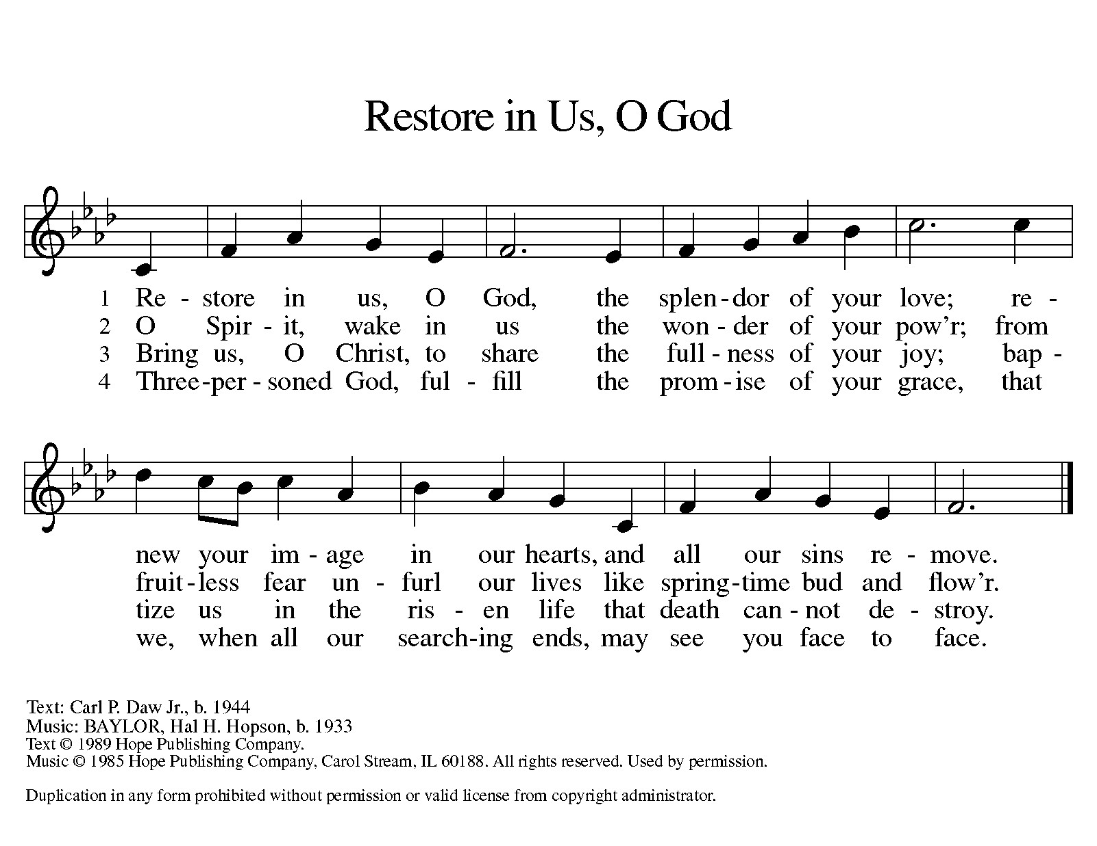

GREETING
The grace of our Lord Jesus Christ, the love of God, and the communion of the Holy Spirit be with you all.
And also with you.

Praise hymn: “Kyrie Eleison”
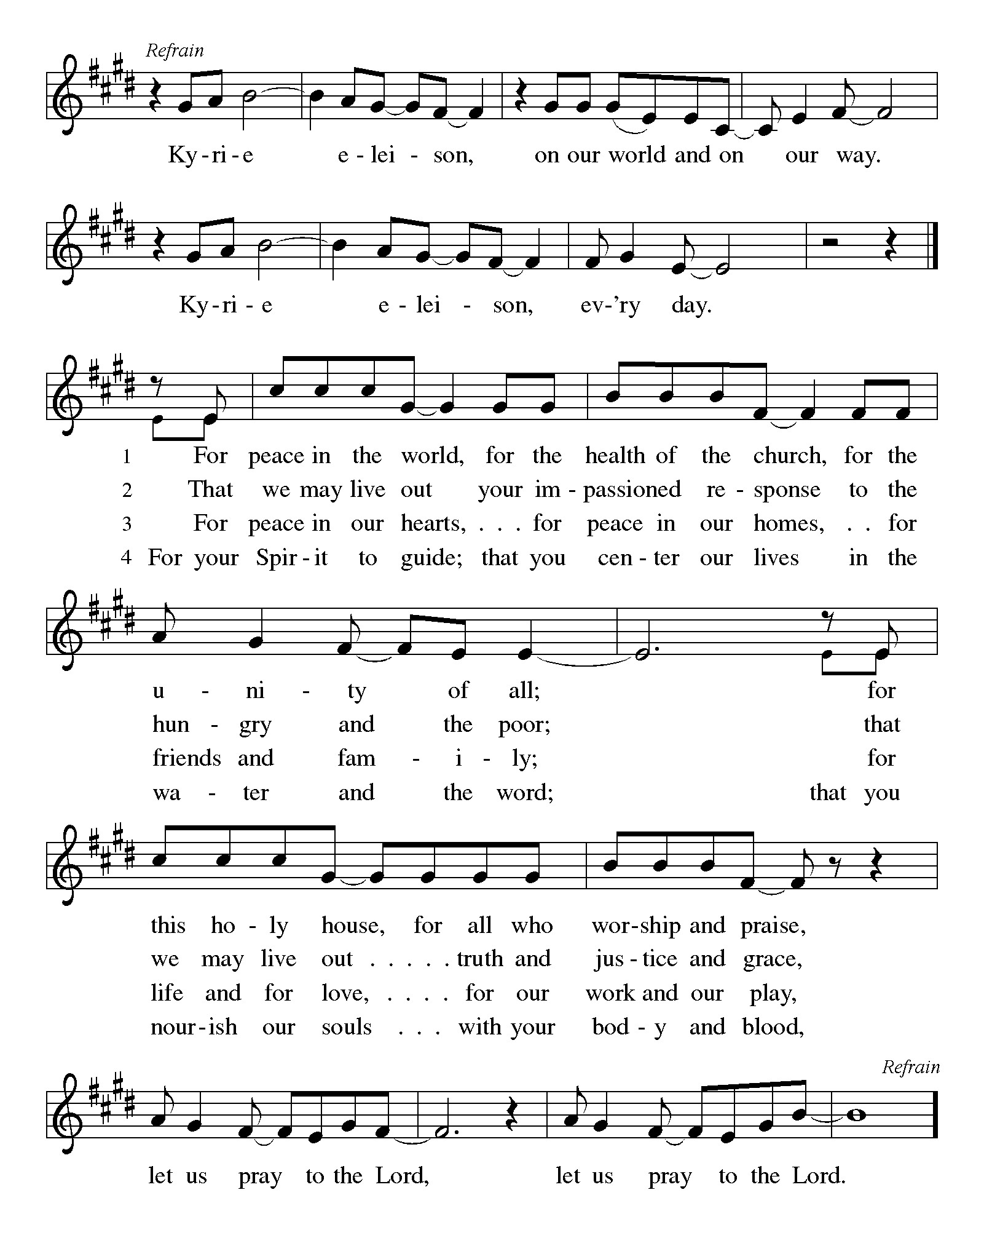

Prayer of the Day
Let us pray together.
Almighty God, your Son came into the world to free us all from sin and death. Breathe upon us the power of your Spirit, that we may be raised to new life in Christ and serve you in righteousness all our days, through Jesus Christ, our Savior and Lord, who lives and reigns with you and the Holy Spirit, one God, now and forever.
Amen.

First Reading Ezekiel 37:1-14
A reading from Ezekiel.

¹ The hand of the Lord came upon me, and he brought me out by the spirit of the Lord and set me down in the middle of a valley; it was full of bones. ² He led me all around them; there were very many lying in the valley, and they were very dry. ³ He said to me, “Mortal, can these bones live?” I answered, “O Lord God, you know.” ⁴ Then he said to me, “Prophesy to these bones and say to them: O dry bones, hear the word of the Lord. ⁵ Thus says the Lord God to these bones: I will cause breath to enter you, and you shall live. ⁶ I will lay sinews on you and will cause flesh to come upon you and cover you with skin and put breath in you, and you shall live, and you shall know that I am the Lord.”
⁷ So I prophesied as I had been commanded, and as I prophesied, suddenly there was a noise, a rattling, and the bones came together, bone to its bone. ⁸ I looked, and there were sinews on them, and flesh had come upon them, and skin had covered them, but there was no breath in them. ⁹ Then he said to me, “Prophesy to the breath, prophesy, mortal, and say to the breath: Thus says the Lord God: Come from the four winds, O breath, and breathe upon these slain, that they may live.” ¹⁰ I prophesied as he commanded me, and the breath came into them, and they lived and stood on their feet, a vast multitude.
¹¹ Then he said to me, “Mortal, these bones are the whole house of Israel. They say, ‘Our bones are dried up, and our hope is lost; we are cut off completely.’ ¹² Therefore prophesy and say to them: Thus says the Lord God: I am going to open your graves and bring you up from your graves, O my people, and I will bring you back to the land of Israel. ¹³ And you shall know that I am the Lord when I open your graves and bring you up from your graves, O my people. ¹⁴ I will put my spirit within you, and you shall live, and I will place you on your own soil; then you shall know that I, the Lord, have spoken and will act, says the Lord.”

The word of the Lord.
Thanks be to God.

Psalm Psalm 130
¹ Out | of the depths
I cry to | you, O Lord;
² O Lord, | hear my voice!
Let your ears be attentive to the voice of my | supplication.
³ If you were to keep watch | over sins,
O Lord, | who could stand?
⁴ Yet with you | is forgiveness,
in order that you | may be feared.
⁵ I wait for you, O Lord; | my soul waits;
in your word | is my hope.
⁶ My soul waits for the Lord more than those who keep watch | for the morning,
more than those who keep watch | for the morning.
⁷ O Israel, wait for the Lord, for with the Lord there is | steadfast love;
with the Lord there is plen- | teous redemption.
⁸ For the Lord shall | redeem Israel
from | all their sins.

Second Reading Romans 8:6-11
A reading from Romans.
⁶ To set the mind on the flesh is death, but to set the mind on the Spirit is life and peace. ⁷ For this reason the mind that is set on the flesh is hostile to God; it does not submit to God’s law—indeed, it cannot, ⁸ and those who are in the flesh cannot please God.
⁹ But you are not in the flesh; you are in the Spirit, since the Spirit of God dwells in you. Anyone who does not have the Spirit of Christ does not belong to him. ¹⁰ But if Christ is in you, then the body is dead because of sin, but the Spirit is life because of righteousness. ¹¹ If the Spirit of him who raised Jesus from the dead dwells in you, he who raised Christ Jesus from the dead will give life to your mortal bodies also through his Spirit that dwells in you.

The Word of the Lord
Thanks be to God.

Gospel Acclamation

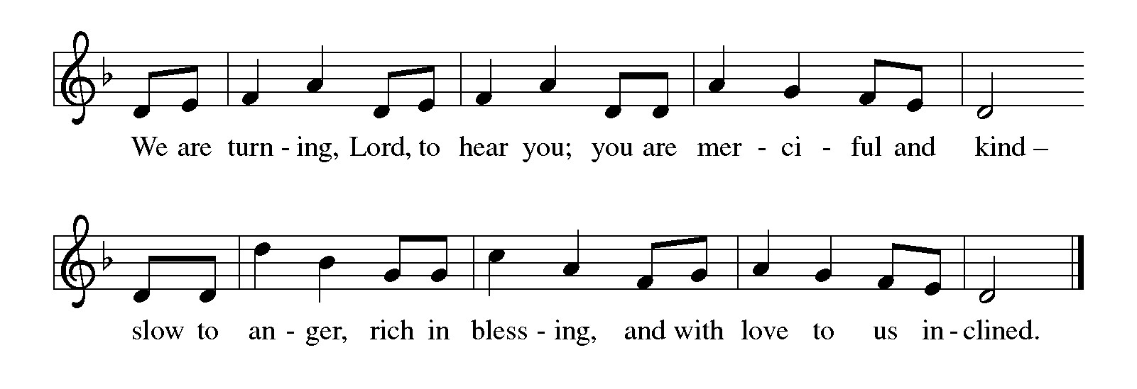

Gospel John 11:1-45
The holy gospel according to John.
Glory to You O Lord.
¹ Now a certain man was ill, Lazarus of Bethany, the village of Mary and her sister Martha. ² Mary was the one who anointed the Lord with perfume and wiped his feet with her hair; her brother Lazarus was ill. ³ So the sisters sent a message to Jesus, “Lord, he whom you love is ill.” ⁴ But when Jesus heard it, he said, “This illness does not lead to death; rather, it is for God’s glory, so that the Son of God may be glorified through it.” ⁵ Accordingly, though Jesus loved Martha and her sister and Lazarus, ⁶ after having heard that Lazarus was ill, he stayed two days longer in the place where he was.
⁷ Then after this he said to the disciples, “Let us go to Judea again.” ⁸ The disciples said to him, “Rabbi, the Jews were just now trying to stone you, and are you going there again?” ⁹ Jesus answered, “Are there not twelve hours of daylight? Those who walk during the day do not stumble because they see the light of this world. ¹⁰ But those who walk at night stumble because the light is not in them.” ¹¹ After saying this, he told them, “Our friend Lazarus has fallen asleep, but I am going there to awaken him.” ¹² The disciples said to him, “Lord, if he has fallen asleep, he will be all right.” ¹³ Jesus, however, had been speaking about his death, but they thought that he was referring merely to sleep. ¹⁴ Then Jesus told them plainly, “Lazarus is dead. ¹⁵ For your sake I am glad I was not there, so that you may believe. But let us go to him.” ¹⁶ Thomas, who was called the Twin, said to his fellow disciples, “Let us also go, that we may die with him.”
¹⁷ When Jesus arrived, he found that Lazarus had already been in the tomb four days. ¹⁸ Now Bethany was near Jerusalem, some two miles away, ¹⁹ and many of the Jews had come to Martha and Mary to console them about their brother. ²⁰ When Martha heard that Jesus was coming, she went and met him, while Mary stayed at home. ²¹ Martha said to Jesus, “Lord, if you had been here, my brother would not have died. ²² But even now I know that God will give you whatever you ask of him.” ²³ Jesus said to her, “Your brother will rise again.” ²⁴ Martha said to him, “I know that he will rise again in the resurrection on the last day.” ²⁵ Jesus said to her, “I am the resurrection and the life. Those who believe in me, even though they die, will live, ²⁶ and everyone who lives and believes in me will never die. Do you believe this?” ²⁷ She said to him, “Yes, Lord, I believe that you are the Messiah, the Son of God, the one coming into the world.”
²⁸ When she had said this, she went back and called her sister Mary and told her privately, “The Teacher is here and is calling for you.” ²⁹ And when she heard it, she got up quickly and went to him. ³⁰ Now Jesus had not yet come to the village but was still at the place where Martha had met him. ³¹ The Jews who were with her in the house consoling her saw Mary get up quickly and go out. They followed her because they thought that she was going to the tomb to weep there. ³² When Mary came where Jesus was and saw him, she knelt at his feet and said to him, “Lord, if you had been here, my brother would not have died.” ³³ When Jesus saw her weeping and the Jews who came with her also weeping, he was greatly disturbed in spirit and deeply moved. ³⁴ He said, “Where have you laid him?” They said to him, “Lord, come and see.” ³⁵ Jesus began to weep. ³⁶ So the Jews said, “See how he loved him!” ³⁷ But some of them said, “Could not he who opened the eyes of the blind man have kept this man from dying?”
³⁸ Then Jesus, again greatly disturbed, came to the tomb. It was a cave, and a stone was lying against it. ³⁹ Jesus said, “Take away the stone.” Martha, the sister of the dead man, said to him, “Lord, already there is a stench because he has been dead four days.” ⁴⁰ Jesus said to her, “Did I not tell you that if you believed you would see the glory of God?” ⁴¹ So they took away the stone. And Jesus looked upward and said, “Father, I thank you for having heard me. ⁴² I knew that you always hear me, but I have said this for the sake of the crowd standing here, so that they may believe that you sent me.” ⁴³ When he had said this, he cried with a loud voice, “Lazarus, come out!” ⁴⁴ The dead man came out, his hands and feet bound with strips of cloth and his face wrapped in a cloth. Jesus said to them, “Unbind him, and let him go.”
The gospel of the Lord.
Praise to you, O Christ.

CHILDREN’S MOMENT
SERMON Bishop Julie Schneider-Thomas

hymn of the day “Jesus Is a Rock in a Weary Land” #333
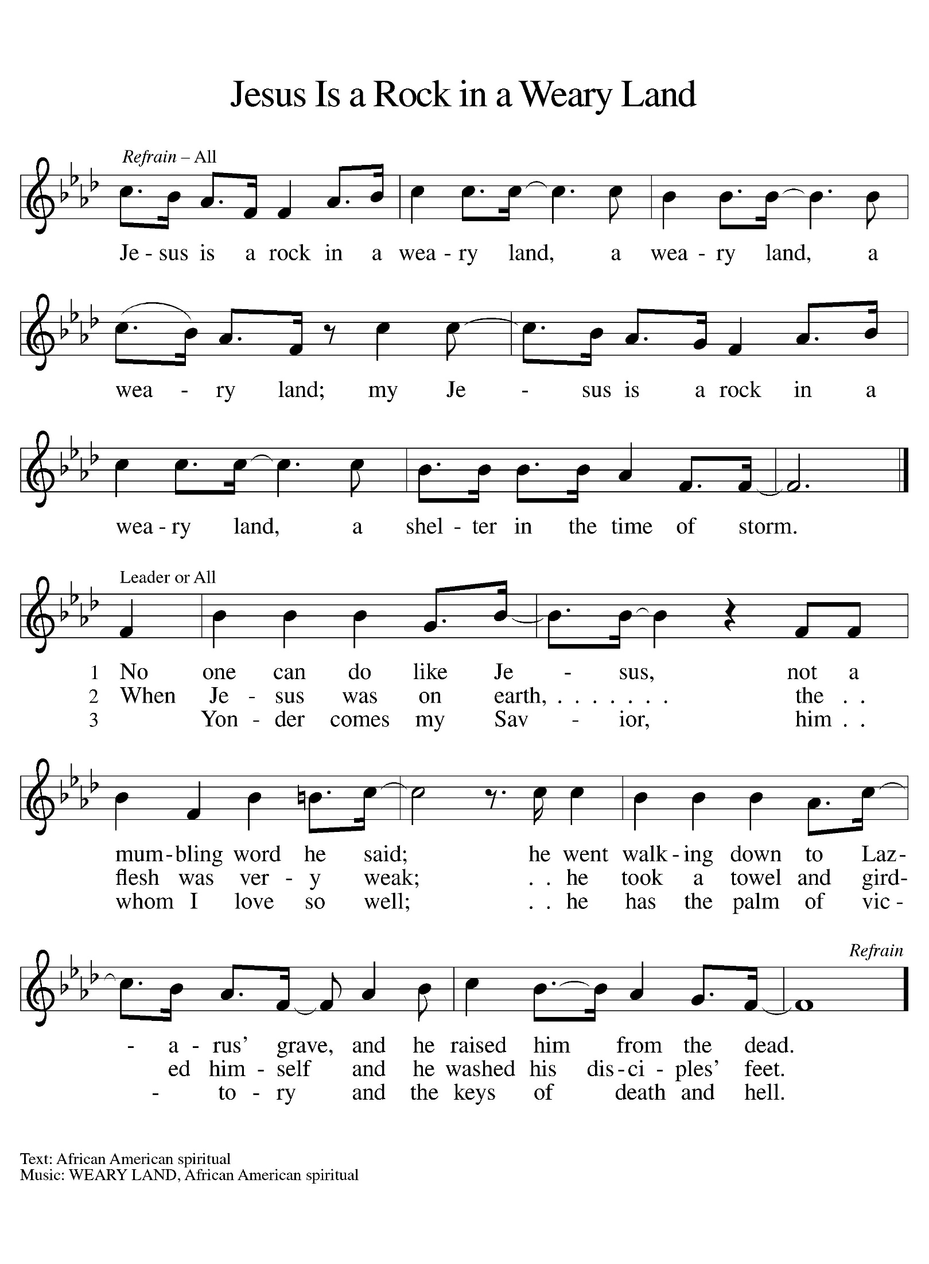
INSTALLATION OF PASTOR KENNETH DAVID SCHECK II

PRESENTATION

Bishop Schneider-Thomas addresses the assembly:
Having been authorized by the Zion Lutheran Church to install Kenneth David Scheck II, our co-worker in the gospel, as pastor, I now ask for the letter of agreement between Zion Lutheran Church and Grace Lutheran Church, Hastings, Michigan.

Paul Meade or another representative addresses the bishop:
After prayerful deliberation,
we, of Zion Lutheran Church, Woodland, Michigan,
have contracted Pastor Kenneth David Scheck II to serve as a minister of word and sacrament in the position of pastor.

I present Kenneth David Scheck II and this letter of agreement to you.

(The letter certifying that the agreement has been received and accepted is give to the Bishop.)

The representative moves aside, and the assembly is seated.

ADDRESS AND QUESTIONS

Bishop Schneider-Thomas addresses the minister of word and sacrament.
A reading from John: Jesus said, “Peace be with you. As the father has sent me, so I send you. Receive the Holy Spirit. If you forgive the sins of any, they are forgiven them; if you retain the sins of any, they are retained.” (John 20:21-23)

A reading from Matthew: Jesus said, “All authority in heaven and on earth has been given to me. Go therefore and make disciples of all nations, baptizing them in the name of the Father and of the Son and of the Holy Spirit, and teaching them to obey everything that I have commanded you. And remember, I am with you always, to the end of the age.” (Matthew 28:18-20)

A reading from First Timothy: Set the believers an example in speech and conduct, in love, in faith, in purity. Attend to the public reading of scripture, to exhorting, to teaching. Do not neglect the gift that is in you, which was given to you through prophecy with the laying on of hands by the council of elders. Put these things into practice, devote yourself to them, so that all may see your progress. Pay close attention to yourself and to your teaching; continue in these things, for in doing this you will save both yourself and your hearers. (1 Timothy 4:12-16)

Bishop Schneider-Thomas addresses questions to the minister of word and sacrament.
Kenneth David Scheck II, in the presence of this assembly
Will you commit yourself to this new trust and responsibility,
in the confidence that it comes from God through the call of the church?
Response: I will, and I ask God to help me.

Will you preach and teach in accordance with the holy scriptures
And with the confessions of the Lutheran church?
Will you carry out this ministry in harmony with the constitutions
of the Evangelical Lutheran Church in America?
Response: I will, and I ask God to help me.

Will you be diligent in your study of the holy scriptures
and faithful in your use of the means of grace?
Response: I will, and I ask God to help me.

Trusting in God’s care,
will you love, serve, and pray for God’s people,
nourish them with the word and sacraments,
and lead them by your own example in faithful service and holy living?
Response: I will, and I ask God to help me.

Will you give faithful witness in the world,
that God’s love may be known in all that you do?
Response: I will, and I ask God to help me.

Almighty God, who has given you the will to do these things,
graciously give you the strength and compassion to perform them.
Amen.

The assembly stands.

Bishop Schneider-Thomas addresses the assembly.
People of God,
Will you receive Kenneth David Scheck II as a messenger of Jesus Christ
sent to serve all people with the gospel of hope and salvation?
Will you regard Pastor Ken as a servant of Christ and a steward of the mysteries of God?
We will, and we ask God to help us.

Will you pray for Pastor Ken?
Will you help and honor Pastor Ken in carrying out this ministry?
In all things, will you strive to live together in the peace and unity of Christ?
We will, and we ask God to help us.

Bishop Schneider-Thomas addresses the minister of word and sacrament.
Kenneth David Scheck II the office of pastor is now committed to you
in the name of the Father, and of the Son, and of the Holy Spirit.
Amen.

BLESSING
(Pastor Ken kneels as the bishop proclaims God’s blessing.)

The God of peace, who brought again from the dead our Lord Jesus,
the great shepherd of the sheep, by the blood of the eternal covenant,
make you complete in everything good so that you may do God’s will,
working in you that which is pleasing in God’s sight;
through Jesus Christ, to whom be the glory forever and ever.
Amen.

(Pastor Ken stands)

Bishop Schneider-Thomas escorts the Pastor Ken to the place of baptism.

Paul Meade or another representative of the congregation says:
You have been called to be among us to baptize, to teach, and to forgive sins.

They proceed to the place of the word.

Martha Yoder or another representative of the congregation says:
You have been called to be among us to proclaim the good news.

They proceed to the place of the meal.
Naomi Wilson or another representative of the congregation says:
You have been called to be among us to preside at the Lord’s Supper.

Bishop Schneider-Thomas addresses the assembly.
People of God, I present to you Pastor Ken Scheck, as the newly installed pastor of Zion Lutheran Church.

Let us welcome Pastor Ken in the name of Christ.

The assembly offers acclamation with applause.

prayers of Intercession
(Please Be Seated)
Reconciled by God’s mercy and sustained by God’s presence, let us pray for the world and its needs.
A brief silence.
We pray for the church. Grant life and peace to all who gather in your name. Breathe into us so that we may share your message of forgiveness, hope, and love. We Pray for Leer Lutheran in Posen and their Supply Pastors. Today we especially pray for our Pastor, Kenneth David Scheck II, all ministries in the church and all Christians in their vocations.
Hear us, O God.
Your mercy is great.
We pray for creation. Renew landscapes that have dried up, prosper the work of those who restore homes and habitats after natural disasters, and sustain places where biodiversity thrives . Hear us, O God.
Your mercy is great.
We pray for the nations. Unbind leaders trapped by fear to act boldly for justice, free all who live in places of war and violence, and guide refugees and asylum seekers to safety. Hear us, O God.
Your mercy is great.
We pray for all people in need. Take away the stone of poverty that weighs down so many. Console any who weep and heal all who are sick. Hear us, O God.
Your mercy is great.
We pray for this assembly. Ready the hearts and spirits of all preparing to be baptized. Deepen our wonder at the mystery of your resurrection and life. Hear us, O God.
Your mercy is great.
We offer our thanksgiving for all people who have died in faith. Give us faith to trust in your power to redeem and save, and bring us up from our graves to life in you. Hear us, O God.
Your mercy is great.
Receive our prayers, O God, through Jesus Christ, our strength and salvation.
Amen.

PEACE
The peace of Christ be with you always.
And also with you.

OFFERING & OFFERING SONG
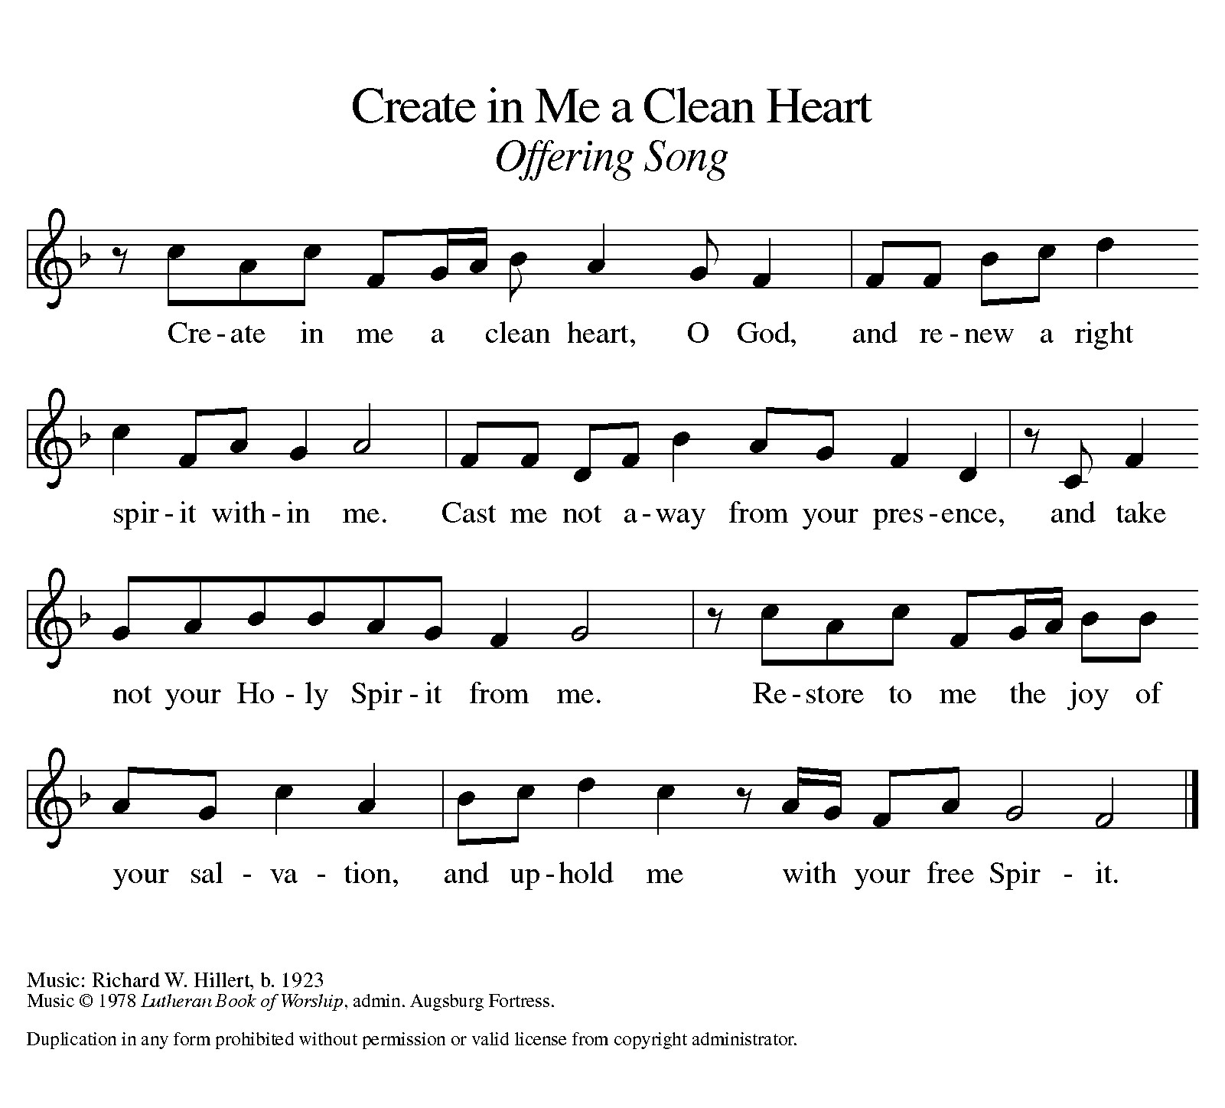

Offering Prayer
Let us pray.
Holy God, gracious and merciful, you bring forth food from the earth and nourish your whole creation. Turn our hearts toward those who hunger in any way, that all may know your care; and prepare us now to feast on the bread of life, Jesus Christ, our Savior and Lord.
Amen.

DIALOGUE
The Lord be with you.
And also with you.
Lift up your hearts.
We lift them to the Lord.
Let us give thanks to the Lord our God.
It is right to give our thanks and praise.

PREFACE (Pastor)
It is indeed right, our duty and our joy,
that we should at all times and in all places
give thanks and praise to you, almighty and merciful God,
through our Savior Jesus Christ;
who on this day overcame death and the grave,
and by his glorious resurrection opened to us the way of everlasting life.
And so, with all the choirs of angels,
with the church on earth and the hosts of heaven,
we praise your name and join their unending hymn

holy, holy, holy

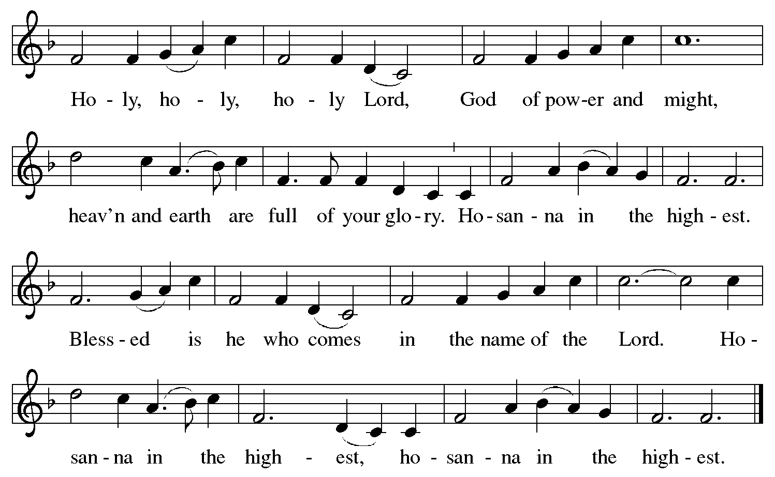

Thanksgiving at the Table
In the night in which he was betrayed,
our Lord Jesus took bread, and gave thanks;
broke it, and gave it to his disciples, saying:
Take and eat; this is my body, given for you.
Do this for the remembrance of me.

Again, after supper, he took the cup, gave thanks,
and gave it for all to drink, saying:
This cup is the new covenant in my blood,
shed for you and for all people for the forgiveness of sin.
Do this for the remembrance of me.

For as often as we eat of this bread and drink from this cup,
we proclaim the Lord’s death until he comes.

Lord’s Prayer
Gathered into one by the Holy Spirit, let us pray as Jesus taught us.
Our Father, who art in heaven,
hallowed be thy name,
thy kingdom come,
thy will be done,
on earth as it is in heaven.
Give us this day our daily bread;
and forgive us our trespasses,
as we forgive those
who trespass against us;
and lead us not into temptation,
but deliver us from evil.
For thine is the kingdom,
and the power, and the glory,
forever and ever. Amen.

INVITATION TO COMMUNION
Come to the banquet, for all is now ready.

COMMUNION *continuous
*People are welcome to kneel at the altar rail for a time of prayer after they receive their communion elements.
COMMUNION HYMNS
“I Want Jesus to Walk with Me” #325
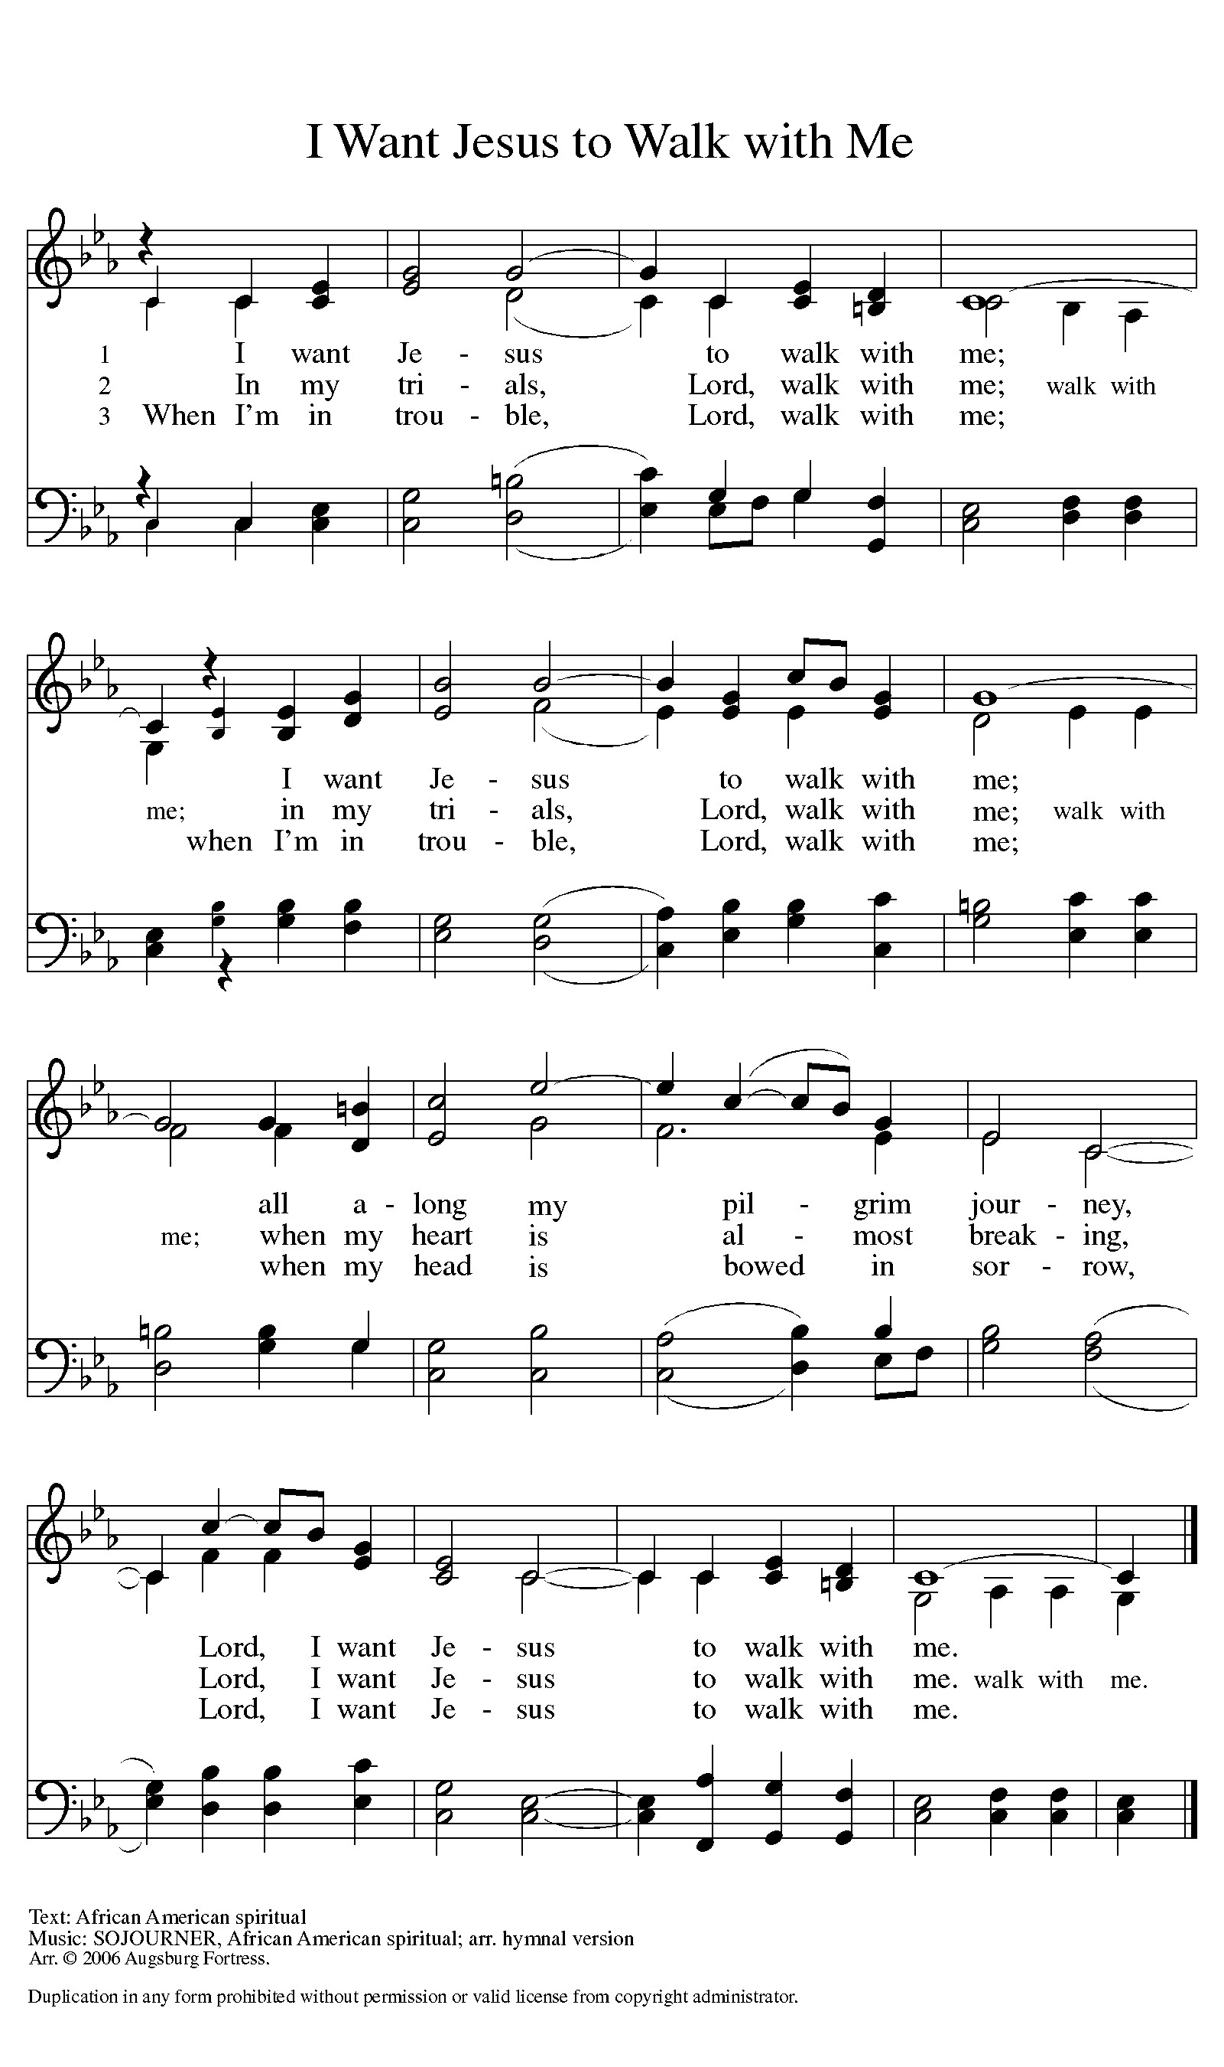

“Precious Lord, Take My Hand” #773
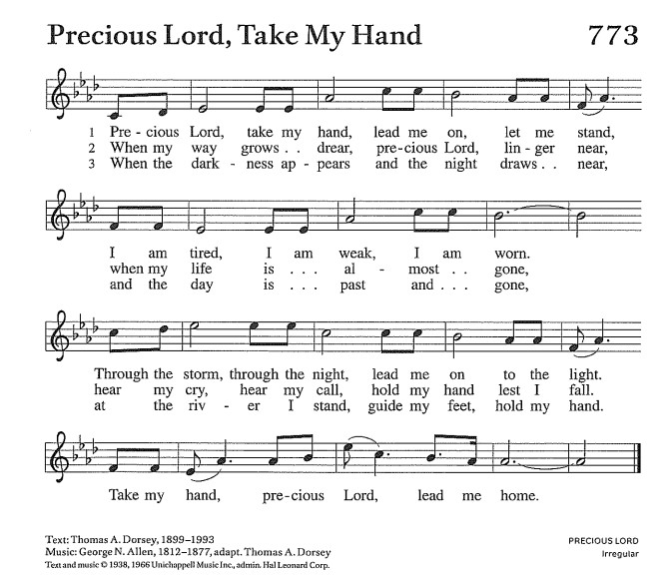

PRAYER AFTER COMMUNION
Let us pray.
We give you thanks, almighty God, that you have refreshed us through the healing power of this gift of life. In your mercy, strengthen us through this gift, in faith toward you and in fervent love toward one another; for the sake of Jesus Christ our Lord.
Amen.

Sending
God blesses us and sends us in mission to the world.

Blessing
The Lord bless you and keep you.
The Lord’s face shine on you with grace and mercy.
The Lord look upon you with favor and ☩ give you peace.
Amen.
Sending SonG “You Are the Way” #758
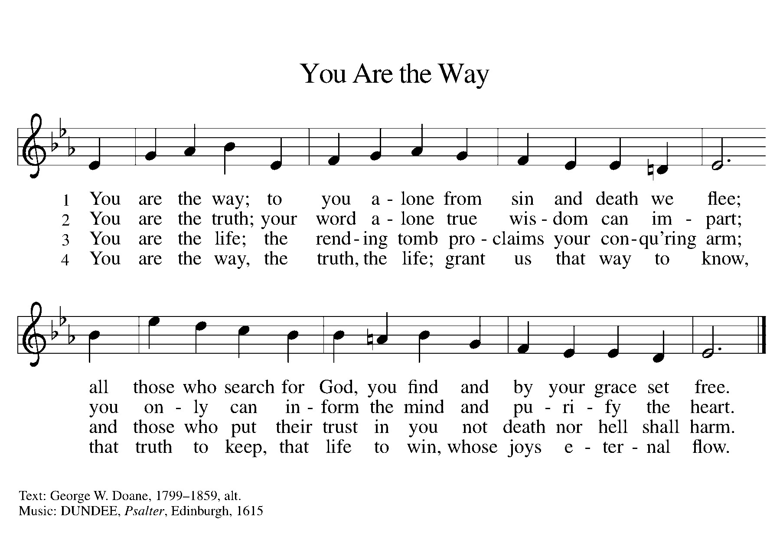

Dismissal
Go in peace. Christ is with you.
Thanks be to God.
From sundaysandseasons.com. Copyright © 2017 Augsburg Fortress. All rights reserved.

Thank you to all who served in worship today!
Presiders: Bishop Julie Schneider-Thomas and Pastor Ken Scheck
Musicians: Jayne Flanigan and Martha Yoder
Acolyte: Safety Person:
Elder: Buffy Meyers Trustee: Doug MacKenzie
Offering Counters: Paul Meade & Carlotta Willard



PRAYERS OF THE FAITHFUL

With thanks for all God’s blessings and his love for all people. Our Bishops, Julie Schneider-Thomas, Yehiel Curry, and the congregations of the North/West Lower Michigan Synod, and for Leer Lutheran in Posen and their Supply Pastors. We pray especially today for our Pastor, Kenneth David Scheck II, all ministries in the church and all Christians in their vocations.

Prayers for our friends, for all who are sick or hospitalized and for all health care workers who care for them.

This week at Zion:
- Men’s Breakfast 8am, Wednesday 25
- Bulletin Deadline, Wednesday 25
- Lenten Soup Supper, 7pm Wednesday 25
- Newsletter Deadline ,Thursday 26
- Bell Ringing & Prayer, 1 pm, Saturday 28

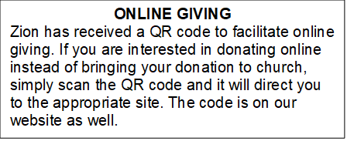

How to Contact the Pastor: If there is a pastoral need, please contact Pastor Ken Scheck II at 269-370-4632 or by email at kscheckii@aol.com.

ANNOUNCEMENTS
- We welcome Bishop Julie Schneider-Thomas this morning. We are thankful for the partnership we have with the North/West Lower Michigan Synod. With God's blessing, we now have a pastor, and Bishop Julie helped us work to develop a shared ministry with Grace Lutheran Church, Hastings. We all benefit with sharing the ministry of Jesus Christ. To God be the Glory!
- Note from the Board of Stewardship: Our congregation continues to grow in its mission to share Christ’s love in our community. As we look ahead to the coming months, we will be facing a shortfall in our operating budget. If you are able, we invite you to consider an additional gift to support our worship, outreach, and care ministries. Every contribution, large or small, strengthens the work we do together in Christ’s name. Thank you for your faithful generosity.
- Annual Easter Egg Hunt for Zion’s Kids: The Parish Board will be sponsoring an Easter Egg Hunt for our kiddos on Palm Sunday, March 29th. We are asking for donations of candy, trinkets, coins or other kid friendly items that will fit into our plastic Easter eggs. Please put donations in the box marked for these donations in the Fellowship Hall by March 22nd. We want to thank the congregation for their continued support for this event for our Sunday School kids.
- Service for Jerry Engle and Thank You: My family and I want to thank you all for the prayers, kind messages, cards, calls and gifts of food and other items since the time of Jerry's passing. These kindnesses are greatly appreciated. Jerry's celebration of life service will be at Zion on Saturday, April 11th. Visitation will begin at 10:00 with the service at 11:00. We will have time to share stories of Jerry at the lunch, prepared and served by our church family, in the Fellowship Hall immediately following the service. --- Carol Engle and family
- First-Aid Supplies “Thank You”: The first-aid supplies and monetary gifts collected for the synod mission trip to Honduras have been delivered to University Lutheran Church in East Lansing for packing. Pastor Megan Crouch, Peace Lutheran, Gaylord, who is heading the mission trip sent these words, “These (supplies) are wonderful! Please pass along my deep thanks to your congregation and pastor for collecting and blessing them. They will be a blessing for sure on our trip.” Thank you to everyone who brought supplies and give gifts!!
- Palm Sunday Path: The Palm Sunday Path is a Christian walk being planned for Palm Sunday in Lansing from Pilgrim Church to the Capitol Building at 3:00 pm. If you are interested in more information or joining in the walk, there are information sheets on the table in the Narthex.
- Seeking GOD’S Way: This Lent you are invited to journey with God. Come to our dinner and worships (7:00 pm after Ash Wednesday), as we Seek God’s Way. We will explore God’s MERCY, which is the heart of God. As we journey, we will find God’s PASSION for each of us. We will find that God’s LOVE is on the move, allowing us to realize the grace that is given to all creation. Even in hardship Christians know the gift of LIFE, as we walk with the knowledge of God’s care, allowing all of us to have JOY. Zion Dinners at 6:00 p.m. Wednesdays on February 25; March 4, 11, 18 and 25.
- Pastor’s Availability: Pastor Ken Scheck II is available by appointment to meet with you. As you know homebound visitation has begun and will continue until all homebound have been visited by Pastor Ken. Generally speaking, he is at Grace on Mondays and Wednesdays and Zion on Tuesdays and Thursdays with a day off on Friday. As you may be aware, Pastor Ken has come to the Men’s meeting and Lakewood Area Ministerial Association meetings on Wednesday here at Zion. Flexibility is the name of the game. He is more than willing to be contacted at any time by cellphone or email. Please feel free to contact him at 269-370-4632 or at kscheckii@aol.com. You are able to send a text to the cellphone, but please identify yourself at least the first time.
- Save the Date: Mark your calendar for April 19th! We will be hosting an open house for Pastor Ken and inviting the community to come, have lunch with us, and meet our Pastor. Watch for more details!
- Announcement and Newsletter Items: Please forward items for the bulletin announcements and the newsletter to the church email (Office@Zion.org). Please do not send items to people’s personal emails. Thank you.
- Door Locking Policy: Our door locking policy relies on having a volunteer(s) each Sunday to serve as the Safety Person of the Day. On Sundays where no one has volunteered, if someone arrives at church and is willing to be the Safety Person of the Day, we will follow the door locking policy. If no one steps forward to serve as the Safety Person of the Day, the doors will not be locked. Please consider volunteering for this important duty.

