ZION LUTHERAN CHURCH, WOODLAND, MI
Palm Sunday March 29, 2026
*If you are listening in your car, please tune your radio to FM 87.7*
(Please silence your cell phones while in the sanctuary. Thank you.)


WELCOME AND ANNOUNCEMENTS

Gathering
The Holy Spirit calls us together as the people of God.

Confession and Forgiveness
In the name of the Father,
and of the ☩ Son,
and of the Holy Spirit.
Amen.

Almighty God, to whom all hearts are open, all desires known, and from whom no secrets are hid: cleanse the thoughts of our hearts by the inspiration of your Holy Spirit, that we may perfectly love you and worthily magnify your holy name, through Jesus Christ our Lord.
Amen.

Let us confess our sin in the presence of God and of one another. Most merciful God,
we confess that we are captive to sin and cannot free ourselves. We have sinned against you in thought, word, and deed, by what we have done and by what we have left undone. We have not loved you with our whole heart; we have not loved our neighbors as ourselves. For the sake of your Son, Jesus Christ, have mercy on us. Forgive us, renew us, and lead us, so that we may delight in your will and walk in your ways, to the glory of your holy name.
Amen.

God, who is rich in mercy, loved us even when we were dead in sin, and made us alive together with Christ. By grace you have been saved. In the name of ☩ Jesus Christ, your sins are forgiven. Almighty God strengthen you with power through the Holy Spirit, that Christ may live in your hearts through faith. Amen.

Gathering Song “All Glory, Laud, and Honor” #344

GREETING
The grace of our Lord Jesus Christ, the love of God, and the communion of the Holy Spirit be with you all.
And also with you.

Praise hymn: “Kyrie Eleison”
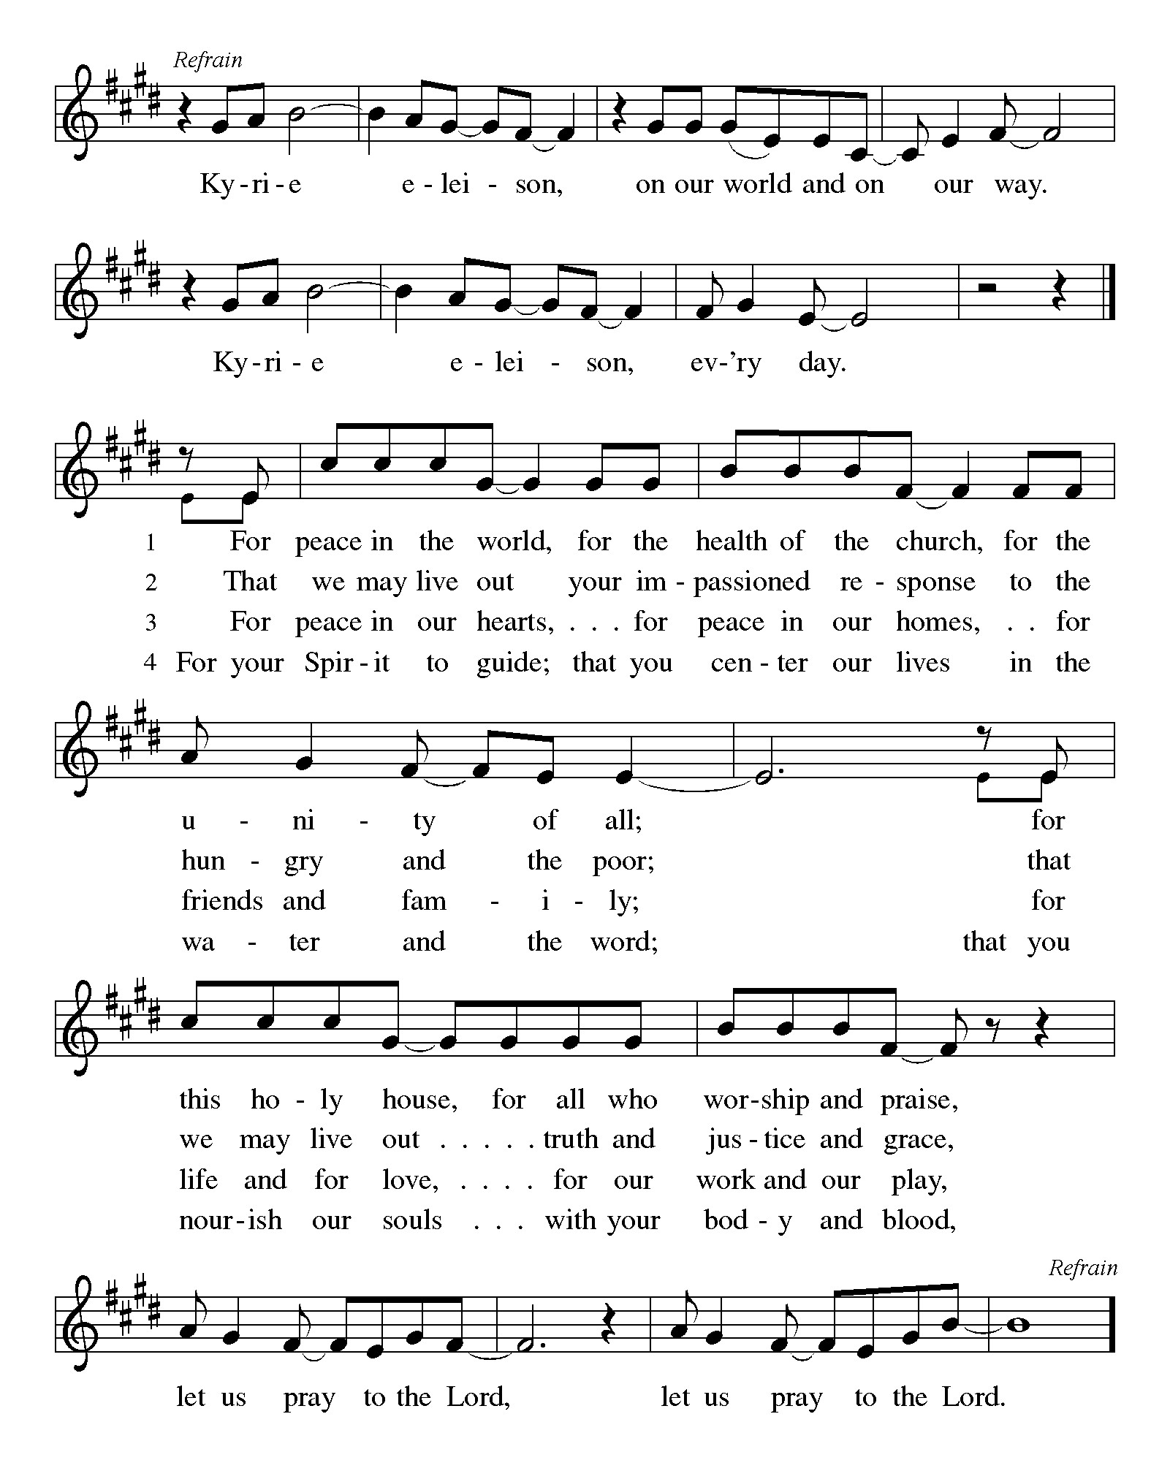

Prayer of the Day
Let us pray together.
As we now enter into the contemplation of the passion of our Lord Jesus Christ and meditate on the salvation of the world through his sufferings, death, burial, and resurrection, let us pray.
Amen.

First Reading Isaiah 50:4-9a
A reading from Isaiah.

⁴ The Lord God has given me
a trained tongue,
that I may know how to sustain
the weary with a word.
Morning by morning he wakens,
wakens my ear
to listen as those who are taught.
⁵ The Lord God has opened my ear,
and I was not rebellious;
I did not turn backward.
⁶ I gave my back to those who struck me
and my cheeks to those who pulled out the beard;
I did not hide my face
from insult and spitting.
⁷ The Lord God helps me;
therefore I have not been disgraced;
therefore I have set my face like flint,
and I know that I shall not be put to shame;
⁸ he who vindicates me is near.
Who will contend with me?
Let us stand in court together.
Who are my adversaries?
Let them confront me.
^{9a} It is the Lord God who helps me;
who will declare me guilty?

The word of the Lord.
Thanks be to God.

Psalm Psalm 130

⁹ Have mercy on me, O Lord, for I | am in trouble;
my eye is consumed with sorrow, and also my throat | and my belly.
¹⁰ For my life is wasted with grief, and my | years with sighing;
my strength fails me because of affliction, and my bones | are consumed.
¹¹ I am the scorn of all my enemies, a disgrace to my neighbors, a dismay to | my acquaintances;
when they see me in the street | they avoid me.
¹² Like the dead I am forgotten, | out of mind;
I am as useless as a | broken pot.
¹³ For I have heard the whispering of the crowd; fear is | all around;
they put their heads together against me; they plot to | take my life.
¹⁴ But as for me, I have trusted in | you, O Lord.
I have said, “You | are my God.
¹⁵ My times are | in your hand;
rescue me from the hand of my enemies, and from those who | persecute me.
¹⁶ Let your face shine up- | on your servant;
save me in your | steadfast love.”

Second Reading Philippians 2:5-11
A reading from Philippians.
⁵ Let the same mind be in you that was in Christ Jesus,
⁶ who, though he existed in the form of God,
did not regard equality with God
as something to be grasped,
⁷ but emptied himself,
taking the form of a slave,
assuming human likeness.
And being found in appearance as a human,
⁸ he humbled himself
and became obedient to the point of death—
even death on a cross.
⁹ Therefore God exalted him even more highly
and gave him the name
that is above every other name,
¹⁰ so that at the name given to Jesus
every knee should bend,
in heaven and on earth and under the earth,
¹¹ and every tongue should confess
that Jesus Christ is Lord,
to the glory of God the Father.

The Word of the Lord
Thanks be to God.

Gospel Acclamation

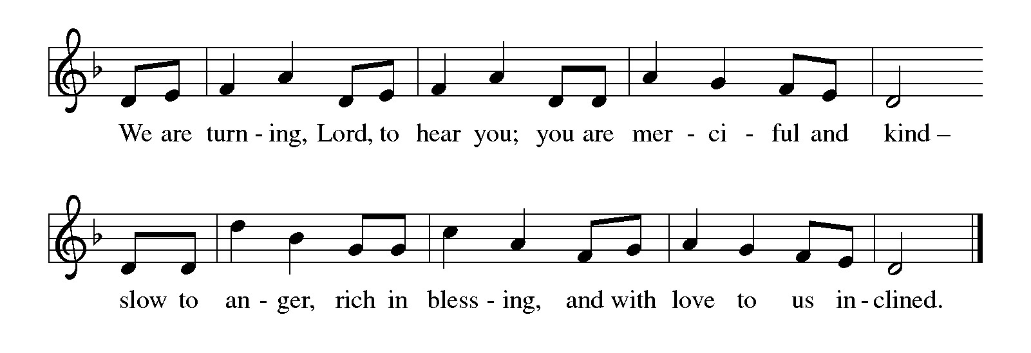

Gospel Matthew 26:14—27:66
The holy gospel according to Matthew.
Glory to You O Lord.
¹⁴ One of the twelve, who was called Judas Iscariot, went to the chief priests ¹⁵ and said, “What will you give me if I betray him to you?” They paid him thirty pieces of silver. ¹⁶ And from that moment he began to look for an opportunity to betray him.
¹⁷ On the first day of Unleavened Bread the disciples came to Jesus, saying, “Where do you want us to make the preparations for you to eat the Passover?” ¹⁸ He said, “Go into the city to a certain man and say to him, ‘The Teacher says, My time is near; I will keep the Passover at your house with my disciples.’ ” ¹⁹ So the disciples did as Jesus had directed them, and they prepared the Passover meal.
²⁰ When it was evening, he took his place with the twelve disciples, ²¹ and while they were eating he said, “Truly I tell you, one of you will betray me.” ²² And they became greatly distressed and began to say to him one after another, “Surely not I, Lord?” ²³ He answered, “The one who has dipped his hand into the bowl with me will betray me. ²⁴ The Son of Man goes as it is written of him, but woe to that one by whom the Son of Man is betrayed! It would have been better for that one not to have been born.” ²⁵ Judas, who betrayed him, said, “Surely not I, Rabbi?” He replied, “You have said so.”
²⁶ While they were eating, Jesus took a loaf of bread, and after blessing it he broke it, gave it to the disciples, and said, “Take, eat; this is my body.” ²⁷ Then he took a cup, and after giving thanks he gave it to them, saying, “Drink from it, all of you, ²⁸ for this is my blood of the covenant, which is poured out for many for the forgiveness of sins. ²⁹ I tell you, I will never again drink of this fruit of the vine until that day when I drink it new with you in my Father’s kingdom.”
³⁰ When they had sung the hymn, they went out to the Mount of Olives.
³¹ Then Jesus said to them, “You will all fall away because of me this night, for it is written,
‘I will strike the shepherd,
and the sheep of the flock will be scattered.’
³² “But after I am raised up, I will go ahead of you to Galilee.” ³³ Peter said to him, “Even if all fall away because of you, I will never fall away.” ³⁴ Jesus said to him, “Truly I tell you, this very night, before the cock crows, you will deny me three times.” ³⁵ Peter said to him, “Even though I must die with you, I will not deny you.” And so said all the disciples.
³⁶ Then Jesus went with them to a place called Gethsemane, and he said to his disciples, “Sit here while I go over there and pray.” ³⁷ He took with him Peter and the two sons of Zebedee and began to be grieved and agitated. ³⁸ Then he said to them, “My soul is deeply grieved, even to death; remain here, and stay awake with me.” ³⁹ And going a little farther, he threw himself on the ground and prayed, “My Father, if it is possible, let this cup pass from me, yet not what I want but what you want.” ⁴⁰ Then he came to the disciples and found them sleeping, and he said to Peter, “So, could you not stay awake with me one hour? ⁴¹ Stay awake and pray that you may not come into the time of trial; the spirit indeed is willing, but the flesh is weak.” ⁴² Again he went away for the second time and prayed, “My Father, if this cannot pass unless I drink it, your will be done.” ⁴³ Again he came and found them sleeping, for their eyes were heavy. ⁴⁴ So leaving them again, he went away and prayed for the third time, saying the same words. ⁴⁵ Then he came to the disciples and said to them, “Are you still sleeping and taking your rest? Now the hour is at hand, and the Son of Man is betrayed into the hands of sinners. ⁴⁶ Get up, let us be going. Look, my betrayer is at hand.”
⁴⁷ While he was still speaking, Judas, one of the twelve, arrived; with him was a large crowd with swords and clubs, from the chief priests and the elders of the people. ⁴⁸ Now the betrayer had given them a sign, saying, “The one I will kiss is the man; arrest him.” ⁴⁹ At once he came up to Jesus and said, “Greetings, Rabbi!” and kissed him. ⁵⁰ Jesus said to him, “Friend, do what you are here to do.” Then they came and laid hands on Jesus and arrested him. ⁵¹ Suddenly one of those with Jesus put his hand on his sword, drew it, and struck the slave of the high priest, cutting off his ear. ⁵² Then Jesus said to him, “Put your sword back into its place, for all who take the sword will die by the sword. ⁵³ Do you think that I cannot appeal to my Father, and he will at once send me more than twelve legions of angels? ⁵⁴ But how then would the scriptures be fulfilled, which say it must happen in this way?” ⁵⁵ At that hour Jesus said to the crowds, “Have you come out with swords and clubs to arrest me as though I were a rebel? Day after day I sat in the temple teaching, and you did not arrest me. ⁵⁶ But all this has taken place, so that the scriptures of the prophets may be fulfilled.” Then all the disciples deserted him and fled.
⁵⁷ Those who had arrested Jesus took him to Caiaphas the high priest, where the scribes and the elders had gathered. ⁵⁸ But Peter was following him at a distance, as far as the courtyard of the high priest, and going inside he sat with the guards in order to see how this would end. ⁵⁹ Now the chief priests and the whole council were looking for false testimony against Jesus so that they might put him to death, ⁶⁰ but they found none, though many false witnesses came forward. At last two came forward ⁶¹ and said, “This fellow said, ‘I am able to destroy the temple of God and to build it in three days.’ ” ⁶² The high priest stood up and said, “Have you no answer? What is it that they testify against you?” ⁶³ But Jesus was silent. Then the high priest said to him, “I put you under oath before the living God, tell us if you are the Messiah, the Son of God.” ⁶⁴ Jesus said to him, “You have said so. But I tell you,
From now on you will see the Son of Man
seated at the right hand of Power
and coming on the clouds of heaven.”
⁶⁵ Then the high priest tore his clothes and said, “He has blasphemed! Why do we still need witnesses? You have now heard his blasphemy. ⁶⁶ What do you think?” They answered, “He deserves death.” ⁶⁷ Then they spat in his face and struck him, and some slapped him, ⁶⁸ saying, “Prophesy to us, you Messiah! Who is it that struck you?”
⁶⁹ Now Peter was sitting outside in the courtyard. A female servant came to him and said, “You also were with Jesus the Galilean.” ⁷⁰ But he denied it before all of them, saying, “I do not know what you are talking about.” ⁷¹ When he went out to the porch, another female servant saw him, and she said to the bystanders, “This man was with Jesus the Nazarene.” ⁷² Again he denied it with an oath, “I do not know the man.” ⁷³ After a little while the bystanders came up and said to Peter, “Certainly you are also one of them, for your accent betrays you.” ⁷⁴ Then he began to curse, and he swore an oath, “I do not know the man!” At that moment the cock crowed. ⁷⁵ Then Peter remembered what Jesus had said: “Before the cock crows, you will deny me three times.” And he went out and wept bitterly.
^{27:1} When morning came, all the chief priests and the elders of the people conferred together against Jesus in order to bring about his death. ² They bound him, led him away, and handed him over to Pilate the governor.
³ When Judas, his betrayer, saw that Jesus was condemned, he repented and brought back the thirty pieces of silver to the chief priests and the elders. ⁴ He said, “I have sinned by betraying innocent blood.” But they said, “What is that to us? See to it yourself.” ⁵ Throwing down the pieces of silver in the temple, he departed, and he went and hanged himself. ⁶ But the chief priests, taking the pieces of silver, said, “It is not lawful to put them into the treasury, since they are blood money.” ⁷ After conferring together, they used them to buy the potter’s field as a place to bury foreigners. ⁸ For this reason that field has been called the Field of Blood to this day. ⁹ Then was fulfilled what had been spoken through the prophet Jeremiah, “And they took the thirty pieces of silver, the price of the one on whom a price had been set, on whom some of the people of Israel had set a price, ¹⁰ and they gave them for the potter’s field, as the Lord commanded me.”
¹¹ Now Jesus stood before the governor, and the governor asked him, “Are you the king of the Jews?” Jesus said, “You say so.” ¹² But when he was accused by the chief priests and elders, he did not answer. ¹³ Then Pilate said to him, “Do you not hear how many accusations they make against you?” ¹⁴ But he gave him no answer, not even to a single charge, so that the governor was greatly amazed.
¹⁵ Now at the festival the governor was accustomed to release a prisoner for the crowd, anyone whom they wanted. ¹⁶ At that time they had a notorious prisoner called Jesus Barabbas. ¹⁷ So after they had gathered, Pilate said to them, “Whom do you want me to release for you, Jesus Barabbas or Jesus who is called the Messiah?” ¹⁸ For he realized that it was out of jealousy that they had handed him over. ¹⁹ While he was sitting on the judgment seat, his wife sent word to him, “Have nothing to do with that innocent man, for today I have suffered a great deal because of a dream about him.” ²⁰ Now the chief priests and the elders persuaded the crowds to ask for Barabbas and to have Jesus killed. ²¹ The governor again said to them, “Which of the two do you want me to release for you?” And they said, “Barabbas.” ²² Pilate said to them, “Then what should I do with Jesus who is called the Messiah?” All of them said, “Let him be crucified!” ²³ Then he asked, “Why, what evil has he done?” But they shouted all the more, “Let him be crucified!”
²⁴ So when Pilate saw that he could do nothing but rather that a riot was beginning, he took some water and washed his hands before the crowd, saying, “I am innocent of this man’s blood; see to it yourselves.” ²⁵ Then the people as a whole answered, “His blood be on us and on our children!” ²⁶ So he released Barabbas for them, and after flogging Jesus he handed him over to be crucified.
²⁷ Then the soldiers of the governor took Jesus into the governor’s headquarters, and they gathered the whole cohort around him. ²⁸ They stripped him and put a scarlet robe on him, ²⁹ and after twisting some thorns into a crown they put it on his head. They put a reed in his right hand and knelt before him and mocked him, saying, “Hail, King of the Jews!” ³⁰ They spat on him and took the reed and struck him on the head. ³¹ After mocking him, they stripped him of the robe and put his own clothes on him. Then they led him away to crucify him.
³² As they went out, they came upon a man from Cyrene named Simon; they compelled this man to carry his cross. ³³ And when they came to a place called Golgotha (which means Place of a Skull), ³⁴ they offered him wine to drink, mixed with gall, but when he tasted it, he would not drink it. ³⁵ And when they had crucified him, they divided his clothes among themselves by casting lots; ³⁶ then they sat down there and kept watch over him. ³⁷ Over his head they put the charge against him, which read, “This is Jesus, the King of the Jews.”
³⁸ Then two rebels were crucified with him, one on his right and one on his left. ³⁹ Those who passed by derided him, shaking their heads ⁴⁰ and saying, “You who would destroy the temple and build it in three days, save yourself! If you are the Son of God, come down from the cross.” ⁴¹ In the same way the chief priests also, along with the scribes and elders, were mocking him, saying, ⁴² “He saved others; he cannot save himself. He is the King of Israel; let him come down from the cross now, and we will believe in him. ⁴³ He trusts in God; let God deliver him now, if he wants to, for he said, ‘I am God’s Son.’ ” ⁴⁴ The rebels who were crucified with him also taunted him in the same way.
⁴⁵ From noon on, darkness came over the whole land until three in the afternoon. ⁴⁶ And about three o’clock Jesus cried with a loud voice, “Eli, Eli, lema sabachthani?” that is, “My God, my God, why have you forsaken me?” ⁴⁷ When some of the bystanders heard it, they said, “This man is calling for Elijah.” ⁴⁸ At once one of them ran and got a sponge, filled it with sour wine, put it on a stick, and gave it to him to drink. ⁴⁹ But the others said, “Wait, let us see whether Elijah will come to save him.” ⁵⁰ Then Jesus cried again with a loud voice and breathed his last. ⁵¹ At that moment the curtain of the temple was torn in two, from top to bottom. The earth shook, and the rocks were split. ⁵² The tombs also were opened, and many bodies of the saints who had fallen asleep were raised. ⁵³ After his resurrection they came out of the tombs and entered the holy city and appeared to many. ⁵⁴ Now when the centurion and those with him, who were keeping watch over Jesus, saw the earthquake and what took place, they were terrified and said, “Truly this man was God’s Son!”
⁵⁵ Many women were also there, looking on from a distance; they had followed Jesus from Galilee, ministering to him. ⁵⁶ Among them were Mary Magdalene, and Mary the mother of James and Joseph, and the mother of the sons of Zebedee.
⁵⁷ When it was evening, there came a rich man from Arimathea named Joseph, who also was himself a disciple of Jesus. ⁵⁸ He went to Pilate and asked for the body of Jesus; then Pilate ordered it to be given to him. ⁵⁹ So Joseph took the body and wrapped it in a clean linen cloth ⁶⁰ and laid it in his new tomb, which he had hewn in the rock. He then rolled a great stone to the door of the tomb and went away. ⁶¹ Mary Magdalene and the other Mary were there, sitting opposite the tomb.
⁶² The next day, that is, after the day of Preparation, the chief priests and the Pharisees gathered before Pilate ⁶³ and said, “Sir, we remember what that impostor said while he was still alive, ‘After three days I will rise again.’ ⁶⁴ Therefore command the tomb to be made secure until the third day; otherwise, his disciples may go and steal him away and tell the people, ‘He has been raised from the dead,’ and the last deception would be worse than the first.” ⁶⁵ Pilate said to them, “You have a guard of soldiers; go, make it as secure as you can.” ⁶⁶ So they went with the guard and made the tomb secure by sealing the stone.

The gospel of the Lord.
Praise to you, O Christ.

CHILDREN’S MOMENT
SERMON Pastor Ken Scheck

hymn of the day “There In God’s Garden” #342

prayers of Intercession
(Please Be Seated)
Reconciled by God’s mercy and sustained by God’s presence, let us pray for the world and its needs.
O God, you announce words of grace and truth. Give wisdom to all preachers in your church both globally and locally. We pray especially St Paul Lutheran Church in Reed City, and their pastor Rev. Marcy Miller.
Open our hearts to encounter the infinite life you offer in Jesus. Hear us, O God.
Your mercy is great.
You hold the whole universe. Gather sun and moon, clouds and stars, land and sea, and plants and animals around the cross, so that all creation bears witness to your saving love. Hear us, O God.
Your mercy is great.
Your power is sure. Destroy inequity and division in every place, and build your beloved community among all people. Guide judges, attorneys, and juries so that they act with justice and fairness. Hear us, O God.
Your mercy is great.
Your heart breaks open at our pain. Send healing and vindication to all who, like Jesus, know the sting of betrayal, denial, abuse, or false accusations. Be with those experiencing pain or loss this day. Hear us, O God.
Your mercy is great.
Your ways show compassion. Let this same mind be in us as we enter Holy Week. Bless those here who will lead worship and tell the story of Jesus’ death and resurrection. Hear us, O God.
Your mercy is great.
O God, your embrace is eternal. Praise and thanks to you for all the faithful departed who rest in your mercy. Deliver us all from death’s power and raise us to life in you. Hear us, O God.
Your mercy is great.
Receive our prayers, O God, through Jesus Christ, our strength and salvation.
Amen.

OFFERING & OFFERING SONG
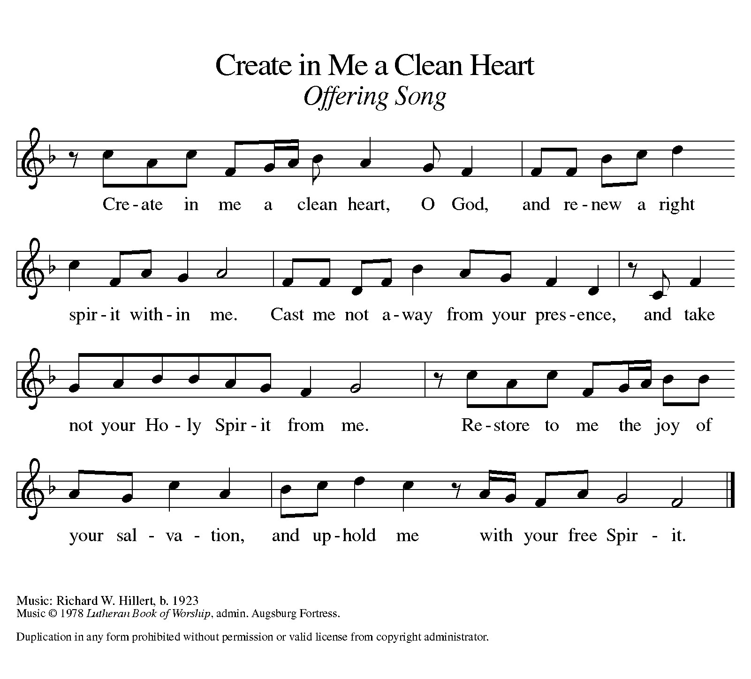

Offering Prayer
Let us pray.
Holy God, gracious and merciful, you bring forth food from the earth and nourish your whole creation. Turn our hearts toward those who hunger in any way, that all may know your care; and prepare us now to feast on the bread of life, Jesus Christ, our Savior and Lord.
Amen.

DIALOGUE
The Lord be with you.
And also with you.
Lift up your hearts.
We lift them to the Lord.
Let us give thanks to the Lord our God.
It is right to give our thanks and praise.

PREFACE (Pastor)
It is indeed right, our duty and our joy,
that we should at all times and in all places
give thanks and praise to you, almighty and merciful God,
through our Savior Jesus Christ;
who on this day overcame death and the grave,
and by his glorious resurrection opened to us the way of everlasting life.
And so, with all the choirs of angels,
with the church on earth and the hosts of heaven,
we praise your name and join their unending hymn

holy, holy, holy

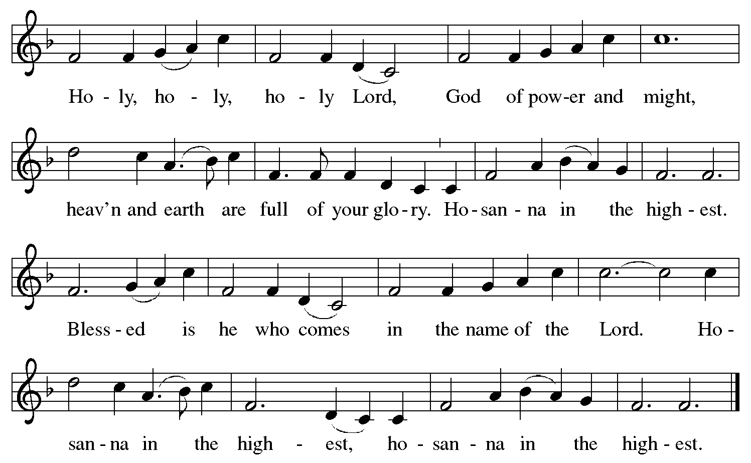

Thanksgiving at the Table
In the night in which he was betrayed,
our Lord Jesus took bread, and gave thanks;
broke it, and gave it to his disciples, saying:
Take and eat; this is my body, given for you.
Do this for the remembrance of me.

Again, after supper, he took the cup, gave thanks,
and gave it for all to drink, saying:
This cup is the new covenant in my blood,
shed for you and for all people for the forgiveness of sin.
Do this for the remembrance of me.

For as often as we eat of this bread and drink from this cup,
we proclaim the Lord’s death until he comes.

Christ has died. Christ is risen. Christ will come again.

Lord’s Prayer
Gathered into one by the Holy Spirit, let us pray as Jesus taught us.
Our Father, who art in heaven,
hallowed be thy name,
thy kingdom come,
thy will be done,
on earth as it is in heaven.
Give us this day our daily bread;
and forgive us our trespasses,
as we forgive those
who trespass against us;
and lead us not into temptation,
but deliver us from evil.
For thine is the kingdom,
and the power, and the glory,
forever and ever. Amen.

INVITATION TO COMMUNION
Come to the banquet, for all is now ready.

COMMUNION *continuous
*People are welcome to kneel at the altar rail for a time of prayer after they receive their communion elements.

COMMUNION HYMNS
“Were You There” #353
“Stay With Me” #348

PRAYER AFTER COMMUNION
Let us pray.
We give you thanks, almighty God, that you have refreshed us through the healing power of this gift of life. In your mercy, strengthen us through this gift, in faith toward you and in fervent love toward one another; for the sake of Jesus Christ our Lord.
Amen.

Sending
God blesses us and sends us in mission to the world.

Blessing
The Lord bless you and keep you.
The Lord’s face shine on you with grace and mercy.
The Lord look upon you with favor and ☩ give you peace.
Amen.
Sending SonG “Beneath the Cross of Jesus ” #338

Dismissal
Go in peace. Christ is with you.
Thanks be to God.
From sundaysandseasons.com. Copyright © 2017 Augsburg Fortress. All rights reserved.

Thank you to all who served in worship today!
Presiders: Pastor Ken Scheck Musicians: Jayne Flanigan
Acolyte: Safety Person:
Elder: Naomi Wilson Trustee: Jimmy Hindman
Offering Counters: Paul Meade & Carlotta Willard



PRAYERS OF THE FAITHFUL

With thanks for all God’s blessings and his love for all people. Our Bishops, Julie Schneider-Thomas, Yehiel Curry, and the congregations of the North/West Lower Michigan Synod, and for St Paul Lutheran Church in Reed City, and their pastor Rev. Marcy Miller.

Prayers for our friends, for all who are sick or hospitalized and for all health care workers who care for them. All those members of Zion’s family traveling; all those homebound or in frail health; all those suffering with quiet, unknown needs or worries. For those who serve on our behalf: public safety, utility workers, medical personnel, military personnel. For those who might be forgotten. We pray especially for all countries involved in ongoing conflicts.

This week at Zion:
- Men’s Breakfast 8am, Wednesday 1
- Bulletin Deadline, Wednesday 1
- Lenten Soup Supper, 7pm Wednesday 25
- Newsletter Deadline, Thursday 2
- Bell Ringing & Prayer, 1 pm, Saturday 4

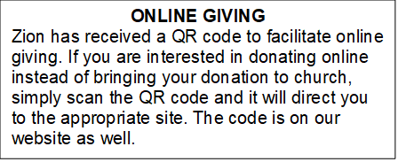

How to Contact the Pastor: If there is a pastoral need, please contact Pastor Ken Scheck II at 269-370-4632 or by email at kscheckii@aol.com.

ANNOUNCEMENTS
- Shut-ins Bags: Bags for the shut-ins are on the table in the narthex hall. Please consider putting an Easter treat or small item to bring cheer to our shut-ins during the Easter season. We have 7 single and 3 couple bags. If you have any questions, please see an ZLCW Board member.
- Note from the Board of Stewardship: Our congregation continues to grow in its mission to share Christ’s love in our community. As we look ahead to the coming months, we will be facing a shortfall in our operating budget. If you are able, we invite you to consider an additional gift to support our worship, outreach, and care ministries. Every contribution, large or small, strengthens the work we do together in Christ’s name. Thank you for your faithful generosity.
- Annual Easter Egg Hunt for Zion’s Kids: The Parish Board will be sponsoring an Easter Egg Hunt for our kiddos on Palm Sunday, March 29th. We are asking for donations of candy, trinkets, coins or other kid friendly items that will fit into our plastic Easter eggs. Please put donations in the box marked for these donations in the Fellowship Hall by March 22nd. We want to thank the congregation for their continued support for this event for our Sunday School kids.
- Fun for Kids: Approximately 9:45 am kids of all ages are invited to work on craft projects and a game of Easter Bingo! We will be gathering at the far end of the Fellowship Hall. See you then kids!!! Miss Mary and Miss Naomi
- Maundy Thursday Service, April 2nd, 7 pm at Zion
The Maundy Thursday Service will be at 7:00 pm and will include the stripping of the altar. Plan to attend this important Holy Week service.
- Good Friday Service, April 3rd, 1:00 pm at Central UMC, Lake Odessa
Zion is participating in the community Good Friday Service, 1:00 pm, April 3rd at Central United Methodist Church in Lake Odessa. This is always a very meaningful service. There will be a community choir. If you are interested in participating, there is practice at 6 pm on April 1st and at 12 noon on April 3rd.
- Service for Jerry Engle and Thank You: My family and I want to thank you all for the prayers, kind messages, cards, calls and gifts of food and other items since the time of Jerry's passing. These kindnesses are greatly appreciated. Jerry's celebration of life service will be at Zion on Saturday, April 11th. Visitation will begin at 10:00 with the service at 11:00. We will have time to share stories of Jerry at the lunch, prepared and served by our church family, in the Fellowship Hall immediately following the service. --- Carol Engle and family
- Palm Sunday Path: The Palm Sunday Path is a Christian walk being planned for Palm Sunday in Lansing from Pilgrim Church to the Capitol Building at 3:00 pm. If you are interested in more information or joining in the walk, there are information sheets on the table in the Narthex.
- Seeking GOD’S Way: This Lent you are invited to journey with God. Come to our dinner and worships (7:00 pm after Ash Wednesday), as we Seek God’s Way. We will explore God’s MERCY, which is the heart of God. As we journey, we will find God’s PASSION for each of us. We will find that God’s LOVE is on the move, allowing us to realize the grace that is given to all creation. Even in hardship Christians know the gift of LIFE, as we walk with the knowledge of God’s care, allowing all of us to have JOY. Zion Dinners at 6:00 p.m. Wednesdays on February 25; March 4, 11, 18 and 25.
- Pastor’s Availability: Pastor Ken Scheck II is available by appointment to meet with you. As you know homebound visitation has begun and will continue until all homebound have been visited by Pastor Ken. Generally speaking, he is at Grace on Mondays and Wednesdays and Zion on Tuesdays and Thursdays with a day off on Friday. As you may be aware, Pastor Ken has come to the Men’s meeting and Lakewood Area Ministerial Association meetings on Wednesday here at Zion. Flexibility is the name of the game. He is more than willing to be contacted at any time by cellphone or email. Please feel free to contact him at 269-370-4632 or at kscheckii@aol.com. You are able to send a text to the cellphone, but please identify yourself at least the first time.
- Save the Date: Mark your calendar for April 19th! We will be hosting an open house for Pastor Ken and inviting the community to come, have lunch with us, and meet our Pastor. Watch for more details!
- Announcement and Newsletter Items: Please forward items for the bulletin announcements and the newsletter to the church email (Office@Zion.org). Please do not send items to people’s personal emails. Thank you.
- Door Locking Policy: Our door locking policy relies on having a volunteer(s) each Sunday to serve as the Safety Person of the Day. On Sundays where no one has volunteered, if someone arrives at church and is willing to be the Safety Person of the Day, we will follow the door locking policy. If no one steps forward to serve as the Safety Person of the Day, the doors will not be locked. Please consider volunteering for this important duty.

