ZION LUTHERAN CHURCH, WOODLAND, MI
Resurrection of Our Lord Sunday April 5, 2026
Easter Sunday
*If you are listening in your car, please tune your radio to FM 87.7*
(Please silence your cell phones while in the sanctuary. Thank you.)
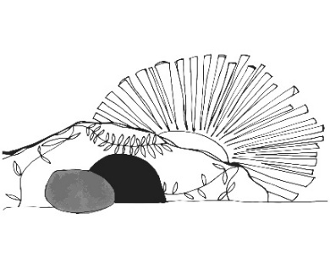
WELCOME AND ANNOUNCEMENTS
Gathering
The Holy Spirit calls us together as the people of God.

EASTER GOOD NEWS
On Good Friday when Jesus suffered and died on the cross the light went out of the world. Our sins were paid, and our salvation won; but the cost was the very life of Jesus Christ. Christ suffered and died, and darkness and silence covered the world. But darkness could not overcome the Light. Death could not conquer our Lord. On the third day Christ rose from the grave. Christ’s life and glory and presence fill the world and fill our very lives. Our hearts fill with joy and our voices fill with praise. Jesus Christ lives. Alleluia!

It is Easter Sunday and the tomb is empty. So, we come to proclaim together:
Christ is risen!

Alleluia! Christ is risen!
Christ is risen, indeed! Alleluia!

Jesus Christ is risen today! Alleluia!
Jesus Christ is risen today! Alleluia! Praise be to God!

Gathering Song “Jesus Christ Is Risen Today” #365

EASTER GREETING
Holy people of God, given new life through the gospel of Christ, and enlightened by the Spirit: grace, mercy, and peace be with you all.
And also with you.

Prayer of the Day
Let us pray together.
O God, you gave your only Son to suffer death on the cross for our redemption, and by his glorious resurrection you delivered us from the power of death. Make us die every day to sin, that we may live with him forever in the joy of the resurrection, through your Son, Jesus Christ our Lord, who lives and reigns with you and the Holy Spirit, one God, now and forever.
Amen.

SPECIAL MUSIC “He Lives” Choir

First Reading Acts 10:34-43
A reading from Acts.
³⁴ Peter began to speak to [Cornelius and his household]: “I truly understand that God shows no partiality, ³⁵ but in every people anyone who fears him and practices righteousness is acceptable to him. ³⁶ You know the message he sent to the people of Israel, preaching peace by Jesus Christ—he is Lord of all. ³⁷ That message spread throughout Judea, beginning in Galilee after the baptism that John announced: ³⁸ how God anointed Jesus of Nazareth with the Holy Spirit and with power; how he went about doing good and healing all who were oppressed by the devil, for God was with him. ³⁹ We are witnesses to all that he did both in Judea and in Jerusalem. They put him to death by hanging him on a tree, ⁴⁰ but God raised him on the third day and allowed him to appear, ⁴¹ not to all the people but to us who were chosen by God as witnesses and who ate and drank with him after he rose from the dead. ⁴² He commanded us to preach to the people and to testify that he is the one ordained by God as judge of the living and the dead. ⁴³ All the prophets testify about him that everyone who believes in him receives forgiveness of sins through his name.”

The word of the Lord.
Thanks be to God.

Psalm Psalm 118:1-2, 14-24

¹ Give thanks to the Lord, for the | Lord is good;
God’s mercy en- | dures forever.
² Let Israel | now declare,
“God’s mercy en- | dures forever.”
¹⁴ The Lord is my strength | and my song,
and has become | my salvation.
¹⁵ Shouts of rejoicing and salvation echo in the tents | of the righteous:
“The right hand of the | Lord acts valiantly!
¹⁶ The right hand of the Lord | is exalted!
The right hand of the | Lord acts valiantly!”
¹⁷ I shall not | die, but live,
and declare the works | of the Lord.
¹⁸ The Lord indeed pun- | ished me sorely,
but did not hand me o- | ver to death.
¹⁹ Open for me the | gates of righteousness;
I will enter them and give thanks | to the Lord.
²⁰ “This is the gate | of the Lord;
here the righ- | teous may enter.”
²¹ I give thanks to you, for you have | answered me
and you have become | my salvation.
²² The stone that the build- | ers rejected
has become the chief | cornerstone.
²³ By the Lord has | this been done;
it is marvelous | in our eyes.
²⁴ This is the day that the | Lord has made;
let us rejoice and be | glad in it.

Second Reading Colossians 3:1-4
A reading from Colossians.
¹ If you have been raised with Christ, seek the things that are above, where Christ is, seated at the right hand of God. ² Set your minds on the things that are above, not on the things that are on earth, ³ for you have died, and your life is hidden with Christ in God. ⁴ When Christ who is your life is revealed, then you also will be revealed with him in glory.

The Word of the Lord.
Thanks be to God.

Gospel Acclamation

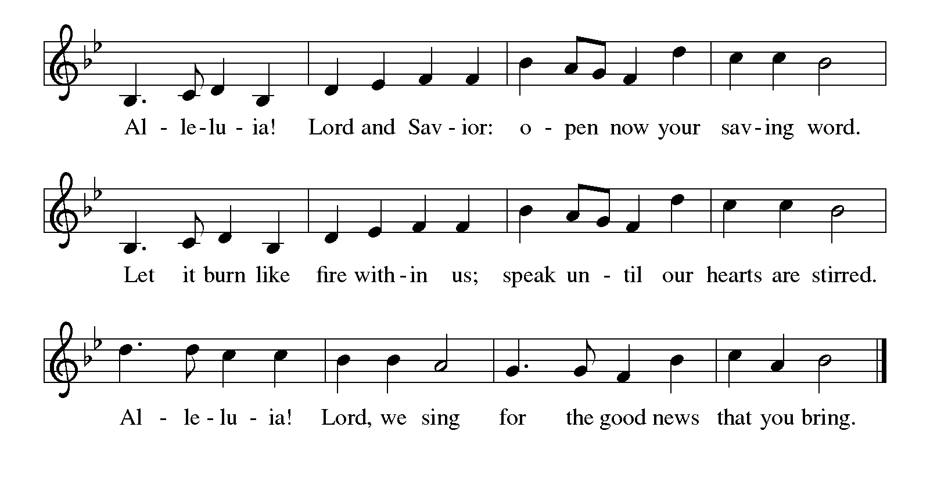

Gospel Matthew 28:1-10
The holy gospel according to Matthew.
Glory to You, O Lord.
¹ After the Sabbath, as the first day of the week was dawning, Mary Magdalene and the other Mary went to see the tomb. ² And suddenly there was a great earthquake, for an angel of the Lord, descending from heaven, came and rolled back the stone and sat on it. ³ His appearance was like lightning and his clothing white as snow. ⁴ For fear of him the guards shook and became like dead men. ⁵ But the angel said to the women, “Do not be afraid, for I know that you are looking for Jesus who was crucified. ⁶ He is not here, for he has been raised, as he said. Come, see the place where he lay. ⁷ Then go quickly and tell his disciples, ‘He has been raised from the dead, and indeed he is going ahead of you to Galilee; there you will see him.’ This is my message for you.” ⁸ So they left the tomb quickly with fear and great joy and ran to tell his disciples. ⁹ Suddenly Jesus met them and said, “Greetings!” And they came to him, took hold of his feet, and worshiped him. ¹⁰ Then Jesus said to them, “Do not be afraid; go and tell my brothers and sisters to go to Galilee; there they will see me.”

The gospel of the Lord.
Praise to you, O Christ.

CHILDREN’S MOMENT
SERMON Pastor Ken Scheck

hymn of the day “Now All The Vault Of Heaven Resounds” #367

cREED
We believe in one God,
the Father, the Almighty,
maker of heaven and earth,
of all that is, seen and unseen.
We believe in one Lord, Jesus Christ,
the only Son of God,
eternally begotten of the Father,
God from God, Light from Light,
true God from true God,
begotten, not made,
of one Being with the Father;
through him all things were made.
For us and for our salvation
he came down from heaven,
was incarnate of the Holy Spirit and the virgin Mary
and became truly human.
For our sake he was crucified under Pontius Pilate;
he suffered death and was buried.
On the third day he rose again
in accordance with the scriptures;
he ascended into heaven
and is seated at the right hand of the Father.
He will come again in glory to judge the living and the dead,
and his kingdom will have no end.
We believe in the Holy Spirit, the Lord, the giver of life,
who proceeds from the Father and the Son,*
who with the Father and the Son is worshiped and glorified,
who has spoken through the prophets.
We believe in one holy catholic and apostolic church.
We acknowledge one baptism for the forgiveness of sins.
We look for the resurrection of the dead,
and the life of the world to come. Amen.

*Or, “who proceeds from the Father.” The phrase “and the Son” is a later addition to the creed.

prayers of Intercession
(Please Be Seated)
Trusting in the power of Christ’s resurrection to heal and redeem our broken world, let us pray for the needs of all creation.
A brief silence.
Risen Savior, you have conquered death and opened the gates of everlasting life. Dispel our doubts and fears and renew our faith and hope in you.
We pray especially for Hope Lutheran in Rhodes, and their pastor Rev. Roger Bauer. Merciful God,
receive our prayer.
Life-giving God, the created world rejoices in Christ’s victory over death. May all the earth be renewed by the light of Jesus’ resurrection, and may we be faithful stewards of all you have made. Merciful God,
receive our prayer.
Sovereign God, let the nations acknowledge your reign of justice and truth. Where violence, oppression, and corruption hold sway, pour out your holy and life-giving Spirit to transform and redeem. Merciful God,
receive our prayer.
Gentle Shepherd, like the women at the empty tomb, many grieve or feel lost and afraid. Draw near to those who are ill or in pain. Reveal yourself to them as the Risen One. We pray for all those on our prayer list and those in our heart We pray for all countries involved in ongoing conflicts and all who are affected by natural disasters. Merciful God,
receive our prayer.
Faithful God, we thank you for the living hope you give us through Christ’s resurrection. Bless this community, that we may boldly proclaim Christ’s victory over death in word and deed. Merciful God,
receive our prayer.
Eternal One, we give thanks for all who have died and now share in the joy of your resurrection. Bring us, with them, to the unending feast of your victory. Merciful God,
receive our prayer.
Use us and these prayers to proclaim the good news of new life to all the world, through Jesus Christ, our risen Savior.
Amen.

PEACE
Sharing the Peace of God
The peace of the risen Christ be with you always.
And also with you.
(We share the peace of Christ with one another.)

OFFERING & OFFERING SONG
The joy of the Lord is my strength,
The joy of the Lord is my strength,
The joy of the Lord is my strength,
The joy of the Lord is my strength.

Offering Prayer
Let us pray.
Be known to us, O Lord, as you were made known to the disciples. Receive these gifts, and the offering of our lives, that we may be your risen body in the world. Amen..
Amen.

DIALOGUE
The Lord be with you.
And also with you.
Lift up your hearts.
We lift them to the Lord.
Let us give thanks to the Lord our God.
It is right to give our thanks and praise.

PREFACE (Pastor)
It is indeed right, our duty and our joy,
that we should at all times and in all places
give thanks and praise to you, almighty and merciful God,
through our Savior Jesus Christ;
who on this day overcame death and the grave,
and by his glorious resurrection opened to us the way of everlasting life.
And so, with all the choirs of angels,
with the church on earth and the hosts of heaven,
we praise your name and join their unending hymn

Holy, holy, holy

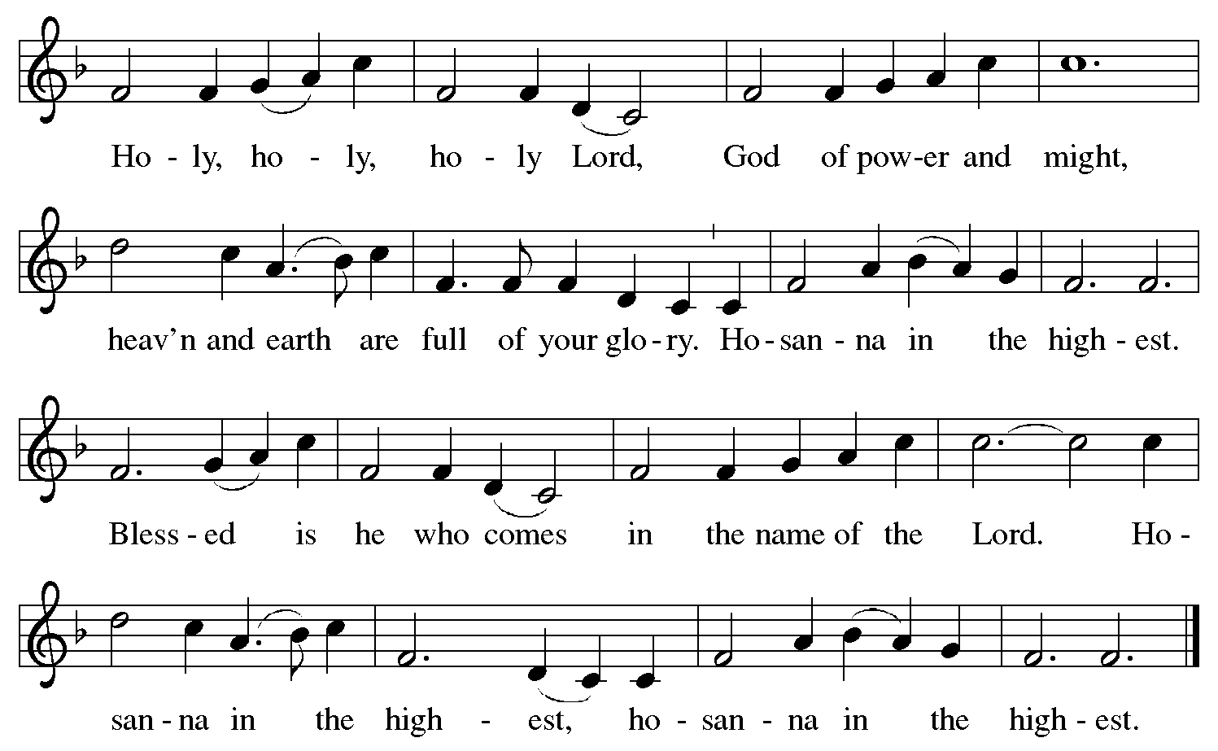

Thanksgiving at the Table
In the night in which he was betrayed,
our Lord Jesus took bread, and gave thanks;
broke it, and gave it to his disciples, saying:
Take and eat; this is my body, given for you.
Do this for the remembrance of me.

Again, after supper, he took the cup, gave thanks,
and gave it for all to drink, saying:
This cup is the new covenant in my blood,
shed for you and for all people for the forgiveness of sin.
Do this for the remembrance of me.

For as often as we eat of this bread and drink from this cup,
we proclaim the Lord’s death until he comes.

Christ has died. Christ is risen. Christ will come again.

Lord’s Prayer
Gathered into one by the Holy Spirit, let us pray as Jesus taught us.
Our Father, who art in heaven,
hallowed be thy name,
thy kingdom come,
thy will be done,
on earth as it is in heaven.
Give us this day our daily bread;
and forgive us our trespasses,
as we forgive those
who trespass against us;
and lead us not into temptation,
but deliver us from evil.
For thine is the kingdom,
and the power, and the glory,
forever and ever. Amen.

INVITATION TO COMMUNION
Come to the banquet, for all is now ready.

COMMUNION *continuous
*People are welcome to kneel at the altar rail for a time of prayer after they receive their communion elements.

COMMUNION HYMNS
“Now the Green Blade Rises” #379
“Thine The Amen” #826

PRAYER AFTER COMMUNION
Let us pray.
We give you thanks, almighty God, that you have refreshed us through the healing power of this gift of life. In your mercy, strengthen us through this gift, in faith toward you and in fervent love toward one another; for the sake of Jesus Christ our Lord.
Amen.

Sending
God blesses us and sends us in mission to the world.

Blessing
The Lord bless you and keep you.
The Lord’s face shine on you with grace and mercy.
The Lord look upon you with favor and ☩ give you peace.
Amen.
Sending SonG “Christ Is Risen! Alleluia! ” #382

SENDING
Alleluia! Christ is risen.
Christ is risen indeed. Alleluia!
You are the body of Christ raised up for the world. Go in peace, share the good news.
Thanks be to God.

From sundaysandseasons.com. Copyright © 2017 Augsburg Fortress. All rights reserved.

Thank you to all who served in worship today!
Presiders: Pastor Ken Scheck
Musicians: Jayne Flanigan & Martha Yoder
Acolyte: Safety Person:
Elder: Dan Utterback Trustee: Mike Johnson
Offering Counters: Doug MacKenzie & Mike Johnson



PRAYERS OF THE FAITHFUL

With thanks for all God’s blessings and his love for all people. Our Bishops, Julie Schneider-Thomas, Yehiel Curry, and the congregations of the North/West Lower Michigan Synod, and for Hope Lutheran in Rhodes, and their pastor Rev. Roger Bauer.

Prayers for our friends, for all who are sick or hospitalized and for all health care workers who care for them. All those members of Zion’s family traveling; all those homebound or in frail health; all those suffering with quiet, unknown needs or worries. For those who serve on our behalf: public safety, utility workers, medical personnel, military personnel. For those who might be forgotten. We pray especially for all countries involved in ongoing conflicts.

This week at Zion:
- Men’s Breakfast 8am, Wednesday 8th
- Bulletin Deadline, Wednesday 8th
- Women’s Breakfast 9am C&R’s, Thursday 9th

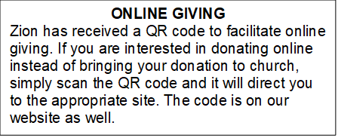

How to Contact the Pastor: If there is a pastoral need, please contact
Pastor Ken Scheck II at 269-370-4632 or by email at kscheckii@aol.com.

ANNOUNCEMENTS
- Note from the Board of Stewardship: Our congregation continues to grow in its mission to share Christ’s love in our community. As we look ahead to the coming months, we will be facing a shortfall in our operating budget. If you are able, we invite you to consider an additional gift to support our worship, outreach, and care ministries. Every contribution, large or small, strengthens the work we do together in Christ’s name. Thank you for your faithful generosity.
- Service for Jerry Engle and Thank You: My family and I want to thank you all for the prayers, kind messages, cards, calls and gifts of food and other items since the time of Jerry's passing. These kindnesses are greatly appreciated. Jerry's celebration of life service will be at Zion on Saturday, April 11th. Visitation will begin at 10:00 with the service at 11:00. We will have time to share stories of Jerry at the lunch, prepared and served by our church family, in the Fellowship Hall immediately following the service. --- Carol Engle and family
- Service for Wayne Hazel: There will be visitation and a service for Wayne Hazel on Saturday, May 2nd. Visitation will be at 10:00 am and the service will be at 11:00 am with a luncheon following. --- Jill Plummer and Family
- Recipes Requested: Zion’s super power is feeding people! There were some requests for the soups that nourished us during the Lent season, and the breakfast casseroles we’ll enjoy on Easter. If you brought soup or a casserole, please send your recipe to Jolene by April 12th. Thank you!
- Community Open House for Pastor Ken, April 19, 12-2 pm: The open house for Pastor Ken is quickly approaching! Invitations have been sent to all area churches, posters are being put up, announcements are on Facebook and we will have an ad in the Reminder next week. We need as many people as possible to be in attendance to welcome and visit with our guests! We also need people to bring food items. The Boards of Evangelism and Fellowship are hosting and making lots of sloppy joes. We are looking for salads, veggies, fruit, chips, cookies/bars etc. There is a sign-up sheet in the Narthex. We are looking forward to this special time of fellowship. If you have questions, please see a member of Evangelism or Fellowship.
- Pastor’s Availability: Pastor Ken Scheck II is available by appointment to meet with you. As you know homebound visitation has begun and will continue until all homebound have been visited by Pastor Ken. Generally speaking, he is at Grace on Mondays and Wednesdays and Zion on Tuesdays and Thursdays with a day off on Friday. As you may be aware, Pastor Ken has come to the Men’s meeting and Lakewood Area Ministerial Association meetings on Wednesday here at Zion. Flexibility is the name of the game. He is more than willing to be contacted at any time by cellphone or email. Please feel free to contact him at 269-370-4632 or at kscheckii@aol.com. You are able to send a text to the cellphone, but please identify yourself at least the first time.
- Announcement and Newsletter Items: Please forward items for the bulletin announcements and the newsletter to the church email (Office@Zion.org). Please do not send items to people’s personal emails. Thank you.
- Door Locking Policy: Our door locking policy relies on having a volunteer(s) each Sunday to serve as the Safety Person of the Day. On Sundays where no one has volunteered, if someone arrives at church and is willing to be the Safety Person of the Day, we will follow the door locking policy. If no one steps forward to serve as the Safety Person of the Day, the doors will not be locked. Please consider volunteering for this important duty.

Zion ‘s Easter Garden

In Memory of ……..

Ken, Chris, and Tammy Makley by Your Family
Peter Brodbeck by Your Loved Ones
Florence Brodbeck by Your Loved Ones
Alan Sellman and Katie Presnell by Your Loved Ones
Chuck Krikke by Tom, Lisa and Kids
Justin Hokanson by Mom and Mike, Fred & Family
Bill and Margaret Brodbeck by Phil, Dawn, and Family
Bob and Phyllis Baes by Phil, Dawn and Family
Jim and Helena Rockefellow by Phil, Dawn and Family
Grandma Marguerita by Buffy
Lester Forman by Arlene Forman
Mark Willard by Your Loved Ones
Uncle Emil by Buffy and Emil

In Honor of …….
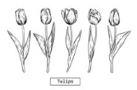
Our Families by Lyle Sandbrook and Martha Yoder
Our Family by the Griffins
For All of My Loved Ones by Caroline Brecheisen
Pastor Ken and His Family by the Congregation of Zion

