ZION LUTHERAN CHURCH, WOODLAND, MI
Second Sunday of Easter, Sunday April 12, 2026
*If you are listening in your car, please tune your radio to FM 87.7*
(Please silence your cell phones while in the sanctuary. Thank you.)


WELCOME AND ANNOUNCEMENTS

Gathering
The Holy Spirit calls us together as the people of God.

EASTER GOOD NEWS
Alleluia! Christ is risen!
Christ is risen indeed! Alleluia!

This is the day that the Lord has made;
We will rejoice and be glad in it!

Gathering Song “That Easter Day with Joy Was Bright” #384

Prayer of the Day
Let us pray together.
Almighty and eternal God, the strength of those who believe and the hope of those who doubt, may we, who have not seen, have faith in you and receive the fullness of Christ’s blessing, who lives and reigns with you and the Holy Spirit, one God, now and forever.

Amen.

First Reading Acts 2:14a, 22-32
A reading from Acts.
^{14a} Peter, standing with the eleven, raised his voice and addressed [the crowd]: ²² “Fellow Israelites, listen to what I have to say: Jesus of Nazareth, a man attested to you by God with deeds of power, wonders, and signs that God did through him among you, as you yourselves know ²³ this man, handed over to you according to the definite plan and foreknowledge of God, you crucified and killed by the hands of those outside the law. ²⁴ But God raised him up, having released him from the agony of death, because it was impossible for him to be held in its power. ²⁵ For David says concerning him,
‘I saw the Lord always before me,
for he is at my right hand so that I will not be shaken;
²⁶ therefore my heart was glad, and my tongue rejoiced;
moreover, my flesh will live in hope.
²⁷ For you will not abandon my soul to Hades
or let your Holy One experience corruption.
²⁸ You have made known to me the ways of life;
you will make me full of gladness with your presence.’
²⁹ “Fellow Israelites, I may say to you confidently of our ancestor David that he both died and was buried, and his tomb is with us to this day. ³⁰ Since he was a prophet, he knew that God had sworn with an oath to him that he would put one of his descendants on his throne. ³¹ Foreseeing this, David spoke of the resurrection of the Messiah, saying,
‘He was not abandoned to Hades,
nor did his flesh experience corruption.’
³² “This Jesus God raised up, and of that all of us are witnesses.”

The word of the Lord.
Thanks be to God.

Psalm Psalm 16
¹ Protect me, O God, for I take ref- | uge in you;
I have said to the Lord, “You are my Lord, my good a- | bove all other.”
² All my delight is in the godly that are | in the land,
upon those who are noble a- | mong the people.
³ But those who run after | other gods
shall have their troubles | multiplied.
⁴ I will not pour out drink offerings | to such gods,
never take their names up- | on my lips.
⁵ O Lord, you are my portion | and my cup;
it is you who up- | hold my lot.
⁶ My boundaries enclose a | pleasant land;
indeed, I have a | rich inheritance.
⁷ I will bless the Lord who | gives me counsel;
my heart teaches me night | after night.
⁸ I have set the Lord al- | ways before me;
because God is at my right hand, I shall | not be shaken.
⁹ My heart, therefore, is glad, and my spir- | it rejoices;
my body also shall | rest in hope.
¹⁰ For you will not abandon me | to the grave,
nor let your holy one | see the pit.
¹¹ You will show me the | path of life;
in your presence there is fullness of joy, and in your right hand are pleasures for- | evermore.

Second Reading 1 Peter 1:3-9

A reading from 1 Peter.
³ Blessed be the God and Father of our Lord Jesus Christ! By his great mercy he has given us a new birth into a living hope through the resurrection of Jesus Christ from the dead ⁴ and into an inheritance that is imperishable, undefiled, and unfading, kept in heaven for you, ⁵ who are being protected by the power of God through faith for a salvation ready to be revealed in the last time. ⁶ In this you rejoice, even if now for a little while you have had to suffer various trials, ⁷ so that the genuineness of your faith—being more precious than gold that, though perishable, is tested by fire—may be found to result in praise and glory and honor when Jesus Christ is revealed. ⁸ Although you have not seen him, you love him, and even though you do not see him now, you believe in him and rejoice with an indescribable and glorious joy, ⁹ for you are receiving the outcome of your faith, the salvation of your souls.

The Word of the Lord.
Thanks be to God.

Gospel Acclamation

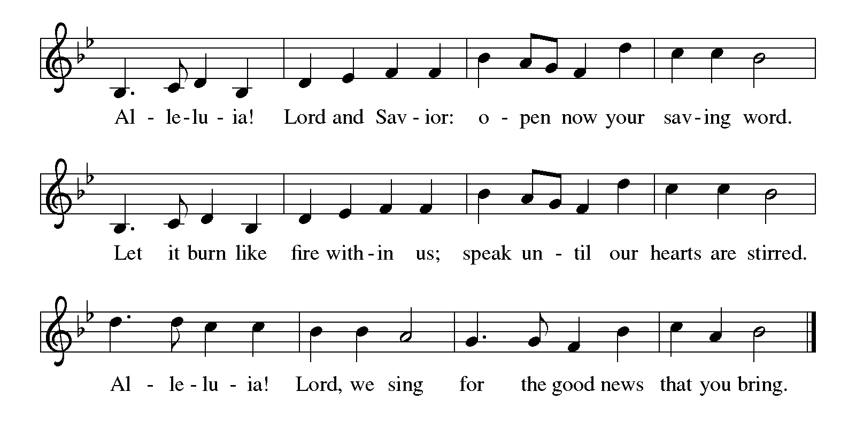

Gospel John 20:19-31
The holy gospel according to John.
Glory to You, O Lord.
¹⁹ When it was evening on that day, the first day of the week, and the doors were locked where the disciples were, for fear of the Jews, Jesus came and stood among them and said, “Peace be with you.” ²⁰ After he said this, he showed them his hands and his side. Then the disciples rejoiced when they saw the Lord. ²¹ Jesus said to them again, “Peace be with you. As the Father has sent me, so I send you.” ²² When he had said this, he breathed on them and said to them, “Receive the Holy Spirit. ²³ If you forgive the sins of any, they are forgiven them; if you retain the sins of any, they are retained.”
²⁴ But Thomas (who was called the Twin), one of the twelve, was not with them when Jesus came. ²⁵ So the other disciples told him, “We have seen the Lord.” But he said to them, “Unless I see the mark of the nails in his hands and put my finger in the mark of the nails and my hand in his side, I will not believe.”
²⁶ A week later his disciples were again in the house, and Thomas was with them. Although the doors were shut, Jesus came and stood among them and said, “Peace be with you.” ²⁷ Then he said to Thomas, “Put your finger here and see my hands. Reach out your hand and put it in my side. Do not doubt but believe.” ²⁸ Thomas answered him, “My Lord and my God!” ²⁹ Jesus said to him, “Have you believed because you have seen me? Blessed are those who have not seen and yet have come to believe.”
³⁰ Now Jesus did many other signs in the presence of his disciples that are not written in this book. ³¹ But these are written so that you may continue to believe that Jesus is the Messiah, the Son of God, and that through believing you may have life in his name.

The gospel of the Lord.
Praise to you, O Christ.

CHILDREN’S MOMENT
SERMON Pastor Ken Scheck

hymn of the day “The Risen Christ” #390

cREED
We believe in one God,
the Father, the Almighty,
maker of heaven and earth,
of all that is, seen and unseen.
We believe in one Lord, Jesus Christ,
the only Son of God,
eternally begotten of the Father,
God from God, Light from Light,
true God from true God,
begotten, not made,
of one Being with the Father;
through him all things were made.
For us and for our salvation
he came down from heaven,
was incarnate of the Holy Spirit and the virgin Mary
and became truly human.
For our sake he was crucified under Pontius Pilate;
he suffered death and was buried.
On the third day he rose again
in accordance with the scriptures;
he ascended into heaven
and is seated at the right hand of the Father.
He will come again in glory to judge the living and the dead,
and his kingdom will have no end.
We believe in the Holy Spirit, the Lord, the giver of life,
who proceeds from the Father and the Son,*
who with the Father and the Son is worshiped and glorified,
who has spoken through the prophets.
We believe in one holy catholic and apostolic church.
We acknowledge one baptism for the forgiveness of sins.
We look for the resurrection of the dead,
and the life of the world to come. Amen.

*Or, “who proceeds from the Father.” The phrase “and the Son” is a later addition to the creed.

prayers of Intercession
(Please Be Seated)
Trusting in the power of Christ’s resurrection to heal and redeem our broken world, let us pray for the needs of all creation.
A brief silence.
Almighty God, you give life to the dead and call into existence things that do not exist. Breathe your Spirit upon us, that our faith may be renewed day by day. We pray especially for St. James Lutheran in Roger’s City, and their pastor Rev. Mary Hughes. Merciful God,
receive our prayer.
Maker of heaven and earth, your mercies are new every morning. Open us to the wonders of creation, from the beauty of flowers to the complexity of subatomic particles. Merciful God,
receive our prayer.
God of peace, in every place where conflict rages, sow seeds of calm and openness to reconciliation. Strengthen the resolve of leaders and citizens to work for peace in their nations. Merciful God,
receive our prayer.
Healing God, come alongside all who are doubting, fearful, or suffering in any way. Reveal to them your presence and assure them of the inheritance you have prepared for them. We pray especially for all those on your prayer list and in our heart. We pray for all countries involved in ongoing conflicts and all who are affected by natural disasters. Merciful God,
receive our prayer.
Giver of joy, let this assembly be a place of genuine love and mutual affection. Deepen our care for one another and help us to embody your forgiving and sacrificial love. Merciful God,
receive our prayer.
Eternal One, we give thanks for saints who were faithful unto death and have joined the church triumphant. Inspire us by their witness and bring us with them into your glorious presence. Merciful God,
receive our prayer.
God of resurrection power, use us and these prayers to proclaim the good news of new life to all the world, through Jesus Christ, our risen Savior.
Amen.

PEACE
Sharing the Peace of God
The peace of the risen Christ be with you always.
And also with you.
(We share the peace of Christ with one another.)

OFFERING & OFFERING SONG
The joy of the Lord is my strength,
The joy of the Lord is my strength,
The joy of the Lord is my strength,
The joy of the Lord is my strength.

Offering Prayer
Let us pray.
Be known to us, O Lord, as you were made known to the disciples. Receive these gifts, and the offering of our lives, that we may be your risen body in the world. Amen..
Amen.

DIALOGUE
The Lord be with you.
And also with you.
Lift up your hearts.
We lift them to the Lord.
Let us give thanks to the Lord our God.
It is right to give our thanks and praise.

PREFACE (Pastor)
It is indeed right, our duty and our joy,
that we should at all times and in all places
give thanks and praise to you, almighty and merciful God,
through our Savior Jesus Christ;
who on this day overcame death and the grave,
and by his glorious resurrection opened to us the way of everlasting life.
And so, with all the choirs of angels,
with the church on earth and the hosts of heaven,
we praise your name and join their unending hymn

Holy, holy, holy

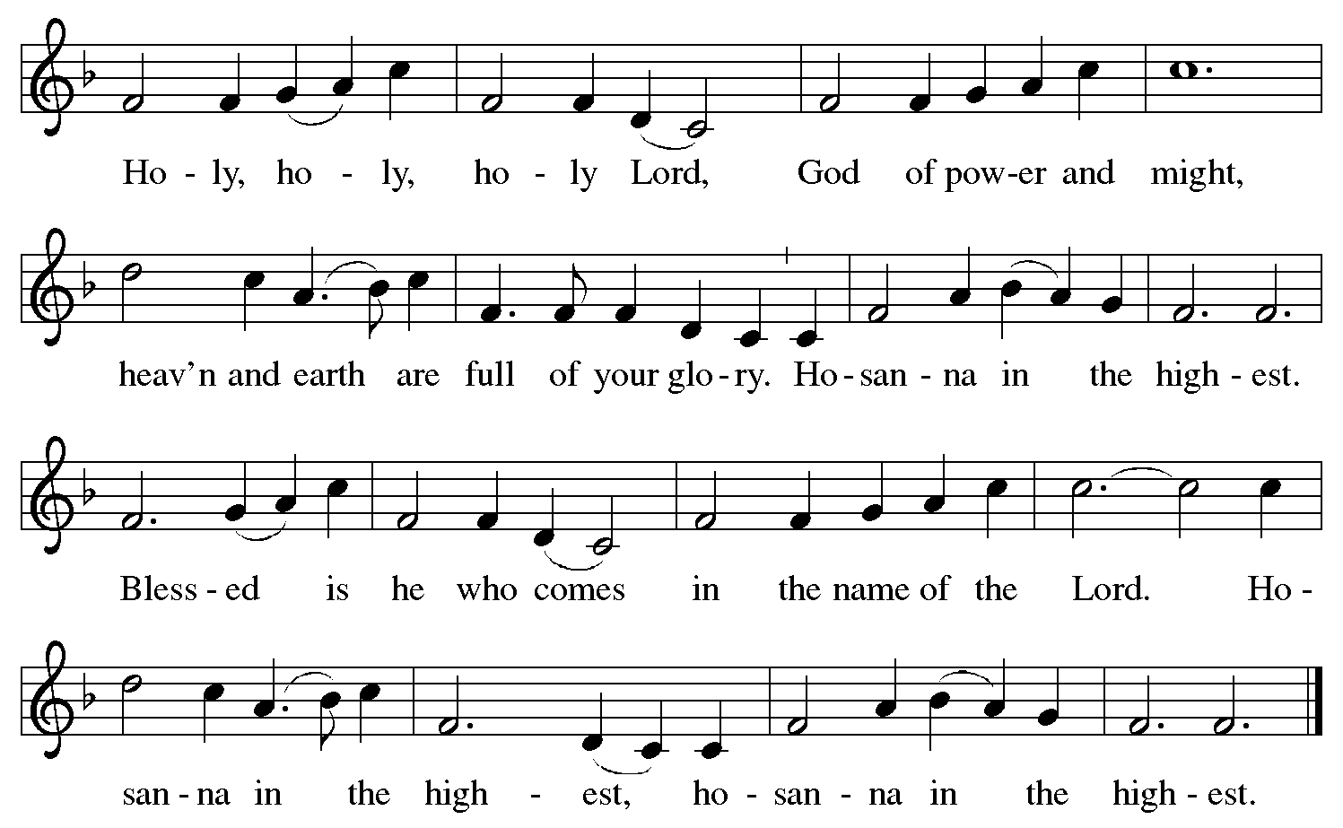

Thanksgiving at the Table
In the night in which he was betrayed,
our Lord Jesus took bread, and gave thanks;
broke it, and gave it to his disciples, saying:
Take and eat; this is my body, given for you.
Do this for the remembrance of me.

Again, after supper, he took the cup, gave thanks,
and gave it for all to drink, saying:
This cup is the new covenant in my blood,
shed for you and for all people for the forgiveness of sin.
Do this for the remembrance of me.

For as often as we eat of this bread and drink from this cup,
we proclaim the Lord’s death until he comes.

Christ has died. Christ is risen. Christ will come again.

Lord’s Prayer
Gathered into one by the Holy Spirit, let us pray as Jesus taught us.
Our Father, who art in heaven,
hallowed be thy name,
thy kingdom come,
thy will be done,
on earth as it is in heaven.
Give us this day our daily bread;
and forgive us our trespasses,
as we forgive those
who trespass against us;
and lead us not into temptation,
but deliver us from evil.
For thine is the kingdom,
and the power, and the glory,
forever and ever. Amen.

INVITATION TO COMMUNION
Come to the banquet, for all is now ready.

COMMUNION *continuous
*People are welcome to kneel at the altar rail for a time of prayer after they receive their communion elements.

COMMUNION HYMNS
“The Peace of the Lord” #646
“Eat This Bread” #472

PRAYER AFTER COMMUNION
Let us pray.
We give you thanks, almighty God, that you have refreshed us through the healing power of this gift of life. In your mercy, strengthen us through this gift, in faith toward you and in fervent love toward one another; for the sake of Jesus Christ our Lord.
Amen.

Sending
God blesses us and sends us in mission to the world.

Blessing
The Lord bless you and keep you.
The Lord’s face shine on you with grace and mercy.
The Lord look upon you with favor and ☩ give you peace.
Amen.

Sending SonG “Hallelujah! Jesus Lives!” #380

Dismissal
Go in peace. Christ is with you.
Thanks be to God.

From sundaysandseasons.com. Copyright © 2017 Augsburg Fortress. All rights reserved.

Thank you to all who served in worship today!
Presiders: Pastor Ken Scheck Musicians: Jayne Flanigan
Acolyte: Safety Person:
Elder: Buffy Meyers Trustee: Doug MacKenzie
Offering Counters: Mary Makley & Martha Yoder



PRAYERS OF THE FAITHFUL

With thanks for all God’s blessings and his love for all people. Our Bishops, Julie Schneider-Thomas, Yehiel Curry, and the congregations of the North/West Lower Michigan Synod, and especially St. James Lutheran in Roger’s City, and their pastor Rev. Mary Hughes.

Prayers for our friends, for all who are sick or hospitalized and for all health care workers who care for them. All those members of Zion’s family traveling; all those homebound or in frail health; all those suffering with quiet, unknown needs or worries. For those who serve on our behalf: public safety, utility workers, medical personnel, military personnel. For those who might be forgotten. We pray especially for all countries involved in ongoing conflicts.

This week at Zion:
- Council Metting 6:30pm, Tuesday 14th
- Men’s Breakfast 8am, Wednesday 15th
- Bulletin Deadline, Wednesday 15th

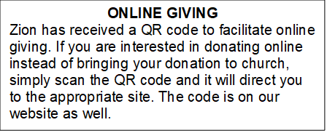

How to Contact the Pastor: If there is a pastoral need, please contact
Pastor Ken Scheck II at 269-370-4632 or by email at kscheckii@aol.com.

ANNOUNCEMENTS
- Service for Wayne Hazel: There will be visitation and a service for Wayne Hazel on Saturday, May 2nd. Visitation will be at 10:00 am and the service will be at 11:00 am with a luncheon following. --- Jill Plummer and Family
- Thank You! Everyone who helped make our Lenten Season and Easter Sunday Breakfast and Worship special this year. It was a wonderful time of reflecting, worship, and growing in our relationship with the Lord!
- Recipes Requested: Zion’s super power is feeding people! There were some requests for the soups that nourished us during the Lent season, and the breakfast casseroles we’ll enjoy on Easter. If you brought soup or a casserole, please send your recipe to Jolene by April 12th. Thank you!
- Community Open House for Pastor Ken, April 19, 12-2 pm: The open house for Pastor Ken is quickly approaching! Invitations have been sent to all area churches, posters are being put up, announcements are on Facebook and we will have an ad in the Reminder next week. We need as many people as possible to be in attendance to welcome and visit with our guests! We also need people to bring food items. The Boards of Evangelism and Fellowship are hosting and making lots of sloppy joes. We are looking for salads, veggies, fruit, chips, cookies/bars etc. There is a sign-up sheet in the Narthex. We are looking forward to this special time of fellowship. If you have questions, please see a member of Evangelism or Fellowship.
- Pastor’s Availability: Pastor Ken Scheck II is available by appointment to meet with you. As you know homebound visitation has begun and will continue until all homebound have been visited by Pastor Ken. Generally speaking, he is at Grace on Mondays and Wednesdays and Zion on Tuesdays and Thursdays with a day off on Friday. As you may be aware, Pastor Ken has come to the Men’s meeting and Lakewood Area Ministerial Association meetings on Wednesday here at Zion. Flexibility is the name of the game. He is more than willing to be contacted at any time by cellphone or email. Please feel free to contact him at 269-370-4632 or at kscheckii@aol.com. You are able to send a text to the cellphone, but please identify yourself at least the first time.
- Announcement and Newsletter Items: Please forward items for the bulletin announcements and the newsletter to the church email (Office@Zion.org). Please do not send items to people’s personal emails. Thank you.
- Door Locking Policy: Our door locking policy relies on having a volunteer(s) each Sunday to serve as the Safety Person of the Day. On Sundays where no one has volunteered, if someone arrives at church and is willing to be the Safety Person of the Day, we will follow the door locking policy. If no one steps forward to serve as the Safety Person of the Day, the doors will not be locked. Please consider volunteering for this important duty.

