ZION LUTHERAN CHURCH, WOODLAND, MI
Third Sunday of Easter, Sunday April 19, 2026
*If you are listening in your car, please tune your radio to FM 87.7*
(Please silence your cell phones while in the sanctuary. Thank you.)


WELCOME AND ANNOUNCEMENTS

Gathering
The Holy Spirit calls us together as the people of God.

EASTER GOOD NEWS
Alleluia! Christ is risen!
Christ is risen indeed! Alleluia!

This is the day that the Lord has made;
We will rejoice and be glad in it!

Gathering Song “We Come to the Hungry Feast” #479

Prayer of the Day
Let us pray together.
O God, your Son makes himself known to all his disciples in the breaking of bread. Open the eyes of our faith, that we may see him in his redeeming work, who lives and reigns with you and the Holy Spirit, one God, now and forever.
Amen.

First Reading Acts 2:14a, 36-41
A reading from Acts.
^{14a} Peter, standing with the eleven, raised his voice and addressed [the crowd]: ³⁶ “Therefore let the entire house of Israel know with certainty that God has made him both Lord and Messiah, this Jesus whom you crucified.”
³⁷ Now when they heard this, they were cut to the heart and said to Peter and to the other apostles, “Brothers, what should we do?” ³⁸ Peter said to them, “Repent and be baptized every one of you in the name of Jesus Christ so that your sins may be forgiven, and you will receive the gift of the Holy Spirit. ³⁹ For the promise is for you, for your children, and for all who are far away, everyone whom the Lord our God calls to him.” ⁴⁰ And he testified with many other arguments and exhorted them, saying, “Save yourselves from this corrupt generation.” ⁴¹ So those who welcomed his message were baptized, and that day about three thousand persons were added.

The word of the Lord.
Thanks be to God.

Psalm Psalm 116:1-4, 12-19
¹ I love the Lord, who has | heard my voice,
and listened to my | supplication,
² for the Lord has given | ear to me
whenev- | er I called.
³ The cords of death entangled me; the anguish of the grave | came upon me;
I came to | grief and sorrow.
⁴ Then I called upon the name | of the Lord:
“O Lord, I pray you, | save my life.”
¹² How shall I re- | pay the Lord
for all the good things God has | done for me?
¹³ I will lift the cup | of salvation
and call on the name | of the Lord.
¹⁴ I will fulfill my vows | to the Lord
in the presence of | all God’s people.
¹⁵ Precious in your | sight, O Lord,
is the death | of your servants.
¹⁶ O Lord, truly I | am your servant;
I am your servant, the child of your handmaid; you have freed me | from my bonds.
¹⁷ I will offer you the sacrifice | of thanksgiving
and call upon the name | of the Lord.
¹⁸ I will fulfill my vows | to the Lord
in the presence of | all God’s people,
¹⁹ in the courts of | the Lord’s house,
in the midst of you, O Jerusalem. | Hallelujah!

Second Reading 1 Peter 1:17-23
A reading from 1 Peter.
¹⁷ If you invoke as Father the one who judges impartially according to each person’s work, live in fear during the time of your exile. ¹⁸ You know that you were ransomed from the futile conduct inherited from your ancestors, not with perishable things like silver or gold ¹⁹ but with the precious blood of Christ, like that of a lamb without defect or blemish. ²⁰ He was destined before the foundation of the world but was revealed at the end of the ages for your sake. ²¹ Through him you have come to trust in God, who raised him from the dead and gave him glory, so that your trust and hope are in God.
²² Now that you have purified your souls by your obedience to the truth so that you have genuine mutual affection, love one another deeply from the heart. ²³ You have been born anew, not of perishable but of imperishable seed, through the living and enduring word of God.

The Word of the Lord.
Thanks be to God.

Gospel Acclamation

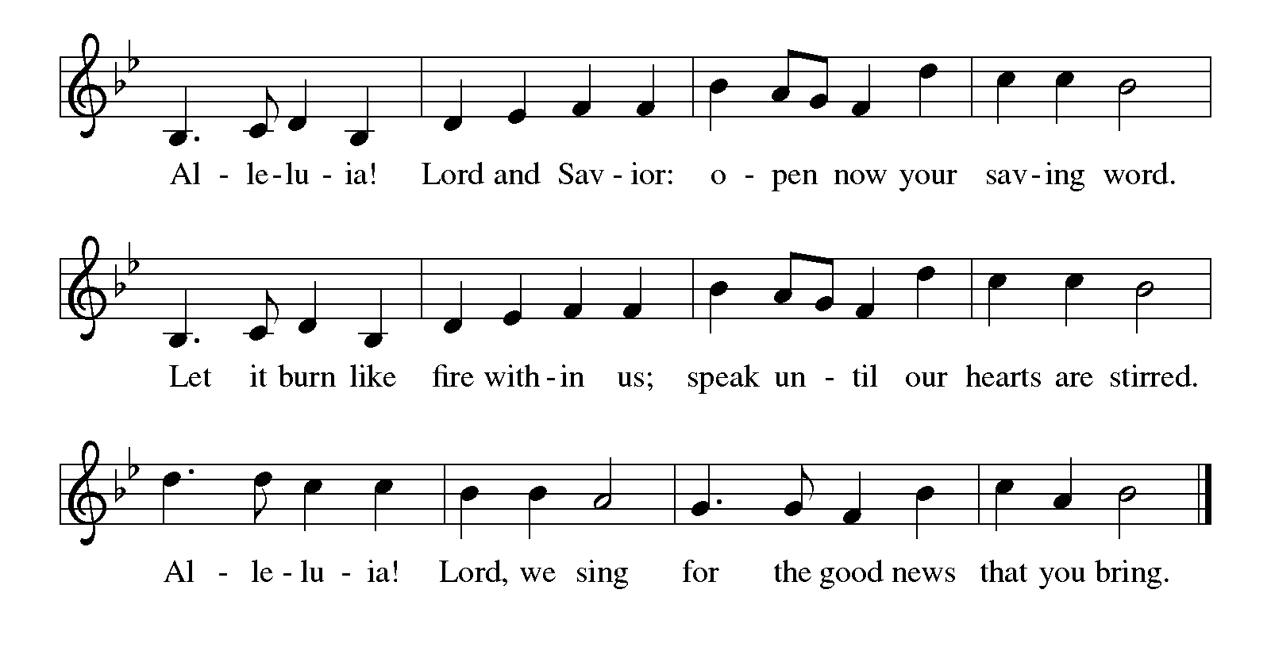

Gospel Luke 24:13-35
The holy gospel according to Luke.
Glory to You, O Lord.
¹³ Now on that same day two [disciples] were going to a village called Emmaus, about seven miles from Jerusalem, ¹⁴ and talking with each other about all these things that had happened. ¹⁵ While they were talking and discussing, Jesus himself came near and went with them, ¹⁶ but their eyes were kept from recognizing him. ¹⁷ And he said to them, “What are you discussing with each other while you walk along?” They stood still, looking sad. ¹⁸ Then one of them, whose name was Cleopas, answered him, “Are you the only stranger in Jerusalem who does not know the things that have taken place there in these days?” ¹⁹ He asked them, “What things?” They replied, “The things about Jesus of Nazareth, who was a prophet mighty in deed and word before God and all the people, ²⁰ and how our chief priests and leaders handed him over to be condemned to death and crucified him. ²¹ But we had hoped that he was the one to redeem Israel. Yes, and besides all this, it is now the third day since these things took place. ²² Moreover, some women of our group astounded us. They were at the tomb early this morning, ²³ and when they did not find his body there they came back and told us that they had indeed seen a vision of angels who said that he was alive. ²⁴ Some of those who were with us went to the tomb and found it just as the women had said, but they did not see him.” ²⁵ Then he said to them, “Oh, how foolish you are and how slow of heart to believe all that the prophets have declared! ²⁶ Was it not necessary that the Messiah should suffer these things and then enter into his glory?” ²⁷ Then beginning with Moses and all the prophets, he interpreted to them the things about himself in all the scriptures.
²⁸ As they came near the village to which they were going, he walked ahead as if he were going on. ²⁹ But they urged him strongly, saying, “Stay with us, because it is almost evening and the day is now nearly over.” So he went in to stay with them. ³⁰ When he was at the table with them, he took bread, blessed and broke it, and gave it to them. ³¹ Then their eyes were opened, and they recognized him, and he vanished from their sight. ³² They said to each other, “Were not our hearts burning within us while he was talking to us on the road, while he was opening the scriptures to us?” ³³ That same hour they got up and returned to Jerusalem, and they found the eleven and their companions gathered together. ³⁴ They were saying, “The Lord has risen indeed, and he has appeared to Simon!” ³⁵ Then they told what had happened on the road and how he had been made known to them in the breaking of the bread.

The gospel of the Lord.
Praise to you, O Christ.

CHILDREN’S MOMENT
SERMON Pastor Ken Scheck

hymn of the day “Alleluia! Jesus Is Risen!” #377

cREED
We believe in one God,
the Father, the Almighty,
maker of heaven and earth,
of all that is, seen and unseen.
We believe in one Lord, Jesus Christ,
the only Son of God,
eternally begotten of the Father,
God from God, Light from Light,
true God from true God,
begotten, not made,
of one Being with the Father;
through him all things were made.
For us and for our salvation
he came down from heaven,
was incarnate of the Holy Spirit and the virgin Mary
and became truly human.
For our sake he was crucified under Pontius Pilate;
he suffered death and was buried.
On the third day he rose again
in accordance with the scriptures;
he ascended into heaven
and is seated at the right hand of the Father.
He will come again in glory to judge the living and the dead,
and his kingdom will have no end.
We believe in the Holy Spirit, the Lord, the giver of life,
who proceeds from the Father and the Son,*
who with the Father and the Son is worshiped and glorified,
who has spoken through the prophets.
We believe in one holy catholic and apostolic church.
We acknowledge one baptism for the forgiveness of sins.
We look for the resurrection of the dead,
and the life of the world to come. Amen.

*Or, “who proceeds from the Father.” The phrase “and the Son” is a later addition to the creed.

prayers of Intercession
(Please Be Seated)
Trusting in the power of Christ’s resurrection to heal and redeem our broken world, let us pray for the needs of all creation.
A brief silence.
Living Savior, just as you journeyed with the disciples to Emmaus, accompany us on our journey of faith. Gather us at your table, that we recognize you in the breaking of the bread. We pray especially for Hope Lutheran Church in Rockford, and their Supply pastors.
Merciful God,
receive our prayer.
Almighty God, you provide for the needs of all creation. Bless the fields that are being prepared for planting, and send favorable weather so that the soil may yield an abundant harvest. Merciful God,
receive our prayer.
God of justice, where leaders abuse power, confront them and call them to repentance. Where there is corruption, bring integrity; where there is violence, sow peace. Merciful God,
receive our prayer.
Healing Savior, your resurrection brings hope to a hurting world. Heal those who are sick. We pray especially for all those on your prayer list and in our heart. We pray for all countries involved in ongoing conflicts and all who are affected by natural disasters. Strengthen the weary, give courage to the despairing, and comfort the dying. Merciful God,
receive our prayer.
Gracious One, you have made us your own through the gift of baptism. Unite us in genuine love for one another and uphold this community in your name. Merciful God,
receive our prayer.
Eternal Light, we give thanks for all who have nurtured your church’s life in ages past. Bring us at last with them to the brightness of your glorious presence. Merciful God,
receive our prayer.
God of resurrection power, use us and these prayers to proclaim the good news of new life to all the world, through Jesus Christ, our risen Savior.
Amen.

PEACE
Sharing the Peace of God
The peace of the risen Christ be with you always.
And also with you.
(We share the peace of Christ with one another.)

OFFERING & OFFERING SONG
The joy of the Lord is my strength,
The joy of the Lord is my strength,
The joy of the Lord is my strength,
The joy of the Lord is my strength.

Offering Prayer
Let us pray.
Be known to us, O Lord, as you were made known to the disciples. Receive these gifts, and the offering of our lives, that we may be your risen body in the world. Amen..
Amen.

DIALOGUE
The Lord be with you.
And also with you.
Lift up your hearts.
We lift them to the Lord.
Let us give thanks to the Lord our God.
It is right to give our thanks and praise.

PREFACE (Pastor)
It is indeed right, our duty and our joy,
that we should at all times and in all places
give thanks and praise to you, almighty and merciful God,
through our Savior Jesus Christ;
who on this day overcame death and the grave,
and by his glorious resurrection opened to us the way of everlasting life.
And so, with all the choirs of angels,
with the church on earth and the hosts of heaven,
we praise your name and join their unending hymn

Holy, holy, holy

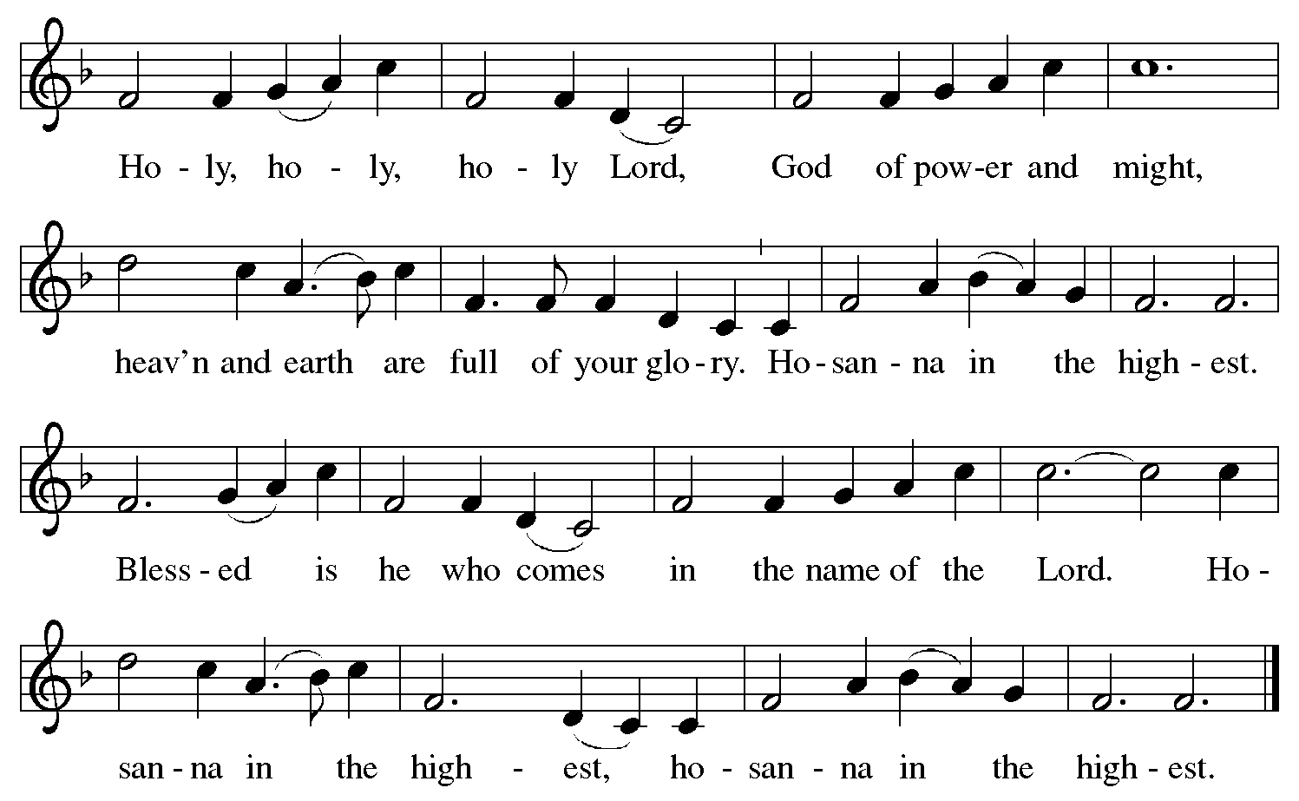

Thanksgiving at the Table
In the night in which he was betrayed,
our Lord Jesus took bread, and gave thanks;
broke it, and gave it to his disciples, saying:
Take and eat; this is my body, given for you.
Do this for the remembrance of me.

Again, after supper, he took the cup, gave thanks,
and gave it for all to drink, saying:
This cup is the new covenant in my blood,
shed for you and for all people for the forgiveness of sin.
Do this for the remembrance of me.

For as often as we eat of this bread and drink from this cup,
we proclaim the Lord’s death until he comes.

Christ has died. Christ is risen. Christ will come again.

Lord’s Prayer
Gathered into one by the Holy Spirit, let us pray as Jesus taught us.
Our Father, who art in heaven,
hallowed be thy name,
thy kingdom come,
thy will be done,
on earth as it is in heaven.
Give us this day our daily bread;
and forgive us our trespasses,
as we forgive those
who trespass against us;
and lead us not into temptation,
but deliver us from evil.
For thine is the kingdom,
and the power, and the glory,
forever and ever. Amen.

INVITATION TO COMMUNION
Come to the banquet, for all is now ready.

COMMUNION *continuous
*People are welcome to kneel at the altar rail for a time of prayer after they receive their communion elements.

COMMUNION HYMNS
“Eat This Bread, Drink This Cup” #492
“Taste and See” #493

PRAYER AFTER COMMUNION
Let us pray.
We give you thanks, almighty God, that you have refreshed us through the healing power of this gift of life. In your mercy, strengthen us through this gift, in faith toward you and in fervent love toward one another; for the sake of Jesus Christ our Lord.
Amen.

Sending
God blesses us and sends us in mission to the world.

Blessing
The Lord bless you and keep you.
The Lord’s face shine on you with grace and mercy.
The Lord look upon you with favor and ☩ give you peace.
Amen.

Sending SonG “Come with Us, O Blessed Jesus” #501

Dismissal
Go in peace. Christ is with you.
Thanks be to God.

From sundaysandseasons.com. Copyright © 2017 Augsburg Fortress. All rights reserved.

Thank you to all who served in worship today!
Presiders: Pastor Ken Scheck Musicians: Martha Yoder
Acolyte: Safety Person:
Elder: Naomi Wilson Trustee: Jimmy Hindman
Offering Counters: Diane Griffin & Carlotta Willard



PRAYERS OF THE FAITHFUL

With thanks for all God’s blessings and his love for all people. Our Bishops, Julie Schneider-Thomas, Yehiel Curry, and the congregations of the North/West Lower Michigan Synod, and especially Hope Lutheran Church in Rockford, and their Supply pastors.

Prayers for our friends, for all who are sick or hospitalized and for all health care workers who care for them. All those members of Zion’s family traveling; all those homebound or in frail health; all those suffering with quiet, unknown needs or worries. For those who serve on our behalf: public safety, utility workers, medical personnel, military personnel. For those who might be forgotten. We pray especially for all countries involved in ongoing conflicts.

This week at Zion:
- Men’s Breakfast 8am, Wednesday 22nd
- Bulletin Deadline, Wednesday 22nd
- Newsletter Deadline, Thursday 23rd

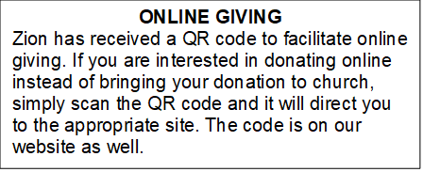

How to Contact the Pastor: If there is a pastoral need, please contact
Pastor Ken Scheck II at 269-370-4632 or by email at kscheckii@aol.com.

ANNOUNCEMENTS
- Community Open House for Pastor Ken, Today April 19, 12-2 pm:
Please stay and enjoy this time of food and fellowship.
- Crop Walk: The annual Crop Walk is Sunday April 26th. Please consider participating in this opportunity to help raise funds to provide food for people locally and throughout the country. Please see Claude or Mary Smith for more information.
- Note from the Board of Stewardship: Our congregation continues to grow in its mission to share Christ’s love in our community. As we look ahead to the coming months, we will be facing a shortfall in our operating budget. If you are able, we invite you to consider an additional gift to support our worship, outreach, and care ministries. Every contribution, large or small, strengthens the work we do together in Christ’s name. Thank you for your faithful generosity.
- Service for Wayne Hazel: There will be visitation and a service for Wayne Hazel on Saturday, May 2nd. Visitation will be at 10:00 am and the service will be at 11:00 am with a luncheon following. --- Jill Plummer and Family
- Thank You! Everyone who helped make our Lenten Season and Easter Sunday Breakfast and Worship special this year. It was a wonderful time of reflecting, worship, and growing in our relationship with the Lord!
- Pastor’s Availability: Pastor Ken Scheck II is available by appointment to meet with you. As you know homebound visitation has begun and will continue until all homebound have been visited by Pastor Ken. Generally speaking, he is at Grace on Mondays and Wednesdays and Zion on Tuesdays and Thursdays with a day off on Friday. As you may be aware, Pastor Ken has come to the Men’s meeting and Lakewood Area Ministerial Association meetings on Wednesday here at Zion. Flexibility is the name of the game. He is more than willing to be contacted at any time by cellphone or email. Please feel free to contact him at 269-370-4632 or at kscheckii@aol.com. You are able to send a text to the cellphone, but please identify yourself at least the first time.
- Announcement and Newsletter Items: Please forward items for the bulletin announcements and the newsletter to the church email (Office@Zion.org). Please do not send items to people’s personal emails. Thank you.
- Door Locking Policy: Our door locking policy relies on having a volunteer(s) each Sunday to serve as the Safety Person of the Day. On Sundays where no one has volunteered, if someone arrives at church and is willing to be the Safety Person of the Day, we will follow the door locking policy. If no one steps forward to serve as the Safety Person of the Day, the doors will not be locked. Please consider volunteering for this important duty.

