ZION LUTHERAN CHURCH, WOODLAND, MI
Fourth Sunday of Easter, Sunday April 26, 2026
*If you are listening in your car, please tune your radio to FM 87.7*
(Please silence your cell phones while in the sanctuary. Thank you.)


WELCOME AND ANNOUNCEMENTS

Gathering
The Holy Spirit calls us together as the people of God.

EASTER GOOD NEWS
Alleluia! Christ is risen!
Christ is risen indeed! Alleluia!

This is the day that the Lord has made;
We will rejoice and be glad in it!

Gathering Song “Good Christian Friends, Rejoice and Sing!” #385

Prayer of the Day
Let us pray together.
O God our shepherd, you know your sheep by name and lead us to safety through the valleys of death. Guide us by your voice, that we may walk in certainty and security to the joyous feast prepared in your house, through Jesus Christ, our Savior and Lord, who lives and reigns with you and the Holy Spirit, one God, now and forever.

Amen.

First Reading Acts 2:42-47
A reading from Acts.

⁴² [The baptized] devoted themselves to the apostles’ teaching and fellowship, to the breaking of bread and the prayers.
⁴³ Awe came upon everyone because many wonders and signs were being done through the apostles. ⁴⁴ All who believed were together and had all things in common; ⁴⁵ they would sell their possessions and goods and distribute the proceeds to all, as any had need. ⁴⁶ Day by day, as they spent much time together in the temple, they broke bread at home and ate their food with glad and generous hearts, ⁴⁷ praising God and having the goodwill of all the people. And day by day the Lord added to their number those who were being saved.

The word of the Lord.
Thanks be to God.

Psalm Psalm 23
¹ The Lord | is my shepherd;
I shall not | be in want.
² The Lord makes me lie down | in green pastures
and leads me be- | side still waters.
³ You restore my | soul, O Lord,
and guide me along right pathways | for your name’s sake.
⁴ Though I walk through the valley of the shadow of death, I shall | fear no evil;
for you are with me; your rod and your staff, they | comfort me.
⁵ You prepare a table before me in the presence | of my enemies;
you anoint my head with oil, and my cup is | running over.
⁶ Surely goodness and mercy shall follow me all the days | of my life,
and I will dwell in the house of the | Lord forever.

Second Reading 1 Peter 2:19-25
A reading from 1 Peter.
¹⁹ It is a commendable thing if, being aware of God, a person endures pain while suffering unjustly. ²⁰ If you endure when you are beaten for doing wrong, what credit is that? But if you endure when you do good and suffer for it, this is a commendable thing before God. ²¹ For to this you have been called, because Christ also suffered for you, leaving you an example, so that you should follow in his steps.
²² “He committed no sin,
and no deceit was found in his mouth.”
²³ When he was abused, he did not return abuse; when he suffered, he did not threaten, but he entrusted himself to the one who judges justly. ²⁴ He himself bore our sins in his body on the cross, so that, having died to sins, we might live for righteousness; by his wounds you have been healed. ²⁵ For you were going astray like sheep, but now you have returned to the shepherd and guardian of your souls.

The Word of the Lord.
Thanks be to God.

Gospel Acclamation
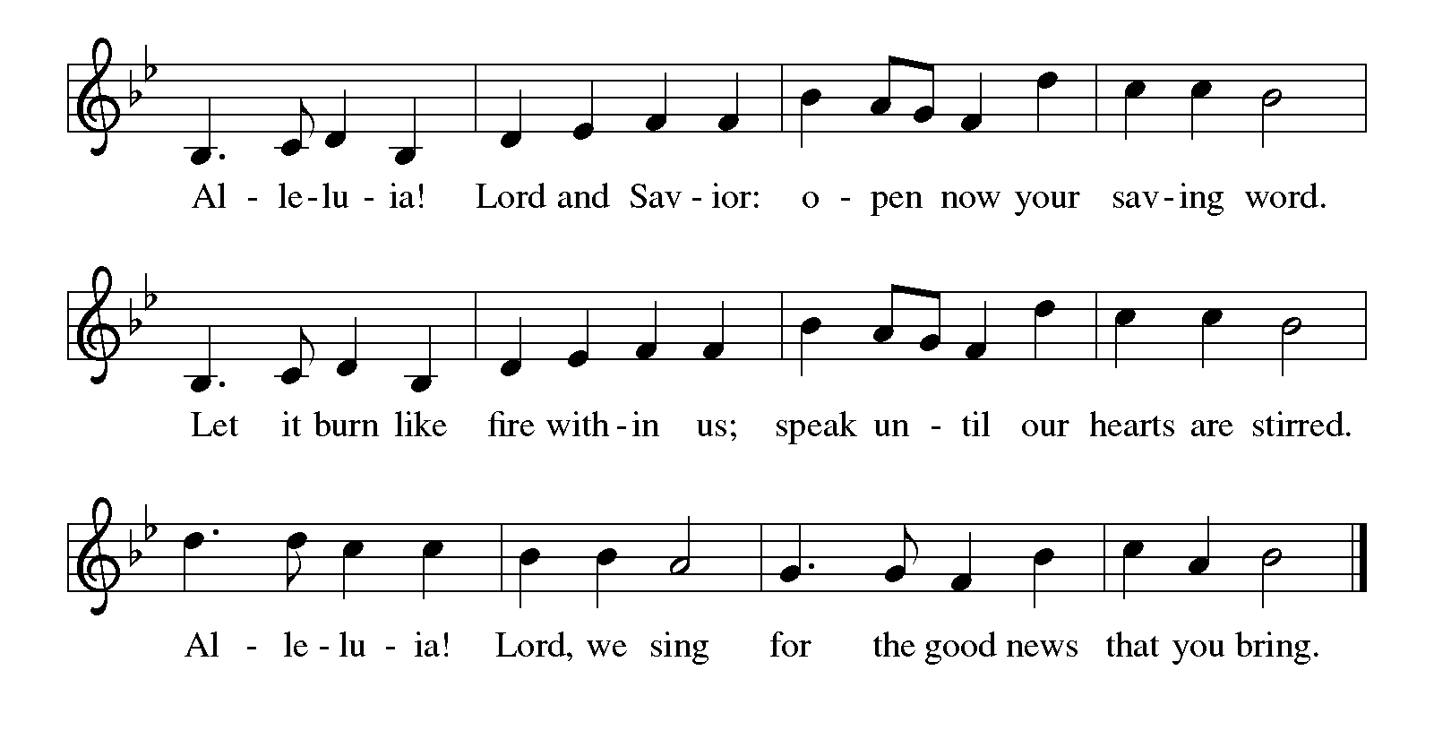

Gospel John 10:1-10
The holy gospel according to Luke.
Glory to You, O Lord.
[Jesus said:] ¹ “Very truly, I tell you, anyone who does not enter the sheepfold by the gate but climbs in by another way is a thief and a bandit. ² The one who enters by the gate is the shepherd of the sheep. ³ The gatekeeper opens the gate for him, and the sheep hear his voice. He calls his own sheep by name and leads them out. ⁴ When he has brought out all his own, he goes ahead of them, and the sheep follow him because they know his voice. ⁵ They will not follow a stranger, but they will run from him because they do not know the voice of strangers.” ⁶ Jesus used this figure of speech with them, but they did not understand what he was saying to them.
⁷ So again Jesus said to them, “Very truly, I tell you, I am the gate for the sheep. ⁸ All who came before me are thieves and bandits, but the sheep did not listen to them. ⁹ I am the gate. Whoever enters by me will be saved and will come in and go out and find pasture. ¹⁰ The thief comes only to steal and kill and destroy. I came that they may have life and have it abundantly.”

The gospel of the Lord.
Praise to you, O Christ.

CHILDREN’S MOMENT
SERMON Pastor Ken Scheck

hymn of the day “Have No Fear, Little Flock” #764

cREED
We believe in one God,
the Father, the Almighty,
maker of heaven and earth,
of all that is, seen and unseen.
We believe in one Lord, Jesus Christ,
the only Son of God,
eternally begotten of the Father,
God from God, Light from Light,
true God from true God,
begotten, not made,
of one Being with the Father;
through him all things were made.
For us and for our salvation
he came down from heaven,
was incarnate of the Holy Spirit and the virgin Mary
and became truly human.
For our sake he was crucified under Pontius Pilate;
he suffered death and was buried.
On the third day he rose again
in accordance with the scriptures;
he ascended into heaven
and is seated at the right hand of the Father.
He will come again in glory to judge the living and the dead,
and his kingdom will have no end.
We believe in the Holy Spirit, the Lord, the giver of life,
who proceeds from the Father and the Son,*
who with the Father and the Son is worshiped and glorified,
who has spoken through the prophets.
We believe in one holy catholic and apostolic church.
We acknowledge one baptism for the forgiveness of sins.
We look for the resurrection of the dead,
and the life of the world to come. Amen.

*Or, “who proceeds from the Father.” The phrase “and the Son” is a later addition to the creed.
prayers of Intercession
(Please Be Seated)
Trusting in the power of Christ’s resurrection to heal and redeem our broken world, let us pray for the needs of all creation.
A brief silence.
Shepherding God, draw all people to yourself and lead them in paths of righteousness. Embolden your church to enter the valleys of the world and guide us beside the still waters of your grace. We pray for military and prison chaplains serving near and far. We pray especially Prince of Peace Lutheran in Rose City and their pastor Rev. David Sprang.
Merciful God,
receive our prayer.
Creator God, by the resurrection of your Son, show us your steadfast love and instruct our hearts in your ways. Help us to revere and protect the wonders of your creation. Merciful God,
receive our prayer.
Righteous Judge, strengthen and uphold those who work for justice and advocate for human rights. Bring an end to oppression and save us from the temptation of violence or vengeance. Merciful God,
receive our prayer.
Great Physician, walk with those who are grieving, and anoint those who are ill or injured. We pray especially for all those on your prayer list and in our heart. We pray for all countries involved in ongoing conflicts and all who are affected by natural disasters. Restore them to health of body, mind, and spirit. Merciful God,
receive our prayer.
Good Shepherd, continually seek us out as lambs of your flock, and form us into a community where all are honored and cared for. Spread a feast before us and fill our cups to overflowing. Merciful God,
receive our prayer.
Living God, we praise you for the saints who have died in faith and now dwell in your love. At our end, bring us, with them, to our heavenly home. Merciful God,
receive our prayer.
God of resurrection power, use us and these prayers to proclaim the good news of new life to all the world, through Jesus Christ, our risen Savior.
Amen.

PEACE
Sharing the Peace of God
The peace of the risen Christ be with you always.

And also with you.
(We share the peace of Christ with one another.)
OFFERING & OFFERING SONG
The joy of the Lord is my strength,
The joy of the Lord is my strength,
The joy of the Lord is my strength,
The joy of the Lord is my strength.

Offering Prayer
Let us pray.
Be known to us, O Lord, as you were made known to the disciples. Receive these gifts, and the offering of our lives, that we may be your risen body in the world. Amen..
Amen.

DIALOGUE
The Lord be with you.
And also with you.
Lift up your hearts.
We lift them to the Lord.
Let us give thanks to the Lord our God.
It is right to give our thanks and praise.

PREFACE (Pastor)
It is indeed right, our duty and our joy,
that we should at all times and in all places
give thanks and praise to you, almighty and merciful God,
through our Savior Jesus Christ;
who on this day overcame death and the grave,
and by his glorious resurrection opened to us the way of everlasting life.
And so, with all the choirs of angels,
with the church on earth and the hosts of heaven,
we praise your name and join their unending hymn

Holy, holy, holy
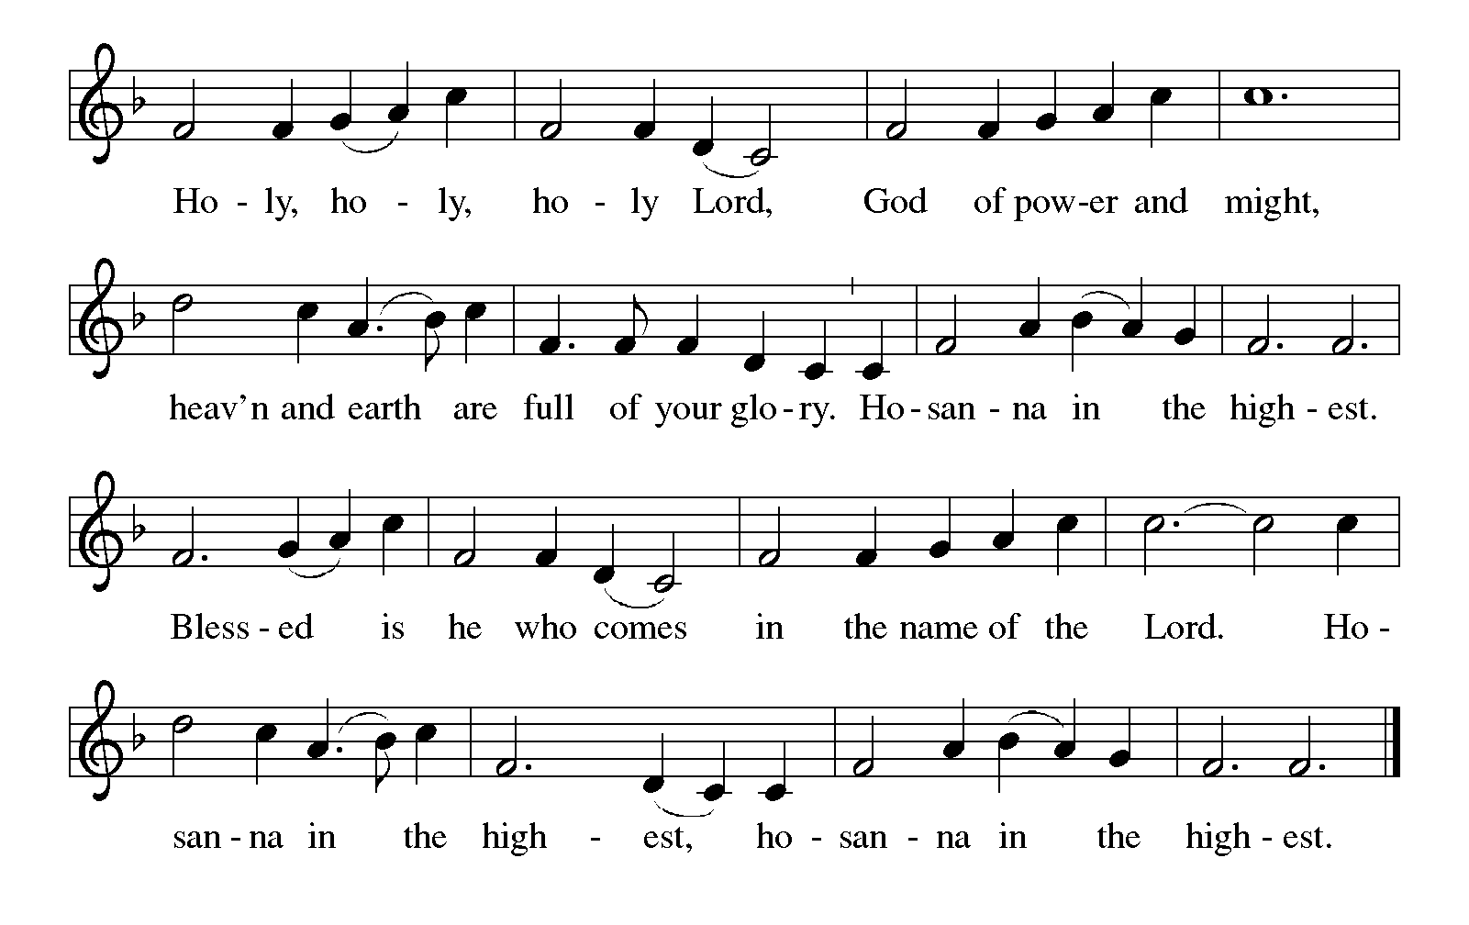

Thanksgiving at the Table
In the night in which he was betrayed,
our Lord Jesus took bread, and gave thanks;
broke it, and gave it to his disciples, saying:
Take and eat; this is my body, given for you.
Do this for the remembrance of me.

Again, after supper, he took the cup, gave thanks,
and gave it for all to drink, saying:
This cup is the new covenant in my blood,
shed for you and for all people for the forgiveness of sin.
Do this for the remembrance of me.

For as often as we eat of this bread and drink from this cup,
we proclaim the Lord’s death until he comes.

Christ has died. Christ is risen. Christ will come again.

Lord’s Prayer
Gathered into one by the Holy Spirit, let us pray as Jesus taught us.
Our Father, who art in heaven,
hallowed be thy name,
thy kingdom come,
thy will be done,
on earth as it is in heaven.
Give us this day our daily bread;
and forgive us our trespasses,
as we forgive those
who trespass against us;
and lead us not into temptation,
but deliver us from evil.
For thine is the kingdom,
and the power, and the glory,
forever and ever. Amen.

INVITATION TO COMMUNION
Come to the banquet, for all is now ready.

COMMUNION *continuous
*People are welcome to kneel at the altar rail for a time of prayer after they receive their communion elements.

COMMUNION HYMNS
“Savior, like a Shepherd Lead Us” #789
“You Satisfy the Hungry Heart” #484

PRAYER AFTER COMMUNION
Let us pray.
We give you thanks, almighty God, that you have refreshed us through the healing power of this gift of life. In your mercy, strengthen us through this gift, in faith toward you and in fervent love toward one another; for the sake of Jesus Christ our Lord.
Amen.

Sending
God blesses us and sends us in mission to the world.

Blessing
The Lord bless you and keep you.
The Lord’s face shine on you with grace and mercy.
The Lord look upon you with favor and ☩ give you peace.
Amen.
Sending SonG “What a Fellowship, What a Joy Divine” #774

Dismissal
Go in peace. Christ is with you.
Thanks be to God.

From sundaysandseasons.com. Copyright © 2017 Augsburg Fortress. All rights reserved.

Thank you to all who served in worship today!
Presiders: Pastor Ken Scheck Musicians: Martha Yoder
Acolyte: Kole Hokanson Safety Person:
Elder: Dan Utterback Trustee: Mike Johnson
Offering Counters: Paul Meade & Carlotta Willard



PRAYERS OF THE FAITHFUL

With thanks for all God’s blessings and his love for all people. Our Bishops, Julie Schneider-Thomas, Yehiel Curry, and the congregations of the North/West Lower Michigan Synod, and especially Prince of Peace Lutheran in Rose City and their pastor Rev. David Sprang.

Prayers for our friends, for all who are sick or hospitalized and for all health care workers who care for them. All those members of Zion’s family traveling; all those homebound or in frail health; all those suffering with quiet, unknown needs or worries. For those who serve on our behalf: public safety, utility workers, medical personnel, military personnel. For those who might be forgotten. We pray especially for the family of all countries involved in ongoing conflicts.

This week at Zion:
- Men’s Breakfast at 8am, Wednesday 29th
- Bulletin Deadline, Wednesday 29th

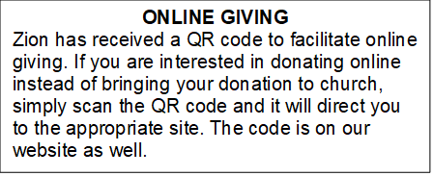

How to Contact the Pastor: If there is a pastoral need, please contact
Pastor Ken Scheck II at 269-370-4632 or by email at kscheckii@aol.com.

ANNOUNCEMENTS
- Crop Walk: The annual Crop Walk is Sunday April 26th. Please consider participating in this opportunity to help raise funds to provide food for people locally and throughout the country. Please see Claude or Mary Smith for more information.
- Note from the Board of Stewardship: Our congregation continues to grow in its mission to share Christ’s love in our community. As we look ahead to the coming months, we will be facing a shortfall in our operating budget. If you are able, we invite you to consider an additional gift to support our worship, outreach, and care ministries. Every contribution, large or small, strengthens the work we do together in Christ’s name. Thank you for your faithful generosity.
- Service for Wayne Hazel: There will be visitation and a service for Wayne Hazel on Saturday, May 2nd. Visitation will be at 10:00 am and the service will be at 11:00 am with a luncheon following. --- Jill Plummer and Family
- Offering for Synod Assembly: The synod is asking congregations across the synod to take part in a special "million penny offering." The idea is to collect the equivalent of one million pennies ($10,000). The offering collected at Synod Assembly will be split evenly and sent to two organizations: Lutheran Disaster Response Ukraine and Samaritas New Americans. We will not be collecting pennies, but if you would like to contribute toward this offering, you can do so through the offering and designate the offering for "Synod Assembly."
- Thank you - My family and I wish to thank you all for providing such a special service honoring Jerry. Thank you to Pastor Ken for sharing the message, Claude for reading the scriptures, Martha for sharing her musical talent and the Lake Odessa VFW Post for their military ceremony. Thank you also for the beautiful bouquet. I underestimated the number of friends and family coming but you all helped by printing and folding more programs and set up more tables and chairs. Thank you to Dawn, her kitchen helpers and all who helped in so many other ways. It was a nice luncheon with time for all to share memories of fun and good times. Dawn, thank you for the unique table arrangements highlighting Jerry. We appreciate all your support and prayers these last few months and help on this difficult day. My family and I know you all miss Jerry's witty charm too. -- Carol Engle and family
- Thank You! Everyone who helped with all our special times of fellowship. The open house for Pastor Ken was a great day filled with delicious food and good fellowship. Our Lenten Season dinners and Easter Sunday Breakfast were wonderful times of food and fellowship too. Thank you to everyone who helped set-up, clean-up, host, and brought food. It has been so good to be together!
- Pastor’s Availability: Pastor Ken Scheck II is available by appointment to meet with you. As you know homebound visitation has begun and will continue until all homebound have been visited by Pastor Ken. Generally speaking, he is at Grace on Mondays and Wednesdays and Zion on Tuesdays and Thursdays with a day off on Friday. As you may be aware, Pastor Ken has come to the Men’s meeting and Lakewood Area Ministerial Association meetings on Wednesday here at Zion. Flexibility is the name of the game. He is more than willing to be contacted at any time by cellphone or email. Please feel free to contact him at 269-370-4632 or at kscheckii@aol.com. You are able to send a text to the cellphone, but please identify yourself at least the first time.
- Announcement and Newsletter Items: Please forward items for the bulletin announcements and the newsletter to the church email (Office@Zion.org). Please do not send items to people’s personal emails. Thank you.
- Door Locking Policy: Our door locking policy relies on having a volunteer(s) each Sunday to serve as the Safety Person of the Day. On Sundays where no one has volunteered, if someone arrives at church and is willing to be the Safety Person of the Day, we will follow the door locking policy. If no one steps forward to serve as the Safety Person of the Day, the doors will not be locked. Please consider volunteering for this important duty.

