ZION LUTHERAN CHURCH, WOODLAND, MI
Fifth Sunday of Easter, Sunday May 3, 2026
*If you are listening in your car, please tune your radio to FM 87.7*
(Please silence your cell phones while in the sanctuary. Thank you.)


WELCOME AND ANNOUNCEMENTS

Gathering
The Holy Spirit calls us together as the people of God.

EASTER GOOD NEWS
Alleluia! Christ is risen!
Christ is risen indeed! Alleluia!

This is the day that the Lord has made;
We will rejoice and be glad in it!

Gathering Song “Lord God, We Praise You” #558

Prayer of the Day
Let us pray together.
Almighty God, your Son Jesus Christ is the way, the truth, and the life. Give us grace to love one another, to follow in the way of his commandments, and to share his risen life with all the world, for he lives and reigns with you and the Holy Spirit, one God, now and forever.

Amen.

First Reading Acts 7:55-60
A reading from Acts.
⁵⁵ Filled with the Holy Spirit, [Stephen] gazed into heaven and saw the glory of God and Jesus standing at the right hand of God. ⁵⁶ “Look,” he said, “I see the heavens opened and the Son of Man standing at the right hand of God!” ⁵⁷ But they covered their ears, and with a loud shout all rushed together against him. ⁵⁸ Then they dragged him out of the city and began to stone him, and the witnesses laid their coats at the feet of a young man named Saul. ⁵⁹ While they were stoning Stephen, he prayed, “Lord Jesus, receive my spirit.” ⁶⁰ Then he knelt down and cried out in a loud voice, “Lord, do not hold this sin against them.” When he had said this, he died.

The word of the Lord.
Thanks be to God.

Psalm Psalm 31:1-5, 15-16
¹ In you, O Lord, have I taken refuge; let me never be | put to shame;
deliver me | in your righteousness.
² Incline your | ear to me;
make haste to de- | liver me.
³ Be my strong rock, a castle to keep me safe, for you are my crag | and my stronghold;
for the sake of your name, lead | me and guide me.
⁴ Take me out of the net that they have secretly | set for me,
for you are my tow- | er of strength.
⁵ Into your hands I com- | mend my spirit,
for you have redeemed me, O Lord, | God of truth.
¹⁵ My times are | in your hand;
rescue me from the hand of my enemies, and from those who | persecute me.
¹⁶ Let your face shine up- | on your servant;
save me in your | steadfast love.”

Second Reading 1 Peter 2:2-10
A reading from 1 Peter.
² Like newborn infants, long for the pure, spiritual milk, so that by it you may grow into salvation ³ if indeed you have tasted that the Lord is good.
⁴ Come to him, a living stone, though rejected by mortals yet chosen and precious in God’s sight, and ⁵ like living stones let yourselves be built into a spiritual house, to be a holy priesthood, to offer spiritual sacrifices acceptable to God through Jesus Christ. ⁶ For it stands in scripture:
“See, I am laying in Zion a stone,
a cornerstone chosen and precious,
and whoever believes in him will not be put to shame.”
⁷ This honor, then, is for you who believe, but for those who do not believe,
“The stone that the builders rejected
has become the very head of the corner,”
⁸ and
“A stone that makes them stumble
and a rock that makes them fall.”
They stumble because they disobey the word, as they were destined to do.
⁹ But you are a chosen people, a royal priesthood, a holy nation, God’s own people, in order that you may proclaim the excellence of him who called you out of darkness into his marvelous light.
¹⁰ Once you were not a people,
but now you are God’s people;
once you had not received mercy,
but now you have received mercy.

The Word of the Lord.
Thanks be to God.

Gospel Acclamation
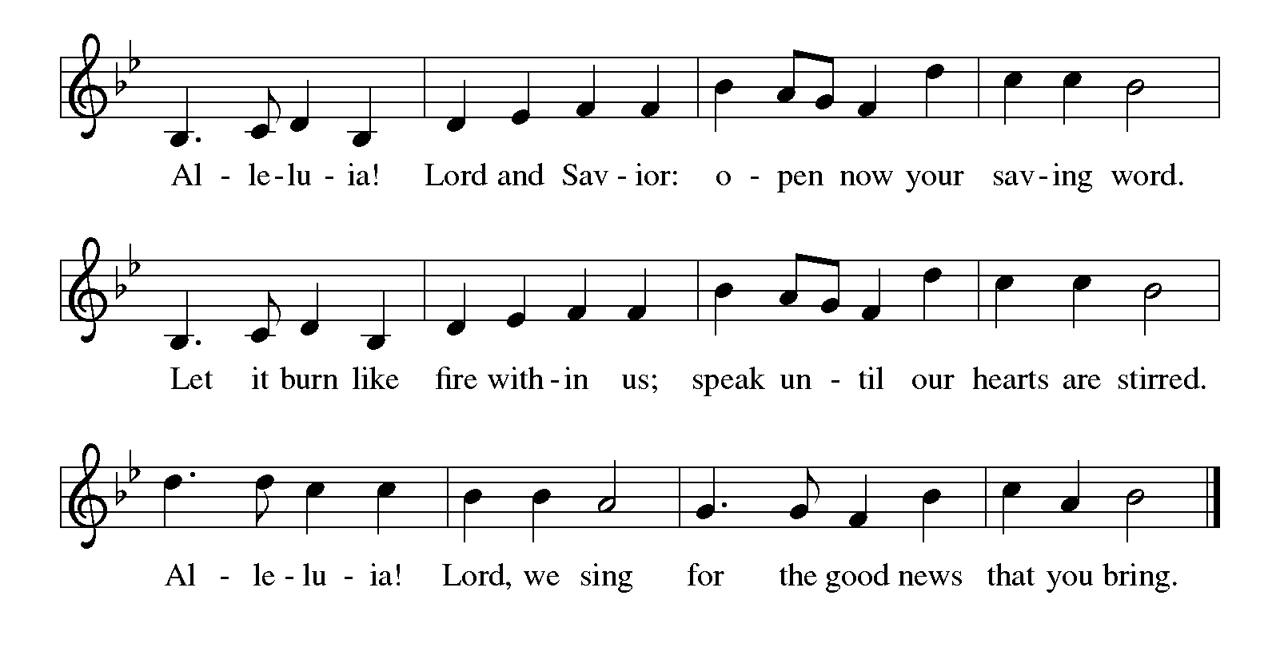

Gospel John 14:1-14
The holy gospel according to John.
Glory to You, O Lord.
[Jesus said to the disciples:] ¹ “Do not let your hearts be troubled. Believe in God; believe also in me. ² In my Father’s house there are many dwelling places. If it were not so, would I have told you that I go to prepare a place for you? ³ And if I go and prepare a place for you, I will come again and will take you to myself, so that where I am, there you may be also. ⁴ And you know the way to the place where I am going.” ⁵ Thomas said to him, “Lord, we do not know where you are going. How can we know the way?” ⁶ Jesus said to him, “I am the way and the truth and the life. No one comes to the Father except through me. ⁷ If you know me, you will know my Father also. From now on you do know him and have seen him.”
⁸ Philip said to him, “Lord, show us the Father, and we will be satisfied.” ⁹ Jesus said to him, “Have I been with you all this time, Philip, and you still do not know me? Whoever has seen me has seen the Father. How can you say, ‘Show us the Father’? ¹⁰ Do you not believe that I am in the Father and the Father is in me? The words that I say to you I do not speak on my own, but the Father who dwells in me does his works. ¹¹ Believe me that I am in the Father and the Father is in me, but if you do not, then believe because of the works themselves. ¹² Very truly, I tell you, the one who believes in me will also do the works that I do and, in fact, will do greater works than these, because I am going to the Father. ¹³ I will do whatever you ask in my name, so that the Father may be glorified in the Son. ¹⁴ If in my name you ask me for anything, I will do it.”
The gospel of the Lord.
Praise to you, O Christ.

CHILDREN’S MOMENT
SERMON Pastor Ken Scheck

hymn of the day “A Hymn of Glory Let Us Sing!” #393

cREED
We believe in one God,
the Father, the Almighty,
maker of heaven and earth,
of all that is, seen and unseen.
We believe in one Lord, Jesus Christ,
the only Son of God,
eternally begotten of the Father,
God from God, Light from Light,
true God from true God,
begotten, not made,
of one Being with the Father;
through him all things were made.
For us and for our salvation
he came down from heaven,
was incarnate of the Holy Spirit and the virgin Mary
and became truly human.
For our sake he was crucified under Pontius Pilate;
he suffered death and was buried.
On the third day he rose again
in accordance with the scriptures;
he ascended into heaven
and is seated at the right hand of the Father.
He will come again in glory to judge the living and the dead,
and his kingdom will have no end.
We believe in the Holy Spirit, the Lord, the giver of life,
who proceeds from the Father and the Son,*
who with the Father and the Son is worshiped and glorified,
who has spoken through the prophets.
We believe in one holy catholic and apostolic church.
We acknowledge one baptism for the forgiveness of sins.
We look for the resurrection of the dead,
and the life of the world to come. Amen.

*Or, “who proceeds from the Father.” The phrase “and the Son” is a later addition to the creed.
prayers of Intercession
(Please Be Seated)
Trusting in the power of Christ’s resurrection to heal and redeem our broken world, let us pray for the needs of all creation.
A brief silence.
God of glory, you have built your church on Christ the cornerstone. Inspire lay leaders, deacons, pastors, and bishops to proclaim forgiveness and your steadfast love to all whom they encounter. We pray especially for Ascension Lutheran Church in Saginaw and their pastor Rev. Julie Bailey.
Merciful God,
receive our prayer.
God of majesty, you bring forth plants and animals, skies and seas, mountains and valleys. Protect all you have made from the ravages of pollution and climate disaster. Merciful God,
receive our prayer.
God of mercy, you intend governments and social service agencies to be instruments of peace and justice. Guide political leaders and organizations to be agents of compassion, and raise up advocates for those who seek refuge and assistance. Merciful God,
receive our prayer.
God of well-being, you soothe those in distress, console all who grieve, provide for any in need, and comfort those who are sick. We pray especially for all those on your prayer list and in our heart. We pray for all countries involved in ongoing conflicts and all who are affected by natural disasters. Instill caregivers with a sense of purpose to be your healing hands in this world. Merciful God,
receive our prayer.
God of community, you call us together as your people for mutual support and to witness to your love in the world. Make your presence known among those unable to attend worship today. Merciful God,
receive our prayer.
God of eternal life, you have prepared dwelling places for your people, so that we are never separated from you. We give you thanks for the faithful departed who witnessed to your mighty acts in word and deed. Merciful God,
receive our prayer.
God of resurrection power, use us and these prayers to proclaim the good news of new life to all the world, through Jesus Christ, our risen Savior.
Amen.

PEACE
Sharing the Peace of God
The peace of the risen Christ be with you always.

And also with you.
(We share the peace of Christ with one another.)

OFFERING & OFFERING SONG
The joy of the Lord is my strength,
The joy of the Lord is my strength,
The joy of the Lord is my strength,
The joy of the Lord is my strength.

Offering Prayer
Let us pray.
Be known to us, O Lord, as you were made known to the disciples. Receive these gifts, and the offering of our lives, that we may be your risen body in the world. Amen..
Amen.

DIALOGUE
The Lord be with you.
And also with you.
Lift up your hearts.
We lift them to the Lord.
Let us give thanks to the Lord our God.
It is right to give our thanks and praise.

PREFACE (Pastor)
It is indeed right, our duty and our joy,
that we should at all times and in all places
give thanks and praise to you, almighty and merciful God,
through our Savior Jesus Christ;
who on this day overcame death and the grave,
and by his glorious resurrection opened to us the way of everlasting life.
And so, with all the choirs of angels,
with the church on earth and the hosts of heaven,
we praise your name and join their unending hymn

Holy, holy, holy
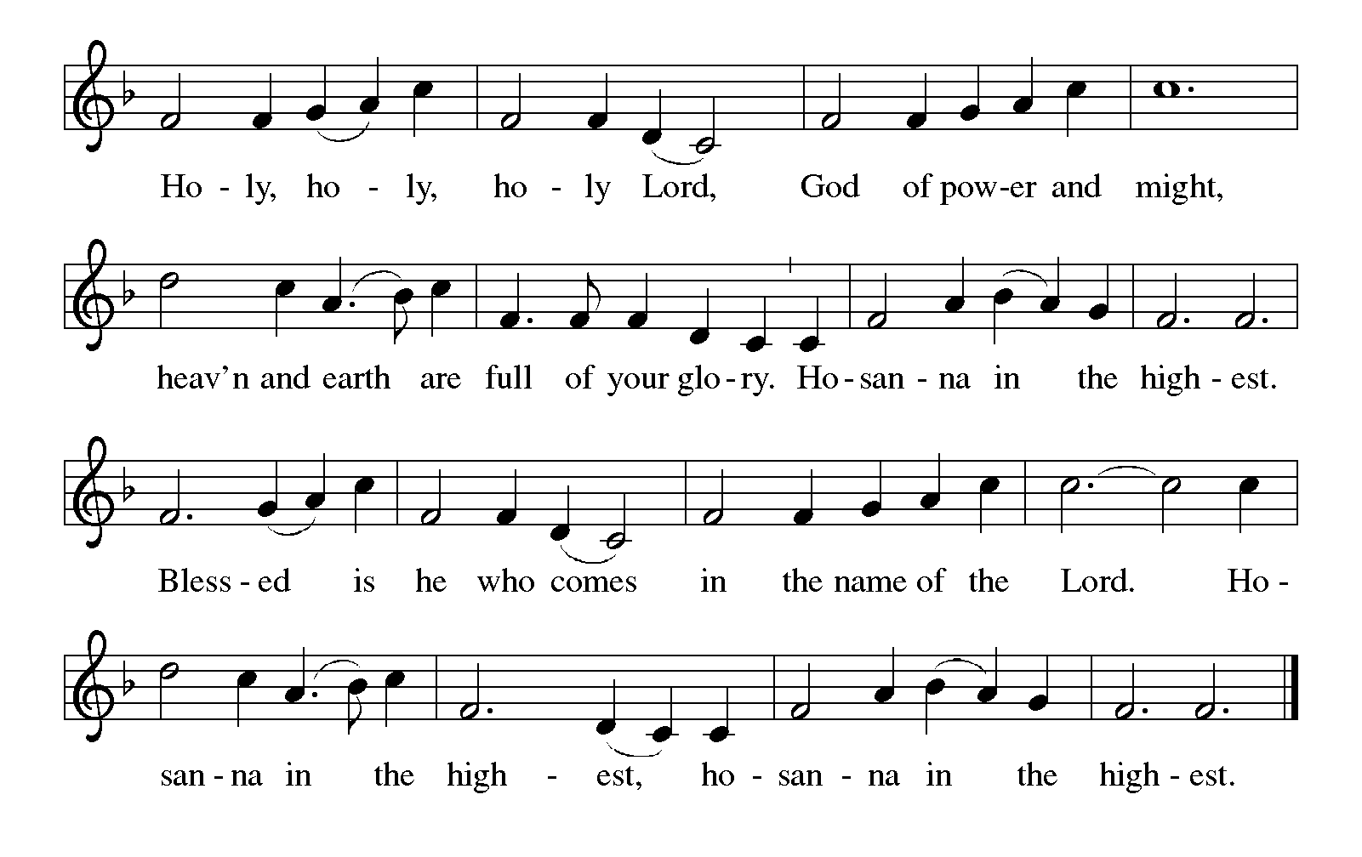

Thanksgiving at the Table
In the night in which he was betrayed,
our Lord Jesus took bread, and gave thanks;
broke it, and gave it to his disciples, saying:
Take and eat; this is my body, given for you.
Do this for the remembrance of me.

Again, after supper, he took the cup, gave thanks,
and gave it for all to drink, saying:
This cup is the new covenant in my blood,
shed for you and for all people for the forgiveness of sin.
Do this for the remembrance of me.

For as often as we eat of this bread and drink from this cup,
we proclaim the Lord’s death until he comes.

Christ has died. Christ is risen. Christ will come again.

Lord’s Prayer
Gathered into one by the Holy Spirit, let us pray as Jesus taught us.
Our Father, who art in heaven,
hallowed be thy name,
thy kingdom come,
thy will be done,
on earth as it is in heaven.
Give us this day our daily bread;
and forgive us our trespasses,
as we forgive those
who trespass against us;
and lead us not into temptation,
but deliver us from evil.
For thine is the kingdom,
and the power, and the glory,
forever and ever. Amen.

INVITATION TO COMMUNION
Come to the banquet, for all is now ready.

COMMUNION *continuous
*People are welcome to kneel at the altar rail for a time of prayer after they receive their communion elements.

COMMUNION HYMNS
“At the Lamb's High Feast We Sing” #362

PRAYER AFTER COMMUNION
Let us pray.
We give you thanks, almighty God, that you have refreshed us through the healing power of this gift of life. In your mercy, strengthen us through this gift, in faith toward you and in fervent love toward one another; for the sake of Jesus Christ our Lord.
Amen.

Sending
God blesses us and sends us in mission to the world.

Blessing
The Lord bless you and keep you.
The Lord’s face shine on you with grace and mercy.
The Lord look upon you with favor and ☩ give you peace.
Amen.

Sending SonG “Hallelujah! Jesus Lives!” #380

Dismissal
Go in peace. Christ is with you.
Thanks be to God.

From sundaysandseasons.com. Copyright © 2017 Augsburg Fortress. All rights reserved.

Thank you to all who served in worship today!
Presiders: Pastor Ken Scheck Musicians: Jayne Flanigan
Acolyte: Safety Person:
Elder: Buffy Meyers Trustee: Doug MacKenzie
Offering Counters: Doug MacKenzie & Mike Johnson



PRAYERS OF THE FAITHFUL

With thanks for all God’s blessings and his love for all people. Our Bishops, Julie Schneider-Thomas, Yehiel Curry, and the congregations of the North/West Lower Michigan Synod, and especially Ascension Lutheran Church in Saginaw and their pastor Rev. Julie Bailey.

Prayers for our friends, for all who are sick or hospitalized and for all health care workers who care for them. All those members of Zion’s family traveling; all those homebound or in frail health; all those suffering with quiet, unknown needs or worries. For those who serve on our behalf: public safety, utility workers, medical personnel, military personnel. For those who might be forgotten. We pray especially for all countries involved in ongoing conflicts.

This week at Zion:
- Men’s Breakfast at 8am, Wednesday 6th
- Bulletin Deadline, Wednesday 6th

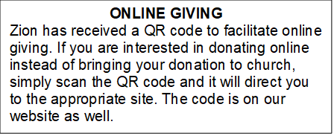

How to Contact the Pastor: If there is a pastoral need, please contact
Pastor Ken Scheck II at 269-370-4632 or by email at kscheckii@aol.com.

ANNOUNCEMENTS

- Please start looking for gently used household items, tools, home decor, craft and sewing items, toys, furniture, purses and accessories. Please send only appliances that are in good condition. Please no clothing, we are restricted in the amount space we have to use for the sale. Items can be sent in boxes or tubs (PLEASE PUT YOUR NAME Clearly on both the tub and lid). If you send tubs, I will text you when I empty them, so you can get your tub back. Our sale will be June 25th and 26th, the ZLCW is organizing but we are raising the profits for church maintenance. The last day we will take donations is Sunday June 21st.
If you have any questions, ask Mary M. or Buffy.
- Note from the Board of Stewardship: Our congregation continues to grow in its mission to share Christ’s love in our community. As we look ahead to the coming months, we will be facing a shortfall in our operating budget. If you are able, we invite you to consider an additional gift to support our worship, outreach, and care ministries. Every contribution, large or small, strengthens the work we do together in Christ’s name. Thank you for your faithful generosity.
- Offering for Synod Assembly: The synod is asking congregations across the synod to take part in a special "million penny offering." The idea is to collect the equivalent of one million pennies ($10,000). The offering collected at Synod Assembly will be split evenly and sent to two organizations: Lutheran Disaster Response Ukraine and Samaritas New Americans. We will not be collecting pennies, but if you would like to contribute toward this offering, you can do so through the offering and designate the offering for "Synod Assembly."
- Thank you - My family and I wish to thank you all for providing such a special service honoring Jerry. Thank you to Pastor Ken for sharing the message, Claude for reading the scriptures, Martha for sharing her musical talent and the Lake Odessa VFW Post for their military ceremony. Thank you also for the beautiful bouquet. I underestimated the number of friends and family coming but you all helped by printing and folding more programs and set up more tables and chairs. Thank you to Dawn, her kitchen helpers and all who helped in so many other ways. It was a nice luncheon with time for all to share memories of fun and good times. Dawn, thank you for the unique table arrangements highlighting Jerry. We appreciate all your support and prayers these last few months and help on this difficult day. My family and I know you all miss Jerry's witty charm too. -- Carol Engle and family
- Thank You! Everyone who helped with all our special times of fellowship. The open house for Pastor Ken was a great day filled with delicious food and good fellowship. Our Lenten Season dinners and Easter Sunday Breakfast were wonderful times of food and fellowship too. Thank you to everyone who helped set-up, clean-up, host, and brought food. It has been so good to be together!
- Pastor’s Availability: Pastor Ken Scheck II is available by appointment to meet with you. As you know homebound visitation has begun and will continue until all homebound have been visited by Pastor Ken. Generally speaking, he is at Grace on Mondays and Wednesdays and Zion on Tuesdays and Thursdays with a day off on Friday. As you may be aware, Pastor Ken has come to the Men’s meeting and Lakewood Area Ministerial Association meetings on Wednesday here at Zion. Flexibility is the name of the game. He is more than willing to be contacted at any time by cellphone or email. Please feel free to contact him at 269-370-4632 or at kscheckii@aol.com. You are able to send a text to the cellphone, but please identify yourself at least the first time.
- Announcement and Newsletter Items: Please forward items for the bulletin announcements and the newsletter to the church email (Office@Zion.org). Please do not send items to people’s personal emails. Thank you.
- Door Locking Policy: Our door locking policy relies on having a volunteer(s) each Sunday to serve as the Safety Person of the Day. On Sundays where no one has volunteered, if someone arrives at church and is willing to be the Safety Person of the Day, we will follow the door locking policy. If no one steps forward to serve as the Safety Person of the Day, the doors will not be locked. Please consider volunteering for this important duty.

