Zion Messenger + April 2026
Pastor Ken Scheck II 269-370-4632 + Church Office 269-367-4817
Emergency Number President Paul Meade 616-640-7305

A Message from our Pastor
The Spirit of God made me what I am, the breath of God Almighty gives me life! Job 33:4

As I reflect on Job 33:4, I realize that at times I feel like Job. Life has its challenges, and at times we may feel dead. Many of you know this feeling, you can relate to feeling burned out, exhausted, drained, and disconnected. Many have felt that same condemnation that Job felt. Some have confessed to me that they have even felt condemnation by God. Everyone I know realizes they are sinners and many see no way out. Yet, the word of God found in Romans 8:1 helped me realize God’s grace. “There is therefore now no condemnation for those who are in Christ Jesus.”

The Spirit dwells in the body which in baptism kills sin and gives us life. That same Spirit of God who raised Jesus from the dead will make alive the mortal bodies of each and every one of us believers.

It was so good to see the life that was celebrated at the installation service. We once again felt alive, refreshed and renewed. THANK YOU for allowing me to become part of your church family. I am blessed by your generosity, love, support and kindness. It was so good to see former pastors, Bishop Julie Scheinder-Thomas and a host of visitors among us.

As we prepared for Easter, let the spirit of God breathe new life in each of us.

Peace and joy be with you!

Pastor Ken +

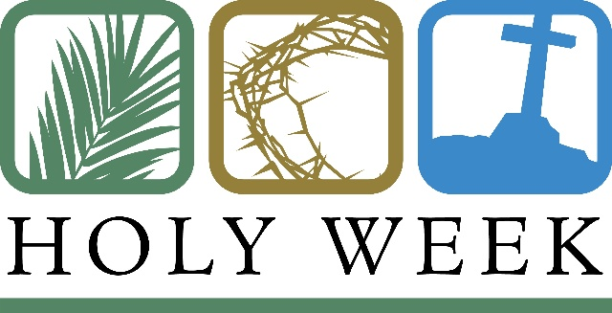
Maundy Thursday Service, April 2nd, 7 pm at Zion
The Maundy Thursday Service will be at 7:00 pm and will include the stripping of the altar. Plan to attend this important Holy Week service.

Good Friday Service, April 3rd, 1:00 pm at Central UMC, Lake Odessa
Zion is participating in the community Good Friday Service, 1:00 pm, April 3rd at Central United Methodist Church in Lake Odessa. This is always a very meaningful service. There will be a community choir. If you are interested in participating, there is practice at 6 pm on April 1st and at 12 noon on April 3rd.
Easter Breakfast
Easter Breakfast is at 9:15am and Dawn is asking that all be here and ready to serve at that time. There are sign up sheets for food in the narthex. We also need volunteers to help cleanup, so everyone can be at Easter Festival Service.
Kid Craft Time
Following breakfast, there will be a fun activity for kids at approximately 9:45am. Kids of all ages are invited to work on craft projects and a game of Easter Bingo! We will be gathering at the far end of the Fellowship Hall. See you then kids!!! Miss Mary and Miss Naomi

Easter Service
Please invite your family and friends to Easter Worship at 11am. We look forward to Zion’s Easter garden at the altar and everyone’s joy as we give praise to our Risen Savior. Let’s fill the pews with happy faces, joyous voices, and grateful hearts!

Open House for Pastor Ken – April 19th 12 – 2 pm
Mark you calendar and be sure to stay after church on April 19th to help host a
community open house for people to come, meet Pastor Ken, and have lunch with us at
Zion. We are sending invitations to all the area churches, posting on social media, and
placing an ad in the paper. The Boards of Evangelism and Fellowship are planning the
lunch menu and hosting. It will be open house stye for people to come when they can
and stay as long as they are able. Invite your neighbors and friends too! If you have
questions or would like to help, please see Martha or Jolene.



Pray Without Ceasing
Pray Without Ceasing will be returning after Easter. As you know, we have been
praying around the bell on Saturdays at 1:00 through the Lenten season. After Lent,
look for information on how our time of prayer will continue. If you have questions or
suggestions, please let Martha know.


Provisions for the Homeless
The Board of Evangelism has provided items to create bags of provisions people who
are homeless or in need. You are invited to take a bag and give it to someone you see
in your daily travels. There are also bags for dogs! In addition, there is a shopping list
with suggested items for the bags. If you would like to help us keep a stock of bags on
hand, any donations are welcome.

Thank You
The Board of Parish Education/Youth would like to thank everyone who donated items for the Easter Egg Hunt, those who filled eggs, and hid eggs. This is a special tradition that the kids really enjoy.

“What a Mess” Vacation Bible School, July 14, 15, 16, 6:00-8:30 pm

Zion is actively involved with the Lakewood Ministerial Association group working to
plan this community VBS that will be held at the Lake Odessa Fairgrounds. Karen
Heise and Martha Yoder have developed and will be administering the registration
system for VBS. In addition, Zion donated the curriculum that is being used. As you
know, VBS requires lots of volunteers! You can sign-up to volunteers on a sheet in the
narthex or by using the online registration process. The process is also up and running
to register our kids. Look for flyers with a QR code on the table in the narthex. If you
have questions, please see Martha or Karen.

Zion Nominated for Non-Profit of the Year 2025 – Lakewood Area Chamber of
Commerce
We were honored to be among the ten nonprofit organizations to be nominated for the
chamber’s Non-Profit of the year award. It was wonderful to be part of the group
considered for this award. The winner was Manna’s Market and we think that is a great
choice! The criteria for the award was, “This award honors a nonprofit whose passion,
dedication, and service make a real impact. The recipient exemplifies compassion,
integrity, and leadership, inspiring positive change and making the Lakewood area a
better place to live.” It is our desire to have the kind of impact in our community this
award describes. Our thanks to the person who nominated Zion and to all who voted
for us.
Zion had a great group attending the chamber annual dinner including: Pastor Ken, Paul
Meade, Ruth and Jimmy Hindman, Buffy Meyers, Lyle Sandbrook, Martha Yoder,
Cheyenne Wallace and Hunter Levering. We enjoyed being with so many from our area
celebrating all the good that happens in our community.


Manna’s Market
Dear Friends in Christ:
You did it again! You all have a heart for serving the community in such an amazing way. The most recent is your donation to the Simply Give Event with Meijer. $2,000! Meijer will do a double match on that money which means that Manna's Market has $6,000 to buy food for those who are food insecure. Right here in our community. May God bless you for all you do.

In Christ's Love--Jayne Flanigan
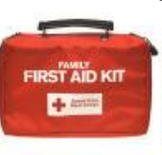
First Aid Supply Collection for Synod Honduras Mission Trip – Thank You
Thank you to everyone who brought first aid supplies to give to our synod team going to Honduras. In all we collected:
5 rolls paper tape
10 tubes of triple antibiotic cream
6 boxes of 2" x 3" sterile gauze pads
4 boxes of 3' X 3' sterile gauze pads
13 rolls of gauze bandaging
760 band-aids (many boxes with various sizes and types i.e., cloth, waterproof, etc.)
6 rolls of self-adhesive rolls
148 nitrile gloves
1 ear thermometer
4 single use thermometers
28 tweezers
6 pairs of scissors
$225 to be used however it is needed.

Pastor Megan Crouch, Pastor, Peace Lutheran, Gaylord, is the leader for the mission team. She wrote to use, “These are wonderful! Please pass along my deep thanks to your congregation and pastor for collecting them and blessing them! They will be a blessing for sure on our trip!”
The mission trip is April 16 through April 28th. We are invited to download the app for free by scanning the QR code below, to receive a daily post starting April 16th and going through April 28th telling about the trip,

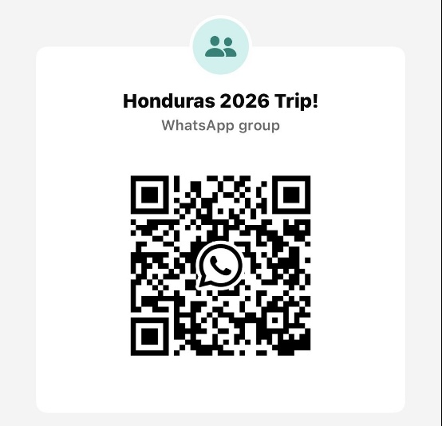

A Message from our Treasurer
Our congregation continues to grow in its mission to share Christ’s love in our community. As we look ahead to the coming months, we will be facing a shortfall in our operating budget. If you are able, we invite you to consider an additional gift to support our worship, outreach, and care ministries. Every contribution, large or small, strengthens the work we do together in Christ’s name. Thank you for your faithful generosity.

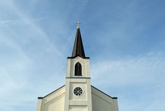

Installation Sunday
A big thank you to everyone who worked to get the church ready in any way for March 22nd. We appreciate the trustees, who worked to make sure Brown’s could lay the carpet in the fireside room. Ruth for cleaning the church, Mary for setting up communion, Martha for the adorable bulletin board in the kitchen area, and the countless anonymous jobs to get the church ready. Everyone who welcomed Bishop Julie Schneider-Thomas!
The congregation supplied a great variety of food that was enjoyed by our guests from Grace and all of us! It looked amazing and tasted even better.
It was a wonderful day and it is great to see everyone working together to make this a special day for Pastor Ken and the entire congregation! Many Blessings have been bestowed on Zion!
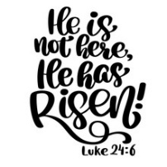
We Are Living! (submitted by Pastor Ken)
Death is swallowed up in vict'ry;
sin has lost its
poison sting.

Life will blossom from the
grain sown,
Christ the first fruits of the spring.

For the sureness of salvation
let us sing,
"Thanks be to God!"
Christ is risen!
We are living!

Spread the word of grace abroad.
~ Martin Seltz



Easter Sunday, April 5th Worship & Communion April 12th
Pastor Ken Scheck Pastor Ken Scheck
Acolyte: Kole Hokanson Elder: Buffy Meyers
Elder: Dan Utterback Trustee: Doug MacKenzie
Trustee: Mike Johnson Musician: Jayne Flanigan
Musicians: Jayne Flanigan & Offering Counters: Mary Makley &
Martha Yoder Martha Yoder
Offering Counters: Doug MacKenzie &
Mike Johnson

Sunday, April 19th Sunday, April 26th
Pastor Ken Scheck Pastor Ken Scheck
Elder: Naomi Wilson Acolyte: Kole Hokanson
Trustee: Jimmy Hindman Elder: Dan Utterback
Musician: Martha Yoder Trustee: Mike Johnaon
Offering Counters: Diane Griffin & Musician: Martha Yoder
Carlotta Willard Offering Counters: Paul Meade &
Carlotta Willard

