ZION LUTHERAN CHURCH, WOODLAND, MI
Sixth Sunday of Easter, Sunday May 10, 2026
*If you are listening in your car, please tune your radio to FM 87.7*
(Please silence your cell phones while in the sanctuary. Thank you.)


WELCOME AND ANNOUNCEMENTS

Gathering
The Holy Spirit calls us together as the people of God.

EASTER GOOD NEWS
Alleluia! Christ is risen!
Christ is risen indeed! Alleluia!

This is the day that the Lord has made;
We will rejoice and be glad in it!

Gathering Song “Come, Thou Almighty King” #408

Prayer of the Day
Let us pray together.
Almighty and ever-living God, you hold together all things in heaven and on earth. In your great mercy receive the prayers of all your children, and give to all the world the Spirit of your truth and peace, through Jesus Christ, our Savior and Lord, who lives and reigns with you and the Holy Spirit, one God, now and forever.
Amen.

First Reading Acts 17:22-31
A reading from Acts.
²² Paul stood in front of the Areopagus and said, “Athenians, I see how extremely spiritual you are in every way. ²³ For as I went through the city and looked carefully at the objects of your worship, I found among them an altar with the inscription, ‘To an unknown god.’ What therefore you worship as unknown, this I proclaim to you. ²⁴ The God who made the world and everything in it, he who is Lord of heaven and earth, does not live in shrines made by human hands, ²⁵ nor is he served by human hands, as though he needed anything, since he himself gives to all mortals life and breath and all things. ²⁶ From one ancestor he made all peoples to inhabit the whole earth, and he allotted the times of their existence and the boundaries of the places where they would live, ²⁷ so that they would search for God and perhaps fumble about for him and find him—though indeed he is not far from each one of us. ²⁸ For ‘In him we live and move and have our being’; as even some of your own poets have said,
‘For we, too, are his offspring.’
²⁹ “Since we are God’s offspring, we ought not to think that the deity is like gold or silver or stone, an image formed by the art and imagination of mortals. ³⁰ While God has overlooked the times of human ignorance, now he commands all people everywhere to repent, ³¹ because he has fixed a day on which he will have the world judged in righteousness by a man whom he has appointed, and of this he has given assurance to all by raising him from the dead.”

The word of the Lord.
Thanks be to God.

Psalm Psalm 66:8-20

⁸ Bless our | God, you peoples;
let the sound of | praise be heard.
⁹ Our God has kept us a- | mong the living
and has not allowed our | feet to slip. R
¹⁰ For you, O God, have | tested us;
you have tried us just as sil- | ver is tried.
¹¹ You brought us in- | to the net;
you laid heavy burdens up- | on our backs.
¹² You let people ride over our heads; we went through | fire and water,
but you brought us out into a place | of refreshment.
¹³ I will enter your house | with burnt offerings
and will pay | you my vows—
¹⁴ those that I promised | with my lips
and spoke with my mouth when I | was in trouble.
¹⁵ I will offer you burnt offerings of fatlings with the | smoke of rams;
I will give you ox- | en and goats.
¹⁶ Come and listen, all you | who believe,
and I will tell you what God has | done for me.
¹⁷ I called out to God | with my mouth,
and praised the Lord | with my tongue.
¹⁸ If I had cherished evil | in my heart,
the Lord would | not have heard me;
¹⁹ but in truth | God has heard me
and has attended to the sound | of my prayer.
²⁰ Blessed be God, who has not reject- | ed my prayer,
nor withheld unfailing | love from me.

Second Reading 1 Peter 3:13-22
A reading from 1 Peter.
¹³ Now who will harm you if you are eager to do what is good? ¹⁴ But even if you do suffer for doing what is right, you are blessed. Do not fear what they fear, and do not be intimidated, ¹⁵ but in your hearts sanctify Christ as Lord. Always be ready to make your defense to anyone who demands from you an accounting for the hope that is in you, ¹⁶ yet do it with gentleness and respect. Maintain a good conscience so that, when you are maligned, those who abuse you for your good conduct in Christ may be put to shame. ¹⁷ For it is better to suffer for doing good, if suffering should be God’s will, than to suffer for doing evil. ¹⁸ For Christ also suffered for sins once for all, the righteous for the unrighteous, in order to bring you to God. He was put to death in the flesh but made alive in the spirit, ¹⁹ in which also he went and made a proclamation to the spirits in prison, ²⁰ who in former times did not obey, when God waited patiently in the days of Noah, during the building of the ark, in which a few, that is, eight lives, were saved through water. ²¹ And baptism, which this prefigured, now saves you—not as a removal of dirt from the body but as an appeal to God for a good conscience, through the resurrection of Jesus Christ, ²² who has gone into heaven and is at the right hand of God, with angels, authorities, and powers made subject to him.

The Word of the Lord.
Thanks be to God.

Gospel Acclamation
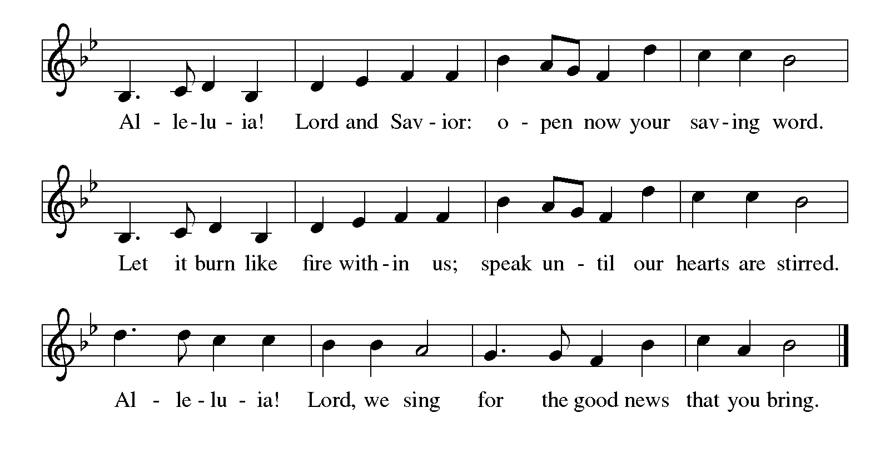

Gospel John 14:1-14
The holy gospel according to John.
Glory to You, O Lord.
[Jesus said to the disciples:] ¹⁵ “If you love me, you will keep my commandments. ¹⁶ And I will ask the Father, and he will give you another Advocate, to be with you forever. ¹⁷ This is the Spirit of truth, whom the world cannot receive because it neither sees him nor knows him. You know him because he abides with you, and he will be in you.
¹⁸ “I will not leave you orphaned; I am coming to you. ¹⁹ In a little while the world will no longer see me, but you will see me; because I live, you also will live. ²⁰ On that day you will know that I am in my Father, and you in me, and I in you. ²¹ They who have my commandments and keep them are those who love me, and those who love me will be loved by my Father, and I will love them and reveal myself to them.”

The gospel of the Lord.
Praise to you, O Christ.

CHILDREN’S MOMENT
SERMON Pastor Ken Scheck

hymn of the day “Holy Spirit, Truth Divine” #398

cREED
We believe in one God,
the Father, the Almighty,
maker of heaven and earth,
of all that is, seen and unseen.
We believe in one Lord, Jesus Christ,
the only Son of God,
eternally begotten of the Father,
God from God, Light from Light,
true God from true God,
begotten, not made,
of one Being with the Father;
through him all things were made.
For us and for our salvation
he came down from heaven,
was incarnate of the Holy Spirit and the virgin Mary
and became truly human.
For our sake he was crucified under Pontius Pilate;
he suffered death and was buried.
On the third day he rose again
in accordance with the scriptures;
he ascended into heaven
and is seated at the right hand of the Father.
He will come again in glory to judge the living and the dead,
and his kingdom will have no end.
We believe in the Holy Spirit, the Lord, the giver of life,
who proceeds from the Father and the Son,*
who with the Father and the Son is worshiped and glorified,
who has spoken through the prophets.
We believe in one holy catholic and apostolic church.
We acknowledge one baptism for the forgiveness of sins.
We look for the resurrection of the dead,
and the life of the world to come. Amen.

*Or, “who proceeds from the Father.” The phrase “and the Son” is a later addition to the creed.

prayers of Intercession
(Please Be Seated)
Trusting in the power of Christ’s resurrection to heal and redeem our broken world, let us pray for the needs of all creation.
A brief silence.
God of new life, you call us through the waters of baptism to be in relationship with you and one another. Guide the church and its leaders to proclaim Christ’s righteousness throughout the world. We pray especially for Faith Evangelical Lutheran in Saginaw, and their pastor Rev. Tina Schultz.
Merciful God,
receive our prayer.
You create the world and all that is in it. Shelter budding plants and young animals, provide unpolluted habitats and clean water, and raise up stewards for the environment. Merciful God,
receive our prayer.
You set civil servants in the places where we live. Instill truth and equity among judges and lawyers, gentleness and courage among first responders, and peace among leaders of towns and nations. Merciful God,
receive our prayer.
You provide comfort in times of trouble. Heal those who are sick, shelter any who are unhoused, feed those undernourished, and accompany and console all who are lonely, bereaved, anxious, or ill. We pray especially for all those on your prayer list and in our heart. We pray for all countries involved in ongoing conflicts and all who are affected by natural disasters.
Merciful God,
receive our prayer.
You are love and you desire that we love one another. As a mother hen cares for her chicks, bless all who provide motherly care in our lives, and inspire us to care for one another. Merciful God,
receive our prayer.
God of new life, your steadfast love endures forever. Inspire us by the example of the faithful departed, who clung to your promises of life, forgiveness of sins, and salvation. Merciful God,
receive our prayer.
God of resurrection power, use us and these prayers to proclaim the good news of new life to all the world, through Jesus Christ, our risen Savior.
Amen.

PEACE
Sharing the Peace of God
The peace of the risen Christ be with you always.

And also with you.
(We share the peace of Christ with one another.)

OFFERING & OFFERING SONG
The joy of the Lord is my strength,
The joy of the Lord is my strength,
The joy of the Lord is my strength,
The joy of the Lord is my strength.

Offering Prayer
Let us pray.
Be known to us, O Lord, as you were made known to the disciples. Receive these gifts, and the offering of our lives, that we may be your risen body in the world. Amen..
Amen.

DIALOGUE
The Lord be with you.
And also with you.
Lift up your hearts.
We lift them to the Lord.
Let us give thanks to the Lord our God.
It is right to give our thanks and praise.

PREFACE (Pastor)
It is indeed right, our duty and our joy,
that we should at all times and in all places
give thanks and praise to you, almighty and merciful God,
through our Savior Jesus Christ;
who on this day overcame death and the grave,
and by his glorious resurrection opened to us the way of everlasting life.
And so, with all the choirs of angels,
with the church on earth and the hosts of heaven,
we praise your name and join their unending hymn

Holy, holy, holy
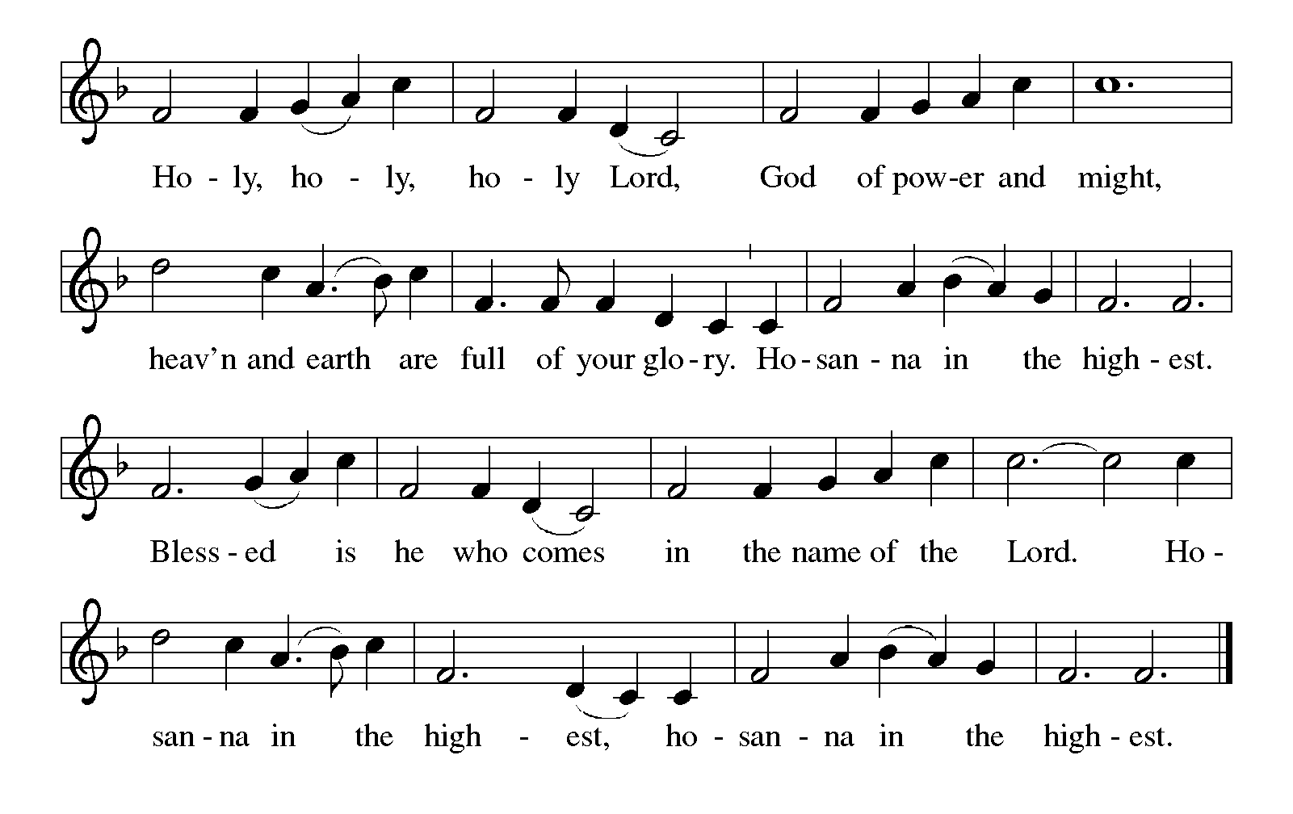

Thanksgiving at the Table
In the night in which he was betrayed,
our Lord Jesus took bread, and gave thanks;
broke it, and gave it to his disciples, saying:
Take and eat; this is my body, given for you.
Do this for the remembrance of me.

Again, after supper, he took the cup, gave thanks,
and gave it for all to drink, saying:
This cup is the new covenant in my blood,
shed for you and for all people for the forgiveness of sin.
Do this for the remembrance of me.

For as often as we eat of this bread and drink from this cup,
we proclaim the Lord’s death until he comes.

Christ has died. Christ is risen. Christ will come again.

Lord’s Prayer
Gathered into one by the Holy Spirit, let us pray as Jesus taught us.
Our Father, who art in heaven,
hallowed be thy name,
thy kingdom come,
thy will be done,
on earth as it is in heaven.
Give us this day our daily bread;
and forgive us our trespasses,
as we forgive those
who trespass against us;
and lead us not into temptation,
but deliver us from evil.
For thine is the kingdom,
and the power, and the glory,
forever and ever. Amen.

INVITATION TO COMMUNION
Come to the banquet, for all is now ready.

COMMUNION *continuous
*People are welcome to kneel at the altar rail for a time of prayer after they receive their communion elements.

COMMUNION HYMNS
“Children of the Heavenly Father” #781
“Just As I Am, without One Plea” #592

PRAYER AFTER COMMUNION
Let us pray.
We give you thanks, almighty God, that you have refreshed us through the healing power of this gift of life. In your mercy, strengthen us through this gift, in faith toward you and in fervent love toward one another; for the sake of Jesus Christ our Lord.
Amen.

Sending
God blesses us and sends us in mission to the world.

Blessing
The Lord bless you and keep you.
The Lord’s face shine on you with grace and mercy.
The Lord look upon you with favor and ☩ give you peace.
Amen.
Sending SonG “Alleluia! Sing to Jesus” #392

Dismissal
Go in peace. Christ is with you.
Thanks be to God.

From sundaysandseasons.com. Copyright © 2017 Augsburg Fortress. All rights reserved.

Thank you to all who served in worship today!
Presiders: Pastor Ken Scheck Musicians: Martha Yoder
Acolyte: Kole Hokanson Safety Person:
Elder: Naomi Wilson Trustee: Jimmy Hindman
Offering Counters: Mary Makley & Martha Yoder



PRAYERS OF THE FAITHFUL

With thanks for all God’s blessings and his love for all people. Our Bishops, Julie Schneider-Thomas, Yehiel Curry, and the congregations of the North/West Lower Michigan Synod, and especially Faith Evangelical Lutheran in Saginaw, and their pastor Rev. Tina Schultz.

Prayers for our friends, for all who are sick or hospitalized and for all health care workers who care for them. All those members of Zion’s family traveling; all those homebound or in frail health; all those suffering with quiet, unknown needs or worries. For those who serve on our behalf: public safety, utility workers, medical personnel, military personnel. For those who might be forgotten. We pray especially for all countries involved in ongoing conflicts.

This week at Zion:
- Men’s Breakfast at 8am, Wednesday 13th
- Bulletin Deadline, Wednesday 13th

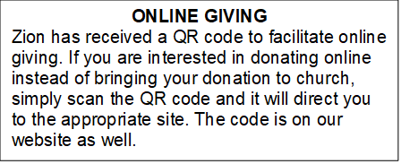

How to Contact the Pastor: If there is a pastoral need, please contact
Pastor Ken Scheck II at 269-370-4632 or by email at kscheckii@aol.com.

ANNOUNCEMENTS

- Soup Recipes: It was suggested that we publish the great soup recipes that we enjoyed during our Lenten soup and salad dinners this year. Thank you Jolene for requesting recipes and publishing those that were submitted. Copies are available on the table in the narthex for anyone who would like a copy.
- Zion Coffee Cups: The Board of Evangelism has purchased coffee cups with the Zion logo on them to use for outreach. The mugs are also available for purchase. There is one on display on the table in the narthex. The mugs are a great 16-ounce size and they’re being sold for $10 each. All proceeds will be used for evangelism ministries. If you would like to purchase a mug, please see Karen, Martha, or Ruth, Please start looking for gently used household items, tools, home decor, craft and sewing items, toys, furniture, purses and accessories. Please send only appliances that are in good condition. Please no clothing, we are restricted in the amount space we have to use for the sale. Items can be sent in boxes or tubs (PLEASE PUT YOUR NAME Clearly on both the tub and lid). If you send tubs, I will text you when I empty them, so you can get your tub back. Our sale will be June 25th and 26th, the ZLCW is organizing but we are raising the profits for church maintenance. The last day we will take donations is Sunday June 21st. If you have any questions, ask Mary M. or Buffy.
- Note from the Board of Stewardship: Our congregation continues to grow in its mission to share Christ’s love in our community. As we look ahead to the coming months, we will be facing a shortfall in our operating budget. If you are able, we invite you to consider an additional gift to support our worship, outreach, and care ministries. Every contribution, large or small, strengthens the work we do together in Christ’s name. Thank you for your faithful generosity.
- Offering for Synod Assembly: The synod is asking congregations across the synod to take part in a special "million penny offering." The idea is to collect the equivalent of one million pennies ($10,000). The offering collected at Synod Assembly will be split evenly and sent to two organizations: Lutheran Disaster Response Ukraine and Samaritas New Americans. We will not be collecting pennies, but if you would like to contribute toward this offering, you can do so through the offering and designate the offering for "Synod Assembly."
- Thank you - My family and I wish to thank you all for providing such a special service honoring Jerry. Thank you to Pastor Ken for sharing the message, Claude for reading the scriptures, Martha for sharing her musical talent and the Lake Odessa VFW Post for their military ceremony. Thank you also for the beautiful bouquet. I underestimated the number of friends and family coming but you all helped by printing and folding more programs and set up more tables and chairs. Thank you to Dawn, her kitchen helpers and all who helped in so many other ways. It was a nice luncheon with time for all to share memories of fun and good times. Dawn, thank you for the unique table arrangements highlighting Jerry. We appreciate all your support and prayers these last few months and help on this difficult day. My family and I know you all miss Jerry's witty charm too.
--Carol Engle and family
- Thank You! Everyone who helped with all our special times of fellowship. The open house for Pastor Ken was a great day filled with delicious food and good fellowship. Our Lenten Season dinners and Easter Sunday Breakfast were wonderful times of food and fellowship too. Thank you to everyone who helped set-up, clean-up, host, and brought food. It has been so good to be together!
- Pastor’s Availability: Pastor Ken Scheck II is available by appointment to meet with you. As you know homebound visitation has begun and will continue until all homebound have been visited by Pastor Ken. Generally speaking, he is at Grace on Mondays and Wednesdays and Zion on Tuesdays and Thursdays with a day off on Friday. As you may be aware, Pastor Ken has come to the Men’s meeting and Lakewood Area Ministerial Association meetings on Wednesday here at Zion. Flexibility is the name of the game. He is more than willing to be contacted at any time by cellphone or email. Please feel free to contact him at 269-370-4632 or at kscheckii@aol.com. You are able to send a text to the cellphone, but please identify yourself at least the first time.
- Announcement and Newsletter Items: Please forward items for the bulletin announcements and the newsletter to the church email (Office@Zion.org). Please do not send items to people’s personal emails. Thank you.
- Door Locking Policy: Our door locking policy relies on having a volunteer(s) each Sunday to serve as the Safety Person of the Day. On Sundays where no one has volunteered, if someone arrives at church and is willing to be the Safety Person of the Day, we will follow the door locking policy. If no one steps forward to serve as the Safety Person of the Day, the doors will not be locked. Please consider volunteering for this important duty.

