ZION LUTHERAN CHURCH, WOODLAND, MI
Seventh Sunday of Easter, Sunday May 17, 2026
*If you are listening in your car, please tune your radio to FM 87.7*
(Please silence your cell phones while in the sanctuary. Thank you.)


WELCOME AND ANNOUNCEMENTS

Gathering
The Holy Spirit calls us together as the people of God.

EASTER GOOD NEWS
Alleluia! Christ is risen!
Christ is risen indeed! Alleluia!

This is the day that the Lord has made;
We will rejoice and be glad in it!

Gathering Song “God Is Here!” #526

Prayer of the Day
Let us pray together.
O God of glory, your Son Jesus Christ suffered for us and ascended to your right hand. Unite us with Christ and each other in suffering and in joy, that all the world may be drawn into your bountiful presence, through Jesus Christ, our Savior and Lord, who lives and reigns with you and the Holy Spirit, one God, now and forever.
Amen.

First Reading Acts 1:6-14
A reading from Acts.
⁶ When [the apostles] had come together, they asked [Jesus], “Lord, is this the time when you will restore the kingdom to Israel?” ⁷ He replied, “It is not for you to know the times or periods that the Father has set by his own authority. ⁸ But you will receive power when the Holy Spirit has come upon you, and you will be my witnesses in Jerusalem, in all Judea and Samaria, and to the ends of the earth.” ⁹ When he had said this, as they were watching, he was lifted up, and a cloud took him out of their sight. ¹⁰ While he was going and they were gazing up toward heaven, suddenly two men in white robes stood by them. ¹¹ They said, “Men of Galilee, why do you stand looking up toward heaven? This Jesus, who has been taken up from you into heaven, will come in the same way as you saw him go into heaven.”
¹² Then they returned to Jerusalem from the mount called Olivet, which is near Jerusalem, a Sabbath day’s journey away. ¹³ When they had entered the city, they went to the room upstairs where they were staying: Peter, and John, and James, and Andrew, Philip and Thomas, Bartholomew and Matthew, James son of Alphaeus, and Simon the Zealot, and Judas son of James. ¹⁴ All these were constantly devoting themselves to prayer, together with certain women, including Mary the mother of Jesus, as well as his brothers.

The word of the Lord.
Thanks be to God.

Psalm 68:1-10, 32-35

¹ Let God arise, and let God’s ene- | mies be scattered;
let those who | hate God flee.
² As smoke is driven away, so you should drive | them away;
as the wax melts before the fire, so let the wicked perish at the pres- | ence of God.
³ But let the righteous be glad and rejoice | before God;
let them also be mer- | ry and joyful.
⁴ Sing to God, sing praises to God’s name; exalt the one who | rides the clouds;
I Am is that name, rejoice | before God!
⁵ In your holy habita- | tion, O God,
you are a father to orphans, defend- | er of widows;
⁶ you give the solitary a home and bring forth prisoners | into freedom;
but the rebels shall live in | desert places.
⁷ O God, when you went forth be- | fore your people,
when you marched | through the wilderness,
⁸ the earth quaked, and the skies poured down rain, at the presence of God, the | God of Sinai,
at the presence of God, the | God of Israel.
⁹ You sent a bountiful | rain, O God;
you restored your inheritance | when it languished.
¹⁰ Your people found their | home in it;
in your goodness, O God, you have made provision | for the poor.
³² Sing to God, O kingdoms | of the earth;
sing praises | to the Lord.
³³ You ride in the heavens, O God, in the | ancient heavens;
you send forth your voice, your | mighty voice.
³⁴ Ascribe pow- | er to God,
whose majesty is over Israel; whose strength is | in the skies.
³⁵ How wonderful you are in your holy places, O | God of Israel,
giving strength and power to your people! | Blessed be God!

Second Reading 1 Peter 4:12-14; 5:6-11
A reading from 1 Peter.
¹² Beloved, do not be surprised at the fiery ordeal that is taking place among you to test you, as though something strange were happening to you. ¹³ But rejoice insofar as you are sharing Christ’s sufferings, so that you may also be glad and shout for joy when his glory is revealed. ¹⁴ If you are reviled for the name of Christ, you are blessed, because the spirit of glory, which is the Spirit of God, is resting on you.
^{5:6} Humble yourselves, therefore, under the mighty hand of God, so that he may exalt you in due time. ⁷ Cast all your anxiety on him, because he cares for you. ⁸ Discipline yourselves; keep alert. Like a roaring lion your adversary the devil prowls around, looking for someone to devour. ⁹ Resist him, steadfast in your faith, for you know that your brothers and sisters in all the world are undergoing the same kinds of suffering. ¹⁰ And after you have suffered for a little while, the God of all grace, who has called you to his eternal glory in Christ, will himself restore, support, strengthen, and establish you. ¹¹ To him be the power forever and ever. Amen.

The Word of the Lord.
Thanks be to God.

Gospel Acclamation
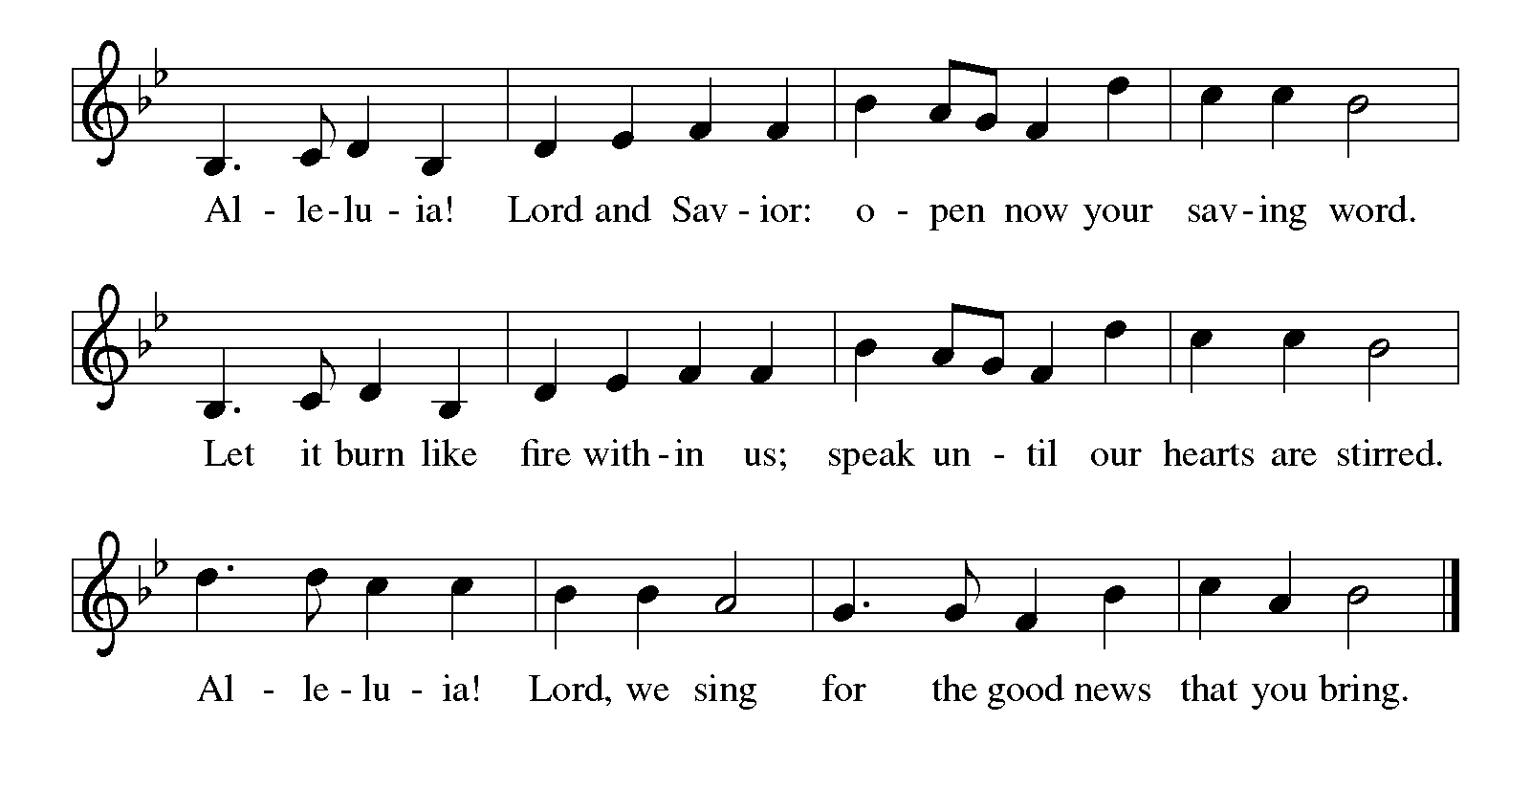

Gospel John 17:1-11
The holy gospel according to John.
Glory to You, O Lord.
¹ After Jesus had spoken these words [to his disciples,] he looked up to heaven and said, “Father, the hour has come; glorify your Son so that the Son may glorify you, ² since you have given him authority over all people, to give eternal life to all whom you have given him. ³ And this is eternal life, that they may know you, the only true God, and Jesus Christ, whom you have sent. ⁴ I glorified you on earth by finishing the work that you gave me to do. ⁵ So now, Father, glorify me in your own presence with the glory that I had in your presence before the world existed.
⁶ “I have made your name known to those whom you gave me from the world. They were yours, and you gave them to me, and they have kept your word. ⁷ Now they know that everything you have given me is from you, ⁸ for the words that you gave to me I have given to them, and they have received them and know in truth that I came from you, and they have believed that you sent me. ⁹ I am asking on their behalf; I am not asking on behalf of the world but on behalf of those whom you gave me, because they are yours. ¹⁰ All mine are yours, and yours are mine, and I have been glorified in them. ¹¹ And now I am no longer in the world, but they are in the world, and I am coming to you. Holy Father, protect them in your name that you have given me, so that they may be one, as we are one.”

The gospel of the Lord.
Praise to you, O Christ.

CHILDREN’S MOMENT
SERMON Pastor Ken Scheck

hymn of the day “I Come with Joy” #482

cREED
We believe in one God,
the Father, the Almighty,
maker of heaven and earth,
of all that is, seen and unseen.
We believe in one Lord, Jesus Christ,
the only Son of God,
eternally begotten of the Father,
God from God, Light from Light,
true God from true God,
begotten, not made,
of one Being with the Father;
through him all things were made.
For us and for our salvation
he came down from heaven,
was incarnate of the Holy Spirit and the virgin Mary
and became truly human.
For our sake he was crucified under Pontius Pilate;
he suffered death and was buried.
On the third day he rose again
in accordance with the scriptures;
he ascended into heaven
and is seated at the right hand of the Father.
He will come again in glory to judge the living and the dead,
and his kingdom will have no end.
We believe in the Holy Spirit, the Lord, the giver of life,
who proceeds from the Father and the Son,*
who with the Father and the Son is worshiped and glorified,
who has spoken through the prophets.
We believe in one holy catholic and apostolic church.
We acknowledge one baptism for the forgiveness of sins.
We look for the resurrection of the dead,
and the life of the world to come. Amen.

*Or, “who proceeds from the Father.” The phrase “and the Son” is a later addition to the creed.

prayers of Intercession
(Please Be Seated)
Trusting in the power of Christ’s resurrection to heal and redeem our broken world, let us pray for the needs of all creation.
A brief silence.
O God, your people sing praises throughout the church. By your Holy Spirit, inspire musicians, deacons, pastors, and bishops to proclaim the gospel of Jesus. We pray especially for Our Saviour Lutheran in Saginaw, and their Supply Pastors.
Merciful God,
receive our prayer.
Your creative power fills the universe. Bring favorable weather, nurture plants and animals, protect us from natural disasters, and guide us to care for all you have made. Merciful God,
receive our prayer.
Your justice is exercised in society by those in authority. Instill in political leaders, business leaders, school administrators, and all who care for others a desire for peace and equity. Merciful God,
receive our prayer.
Your compassion and care come through the gifts of medicine and relationships. Soothe the anxious, protect widows and orphans, comfort those living with memory loss and their families, and heal the sick. We pray especially for all those on our prayer list and in our hearts. We pray for all countries involved in ongoing conflicts and all who are affected by natural disasters. Merciful God,
receive our prayer.
Your love radiates from communities gathered in your name. Bless those experiencing significant transitions in life such as graduation, retirement, new employment, and accompany us in our prayers during these times. Merciful God,
receive our prayer.
O God, your promise of eternal life is certain and sure. Inspire us by the steadfast faith of those who have gone before us, so that we may be confident in the assurances you give. Merciful God,
receive our prayer.
God of resurrection power, use us and these prayers to proclaim the good news of new life to all the world, through Jesus Christ, our risen Savior.
Amen.

PEACE
Sharing the Peace of God
The peace of the risen Christ be with you always.

And also with you.
(We share the peace of Christ with one another.)

OFFERING & OFFERING SONG
The joy of the Lord is my strength,
The joy of the Lord is my strength,
The joy of the Lord is my strength,
The joy of the Lord is my strength.

Offering Prayer
Let us pray.
Be known to us, O Lord, as you were made known to the disciples. Receive these gifts, and the offering of our lives, that we may be your risen body in the world. Amen.

DIALOGUE
The Lord be with you.
And also with you.
Lift up your hearts.
We lift them to the Lord.
Let us give thanks to the Lord our God.
It is right to give our thanks and praise.

PREFACE (Pastor)
It is indeed right, our duty and our joy,
that we should at all times and in all places
give thanks and praise to you, almighty and merciful God,
through our Savior Jesus Christ;
who on this day overcame death and the grave,
and by his glorious resurrection opened to us the way of everlasting life.
And so, with all the choirs of angels,
with the church on earth and the hosts of heaven,
we praise your name and join their unending hymn

Holy, holy, holy
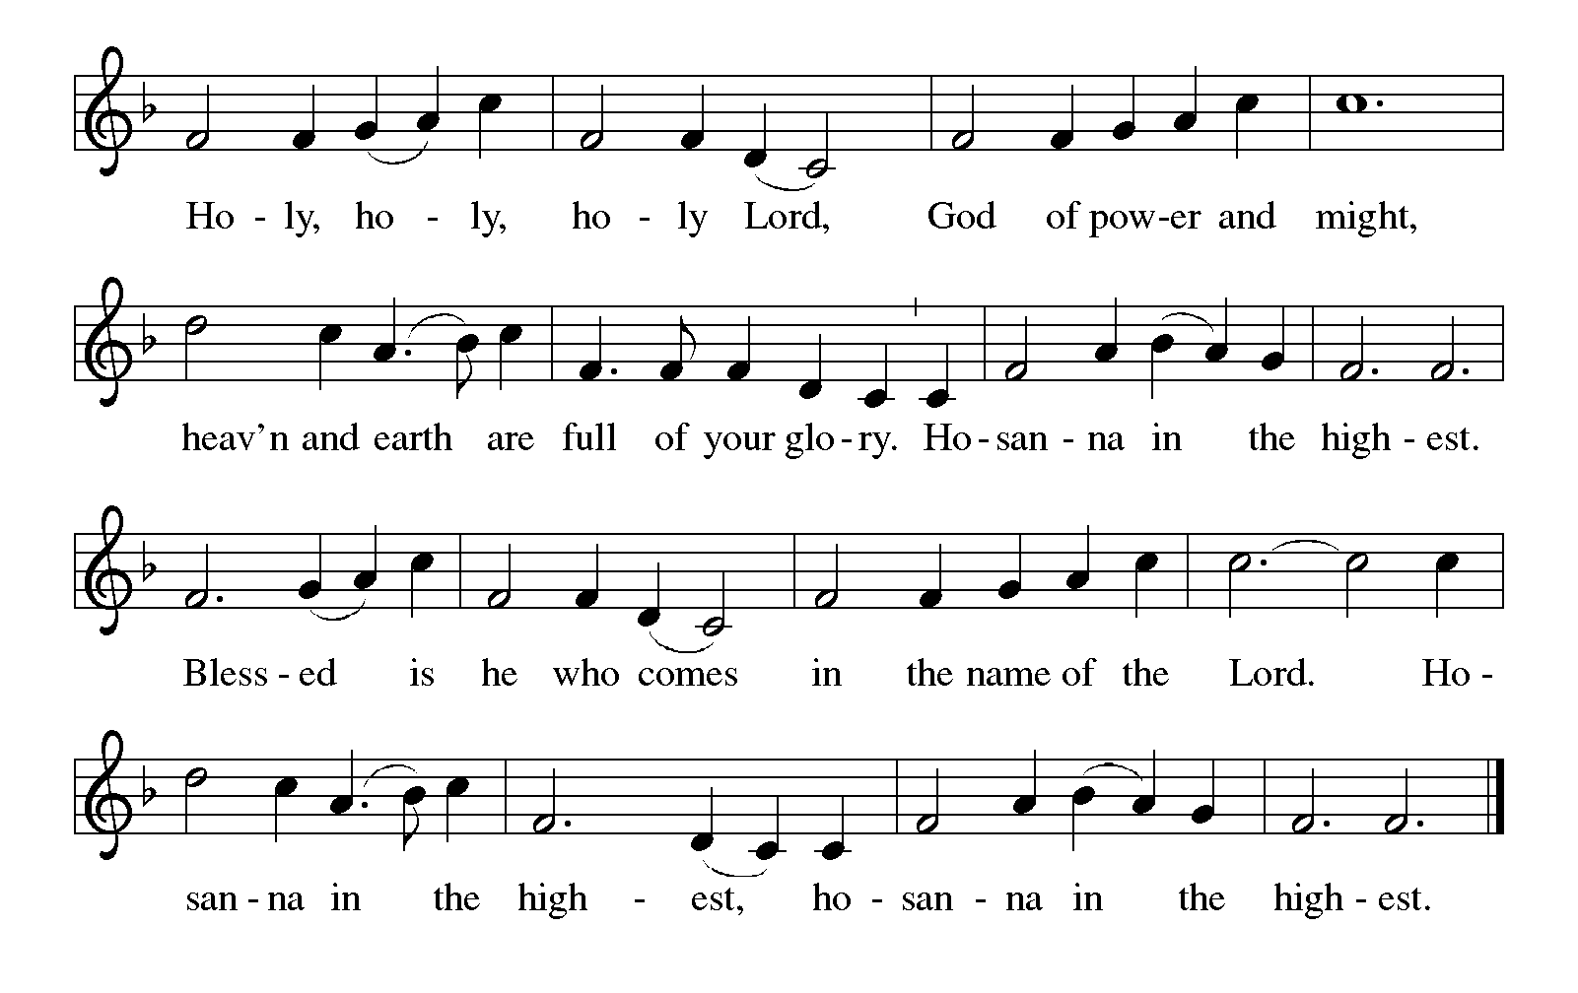

Thanksgiving at the Table
In the night in which he was betrayed,
our Lord Jesus took bread, and gave thanks;
broke it, and gave it to his disciples, saying:
Take and eat; this is my body, given for you.
Do this for the remembrance of me.

Again, after supper, he took the cup, gave thanks,
and gave it for all to drink, saying:
This cup is the new covenant in my blood,
shed for you and for all people for the forgiveness of sin.
Do this for the remembrance of me.

For as often as we eat of this bread and drink from this cup,
we proclaim the Lord’s death until he comes.

Christ has died. Christ is risen. Christ will come again.

Lord’s Prayer
Gathered into one by the Holy Spirit, let us pray as Jesus taught us.
Our Father, who art in heaven,
hallowed be thy name,
thy kingdom come,
thy will be done,
on earth as it is in heaven.
Give us this day our daily bread;
and forgive us our trespasses,
as we forgive those
who trespass against us;
and lead us not into temptation,
but deliver us from evil.
For thine is the kingdom,
and the power, and the glory,
forever and ever. Amen.

INVITATION TO COMMUNION
Come to the banquet, for all is now ready.

COMMUNION *continuous
*People are welcome to kneel at the altar rail for a time of prayer after they receive their communion elements.

COMMUNION HYMNS
“Let Us Break Bread Together” #471

“Like the Murmur of the Dove's Song” #403

PRAYER AFTER COMMUNION
Let us pray.
We give you thanks, almighty God, that you have refreshed us through the healing power of this gift of life. In your mercy, strengthen us through this gift, in faith toward you and in fervent love toward one another; for the sake of Jesus Christ our Lord.
Amen.

Sending
God blesses us and sends us in mission to the world.

Blessing
The Lord bless you and keep you.
The Lord’s face shine on you with grace and mercy.
The Lord look upon you with favor and ☩ give you peace.
Amen.

Sending SonG “O Sun of Righteousness” #657

Dismissal
Go in peace. Christ is with you.
Thanks be to God.

From sundaysandseasons.com. Copyright © 2017 Augsburg Fortress. All rights reserved.

Thank you to all who served in worship today!
Presiders: Pastor Ken Scheck Musicians: Martha Yoder
Acolyte: Kole Hokanson Safety Person:
Elder: Dan Utterback Trustee: Mike Johnson
Offering Counters: Diane Griffin & Carlotta Willard



PRAYERS OF THE FAITHFUL

With thanks for all God’s blessings and his love for all people. Our Bishops, Julie Schneider-Thomas, Yehiel Curry, and the congregations of the North/West Lower Michigan Synod, and especially Our Saviour Lutheran in Saginaw, and their Supply Pastors.

Prayers for our friends, for all who are sick or hospitalized and for all health care workers who care for them. All those members of Zion’s family traveling; all those homebound or in frail health; all those suffering with quiet, unknown needs or worries. For those who serve on our behalf: public safety, utility workers, medical personnel, military personnel. For those who might be forgotten. We pray especially for all countries involved in ongoing conflicts.

This week at Zion:
- Men’s Breakfast at 8am, Wednesday 20th
- Bulletin Deadline, Wednesday 20th
- Ladies Craft Night, 5 pm, Friday 22nd

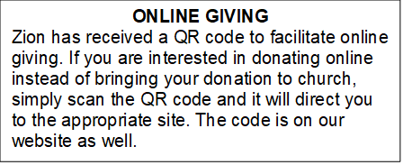

How to Contact the Pastor: If there is a pastoral need, please contact
Pastor Ken Scheck II at 269-370-4632 or by email at kscheckii@aol.com.

ANNOUNCEMENTS

- Graduate Recognition on Sunday, May 31st: Zion will honor graduate Anna Zylstra on Sunday, May 31st at the beginning of worship. There will be a potluck lunch and a cake for Anna following worship. Please plan to be there for this special recognition Sunday!
- Today! Lakewood High School Baccalaureate Service, 6 pm: Zion and Harvest will co-host a reception for students at the Baccalaureate service this evening at the High School. There will be a variety of beverages, cookies and treats. Zion has also purchased cross string bracelets to give to the graduates. All are welcome to attend this special program.
- VBS July 14,15,16: The community VBS sponsored by the Lakewood Area Ministerial Association is quickly approaching! It is time to register your kids and sign-up to volunteer. Zion and Central will be in charge of the craft station and lots of help is needed! Volunteers group leaders are also needed. There is a sign-up sheet in the Narthex and also a flyer with a QR code to register kids and volunteers online. Please see Karen or Martha if you have questions.
- Ladies Craft Night: Friday, May 22nd is craft night from 5pm to 9pm. Bring a craft to work on and a snack to share. We will make some tea and set and enjoy great company and get some work done on one of our UFPs (unfinished projects).
- Soup Recipes: It was suggested that we publish the great soup recipes that we enjoyed during our Lenten soup and salad dinners this year. Thank you Jolene for requesting recipes and publishing those that were submitted. Copies are available on the table in the narthex for anyone who would like a copy.
- Zion Coffee Cups: The Board of Evangelism has purchased coffee cups with the Zion logo on them to use for outreach. The mugs are also available for purchase. There is one on display on the table in the narthex. The mugs are a great 16-ounce size and they’re being sold for $10 each. All proceeds will be used for evangelism ministries. If you would like to purchase a mug, please see Karen Martha or Ruth.
- Second Time Around Sale: Please start looking for gently used household items, tools, home decor, craft and sewing items, toys, furniture, purses and accessories. Please send only appliances that are in good condition. There will be a bake sale, please see Dawn for details. Our sale will be June 25th and 26th, the ZLCW is organizing but we are raising the profits for church maintenance. The last day we will take donations is Sunday June 21st. Look for a sign-up sheet for helpers and baked goods on the table in the Narthex. There will also be a silent auction or items already donated. If you have any questions, ask Mary M. or Buffy.
- Note from the Board of Stewardship: Our congregation continues to grow in its mission to share Christ’s love in our community. As we look ahead to the coming months, we will be facing a shortfall in our operating budget. If you are able, we invite you to consider an additional gift to support our worship, outreach, and care ministries. Every contribution, large or small, strengthens the work we do together in Christ’s name. Thank you for your faithful generosity.
- Pastor’s Availability: Pastor Ken Scheck II is available by appointment to meet with you. As you know homebound visitation has begun and will continue until all homebound have been visited by Pastor Ken. Generally speaking, he is at Grace on Mondays and Wednesdays and Zion on Tuesdays and Thursdays with a day off on Friday. As you may be aware, Pastor Ken has come to the Men’s meeting and Lakewood Area Ministerial Association meetings on Wednesday here at Zion. Flexibility is the name of the game. He is more than willing to be contacted at any time by cellphone or email. Please feel free to contact him at 269-370-4632 or at kscheckii@aol.com. You are able to send a text to the cellphone, but please identify yourself at least the first time.
- Announcement and Newsletter Items: Please forward items for the bulletin announcements and the newsletter to the church email (Office@Zion.org). Please do not send items to people’s personal emails. Thank you.
- Door Locking Policy: Our door locking policy relies on having a volunteer(s) each Sunday to serve as the Safety Person of the Day. On Sundays where no one has volunteered, if someone arrives at church and is willing to be the Safety Person of the Day, we will follow the door locking policy. If no one steps forward to serve as the Safety Person of the Day, the doors will not be locked. Please consider volunteering for this important duty.

