ZION LUTHERAN CHURCH, WOODLAND, MI
Day Of Pentecost Sunday May 24, 2026
*If you are listening in your car, please tune your radio to FM 87.7*
(Please silence your cell phones while in the sanctuary. Thank you.)


WELCOME AND ANNOUNCEMENTS

Gathering
The Holy Spirit calls us together as the people of God.

Confession and Forgiveness
In the name of the Father,
and of the ☩ Son,
and of the Holy Spirit.
Amen.

Almighty God, to whom all hearts are open, all desires known, and from whom no secrets are hid: cleanse the thoughts of our hearts by the inspiration of your Holy Spirit, that we may perfectly love you and worthily magnify your holy name, through Jesus Christ our Lord.
Amen.

Let us confess our sin in the presence of God and of one another. Most merciful God,
we confess that we are captive to sin and cannot free ourselves. We have sinned against you in thought, word, and deed, by what we have done and by what we have left undone. We have not loved you with our whole heart; we have not loved our neighbors as ourselves. For the sake of your Son, Jesus Christ, have mercy on us. Forgive us, renew us, and lead us, so that we may delight in your will and walk in your ways, to the glory of your holy name.
Amen.

God, who is rich in mercy, loved us even when we were dead in sin, and made us alive together with Christ. By grace you have been saved. In the name of ☩ Jesus Christ, your sins are forgiven. Almighty God strengthen you with power through the Holy Spirit, that Christ may live in your hearts through faith.

Gathering Song “Every Time I Feel the Spirit” #942

Prayer of the Day
Let us pray together.
O God of glory, your Son Jesus Christ suffered for us and ascended to your right hand. Unite us with Christ and each other in suffering and in joy, that all the world may be drawn into your bountiful presence, through Jesus Christ, our Savior and Lord, who lives and reigns with you and the Holy Spirit, one God, now and forever.
Amen.

First Reading Acts 2:1-21
A reading from Acts.
¹ When the day of Pentecost had come, [the apostles] were all together in one place. ² And suddenly from heaven there came a sound like the rush of a violent wind, and it filled the entire house where they were sitting. ³ Divided tongues, as of fire, appeared among them, and a tongue rested on each of them. ⁴ All of them were filled with the Holy Spirit and began to speak in other languages, as the Spirit gave them ability.
⁵ Now there were devout Jews from every people under heaven living in Jerusalem. ⁶ And at this sound the crowd gathered and was bewildered, because each one heard them speaking in the native language of each. ⁷ Amazed and astonished, they asked, “Are not all these who are speaking Galileans? ⁸ And how is it that we hear, each of us, in our own native language? ⁹ Parthians, Medes, Elamites, and residents of Mesopotamia, Judea and Cappadocia, Pontus and Asia, ¹⁰ Phrygia and Pamphylia, Egypt and the parts of Libya belonging to Cyrene, and visitors from Rome, both Jews and proselytes, ¹¹ Cretans and Arabs—in our own languages we hear them speaking about God’s deeds of power.” ¹² All were amazed and perplexed, saying to one another, “What does this mean?” ¹³ But others sneered and said, “They are filled with new wine.”
¹⁴ But Peter, standing with the eleven, raised his voice and addressed them, “Fellow Jews and all who live in Jerusalem, let this be known to you, and listen to what I say. ¹⁵ Indeed, these are not drunk, as you suppose, for it is only nine o’clock in the morning. ¹⁶ No, this is what was spoken through the prophet Joel:
¹⁷ ‘In the last days it will be, God declares,
that I will pour out my Spirit upon all flesh,
and your sons and your daughters shall prophesy,
and your young men shall see visions,
and your old men shall dream dreams.
¹⁸ Even upon my slaves, both men and women,
in those days I will pour out my Spirit,
and they shall prophesy.
¹⁹ And I will show portents in the heaven above
and signs on the earth below,
blood, and fire, and smoky mist.
²⁰ The sun shall be turned to darkness
and the moon to blood,
before the coming of the Lord’s great and glorious day.
²¹ Then everyone who calls on the name of the Lord shall be saved.’ ”

The word of the Lord.
Thanks be to God.

Psalm 104:24-34, 35b

²⁴ How manifold are your | works, O Lord!
In wisdom you have made them all; the earth is full | of your creatures.
²⁵ Yonder is the sea, great and wide, with its swarms too man- | y to number,
living things both | small and great.
²⁶ There go the ships | to and fro,
and Leviathan, which you made for the | sport of it.
²⁷ All of them | look to you
to give them their food | in due season.
²⁸ You give it to them; they | gather it;
you open your hand, and they are filled | with good things.
²⁹ When you hide your face, | they are terrified;
when you take away their breath, they die and return | to their dust.
³⁰ You send forth your Spirit, and they | are created;
and so you renew the face | of the earth.
³¹ May the glory of the Lord en- | dure forever;
O Lord, rejoice in | all your works.
³² You look at the earth | and it trembles;
you touch the mountains | and they smoke.
³³ I will sing to the Lord as long | as I live;
I will praise my God while I | have my being.
³⁴ May these words of | mine please God.
I will rejoice | in the Lord.
^{35b} Bless the Lord, | O my soul.
Hal- | lelujah!

Second Reading 1 Corinthians 12:3b-13
A reading from 1 Corinthians.
^{3b} No one can say “Jesus is Lord” except by the Holy Spirit.
⁴ Now there are varieties of gifts but the same Spirit, ⁵ and there are varieties of services but the same Lord, ⁶ and there are varieties of activities, but it is the same God who activates all of them in everyone. ⁷ To each is given the manifestation of the Spirit for the common good. ⁸ To one is given through the Spirit the utterance of wisdom and to another the utterance of knowledge according to the same Spirit, ⁹ to another faith by the same Spirit, to another gifts of healing by the one Spirit, ¹⁰ to another the working of powerful deeds, to another prophecy, to another the discernment of spirits, to another various kinds of tongues, to another the interpretation of tongues. ¹¹ All these are activated by one and the same Spirit, who allots to each one individually just as the Spirit chooses.
¹² For just as the body is one and has many members, and all the members of the body, though many, are one body, so it is with Christ. ¹³ For in the one Spirit we were all baptized into one body—Jews or Greeks, slaves or free—and we were all made to drink of one Spirit.

The Word of the Lord.
Thanks be to God.

Gospel Acclamation
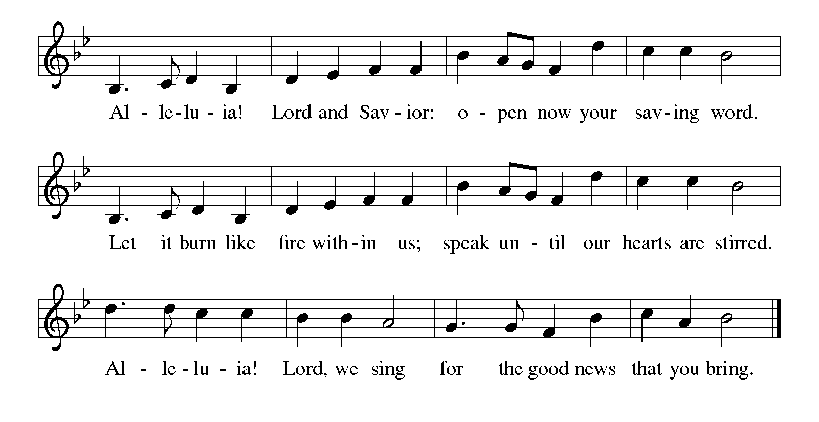

Gospel John 20:19-23
The holy gospel according to John.
Glory to You, O Lord.
¹⁹ When it was evening on that day, the first day of the week, and the doors were locked where the disciples were, for fear of the Jews, Jesus came and stood among them and said, “Peace be with you.” ²⁰ After he said this, he showed them his hands and his side. Then the disciples rejoiced when they saw the Lord. ²¹ Jesus said to them again, “Peace be with you. As the Father has sent me, so I send you.” ²² When he had said this, he breathed on them and said to them, “Receive the Holy Spirit. ²³ If you forgive the sins of any, they are forgiven them; if you retain the sins of any, they are retained.”

The gospel of the Lord.
Praise to you, O Christ.

CHILDREN’S MOMENT
SERMON Pastor Ken Scheck

hymn of the day “Gracious Spirit, Heed Our Pleading” #401

cREED
I believe in God, the Father almighty,
creator of heaven and earth.
I believe in Jesus Christ, God’s only Son, our Lord,
who was conceived by the Holy Spirit,
born of the virgin Mary,
suffered under Pontius Pilate,
was crucified, died, and was buried;
he descended to the dead.*
On the third day he rose again;
he ascended into heaven,
he is seated at the right hand of the Father,
and he will come to judge the living and the dead.
I believe in the Holy Spirit,
the holy catholic church,
the communion of saints,
the forgiveness of sins,
the resurrection of the body,
and the life everlasting. Amen.

*Or, “he descended into hell,” another translation of this text in widespread use.

prayers of Intercession
(Please Be Seated)
Trusting in the power of Christ’s resurrection to heal and redeem our broken world, let us pray for the needs of all creation.
A brief silence.
O God, you send the Holy Spirit to gather your church into one. Inspire all ministers of the gospel to speak prophetic and hope-filled words to all whom they encounter. Bless the work of interreligious dialogue. We pray especially for Resurrection Lutheran church in Saginaw, and their Supply Pastors. Merciful God,
receive our prayer.
You send the Holy Spirit to renew the face of the earth. Protect all living things, bring forth clean water and abundant food, and grant us wonder as we contemplate all you have made. Merciful God,
receive our prayer.
You send the Holy Spirit to break down the barriers of communication among nations. Bestow peace in war-torn areas, guide all in government and society to work for justice, and guard those serving in the armed forces, especially this weekend as we remember those who died in service to their country. Merciful God,
receive our prayer.
You send the Holy Spirit to accompany those who feel abandoned. Provide food for those who hunger and drink for those who thirst, soothe those who are anxious or bereaved, comfort those who are sick or suffering, and answer all who call upon your name. We pray especially for all those on your prayer list and in our heart. We pray for all countries involved in ongoing conflicts and all who are affected by natural disasters.
Merciful God,
receive our prayer.
You send the Holy Spirit through the gift of baptism. Bless both those preparing for or affirming their baptism. May they be encouraged by this community of faith as they live out their baptismal promises. Merciful God,
receive our prayer.
You send the Holy Spirit to console us in our grief. We give you thanks for our ancestors in the faith, witnessing your mighty works continues to inspire our lives. Merciful God,
receive our prayer.
God of resurrection power, use us and these prayers to proclaim the good news of new life to all the world, through Jesus Christ, our risen Savior.
Amen.

PEACE
Sharing the Peace of God
The peace of the risen Christ be with you always.

And also with you.
(We share the peace of Christ with one another.)

OFFERING & OFFERING SONG
The joy of the Lord is my strength,
The joy of the Lord is my strength,
The joy of the Lord is my strength,
The joy of the Lord is my strength.

Offering Prayer
Let us pray.
Be known to us, O Lord, as you were made known to the disciples. Receive these gifts, and the offering of our lives, that we may be your risen body in the world. Amen..
Amen.

DIALOGUE
The Lord be with you.
And also with you.
Lift up your hearts.
We lift them to the Lord.
Let us give thanks to the Lord our God.
It is right to give our thanks and praise.

PREFACE (Pastor)
It is indeed right, our duty and our joy,
that we should at all times and in all places
give thanks and praise to you, almighty and merciful God,
through our Savior Jesus Christ;
who on this day overcame death and the grave,
and by his glorious resurrection opened to us the way of everlasting life.
And so, with all the choirs of angels,
with the church on earth and the hosts of heaven,
we praise your name and join their unending hymn

Holy, holy, holy
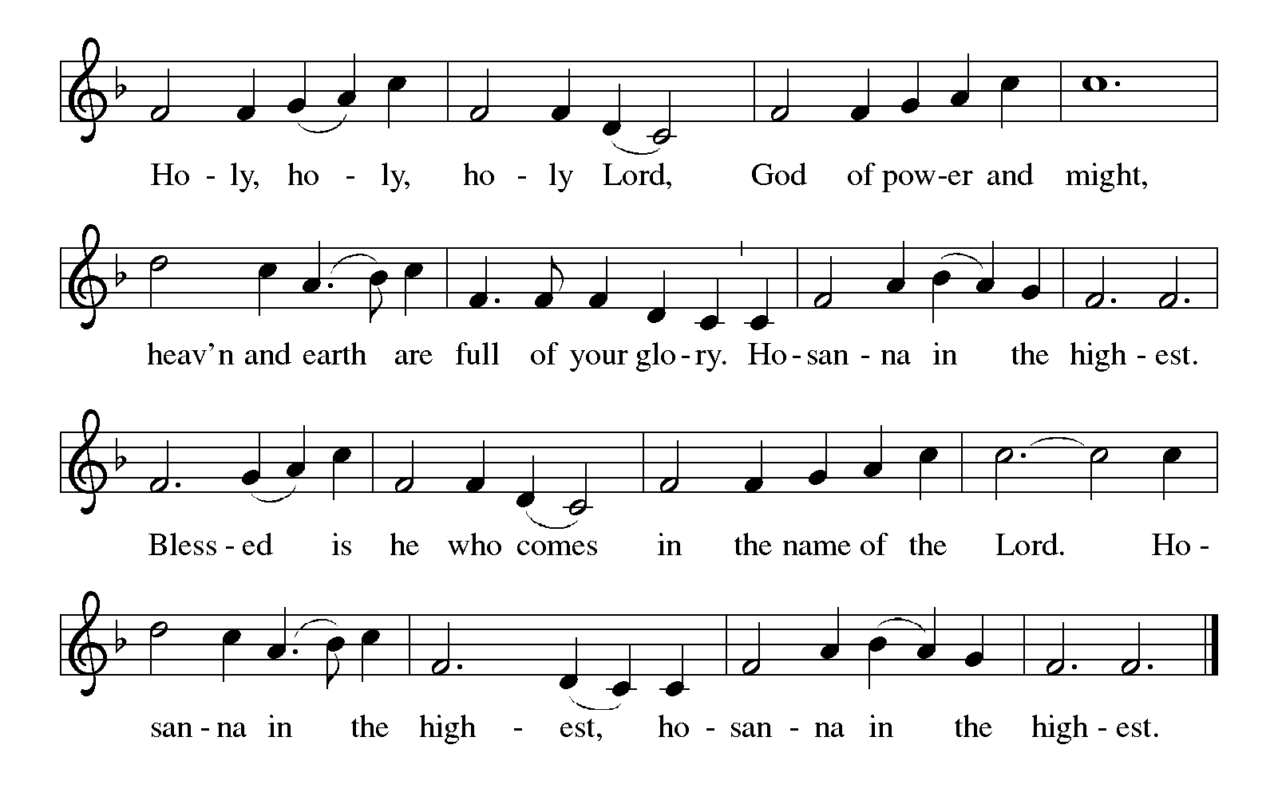

Thanksgiving at the Table
In the night in which he was betrayed,
our Lord Jesus took bread, and gave thanks;
broke it, and gave it to his disciples, saying:
Take and eat; this is my body, given for you.
Do this for the remembrance of me.

Again, after supper, he took the cup, gave thanks,
and gave it for all to drink, saying:
This cup is the new covenant in my blood,
shed for you and for all people for the forgiveness of sin.
Do this for the remembrance of me.

For as often as we eat of this bread and drink from this cup,
we proclaim the Lord’s death until he comes.

Christ has died. Christ is risen. Christ will come again.

Lord’s Prayer
Gathered into one by the Holy Spirit, let us pray as Jesus taught us.
Our Father, who art in heaven,
hallowed be thy name,
thy kingdom come,
thy will be done,
on earth as it is in heaven.
Give us this day our daily bread;
and forgive us our trespasses,
as we forgive those
who trespass against us;
and lead us not into temptation,
but deliver us from evil.
For thine is the kingdom,
and the power, and the glory,
forever and ever. Amen.

INVITATION TO COMMUNION
Come to the banquet, for all is now ready.

COMMUNION *continuous
*People are welcome to kneel at the altar rail for a time of prayer after they receive their communion elements.

COMMUNION HYMNS
“Spirit of Gentleness” #396

PRAYER AFTER COMMUNION
Let us pray.
We give you thanks, almighty God, that you have refreshed us through the healing power of this gift of life. In your mercy, strengthen us through this gift, in faith toward you and in fervent love toward one another; for the sake of Jesus Christ our Lord.
Amen.

Sending
God blesses us and sends us in mission to the world.

Blessing
The Lord bless you and keep you.
The Lord’s face shine on you with grace and mercy.
The Lord look upon you with favor and ☩ give you peace.
Amen.
Sending SonG “God of Tempest, God of Whirlwind” #400
Dismissal
Go in peace. Christ is with you.
Thanks be to God.

From sundaysandseasons.com. Copyright © 2017 Augsburg Fortress. All rights reserved.

Thank you to all who served in worship today!
Presiders: Pastor Ken Scheck Musicians: Martha Yoder
Acolyte: Safety Person:
Elder: Buffy Meyers Trustee: Doug MacKenzie
Offering Counters: Doug MacKenize & Mike Johnson



PRAYERS OF THE FAITHFUL

With thanks for all God’s blessings and his love for all people. Our Bishops, Julie Schneider-Thomas, Yehiel Curry, and the congregations of the North/West Lower Michigan Synod, and especially Resurrection Lutheran church in Saginaw, and their Supply Pastors.

Prayers for our friends, for all who are sick or hospitalized and for all health care workers who care for them. All those members of Zion’s family traveling; all those homebound or in frail health; all those suffering with quiet, unknown needs or worries. For those who serve on our behalf: public safety, utility workers, medical personnel, military personnel. For those who might be forgotten. We pray especially for all countries involved in ongoing conflicts.

This week at Zion:
- Men’s Breakfast at 8am, Wednesday 27th
- Bulletin Deadline, Wednesday 27th
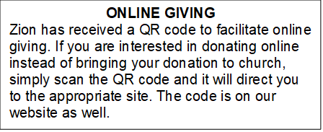

How to Contact the Pastor: If there is a pastoral need, please contact
Pastor Ken Scheck II at 269-370-4632 or by email at kscheckii@aol.com.

ANNOUNCEMENTS

- Soup Recipes: It was suggested that we publish the great soup recipes that we enjoyed during our Lenten soup and salad dinners this year. Thank you Jolene for requesting recipes and publishing those that were submitted. Copies are available on the table in the narthex for anyone who would like a copy.
- Zion Coffee Cups: The Board of Evangelism has purchased coffee cups with the Zion logo on them to use for outreach. The mugs are also available for purchase. There is one on display on the table in the narthex. The mugs are a great 16-ounce size and they’re being sold for $10 each. All proceeds will be used for evangelism ministries. If you would like to purchase a mug, please see Karen, Martha, or Ruth, Please start looking for gently used household items, tools, home decor, craft and sewing items, toys, furniture, purses and accessories. Please send only appliances that are in good condition. Please no clothing, we are restricted in the amount space we have to use for the sale. Items can be sent in boxes or tubs (PLEASE PUT YOUR NAME Clearly on both the tub and lid). If you send tubs, I will text you when I empty them, so you can get your tub back. Our sale will be June 25th and 26th, the ZLCW is organizing but we are raising the profits for church maintenance. The last day we will take donations is Sunday June 21st. If you have any questions, ask Mary M. or Buffy.
- Note from the Board of Stewardship: Our congregation continues to grow in its mission to share Christ’s love in our community. As we look ahead to the coming months, we will be facing a shortfall in our operating budget. If you are able, we invite you to consider an additional gift to support our worship, outreach, and care ministries. Every contribution, large or small, strengthens the work we do together in Christ’s name. Thank you for your faithful generosity.
- Offering for Synod Assembly: The synod is asking congregations across the synod to take part in a special "million penny offering." The idea is to collect the equivalent of one million pennies ($10,000). The offering collected at Synod Assembly will be split evenly and sent to two organizations: Lutheran Disaster Response Ukraine and Samaritas New Americans. We will not be collecting pennies, but if you would like to contribute toward this offering, you can do so through the offering and designate the offering for "Synod Assembly."
- Thank you - My family and I wish to thank you all for providing such a special service honoring Jerry. Thank you to Pastor Ken for sharing the message, Claude for reading the scriptures, Martha for sharing her musical talent and the Lake Odessa VFW Post for their military ceremony. Thank you also for the beautiful bouquet. I underestimated the number of friends and family coming but you all helped by printing and folding more programs and set up more tables and chairs. Thank you to Dawn, her kitchen helpers and all who helped in so many other ways. It was a nice luncheon with time for all to share memories of fun and good times. Dawn, thank you for the unique table arrangements highlighting Jerry. We appreciate all your support and prayers these last few months and help on this difficult day. My family and I know you all miss Jerry's witty charm too.
--Carol Engle and family
- Thank You! Everyone who helped with all our special times of fellowship. The open house for Pastor Ken was a great day filled with delicious food and good fellowship. Our Lenten Season dinners and Easter Sunday Breakfast were wonderful times of food and fellowship too. Thank you to everyone who helped set-up, clean-up, host, and brought food. It has been so good to be together!
- Pastor’s Availability: Pastor Ken Scheck II is available by appointment to meet with you. As you know homebound visitation has begun and will continue until all homebound have been visited by Pastor Ken. Generally speaking, he is at Grace on Mondays and Wednesdays and Zion on Tuesdays and Thursdays with a day off on Friday. As you may be aware, Pastor Ken has come to the Men’s meeting and Lakewood Area Ministerial Association meetings on Wednesday here at Zion. Flexibility is the name of the game. He is more than willing to be contacted at any time by cellphone or email. Please feel free to contact him at 269-370-4632 or at kscheckii@aol.com. You are able to send a text to the cellphone, but please identify yourself at least the first time.
- Announcement and Newsletter Items: Please forward items for the bulletin announcements and the newsletter to the church email (Office@Zion.org). Please do not send items to people’s personal emails. Thank you.
- Door Locking Policy: Our door locking policy relies on having a volunteer(s) each Sunday to serve as the Safety Person of the Day. On Sundays where no one has volunteered, if someone arrives at church and is willing to be the Safety Person of the Day, we will follow the door locking policy. If no one steps forward to serve as the Safety Person of the Day, the doors will not be locked. Please consider volunteering for this important duty.

