ZION LUTHERAN CHURCH, WOODLAND, MI
Fifth Sunday After Pentecost, Sunday June 28, 2026
*If you are listening in your car, please tune your radio to FM 87.7*
(Please silence your cell phones while in the sanctuary. Thank you.)



WELCOME AND ANNOUNCEMENTS

Gathering
The Holy Spirit calls us together as the people of God.

Confession and Forgiveness
In the name of the Father,
and of the ☩ Son,
and of the Holy Spirit.
Amen.

Almighty God, to whom all hearts are open, all desires known, and from whom no secrets are hid: cleanse the thoughts of our hearts by the inspiration of your Holy Spirit, that we may perfectly love you and worthily magnify your holy name, through Jesus Christ our Lord.
Amen.

Let us confess our sin in the presence of God and of one another. Most merciful God,
we confess that we are captive to sin and cannot free ourselves. We have sinned against you in thought, word, and deed, by what we have done and by what we have left undone. We have not loved you with our whole heart; we have not loved our neighbors as ourselves. For the sake of your Son, Jesus Christ, have mercy on us. Forgive us, renew us, and lead us, so that we may delight in your will and walk in your ways, to the glory of your holy name.
Amen.

God, who is rich in mercy, loved us even when we were dead in sin, and made us alive together with Christ. By grace you have been saved. In the name of ☩ Jesus Christ, your sins are forgiven. Almighty God strengthen you with power through the Holy Spirit, that Christ may live in your hearts through faith.
Amen.

Opening
O Lord, open our lips,
and our mouths shall proclaim your praise.
Blessed God, satisfy us in the morning with your steadfast love,
that we may rejoice and be glad in all our days.
Give praise to the Holy Trinity our true God,
who gives us life, salvation, and resurrection.

“You Are Holy” #525

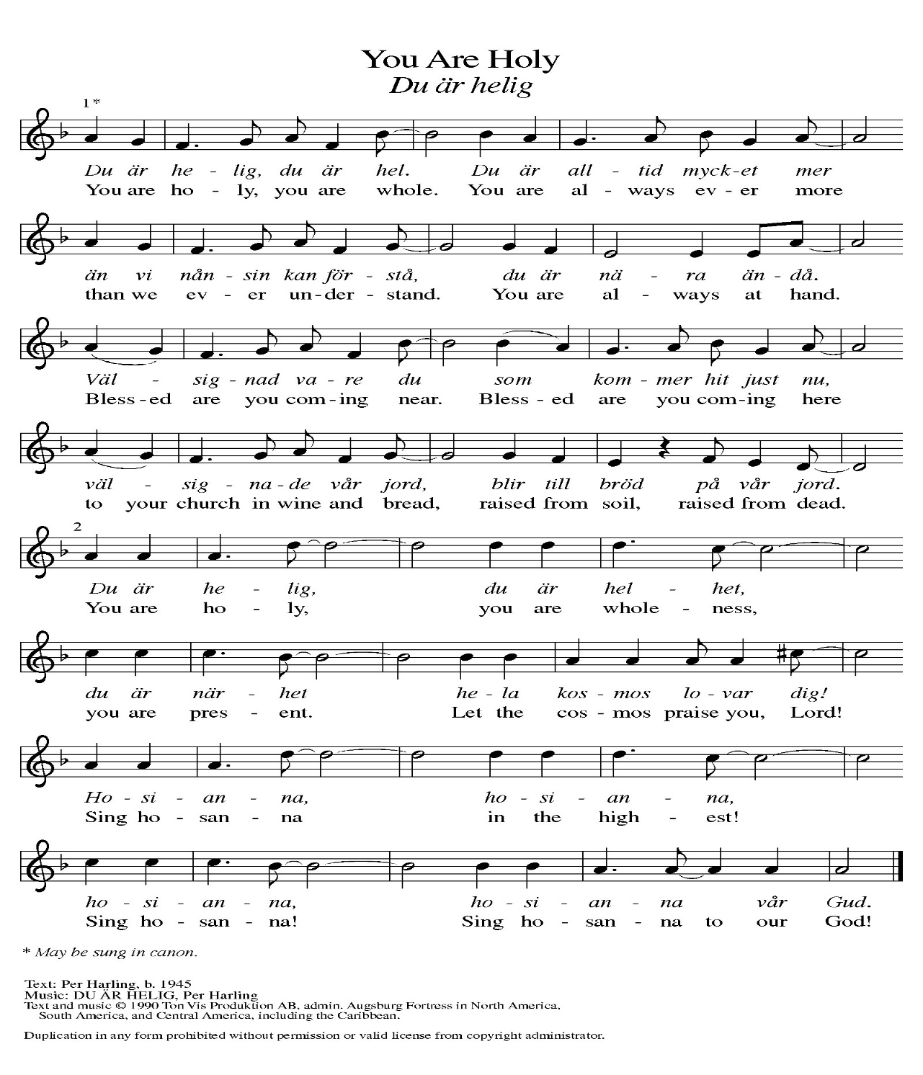
Prayer of the Day
Let us pray together.
O God, you direct our lives by your grace, and your words of justice and mercy reshape the world. Mold us into a people who welcome your word and serve one another, through Jesus Christ, our Savior and Lord.
Amen.
First Reading Jeremiah 28:5-9
A reading from Jeremiah.
⁵ The prophet Jeremiah spoke to the prophet Hananiah in the presence of the priests and all the people who were standing in the house of the Lord, ⁶ and the prophet Jeremiah said, “Amen! May the Lord do so; may the Lord fulfill the words that you have prophesied and bring back to this place from Babylon the vessels of the house of the Lord and all the exiles. ⁷ But listen now to this word that I speak in your hearing and in the hearing of all the people. ⁸ The prophets who preceded you and me from ancient times prophesied war, famine, and pestilence against many countries and great kingdoms. ⁹ As for the prophet who prophesies peace, when the word of that prophet comes true, then it will be known that the Lord has truly sent the prophet.”

The word of the Lord.
Thanks be to God.

Psalm Psalm 89:1-4, 15-18

¹ Your love, O Lord, forever | will I sing;
from age to age my mouth will pro- | claim your faithfulness.
² For I am persuaded that your steadfast love is estab- | lished forever;
you have set your faithfulness firmly | in the heavens.
³ “I have made a covenant with my | chosen one;
I have sworn an oath to Da- | vid my servant:
⁴ ‘I will establish your | line forever,
and preserve your throne for all | generations.’ ”
¹⁵ Happy are the people who know the | festal shout!
They walk, O Lord, in the light | of your presence.
¹⁶ They rejoice daily | in your name;
they are jubilant | in your righteousness.
¹⁷ For you are the glory | of their strength,
and by your favor our might | is exalted.
¹⁸ Truly, our shield belongs | to the Lord;
our king to the Holy | One of Israel.

Second Reading Romans 6:12-23
A reading from Romans.
¹² Do not let sin reign in your mortal bodies, so that you obey their desires. ¹³ No longer present your members to sin as instruments of unrighteousness, but present yourselves to God as those who have been brought from death to life, and present your members to God as instruments of righteousness. ¹⁴ For sin will have no dominion over you, since you are not under law but under grace.
¹⁵ What then? Should we sin because we are not under law but under grace? By no means! ¹⁶ Do you not know that, if you present yourselves to anyone as obedient slaves, you are slaves of the one whom you obey, either of sin, which leads to death, or of obedience, which leads to righteousness? ¹⁷ But thanks be to God that you who were slaves of sin have become obedient from the heart to the form of teaching to which you were entrusted ¹⁸ and that you, having been set free from sin, have become enslaved to righteousness. ¹⁹ I am speaking in human terms because of your limitations. For just as you once presented your members as slaves to impurity and lawlessness, leading to even more lawlessness, so now present your members as slaves to righteousness, leading to sanctification.
²⁰ When you were slaves of sin, you were free in regard to righteousness. ²¹ So what fruit did you then gain from the things of which you now are ashamed? The end of those things is death. ²² But now that you have been freed from sin and enslaved to God, the fruit you have leads to sanctification, and the end is eternal life. ²³ For the wages of sin is death, but the free gift of God is eternal life in Christ Jesus our Lord.

The Word of the Lord.
Thanks be to God.

Gospel Acclamation
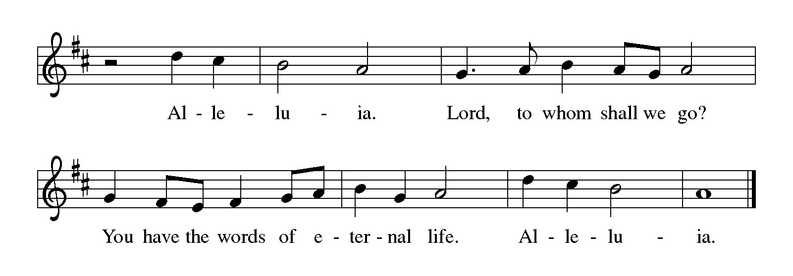

Gospel Matthew 10:40-42
The holy gospel according to Matthew.
Glory to You, O Lord.
[Jesus said to the twelve:] ⁴⁰ “Whoever welcomes you welcomes me, and whoever welcomes me welcomes the one who sent me. ⁴¹ Whoever welcomes a prophet in the name of a prophet will receive a prophet’s reward, and whoever welcomes a righteous person in the name of a righteous person will receive the reward of the righteous, ⁴² and whoever gives even a cup of cold water to one of these little ones in the name of a disciple—truly I tell you, none of these will lose their reward.”

The gospel of the Lord.
Praise to you, O Christ.

CHILDREN’S MOMENT
TESTIMONIAL Caroline Brecheisen
SERMON Pastor Ken Scheck

hymn of the day “The Church of Christ, In Every Age” #729

cREED
I believe in God, the Father almighty,
creator of heaven and earth.
I believe in Jesus Christ, God’s only Son, our Lord,
who was conceived by the Holy Spirit,
born of the virgin Mary,
suffered under Pontius Pilate,
was crucified, died, and was buried;
he descended to the dead.*
On the third day he rose again;
he ascended into heaven,
he is seated at the right hand of the Father,
and he will come to judge the living and the dead.
I believe in the Holy Spirit,
the holy catholic church,
the communion of saints,
the forgiveness of sins,
the resurrection of the body,
and the life everlasting. Amen.

*Or, “he descended into hell,” another translation of this text in widespread use.

prayers of Intercession (Please Be Seated)
Gathered together by the Holy Spirit, let us pray for the church and the needs of the world.
A brief silence.
Faithful God, establish your church to offer welcome and proclaim your peace. Nourish us so we can proclaim your hope to the world. We pray especially for Spruce Lutheran Church in Spruce, and their pastor Rev. Leslie Nye.
God of grace,
hear our prayer.
Creator God, bring life to places experiencing drought, deforestation, and pollution. Help us to cultivate and care for the natural world around us. God of grace,
hear our prayer.
Loving God, bring an end to conflict and division. Sustain the work of prophets in our time, and work through world leaders to foster understanding, justice, and peace. God of grace,
hear our prayer.
Provider God, give your children what they need physically, emotionally, and spiritually. We pray especially for all those on our prayer list and in our hearts.
Bless caregivers as they show God’s hospitality through their generous service. God of grace,
hear our prayer.
Living God, lead us from death to life. Inspire new ministries and endeavors, renew established ones, and strengthen our welcoming presence to our neighbors. God of grace,
hear our prayer.
Eternal God, we remember the faithful departed of this community and of the wider church and world. We give thanks for saints of all times and places. God of grace,
hear our prayer.
Trusting you receive all our prayers, we commend our spoken and unspoken prayers to you, O God, through Jesus our Savior.
Amen.

PEACE
Sharing the Peace of God
The peace of the risen Christ be with you always.
And also with you.
(We share the peace of Christ with one another.)

OFFERING & OFFERING SONG
The joy of the Lord is my strength,
The joy of the Lord is my strength,
The joy of the Lord is my strength,
The joy of the Lord is my strength.

Offering Prayer
Let us pray.
Be known to us, O Lord, as you were made known to the disciples. Receive these gifts, and the offering of our lives, that we may be your risen body in the world. Amen..
Amen.

DIALOGUE
The Lord be with you.
And also with you.
Lift up your hearts.
We lift them to the Lord.
Let us give thanks to the Lord our God.
It is right to give our thanks and praise.

PREFACE (Pastor)
It is indeed right, our duty and our joy,
that we should at all times and in all places
give thanks and praise to you, almighty and merciful God,
through our Savior Jesus Christ;
who on this day overcame death and the grave,
and by his glorious resurrection opened to us the way of everlasting life.
And so, with all the choirs of angels,
with the church on earth and the hosts of heaven,
we praise your name and join their unending hymn

Holy, holy, holy
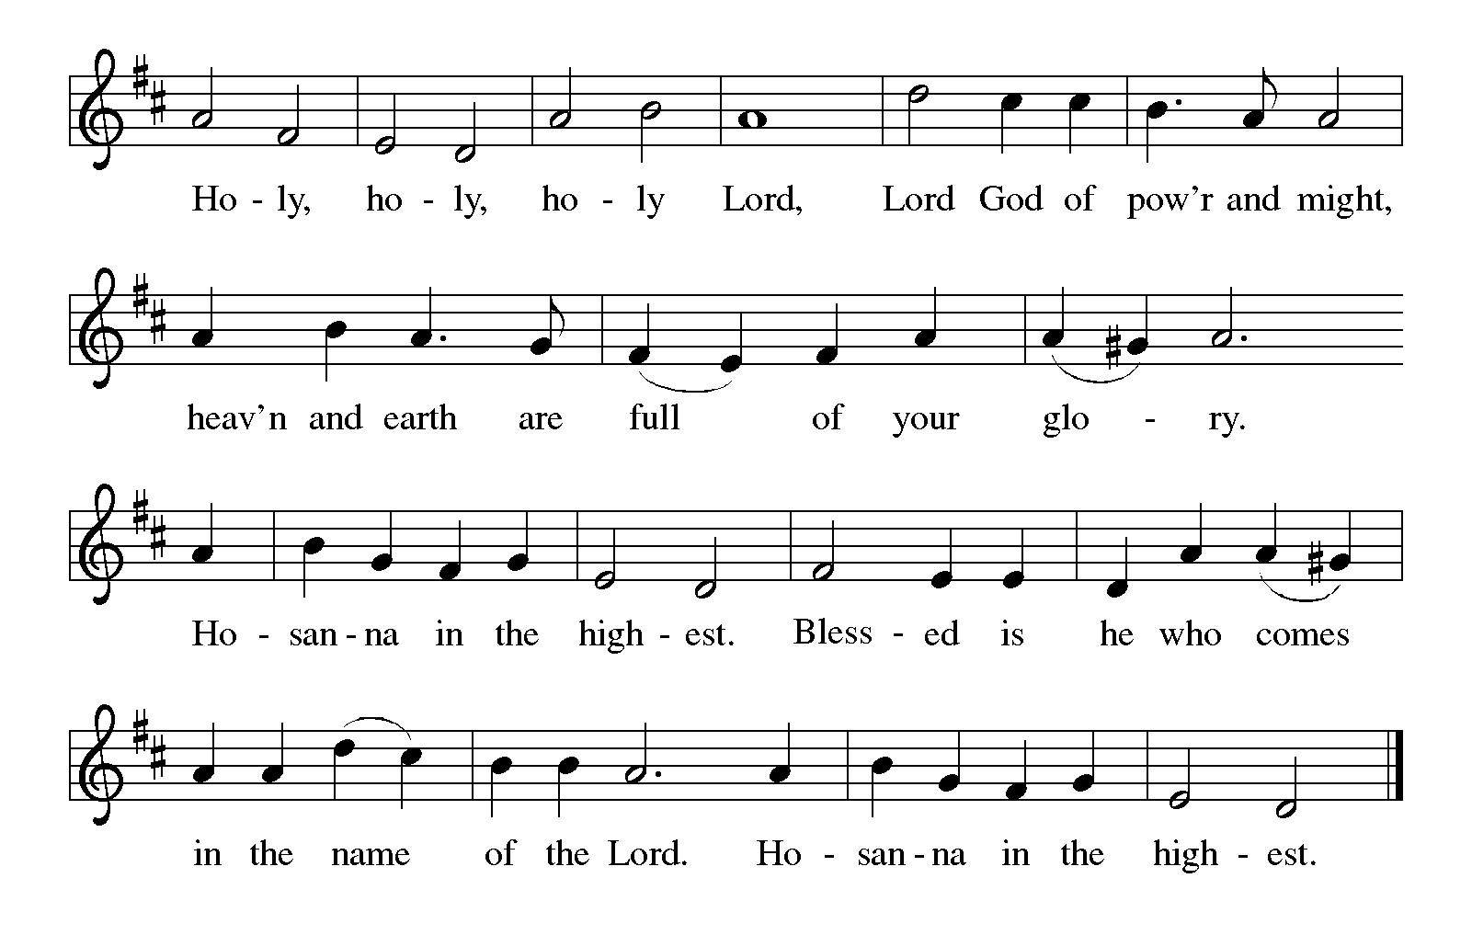

Thanksgiving at the Table
In the night in which he was betrayed,
our Lord Jesus took bread, and gave thanks;
broke it, and gave it to his disciples, saying:
Take and eat; this is my body, given for you.
Do this for the remembrance of me.

Again, after supper, he took the cup, gave thanks,
and gave it for all to drink, saying:
This cup is the new covenant in my blood,
shed for you and for all people for the forgiveness of sin.
Do this for the remembrance of me.

For as often as we eat of this bread and drink from this cup,
we proclaim the Lord’s death until he comes.

Christ has died. Christ is risen. Christ will come again.

Lord’s Prayer
Gathered into one by the Holy Spirit, let us pray as Jesus taught us.
Our Father, who art in heaven,
hallowed be thy name,
thy kingdom come,
thy will be done,
on earth as it is in heaven.
Give us this day our daily bread;
and forgive us our trespasses,
as we forgive those
who trespass against us;
and lead us not into temptation,
but deliver us from evil.
For thine is the kingdom,
and the power, and the glory,
forever and ever. Amen.

INVITATION TO COMMUNION
Come to the banquet, for all is now ready.

COMMUNION *continuous
*People are welcome to kneel at the altar rail for a time of prayer after they receive their communion elements.

COMMUNION HYMNS
“Just As I Am, without One Plea” # 592
“Let Us Ever Walk with Jesus” #802

PRAYER AFTER COMMUNION
Let us pray.
We give you thanks, almighty God, that you have refreshed us through the healing power of this gift of life. In your mercy, strengthen us through this gift, in faith toward you and in fervent love toward one another; for the sake of Jesus Christ our Lord.
Amen.

Sending
God blesses us and sends us in mission to the world.

Blessing
The Lord bless you and keep you.
The Lord’s face shine on you with grace and mercy.
The Lord look upon you with favor and ☩ give you peace.
Amen.
Sending SonG “Lord, Speak to Us, That We May Speak” #676

Dismissal
Go in peace. Christ is with you.
Thanks be to God.

From sundaysandseasons.com. Copyright © 2017 Augsburg Fortress. All rights reserved.

Thank you to all who served in worship today!
Presiders: Pastor Ken Scheck Musician: Jayne Flanigan
Acolyte: Kole Hokanson Safety Person:
Elder: Dan Utterback Trustee: Mike Johnson
Offering Counters: Doug MacKenzie & Mike Johnson



PRAYERS OF THE FAITHFUL

With thanks for all God’s blessings and his love for all people. Our Bishops, Julie Schneider-Thomas, Yehiel Curry, and the congregations of the North/West Lower Michigan Synod, and especially Spruce Lutheran Church in Spruce, and their pastor Rev. Leslie Nye.

Prayers for our friends, for all who are sick or hospitalized and for all health care workers who care for them. All those members of Zion’s family traveling; all those homebound or in frail health; all those suffering with quiet, unknown needs or worries. For those who serve on our behalf: public safety, utility workers, medical personnel, military personnel. For those who might be forgotten..

This week at Zion:
- Men’s Breakfast at 8am, Wednesday 1st
- Bulletin Deadline, Wednesday 1st

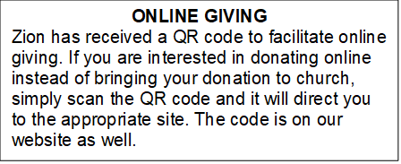

How to Contact the Pastor: If there is a pastoral need, please contact
Pastor Ken Scheck II at 269-370-4632 or by email at kscheckii@aol.com.

ANNOUNCEMENTS

- Thank You: A huge thank you to everyone who helped at my dad’s funeral. The food and decorations were great. It is a blessing to have such organized hardworking church members. Thank you for helping to make that day less stressful. The Hazel Family.
- Semi-Annual Meeting, July 19: The semi-annual meeting will be immediately following worship on July 19th. There are several important issues to be considered at the meeting. The congregation will vote on replacing carpet in the mailbox area, the ladies lounge and the men’s lounge. The congregation will also vote on adopting new bi-laws for Zion. In addition, the future of the parsonage will be considered. Please plan to attend this important meeting.
- Annual Volunteer Appreciation Lunch: The annual volunteer appreciation lunch will be immediately following the semi-annual meeting. Please plan to stay for this special time of recognition and fellowship. The lunch is hosted by the Board of Evangelism.
- Pastor’s Availability: Pastor Ken Scheck II is available by appointment to meet with you. As you know homebound visitation has begun and will continue until all homebound have been visited by Pastor Ken. Generally speaking, he is at Grace on Mondays and Wednesdays and Zion on Tuesdays and Thursdays with a day off on Friday. As you may be aware, Pastor Ken has come to the Men’s meeting and Lakewood Area Ministerial Association meetings on Wednesday here at Zion. Flexibility is the name of the game. He is more than willing to be contacted at any time by cellphone or email. Please feel free to contact him at 269-370-4632 or at kscheckii@aol.com. You are able to send a text to the cellphone, but please identify yourself at least the first time.
- Zion Coffee Cups: The Board of Evangelism has purchased coffee cups with the Zion logo on them to use for outreach. The mugs are also available for purchase. There is one on display on the table in the narthex. The mugs are a great 16-ounce size and they’re being sold for $10 each. All proceeds will be used for evangelism ministries. If you would like to purchase a mug, please see Karen, Martha, or Ruth,
- Note from the Board of Stewardship: Our congregation continues to grow in its mission to share Christ’s love in our community. As we look ahead to the coming months, we will be facing a shortfall in our operating budget. If you are able, we invite you to consider an additional gift to support our worship, outreach, and care ministries. Every contribution, large or small, strengthens the work we do together in Christ’s name. Thank you for your faithful generosity.
- Announcement and Newsletter Items: Please forward items for the bulletin announcements and the newsletter to the church email (Office@Zion.org). Please do not send items to people’s personal emails. Thank you.
- Door Locking Policy: Our door locking policy relies on having a volunteer(s) each Sunday to serve as the Safety Person of the Day. On Sundays where no one has volunteered, if someone arrives at church and is willing to be the Safety Person of the Day, we will follow the door locking policy. If no one steps forward to serve as the Safety Person of the Day, the doors will not be locked. Please consider volunteering for this important duty.

