ZION LUTHERAN CHURCH, WOODLAND, MI
Seventh Sunday After Pentecost, Sunday July 12, 2026
*If you are listening in your car, please tune your radio to FM 87.7*
(Please silence your cell phones while in the sanctuary. Thank you.)



WELCOME AND ANNOUNCEMENTS

Gathering
The Holy Spirit calls us together as the people of God.

Confession and Forgiveness
In the name of the Father,
and of the ☩ Son,
and of the Holy Spirit.
Amen.

Almighty God, to whom all hearts are open, all desires known, and from whom no secrets are hid: cleanse the thoughts of our hearts by the inspiration of your Holy Spirit, that we may perfectly love you and worthily magnify your holy name, through Jesus Christ our Lord.
Amen.

Let us confess our sin in the presence of God and of one another. Most merciful God,
we confess that we are captive to sin and cannot free ourselves. We have sinned against you in thought, word, and deed, by what we have done and by what we have left undone. We have not loved you with our whole heart; we have not loved our neighbors as ourselves. For the sake of your Son, Jesus Christ, have mercy on us. Forgive us, renew us, and lead us, so that we may delight in your will and walk in your ways, to the glory of your holy name.
Amen.
God, who is rich in mercy, loved us even when we were dead in sin, and made us alive together with Christ. By grace you have been saved. In the name of ☩ Jesus Christ, your sins are forgiven. Almighty God strengthen you with power through the Holy Spirit, that Christ may live in your hearts through faith.
Amen.

Opening
O Lord, open our lips,
and our mouths shall proclaim your praise.
Blessed God, satisfy us in the morning with your steadfast love,
that we may rejoice and be glad in all our days.
Give praise to the Holy Trinity our true God,
who gives us life, salvation, and resurrection.
“You Are Holy” #525
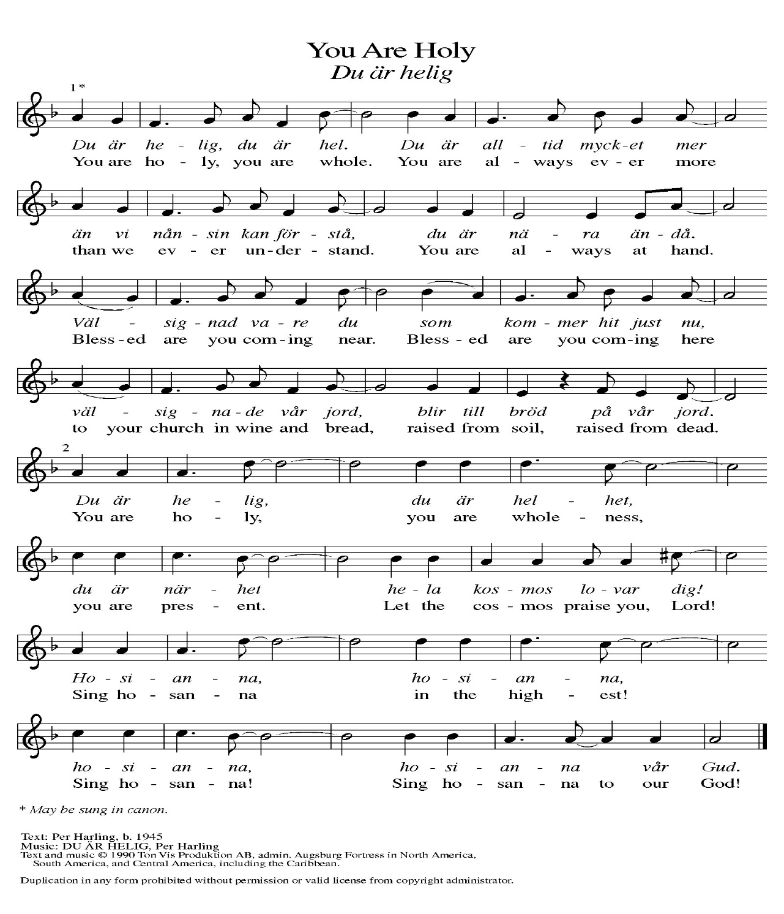
Prayer of the Day
Let us pray together.
Almighty God, we thank you for planting in us the seed of your word. By your Holy Spirit help us to receive it with joy, live according to it, and grow in faith and hope and love, through Jesus Christ, our Savior and Lord.

Amen.

First Reading Isaiah 55:10-13
A reading from Isaiah.
¹⁰ For as the rain and the snow come down from heaven
and do not return there until they have watered the earth,
making it bring forth and sprout,
giving seed to the sower and bread to the eater,
¹¹ so shall my word be that goes out from my mouth;
it shall not return to me empty,
but it shall accomplish that which I purpose
and succeed in the thing for which I sent it.
¹² For you shall go out in joy
and be led back in peace;
the mountains and the hills before you
shall burst into song,
and all the trees of the field shall clap their hands.
¹³ Instead of the thorn shall come up the cypress;
instead of the brier shall come up the myrtle,
and it shall be to the Lord for a memorial,
for an everlasting sign that shall not be cut off.

The word of the Lord.
Thanks be to God.

Psalm Psalm 65:[1-8] 9-13
¹ You are to be praised, O | God, in Zion;
to you shall vows | be fulfilled.
² To you, the one | who answers prayer,
to you all | flesh shall come.
³ Our sins are strong- | er than we are,
but you blot out | our transgressions.
⁴ Happy are they whom you choose and draw to your | courts to dwell there!
They will be satisfied by the beauty of your house, by the holiness | of your temple.
⁵ Awesome things will you show us in your righteousness, O God of | our salvation,
O hope of all the ends of the earth and of the oceans | far away.
⁶ You make firm the mountains | by your power;
you are girded a- | bout with might.
⁷ You still the roaring | of the seas,
the roaring of their waves, and the clamor | of the peoples.
⁸ Those who dwell at the ends of the earth will tremble at your | marvelous signs;
you make the dawn and the dusk to | sing for joy.
⁹ You visit the earth and water it abundantly; you make it very plenteous; the river of God is | full of water.
You prepare the grain, for so you provide | for the earth.
¹⁰ You drench the furrows and smooth | out the ridges;
with heavy rain you soften the ground and | bless its increase.
¹¹ You crown the year | with your goodness,
and your paths over- | flow with plenty.
¹² May the fields of the wilderness be | rich for grazing,
and the hills be | clothed with joy.
¹³ May the meadows cover themselves with flocks, and the valleys cloak them- | selves with grain;
let them shout for | joy and sing.

Second Reading Romans 8:1-11
A reading from Romans.
¹ Therefore there is now no condemnation for those who are in Christ Jesus. ² For the law of the Spirit of life in Christ Jesus has set you free from the law of sin and of death. ³ For God has done what the law, weakened by the flesh, could not do: by sending his own Son in the likeness of sinful flesh and to deal with sin, he condemned sin in the flesh, ⁴ so that the just requirement of the law might be fulfilled in us, who walk not according to the flesh but according to the Spirit. ⁵ For those who live according to the flesh set their minds on the things of the flesh, but those who live according to the Spirit set their minds on the things of the Spirit. ⁶ To set the mind on the flesh is death, but to set the mind on the Spirit is life and peace. ⁷ For this reason the mind that is set on the flesh is hostile to God; it does not submit to God’s law—indeed, it cannot, ⁸ and those who are in the flesh cannot please God.
⁹ But you are not in the flesh; you are in the Spirit, since the Spirit of God dwells in you. Anyone who does not have the Spirit of Christ does not belong to him. ¹⁰ But if Christ is in you, then the body is dead because of sin, but the Spirit is life because of righteousness. ¹¹ If the Spirit of him who raised Jesus from the dead dwells in you, he who raised Christ Jesus from the dead will give life to your mortal bodies also through his Spirit that dwells in you.

The Word of the Lord.
Thanks be to God.

Gospel Acclamation
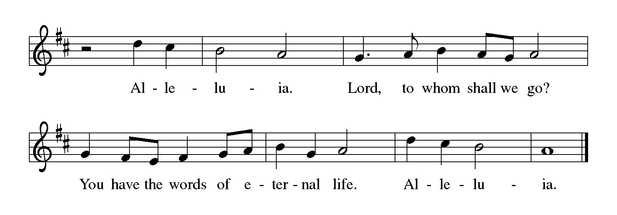

Gospel Matthew 13:1-9, 18-23
The holy gospel according to Matthew.
Glory to You, O Lord.
¹ That same day Jesus went out of the house and sat beside the sea. ² Such great crowds gathered around him that he got into a boat and sat there, while the whole crowd stood on the beach. ³ And he told them many things in parables, saying: “Listen! A sower went out to sow. ⁴ And as he sowed, some seeds fell on a path, and the birds came and ate them up. ⁵ Other seeds fell on rocky ground, where they did not have much soil, and they sprang up quickly, since they had no depth of soil. ⁶ But when the sun rose, they were scorched, and since they had no root, they withered away. ⁷ Other seeds fell among thorns, and the thorns grew up and choked them. ⁸ Other seeds fell on good soil and brought forth grain, some a hundredfold, some sixty, some thirty. ⁹ If you have ears, hear!”
¹⁸ “Hear, then, the parable of the sower. ¹⁹ When anyone hears the word of the kingdom and does not understand it, the evil one comes and snatches away what is sown in the heart; this is what was sown on the path. ²⁰ As for what was sown on rocky ground, this is the one who hears the word and immediately receives it with joy, ²¹ yet such a person has no root but endures only for a while, and when trouble or persecution arises on account of the word, that person immediately falls away. ²² As for what was sown among thorns, this is the one who hears the word, but the cares of this age and the lure of wealth choke the word, and it yields nothing. ²³ But as for what was sown on good soil, this is the one who hears the word and understands it, who indeed bears fruit and yields in one case a hundredfold, in another sixty, and in another thirty.”

The gospel of the Lord.
Praise to you, O Christ.

CHILDREN’S MOMENT
TESTIMONIAL Claude Smith
SERMON Pastor Ken Scheck

hymn of the day “As Rain From The Clouds” #508
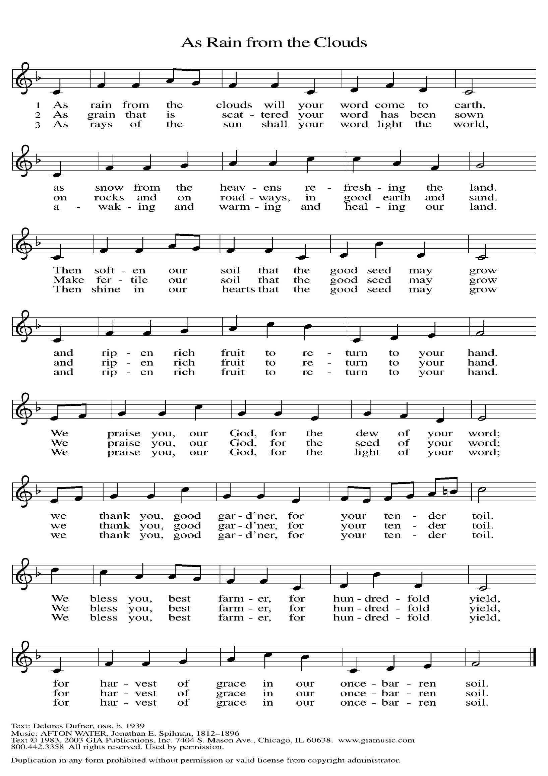

cREED
I believe in God, the Father almighty,
creator of heaven and earth.
I believe in Jesus Christ, God’s only Son, our Lord,
who was conceived by the Holy Spirit,
born of the virgin Mary,
suffered under Pontius Pilate,
was crucified, died, and was buried;
he descended to the dead.*
On the third day he rose again;
he ascended into heaven,
he is seated at the right hand of the Father,
and he will come to judge the living and the dead.
I believe in the Holy Spirit,
the holy catholic church,
the communion of saints,
the forgiveness of sins,
the resurrection of the body,
and the life everlasting. Amen.

*Or, “he descended into hell,” another translation of this text in widespread use.

prayers of Intercession (Please Be Seated)
Trusting in God’s steadfast love for all God has made, let us pray for the church, the world, and all of creation.
A brief silence.
God our gardener, you scatter grace like seed across the world. Continue to cultivate the garden of your church with your abundant Spirit. We Pray especially for Immanuel Lutheran in Suttons Bay, and their pastor Rev. Jonathan Reid.
God of grace,
hear our prayer.
God our joy, your bountiful creation reflects your commitment to life despite our actions disregarding its wonder. We look toward Isaiah’s vision, when all creation rejoices, and the trees will clap for joy at your salvation. God of grace,
hear our prayer.
God our life, you give us the same Spirit by which you raised Christ from the dead. Set our minds on that Spirit whenever fear or condemnation overwhelm throughout the world. God of grace,
hear our prayer.
God our host and table, we pray for children who hunger and rely on school meals, for all who toil under the hot sun without refreshment, for the chronically ill who have exhausted their resources, and for local concerns. We pray especially for all those on our prayer list and in our hearts.
God of grace,
hear our prayer.
God our source, tend this assembly with your grace throughout this summer season. May those who travel for work or recreation do so safely, and may visitors find refreshment among us. God of grace,
hear our prayer.
We give you thanks that the roots of your goodness run deep throughout history. We remember those saints who have gone before us in faith (especially Bishop Nathan Söderblom, whom the church commemorates today). God of grace,
hear our prayer.
Grateful for your abundant provision and trusting in your goodness, we cast all our cares upon you, through the abundant grace of Christ Jesus.
Amen.

PEACE
Sharing the Peace of God
The peace of the risen Christ be with you always.
And also with you.
(We share the peace of Christ with one another.)

OFFERING & OFFERING SONG
The joy of the Lord is my strength,
The joy of the Lord is my strength,
The joy of the Lord is my strength,
The joy of the Lord is my strength.

Offering Prayer
Let us pray.
Be known to us, O Lord, as you were made known to the disciples. Receive these gifts, and the offering of our lives, that we may be your risen body in the world.
Amen.

DIALOGUE
The Lord be with you.
And also with you.
Lift up your hearts.
We lift them to the Lord.
Let us give thanks to the Lord our God.
It is right to give our thanks and praise.

PREFACE (Pastor)
It is indeed right, our duty and our joy,
that we should at all times and in all places
give thanks and praise to you, almighty and merciful God,
through our Savior Jesus Christ;
who on this day overcame death and the grave,
and by his glorious resurrection opened to us the way of everlasting life.
And so, with all the choirs of angels,
with the church on earth and the hosts of heaven,
we praise your name and join their unending hymn

Holy, holy, holy
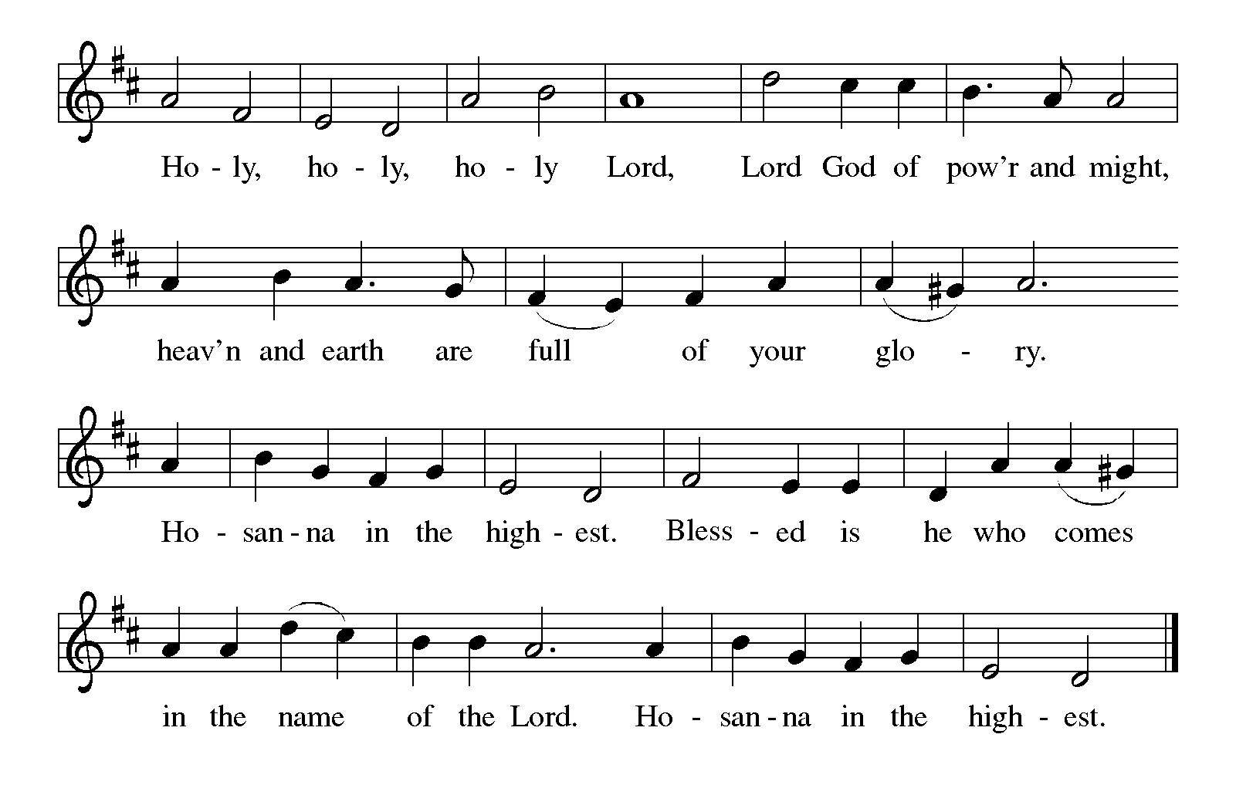

Thanksgiving at the Table
In the night in which he was betrayed,
our Lord Jesus took bread, and gave thanks;
broke it, and gave it to his disciples, saying:
Take and eat; this is my body, given for you.
Do this for the remembrance of me.

Again, after supper, he took the cup, gave thanks,
and gave it for all to drink, saying:
This cup is the new covenant in my blood,
shed for you and for all people for the forgiveness of sin.
Do this for the remembrance of me.

For as often as we eat of this bread and drink from this cup,
we proclaim the Lord’s death until he comes.

Christ has died. Christ is risen. Christ will come again.

Lord’s Prayer
Gathered into one by the Holy Spirit, let us pray as Jesus taught us.
Our Father, who art in heaven,
hallowed be thy name,
thy kingdom come,
thy will be done,
on earth as it is in heaven.
Give us this day our daily bread;
and forgive us our trespasses,
as we forgive those
who trespass against us;
and lead us not into temptation,
but deliver us from evil.
For thine is the kingdom,
and the power, and the glory,
forever and ever. Amen.

INVITATION TO COMMUNION
Come to the banquet, for all is now ready.

COMMUNION *continuous
*People are welcome to kneel at the altar rail for a time of prayer after they receive their communion elements.

COMMUNION HYMNS
“Lord, Let My Heart Be Good Soil” # 512
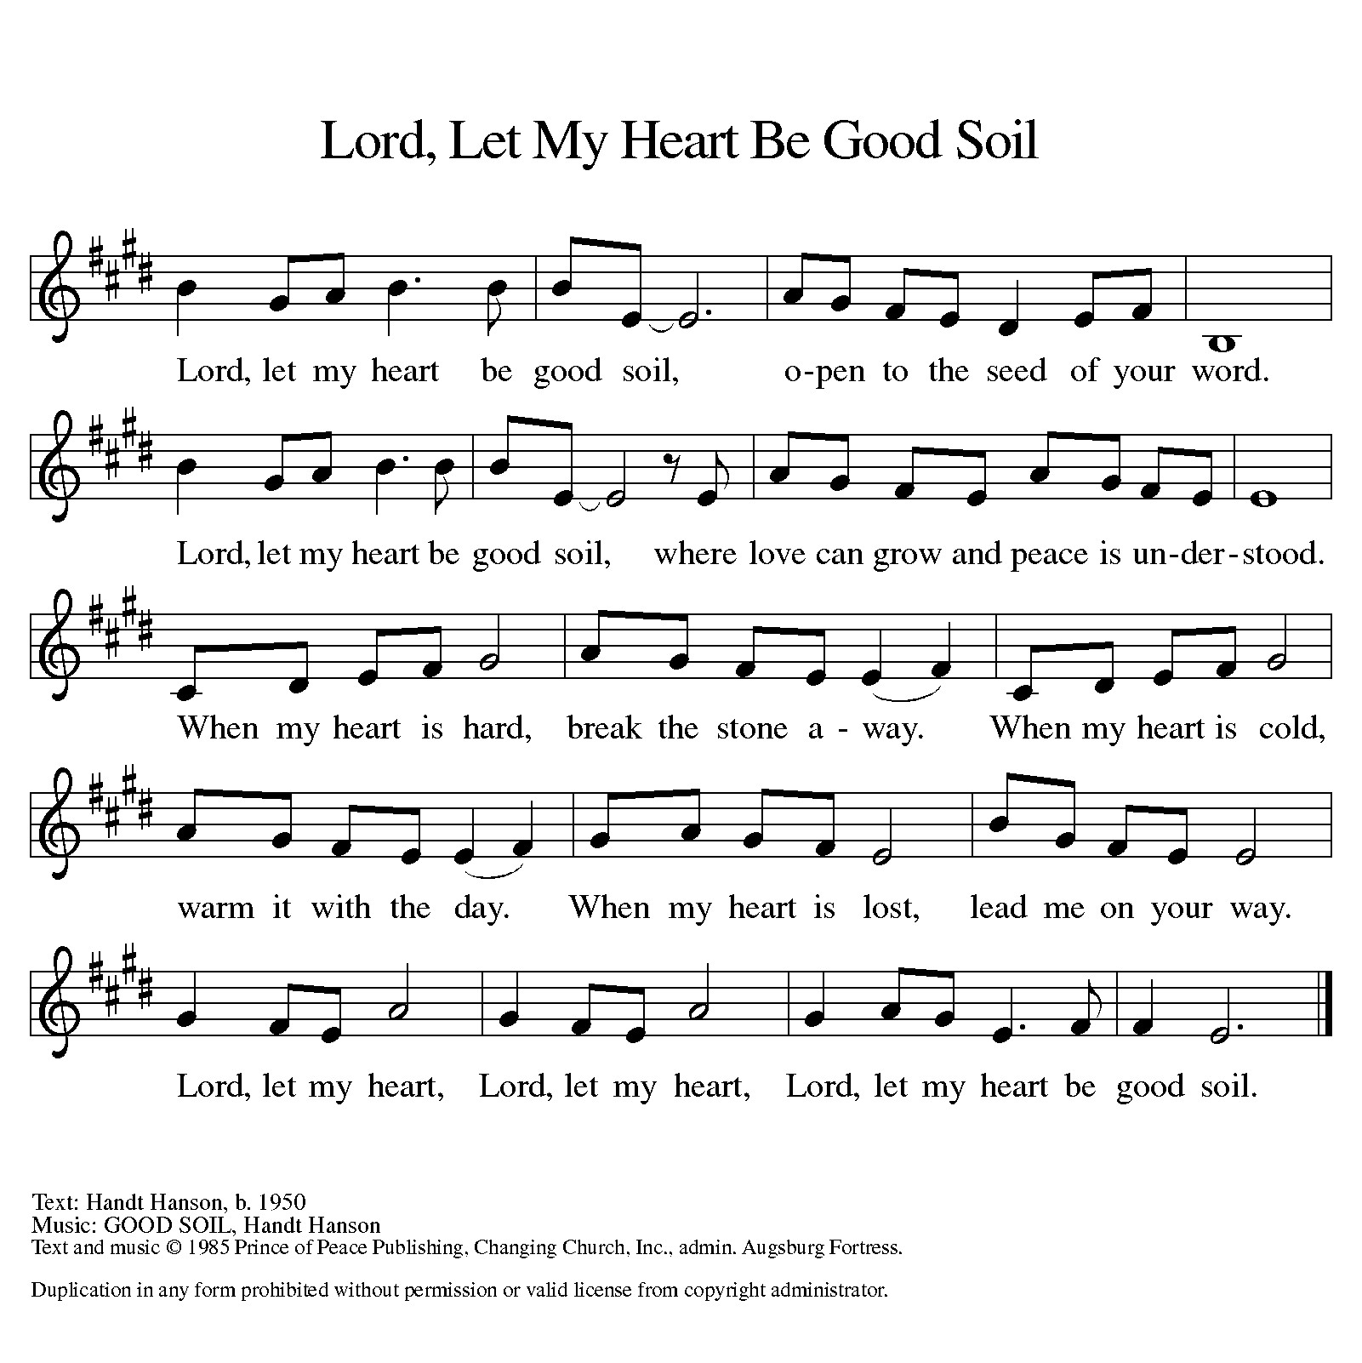

“As the Grains of Wheat” #465

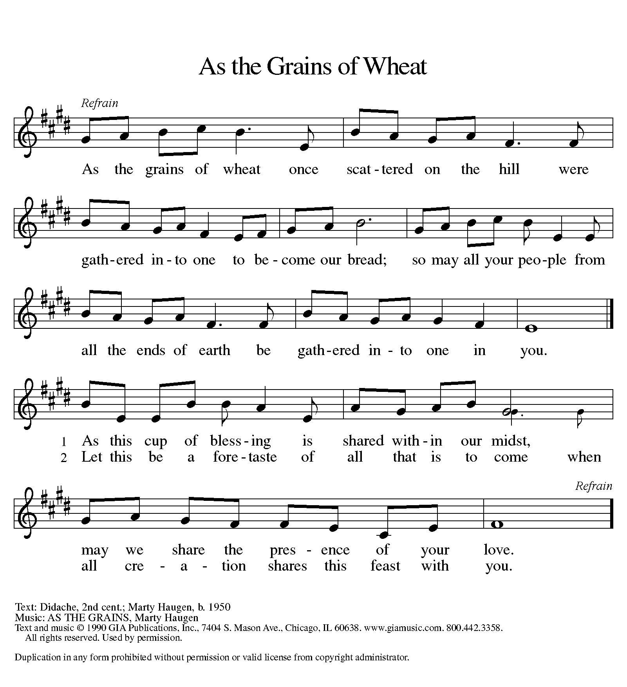

PRAYER AFTER COMMUNION
Let us pray.
We give you thanks, almighty God, that you have refreshed us through the healing power of this gift of life. In your mercy, strengthen us through this gift, in faith toward you and in fervent love toward one another; for the sake of Jesus Christ our Lord.
Amen.

Sending
God blesses us and sends us in mission to the world.

Blessing
The Lord bless you and keep you.
The Lord’s face shine on you with grace and mercy.
The Lord look upon you with favor and ☩ give you peace.
Amen.
Sending SonG “Sent Forth by God's Blessing” #547
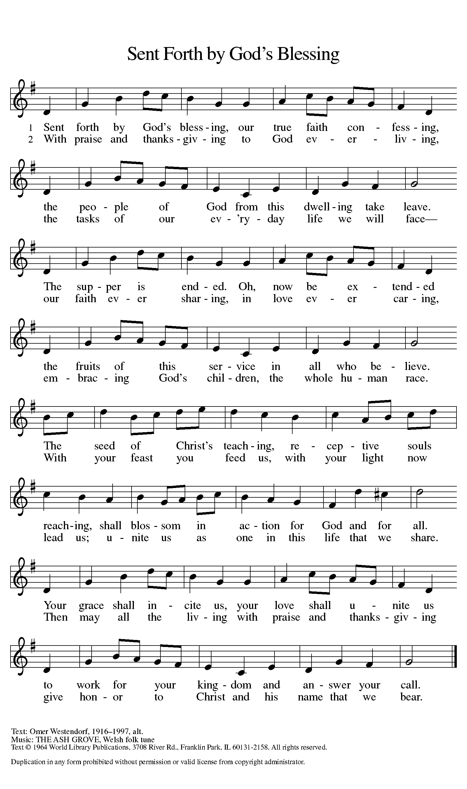

Dismissal
Go in peace. Christ is with you.
Thanks be to God.

From sundaysandseasons.com. Copyright © 2017 Augsburg Fortress. All rights reserved.

Thank you to all who served in worship today!
Presiders: Pastor Ken Scheck Musician: Martha Yoder
Acolyte: Safety Person:
Elder: Naomi Wilson Trustee: Jimmy Hindman
Offering Counters: Diane Griffin & Carlotta Willard



PRAYERS OF THE FAITHFUL

With thanks for all God’s blessings and his love for all people. Our Bishops, Julie Schneider-Thomas, Yehiel Curry, and the congregations of the North/West Lower Michigan Synod, and especially Immanuel Lutheran in Suttons Bay, and their pastor Rev. Jonathan Reid.

Prayers for our friends, for all who are sick or hospitalized and for all health care workers who care for them. All those members of Zion’s family traveling; all those homebound or in frail health; all those suffering with quiet, unknown needs or worries. For those who serve on our behalf: public safety, utility workers, medical personnel, military personnel. For those who might be forgotten.

This week at Zion:
- Men’s Breakfast at 8am, Wednesday 15th
- Bulletin Deadline, Wednesday 15th

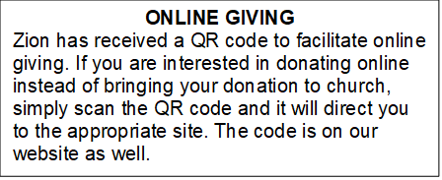

How to Contact the Pastor: If there is a pastoral need, please contact
Pastor Ken Scheck II at 269-370-4632 or by email at kscheckii@aol.com.

ANNOUNCEMENTS

- Thank You: A huge thank you to everyone who helped at my dad’s funeral. The food and decorations were great. It is a blessing to have such organized hardworking church members. Thank you for helping to make that day less stressful. The Hazel Family.
- Semi-Annual Meeting, July 19: The semi-annual meeting will be immediately following worship on July 19th. There are several important issues to be considered at the meeting. The congregation will vote on replacing carpet in the mailbox area, the ladies lounge and the men’s lounge. The congregation will also vote on adopting new bi-laws for Zion. In addition, the future of the parsonage will be considered. Please plan to attend this important meeting.
- Annual Volunteer Appreciation Lunch: The annual volunteer appreciation lunch will be immediately following the semi-annual meeting. Please plan to stay for this special time of recognition and fellowship. The lunch is hosted by the Board of Evangelism.
- Pastor’s Availability: Pastor Ken Scheck II is available by appointment to meet with you. As you know homebound visitation has begun and will continue until all homebound have been visited by Pastor Ken. Generally speaking, he is at Grace on Mondays and Wednesdays and Zion on Tuesdays and Thursdays with a day off on Friday. As you may be aware, Pastor Ken has come to the Men’s meeting and Lakewood Area Ministerial Association meetings on Wednesday here at Zion. Flexibility is the name of the game. He is more than willing to be contacted at any time by cellphone or email. Please feel free to contact him at 269-370-4632 or at kscheckii@aol.com. You are able to send a text to the cellphone, but please identify yourself at least the first time.
- Zion Coffee Cups: The Board of Evangelism has purchased coffee cups with the Zion logo on them to use for outreach. The mugs are also available for purchase. There is one on display on the table in the narthex. The mugs are a great 16-ounce size and they’re being sold for $10 each. All proceeds will be used for evangelism ministries. If you would like to purchase a mug, please see Karen, Martha, or Ruth,
- Note from the Board of Stewardship: Our congregation continues to grow in its mission to share Christ’s love in our community. As we look ahead to the coming months, we will be facing a shortfall in our operating budget. If you are able, we invite you to consider an additional gift to support our worship, outreach, and care ministries. Every contribution, large or small, strengthens the work we do together in Christ’s name. Thank you for your faithful generosity.
- Announcement and Newsletter Items: Please forward items for the bulletin announcements and the newsletter to the church email (Office@Zion.org). Please do not send items to people’s personal emails. Thank you.
- Door Locking Policy: Our door locking policy relies on having a volunteer(s) each Sunday to serve as the Safety Person of the Day. On Sundays where no one has volunteered, if someone arrives at church and is willing to be the Safety Person of the Day, we will follow the door locking policy. If no one steps forward to serve as the Safety Person of the Day, the doors will not be locked. Please consider volunteering for this important duty.

