ZION LUTHERAN CHURCH, WOODLAND, MI
Eighth Sunday After Pentecost, Sunday July 19, 2026
*If you are listening in your car, please tune your radio to FM 87.7*
(Please silence your cell phones while in the sanctuary. Thank you.)



WELCOME AND ANNOUNCEMENTS

Gathering
The Holy Spirit calls us together as the people of God.

Confession and Forgiveness
In the name of the Father,
and of the ☩ Son,
and of the Holy Spirit.
Amen.

Almighty God, to whom all hearts are open, all desires known, and from whom no secrets are hid: cleanse the thoughts of our hearts by the inspiration of your Holy Spirit, that we may perfectly love you and worthily magnify your holy name, through Jesus Christ our Lord.
Amen.

Let us confess our sin in the presence of God and of one another. Most merciful God,
we confess that we are captive to sin and cannot free ourselves. We have sinned against you in thought, word, and deed, by what we have done and by what we have left undone. We have not loved you with our whole heart; we have not loved our neighbors as ourselves. For the sake of your Son, Jesus Christ, have mercy on us. Forgive us, renew us, and lead us, so that we may delight in your will and walk in your ways, to the glory of your holy name.
Amen.
God, who is rich in mercy, loved us even when we were dead in sin, and made us alive together with Christ. By grace you have been saved. In the name of ☩ Jesus Christ, your sins are forgiven. Almighty God strengthen you with power through the Holy Spirit, that Christ may live in your hearts through faith.
Amen.

Opening
O Lord, open our lips,
and our mouths shall proclaim your praise.
Blessed God, satisfy us in the morning with your steadfast love,
that we may rejoice and be glad in all our days.
Give praise to the Holy Trinity our true God,
who gives us life, salvation, and resurrection.
“You Are Holy” #525
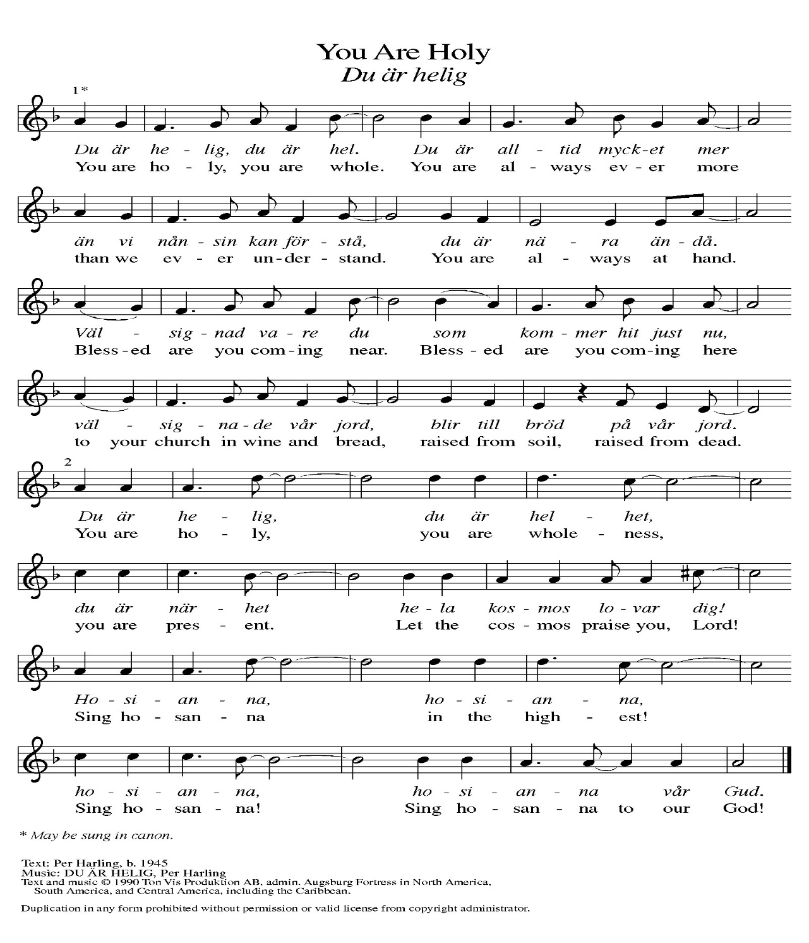

Prayer of the Day
Let us pray together.
Faithful God, most merciful judge, you care for your children with firmness and compassion. By your Spirit nurture us who live in your kingdom, that we may be rooted in the way of your Son, Jesus Christ, our Savior and Lord.

Amen.

First Reading Isaiah 44:6-8
A reading from Isaiah.
⁶ Thus says the Lord, the King of Israel,
and his Redeemer, the Lord of hosts:
I am the first, and I am the last;
besides me there is no god.
⁷ Who is like me? Let them proclaim it;
let them declare and set it forth before me.
Who has announced from of old the things to come?
Let them tell us what is yet to be.
⁸ Do not fear or be afraid;
have I not told you from of old and declared it?
You are my witnesses!
Is there any god besides me?
There is no other rock; I know not one.

The word of the Lord.
Thanks be to God.

Psalm Psalm 86:11-17

Teach me your way, O Lord, and I will walk in your truth. (Ps. 86:11)
¹¹ Teach me your way, O Lord, and I will walk | in your truth;
give me an undivided heart to re- | vere your name.
¹² I will thank you, O Lord my God, with | all my heart,
and glorify your name for- | evermore.
¹³ For great is your | love toward me;
you have delivered me from the | pit of death.
¹⁴ The arrogant rise up against me, O God, and a band of violent people | seeks my life;
they have not set you be- | fore their eyes.
¹⁵ But you, O Lord, are gracious and full | of compassion,
slow to anger, and full of kind- | ness and truth.
¹⁶ Turn to me and have mer- | cy on me;
give your strength to your servant, and save the child | of your handmaid.
¹⁷ Show me a sign of your favor, so that those who hate me may see it and be | put to shame;
because you, Lord, have helped me and com- | forted me.

Second Reading Romans 8:12-25
A reading from Romans.
¹² So then, brothers and sisters, we are obligated, not to the flesh, to live according to the flesh—¹³ for if you live according to the flesh, you will die, but if by the Spirit you put to death the deeds of the body, you will live. ¹⁴ For all who are led by the Spirit of God are children of God. ¹⁵ For you did not receive a spirit of slavery to fall back into fear, but you received a spirit of adoption. When we cry, “Abba! Father!” ¹⁶ it is that very Spirit bearing witness with our spirit that we are children of God, ¹⁷ and if children, then heirs: heirs of God and joint heirs with Christ, if we in fact suffer with him so that we may also be glorified with him.
¹⁸ I consider that the sufferings of this present time are not worth comparing with the glory about to be revealed to us. ¹⁹ For the creation waits with eager longing for the revealing of the children of God, ²⁰ for the creation was subjected to futility, not of its own will, but by the will of the one who subjected it, in hope ²¹ that the creation itself will be set free from its enslavement to decay and will obtain the freedom of the glory of the children of God. ²² We know that the whole creation has been groaning together as it suffers together the pains of labor, ²³ and not only the creation, but we ourselves, who have the first fruits of the Spirit, groan inwardly while we wait for adoption, the redemption of our bodies. ²⁴ For in hope we were saved. Now hope that is seen is not hope, for who hopes for what one already sees? ²⁵ But if we hope for what we do not see, we wait for it with patience.

The Word of the Lord.
Thanks be to God.

Gospel Acclamation
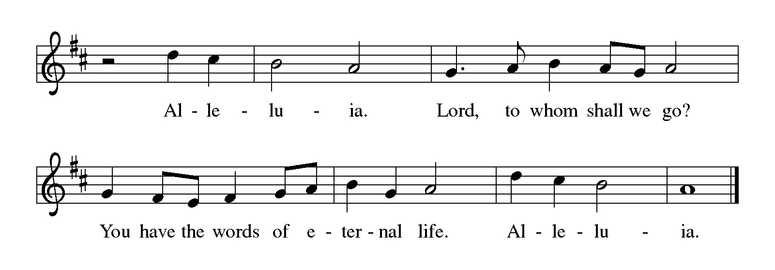

Gospel Matthew 13:24-30, 36-43
The holy gospel according to Matthew.
Glory to You, O Lord.
²⁴ [Jesus] put before [the crowds] another parable: “The kingdom of heaven may be compared to someone who sowed good seed in his field,²⁵ but while everybody was asleep an enemy came and sowed weeds among the wheat and then went away. ²⁶ So when the plants came up and bore grain, then the weeds appeared as well. ²⁷ And the slaves of the householder came and said to him, ‘Master, did you not sow good seed in your field? Where, then, did these weeds come from?’ ²⁸ He answered, ‘An enemy has done this.’ The slaves said to him, ‘Then do you want us to go and gather them?’ ²⁹ But he replied, ‘No, for in gathering the weeds you would uproot the wheat along with them. ³⁰ Let both of them grow together until the harvest, and at harvest time I will tell the reapers, Collect the weeds first and bind them in bundles to be burned, but gather the wheat into my barn.’ ”
³⁶ Then he left the crowds and went into the house. And his disciples approached him, saying, “Explain to us the parable of the weeds of the field.” ³⁷ He answered, “The one who sows the good seed is the Son of Man; ³⁸ the field is the world, and the good seed are the children of the kingdom; the weeds are the children of the evil one, ³⁹ and the enemy who sowed them is the devil; the harvest is the end of the age, and the reapers are angels. ⁴⁰ Just as the weeds are collected and burned up with fire, so will it be at the end of the age. ⁴¹ The Son of Man will send his angels, and they will collect out of his kingdom all causes of sin and all evildoers, ⁴² and they will throw them into the furnace of fire, where there will be weeping and gnashing of teeth. ⁴³ Then the righteous will shine like the sun in the kingdom of their Father. Let anyone with ears listen!”

The gospel of the Lord.
Praise to you, O Christ.

CHILDREN’S MOMENT
TESTIMONIAL Buffy Meyers
SERMON Pastor Ken Scheck

hymn of the day “For The Fruit Of All Creation ” #679

cREED
I believe in God, the Father almighty,
creator of heaven and earth.
I believe in Jesus Christ, God’s only Son, our Lord,
who was conceived by the Holy Spirit,
born of the virgin Mary,
suffered under Pontius Pilate,
was crucified, died, and was buried;
he descended to the dead.*
On the third day he rose again;
he ascended into heaven,
he is seated at the right hand of the Father,
and he will come to judge the living and the dead.
I believe in the Holy Spirit,
the holy catholic church,
the communion of saints,
the forgiveness of sins,
the resurrection of the body,
and the life everlasting. Amen.

*Or, “he descended into hell,” another translation of this text in widespread use.

prayers of Intercession (Please Be Seated)
Trusting in God’s steadfast love for all God has made, let us pray for the church, the world, and all of creation.
A brief silence.
God our source, protect your church from those who sow weeds among the wheat. Where we trade grace for judgment, restore us, and where we get lost among the complexities of life, guide us. We pray especially for St. John’s Lutheran in Three Rivers, and their pastor Rev. Vicky Blough.
God of grace,
hear our prayer.
God our creator, sustain creation in places not easily seen; the depths of oceans, microscopic plants and animals, galaxies beyond our own. May we share earth’s dedication to hope for what we do not yet see. God of grace,
hear our prayer.
God our soil, we yearn to live on your lands and waters with justice and in righteousness. Renew the hearts of all in authority, that our leaders guide wisely toward the flourishing of all. God of grace,
hear our prayer.
God our rock, be a source of constancy for those whose lives have been uprooted by war, eviction, global climate change, unemployment, harassment, false witness to their character, or illness or injury. We pray especially for all those on our prayer list and in our hearts. God of grace,
hear our prayer.
God our teacher, guide and provide for all summer camp staff and campers, daycare professionals, librarians, summer school educators and coaches, teachers preparing for the coming academic year, and youth becoming first-time babysitters. God of grace,
hear our prayer.
Here other intercessions may be offered.
God our hope, the message of your salvation is planted among us in all times and places. We give you thanks for the witness of all the saints who shine like the sun in your presence. God of grace,
hear our prayer.
Grateful for your abundant provision and trusting in your goodness, we cast all our cares upon you, through the abundant grace of Christ Jesus.
Amen.

PEACE
Sharing the Peace of God
The peace of the risen Christ be with you always.
And also with you.
(We share the peace of Christ with one another.)

OFFERING & OFFERING SONG
The joy of the Lord is my strength,
The joy of the Lord is my strength,
The joy of the Lord is my strength,
The joy of the Lord is my strength.

Offering Prayer
Let us pray.
Be known to us, O Lord, as you were made known to the disciples. Receive these gifts, and the offering of our lives, that we may be your risen body in the world.
Amen.

DIALOGUE
The Lord be with you.
And also with you.
Lift up your hearts.
We lift them to the Lord.
Let us give thanks to the Lord our God.
It is right to give our thanks and praise.
PREFACE (Pastor)
It is indeed right, our duty and our joy,
that we should at all times and in all places
give thanks and praise to you, almighty and merciful God,
through our Savior Jesus Christ;
who on this day overcame death and the grave,
and by his glorious resurrection opened to us the way of everlasting life.
And so, with all the choirs of angels,
with the church on earth and the hosts of heaven,
we praise your name and join their unending hymn

Holy, holy, holy
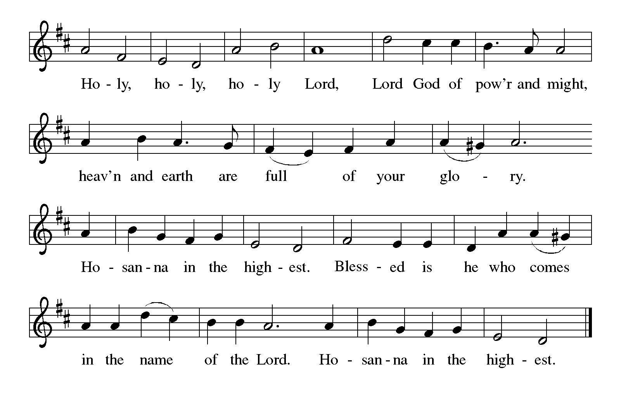
Thanksgiving at the Table
In the night in which he was betrayed,
our Lord Jesus took bread, and gave thanks;
broke it, and gave it to his disciples, saying:
Take and eat; this is my body, given for you.
Do this for the remembrance of me.

Again, after supper, he took the cup, gave thanks,
and gave it for all to drink, saying:
This cup is the new covenant in my blood,
shed for you and for all people for the forgiveness of sin.
Do this for the remembrance of me.

For as often as we eat of this bread and drink from this cup,
we proclaim the Lord’s death until he comes.

Christ has died. Christ is risen. Christ will come again.

Lord’s Prayer
Gathered into one by the Holy Spirit, let us pray as Jesus taught us.
Our Father, who art in heaven,
hallowed be thy name,
thy kingdom come,
thy will be done,
on earth as it is in heaven.
Give us this day our daily bread;
and forgive us our trespasses,
as we forgive those
who trespass against us;
and lead us not into temptation,
but deliver us from evil.
For thine is the kingdom,
and the power, and the glory,
forever and ever. Amen.

INVITATION TO COMMUNION
Come to the banquet, for all is now ready.

COMMUNION *continuous
*People are welcome to kneel at the altar rail for a time of prayer after they receive their communion elements.

COMMUNION HYMNS
“Praise and Thanksgiving” # 689
“We Place upon Your Table, Lord” #467

PRAYER AFTER COMMUNION
Let us pray.
We give you thanks, almighty God, that you have refreshed us through the healing power of this gift of life. In your mercy, strengthen us through this gift, in faith toward you and in fervent love toward one another; for the sake of Jesus Christ our Lord.
Amen.

Sending
God blesses us and sends us in mission to the world.

Blessing
The Lord bless you and keep you.
The Lord’s face shine on you with grace and mercy.
The Lord look upon you with favor and ☩ give you peace.
Amen.
Sending SonG “Almighty God, Your Word Is Cast” #516

Dismissal
Go in peace. Christ is with you.
Thanks be to God.

From sundaysandseasons.com. Copyright © 2017 Augsburg Fortress. All rights reserved.

Thank you to all who served in worship today!
Presiders: Pastor Ken Scheck Musician: Martha Yoder
Acolyte: Kole Hokanson Safety Person:
Elder: Dan Utterback Trustee: Mike Johnson
Offering Counters: Paul Meade & Carlotta Willard



PRAYERS OF THE FAITHFUL

With thanks for all God’s blessings and his love for all people. Our Bishops, Julie Schneider-Thomas, Yehiel Curry, and the congregations of the North/West Lower Michigan Synod, and especially St. John’s Lutheran in Three Rivers, and their pastor Rev. Vicky Blough.

Prayers for our friends, for all who are sick or hospitalized and for all health care workers who care for them. All those members of Zion’s family traveling; all those homebound or in frail health; all those suffering with quiet, unknown needs or worries. For those who serve on our behalf: public safety, utility workers, medical personnel, military personnel. For those who might be forgotten.

This week at Zion:
- Men’s Breakfast at 8am, Wednesday 22nd
- Bulletin Deadline, Wednesday 22nd

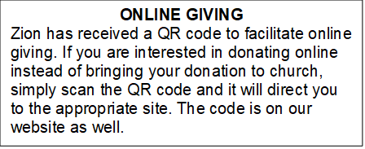

How to Contact the Pastor: If there is a pastoral need, please contact
Pastor Ken Scheck II at 269-370-4632 or by email at kscheckii@aol.com.

ANNOUNCEMENTS

- Thank You: A huge thank you to everyone who helped at my dad’s funeral. The food and decorations were great. It is a blessing to have such organized hardworking church members. Thank you for helping to make that day less stressful. The Hazel Family.
- Semi-Annual Meeting, July 19: The semi-annual meeting will be immediately following worship on July 19th. There are several important issues to be considered at the meeting. The congregation will vote on replacing carpet in the mailbox area, the ladies lounge and the men’s lounge. The congregation will also vote on adopting new bi-laws for Zion. In addition, the future of the parsonage will be considered. Please plan to attend this important meeting.
- Annual Volunteer Appreciation Lunch: The annual volunteer appreciation lunch will be immediately following the semi-annual meeting. Please plan to stay for this special time of recognition and fellowship. The lunch is hosted by the Board of Evangelism.
- Pastor’s Availability: Pastor Ken Scheck II is available by appointment to meet with you. As you know homebound visitation has begun and will continue until all homebound have been visited by Pastor Ken. Generally speaking, he is at Grace on Mondays and Wednesdays and Zion on Tuesdays and Thursdays with a day off on Friday. As you may be aware, Pastor Ken has come to the Men’s meeting and Lakewood Area Ministerial Association meetings on Wednesday here at Zion. Flexibility is the name of the game. He is more than willing to be contacted at any time by cellphone or email. Please feel free to contact him at 269-370-4632 or at kscheckii@aol.com. You are able to send a text to the cellphone, but please identify yourself at least the first time.
- Zion Coffee Cups: The Board of Evangelism has purchased coffee cups with the Zion logo on them to use for outreach. The mugs are also available for purchase. There is one on display on the table in the narthex. The mugs are a great 16-ounce size and they’re being sold for $10 each. All proceeds will be used for evangelism ministries. If you would like to purchase a mug, please see Karen, Martha, or Ruth,
- Announcement and Newsletter Items: Please forward items for the bulletin announcements and the newsletter to the church email (Office@Zion.org). Please do not send items to people’s personal emails. Thank you.
- Door Locking Policy: Our door locking policy relies on having a volunteer(s) each Sunday to serve as the Safety Person of the Day. On Sundays where no one has volunteered, if someone arrives at church and is willing to be the Safety Person of the Day, we will follow the door locking policy. If no one steps forward to serve as the Safety Person of the Day, the doors will not be locked. Please consider volunteering for this important duty.

