ZION LUTHERAN CHURCH, WOODLAND, MI
Sixth Sunday After Pentecost, Sunday July 5, 2026
*If you are listening in your car, please tune your radio to FM 87.7*
(Please silence your cell phones while in the sanctuary. Thank you.)



WELCOME AND ANNOUNCEMENTS

Gathering
The Holy Spirit calls us together as the people of God.

Confession and Forgiveness
In the name of the Father,
and of the ☩ Son,
and of the Holy Spirit.
Amen.

Almighty God, to whom all hearts are open, all desires known, and from whom no secrets are hid: cleanse the thoughts of our hearts by the inspiration of your Holy Spirit, that we may perfectly love you and worthily magnify your holy name, through Jesus Christ our Lord.
Amen.

Let us confess our sin in the presence of God and of one another. Most merciful God,
we confess that we are captive to sin and cannot free ourselves. We have sinned against you in thought, word, and deed, by what we have done and by what we have left undone. We have not loved you with our whole heart; we have not loved our neighbors as ourselves. For the sake of your Son, Jesus Christ, have mercy on us. Forgive us, renew us, and lead us, so that we may delight in your will and walk in your ways, to the glory of your holy name.
Amen.

God, who is rich in mercy, loved us even when we were dead in sin, and made us alive together with Christ. By grace you have been saved. In the name of ☩ Jesus Christ, your sins are forgiven. Almighty God strengthen you with power through the Holy Spirit, that Christ may live in your hearts through faith.
Amen.

Opening
O Lord, open our lips,
and our mouths shall proclaim your praise.
Blessed God, satisfy us in the morning with your steadfast love,
that we may rejoice and be glad in all our days.
Give praise to the Holy Trinity our true God,
who gives us life, salvation, and resurrection.

“You Are Holy” #525

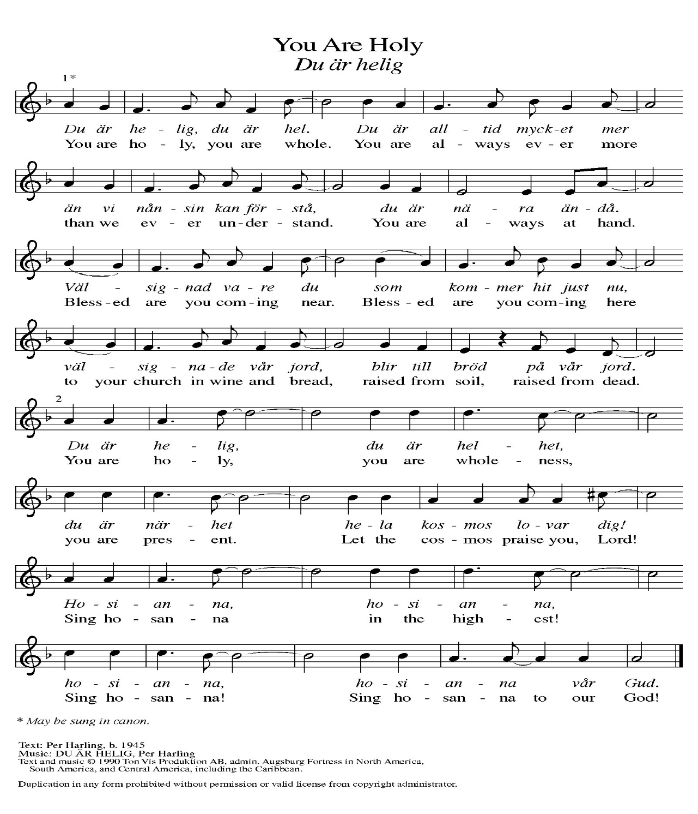
Prayer of the Day
Let us pray together.
You are great, O God, and greatly to be praised. You have made us for yourself, and our hearts are restless until they rest in you. Grant that we may believe in you, call upon you, know you, and serve you, through your Son, Jesus Christ, our Savior and Lord.
Amen.

First Reading Zechariah 9:9-12
A reading from Jeremiah.
⁹ Rejoice greatly, O daughter Zion!
Shout aloud, O daughter Jerusalem!
See, your king comes to you;
triumphant and victorious is he,
humble and riding on a donkey,
on a colt, the foal of a donkey.
¹⁰ He will cut off the chariot from Ephraim
and the war horse from Jerusalem;
and the battle bow shall be cut off,
and he shall command peace to the nations;
his dominion shall be from sea to sea
and from the River to the ends of the earth.
¹¹ As for you also, because of the blood of my covenant with you,
I will set your prisoners free from the waterless pit.
¹² Return to your stronghold, O prisoners of hope;
today I declare that I will restore to you double.
The word of the Lord.
Thanks be to God.

Psalm Psalm 145:8-14

⁸ The Lord is gracious and full | of compassion,
slow to anger and abounding in | steadfast love.
⁹ Lord, you are | good to all,
and your compassion is over | all your works.
¹⁰ All your works shall praise | you, O Lord,
and your faithful | ones shall bless you.
¹¹ They shall tell of the glory | of your kingdom
and speak | of your power,
¹² that all people may know | of your power
and the glorious splendor | of your kingdom.
¹³ Your kingdom is an everlasting kingdom; your dominion endures through- | out all ages.
You, Lord, are faithful in all your words, and loving in | all your works.
¹⁴ The Lord upholds all | those who fall
and lifts up those who | are bowed down.

Second Reading Romans 7:15-25a
A reading from Romans.
¹⁵ I do not understand my own actions. For I do not do what I want, but I do the very thing I hate. ¹⁶ Now if I do what I do not want, I agree that the law is good. ¹⁷ But in fact it is no longer I who do it but sin that dwells within me. ¹⁸ For I know that the good does not dwell within me, that is, in my flesh. For the desire to do the good lies close at hand, but not the ability. ¹⁹ For I do not do the good I want, but the evil I do not want is what I do. ²⁰ Now if I do what I do not want, it is no longer I who do it but sin that dwells within me.
²¹ So I find it to be a law that, when I want to do what is good, evil lies close at hand. ²² For I delight in the law of God in my inmost self, ²³ but I see in my members another law at war with the law of my mind, making me captive to the law of sin that dwells in my members. ²⁴ Wretched person that I am! Who will rescue me from this body of death? ^{25a} Thanks be to God through Jesus Christ our Lord!

The Word of the Lord.
Thanks be to God.

Gospel Acclamation
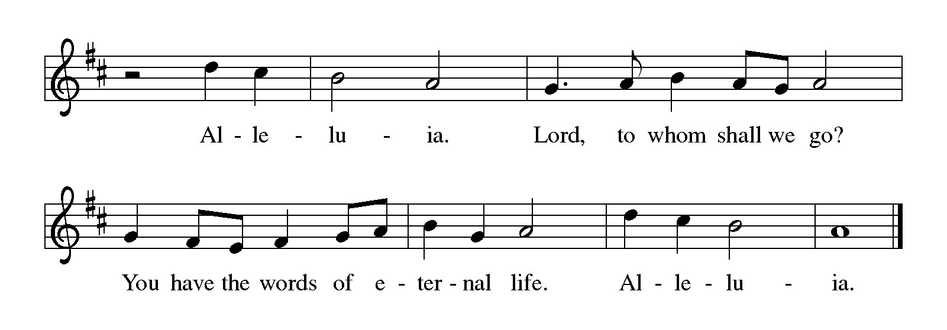

Gospel Matthew 11:16-19, 25-30
The holy gospel according to Matthew.
Glory to You, O Lord.
[Jesus spoke to the crowd saying:] ¹⁶ “To what will I compare this generation? It is like children sitting in the marketplaces and calling to one another,
¹⁷ ‘We played the flute for you, and you did not dance;
we wailed, and you did not mourn.’
¹⁸ “For John came neither eating nor drinking, and they say, ‘He has a demon’; ¹⁹ the Son of Man came eating and drinking, and they say, ‘Look, a glutton and a drunkard, a friend of tax collectors and sinners!’ Yet wisdom is vindicated by her deeds.”
²⁵ At that time Jesus said, “I thank you, Father, Lord of heaven and earth, because you have hidden these things from the wise and the intelligent and have revealed them to infants; ²⁶ yes, Father, for such was your gracious will. ²⁷ All things have been handed over to me by my Father, and no one knows the Son except the Father, and no one knows the Father except the Son and anyone to whom the Son chooses to reveal him.
²⁸ “Come to me, all you who are weary and are carrying heavy burdens, and I will give you rest. ²⁹ Take my yoke upon you, and learn from me, for I am gentle and humble in heart, and you will find rest for your souls. ³⁰ For my yoke is easy, and my burden is light.”

The gospel of the Lord.
Praise to you, O Christ.

CHILDREN’S MOMENT
TESTIMONIAL Cindy Utterback
SERMON Pastor Ken Scheck

hymn of the day “Softly And Tenderly Jesus Is Calling” #608

cREED
I believe in God, the Father almighty,
creator of heaven and earth.
I believe in Jesus Christ, God’s only Son, our Lord,
who was conceived by the Holy Spirit,
born of the virgin Mary,
suffered under Pontius Pilate,
was crucified, died, and was buried;
he descended to the dead.*
On the third day he rose again;
he ascended into heaven,
he is seated at the right hand of the Father,
and he will come to judge the living and the dead.
I believe in the Holy Spirit,
the holy catholic church,
the communion of saints,
the forgiveness of sins,
the resurrection of the body,
and the life everlasting. Amen.

*Or, “he descended into hell,” another translation of this text in widespread use.

prayers of Intercession (Please Be Seated)
Trusting in God’s steadfast love for all God has made, let us pray for the church, the world, and all of creation.
A brief silence.
Gathering God, send your Spirit on the church you have called out from every nation. Knit us together into one body and heal the divisions we have caused. Overcome our timidity to witness and act in the public square when your purpose is being thwarted. Bless rostered and lay leaders with clarity and courage as they center your people in the gospel. God of grace,
hear our prayer.
All your works praise you, O God. From the Arctic to the Caribbean, from the Atlantic to the western islands, these lands and waters have sustained its peoples over many centuries. As we take our part in creation’s praise, revive our wonder at what you have fashioned, and enliven our will to ensure its health for future generations. God of grace,
hear our prayer.
Holy Trinity, you show us the splendor of diversity and the beauty of unity in your own divine life. We come from many nations with many languages; make us a united people that delights in our many different gifts. As the United States of America marks its declaration of independence, give those whom we have entrusted with authority the spirit of wisdom, and curb every abuse of that trust, so that both here and abroad, justice, humility, and peace may flourish. God of grace,
hear our prayer.
You are the Mother of exiles, O God. Extend your arms to all who are tired, who live with poverty, the tempest-tossed, all who yearn to breathe free. Embrace people seeking refuge; those incarcerated, detained, or disappeared; and neighbors fearing those they once trusted. Give healing and hope to people in any oppression and need, especially these we name before you now. We pray especially for all those on our prayer list and in our hearts. God of grace,
hear our prayer.
We remember before you those who have died in every generation: Jan Hus, executed for protesting the ecclesial system; Benedict, teacher of a prayerful life; and those who have died ensuring the freedoms of this country: people in the armed services, peace officers, advocates, and activists. Gather us, together with those who have gone before us, and with saints of every tribe and nation, into the holy city you have prepared. God of grace,
hear our prayer.
Into your mercy, O God, we entrust our restless hearts and all our cares, through Jesus Christ, our Savior.
Amen.

PEACE
Sharing the Peace of God
The peace of the risen Christ be with you always.
And also with you.
(We share the peace of Christ with one another.)

OFFERING & OFFERING SONG
The joy of the Lord is my strength,
The joy of the Lord is my strength,
The joy of the Lord is my strength,
The joy of the Lord is my strength.

Offering Prayer
Let us pray.
Be known to us, O Lord, as you were made known to the disciples. Receive these gifts, and the offering of our lives, that we may be your risen body in the world.
Amen.

DIALOGUE
The Lord be with you.
And also with you.
Lift up your hearts.
We lift them to the Lord.
Let us give thanks to the Lord our God.
It is right to give our thanks and praise.

PREFACE (Pastor)
It is indeed right, our duty and our joy,
that we should at all times and in all places
give thanks and praise to you, almighty and merciful God,
through our Savior Jesus Christ;
who on this day overcame death and the grave,
and by his glorious resurrection opened to us the way of everlasting life.
And so, with all the choirs of angels,
with the church on earth and the hosts of heaven,
we praise your name and join their unending hymn

Holy, holy, holy
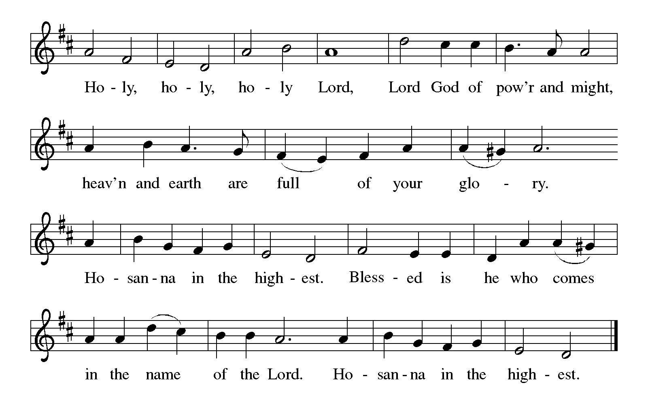

Thanksgiving at the Table
In the night in which he was betrayed,
our Lord Jesus took bread, and gave thanks;
broke it, and gave it to his disciples, saying:
Take and eat; this is my body, given for you.
Do this for the remembrance of me.

Again, after supper, he took the cup, gave thanks,
and gave it for all to drink, saying:
This cup is the new covenant in my blood,
shed for you and for all people for the forgiveness of sin.
Do this for the remembrance of me.

For as often as we eat of this bread and drink from this cup,
we proclaim the Lord’s death until he comes.

Christ has died. Christ is risen. Christ will come again.

Lord’s Prayer
Gathered into one by the Holy Spirit, let us pray as Jesus taught us.
Our Father, who art in heaven,
hallowed be thy name,
thy kingdom come,
thy will be done,
on earth as it is in heaven.
Give us this day our daily bread;
and forgive us our trespasses,
as we forgive those
who trespass against us;
and lead us not into temptation,
but deliver us from evil.
For thine is the kingdom,
and the power, and the glory,
forever and ever. Amen.

INVITATION TO COMMUNION
Come to the banquet, for all is now ready.

COMMUNION *continuous
*People are welcome to kneel at the altar rail for a time of prayer after they receive their communion elements.

COMMUNION HYMNS
“Light Dawns on a Weary World” # 726
“Now We Join in Celebration” #462

PRAYER AFTER COMMUNION
Let us pray.
We give you thanks, almighty God, that you have refreshed us through the healing power of this gift of life. In your mercy, strengthen us through this gift, in faith toward you and in fervent love toward one another; for the sake of Jesus Christ our Lord.
Amen.

Sending
God blesses us and sends us in mission to the world.

Blessing
The Lord bless you and keep you.
The Lord’s face shine on you with grace and mercy.
The Lord look upon you with favor and ☩ give you peace.
Amen.
Sending SonG “Just a Closer Walk with Thee” #697

Dismissal
Go in peace. Christ is with you.
Thanks be to God.

From sundaysandseasons.com. Copyright © 2017 Augsburg Fortress. All rights reserved.

Thank you to all who served in worship today!
Presiders: Pastor Ken Scheck Musician: Jayne Flanigan
Acolyte: Safety Person:
Elder: Buffy Meyers Trustee: Doug MacKenzie
Offering Counters: Mary Makley & Martha Yoder



PRAYERS OF THE FAITHFUL

With thanks for all God’s blessings and his love for all people. Our Bishops, Julie Schneider-Thomas, Yehiel Curry, and the congregations of the North/West Lower Michigan Synod, and especially Saron Lutheran in St. Joseph, and their pastor Rev. James Smith.

Prayers for our friends, for all who are sick or hospitalized and for all health care workers who care for them. All those members of Zion’s family traveling; all those homebound or in frail health; all those suffering with quiet, unknown needs or worries. For those who serve on our behalf: public safety, utility workers, medical personnel, military personnel. For those who might be forgotten.

This week at Zion:
- Men’s Breakfast at 8am, Wednesday 8th
- Bulletin Deadline, Wednesday 8th

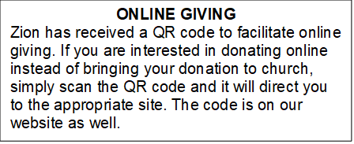

How to Contact the Pastor: If there is a pastoral need, please contact
Pastor Ken Scheck II at 269-370-4632 or by email at kscheckii@aol.com.

ANNOUNCEMENTS

- Thank You: A huge thank you to everyone who helped at my dad’s funeral. The food and decorations were great. It is a blessing to have such organized hardworking church members. Thank you for helping to make that day less stressful. The Hazel Family.
- Semi-Annual Meeting, July 19: The semi-annual meeting will be immediately following worship on July 19th. There are several important issues to be considered at the meeting. The congregation will vote on replacing carpet in the mailbox area, the ladies lounge and the men’s lounge. The congregation will also vote on adopting new bi-laws for Zion. In addition, the future of the parsonage will be considered. Please plan to attend this important meeting.
- Annual Volunteer Appreciation Lunch: The annual volunteer appreciation lunch will be immediately following the semi-annual meeting. Please plan to stay for this special time of recognition and fellowship. The lunch is hosted by the Board of Evangelism.
- Pastor’s Availability: Pastor Ken Scheck II is available by appointment to meet with you. As you know homebound visitation has begun and will continue until all homebound have been visited by Pastor Ken. Generally speaking, he is at Grace on Mondays and Wednesdays and Zion on Tuesdays and Thursdays with a day off on Friday. As you may be aware, Pastor Ken has come to the Men’s meeting and Lakewood Area Ministerial Association meetings on Wednesday here at Zion. Flexibility is the name of the game. He is more than willing to be contacted at any time by cellphone or email. Please feel free to contact him at 269-370-4632 or at kscheckii@aol.com. You are able to send a text to the cellphone, but please identify yourself at least the first time.
- Zion Coffee Cups: The Board of Evangelism has purchased coffee cups with the Zion logo on them to use for outreach. The mugs are also available for purchase. There is one on display on the table in the narthex. The mugs are a great 16-ounce size and they’re being sold for $10 each. All proceeds will be used for evangelism ministries. If you would like to purchase a mug, please see Karen, Martha, or Ruth,
- Note from the Board of Stewardship: Our congregation continues to grow in its mission to share Christ’s love in our community. As we look ahead to the coming months, we will be facing a shortfall in our operating budget. If you are able, we invite you to consider an additional gift to support our worship, outreach, and care ministries. Every contribution, large or small, strengthens the work we do together in Christ’s name. Thank you for your faithful generosity.
- Announcement and Newsletter Items: Please forward items for the bulletin announcements and the newsletter to the church email (Office@Zion.org). Please do not send items to people’s personal emails. Thank you.
- Door Locking Policy: Our door locking policy relies on having a volunteer(s) each Sunday to serve as the Safety Person of the Day. On Sundays where no one has volunteered, if someone arrives at church and is willing to be the Safety Person of the Day, we will follow the door locking policy. If no one steps forward to serve as the Safety Person of the Day, the doors will not be locked. Please consider volunteering for this important duty.

