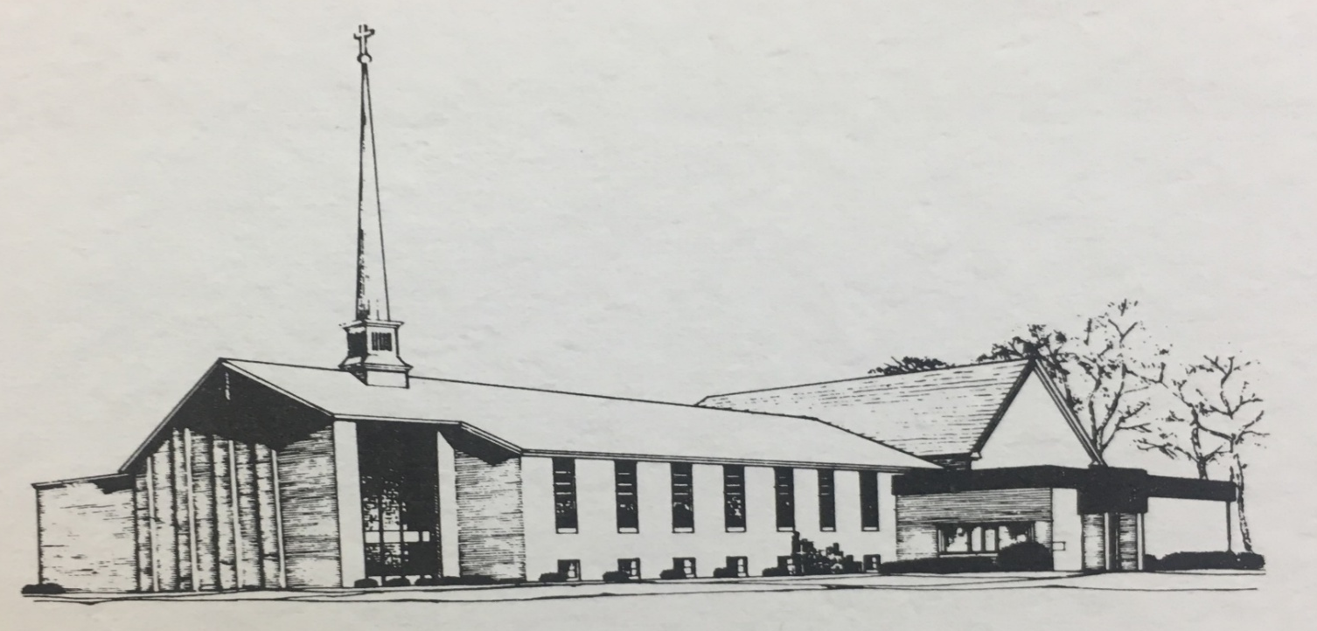
ZION LUTHERAN CHURCH, WOODLAND, MI
170th Anniversary of Zion, August 23, 2026

WELCOME

gathering
The Holy Spirit calls us together as the people of God.

Confession and forgiveness
In the name of the Father,
and of the ☩ Son,
and of the Holy Spirit.
Amen.

Almighty God, to whom all hearts are open, all desires known, and from whom no secrets are hid: cleanse the thoughts of our hearts by the inspiration of your Holy Spirit, that we may perfectly love you and worthily magnify your holy name, through Jesus Christ our Lord.
Amen.

Let us confess our sin in the presence of God and of one another. Most merciful God,
we confess that we are captive to sin and cannot free ourselves. We have sinned against you in thought, word, and deed, by what we have done and by what we have left undone. We have not loved you with our whole heart; we have not loved our neighbors as ourselves. For the sake of your Son, Jesus Christ, have mercy on us. Forgive us, renew us, and lead us, so that we may delight in your will and walk in your ways, to the glory of your holy name.
Amen.
God, who is rich in mercy, loved us even when we were dead in sin, and made us alive together with Christ. By grace you have been saved. In the name of ☩ Jesus Christ, your sins are forgiven. Almighty God strengthen you with power through the Holy Spirit, that Christ may live in your hearts through faith.
Amen.

Opening
O Lord, open our lips,
and our mouths shall proclaim your praise.
Blessed God, satisfy us in the morning with your steadfast love,
that we may rejoice and be glad in all our days.
Give praise to the Holy Trinity our true God,
who gives us life, salvation, and resurrection.

“You Are Holy” #525

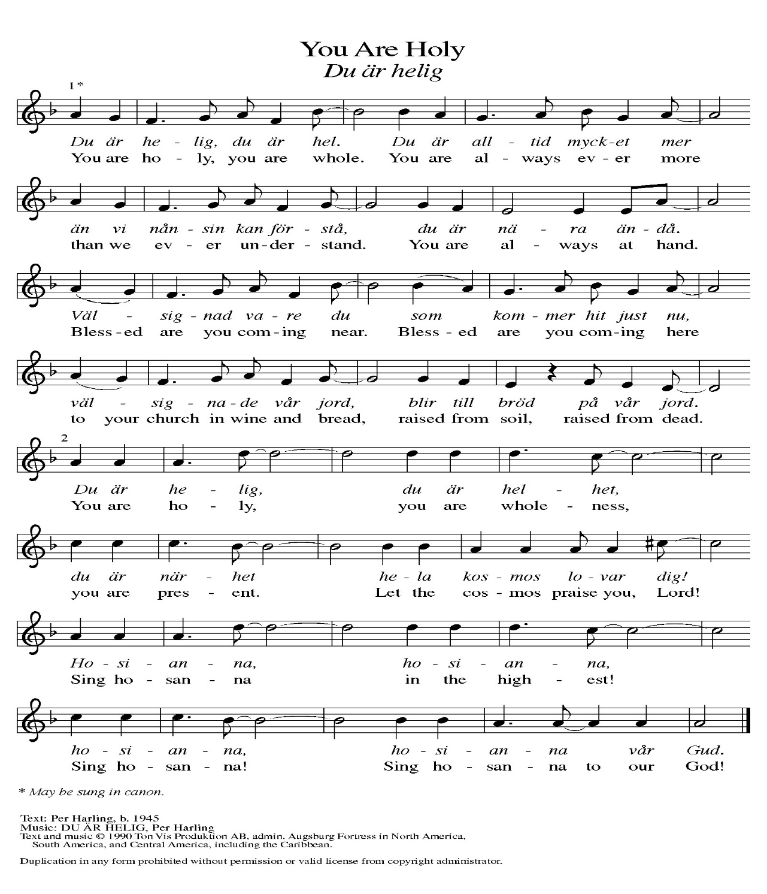
Prayer of the Day
Let us pray together.
O God, you have promised through your Son to be with your church forever. We give you thanks for those who founded this community of believers and for the signs of your presence in our congregation. Increase in us the spirit of faith and love, and make our fellowship an example to all believers and to all nations. We pray through Jesus Christ, our Savior and Lord, who lives and reigns with you and the Holy Spirit, one God, now and forever. Amen

First Reading 1 Kings 8:22-30
A reading from 1 Kings.

²²Then Solomon stood before the altar of the LORD in the presence of all the assembly of Israel, and spread out his hands to heaven. ²³He said, "O LORD, God of Israel, there is no God like you in heaven above or on earth beneath, keeping covenant and steadfast love for your servants who walk before you with all their heart, ²⁴the covenant that you kept for your servant my father David as you declared to him; you promised with your mouth and have this day fulfilled with your hand. ²⁵Therefore, O LORD, God of Israel, keep for your servant my father David that which you promised him, saying, 'There shall never fail you a successor before me to sit on the throne of Israel, if only your children look to their way, to walk before me as you have walked before me.' ²⁶Therefore, O God of Israel, let your word be confirmed, which you promised to your servant my father David.
²⁷But will God indeed dwell on the earth? Even heaven and the highest heaven cannot contain you, much less this house that I have built! ²⁸Regard your servant's prayer and his plea, O LORD my God, heeding the cry and the prayer that your servant prays to you today; ²⁹that your eyes may be open night and day toward this house, the place of which you said, 'My name shall be there,' that you may heed the prayer that your servant prays toward this place. ³⁰Hear the plea of your servant and of your people Israel when they pray toward this place; O hear in heaven your dwelling place; heed and forgive.

The word of the Lord.
Thanks be to God.

ZION: tHE FAITHFUL PIONEERS – Pastor Ken Scheck II

Psalm Psalm 84

¹How dear to me | is your dwelling,
O | Lord of hosts!
²My soul has a desire and longing for the courts | of the Lord;
my heart and my flesh rejoice in the | living God.
³Even the sparrow has found a home, and the swallow a nest where she may | lay her young,
by the side of your altars, O Lord of hosts, my king | and my God.
⁴Happy are they who dwell | in your house!
They will always be | praising you.
⁵Happy are the people whose strength | is in you,
whose hearts are set on the | pilgrims' way.
⁶Those who go through the balsam valley will find it a | place of springs,
for the early rains have covered it with | pools of water.
⁷They will climb from | height to height,
and the God of gods will be | seen in Zion.
⁸Lord God of hosts, | hear my prayer;
give ear, O | God of Jacob.
⁹Behold our defend- | er, O God;
and look upon the face of | your anointed.
¹⁰For one day in your courts is better than a | thousand elsewhere.
I would rather stand at the threshold of the house of my God than dwell in the tents | of the wicked.
¹¹For the Lord God is both sun and shield, bestowing | grace and glory;
no good thing will the Lord withhold from those who walk | with integrity.
¹²O | Lord of hosts,
happy are they who put their | trust in you!

Second Reading 1 Peter 2:1-9
A reading from 1 Peter.

¹Rid yourselves, therefore, of all malice, and all guile, insincerity, envy, and all slander. ²Like newborn infants, long for the pure, spiritual milk, so that by it you may grow into salvation — ³if indeed you have tasted that the Lord is good.
⁴Come to him, a living stone, though rejected by mortals yet chosen and precious in God's sight, and ⁵like living stones, let yourselves be built into a spiritual house, to be a holy priesthood, to offer spiritual sacrifices acceptable to God through Jesus Christ.
⁶For it stands in scripture:
"See, I am laying in Zion a stone,
a cornerstone chosen and precious;
and whoever believes in him will not be put to shame."
⁷To you then who believe, he is precious; but for those who do not believe,
"The stone that the builders rejected
has become the very head of the corner,"
⁸and "A stone that makes them stumble, and a rock that makes them fall."
They stumble because they disobey the word, as they were destined to do.
⁹But you are a chosen race, a royal priesthood, a holy nation, God's own people, in order that you may proclaim the mighty acts of him who called you out of darkness into his marvelous light.

The word of the Lord.
Thanks be to God.

zion: faith in action - Pastor Ken Scheck II

Gospel Acclamation
Alleluia. Lord, to whom shall we go?
You have the words of eternal life. Alleluia

Gospel John 10:22-30
The holy gospel according to John.
Glory to you, O Lord.

²²At that time the festival of the Dedication took place in Jerusalem. It was winter, ²³and Jesus was walking in the temple, in the portico of Solomon. ²⁴So the Jews gathered around him and said to him, "How long will you keep us in suspense? If you are the Messiah, tell us plainly." ²⁵Jesus answered, "I have told you, and you do not believe. The works that I do in my Father's name testify to me; ²⁶but you do not believe, because you do not belong to my sheep. ²⁷My sheep hear my voice. I know them, and they follow me. ²⁸I give them eternal life, and they will never perish. No one will snatch them out of my hand. ²⁹What my Father has given me is greater than all else, and no one can snatch it out of the Father's hand. ³⁰The Father and I are one."

The gospel of the Lord.
Praise to you, O Christ.

zion: A legacy of faith and action continues - Pastor Ken Scheck II

Hymn of the Day “The Church’s One Foundation” ELW 654

cREED
I believe in God, the Father almighty,
creator of heaven and earth.
I believe in Jesus Christ, God’s only Son, our Lord,
who was conceived by the Holy Spirit,
born of the virgin Mary,
suffered under Pontius Pilate,
was crucified, died, and was buried;
he descended to the dead.*
On the third day he rose again;
he ascended into heaven,
he is seated at the right hand of the Father,
and he will come to judge the living and the dead.
I believe in the Holy Spirit,
the holy catholic church,
the communion of saints,
the forgiveness of sins,
the resurrection of the body,
and the life everlasting. Amen.

*Or, “he descended into hell,” another translation of this text in widespread use.

prayers of Intercession
With bold trust in God’s unfailing provision, we pray for the church, those in need, and all of God’s creation.
A brief silence.
God, our rock, you are the foundation on which the church is built. Strengthen and encourage your faithful people everywhere they gather, that they boldly proclaim your word of life to all the world. We pray especially for Lebanon Lutheran Church in Whitehall and their Pastor, the Reverand Doug Ogden. Merciful God,
receive our prayer.
You spoke and all creation came into being. Field and forest, wetland and wilderness—all reveal your glory. Sustain and nourish your creation. Teach us to be wise stewards of all you have made. Merciful God,
receive our prayer.
You bring deliverance to nations and peoples. Come to the aid of nations experiencing war, conflict, disease, famine, and disaster. Guide the work of relief agencies and peacemaking organizations. Merciful God,
receive our prayer.
You regard the lowly and hear us when we cry out to you. Be present among all who struggle with addiction, housing insecurity, incarceration, and mental illness, that they know they are not alone. We pray especially for all those on our prayer list and in our hearts, and all countries involved in ongoing conflicts. Hear our prayers for all in need this day. Merciful God,
receive our prayer.
You draw together people with differing gifts. Lift up the many and varied gifts and talents of this congregation and strengthen the bonds of fellowship that all may be united as the body of Christ. Merciful God,
receive our prayer.
Your steadfast love endures forever. We give thanks for the faithful who died in the hope of this promise. Strengthen us in faith until the day we join them at your eternal banquet. Merciful God,
receive our prayer.
Receive our prayers and answer, O God, as you have promised. All this we ask in the name of your Son, Jesus Christ our Lord.
Amen.

PEACE
Sharing the Peace of God
The peace of the risen Christ be with you always.
And also with you.
(We share the peace of Christ with one another.)

OFFERING & OFFERING SONG
The joy of the Lord is my strength,
The joy of the Lord is my strength,
The joy of the Lord is my strength,
The joy of the Lord is my strength.

Offering Prayer
Let us pray.
Be known to us, O Lord, as you were made known to the disciples. Receive these gifts and the offering of our lives, that we may be your risen body in the world. Amen.

Thanksgiving at the Table
In the night in which he was betrayed,
our Lord Jesus took bread, and gave thanks;
broke it, and gave it to his disciples, saying:
Take and eat; this is my body, given for you.
Do this for the remembrance of me.
Again, after supper, he took the cup, gave thanks,
and gave it for all to drink, saying:
This cup is the new covenant in my blood,
shed for you and for all people for the forgiveness of sin.
Do this for the remembrance of me.

Lord’s Prayer
Gathered into one by the Holy Spirit, let us pray as Jesus taught us.
Our Father in heaven,
hallowed be your name,
your kingdom come,
your will be done,
on earth as in heaven.
Give us today our daily bread.
Forgive us our sins
as we forgive those
who sin against us.
Save us from the time of trial
and deliver us from evil.
For the kingdom, the power,
and the glory are yours,
now and forever. Amen.

cOMMUNION
The body and blood of our Lord Jesus Christ bless you and keep you in His grace.

prayer after communion
Almighty God,
we give you thanks that you have fed us with this heavenly food.
In your grace and by your Spirit, help us to be what we celebrate,
the body of Christ in the world.
Send us out, renewed by this sacramental meal,
to do the work you have given us to do: to witness for Christ,
to love you with singleness of heart, and to serve you with clarity of purpose;
through Jesus Christ, our Savior and Lord.
Amen.

blessing of the backpacks (from Illustrative Ministry)
Pastor: Calling all children of the Living God: the gospel is good news for every age and every stage
All: Let us worship together, the young and the old.
Presider: The good news is proclaimed in God’s words, and also with crayons, silly songs, snacks, and rest time.
All: Let us worship together, every generation
Pastor: As a new school year begins, may it be a year of joyful learning for all ages who are going to school; public, private, college, homeschooled, and Sunday School. Bless the students, parents, and teacher with a positive year ahead.
All: Let us worship together, with our family of faith.
Pastor: We may still feel uncertain, seeing so many faces again, but we come together seeking God’s peace in this beautiful community.
All: Let us worship together, united in Christ.

Pastor: Let us pray.
God of fresh starts and new beginnings, we bring ourselves, our big feelings, and our backpacks to you.

In our backpacks, we carry blank pages, sharpened pencils, and pointy crayons, and in our hearts, we carry big feelings, unanswered questions, and hopeful expectations. There are endless possibilities of what this new year might bring— of what we might learn, who we might meet, and who we might become.

God, our friend who is always with us, be with us through it all.
Be with us as we ride the bus.
Be with us as we walk.
Be with us as we buckle seat belts, zip-up jackets, and tie shoes. However we get there, and whatever we wear, bless this journey into something new.

For the grown-ups going back to school, With-Us God, be with them too.
Thank you for our teachers, helpers, caregivers, and leaders, and for all they do to help us learn and grow.
God, our friend who’s full of wonder, fill their hearts and bless their hands.
Amen.

Sending
God blesses us and sends us in mission to the world.

Sending SonG “On Our Way Rejoicing” ELW 537

Blessing and dismissal
Go forth in peace and with the courage of faith.
Love God with all your heart, with all your soul, and with all your mind,
and love your neighbor as yourself.
Amen

blessing of the meal

From sundaysandseasons.com. Copyright © 2017 Augsburg Fortress. All rights reserved.

THANK YOU TO ALL WHO SERVED TODAY:
Presider: Pastor Ken Scheck II
Musician: Martha Yoder
Elder: Naomi Wilson
Trustee: Jimmy Hindman
Offering Counters: Doug Mackenzie and Mike Johnson
Safety Person:

PRAYERS OF THE FAITHFUL

With thanks for all God’s blessings and his love for all people. Our Bishops, Julie Schneider-Thomas, Yehiel Curry, and the congregations of the North/West Lower Michigan Synod, and especially Lebanon Lutheran Church in Whitehall, and their Pastor, the Reverand Doug Ogden.

Prayers for our friends, for all who are sick or hospitalized and for all health care workers who care for them. All those members of Zion’s family traveling; all those homebound or in frail health; all those suffering with quiet, unknown needs or worries. For those who serve on our behalf: public safety, utility workers, medical personnel, military personnel. For those who might be forgotten. We pray especially for all countries involved in ongoing conflicts.

This week at Zion:
- Men’s Breakfast at 8am, Wednesday 26th
- Bulletin Deadline, Wednesday 26th

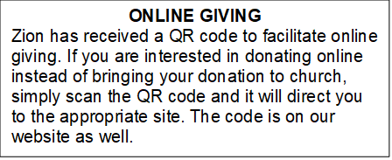

How to Contact the Pastor: If there is a pastoral need, please contact
Pastor Ken Scheck II at 269-370-4632 or by email at kscheckii@aol.com.

ANNOUNCEMENTS

- Welcome to Zion’s 170th Year Celebration! We praise God that you are here to worship and celebrate with us today. The Lord has blessed us with 170 continuous years of worship and service; and we rejoice in this time of celebration. Please stay after worship for a time to visit and enjoy a special picnic lunch. You are invited to explore inside the church. There are displays throughout (main floor and basement) that commemorate Zion’s heritage and celebrate the future. After lunch there will be a hymn sing in memory of member Dana Traub who passed away in 2021. Dana hosted hymn sings at his farm and had a special “hymnal” made that we will use today in his honor.
- Announcement and Newsletter Items: Please forward items for the bulletin announcements and the newsletter to the church email (Office@Zion.org). Please do not send items to people’s personal emails. Thank you.
- Door Locking Policy: Our door locking policy relies on having a volunteer(s) each Sunday to serve as the Safety Person of the Day. On Sundays where no one has volunteered, if someone arrives at church and is willing to be the Safety Person of the Day, we will follow the door locking policy. If no one steps forward to serve as the Safety Person of the Day, the doors will not be locked. Please consider volunteering for this important duty.

