ZION LUTHERAN CHURCH, WOODLAND, MI
Fourteenth Sunday After Pentecost, Sunday August 30, 2026
*If you are listening in your car, please tune your radio to FM 87.7*
(Please silence your cell phones while in the sanctuary. Thank you.)



WELCOME AND ANNOUNCEMENTS

Gathering
The Holy Spirit calls us together as the people of God.

Confession and Forgiveness
In the name of the Father,
and of the ☩ Son,
and of the Holy Spirit.
Amen.

Almighty God, to whom all hearts are open, all desires known, and from whom no secrets are hid: cleanse the thoughts of our hearts by the inspiration of your Holy Spirit, that we may perfectly love you and worthily magnify your holy name, through Jesus Christ our Lord.
Amen.

Let us confess our sin in the presence of God and of one another. Most merciful God,
we confess that we are captive to sin and cannot free ourselves. We have sinned against you in thought, word, and deed, by what we have done and by what we have left undone. We have not loved you with our whole heart; we have not loved our neighbors as ourselves. For the sake of your Son, Jesus Christ, have mercy on us. Forgive us, renew us, and lead us, so that we may delight in your will and walk in your ways, to the glory of your holy name.
Amen.
God, who is rich in mercy, loved us even when we were dead in sin, and made us alive together with Christ. By grace you have been saved. In the name of ☩ Jesus Christ, your sins are forgiven. Almighty God strengthen you with power through the Holy Spirit, that Christ may live in your hearts through faith.
Amen.

GATHERING HYMN “Lift High The Cross” #660

Prayer of the Day
Let us pray together.
O God, we thank you for your Son, who chose the path of suffering for the sake of the world. Humble us by his example, point us to the path of obedience, and give us strength to follow your commands, through Jesus Christ, our Savior and Lord.

Amen.

First Reading Jeremiah 15:15-21
A reading from Jeremiah.
¹⁵ O Lord, you know;
remember me and visit me,
and bring down retribution for me on my persecutors.
In your forbearance do not take me away;
know that on your account I suffer insult.
¹⁶ Your words were found, and I ate them,
and your words became to me a joy
and the delight of my heart,
for I am called by your name,
O Lord, God of hosts.
¹⁷ I did not sit in the company of merrymakers,
nor did I rejoice;
under the weight of your hand I sat alone,
for you had filled me with indignation.
¹⁸ Why is my pain unceasing,
my wound incurable,
refusing to be healed?
Truly, you are to me like a deceitful brook,
like waters that fail.
¹⁹ Therefore thus says the Lord:
If you turn back, I will take you back,
and you shall stand before me.
If you utter what is precious and not what is worthless,
you shall serve as my mouth.
It is they who will turn to you,
not you who will turn to them.
²⁰ And I will make you to this people
a fortified wall of bronze;
they will fight against you,
but they shall not prevail over you,
for I am with you
to save you and deliver you,
says the Lord.
²¹ I will deliver you out of the hand of the wicked
and redeem you from the grasp of the ruthless.

The word of the Lord.
Thanks be to God.

Psalm Psalm 26:1-8
¹ Give judgment for me, O Lord, for I have lived | with integrity;
I have trusted in the Lord and | have not faltered.
² Test me, O | Lord, and try me;
examine my heart | and my mind.
³ For your steadfast love is be- | fore my eyes;
I have walked faithful- | ly with you.
⁴ I have not sat | with the worthless,
nor do I consort with | the deceitful. W
⁵ I have hated the company of | evildoers;
I will not sit down | with the wicked.
⁶ I will wash my hands in inno- | cence, O Lord,
that I may go in procession | round your altar,
⁷ singing aloud a song | of thanksgiving
and recounting all your won- | derful deeds.
⁸ Lord, I love the house in | which you dwell
and the place where your glo- | ry abides.

Second Reading Romans 12:9-21
A reading from Romans.
⁹ Let love be genuine; hate what is evil; hold fast to what is good; ¹⁰ love one another with mutual affection; outdo one another in showing honor. ¹¹ Do not lag in zeal; be ardent in spirit; serve the Lord. ¹² Rejoice in hope; be patient in affliction; persevere in prayer. ¹³ Contribute to the needs of the saints; pursue hospitality to strangers.
¹⁴ Bless those who persecute you; bless and do not curse them. ¹⁵ Rejoice with those who rejoice; weep with those who weep. ¹⁶ Live in harmony with one another; do not be arrogant, but associate with the lowly; do not claim to be wiser than you are. ¹⁷ Do not repay anyone evil for evil, but take thought for what is noble in the sight of all. ¹⁸ If it is possible, so far as it depends on you, live peaceably with all. ¹⁹ Beloved, never avenge yourselves, but leave room for the wrath of God, for it is written, “Vengeance is mine; I will repay, says the Lord.” ²⁰ Instead, “if your enemies are hungry, feed them; if they are thirsty, give them something to drink, for by doing this you will heap burning coals on their heads.” ²¹ Do not be overcome by evil, but overcome evil with good.

The Word of the Lord.
Thanks be to God.

Gospel Acclamation
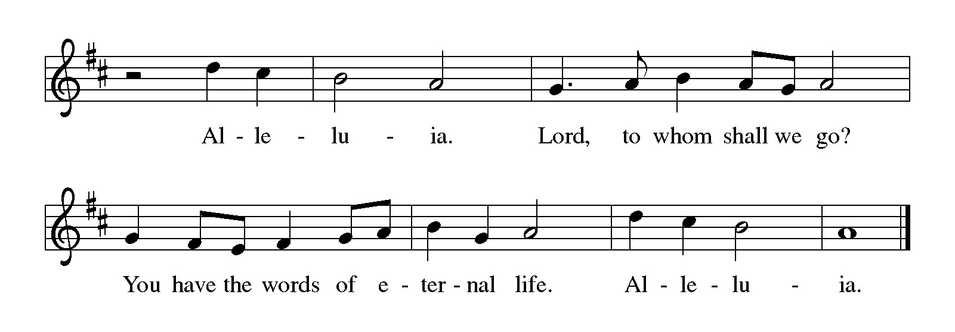

Gospel Matthew 16:21-28
The holy gospel according to Matthew.
Glory to You, O Lord.
²¹ From that time on, [after Peter confessed that Jesus was the Messiah,] Jesus began to show his disciples that he must go to Jerusalem and undergo great suffering at the hands of the elders and chief priests and scribes and be killed and on the third day be raised. ²² And Peter took him aside and began to rebuke him, saying, “God forbid it, Lord! This must never happen to you.” ²³ But he turned and said to Peter, “Get behind me, Satan! You are a hindrance to me, for you are setting your mind not on divine things but on human things.”
²⁴ Then Jesus told his disciples, “If any wish to come after me, let them deny themselves and take up their cross and follow me. ²⁵ For those who want to save their life will lose it, and those who lose their life for my sake will find it. ²⁶ For what will it profit them if they gain the whole world but forfeit their life? Or what will they give in return for their life?
²⁷ “For the Son of Man is to come with his angels in the glory of his Father, and then he will repay everyone for what has been done. ²⁸ Truly I tell you, there are some standing here who will not taste death before they see the Son of Man coming in his kingdom.”

The gospel of the Lord.
Praise to you, O Christ.

CHILDREN’S MOMENT

SERMON Pastor Ken Scheck

hymn of the day “Will You Come And Follow Me” #798

cREED
I believe in God, the Father almighty,
creator of heaven and earth.
I believe in Jesus Christ, God’s only Son, our Lord,
who was conceived by the Holy Spirit,
born of the virgin Mary,
suffered under Pontius Pilate,
was crucified, died, and was buried;
he descended to the dead.*
On the third day he rose again;
he ascended into heaven,
he is seated at the right hand of the Father,
and he will come to judge the living and the dead.
I believe in the Holy Spirit,
the holy catholic church,
the communion of saints,
the forgiveness of sins,
the resurrection of the body,
and the life everlasting. Amen.

*Or, “he descended into hell,” another translation of this text in widespread use.

prayers of Intercession (Please Be Seated)
With bold trust in God’s unfailing provision, we pray for the church, those in need, and all of God’s creation.
A brief silence.
For the church in every land, that its mission and ministry is anchored in the love of Christ. When threats or challenges arise, teach us to take up our cross and follow you in faith. Merciful God,
receive our prayer.
For the well-being of your creation, that all that lives and grows on the earth may thrive. Bring relief to areas ravaged by droughts, floods, fires, storms, and other disasters.
Merciful God,
receive our prayer.
For the nations and all in authority, that they seek to live in peace with one another. Bless the work of international and diplomatic organizations and all who work to bring peace to a world scarred by violence. Merciful God,
receive our prayer.
For all those in need, that they be satisfied. Ensure all your children have safe access to food, water, shelter, and medical care. Bring healing to all who bear wounds in body, mind, and spirit. We pray especially for all those on our prayer list and in our hearts, and all countries involved in ongoing conflicts.
Merciful God,
receive our prayer.
For the congregation gathered here to serve you, that they remain strong in faith and united in purpose. Guide our committees, study groups, and other meetings toward honesty and humility, always seeking genuine love. Merciful God,
receive our prayer.
For the faithful departed, that their witness continues to strengthen and guide the church. Renew our hope in your promises in this life and the life to come. Merciful God,
receive our prayer.
Receive our prayers and answer, O God, as you have promised. All this we ask in the name of your Son, Jesus Christ our Lord.
Amen.

PEACE
Sharing the Peace of God
The peace of the risen Christ be with you always.
And also with you.
(We share the peace of Christ with one another.)

OFFERING & OFFERING SONG
The joy of the Lord is my strength,
The joy of the Lord is my strength,
The joy of the Lord is my strength,
The joy of the Lord is my strength.

Offering Prayer
Let us pray.
Be known to us, O Lord, as you were made known to the disciples. Receive these gifts, and the offering of our lives, that we may be your risen body in the world.
Amen.

DIALOGUE
The Lord be with you.
And also with you.
Lift up your hearts.
We lift them to the Lord.
Let us give thanks to the Lord our God.
It is right to give our thanks and praise.

PREFACE (Pastor)
It is indeed right, our duty and our joy,
that we should at all times and in all places
give thanks and praise to you, almighty and merciful God,
through our Savior Jesus Christ;
who on this day overcame death and the grave,
and by his glorious resurrection opened to us the way of everlasting life.
And so, with all the choirs of angels,
with the church on earth and the hosts of heaven,
we praise your name and join their unending hymn

Holy, holy, holy
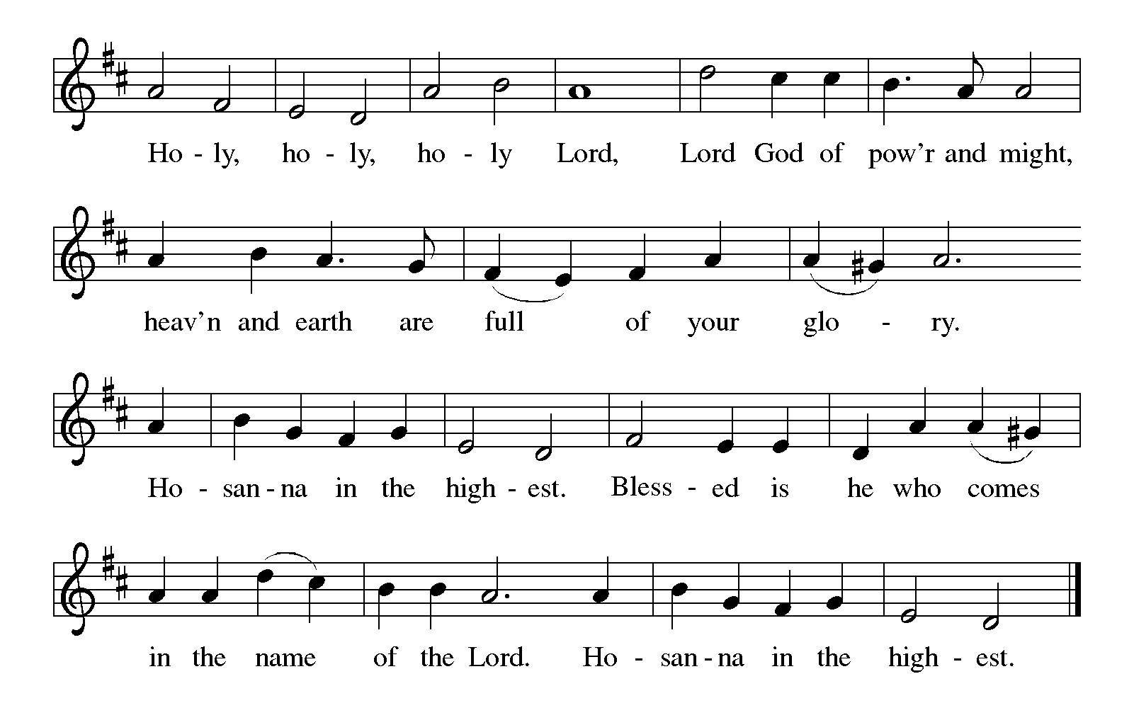

Thanksgiving at the Table
In the night in which he was betrayed,
our Lord Jesus took bread, and gave thanks;
broke it, and gave it to his disciples, saying:
Take and eat; this is my body, given for you.
Do this for the remembrance of me.

Again, after supper, he took the cup, gave thanks,
and gave it for all to drink, saying:
This cup is the new covenant in my blood,
shed for you and for all people for the forgiveness of sin.
Do this for the remembrance of me.

For as often as we eat of this bread and drink from this cup,
we proclaim the Lord’s death until he comes.

Christ has died. Christ is risen. Christ will come again.

Lord’s Prayer
Gathered into one by the Holy Spirit, let us pray as Jesus taught us.
Our Father, who art in heaven,
hallowed be thy name,
thy kingdom come,
thy will be done,
on earth as it is in heaven.
Give us this day our daily bread;
and forgive us our trespasses,
as we forgive those
who trespass against us;
and lead us not into temptation,
but deliver us from evil.
For thine is the kingdom,
and the power, and the glory,
forever and ever. Amen.

INVITATION TO COMMUNION
Come to the banquet, for all is now ready.

COMMUNION *continuous
*People are welcome to kneel at the altar rail for a time of prayer after they receive their communion elements.

COMMUNION HYMNS
“Will You Let Me Be Your Servant” #659
“All Who Hunger, Gather Gladly” # 461

PRAYER AFTER COMMUNION
Let us pray.
We give you thanks, almighty God, that you have refreshed us through the healing power of this gift of life. In your mercy, strengthen us through this gift, in faith toward you and in fervent love toward one another; for the sake of Jesus Christ our Lord.
Amen.

Sending
God blesses us and sends us in mission to the world.

Blessing
The Lord bless you and keep you.
The Lord’s face shine on you with grace and mercy.
The Lord look upon you with favor and ☩ give you peace.
Amen.
Sending SonG “Blest Be the Ties That Bind” #656

Dismissal
Go in peace. Christ is with you.
Thanks be to God.

From sundaysandseasons.com. Copyright © 2017 Augsburg Fortress. All rights reserved.

Thank you to all who served in worship today!
Presiders: Pastor Ken Scheck Musician: Jayne Flanignan
Acolyte: Kole Hokanson Safety Person:
Elder: Dan Utterback Trustee: Mike Johnson
Offering Counters: Mary Makley & Martha Yoder



PRAYERS OF THE FAITHFUL

With thanks for all God’s blessings and his love for all people. Our Bishops, Julie Schneider-Thomas, Yehiel Curry, and the congregations of the North/West Lower Michigan Synod.

Prayers for our friends, for all who are sick or hospitalized and for all health care workers who care for them. All those members of Zion’s family traveling; all those homebound or in frail health; all those suffering with quiet, unknown needs or worries. For those who serve on our behalf: public safety, utility workers, medical personnel, military personnel. For those who might be forgotten. We pray especially for all countries involved in ongoing conflicts.

This week at Zion:
- Men’s Breakfast at 8am, Wednesday 2nd
- Bulletin Deadline, Wednesday 2nd

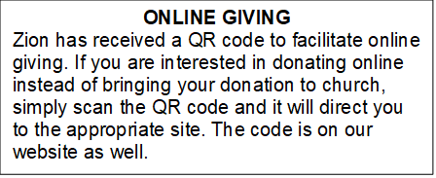

How to Contact the Pastor: If there is a pastoral need, please contact
Pastor Ken Scheck II at 269-370-4632 or by email at kscheckii@aol.com.

ANNOUNCEMENTS

- Zion’s 170th Anniversary Celebration, August 23rd: A sincere “thank you” to everyone who served on the 170th Anniversary Committee for all their planning and hard work. The 170th service and celebration on August 23rd was amazing! We worshiped outside with about 100 people in attendance. We were blessed to have Pastor Becky and Terry Ebb-Speese, Pastor Jim and Sandy Couser, Pastor Polly and John Standley and Pastor Mike and Vicki Anderson with us for this special day. Pastor Marilyn Danielson from the Congregational Church in Lake Odessa joined us for the hymn sing. Everyone enjoyed great fellowship and food following the service. People stayed to tour the church and look at the historical exhibits in the Fireside Lounge, displays in other areas of the church and a hymn sing in the sanctuary. It was a wonderful day! If you were not able to attend, there are extra copies of the timeline, the bulletin from the service, ink pens, coffee mugs and water bottles for you too! Also, attached to the newsletter is a copy of the summary of Zion’s history shared by Pastor Ken during the service. We are so blessed to have a legacy of 170 years of worship and service and look forward to what the future has in store for us at Zion.
- Baby Care Kits: Zion is collecting items and will be assembling Baby Care Kits for Lutheran World Relief. We need your help! We are especially in need of blankets (between 32” and 52” square, lightweight fabric), prefolded diapers, sleepers (no feet)/gowns/pajama sets 6 months to 24 months, bars of soap, and lightweight t-shirts (no onesies) 6 months to 24 months. If you can donate items or provide financial support it would be very appreciated as we do not have a Thrivent grant this year to help purchase needed items. There is a display of items collected and information on what is needed in the fellowship hall. We hope to have 25 kits that will be used in the United States and abroad as needed. The kits will be assembled during the week of October 4th and blessed during worship on October 11th. The blessed kits will packed and taken to St. Matthews Lutheran Church in Grand Rapids on October 17th.
- Announcement and Newsletter Items: Please forward items for the bulletin announcements and the newsletter to the church email (Office@Zion.org). Please do not send items to people’s personal emails. Thank you.
- Door Locking Policy: Our door locking policy relies on having a volunteer(s) each Sunday to serve as the Safety Person of the Day. On Sundays where no one has volunteered, if someone arrives at church and is willing to be the Safety Person of the Day, we will follow the door locking policy. If no one steps forward to serve as the Safety Person of the Day, the doors will not be locked. Please consider volunteering for this important duty.

