ZION LUTHERAN CHURCH, WOODLAND, MI
Sixteenth Sunday After Pentecost, Sunday September 13, 2026
*If you are listening in your car, please tune your radio to FM 87.7*
(Please silence your cell phones while in the sanctuary. Thank you.)

WELCOME AND ANNOUNCEMENTS

Gathering
The Holy Spirit calls us together as the people of God.

Confession and Forgiveness
Blessed be the holy Trinity, ☩ one God,
who pours love into our hearts
and healing upon the earth.
Amen.

Confident that God justifies us by grace through faith,
let us confess our sin.

Compassionate God,
we confess that we struggle to embody your goodness
in the world and in our own hearts.
Creation groans from overuse.
Jealousy and bitterness strain our relationships.
Indifference keeps us from seeking justice.
Divisions disrupt your call to show genuine love
to others.
Turn our hearts back to you.
Restore our world and reconcile us too ne another.
Renew us to live as your holy people,
Following the way of Jesus Christ.
Amen.

Hear the good news:
We have peace with God through ☩ Jesus Christ,
in whom there is no condemnation,
but only forgiveness and the promise of eternal life.
Receive freely this healing gift of grace.
Amen.

GATHERING HYMN “Shout to the Lord” #821

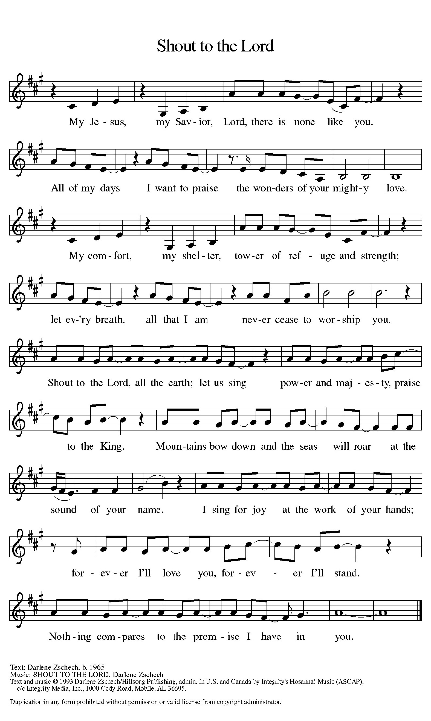

Prayer of the Day
Let us pray together.
O Lord God, merciful judge, you are the inexhaustible fountain of forgiveness. Replace our hearts of stone with hearts that love and adore you, that we may delight in doing your will, through Jesus Christ, our Savior and Lord.
Amen.

First Reading Genesis 50:15-21
A reading from Genesis.

¹⁵ Realizing that their father was dead, Joseph’s brothers said, “What if Joseph still bears a grudge against us and pays us back in full for all the wrong that we did to him?” ¹⁶ So they approached Joseph, saying, “Your father gave this instruction before he died, ¹⁷ ‘Say to Joseph: I beg you, forgive the crime of your brothers and the wrong they did in harming you.’ Now therefore please forgive the crime of the servants of the God of your father.” Joseph wept when they spoke to him. ¹⁸ Then his brothers also wept, fell down before him, and said, “We are here as your slaves.” ¹⁹ But Joseph said to them, “Do not be afraid! Am I in the place of God? ²⁰ Even though you intended to do harm to me, God intended it for good, in order to preserve a numerous people, as he is doing today. ²¹ So have no fear; I myself will provide for you and your little ones.” In this way he reassured them, speaking kindly to them.

The word of the Lord.
Thanks be to God.

Psalm Psalm 103:8-13

⁸ Lord, you are full of compas- | sion and mercy,
slow to anger and abounding in | steadfast love;
⁹ you will not al- | ways accuse us,
nor will you keep your an- | ger forever.
¹⁰ You have not dealt with us according | to our sins,
nor repaid us according to | our iniquities.
¹¹ for as the heavens are high a- | bove the earth,
so great is your steadfast love for | those who fear you.
¹² As far as the east is | from the west,
so far have you removed our transgres- | sions from us.
¹³ as a father has compassion | for his children,
so you have compassion for those who fear | you, O Lord.

Second Reading Romans 14:1-12
A reading from Romans.

¹ Welcome those who are weak in faith but not for the purpose of quarreling over opinions. ² Some believe in eating anything, while the weak eat only vegetables. ³ Those who eat must not despise those who abstain, and those who abstain must not pass judgment on those who eat, for God has welcomed them. ⁴ Who are you to pass judgment on slaves of another? It is before their own lord that they stand or fall. And they will be upheld, for the Lord is able to make them stand.
⁵ Some judge one day to be better than another, while others judge all days to be alike. Let all be fully convinced in their own minds. ⁶ Those who observe the day, observe it for the Lord. Also those who eat, eat for the Lord, since they give thanks to God, while those who abstain, abstain for the Lord and give thanks to God.
⁷ For we do not live to ourselves, and we do not die to ourselves. ⁸ If we live, we live to the Lord, and if we die, we die to the Lord; so then, whether we live or whether we die, we are the Lord’s. ⁹ For to this end Christ died and lived again, so that he might be Lord of both the dead and the living.
¹⁰ Why do you pass judgment on your brother or sister? Or you, why do you despise your brother or sister? For we will all stand before the judgment seat of God. ¹¹ For it is written,
“As I live, says the Lord, every knee shall bow to me,
and every tongue shall give praise to God.”
¹² So then, each one of us will be held accountable.

The Word of the Lord.
Thanks be to God.

Gospel Acclamation
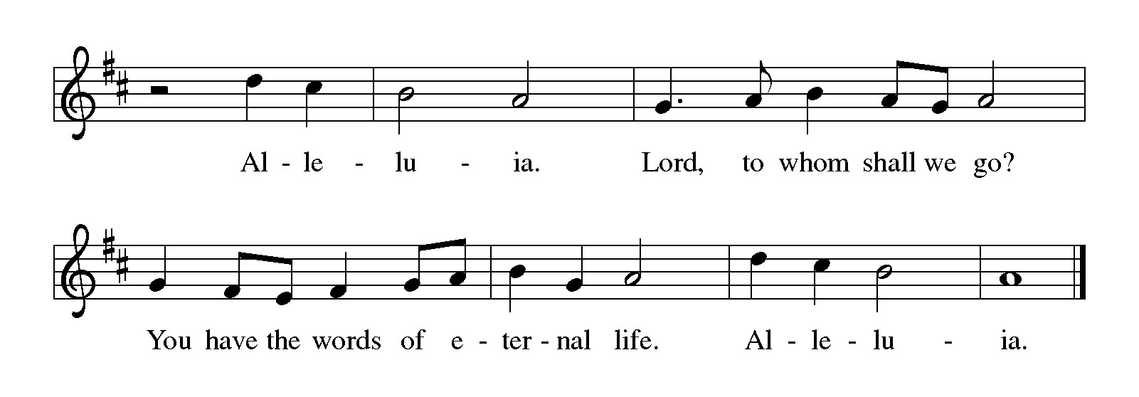

Gospel Matthew 18:21-35
The holy gospel according to Matthew.
Glory to You, O Lord.

²¹ Peter came and said to [Jesus,] “Lord, if my brother or sister sins against me, how often should I forgive? As many as seven times?” ²² Jesus said to him, “Not seven times, but, I tell you, seventy-seven times.
²³ “For this reason the kingdom of heaven may be compared to a king who wished to settle accounts with his slaves. ²⁴ When he began the reckoning, one who owed him ten thousand talents was brought to him, ²⁵ and, as he could not pay, the lord ordered him to be sold, together with his wife and children and all his possessions and payment to be made. ²⁶ So the slave fell on his knees before him, saying, ‘Have patience with me, and I will pay you everything.’ ²⁷ And out of pity for him, the lord of that slave released him and forgave him the debt. ²⁸ But that same slave, as he went out, came upon one of his fellow slaves who owed him a hundred denarii, and seizing him by the throat he said, ‘Pay what you owe.’ ²⁹ Then his fellow slave fell down and pleaded with him, ‘Have patience with me, and I will pay you.’ ³⁰ But he refused; then he went and threw him into prison until he would pay the debt. ³¹ When his fellow slaves saw what had happened, they were greatly distressed, and they went and reported to their lord all that had taken place. ³² Then his lord summoned him and said to him, ‘You wicked slave! I forgave you all that debt because you pleaded with me. ³³ Should you not have had mercy on your fellow slave, as I had mercy on you?’ ³⁴ And in anger his lord handed him over to be tortured until he would pay his entire debt. ³⁵ So my heavenly Father will also do to every one of you, if you do not forgive your brother or sister from your heart.”

The gospel of the Lord.
Praise to you, O Christ.

CHILDREN’S MOMENT

SERMON Pastor Ken Scheck

hymn of the day “Our Father We Have Wandered” #606

CREED
I believe in God, the Father almighty,
creator of heaven and earth.
I believe in Jesus Christ, God’s only Son, our Lord,
who was conceived by the Holy Spirit,
born of the virgin Mary,
suffered under Pontius Pilate,
was crucified, died, and was buried;
he descended to the dead.*
On the third day he rose again;
he ascended into heaven,
he is seated at the right hand of the Father,
and he will come to judge the living and the dead.
I believe in the Holy Spirit,
the holy catholic church,
the communion of saints,
the forgiveness of sins,
the resurrection of the body,
and the life everlasting. Amen.

*Or, “he descended into hell,” another translation of this text in widespread use.

prayers of Intercession (Please Be Seated)
Reminded of God’s gracious and abundant love, we offer our prayers, confident that God hears us.
A brief silence.
Move your church throughout the world away from judging and despising others. Lead us to embody the forgiveness you have given us in Jesus. We pray especially for Covenant Hospital Pastoral Care Department, Saginaw and their Deacon, Kathy Bonn. Hear us, O God.
Your mercy is great.
The endless beauty of your creation reminds us of your mercy. Protect those who care for farms and ranches. Guide those who lead us to wonder at your creation. Hear us, O God.
Your mercy is great.
Raise up leaders to hold all in authority accountable for any misuse of the power entrusted to them. Hear us, O God.
Your mercy is great.
Calm the fears of all in need with your promises. Compassionately free the lives of any who feel bound by their failures. Remember your children in need. Hear us, O God.
Your mercy is great.
Ground this congregation in the welcome you show us in forgiving our sin. Inspire each of us to welcome others for your honor and glory. Hear us, O God.
Your mercy is great.
.
With you is found the joy and promise of eternal life. Keep us in that joy as we remember all those who have gone before us. Hear us, O God.
Your mercy is great.
Grant the prayers we have offered, what we have forgotten to ask, and whatever else you see that we need. We ask this in Jesus’ name.
Amen.

PEACE
Sharing the Peace of God
The peace of the risen Christ be with you always.
And also with you.
(We share the peace of Christ with one another.)

OFFERING & OFFERING SONG
The joy of the Lord is my strength,
The joy of the Lord is my strength,
The joy of the Lord is my strength,
The joy of the Lord is my strength.

Offering Prayer
Let us pray.
God of creation,
you send rain and the earth springs forth abundantly.
All blessings are from you;
make us generous with what we have.
Use our gifts, our abilities, and our hearts
in service to you and in love to our neighbors,
today and always.
Amen.

DIALOGUE
The Lord be with you.
And also with you.
Lift up your hearts.
We lift them to the Lord.
Let us give thanks to the Lord our God.
It is right to give our thanks and praise.
PREFACE (Pastor)
It is indeed right, our duty and our joy,
that we should at all times and in all places
give thanks and praise to you, almighty and merciful God,
through our Savior Jesus Christ;
who on this day overcame death and the grave,
and by his glorious resurrection opened to us the way of everlasting life.
And so, with all the choirs of angels,
with the church on earth and the hosts of heaven,
we praise your name and join their unending hymn

Holy, holy, holy
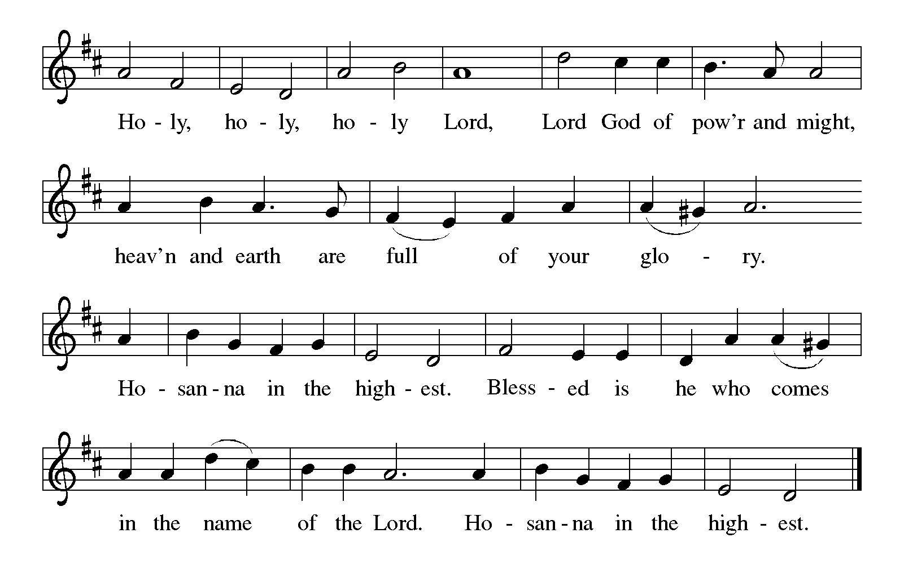

Thanksgiving at the Table
Holy God,
you alone are holy,
you alone are God.

The universe declares your praise:
beyond the stars;
beyond the sea;
within each cell;
with every breath.

Generations bless your faithfulness:
through the water;
by night and day;
across the wilderness;
out of exile;
into the future.

We give you thanks for your dear Son:
at the heart of human life;
near to those who suffer;
beside the sinner;
among the poor;
with us now.

In the night in which he was betrayed,
our Lord Jesus took bread;
and gave thanks; broke it,
and gave it to his disciples,
saying: Take and eat;
this is my body, given for you.
Do this in remembrance of me.

Again, after supper,
he took the cup, gave thanks,
and gave it for all to drink, saying: This is the new covenant I my blood,
shed for you and for all people
for the forgiveness of sin.
Do this for the remembrance of me.

Remembering his love for us
on the way,
at the table,
and to the end,
we proclaim the mystery of faith:

Christ has died.
Christ is risen.
Christ will come again.

Lord’s Prayer
Gathered into one by the Holy Spirit, let us pray as Jesus taught us.
Our Father, who art in heaven,
hallowed be thy name,
thy kingdom come,
thy will be done,
on earth as it is in heaven.
Give us this day our daily bread;
and forgive us our trespasses,
as we forgive those
who trespass against us;
and lead us not into temptation,
but deliver us from evil.
For thine is the kingdom,
and the power, and the glory,
forever and ever. Amen.

INVITATION TO COMMUNION
Christ invites you to this table.
All who are thirsty, all who are hungry, come!

COMMUNION *continuous
*People are welcome to kneel at the altar rail for a time of prayer after they receive their communion elements.

COMMUNION HYMNS
“I Come With Joy” #482
“When We are Living” # 639

PRAYER AFTER COMMUNION
Let us pray.
Sustaining God,
with this bread and cup,
you nourish us with mercy and abundant life.
By your spirit, send us from this table to serve a needy world.
Make us living signs of your liberation, healing, and love,
Following the way of Jesus, in whose name we pray.
Amen.

Blessing
The God of love
draw you into full accord and one mind,
in the body of Christ Jesus.
Amen.
The God of hope
grant you strength and joy in all circumstances
through the interceding of the Spirit.
Amen.
The God of grace
☩ bless you now and forever.
Amen.

Sending SonG “All Creatures Worship God Most High” V-1-4 #835

Dismissal
Go out in joy. Be led forth in peace.
Thanks be to God.

From sundaysandseasons.com. Copyright © 2017 Augsburg Fortress. All rights reserved.

Thank you to all who served in worship today!
Presiders: Pastor Ken Scheck Musician: Martha Yoder
Acolyte: Safety Person:
Elder: Buffy Meyers Trustee: Jimmy Hindman
Offering Counters: Paul Meade & Carlotta Willard



PRAYERS OF THE FAITHFUL

With thanks for all God’s blessings and his love for all people. Our Bishops, Julie Schneider-Thomas, Yehiel Curry, and the congregations of the North/West Lower Michigan Synod. We pray especially for Covenant Hospital Pastoral Care Department, Saginaw and their Deacon, Kathy Bonn.

Prayers for our friends, for all who are sick or hospitalized and for all health care workers who care for them. All those members of Zion’s family traveling; all those homebound or in frail health; all those suffering with quiet, unknown needs or worries. For those who serve on our behalf: public safety, utility workers, medical personnel, military personnel. For those who might be forgotten. We pray especially for Matthew Wilson, Aaron Brown’s Grandpa Louis, Bernie Smith, Suzie Honoman, Terry Cotter, Lee Starks, Phil Walsh, Dave Makley, Linden and Judy Fisher, Ed Markwart, Gloria Anderson, Natalie Merritt and Kids, Larry Duda, Cindy Utterback, Alice Morrow, Jeff Engle, Arlene Forman, Chloe Makley, Erik Anderson, and all countries involved in ongoing conflicts.

This week at Zion:
- Men’s Breakfast at 8am, Wednesday 16th
- Charity Cricle, Tuesday 15th 1pm at Marie Brodbeck’s Home
- Bulletin Deadline, Wednesday 16th

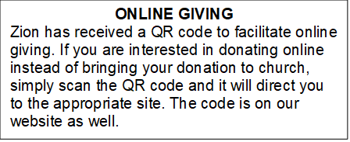

How to Contact the Pastor: If there is a pastoral need, please contact
Pastor Ken Scheck II at 269-370-4632 or by email at kscheckii@aol.com.

ANNOUNCEMENTS

- Sunday School Kickoff and Potluck: Today we kicked off a new year of Sunday School! There are classes for all ages, and we invite you to try Sunday School this year! Please stay after worship for a potluck today.
- Zion’s 170th Anniversary Celebration, August 23rd: A sincere “thank you” to everyone who served on the 170th Anniversary Committee for all their planning and hard work. The 170th service and celebration on August 23rd was amazing! We worshiped outside with about 100 people in attendance. We were blessed to have Pastor Becky and Terry Ebb-Speese, Pastor Jim and Sandy Couser, Pastor Polly and John Standley and Pastor Mike and Vicki Anderson with us for this special day. Pastor Marilyn Danielson from the Congregational Church in Lake Odessa joined us for the hymn sing. Everyone enjoyed great fellowship and food following the service. People stayed to tour the church and look at the historical exhibits in the Fireside Lounge, displays in other areas of the church and a hymn sing in the sanctuary. It was a wonderful day! If you were not able to attend, there are extra copies of the timeline, the bulletin from the service, ink pens, coffee mugs and water bottles for you too! Also, attached to the newsletter is a copy of the summary of Zion’s history shared by Pastor Ken during the service. We are so blessed to have a legacy of 170 years of worship and service and look forward to what the future has in store for us at Zion.
- Baby Care Kits: Zion is collecting items and will be assembling Baby Care Kits for Lutheran World Relief. We need your help! We are especially in need of blankets (between 32” and 52” square, lightweight fabric), prefolded diapers, sleepers (no feet)/gowns/pajama sets 6 months to 24 months, bars of soap, and lightweight t-shirts (no onesies) 6 months to 24 months. If you can donate items or provide financial support it would be very appreciated as we do not have a Thrivent grant this year to help purchase needed items. There is a display of items collected and information on what is needed in the fellowship hall. We hope to have 25 kits that will be used in the United States and abroad as needed. The kits will be assembled during the week of October 4th and blessed during worship on October 11th. The blessed kits will packed and taken to St. Matthews Lutheran Church in Grand Rapids on October 17th.
- Announcement and Newsletter Items: Please forward items for the bulletin announcements and the newsletter to the church email (Office@Zion.org). Please do not send items to people’s personal emails. Thank you.
- Door Locking Policy: Our door locking policy relies on having a volunteer(s) each Sunday to serve as the Safety Person of the Day. On Sundays where no one has volunteered, if someone arrives at church and is willing to be the Safety Person of the Day, we will follow the door locking policy. If no one steps forward to serve as the Safety Person of the Day, the doors will not be locked. Please consider volunteering for this important duty.

