ZION LUTHERAN CHURCH, WOODLAND, MI
Seventeenth Sunday After Pentecost, Sunday September 20, 2026
*If you are listening in your car, please tune your radio to FM 87.7*
(Please silence your cell phones while in the sanctuary. Thank you.)

WELCOME AND ANNOUNCEMENTS

Gathering
The Holy Spirit calls us together as the people of God.

Confession and Forgiveness
Blessed be the holy Trinity, ☩ one God,
who pours love into our hearts
and healing upon the earth.
Amen.

Confident that God justifies us by grace through faith,
let us confess our sin.

Compassionate God,
we confess that we struggle to embody your goodness
in the world and in our own hearts.
Creation groans from overuse.
Jealousy and bitterness strain our relationships.
Indifference keeps us from seeking justice.
Divisions disrupt your call to show genuine love
to others.
Turn our hearts back to you.
Restore our world and reconcile us to one another.
Renew us to live as your holy people,
Following the way of Jesus Christ.
Amen.

Hear the good news:
We have peace with God through ☩ Jesus Christ,
in whom there is no condemnation,
but only forgiveness and the promise of eternal life.
Receive freely this healing gift of grace.
Amen.

GATHERING HYMN “Shout to the Lord” #821

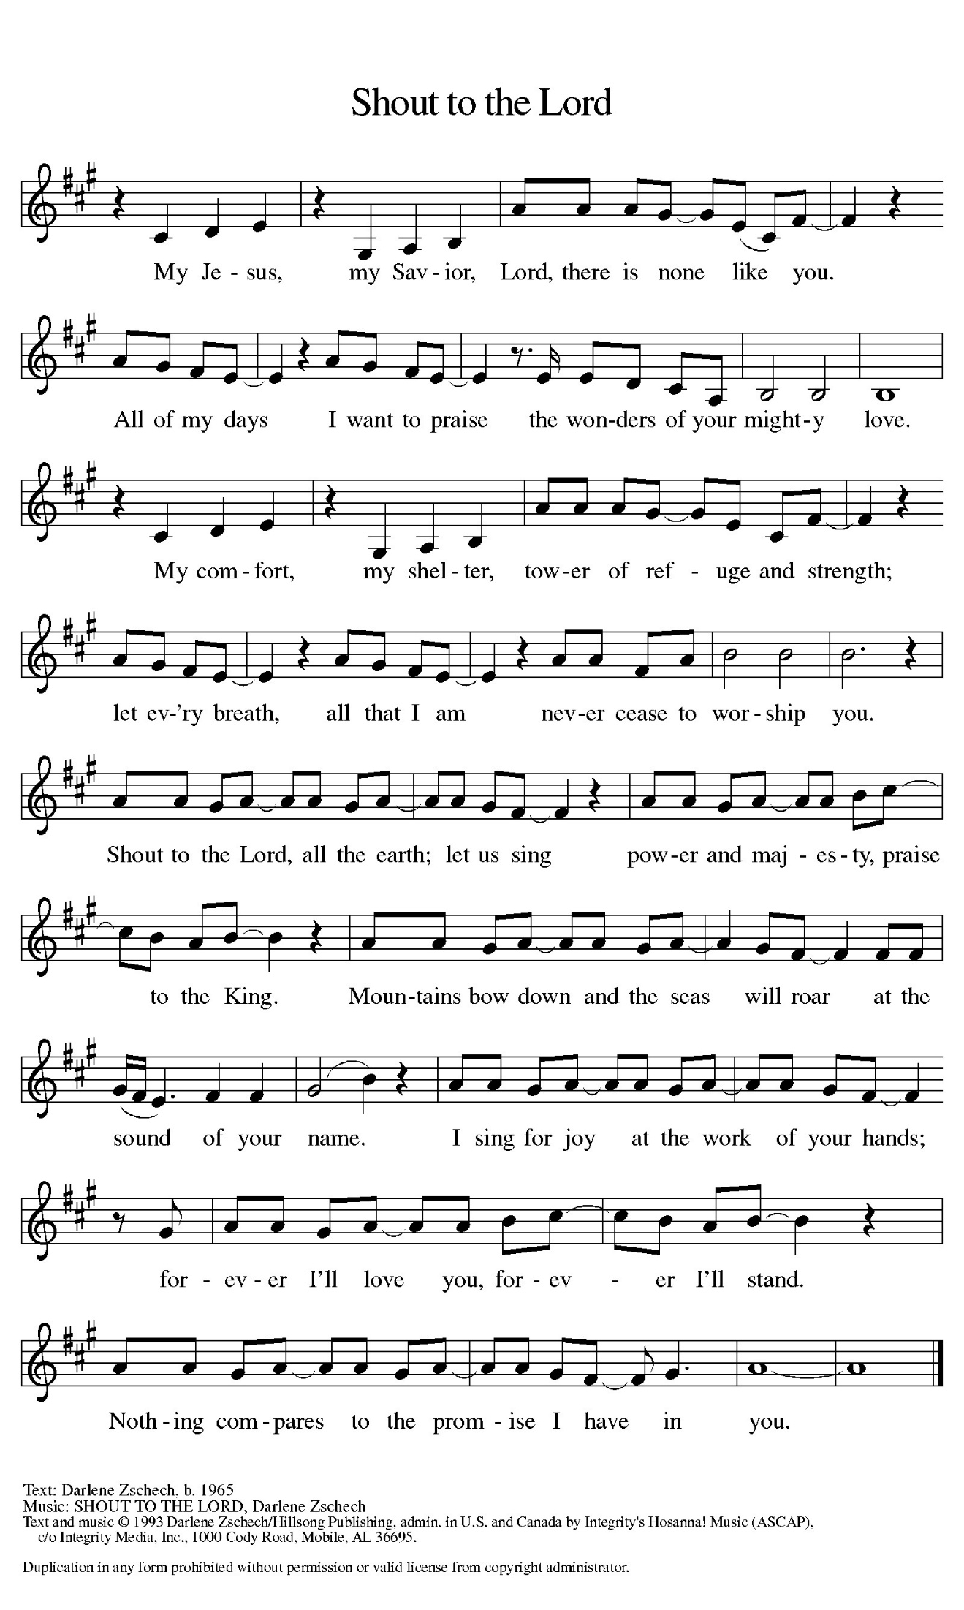

Prayer of the Day
Let us pray together.
Almighty and eternal God, you show perpetual lovingkindness to us your servants. Because we cannot rely on our own abilities, grant us your merciful judgment, and train us to embody the generosity of your Son, Jesus Christ, our Savior and Lord.
Amen.

First Reading Jonah 3:10—4:11

A reading from Jonah.
¹⁰ When God saw what [the people of Ninevah] did, how they turned from their evil ways, God changed his mind about the calamity that he had said he would bring upon them, and he did not do it.
^{4:1} But this was very displeasing to Jonah, and he became angry. ² He prayed to the Lord and said, “O Lord! Is not this what I said while I was still in my own country? That is why I fled to Tarshish at the beginning, for I knew that you are a gracious and merciful God, slow to anger, abounding in steadfast love, and relenting from punishment. ³ And now, O Lord, please take my life from me, for it is better for me to die than to live.” ⁴ And the Lord said, “Is it right for you to be angry?” ⁵ Then Jonah went out of the city and sat down east of the city and made a booth for himself there. He sat under it in the shade, waiting to see what would become of the city.
⁶ The Lord God appointed a bush and made it come up over Jonah, to give shade over his head, to save him from his discomfort, so Jonah was very happy about the bush. ⁷ But when dawn came up the next day, God appointed a worm that attacked the bush, so that it withered. ⁸ When the sun rose, God prepared a sultry east wind, and the sun beat down on the head of Jonah so that he was faint and asked that he might die. He said, “It is better for me to die than to live.”
⁹ But God said to Jonah, “Is it right for you to be angry about the bush?” And he said, “Yes, angry enough to die.” ¹⁰ Then the Lord said, “You are concerned about the bush, for which you did not labor and which you did not grow; it came into being in a night and perished in a night. ¹¹ And should I not be concerned about Nineveh, that great city, in which there are more than a hundred and twenty thousand persons who do not know their right hand from their left and also many animals?”

The word of the Lord.
Thanks be to God.

Psalm Psalm 145:1-8

¹ I will exalt you, my | God and king,
and bless your name forev- | er and ever.
² Every day | will I bless you
and praise your name forev- | er and ever.
³ Great is the Lord and greatly | to be praised!
There is no end | to your greatness.
⁴ One generation shall praise your works | to another
and shall de- | clare your power.
⁵ I will speak of the glorious splendor | of your majesty
and all your | marvelous works.
⁶ They shall tell of the might of your | wondrous acts,
and I will re- | count your greatness.
⁷ They shall publish the remembrance of | your great goodness;
they shall sing joyfully | of your righteousness.
⁸ The Lord is gracious and full | of compassion,
slow to anger and abounding in | steadfast love.

Second Reading Philippians 1:21-30
A reading from Philippians.
²¹ For to me, living is Christ and dying is gain. ²² If I am to live in the flesh, that means fruitful labor for me, yet I cannot say which I will choose. ²³ I am hard pressed between the two: my desire is to depart and be with Christ, for that is far better, ²⁴ but to remain in the flesh is more necessary for you. ²⁵ Since I am convinced of this, I know that I will remain and continue with all of you for your progress and joy in faith, ²⁶ so that, by my presence again with you, your boast might abound in Christ Jesus because of me.
²⁷ Only, live your life in a manner worthy of the gospel of Christ, so that, whether I come and see you or am absent and hear about you, I will know that you are standing firm in one spirit, striving side by side with one mind for the faith of the gospel ²⁸ and in no way frightened by those opposing you. For them, this is evidence of their destruction but of your salvation. And this is God’s doing. ²⁹ For he has graciously granted you the privilege not only of believing in Christ but of suffering for him as well, ³⁰ since you are having the same struggle that you saw I had and now hear that I still have.

The Word of the Lord.
Thanks be to God.

Gospel Acclamation
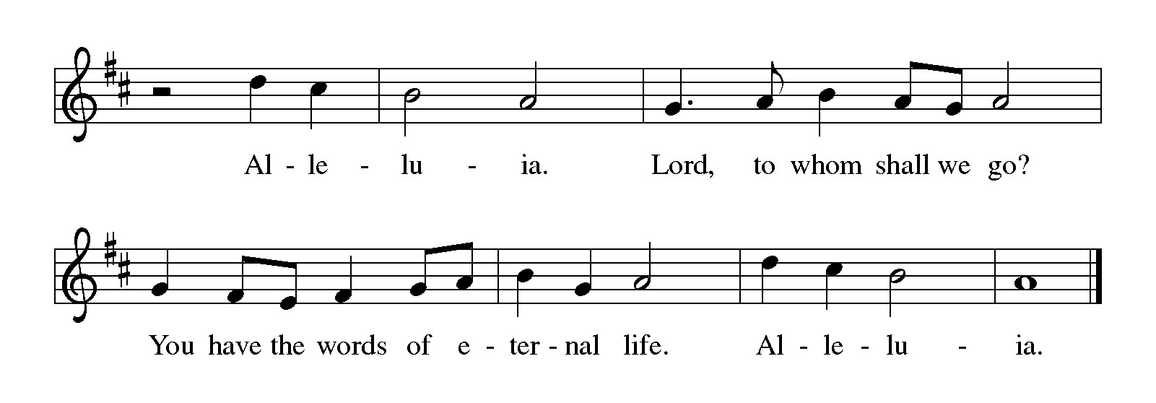

Gospel Matthew 20:1-16
The holy gospel according to Matthew.
Glory to You, O Lord.
[Jesus said to the disciples:] ¹ “The kingdom of heaven is like a landowner who went out early in the morning to hire laborers for his vineyard. ² After agreeing with the laborers for a denarius for the day, he sent them into his vineyard. ³ When he went out about nine o’clock, he saw others standing idle in the marketplace, ⁴ and he said to them, ‘You also go into the vineyard, and I will pay you whatever is right.’ So they went. ⁵ When he went out again about noon and about three o’clock, he did the same. ⁶ And about five o’clock he went out and found others standing around, and he said to them, ‘Why are you standing here idle all day?’ ⁷ They said to him, ‘Because no one has hired us.’ He said to them, ‘You also go into the vineyard.’ ⁸ When evening came, the owner of the vineyard said to his manager, ‘Call the laborers and give them their pay, beginning with the last and then going to the first.’ ⁹ When those hired about five o’clock came, each of them received a denarius. ¹⁰ Now when the first came, they thought they would receive more; but each of them also received a denarius. ¹¹ And when they received it, they grumbled against the landowner, ¹² saying, ‘These last worked only one hour, and you have made them equal to us who have borne the burden of the day and the scorching heat.’ ¹³ But he replied to one of them, ‘Friend, I am doing you no wrong; did you not agree with me for a denarius? ¹⁴ Take what belongs to you and go; I choose to give to this last the same as I give to you. ¹⁵ Am I not allowed to do what I choose with what belongs to me? Or are you envious because I am generous?’ ¹⁶ So the last will be first, and the first will be last.”

The gospel of the Lord.
Praise to you, O Christ.

CHILDREN’S MOMENT

SERMON Pastor Ken Scheck

hymn of the day “Take My Life, That I May Be” #583

CREED
I believe in God, the Father almighty,
creator of heaven and earth.
I believe in Jesus Christ, God’s only Son, our Lord,
who was conceived by the Holy Spirit,
born of the virgin Mary,
suffered under Pontius Pilate,
was crucified, died, and was buried;
he descended to the dead.*
On the third day he rose again;
he ascended into heaven,
he is seated at the right hand of the Father,
and he will come to judge the living and the dead.
I believe in the Holy Spirit,
the holy catholic church,
the communion of saints,
the forgiveness of sins,
the resurrection of the body,
and the life everlasting. Amen.

*Or, “he descended into hell,” another translation of this text in widespread use.

prayers of Intercession (Please Be Seated)
Reminded of God’s gracious and abundant love, we offer our prayers, confident that God hears us.
A brief silence.
Hold your church accountable for our unwillingness to share your good news and our anger at your generosity to others. Nourish us by your grace to be witnesses to your love. We pray especially for Feast of Victory Lutheran Church in Acme and their Pastor Rev. Haley Vay Beaman.
Hear us, O God.
Your mercy is great.
Guide scientists and researchers studying responses to the climate crisis so that all your creation may inspire us to give thanks for your great goodness. Hear us, O God.
Your mercy is great.
Show employers the benefits of equal pay standards for all their employees. Reconcile conflicts between employees. Fill places of employment with camaraderie, and bring an end to employment disparity. Hear us, O God.
Your mercy is great.
Encourage any who cannot work or who cannot work a full day with the truth that their value comes from your everlasting love for them. Provide for those who are injured, ill, and for all in any need. Hear us, O God.
Your mercy is great.
Strengthen all those in this congregation whose labor serves the needs of others in the community. We pray especially for all those on our prayer list and in our hearts, and all countries involved in ongoing conflicts. Inspire all in this congregation to support community endeavors with our time and talents. Hear us, O God.
Your mercy is great.
Comfort us with the promise of the resurrection as we remember all our loved ones whose desire to be with Jesus is fulfilled. Hear us, O God.
Your mercy is great.
Grant the prayers we have offered, what we have forgotten to ask, and whatever else you see that we need. We ask this in Jesus’ name.
Amen.

PEACE
Sharing the Peace of God
The peace of the risen Christ be with you always.
And also with you.
(We share the peace of Christ with one another.)

OFFERING & OFFERING SONG
The joy of the Lord is my strength,
The joy of the Lord is my strength,
The joy of the Lord is my strength,
The joy of the Lord is my strength.

Offering Prayer
Let us pray.
God of creation,
you send rain and the earth springs forth abundantly.
All blessings are from you;
make us generous with what we have.
Use our gifts, our abilities, and our hearts
in service to you and in love to our neighbors,
today and always.
Amen.

DIALOGUE
The Lord be with you.
And also with you.
Lift up your hearts.
We lift them to the Lord.
Let us give thanks to the Lord our God.
It is right to give our thanks and praise.
PREFACE (Pastor)
It is indeed right, our duty and our joy,
that we should at all times and in all places
give thanks and praise to you, almighty and merciful God,
through our Savior Jesus Christ;
who on this day overcame death and the grave,
and by his glorious resurrection opened to us the way of everlasting life.
And so, with all the choirs of angels,
with the church on earth and the hosts of heaven,
we praise your name and join their unending hymn

Holy, holy, holy
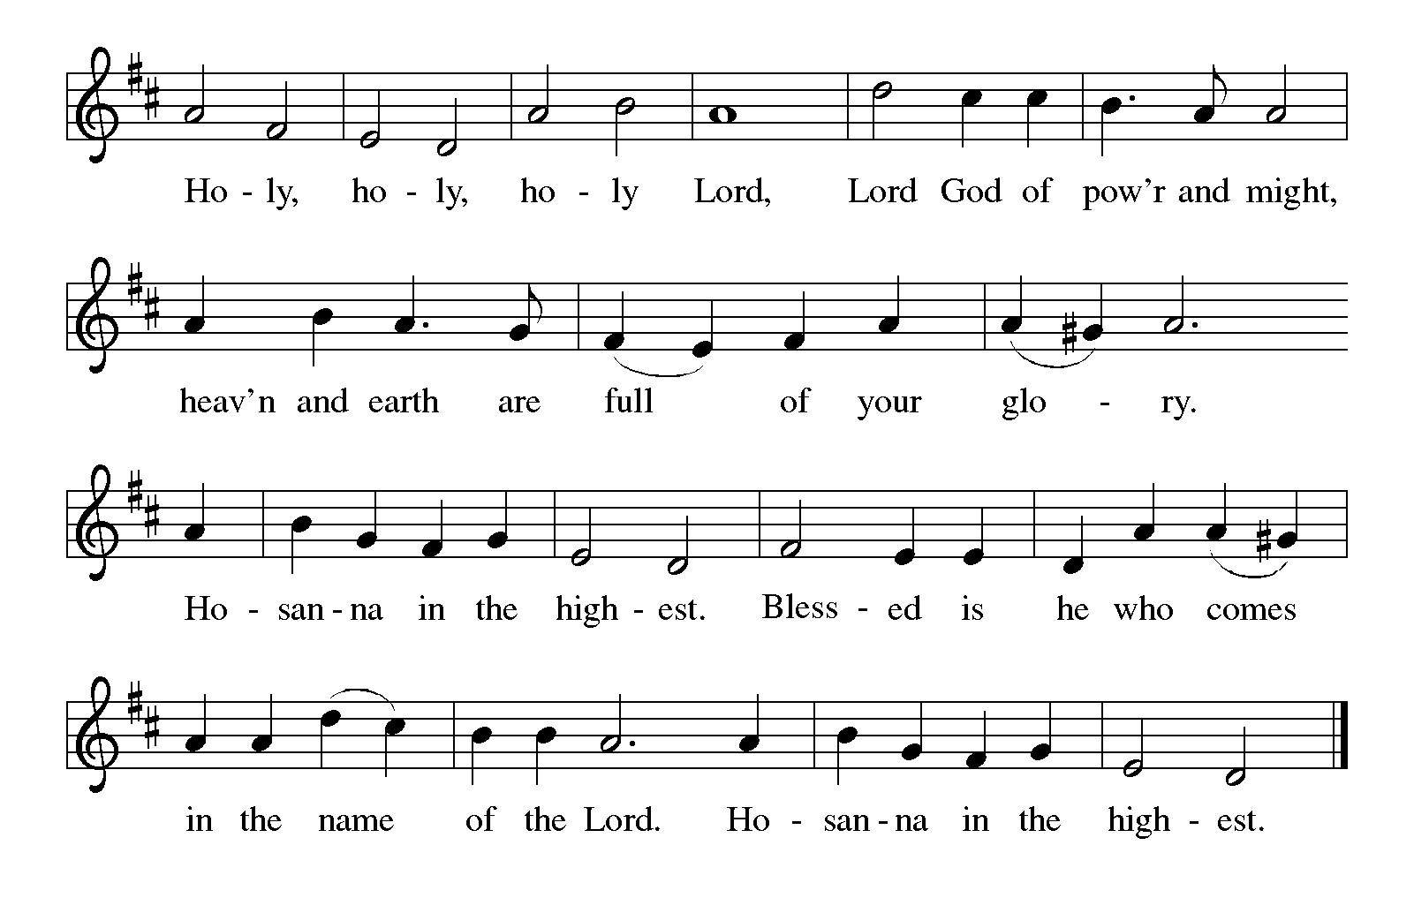

Thanksgiving at the Table
Holy God,
you alone are holy,
you alone are God.

The universe declares your praise:
beyond the stars;
beyond the sea;
within each cell;
with every breath.

Generations bless your faithfulness:
through the water;
by night and day;
across the wilderness;
out of exile;
into the future.

We give you thanks for your dear Son:
at the heart of human life;
near to those who suffer;
beside the sinner;
among the poor;
with us now.

In the night in which he was betrayed,
our Lord Jesus took bread;
and gave thanks; broke it,
and gave it to his disciples,
saying: Take and eat;
this is my body, given for you.
Do this in remembrance of me.

Again, after supper,
he took the cup, gave thanks,
and gave it for all to drink, saying: This is the new covenant I my blood,
shed for you and for all people
for the forgiveness of sin.
Do this for the remembrance of me.

Remembering his love for us
on the way,
at the table,
and to the end,
we proclaim the mystery of faith:

Christ has died.
Christ is risen.
Christ will come again.

Lord’s Prayer
Gathered into one by the Holy Spirit, let us pray as Jesus taught us.
Our Father, who art in heaven,
hallowed be thy name,
thy kingdom come,
thy will be done,
on earth as it is in heaven.
Give us this day our daily bread;
and forgive us our trespasses,
as we forgive those
who trespass against us;
and lead us not into temptation,
but deliver us from evil.
For thine is the kingdom,
and the power, and the glory,
forever and ever. Amen.

INVITATION TO COMMUNION
Christ invites you to this table.
All who are thirsty, all who are hungry, come!

COMMUNION *continuous
*People are welcome to kneel at the altar rail for a time of prayer after they receive their communion elements.

COMMUNION HYMNS
“Will You Let me be your Servant” #659
“Come to the Table” # 481

PRAYER AFTER COMMUNION
Let us pray.
Sustaining God,
with this bread and cup,
you nourish us with mercy and abundant life.
By your spirit, send us from this table to serve a needy world.
Make us living signs of your liberation, healing, and love,
Following the way of Jesus, in whose name we pray.
Amen.

Blessing
The God of love
draw you into full accord and one mind,
in the body of Christ Jesus.
Amen.
The God of hope
grant you strength and joy in all circumstances
through the interceding of the Spirit.
Amen.
The God of grace
☩ bless you now and forever.
Amen.

Sending SonG “Rise Up, O Saints of God” #669

Dismissal
Go out in joy. Be led forth in peace.
Thanks be to God.

From sundaysandseasons.com. Copyright © 2017 Augsburg Fortress. All rights reserved.

Thank you to all who served in worship today!
Presiders: Pastor Ken Scheck Musician: Jayne Flanigan
Acolyte: Kole Hokanson Safety Person:
Elder: Dan Utterback Trustee: Mike Johnson
Offering Counters: Mary Makley & Martha Yoder



PRAYERS OF THE FAITHFUL

With thanks for all God’s blessings and his love for all people. Our Bishops, Julie Schneider-Thomas, Yehiel Curry, and the congregations of the North/West Lower Michigan Synod. We pray especially for Feast of Victory Lutheran Church in Acme and their Pastor Rev. Haley Vay Beaman.

Prayers for our friends, for all who are sick or hospitalized and for all health care workers who care for them. All those members of Zion’s family traveling; all those homebound or in frail health; all those suffering with quiet, unknown needs or worries. For those who serve on our behalf: public safety, utility workers, medical personnel, military personnel. For those who might be forgotten. We pray especially for all countries involved in ongoing conflicts.

This week at Zion:
- Men’s Breakfast at 8am, Wednesday 23th
- Bulletin Deadline, Wednesday 23th

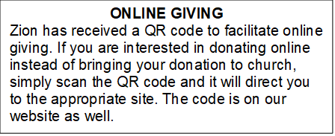

How to Contact the Pastor: If there is a pastoral need, please contact
Pastor Ken Scheck II at 269-370-4632 or by email at kscheckii@aol.com.

ANNOUNCEMENTS

- Baby Shower Table: Please join us in welcoming Raelynn Grace, the daughter to Erin and Travis Scarbrough! We will host a baby shower table in the Fellowship Hall until Sunday, October 25.They have asked for the following: Diapers, size 1 and up Wipes, Gift cards to buy baby formula. If you have any questions, please see Jolene. We welcome Raelynn Grace to Zion's family!
- Soap Needed for Baby Care Kits: Baby Care kits for Lutheran World Relief are underway and we need soap to add to the kits. Each completed kit will have 2-3 bars of "gentle soap." We hope to make 25-30 kits so we need 75-90 bars of soap. If you can help, please bring a bar - or more - of soap to church between now and September 27th. Ivory, Dove, Carass or any gentle brand will do. We will be putting the kits together on Wednesday, October 7th at 10:00 am. If you are free, please come help with this important mission project. Lutheran World Relief distributes the kits in the US and around the world where needed. Thank you for your help and support. If you have questions, please talk with Karen, Martha or Ruth.
- Baptism for Raelynn Scarborough October 4th: We are excited to be welcoming Raelynn into the family of Zion through baptism on Sunday October 4, 2026. Raelynn is the daughter of Erin and Travis Scarborough. There will be fellowship following worship. Please plan to attend and support this family of Zion.
- First Communion, September 27th: On September 27th Layne Griffin and Lennox Griffin will be having their first communion. We will celebrate their first communion during fellowship on October 25th. Layne and Lennox are the children of Jason and Ashley Griffin and grandchildren of Diane and Don Griffin.
- Church Halloween Party, October 25th: There will be a church Halloween Party and potluck following worship on October 25th. Please plan to stay for this time of fellowship and fun.
- Halloween Bags for the Shut-ins: Bags to collect goodies for our shut-ins will be out in the fellowship hall soon. Please bring a card, note, goody or other item to let our shut-ins know they are thought of and cared for. If you have questions, please see Dawn Brodbeck
- Zion’s 170th Anniversary Celebration, August 23rd: A sincere “thank you” to everyone who served on the 170th Anniversary Committee for all their planning and hard work. The 170th service and celebration on August 23rd was amazing! We worshiped outside with about 100 people in attendance. We were blessed to have Pastor Becky and Terry Ebb-Speese, Pastor Jim and Sandy Couser, Pastor Polly and John Standley and Pastor Mike and Vicki Anderson with us for this special day. Pastor Marilyn Danielson from the Congregational Church in Lake Odessa joined us for the hymn sing. Everyone enjoyed great fellowship and food following the service. People stayed to tour the church and look at the historical exhibits in the Fireside Lounge, displays in other areas of the church and a hymn sing in the sanctuary. It was a wonderful day! If you were not able to attend, there are extra copies of the timeline, the bulletin from the service, ink pens, coffee mugs and water bottles for you too! Also, attached to the newsletter is a copy of the summary of Zion’s history shared by Pastor Ken during the service. We are so blessed to have a legacy of 170 years of worship and service and look forward to what the future has in store for us at Zion.
- Announcement and Newsletter Items: Please forward items for the bulletin announcements and the newsletter to the church email (Office@Zion.org). Please do not send items to people’s personal emails. Thank you.
- Door Locking Policy: Our door locking policy relies on having a volunteer(s) each Sunday to serve as the Safety Person of the Day. On Sundays where no one has volunteered, if someone arrives at church and is willing to be the Safety Person of the Day, we will follow the door locking policy. If no one steps forward to serve as the Safety Person of the Day, the doors will not be locked. Please consider volunteering for this important duty.

