ZION LUTHERAN CHURCH, WOODLAND, MI
Eighteenth Sunday After Pentecost, Sunday September 27, 2026
*If you are listening in your car, please tune your radio to FM 87.7*
(Please silence your cell phones while in the sanctuary. Thank you.)

WELCOME AND ANNOUNCEMENTS

Gathering
The Holy Spirit calls us together as the people of God.

Confession and Forgiveness
Blessed be the holy Trinity, ☩ one God,
who pours love into our hearts
and healing upon the earth.
Amen.

Confident that God justifies us by grace through faith,
let us confess our sin.

Compassionate God,
we confess that we struggle to embody your goodness
in the world and in our own hearts.
Creation groans from overuse.
Jealousy and bitterness strain our relationships.
Indifference keeps us from seeking justice.
Divisions disrupt your call to show genuine love
to others.
Turn our hearts back to you.
Restore our world and reconcile us to one another.
Renew us to live as your holy people,
Following the way of Jesus Christ.
Amen.

Hear the good news:
We have peace with God through ☩ Jesus Christ,
in whom there is no condemnation,
but only forgiveness and the promise of eternal life.
Receive freely this healing gift of grace.
Amen.

GATHERING HYMN “Shout to the Lord” #821

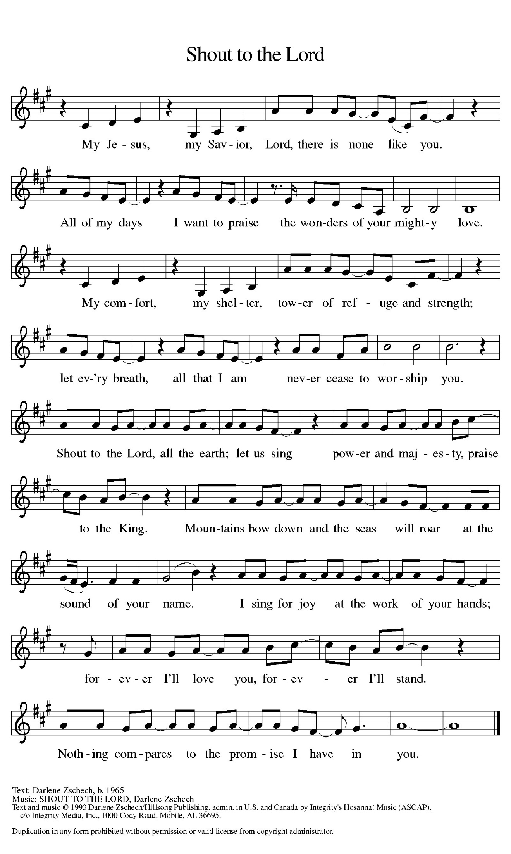

Prayer of the Day
Let us pray together.
God of love, giver of life, you know our frailties and failings. Give us your grace to overcome them, keep us from those things that harm us, and guide us in the way of salvation, through Jesus Christ, our Savior and Lord.
Amen.

First Reading Ezekiel 18:1-4, 25-32

A reading from Ezekiel.
¹ The word of the Lord came to me: ² What do you mean by repeating this proverb concerning the land of Israel, “The parents have eaten sour grapes, and the children’s teeth are set on edge”? ³ As I live, says the Lord God, this proverb shall no more be used by you in Israel. ⁴ Know that all lives are mine; the life of the parent as well as the life of the child is mine: it is only the person who sins who shall die.
²⁵ Yet you say, “The way of the Lord is unfair.” Hear now, O house of Israel: Is my way unfair? Is it not your ways that are unfair? ²⁶ When the righteous turn away from their righteousness and commit iniquity, they shall die for it; for the iniquity that they have committed, they shall die. ²⁷ Again, when the wicked turn away from the wickedness they have committed and do what is lawful and right, they shall save their life. ²⁸ Because they considered and turned away from all the transgressions that they had committed, they shall surely live; they shall not die. ²⁹ Yet the house of Israel says, “The way of the Lord is unfair.” O house of Israel, are my ways unfair? Is it not your ways that are unfair?
³⁰ Therefore I will judge you, O house of Israel, all of you according to your ways, says the Lord God. Repent and turn from all your transgressions; otherwise iniquity will be your ruin. ³¹ Cast away from you all the transgressions that you have committed against me, and get yourselves a new heart and a new spirit! Why will you die, O house of Israel? ³² For I have no pleasure in the death of anyone, says the Lord God. Turn, then, and live.

The word of the Lord.
Thanks be to God.

Psalm Psalm 25:1-9

¹ To | you, O Lord,
I lift | up my soul.
² My God, I put my trust in you; let me not be | put to shame,
nor let my enemies triumph | over me.
³ Let none who look to you be | put to shame;
rather let those be put to shame | who are treacherous.
⁴ Show me your | ways, O Lord,
and teach | me your paths.
⁵ Lead me in your | truth and teach me,
for you are the God of my salvation; in you have I trusted all | the day long.
⁶ Remember, O Lord, your compas- | sion and love,
for they are from | everlasting.
⁷ Remember not the sins of my youth and | my transgressions;
remember me according to your steadfast love and for the sake of your good- | ness, O Lord.
⁸ You are gracious and up- | right, O Lord;
therefore you teach sinners | in your way.
⁹ You lead the low- | ly in justice
and teach the low- | ly your way.

Second Reading Philippians 2:1-13
A reading from Philippians.
¹ If, then, there is any comfort in Christ, any consolation from love, any partnership in the Spirit, any tender affection and sympathy, ² make my joy complete: be of the same mind, having the same love, being in full accord and of one mind. ³ Do nothing from selfish ambition or empty conceit, but in humility regard others as better than yourselves. ⁴ Let each of you look not to your own interests but to the interests of others. ⁵ Let the same mind be in you that was in Christ Jesus,
⁶ who, though he existed in the form of God,
did not regard equality with God
as something to be grasped,
⁷ but emptied himself,
taking the form of a slave,
assuming human likeness.
And being found in appearance as a human,
⁸ he humbled himself
and became obedient to the point of death—
even death on a cross.
⁹ Therefore God exalted him even more highly
and gave him the name
that is above every other name,
¹⁰ so that at the name given to Jesus
every knee should bend,
in heaven and on earth and under the earth,
¹¹ and every tongue should confess
that Jesus Christ is Lord,
to the glory of God the Father.
¹² Therefore, my beloved, just as you have always obeyed me, not only in my presence but much more now in my absence, work on your own salvation with fear and trembling, ¹³ for it is God who is at work in you, enabling you both to will and to work for his good pleasure.

The Word of the Lord.
Thanks be to God.

Gospel Acclamation
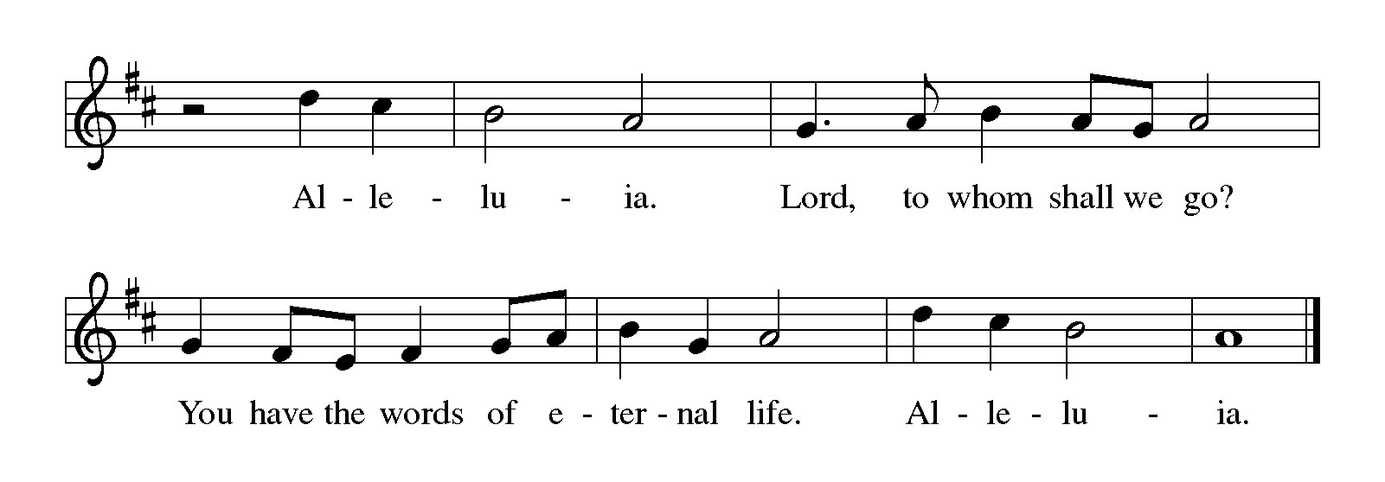

Gospel Matthew 21:23-32
The holy gospel according to Matthew.
Glory to You, O Lord.
²³ When [Jesus] entered the temple, the chief priests and the elders of the people came to him as he was teaching and said, “By what authority are you doing these things, and who gave you this authority?” ²⁴ Jesus said to them, “I will also ask you one question; if you tell me the answer, then I will also tell you by what authority I do these things. ²⁵ Did the baptism of John come from heaven, or was it of human origin?” And they argued with one another, “If we say, ‘From heaven,’ he will say to us, ‘Why, then, did you not believe him?’ ²⁶ But if we say, ‘Of human origin,’ we are afraid of the crowd, for all regard John as a prophet.” ²⁷ So they answered Jesus, “We do not know.” And he said to them, “Neither will I tell you by what authority I am doing these things.
²⁸ “What do you think? A man had two sons; he went to the first and said, ‘Son, go and work in the vineyard today.’ ²⁹ He answered, ‘I will not,’ but later he changed his mind and went. ³⁰ The father went to the second and said the same, and he answered, ‘I go, sir,’ but he did not go. ³¹ Which of the two did the will of his father?” They said, “The first.” Jesus said to them, “Truly I tell you, the tax collectors and the prostitutes are going into the kingdom of God ahead of you. ³² For John came to you in the way of righteousness, and you did not believe him, but the tax collectors and the prostitutes believed him, and even after you saw it you did not change your minds and believe him.”

The gospel of the Lord.
Praise to you, O Christ.

CHILDREN’S MOMENT

SERMON Nathan Unseth

hymn of the day “Lord, Keep Us Steadfast in Your Word” #517

CREED
I believe in God, the Father almighty,
creator of heaven and earth.
I believe in Jesus Christ, God’s only Son, our Lord,
who was conceived by the Holy Spirit,
born of the virgin Mary,
suffered under Pontius Pilate,
was crucified, died, and was buried;
he descended to the dead.*
On the third day he rose again;
he ascended into heaven,
he is seated at the right hand of the Father,
and he will come to judge the living and the dead.
I believe in the Holy Spirit,
the holy catholic church,
the communion of saints,
the forgiveness of sins,
the resurrection of the body,
and the life everlasting. Amen.

*Or, “he descended into hell,” another translation of this text in widespread use.

prayers of Intercession (Please Be Seated)
Reminded of God’s gracious and abundant love, we offer our prayers, confident that God hears us.
A brief silence.
Center your church in humility as we strive to follow in your way. Help us listen to the cries of those who have been unfairly hurt by the church and dare to name difficult truths. Show all your love. We pray especially for Immanuel Lutheran Church in Allegan and their Pastor Rev. Christopher Laughlin. Hear us, O God.
Your mercy is great.
You call us to care for your creation. Lead us into your promise of a better world through sustainable practices and respect for your handiwork. Hear us, O God.
Your mercy is great.
Inspire all in positions of authority to act honorably. Remind them of their call to use their authority for the sake of the common good. Give them the gift of humility. Hear us, O God.
Your mercy is great.
Comfort those who come before you in fear and trembling. Calm troubled hearts with your forgiveness. Help all those in need. We pray especially for all those on our prayer list and in our hearts, and all countries involved in ongoing conflicts. Grant us your salvation. Hear us, O God.
Your mercy is great.
Change this congregation’s heart when we say no to your call. Open us to courageous learning and service in our community, especially in new or challenging places. Hear us, O God.
Your mercy is great.
Your steadfast love holds all the saints who have finished their work and are at rest. As we grieve, remind us of your mercy so we may also give thanks. Hear us, O God.
Your mercy is great.
Grant the prayers we have offered, what we have forgotten to ask, and whatever else you see that we need. We ask this in Jesus’ name.
Amen.
PEACE
Sharing the Peace of God
The peace of the risen Christ be with you always.
And also with you.
(We share the peace of Christ with one another.)

OFFERING & OFFERING SONG
The joy of the Lord is my strength,
The joy of the Lord is my strength,
The joy of the Lord is my strength,
The joy of the Lord is my strength.

Offering Prayer
Let us pray.
God of creation,
you send rain and the earth springs forth abundantly.
All blessings are from you;
make us generous with what we have.
Use our gifts, our abilities, and our hearts
in service to you and in love to our neighbors,
today and always.
Amen.

DIALOGUE
The Lord be with you.
And also with you.
Lift up your hearts.
We lift them to the Lord.
Let us give thanks to the Lord our God.
It is right to give our thanks and praise.
PREFACE (Pastor)
It is indeed right, our duty and our joy,
that we should at all times and in all places
give thanks and praise to you, almighty and merciful God,
through our Savior Jesus Christ;
who on this day overcame death and the grave,
and by his glorious resurrection opened to us the way of everlasting life.
And so, with all the choirs of angels,
with the church on earth and the hosts of heaven,
we praise your name and join their unending hymn

Holy, holy, holy
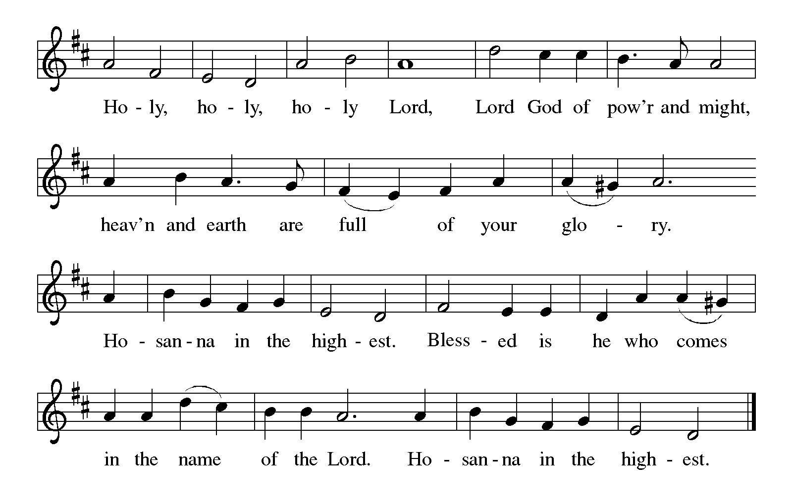

Thanksgiving at the Table
Holy God,
you alone are holy,
you alone are God.

The universe declares your praise:
beyond the stars;
beyond the sea;
within each cell;
with every breath.

Generations bless your faithfulness:
through the water;
by night and day;
across the wilderness;
out of exile;
into the future.

We give you thanks for your dear Son:
at the heart of human life;
near to those who suffer;
beside the sinner;
among the poor;
with us now.

In the night in which he was betrayed,
our Lord Jesus took bread;
and gave thanks; broke it,
and gave it to his disciples,
saying: Take and eat;
this is my body, given for you.
Do this in remembrance of me.

Again, after supper,
he took the cup, gave thanks,
and gave it for all to drink, saying: This is the new covenant in my blood,
shed for you and for all people
for the forgiveness of sin.
Do this for the remembrance of me.

Remembering his love for us
on the way,
at the table,
and to the end,
we proclaim the mystery of faith:

Christ has died.
Christ is risen.
Christ will come again.

Lord’s Prayer
Gathered into one by the Holy Spirit, let us pray as Jesus taught us.
Our Father, who art in heaven,
hallowed be thy name,
thy kingdom come,
thy will be done,
on earth as it is in heaven.
Give us this day our daily bread;
and forgive us our trespasses,
as we forgive those
who trespass against us;
and lead us not into temptation,
but deliver us from evil.
For thine is the kingdom,
and the power, and the glory,
forever and ever. Amen.

INVITATION TO COMMUNION
Christ invites you to this table.
All who are thirsty, all who are hungry, come!

COMMUNION *continuous
*People are welcome to kneel at the altar rail for a time of prayer after they receive their communion elements.

COMMUNION HYMNS
“O Master, Let Me Walk with You” #818
“In the Singing” #466

PRAYER AFTER COMMUNION
Let us pray.
Sustaining God,
with this bread and cup,
you nourish us with mercy and abundant life.
By your spirit, send us from this table to serve a needy world.
Make us living signs of your liberation, healing, and love,
Following the way of Jesus, in whose name we pray.
Amen.
Blessing
The God of love
draw you into full accord and one mind,
in the body of Christ Jesus.
Amen.
The God of hope
grant you strength and joy in all circumstances
through the interceding of the Spirit.
Amen.
The God of grace
☩ bless you now and forever.
Amen.

Sending SonG “I Love to Tell the Story” #661

Dismissal
Go out in joy. Be led forth in peace.
Thanks be to God.

From sundaysandseasons.com. Copyright © 2017 Augsburg Fortress. All rights reserved.

Thank you to all who served in worship today!
Presiders: Nathan Unseth Musician: Jayne Flanigan
Acolyte: Safety Person:
Elder: Buffy Meyers Trustee: Doug MacKenzie
Offering Counters: Doug MacKenzie & Mike Johnson



PRAYERS OF THE FAITHFUL

With thanks for all God’s blessings and his love for all people. Our Bishops, Julie Schneider-Thomas, Yehiel Curry, and the congregations of the North/West Lower Michigan Synod. We pray especially for Immanuel Lutheran Church in Allegan and their Pastor Rev. Christopher Laughlin.

Prayers for our friends, for all who are sick or hospitalized and for all health care workers who care for them. All those members of Zion’s family traveling; all those homebound or in frail health; all those suffering with quiet, unknown needs or worries. For those who serve on our behalf: public safety, utility workers, medical personnel, military personnel. For those who might be forgotten. We pray especially for all countries involved in ongoing conflicts.

This week at Zion:
- Men’s Breakfast at 8am, Wednesday 30th
- Bulletin Deadline, Wednesday 30th

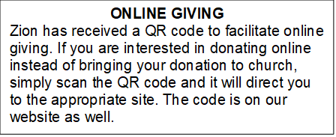

How to Contact the Pastor: If there is a pastoral need, please contact
Pastor Ken Scheck II at 269-370-4632 or by email at kscheckii@aol.com.

ANNOUNCEMENTS

- Baby Shower Table: Please join us in welcoming Raelynn Grace, the daughter to Erin and Travis Scarbrough! We will host a baby shower table in the Fellowship Hall until Sunday, October 25.They have asked for the following: Diapers, size 1 and up Wipes, Gift cards to buy baby formula. If you have any questions, please see Jolene. We welcome Raelynn Grace to Zion's family!
- Soap Needed for Baby Care Kits: Baby Care kits for Lutheran World Relief are underway and we need soap to add to the kits. Each completed kit will have 2-3 bars of "gentle soap." We hope to make 25-30 kits so we need 75-90 bars of soap. If you can help, please bring a bar - or more - of soap to church between now and September 27th. Ivory, Dove, Carass or any gentle brand will do. We will be putting the kits together on Wednesday, October 7th at 10:00 am. If you are free, please come help with this important mission project. Lutheran World Relief distributes the kits in the US and around the world where needed. Thank you for your help and support. If you have questions, please talk with Karen, Martha or Ruth.
- Baptism for Raelynn Scarborough October 4th: We are excited to be welcoming Raelynn into the family of Zion through baptism on Sunday October 4, 2026. Raelynn is the daughter of Erin and Travis Scarborough. There will be fellowship following worship. Please plan to attend and support this family of Zion.
- First Communion, September 27th: On September 27th Layne Griffin and Lennox Griffin will be having their first communion. We will celebrate their first communion during fellowship on October 25th. Layne and Lennox are the children of Jason and Ashley Griffin and grandchildren of Diane and Don Griffin.
- Church Halloween Party, October 25th: There will be a church Halloween Party and potluck following worship on October 25th. Please plan to stay for this time of fellowship and fun.
- Halloween Bags for the Shut-ins: Bags to collect goodies for our shut-ins will be out in the fellowship hall soon. Please bring a card, note, goody or other item to let our shut-ins know they are thought of and cared for. If you have questions, please see Dawn Brodbeck
- Zion’s 170th Anniversary Celebration, August 23rd: A sincere “thank you” to everyone who served on the 170th Anniversary Committee for all their planning and hard work. The 170th service and celebration on August 23rd was amazing! We worshiped outside with about 100 people in attendance. We were blessed to have Pastor Becky and Terry Ebb-Speese, Pastor Jim and Sandy Couser, Pastor Polly and John Standley and Pastor Mike and Vicki Anderson with us for this special day. Pastor Marilyn Danielson from the Congregational Church in Lake Odessa joined us for the hymn sing. Everyone enjoyed great fellowship and food following the service. People stayed to tour the church and look at the historical exhibits in the Fireside Lounge, displays in other areas of the church and a hymn sing in the sanctuary. It was a wonderful day! If you were not able to attend, there are extra copies of the timeline, the bulletin from the service, ink pens, coffee mugs and water bottles for you too! Also, attached to the newsletter is a copy of the summary of Zion’s history shared by Pastor Ken during the service. We are so blessed to have a legacy of 170 years of worship and service and look forward to what the future has in store for us at Zion.
- Announcement and Newsletter Items: Please forward items for the bulletin announcements and the newsletter to the church email (Office@Zion.org). Please do not send items to people’s personal emails. Thank you.
- Door Locking Policy: Our door locking policy relies on having a volunteer(s) each Sunday to serve as the Safety Person of the Day. On Sundays where no one has volunteered, if someone arrives at church and is willing to be the Safety Person of the Day, we will follow the door locking policy. If no one steps forward to serve as the Safety Person of the Day, the doors will not be locked. Please consider volunteering for this important duty.

