ZION LUTHERAN CHURCH, WOODLAND, MI
Nineteenth Sunday After Pentecost, October 4, 2026
*If you are listening in your car, please tune your radio to FM 87.7*
(Please silence your cell phones while in the sanctuary. Thank you.)
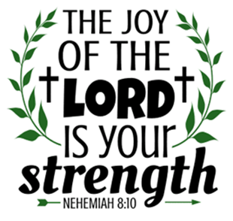
WELCOME AND ANNOUNCEMENTS

Gathering
The Holy Spirit calls us together as the people of God.

Confession and Forgiveness
Blessed be the holy Trinity, ☩ one God,
who pours love into our hearts
and healing upon the earth.
Amen.

Confident that God justifies us by grace through faith,
let us confess our sin.

Compassionate God,
we confess that we struggle to embody your goodness
in the world and in our own hearts.
Creation groans from overuse.
Jealousy and bitterness strain our relationships.
Indifference keeps us from seeking justice.
Divisions disrupt your call to show genuine love
to others.
Turn our hearts back to you.
Restore our world and reconcile us to one another.
Renew us to live as your holy people,
Following the way of Jesus Christ.
Amen.

Hear the good news:
We have peace with God through ☩ Jesus Christ,
in whom there is no condemnation,
but only forgiveness and the promise of eternal life.
Receive freely this healing gift of grace.
Amen.

GATHERING HYMN “Shout to the Lord” #821

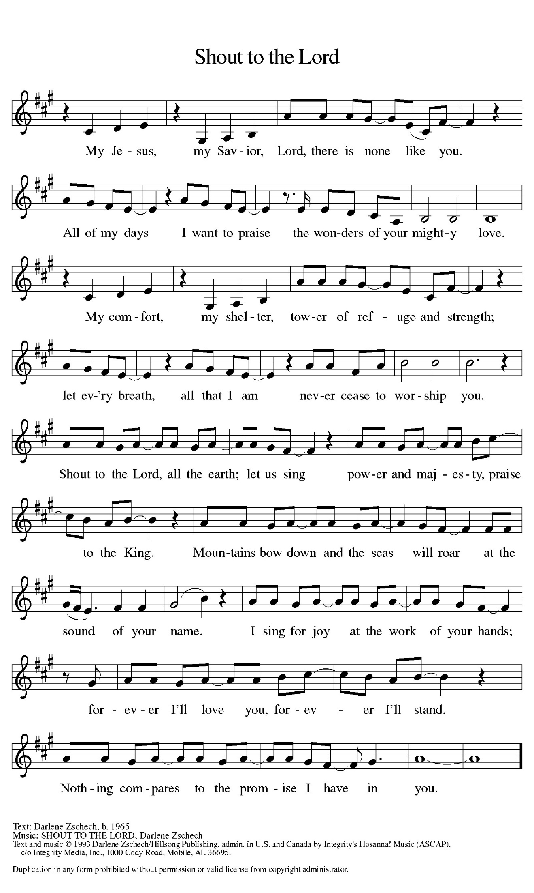

Prayer of the Day
Let us pray together.
Beloved God, from you come all things that are good. Lead us by the inspiration of your Spirit to know those things that are right, and by your merciful guidance, help us to do them, through Jesus Christ, our Savior and Lord.
Amen.

First Reading Isaiah 5:1-7

A reading from Isaiah.
¹ I will sing for my beloved
my love song concerning his vineyard:
My beloved had a vineyard
on a very fertile hill.
² He dug it and cleared it of stones
and planted it with choice vines;
he built a watchtower in the midst of it
and hewed out a wine vat in it;
he expected it to yield grapes,
but it yielded rotten grapes.
³ And now, inhabitants of Jerusalem
and people of Judah,
judge between me
and my vineyard.
⁴ What more was there to do for my vineyard
that I have not done in it?
When I expected it to yield grapes,
why did it yield rotten grapes?
⁵ And now I will tell you
what I will do to my vineyard.
I will remove its hedge,
and it shall be devoured;
I will break down its wall,
and it shall be trampled down.
⁶ I will make it a wasteland;
it shall not be pruned or hoed,
and it shall be overgrown with briers and thorns;
I will also command the clouds
that they rain no rain upon it.
⁷ For the vineyard of the Lord of hosts
is the house of Israel,
and the people of Judah
are his cherished garden;
he expected justice
but saw bloodshed;
righteousness
but heard a cry!

The word of the Lord.
Thanks be to God.

Psalm Psalm 80:7-15
⁷ Restore us, O | God of hosts;
let your face shine upon us, and we | shall be saved.
⁸ You have brought a vine | out of Egypt;
you cast out the nations and | planted it.
⁹ You cleared the | ground for it;
it took root and | filled the land.
¹⁰ The mountains were covered | by its shadow
and the towering cedar trees | by its boughs.
¹¹ You stretched out its tendrils | to the sea
and its branches | to the river.
¹² Why have you broken | down its wall,
so that all who pass by pluck | off its grapes?
¹³ The wild boar of the forest has | ravaged it,
and the beasts of the field have | grazed upon it.
¹⁴ Turn now, O | God of hosts,
look | down from heaven;
¹⁵ behold and | tend this vine;
preserve what your right | hand has planted.

Second Reading Philippians 3:4b-14

A reading from Philippians.
^{4b} If anyone else has reason to be confident in the flesh, I have more: ⁵ circumcised on the eighth day, a member of the people of Israel, of the tribe of Benjamin, a Hebrew born of Hebrews; as to the law, a Pharisee; ⁶ as to zeal, a persecutor of the church; as to righteousness under the law, blameless.
⁷ Yet whatever gains I had, these I have come to regard as loss because of Christ. ⁸ More than that, I regard everything as loss because of the surpassing value of knowing Christ Jesus my Lord. For his sake I have suffered the loss of all things, and I regard them as rubbish, in order that I may gain Christ ⁹ and be found in him, not having a righteousness of my own that comes from the law but one that comes through faith in Christ, the righteousness from God based on faith. ¹⁰ I want to know Christ and the power of his resurrection and the sharing of his sufferings by becoming like him in his death, ¹¹ if somehow I may attain the resurrection from the dead.
¹² Not that I have already obtained this or have already reached the goal, but I press on to lay hold of that for which Christ has laid hold of me. ¹³ Brothers and sisters, I do not consider that I have laid hold of it, but one thing I have laid hold of: forgetting what lies behind and straining forward to what lies ahead, ¹⁴ I press on toward the goal, toward the prize of the heavenly call of God in Christ Jesus.

The Word of the Lord.
Thanks be to God.

Gospel Acclamation
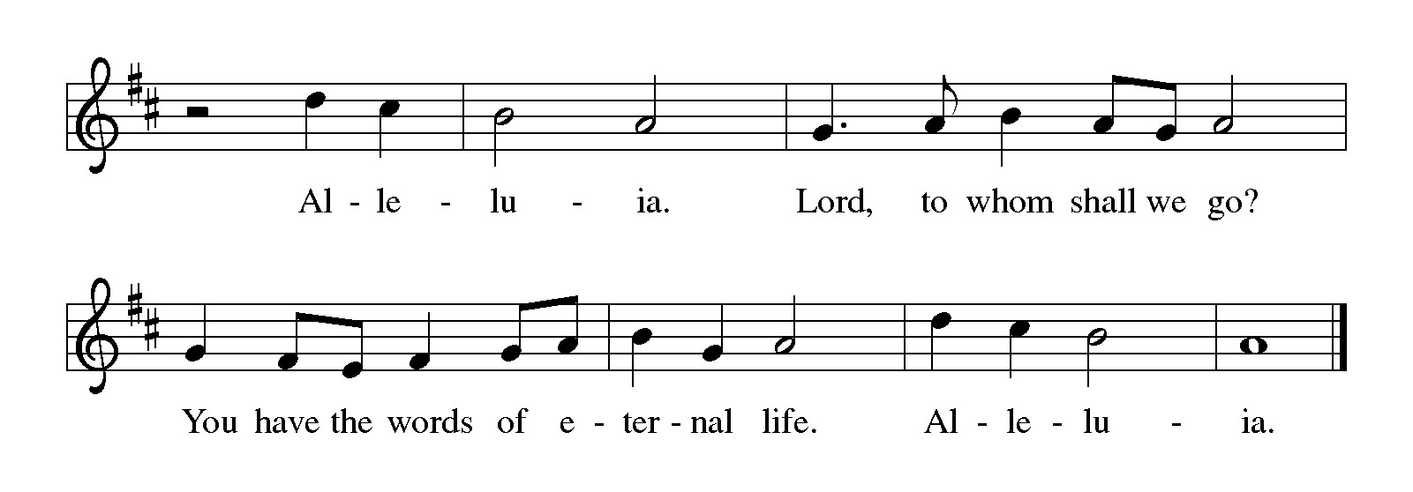

Gospel Matthew 21:33-46
The holy gospel according to Matthew.
Glory to You, O Lord.
³³ “Listen to another parable. There was a landowner who planted a vineyard, put a fence around it, dug a winepress in it, and built a watchtower. Then he leased it to tenants and went away. ³⁴ When the harvest time had come, he sent his slaves to the tenants to collect his produce. ³⁵ But the tenants seized his slaves and beat one, killed another, and stoned another. ³⁶ Again he sent other slaves, more than the first, and they treated them in the same way. ³⁷ Then he sent his son to them, saying, ‘They will respect my son.’ ³⁸ But when the tenants saw the son, they said to themselves, ‘This is the heir; come, let us kill him and get his inheritance.’ ³⁹ So they seized him, threw him out of the vineyard, and killed him. ⁴⁰ Now when the owner of the vineyard comes, what will he do to those tenants?” ⁴¹ They said to him, “He will put those wretches to a miserable death and lease the vineyard to other tenants who will give him the produce at the harvest time.”
⁴² Jesus said to them, “Have you never read in the scriptures:
‘The stone that the builders rejected
has become the cornerstone;
this was the Lord’s doing,
and it is amazing in our eyes’?
⁴³ “Therefore I tell you, the kingdom of God will be taken away from you and given to a people that produces its fruits. ⁴⁴ The one who falls on this stone will be broken to pieces, and it will crush anyone on whom it falls.”
⁴⁵ When the chief priests and the Pharisees heard his parables, they realized that he was speaking about them. ⁴⁶ They wanted to arrest him, but they feared the crowds, because they regarded him as a prophet.

The gospel of the Lord.
Praise to you, O Christ.

CHILDREN’S MOMENT

SERMON Ken Scheck

hymn of the day “There In God’s Garden” #342

HOLY BAPTISM
- Raelynn Grace Scarborough
- Kyle Peake, Sponsor
- Ben Hoffman, Sponsor

PRESENTATION
In Holy Baptism our gracious heavenly Father liberates us from sin and death by joining us to the death and resurrection of our Lord Jesus Christ. We are born children of a fallen humanity; in the waters of Baptism we are reborn children of God and inheritors of eternal life. By water and the Holy Spirit we are made members of the Church which is the body of Christ. As we live with him and with his people, we grow in faith, love, and obedience to the will of God.

- Parents and Sponsor together: We present Raelynn Grace Scarborough
receive the Sacrament of Holy Baptism.

Raelynn, called by the Holy Spirit, trusting in the grace and love of God, do you desire to be baptized into Christ?

Response: I do.

Parent and Sponsor, do you promise to nurture these individuals in the Christian faith as you are empowered by God’s Spirit, and to help them live in the covenant of baptism and in communion with the church?

Parents and Sponsor answer: I do.

People of God, do you promise to support Raelynn and pray for them in their new life in Christ?

Congregation: We do.

PROFESSION OF FAITH
I ask you to profess your faith in Christ Jesus, reject sin, and confess the faith of the church.

Do you renounce the devil and all the forces that defy God?
Response: I renounce them.

Do you renounce the powers of this world that rebel against God?
Response: I renounce them.

I ask you to profess your faith in Christ Jesus, reject sin, and confess the faith of the church, the faith in which we baptize. Do you renounce all the forces of evil, the devil, and all his empty promises?
Response: I do.

Do you believe in God the Father?
I believe in God, the Father almighty,
creator of heaven and earth.

Do you believe in Jesus Christ, the Son of God?
I believe in Jesus Christ, his only Son, our Lord.
He was conceived by the power of the Holy Spirit
and born of the virgin Mary.
He suffered under Pontius Pilate,
was crucified, died, and was buried.
He descended into hell.*
On the third day he rose again.
He ascended into heaven,
and is seated at the right hand of the Father.
He will come again to judge the living and the dead.

Do you believe in God the Holy Spirit?
I believe in the Holy Spirit,
the holy catholic church,
the communion of saints,
the forgiveness of sins,
the resurrection of the body,
and the life everlasting. Amen

THANKSGIVING AT THE FONT

By the baptism of his own death and resurrection your beloved Son has set us free from the bondage to sin and death and has opened the way to the joy and freedom of everlasting life. He made water a sign of the kingdom and of cleansing and rebirth. In obedience to his command, we make disciples of all nations, baptizing them in the name of the Father, and of the Son, and of the Holy Spirit.

Pour out your Holy Spirit, so that the individuals who is here to be baptized may be given new life. Wash away the sin of all those who are cleansed by this water and bring them forth as inheritors of your glorious kingdom.

To you be given praise and honor and worship through your Son, Jesus Christ our Lord, in the unity of the Holy Spirit, now and forever.
Amen

BAPTISM
Raelynn Grace Scarborough, I baptize you in the name of the Father, and of the Son, and of the Holy Spirit. Amen

Let us pray.
God, the Father of our Lord Jesus Christ, we give you thanks for freeing your children from the power of sin and for raising them up to a new life through this holy sacrament. Pour your Holy Spirit upon them: the spirit of wisdom and understanding, the spirit of counsel and might, the spirit of knowledge and the fear of the Lord, the spirit of joy in your presence.
Amen

Raelynn, a Child of God, you have been sealed by the Holy Spirit and marked with the cross of Christ forever.
Amen

A lighted candle is given to the baptized.

Jesus said, I am the light of the world. Whoever follows me will have the light of life.

WELCOME

Let us welcome the newly baptized.
Through Baptism, God has made Raelynn a member of the priesthood we all share in Christ Jesus, that we may proclaim the praise of God and bear his creative and redeeming Word to all the world.
We welcome you into the Lord’s family. We receive you as a fellow member of the body of Christ, child of the same heavenly Father, and worker with us in the kingdom of God. You belong to Christ, in whom you have been baptized. Alleluia.

prayers of Intercession (Please Be Seated)
The prayers are prepared locally for each occasion. The following examples may be adapted or used as appropriate.
Seeking the Spirit of God who makes all things new, we pray for the church and the world.
A brief silence.
God of every generation, we give thanks for all who have sought to renew and transform your holy church We pray especially for Grace Evangelical Lutheran Church in Alpena and their Supply Pastors. Inspire us to follow their example in our own day. Hear us, O God.
Your mercy is great.
God of every creature, bless and protect the earth and all those who dwell within it. We give thanks for those who have helped us to see your Spirit in creation. Hear us, O God.
Your mercy is great.
God of every tribe and nation, restore peace to the world’s conflict zones (regions in crisis may be named), and shelter those who live within them. We pray especially for the safety of displaced people and refugees. Hear us, O God.
Your mercy is great.
God of every comfort, you made us in your own image. Grant healing and relief to all who are sick or suffering. We pray especially for all those on our prayer list and in our hearts, and all countries involved in ongoing conflicts.
Hear us, O God.
Your mercy is great.
God of every truth, you draw us nearer to you through your holy word. We give thanks for teachers of the faith. Fill their hearts with your Spirit, that they inspire others with your truth. Hear us, O God.
Your mercy is great.
Here other intercessions may be offered.
God of every soul, you are the one who calls us home. We give thanks for all the saints who have been restored to perfect unity with you. Hear us, O God.
Your mercy is great.
Trusting in your boundless grace, O God, we lift up these spoken prayers and those in our hearts; through Jesus Christ our Lord.
Amen.

PEACE
Sharing the Peace of God
The peace of the risen Christ be with you always.
And also with you.
(We share the peace of Christ with one another.)

OFFERING & OFFERING SONG
The joy of the Lord is my strength,
The joy of the Lord is my strength,
The joy of the Lord is my strength,
The joy of the Lord is my strength.

Offering Prayer
Let us pray.
God of creation,
you send rain and the earth springs forth abundantly.
All blessings are from you;
make us generous with what we have.
Use our gifts, our abilities, and our hearts
in service to you and in love to our neighbors,
today and always.
Amen.

DIALOGUE
The Lord be with you.
And also with you.
Lift up your hearts.
We lift them to the Lord.
Let us give thanks to the Lord our God.
It is right to give our thanks and praise.
PREFACE (Pastor)
It is indeed right, our duty and our joy,
that we should at all times and in all places
give thanks and praise to you, almighty and merciful God,
through our Savior Jesus Christ;
who on this day overcame death and the grave,
and by his glorious resurrection opened to us the way of everlasting life.
And so, with all the choirs of angels,
with the church on earth and the hosts of heaven,
we praise your name and join their unending hymn

Holy, holy, holy
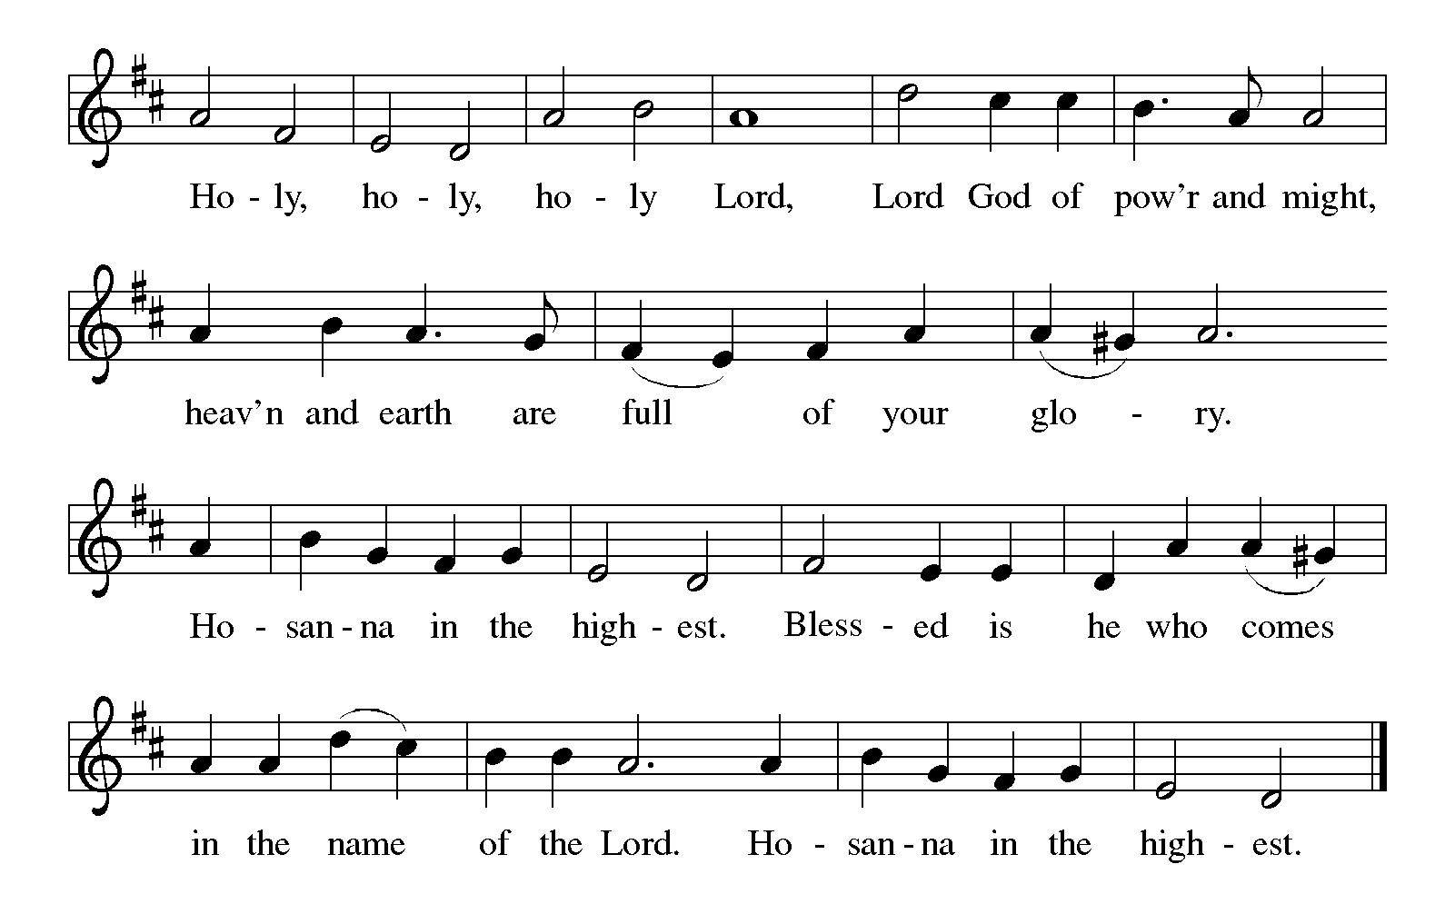

Thanksgiving at the Table
Holy God,
you alone are holy,
you alone are God.

The universe declares your praise:
beyond the stars;
beyond the sea;
within each cell;
with every breath.

Generations bless your faithfulness:
through the water;
by night and day;
across the wilderness;
out of exile;
into the future.

We give you thanks for your dear Son:
at the heart of human life;
near to those who suffer;
beside the sinner;
among the poor;
with us now.

In the night in which he was betrayed,
our Lord Jesus took bread;
and gave thanks; broke it,
and gave it to his disciples,
saying: Take and eat;
this is my body, given for you.
Do this in remembrance of me.

Again, after supper,
he took the cup, gave thanks,
and gave it for all to drink, saying: This is the new covenant in my blood,
shed for you and for all people
for the forgiveness of sin.
Do this for the remembrance of me.

Remembering his love for us
on the way,
at the table,
and to the end,
we proclaim the mystery of faith:

Christ has died.
Christ is risen.
Christ will come again.

Lord’s Prayer
Gathered into one by the Holy Spirit, let us pray as Jesus taught us.
Our Father, who art in heaven,
hallowed be thy name,
thy kingdom come,
thy will be done,
on earth as it is in heaven.
Give us this day our daily bread;
and forgive us our trespasses,
as we forgive those
who trespass against us;
and lead us not into temptation,
but deliver us from evil.
For thine is the kingdom,
and the power, and the glory,
forever and ever. Amen.

INVITATION TO COMMUNION
Christ invites you to this table.
All who are thirsty, all who are hungry, come!

COMMUNION *continuous
*People are welcome to kneel at the altar rail for a time of prayer after they receive their communion elements.

COMMUNION HYMNS
“Just As I Am, without One Plea” #592
“Jesus Loves Me!” #595

PRAYER AFTER COMMUNION
Let us pray.
Sustaining God,
with this bread and cup,
you nourish us with mercy and abundant life.
By your spirit, send us from this table to serve a needy world.
Make us living signs of your liberation, healing, and love,
Following the way of Jesus, in whose name we pray.
Amen.

Blessing
The God of love
draw you into full accord and one mind,
in the body of Christ Jesus.
Amen.
The God of hope
grant you strength and joy in all circumstances
through the interceding of the Spirit.
Amen.
The God of grace
☩ bless you now and forever.
Amen.
Sending SonG “You Servants of God” #825

Dismissal
Go out in joy. Be led forth in peace.
Thanks be to God.

From sundaysandseasons.com. Copyright © 2017 Augsburg Fortress. All rights reserved.

Thank you to all who served in worship today!
Presiders: Pastor Ken Scheck Musician: Martha Yoder
Acolyte: Kole Hokanson Safety Person:
Elder: Naomi Wilson Trustee: Jimmy Hindman
Offering Counters: Diane Griffin & Carlotta Willard



PRAYERS OF THE FAITHFUL

With thanks for all God’s blessings and his love for all people. Our Bishops, Julie Schneider-Thomas, Yehiel Curry, and the congregations of the North/West Lower Michigan Synod. We pray especially for Grace Evangelical Lutheran Church in Alpena and their Supply Pastors.

Prayers for our friends, for all who are sick or hospitalized and for all health care workers who care for them. All those members of Zion’s family traveling; all those homebound or in frail health; all those suffering with quiet, unknown needs or worries. For those who serve on our behalf: public safety, utility workers, medical personnel, military personnel. For those who might be forgotten. We pray especially for all countries involved in ongoing conflicts.

This week at Zion:
- Men’s Breakfast at 8am, Wednesday 7th
- Bulletin Deadline, Wednesday 7th
- Women’s Breakfast at C&R’s, at 9am Thursday 8th

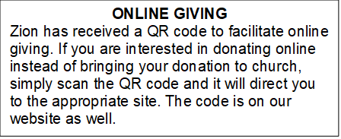

How to Contact the Pastor: If there is a pastoral need, please contact
Pastor Ken Scheck II at 269-370-4632 or by email at kscheckii@aol.com.

ANNOUNCEMENTS

- Baby Shower Table: Please join us in welcoming Raelynn Grace, the daughter to Erin and Travis Scarbrough! We will host a baby shower table in the Fellowship Hall until Sunday, October 25.They have asked for the following: Diapers, size 1 and up Wipes, Gift cards to buy baby formula. If you have any questions, please see Jolene. We welcome Raelynn Grace to Zion's family!
- Soap Needed for Baby Care Kits: Baby Care kits for Lutheran World Relief are underway and we need soap to add to the kits. Each completed kit will have 2-3 bars of "gentle soap." We hope to make 25-30 kits so we need 75-90 bars of soap. If you can help, please bring a bar - or more - of soap to church between now and September 27th. Ivory, Dove, Carass or any gentle brand will do. We will be putting the kits together on Wednesday, October 7th at 10:00 am. If you are free, please come help with this important mission project. Lutheran World Relief distributes the kits in the US and around the world where needed. Thank you for your help and support. If you have questions, please talk with Karen, Martha or Ruth.
- Baptism for Raelynn Scarborough October 4th: We are excited to be welcoming Raelynn into the family of Zion through baptism on Sunday October 4, 2026. Raelynn is the daughter of Erin and Travis Scarborough. There will be fellowship following worship. Please plan to attend and support this family of Zion.
- Church Halloween Party, October 25th: There will be a church Halloween Party and potluck following worship on October 25th. Please plan to stay for this time of fellowship and fun.
- Halloween Bags for the Shut-ins: Bags to collect goodies for our shut-ins will be out in the fellowship hall soon. Please bring a card, note, goody or other item to let our shut-ins know they are thought of and cared for. If you have questions, please see Dawn Brodbeck
- Announcement and Newsletter Items: Please forward items for the bulletin announcements and the newsletter to the church email (Office@Zion.org). Please do not send items to people’s personal emails. Thank you.
- Door Locking Policy: Our door locking policy relies on having a volunteer(s) each Sunday to serve as the Safety Person of the Day. On Sundays where no one has volunteered, if someone arrives at church and is willing to be the Safety Person of the Day, we will follow the door locking policy. If no one steps forward to serve as the Safety Person of the Day, the doors will not be locked. Please consider volunteering for this important duty.

